ECO Guide on virtual participation for attendees
USER EQUIPMENT

- Prepare one of the following audio sets:

- USB-headset connected to your computer or

- Headphones and USB-microphone connected to your computer.
For further guidance on the audio setup, check this guide.
- To improve the quality of your virtual participation, we recommended using two PCs:
Primary PC Secondary PC (optional)
- Primary PC will be used for seeing the discussion document (which will be also displayed on the big screen in the meeting room) and audio communications, and
- Secondary PC (optional) will only be used for an overview of the meeting room.

SETTING UP PRIMARY PC (GoToWebinar)

- Using GoToMeeting/GoToWebinar requires a client software on your PC. To test whether this software can be installed on your PC, go to this webpage and join a live test session. To get familiar with the GoToMeeting system you can review this webpage, for GoToWebinar – this webpage. You can also attend training sessions for both products (register on the above listed webpages).

- There is always a brief download to join as each session has unique security encryption. Therefore in advance of the meeting start time, either go to http://joinwebinar.com and enter the Webinar-ID given by the chairman or ECO staff member or click on the URL provided with the confirmation of your registration for the Primary PC.
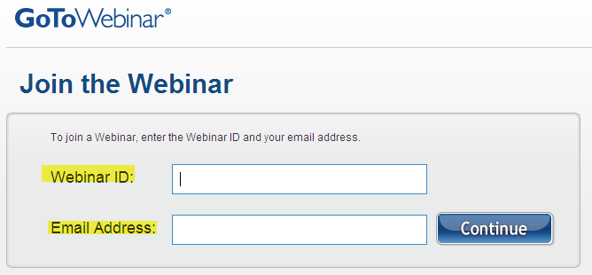

- If prompted, click Yes, Grant or Trust to accept the download. Click on the “Launch GoToWebinar” button when the download is complete. When required, fill in the “Name” filed according to the following pattern: “Firstname_Lastname (Organisation)” (as in the picture below); also enter your e-mail. The text in the “Name” field will appear in the attendees list in the GoToWebinar system and will be visible to the chairman, his/her assistant and other attendees.

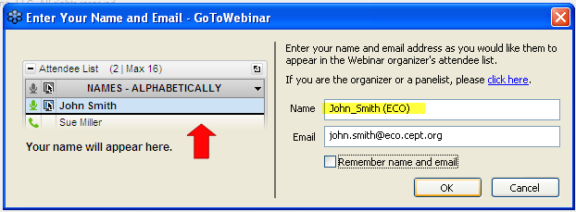

- When the webinar starts, you are connected as “attendee” in a “listen only” mode (i.e. muted). You can choose between “Telephone” (if the local tall number was provided for your country) and “Mic & Speakers” (VoIP, the default setting) options to join the meeting. To be able to take part in the discussion, check your audio setup (microphone and speakers).

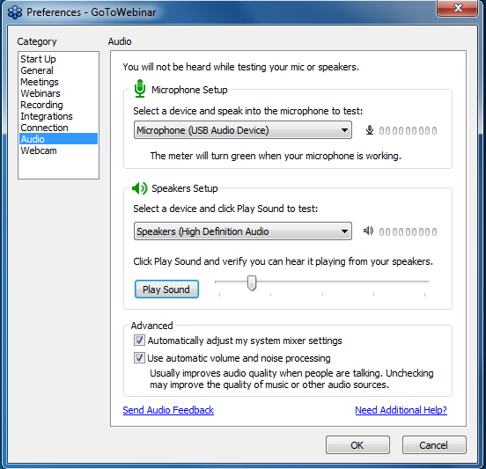
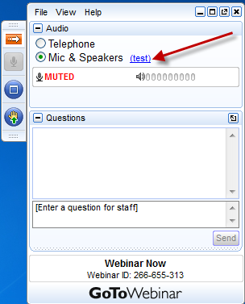

SETTING UP SECONDARY PC (GoToMeeting) - optional

- Secondary PC can be optionally used to view the meeting room through a web camera installed in the meeting room. GoToMeeting application is used for this purpose. If possible, use a different Internet connection for the Secondary PC to allow for more bandwidth for the Primary PC.

- Using GoToMeeting/GoToWebinar requires a client software on your PC. To test whether this software can be installed on your, go to this webpage and join a live test session on your Secondary PC.

- There is always a brief download to join as each session has unique security encryption. Therefore in advance of the meeting start time, either go to http://joingotomeeting.com and enter the Meeting-ID given by the chairman or ECO staff member or click on the URL provided with the confirmation of your registration for the Secondary PC.

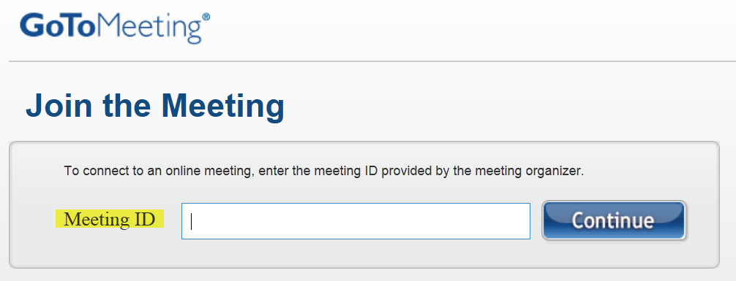
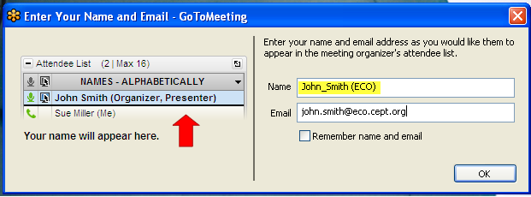
- If prompted, click Yes, Grant or Trust to accept the download. Click on the “Launch GoToMeeting” button when the download is complete. When required, fill in the “Name” filed according to the following pattern: “Firstname_Lastname (Organisation)” (as in the picture below); also enter your e-mail. The text in the “Name” field will appear in the attendees list in the GoToMeeting system and will be visible to the attendees on their secondary PCs.

- When the GoToMeeting session is started, expand the window showing the meeting room to full screen and follow the meeting visually. You shall be able to see people with raised hands in the meeting room (this shall help you to identify a person in addition to his/her introduction by the chairman when giving the floor to this person). You shall be also able to see when sessions are about to start after coffee breaks/lunch.
PARTICIPATING IN THE MEETING (Primary PC)
- You shall be able to see a copy of the chairman’s PC screen (which is also displayed on the big screen in the meeting room) and hear the chairman and the participants in the meeting room when they talk to their table microphones.

- In your control panel you can do the following:

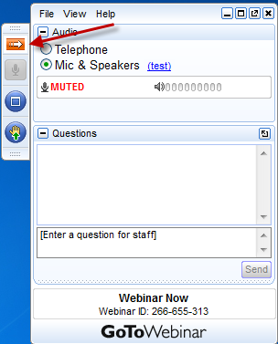

  - Expand and collapse your control panel
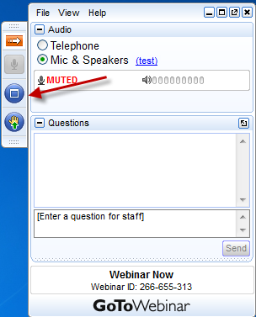

  - View the Chairman’s PC screen in Fullscreen mode

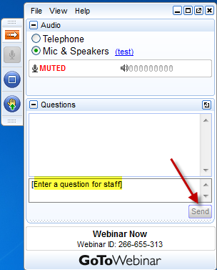
  - Send written questions on the procedure- and connection related issues which may be answered by the assistant (answers will appear within the “Questions” pane).

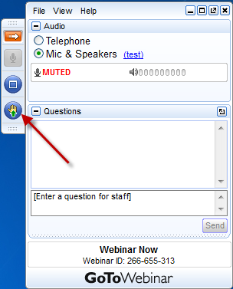
  - “Raise hand” to request the floor. This request will be visible to the chairman and to the assistant. You can lower “raised hand” using the same button.

  - When invited by the chairman/assistant to take the floor, make sure your name and affiliation are clearly identified and check that you are unmuted by the chairman/assistant (see the green icon on the picture below) before going into the discussion.

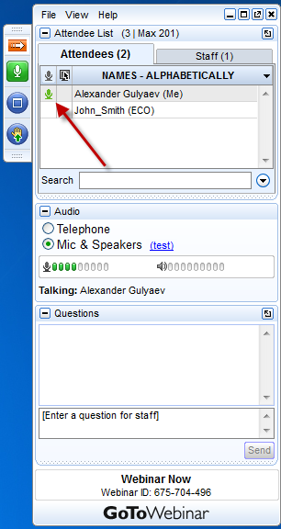

  - You can present a document located on your PC which will be displayed on the big screen in the meeting room and also on the PCs of all other virtual participants. Your voice will be heard by both physical and virtual participants.
To allow for this remote presentation, the chairman/assistant can temporarily make you “presenter”: have your document open on your PC and choose it from the list of applications when prompted (see example below). Talk directly to the microphone.

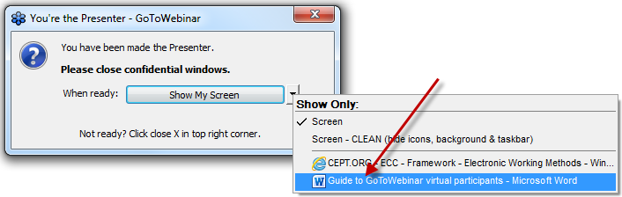

When your presentation is over, the chairman will take the “presenter” role back and you’ll be notified accordingly (see picture below). You will be also muted.

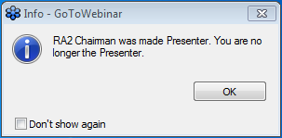

As you were “presenter”, the GoToWebinar system has upgraded your status to the “panelist” and the function “raise hand” has been removed from your control panel. To get it back, you’ll need to close the current session and to reconnect to it again as an attendee (repeat steps 4 and 5).

