CPG PTC(11)TEMP052
CPG PTC(11)069
CPG PTC- 11
Mainz, 27 – 30 September 2011
Date issued: | 21 September 2011
Source: | Coordinator
Subject: | Proposed amendments to PDNR ITU-R M.[CHARLIE]
N
Password protection required? (Y/N)

Summary:
The document presents proposed amendments to the PRELIMINARY DRAFT NEW RECOMMENDATION ITU-R M.[CHARLIE]. Baseline of this document is Annex 21 to Document 5B/727-E
Proposal:
PTC is invited to consider this PDNR and to provide a contribution to the next ITU-R WP 5B

Background:

Radiocommunication Study Groups | 
Source: Document 5B/TEMP/335  Subject: WRC-12 Agenda item 1.4 | Annex 21 to  Document 5B/727-E
 | 26 August 2011
 | English only
Annex 21 to Working Party 5B Chairman’s Report
draFt new reCOMMENDATION ITU-R m.[CHARlIE]
Technical characteristics of, and protection criteria for
non-ICAO ARNS systems, operating around 1 GHz

Scope
TBD
The World Radiocommunication Assembly,
considering
a) that the Tactical Air Navigation system (TACAN) is an aeronautical radionavigation system used on a national basis and operates in the frequency band 960-1 215 MHz;
b) that the TACAN system is used by both civil and state aircraft;
c) that when used by civil aviation, TACAN functionally is equivalent to the ICAO standardized distance measuring equipment (DME);

d) that the TACAN system provides additional functionality to that of DME, i.e. obtaining bearing information;
e) that this additional functionality results in technical characteristics that differ from those of DME and may require additional consideration in future compatibility studies,
f) that the use of TACAN includes shipborne and air to air applications;

noting
a) that according to Resolution 417 (WRC-07) precedence must be given to the ARNS operating in the frequency band 960-1 164 MHz;
b) that ITU-R studies have shown that following the introduction of aeronautical mobile (route) service (AM(R)S) in the band 960-1 164 MHz, more detailed site-specific compatibility studies between TACAN and AM(R)S systems have to be performed,
recommends
that for compatibility studies the characteristics and protection criteria in the annexes to this document should be used.
ANNEX 1
Tactical Air Navigation system (TACAN)
TACAN is an aeronautical radionavigation system used on a national basis operating between 960 and 1 215 MHz. A TACAN system consists of an interrogator on-board an aircraft and a beacon which gives the replies. In most cases the TACAN beacons are fixed ground based installations but there are maritime mobile and aeronautical mobile beacons in use as well. Depending on the generated EIRP and design of the interrogator slant ranges up to 400 NM (740 km) can be achieved but in practice the range is limited to the maximum radio line-of-sight (RLOS). The aircraft unit transmits regular pulse pairs, so-called interrogation pulses which are received by ground based installations (beacons). The TACAN pulses have a pulse width of 3.5 μs at the 50% Amplitude points. The spacing between the pulses of an interrogation pulse pair is 12 μs (X channel) or 36 μs (Y channel). After receiving an interrogator pulse pair a ground station will test the pulse shape and spacing. If these fall within the acceptance limits, it will respond by transmitting a reply after a fixed delay with a ±63 MHz frequency offset from the interrogation frequency depending on selected channel on pulse code. The beacon has a spacing between the reply pulses of 12 μs
(X channel) and 30 μs (Y channel). After receipt of the reply, the interrogator will calculate the momentary slant range distance to the beacon from the time elapsed between transmitting interrogation and receiving reply pulse pairs.
The beacon will receive interrogations from many aircraft and therefore will send out many replies. Each interrogator creates a unique pattern by varying, within certain limits, the time between the pulse pairs to avoid generation of synchronic replies. By this principle each platform is able to recognize among all pulse pairs the replies that are initiated by its own interrogator.
For identification purposes, a TACAN beacon transmits a morse ID code. The ID tone is used at the airborne interrogators to verify if the range readouts are provided by the correct beacon. Besides the pulse responses, proper reception of the ID tone is also an important condition for TACAN interrogators to properly function.
In addition to the range measurements TACAN also offers azimuth bearing information. The bearing information is provided by applying a modulation in the amplitude of the pulses transmitted by the ground beacon. This pulse amplitude modulation (PAM) is created using either a mechanically or electronically scanning beacon antenna. The variation in the azimuth pattern in the form of 15 Hz and 135 Hz antenna lobes at the maximum allowable modulation index of 55% will reduce the signal level of the reply pulses by up to 10.7 dB below the maximum EIRP level of pulses without PAM. In order for the interrogator to decode the orientation of the antenna pattern in reference to north from the PAM, an additional 900 pulse pairs, consisting of a north-reference-pulse-group (NRPG) and additional fine Reference Pulse Groups (RPG) are transmitted by the beacon. In order to obtain accurate bearing information and be able to reply to at least 100 aircraft with 70% reply efficiency a constant number of at least 3 600 pulse pairs have to be transmitted.
The TACAN system is used for aeronautical navigation for both state aircraft as well as civil aviation. When used by civil aviation, the TACAN equipment is functionally equivalent to the ICAO standardized DME. TACAN characteristics are given in Table 1.1.

Table 1.1
Typical characteristics of TACAN stations
Purpose | Radio systems for air navigation (960 and 1 215 MHz)
Radio transmission direction | Earth-aircraft | Aircraft-Earth | Earth-aircraft  maritime | Aircraft-Earth  maritime | Aircraft –aircraft
Operating frequency range (MHz) | 962-1 213 | 1 025-1 150 | 962-977 | 1 025-1 088 | 1 025-1 151
Operation range, (km)  (limited to RLOS) | up to 600 | up to 600 | Up to 600 | up to 600 | up to 740
Transmitted information | Range and bearing response signals,  Identification information | Range and bearing request signal | Range and bearing response signals,  Identification | Range and bearing request signal | Range and bearing response signals,  Identification
Transmitter characteristics
Station name | Beacon | Interrogator | Beacon | Interrogator | Beacon
Height above the ground, (m) | 3  (10ft) | up to 18 288  (60 000ft) | 3  (10ft) | up to 18 288  (60 000ft) | up to 18 288  (60 000ft)
Signal type | Pulsed | Pulsed | Pulsed | Pulsed | Pulsed
Channel spacing (MHz) | 1 | 1 | 1 | 1 | 1
Type of modulation | Pulse form and pulse pair spacing | Pulse form and pulse pair spacing | Pulse form and pulse pair spacing | Pulse form and pulse pair spacing | Pulse form and pulse pair spacing
Transmitter power (pulsed), (dBW) | 39 (max) | 33 (max.) | 39 (max) | 33 (max.) | 33 (max)
Mean output power(min/max), (dBW)
Pulse length, μs | 3.5±0.5  (50% Amplitude) | 3.5 ±0.5  (50% Amplitude) | 3.5 ±0.5  (50% Amplitude) | 3.5 ±0.5  (50% Amplitude) | 3.5 ±0.5  (50% Amplitude)
Typical duty factor (%) | 2.52 | 0.105 | 2.52 | 0.105 | 0.735
Antenna type | Circular array | Omni directional | Circular array | Omni directional | Circular array
Typical antenna gain,( dBi) | 6 | 0 | 6 | 0 | 6

Purpose | Radio systems for air navigation (960 and 1 215 MHz)
Receiver characteristics
Receiving station | Aircraft station | Airport and en-route ground station | Aircraft stations | Maritime station | Aircraft station
Operating frequency range (MHz) | 962-1 213 | 1 025-1 150 | 962-977 | 1 025-1 088 | 1 025-1 151
Height above the ground, (m) | up to 20 880  (60 000ft) | 3  (10ft) | up to 20 880  (60 000ft) | 3  (10ft) | up to 20 880  (60 000ft)
Receiver 3dB bandwidth,(MHz) | 2 | 2-4.5 | 2 | 2-4.5 | 2-4.5
Receiver noise temperature, (K)
Max/min antenna gain, (dBi) | 5.4 / 0 | 9.1 / 4.1 | 5.4 / 0 | 9.1 / 4.1 | 5.4 / 0
Polarization | Vertical | Vertical | Vertical | Vertical | Vertical
Real receiver sensitivity, (dBW) | −122 | −122 | −122 | −122 | −122
Maximum acceptable interference level based on received power (dBW) | −129 | −130 | −129 | −130 | −129
NOTE – The protection ratios shown in Table 5B were obtained for non-pulsed signals. In case of pulsed signals it is required to carry out additional studies.
NOTE – The airborne antenna gain is taken from ITU-R M.1642-1 NOTE – Measurements on some TACAN devices showed that the TACAN sensitivity for the distance and angular measurements only differ by 3 dB for the TACAN interrogator receiver (–90 dBm for distance and –87 dBm for angular measurement).
[Note by the Chairman: The terms used and values given in the table above need to be better defined, clarified to avoid misinterpretation in the future and aligned with figures given in Table 2.1. For instance what does real receiver sensitivity mean and what is the mean output power is it per pulse or over the whole pulse train.]

There is a large installed base of TACAN equipment, both ground stations (beacons) as well as aircraft stations (interrogators), in various Administrations. The actual technical characteristics of the various types of equipment vary. One important factor, that determines the interference effect, is the receiver selectivity curve. Figure 1 shows the receiver selectivity curves of five types of TACAN interrogator equipment’s. It can be seen that there is a great spread in the selectivity of the different TACAN type receivers. In the compatibility studies all TACAN type interrogators should be taken into account in order to guarantee sufficient protection of this aeronautical radionavigation service (ARNS) application including both range and azimuth determination functionality.
Figure 1.2 shows a receiver selectivity curve for a typical TACAN beacon. The TACAN beacon selectivity is worse than those of the TACAN interrogator receivers.
Figure 1.1
Airborne station (interrogator) receiver RF-selectivity curves
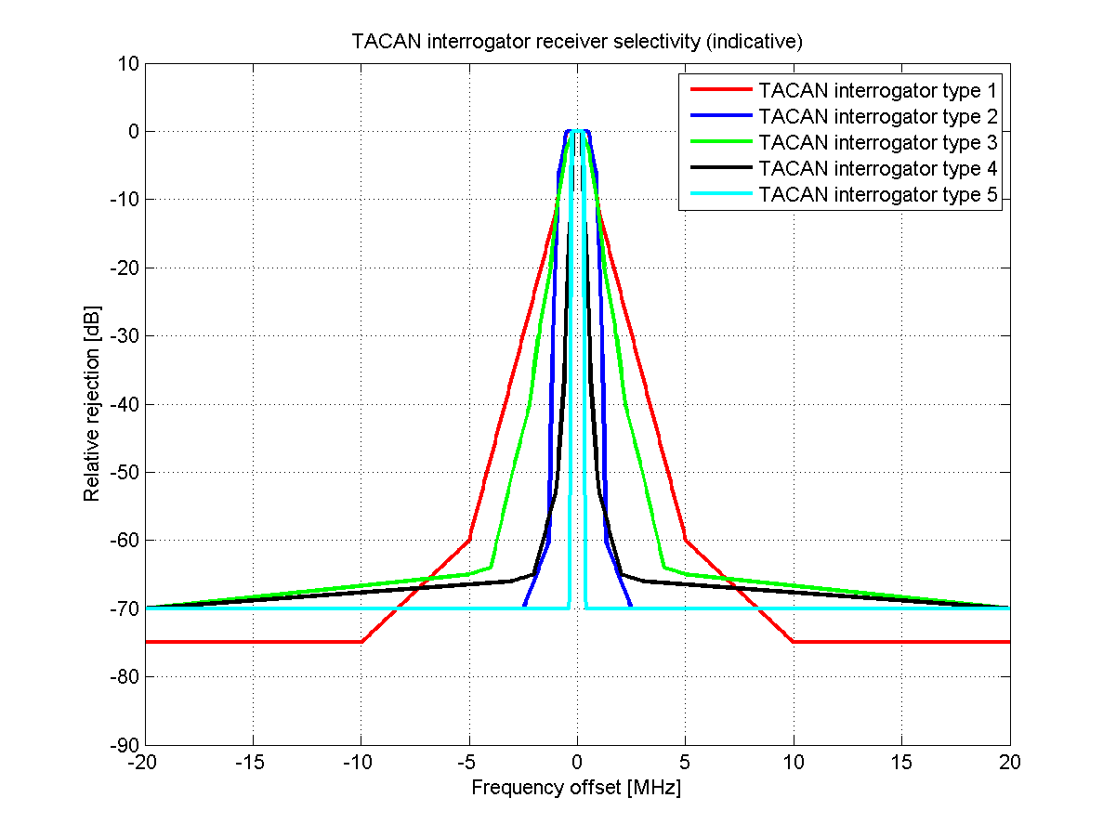

Figure 1.2
Ground station (beacon) receiver RF selectivity curves

ANNEX 2
Non ICAO ARNS Systems operated in countries referred to in RR No. 5.312
Specifically the countries referred to in RR No. 5.312 of the RR operate the ARNS systems of the following three types:
– Type 1: the ARNS systems of the first type refer to direction-finding and ranging systems. The systems are designed for finding an azimuth and a slant range of an aircraft as well as for area surveillance and inter-aircraft navigation. They are composed of air-borne and ground-based stations. The air-borne stations generate requesting signals transmitted via omnidirectional antennae and received at ARNS ground stations which also operate in an omnidirectional mode. The ground stations generate and transmit response signals containing azimuth/ranging information. Those signals are received and decoded at the ARNS airborne stations. The first type stations transmit the signals requesting the azimuth/ranging data outside the 960-1 164 MHz frequency band. After receiving a requesting signal the ARNS ground stations use the 960-1 164 MHz frequency band only for transmitting the ranging data to be received at the ARNS airborne stations. Thus the ARNS systems of the first type use the 960-1 164 MHz frequency band only for transmitting the signals in the surface-to-air direction. The maximum operation range for the first type ARNS systems is 400 km. It is expected that in some of the countries mentioned in RR No. 5.312 the usage of type 1 of ARNS mentioned above may be discontinued.
– Type 2: the ARNS direction-finding and ranging systems of the second type are designed for the same missions as the first type ARNS systems. The primary difference of the second type stations refers to the fact that requesting signals are transmitted by the airborne stations in the same frequency band as responding signals transmitted from the ground stations. Moreover the ground-based ARNS stations of the second type can operate in both directional and omnidirectional modes. Directional mode provides increased number of operational channels at the ARNS stations. The maximum operation range for the first type ARNS systems is 400 km. It is planned to use the overall frequency band 960 – 1 164 MHz allocated to ARNS in order to increase flexibility of operation of the second type ARNS systems. Application of the wideband tuning filter on the ARNS receiver front end is the design peculiarity of the second type ARNS systems which is stipulated by the necessity to receive signals on several channels simultaneously. The passband of this filter is 22 MHz and it allows receiving simultaneously up to 5 channels among 30 overlapping channels of 4.3 MHz each. The simultaneous usage of wideband filter and correlator allows increase in the accuracy of aircraft position data measurement and C/N ratio at the receiver front end as well. Type 2 of ARNS system can operate in a limited number of countries mentioned in RR No. 5.312.
– Type 3: the ARNS systems of the third type are designed for operating at the approach and landing stages of flight. The system provides control functions of heading, range and glide path at aircraft approach and landing. The ARNS ground stations of the third type operate in both directional and omnidirectional modes. Operation range of the third type ARNS systems does not exceed 60 km. The 960-1 164 MHz frequency band is used for operation of the channels designed for control of the glide path and range between air-borne and ground ARNS stations. Type 3 of ARNS system can operate in a limited number of countries mentioned in RR No. 5.312.

Table 5A below provides brief technical description of the ARNS stations.
Thus the stations of the non-ICAO systems operate using the air-to-surface and surface-to-air links are made up of ground and airborne receivers and transmitters.

Table 2.1
Typical characteristics of the ARNS stations operating in the countries referred to in RR No. 5.312
ARNS system characteristics | Type 1 | Type 2 |  | Type 3
Purpose | Radio systems of  short-range navigation | Radio systems of short-range navigation |  | Radio systems of approach and landing
Operating frequency range (MHz) | 960-1 000.5 | 960-1 164
Radioline direction | “Earth-aircraft” | “Earth-aircraft” | “aircraft-Earth” | “Earth-aircraft” | “aircraft-Earth”
Operation range, (km) | up to 400 | up to 400 | up to 400 | up to 45 | up to 45
Transmitted information | Transmission of azimuthal signals, range response signals and request to indication | Transmission of azimuthal signals, range response signals and request to indication | Transmission of range request signal and indication response signal | Transmission of signals in glide path and course channels and range response signals | Transmission of range request
Transmitter characteristics
Station name | Airport and en-route path ground stations | Airport and en-route path ground stations | Aircraft station | Airport ground station | Aircraft station
Signal type | Pulsed | pulsed | pulsed | pulsed | pulsed
Class of emission | 700KРХХ | 4M30P1N | 4M30P1D | 700KP0X; 4M30P1N | 700KP0X; 4M30P1N
Channel spacing (MHz) | 0.7 | 0.7 | 0.7 | 0.7 | 2
Type of modulation | Pulsed | pulsed | pulsed | pulsed | pulsed
Transmitter power (pulsed), (dBW) | 20-45 | 29-39 | 27-33 | 3-30 | 5-33
Mean output power(min/max), (dBW) | 7.6 / 13.2 | 7.1/13.8 | −8.2 | −4/−6 | −7.5
Pulse length, (μs) | 1.5; 5.5 | 1.25; 1.5; 5.5 | 1.5 | 1.7 | 1.7
Duty factor (%) | 0.018; 0.066 | 0.064 - 0.3 | 0.00765 | 0.04; 0.025 | 0.009
Antenna type | Omnidirectional | array antenna | omnidirectional | array antenna | omnidirectional
Max/min antenna gain, (dB) | 6/0 | 15.6 | −10/3 | 10/0 | 1.5/−3
Height above the ground, (m) | 10 | 10 | up to 12 000 | 10 | up to 12 000
Receiver characteristics
Receiving station | Aircraft station | Aircraft station | Airport and en-route path ground stations | Aircraft station | Airport ground station
Height above the ground, m | up to 12 000 | up to 12 000 | 10 | up to 12 000 | 10
Receiver passband, MHz | 1.5 | 22 | 22 | 7 | 7
Receiver noise temperature, K | 400 | 1 060 | 550 | 400 | 400
Max/min antenna gain, dB | 1.5/−3 | 3/−10 | 14 | 1.5/−3 | 10/0
Polarization | horizontal | horizontal | horizontal | horizontal | horizontal
Real receiver sensitivity, dBW | −120 | −118 | −125 | −110…−120 | −113
Protection ratio C/I, dB | 25 | 17 | 20 | 25 | 25
NOTE – The protection ratios shown in Table 2.1 were obtained for non-pulsed signals. In case of pulsed signals it is required to carry out additional studies.
[Note by the Chairman: The terms used and values given in the table above need to be better defined, clarified to avoid misinterpretation in the future and aligned with figures given in Table 1.1. For instance what does real receiver sensitivity mean and what is the mean output power is it per pulse or over the whole pulse train.]

