CPG12- 7
Bucharest, 1 – 4 November 2011

Date issued: 31st October 2011
Source: ECO
Subject: Messaging/Chat system on ECO website

Summary:
A messaging/chat system is put in place on the ECO website for the purpose of CEPT coordination during the WRC-12

Proposal:
This Info document explain how to register and use the system

Introduction

The beta version of a messaging/chat system is put in place on the ECO website for the purpose of CEPT coordination during the WRC-12. The chat system is introduced for the WRC-12 in addition to the messaging system, following the request from CPG-12.

The messaging/chat system can be found at http://ecosms.cept.org

- In order to start registration it is necessary:

- to click on the REGISTER NOW button (box 1) to create a personal account by filling out the form requiring Registration Key provided to CEPT administrations separately by the head of delegation.
- to log in (box 2) with your e-mail and password.
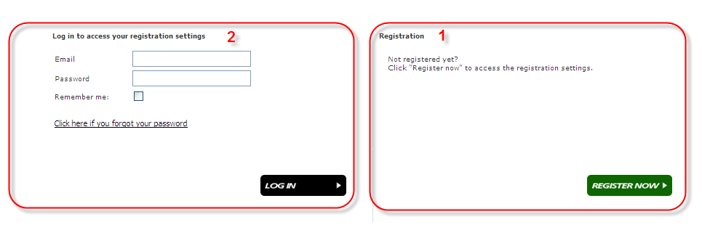
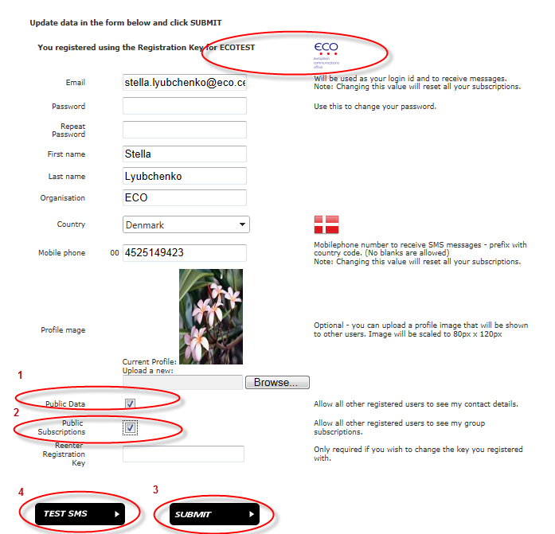

- By clicking on the box ”Public data” you will make you profile public for the users of the messaging/chat system.
- By clicking on “Public Subscriptions” users will have a possibility to see subscriptions of other users of the system.
- Save your profile by clicking on “Submit button”.
- It is necessary to test sms function by clicking on “test sms” button.

- To subscribe to the groups dealing with WRC-12 Agenda Items, to click on “My Group Subscriptions”, pick up groups from the list. To enable text messages, e-mail and chat options, the user needs to check all boxes for different AI’s.

Changes become active after clicking on “SAVE SATTINGS” button

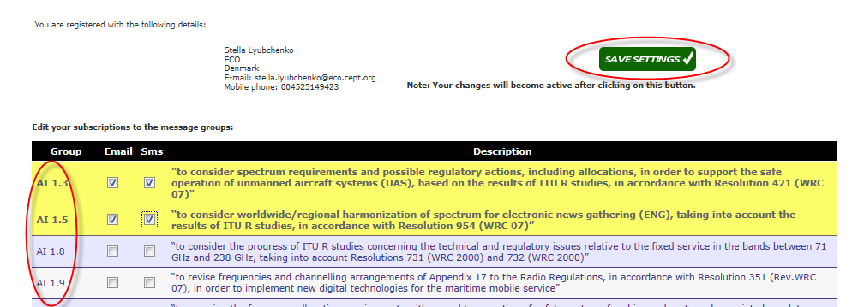

- To start a chat one should do the following:

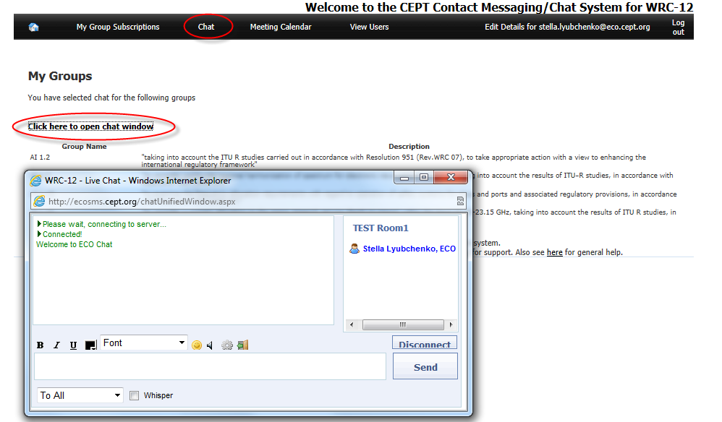

Chat with all subscribers of different group/Agenda Items (TEST Room 1 can be considered as an example) can be enabled in a single chat room, as well as private chat with the people as shown below:

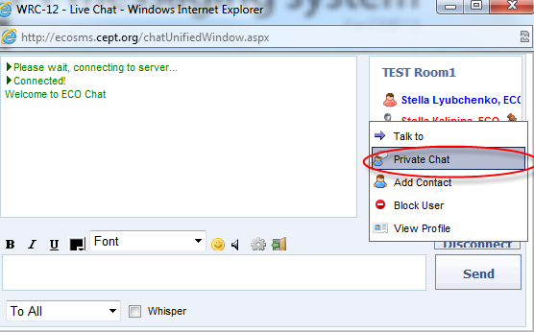

- Favorite users can be selected from the “View Users” menu item by clicking “View Users” button (step 1) and then picking up users from the list.
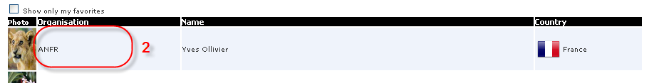
  - This menu item is ONLY visible IF you have selected “Public Data” on your profile: 

