Annex 1
List of CEPT coordinators WRC-12
WRC-12Agenda item | Issue | CEPT coordinator | E-mail address
Overall coordination:
Eric Fournier (F) Steve Bond (G) Alexander Kuehn (D) Christian rissone (F)
CPG Chairman CPG vice-chairman CPG vice-chairman CPG secretary

fournier@anfr.fr steve.bond@ofcom.org.uk alexander.kuehn@bnetza.de rissone@anfr.fr
1.1 | to consider and take appropriate action on requests from administrations to delete their country footnotes or to have their country name deleted from footnotes, if no longer required, taking into account Resolution 26 (Rev.WRC-07); | Vladislav Sorokin (RUS) | v.s@inbox.ru, vladislav.sorokin@ties.itu.int
1.2 | taking into account the ITU-R studies carried out in accordance with Resolution 951 (Rev.WRC-07), to take appropriate action with a view to enhancing the international regulatory framework; | Lilian Jeanty (HOL) |   lilian.jeanty@agentschaptelecom.nl
1.3 | to consider spectrum requirements and possible regulatory actions, including allocations, in order to support the safe operation of unmanned aircraft systems (UAS), based on the results of ITU-R studies, in accordance with Resolution 421 (WRC-07); | Martin Weber (D) |   martin.weber@bnetza.de
1.4 | to consider, based on the results of ITU-R studies, any further regulatory measures to facilitate introduction of new aeronautical mobile (R) service (AM(R)S) systems in the bands 112-117.975 MHz, 960-1 164 MHz and 5 000-5 030 MHz in accordance with Resolutions 413 (Rev.WRC-07), 417 (WRC-07) and 420 (WRC-07); | Gerlof Osinga (HOL) | gerlof.osinga@agentschaptelecom.nl
1.5 | to consider worldwide/regional harmonization of spectrum for electronic news gathering (ENG), taking into account the results of ITU-R studies, in accordance with Resolution 954 (WRC-07); | Christoph Hildebrand (D) | 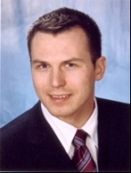  christoph.hildebrand@bnetza.de
1.6 | to review No. 5.565 of the Radio Regulations in order to update the spectrum use by the passive services between 275 GHz and 3 000 GHz, in accordance with Resolution 950 (Rev.WRC-07), and to consider possible procedures for free-space optical-links, taking into account the results of ITU-R studies, in accordance with Resolution 955 (WRC-07); | Philippe Tristant (Eumetnet) | 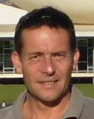  philippe.tristant@eumetnet.eu
1.7 | to consider the results of ITU-R studies in accordance with Resolution 222 (Rev.WRC-07) in order to ensure long-term spectrum availability and access to spectrum necessary to meet requirements for the aeronautical mobile-satellite (R) service, and to take appropriate action on this subject, while retaining unchanged the generic allocation to the mobile-satellite service in the bands 1 525-1 559 MHz and 1 626.5-1 660.5 MHz; | Sylvain Germaine (F) |   chris.vdiepenbeek@agentschaptelecom.nl
1.8 | to consider the progress of ITU-R studies concerning the technical and regulatory issues relative to the fixed service in the bands between 71 GHz and 238 GHz, taking into account Resolutions 731 (WRC-2000) and 732 (WRC-2000); | Nasarat Ali (G) | 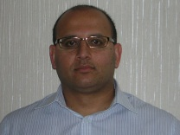  nasarat.ali@ofcom.org.uk
1.9 | to revise frequencies and channelling arrangements of Appendix 17 to the Radio Regulations, in accordance with Resolution 351 (Rev.WRC-07), in order to implement new digital technologies for the maritime mobile service; | Jaap Steenge (HOL) |   jaap.steenge@agentschaptelecom.nl
1.10 | to examine the frequency allocation requirements with regard to operation of safety systems for ships and ports and associated regulatory provisions, in accordance with Resolution 357 (WRC-07); | Aurelian Sorinel Calinciuc (ROU) |   aurelian.calinciuc@ancom.org.ro
1.11 | to consider a primary allocation to the space research service (Earth-to-space) within the band 22.55-23.15 GHz, taking into account the results of ITU-R studies, in accordance with Resolution 753 (WRC-07); | Eduardo Quintas (E) | quintase@inta.es
1.12 | to protect the primary services in the band 37-38 GHz from interference resulting from aeronautical mobile service operations, taking into account the results of ITU-R studies, in accordance with Resolution 754 (WRC-07); | Jean-Yves Guyomard (F) |   guyomard@anfr.fr
1.13 | to consider the results of ITU-R studies in accordance with Resolution 551 (WRC-07) and decide on the spectrum usage of the 21.4-22 GHz band for the broadcasting-satellite service and the associated feeder-link bands in Regions 1 and 3; | Samuel Blondeau (LUX) |   samuel.blondeau@ses.com
1.14 | to consider requirements for new applications in the radiolocation service and review allocations or regulatory provisions for implementation of the radiolocation service in the range 30-300 MHz, in accordance with Resolution 611 (WRC-07); | Sergey Sorokin (RUS)  Victor Glushko (RUS) | sorokin@geyser.ru  glushko@geyser.ru
1.15 | to consider possible allocations in the range 3-50 MHz to the radiolocation service for oceanographic radar applications, taking into account the results of ITU-R studies, in accordance with Resolution 612 (WRC-07); | Stéphanie Vrac (F) | 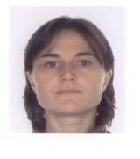  vrac@anfr.fr
1.16 | to consider the needs of passive systems for lightning detection in the meteorological aids service, including the possibility of an allocation in the frequency range below 20 kHz, and to take appropriate action, in accordance with Resolution 671 (WRC-07); | Bharat Dudhia (G) | bharat.dudhia@ofcom.org.uk
1.17 | to consider results of sharing studies between the mobile service and other services in the band 790-862 MHz in Regions 1 and 3, in accordance with Resolution 749 (WRC-07), to ensure the adequate protection of services to which this frequency band is allocated, and take appropriate action; | Jean-Philippe Millet (F) | milletjp@anfr.fr
1.18 | to consider extending the existing primary and secondary radiodetermination-satellite service (space-to-Earth) allocations in the band 2 483.5-2 500 MHz in order to make a global primary allocation, and to determine the necessary regulatory provisions based upon the results of ITU-R studies, in accordance with Resolution 613 (WRC-07); | Dominic Hayes (GSA) |   Dominic.HAYES@ec.europa.eu
1.19 | to consider regulatory measures and their relevance, in order to enable the introduction of software-defined radio and cognitive radio systems, based on the results of ITU-R studies, in accordance with Resolution 956 (WRC-07); | Paul Bender (D) |   Paul.Bender@BnetzA.de
1.20 | to consider the results of ITU-R studies and spectrum identification for gateway links for high altitude platform stations (HAPS) in the range 5 850-7 075 MHz in order to support operations in the fixed and mobile services, in accordance with Resolution 734 (Rev.WRC-07); | Alexander Klyucharev (RUS) | alexander.klyucharev@ties.itu.int
1.21 | to consider a primary allocation to the radiolocation service in the band 15.4-15.7 GHz, taking into account the results of ITU-R studies, in accordance with Resolution 614 (WRC-07); | Volodymyr Lapin (UKR) | valapin@ukr.net
1.22 | to examine the effect of emissions from short-range devices on radiocommunication services, in accordance with Resolution 953 (WRC-07); | Yves Ollivier (F) | 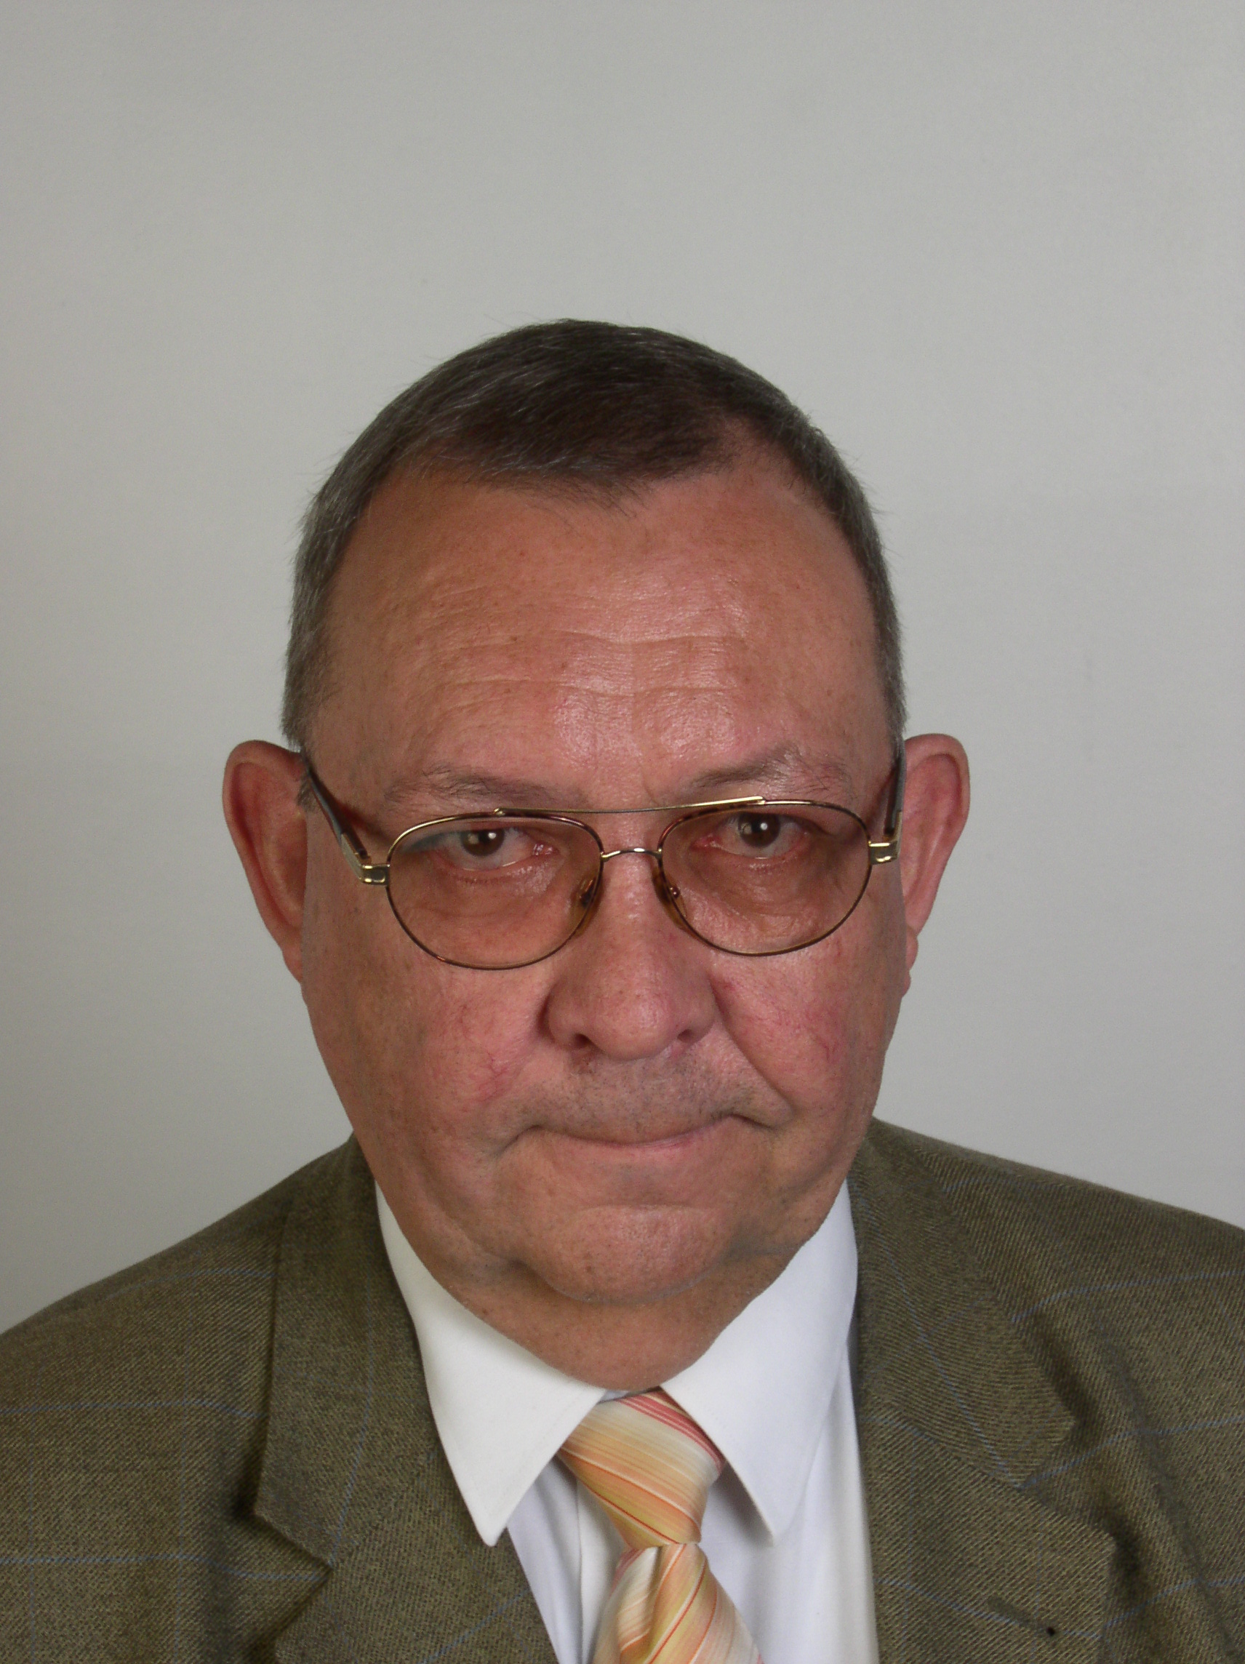  ollivier@anfr.fr
1.23 | to consider an allocation of about 15 kHz in parts of the band 415-526.5 kHz to the amateur service on a secondary basis, taking into account the need to protect existing services; | Colin Thomas (G) |   Colin.thomas@rsgb.org.uk
1.24 | to consider the existing allocation to the meteorological-satellite service in the band 7 750-7 850 MHz with a view to extending this allocation to the band 7 850-7 900 MHz, limited to non-geostationary meteorological satellites in the space-to-Earth direction, in accordance with Resolution 672 (WRC-07); | Markus Dreis (D) | markus.dreis@eumetsat.int
1.25 | to consider possible additional allocations to the mobile-satellite service, in accordance with Resolution 231 (WRC-07); | Juergen Nitschke (D) |   juergen.nitschke@bnetza.de
2 | to examine the revised ITU-R Recommendations incorporated by reference in the Radio Regulations communicated by the Radiocommunication Assembly, in accordance with Resolution 28 (Rev.WRC-03), and to decide whether or not to update the corresponding references in the Radio Regulations, in accordance with principles contained in the Annex 1 to Resolution 27 (Rev.WRC-07); | Alexander Kuehn (D) | alexander.kuehn@bnetza.de
3 | to consider such consequential changes and amendments to the Radio Regulations as may be necessitated by the decisions of the Conference;
4 | in accordance with Resolution 95 (Rev.WRC-07), to review the resolutions and recommendations of previous conferences with a view to their possible revision, replacement or abrogation; | Alexander Kuehn (D) | alexander.kuehn@bnetza.de
5 | to review, and take appropriate action on, the Report from the Radiocommunication Assembly submitted in accordance with Nos. 135 and 136 of the Convention;
6 | to identify those items requiring urgent action by the Radiocommunication Study Groups in preparation for the next world radiocommunication conference;
7 | to consider possible changes in response to Resolution 86 (Rev. Marrakesh, 2002) of the Plenipotentiary Conference: “Advance publication, coordination, notification and recording procedures for frequency assignments pertaining to satellite networks”, in accordance with Resolution 86 (Rev.WRC-07); | Stephen Limb (G) |   stephen.limb@ofcom.org.uk
8 | in accordance with Article 7 of the Convention:
8.1 | to consider and approve the Report of the Director of the Radiocommunication Bureau: | Gabriela Galvano (POR) |   gabriela.galvano@anacom.pt
8.1.1 | on the activities of the Radiocommunication sector since WRC-07; | A+B: Alexander Kuehn (D)  C: Chris Van Diepenbeek (HOL) | gabriela.galvano@anacom.pt  chris.vdiepenbeek@agentschaptelecom.nl
8.1.2 | on any difficulties or inconsistencies encountered in the application of the Radio Regulations; and
8.1.3 | on action in response to Resolution 80 (Rev.WRC-07);
8.2 | to recommend to the Council items for inclusion in the agenda for the next WRC, and to give its views on the preliminary agenda for the subsequent conference and on possible agenda items for future conferences, taking into account Resolution 806 (WRC-07), | Anders Jonsson (S) |   anders.jonsson@pts.se

_____________

