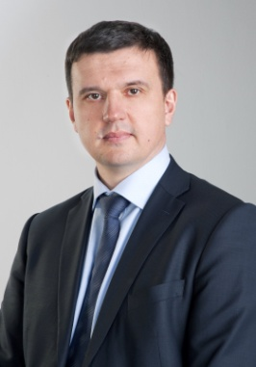
Dr. Victor I. Glushko
Deputy Director General, Geyser-Telecom Ltd, Moscow
Date of birth: January 17, 1969
Married, with two sons

Education
2007-2009 | The Russian Presidential Academy of National Economy and Public Administration, Moscow
2002 | Doctor of Science, Specialty: Methods of electromagnetic compatibility provision for non-geostationary orbiting satellite networks
1986-1991 | Military Institute of Space Engineering named after A.F. Mozhaisky, Saint-Petersburg

Professional Experience
1998-… | GEYSER Scientific & Production Company Ltd, Geyser-Telecom Ltd in positions of Leading Expert, Head of Department, Deputy Director General  Basic Areas of Professional Interests:  - Filing and Coordination of Terrestrial and Satellite Networks at ITU-R  - The work in ITU-R Study Groups and CEPT Working Groups  - Preparation to WRCs and RRCs  - Development of proposals to the National Telecom Regulations  - Conversion of Radio Frequency Spectrum  - Projecting, Constructing and Commissioning of Communication Networks  - EMC Study
1991-1998 | Military service, Russian Space Forces

International Activity
2000, 2003, 2007, 2012 | Participation in World Radiocommunication Conferences as a member of the Russian delegation, CEPT Coordinator for agenda items 1.15 (WRC-2000), 1.31 (WRC-03), 1.5 (WRC-07), 1.14 (WRC-12)
2004, 2006 | Participation in Regional Radiocommunication Conferences on digital broadcasting
2011 | Vice-Chairman of СРМ-11, Rapporteur for Chapter 2 of CPM Report, Chairman of Working Group 2
2012 | Chairman of Working Group 4A at WRC-12
1998 - … | Participation in the work of ITU-R Study Groups, CEPT and RCC Working Groups

