Curriculum vitae

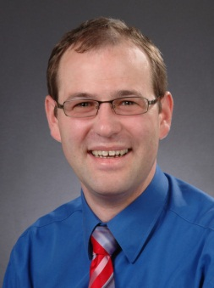 | Alexander Kühn  Assessor iuris  Rosenhügel 29  50259 Pulheim (Germany)  18.04.1973  Married

Experience
2008 - | Federal Network Agency, Assistant Head of Section “International frequency matters”  - Responsible for the coordination of WRC-12  - Chairman of the national preparation group on regulatory, scientific and satellite agenda items (AK1)
2005 – 2008 | Federal Ministry of Economics and Technology  Assistant Head of Division “Frequency policy”  - Responsible for the national preparation process to WRC-07
2004 – 2005 | Federal Network Agency, Assistant Head of Section  “Legal Proceedings”  - Responsible among others for EMC proceedings
2002 – 2004 | Federal Network Agency, Assistant Head of Section  “Electronic Signatures”  - Responsible for authorization and supervision of certificate service operators  - ETSI Standardisation on electronic signatures  - International cooperation of NRA on electronic signatures

Experience at CEPT
2010 | Vice – Chairman of the CPG 12 and Chairman CPG PTA
2008 - 2012 | CEPT Coordinator Agenda Items 2 and 4
2008 - 2010 | Chairman CEPT Ad hoc Group RAG-2009 and RAG-2010
2006 | Participant ECC PT7
2005 – 2007 | Representative for Germany at ERO/ETO Council

Experience at ITU
Special Committee 2012 | Vice-Chairman
Study Group 1 | Head of Delegation to WP1B, Chairman SWG 1B3 – CPM 1.2
Study Group 5 | Head of Delegation to WP5A
Special Committee 2007 | Head of Delegation
RA-12 | Member of the Delegation
WRC-12, WRC-07, RA-07 | Deputy Head of Delegation

Education
2001 | Bar exam
1999 – 2001 | Legal Internship (e.g. at Regional Court and BNetzA)
1998 | State exam
1993 – 1998 | University of Osnabrück, study of law

Language skills
German | Native
English | Fluent

