Doc. ECC/CPG15(12)002rev2
CPG15 – 1
Mainz, 16 April – 18 April 2012

Date issued: 8 March 2012
Source: CPG-12 management team
Subject: Proposed CPG-15 Plan

Background
The proposed structure (Annex 1) has been developed by the CPG-12 chairman and vice-chairmen as a basis for discussion at the first meeting of CPG-15.

In developing the proposal the following principles were considered:

- As far as possible, the structure of the project teams should reflect the organisation of the CPM report as this assists regional co-ordination – two exceptions were identified:
  - A.I. 1.4 (Amateur) is grouped with Chapter 3 issues since it is expected that the relevant experts will be following these subjects rather than mobile/IMT.
  - A.I. 1.3 (PPDR) is identified as being handled in FM49 initially, and PTA later, to avoid a duplication of discussions in WG FM and CPG.
- ECC PT1 is identified as the responsible group for Mobile/IMT with the understanding that for these work items it would report directly to CPG and be treated as a CPG project team. It is expected that the ECC would consider any necessary changes to the PT1 terms of reference at its next meeting.
- The vice-chairmen for WRC-15 preparation will be selected after appointment of the Chairman by the ECC, it should be noted that Alexander Kühn is eligible to serve a second term whilst Steve Bond is not having already served two terms.
- The CPG project teams may be supported by WG SE and FM project teams as required - this is a matter for agreement by CPG project teams and in such cases it is expected that direct liaison will occur between these groups.
- Proposals are encouraged from all members for:
  - The structure (Annex 1)
  - Nominations for CEPT co-ordinators (Annex 2)
  - Nominations for CPG project team chairmen
  - Nominations for vice-chairmen (noting that the vice-chairs will be selected after the ECC appoints the CPG chairman).
  - Meeting venues for future CPG meetings (Annex 3)

Members are encouraged to make nominations which will facilitate the management of CPG-15, and CEPT co-ordination, by a broad range of CEPT administrations. It is suggested that in the first instance nominations and comments on the structure are sent to the CPG-12 management team (fournier@anfr.fr; steve.bond@ofcom.org.uk; alexander.kuehn@BNetzA.de copied to thomas.ewers@BNetzA.de and wesley.milton@ofcom.org.uk) to enable informal discussions to be conducted.

Annex 1 – Proposed structure of CPG-15
The organogram below contains the following information:
- Preliminary CPG structure (based on early contributions)
- Proposed candidates for the CPG-15 management team (as of 12th April 2012) **ECC in June to appoint Chairman and Vice Chairman of CPG**
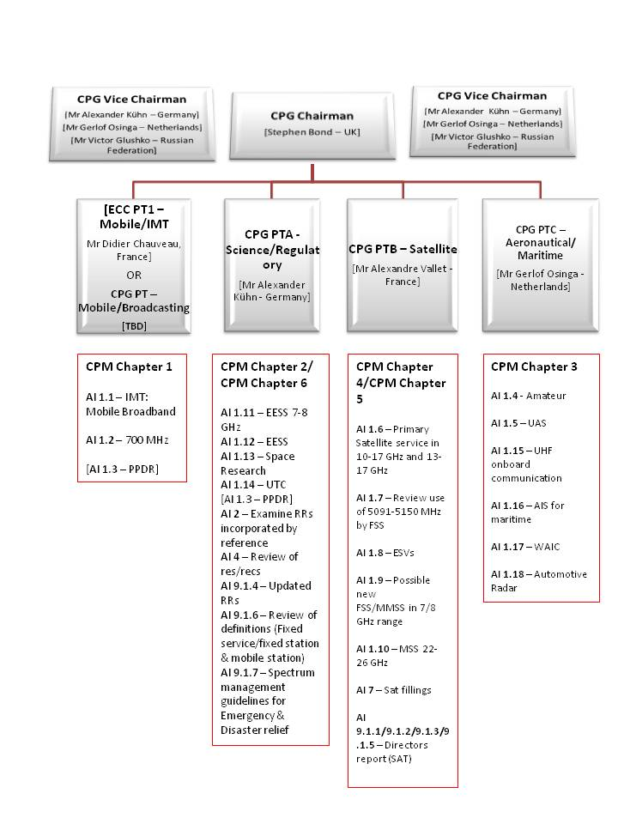
Annex 2 – Proposed list of CEPT Coordinators for WRC-15

WRC-15 Agenda Item | CEPT Coordinator Nominations | Notes
1.1 to consider additional spectrum allocations to the mobile service on a primary basis and identification of additional frequency bands for International Mobile Telecommunications (IMT) and related regulatory provisions, to facilitate the development of terrestrial mobile broadband applications, in accordance with Resolution COM6/8 (WRC 12); | [Mr Steve Green – UK]  [Mr Pasi Toivonen – Finland] | Proposal to have a CEPT coordination team to assist the CEPT coordinators  Nominations  [Mr Anders Jonsson – Sweden]
1.2 to examine the results of ITU R studies, in accordance with Resolution COM5/10 (WRC 12), on the use of the frequency band 694-790 MHz by the mobile, except aeronautical mobile, service in Region 1 and take the appropriate measures; | [Mr Steve Green – UK]
1.3 to review and revise Resolution 646 (Rev.WRC 12) for broadband public protection and disaster relief (PPDR), in accordance with Resolution COM6/11 (WRC 12); | [Mr Peter Buttenschön – Germany]
1.4 to consider possible new allocation to the amateur service on a secondary basis within the band 5 250-5 450 kHz in accordance with Resolution COM6/12 (WRC 12); | [Mr Hans Blondeel Timmerman – Netherlands]
1.5 to consider the use of frequency bands allocated to the fixed-satellite service not subject to Appendices 30, 30A and 30B for the control and non-payload communications of unmanned aircraft systems (UAS) in non-segregated airspaces, in accordance with Resolution COM6/13 (WRC 12);
1.6 to consider possible additional primary allocations:
1.6.1 to the fixed-satellite service (Earth-to-space and space-to-Earth) of 250 MHz in the range between 10 GHz and 17 GHz in Region 1;
1.6.2 to the fixed-satellite service (Earth-to-space) of 250 MHz in Region 2 and 300 MHz in Region 3 within the range 13-17 GHz;
and review the regulatory provisions on the current allocations to the fixed-satellite service within each range, taking into account the results of ITU R studies, in accordance with Resolutions COM6/4 (WRC 12) and COM6/5 (WRC 12), respectively;
1.7 to review the use of the band 5 091-5 150 MHz by the fixed-satellite service (Earth-to-space) (limited to feeder links of the non-geostationary mobile-satellite systems in the mobile-satellite service) in accordance with Resolution 114 (Rev.WRC 12);
1.8 to review the provisions relating to earth stations located on board vessels (ESVs), based on studies conducted in accordance with Resolution COM6/14 (WRC 12);
1.9 to consider, in accordance with Resolution COM6/15 (WRC 12): | [Mr Alexandre Guérin – France]
1.9.1 possible new allocations to the fixed-satellite service in the frequency bands 7 150-7 250 MHz (space-to-Earth) and 8 400-8 500 MHz (Earth-to-space), subject to appropriate sharing conditions; | [Mr Alexandre Guérin – France]
1.9.2 the possibility of allocating the bands 7 375-7 750 MHz and 8 025-8 400 MHz to the maritime-mobile satellite service and additional regulatory measures, depending on the results of appropriate studies; | [Mr Alexandre Guérin – France]
1.10 to consider spectrum requirements and possible additional spectrum allocations for the mobile-satellite service in the Earth-to-space and space-to-Earth directions, including the satellite component for broadband applications, including International Mobile Telecommunications (IMT), within the frequency range from 22 GHz to 26 GHz, in accordance with Resolution COM6/16 (WRC 12);
1.11 to consider a primary allocation for the Earth exploration-satellite service (Earth-to-space) in the 7-8 GHz range, in accordance with Resolution COM6/17 (WRC 12); | [Mrs. Elena Daganzo–Eusebio - Netherlands]
1.12 to consider an extension of the current worldwide allocation to the Earth exploration-satellite (active) service in the frequency band 9 300-9 900 MHz by up to 600 MHz within the frequency bands 8 700-9 300 MHz and/or 9 900-10 500 MHz, in accordance with Resolution COM6/18 (WRC 12); | [Mr Hanspeter Kuhlen – Germany]
1.13 to review No. 5.268 with a view to examining the possibility for increasing the 5 km distance limitation and allowing space research service (space-to-space) use for proximity operations by space vehicles communicating with an orbiting manned space vehicle, in accordance with Resolution COM6/19 (WRC 12);
1.14 to consider the feasibility of achieving a continuous reference time-scale, whether by the modification of coordinated universal time (UTC) or some other method, and take appropriate action, in accordance with Resolution COM6/20 (WRC 12); | [Mr Bharat Dudhia – UK]
1.15 to consider spectrum demands for on-board communication stations in the maritime mobile service in accordance with Resolution COM6/3(WRC 12);
1.16 to consider regulatory provisions and spectrum allocations to enable possible new Automatic Identification System (AIS) technology applications and possible new applications to improve maritime radiocommunication in accordance with Resolution COM6/21 (WRC 12); | [Mr Hans-Karl von Arnim – Germany]  [Mr Christian Rissone – France]
1.17 to consider possible spectrum requirements and regulatory actions, including appropriate aeronautical allocations, to support wireless avionics intra-communications (WAIC), in accordance with Resolution COM6/22 (WRC 12);
1.18 to consider a primary allocation to the radiolocation service for automotive applications in the 77.5-78.0 GHz frequency band in accordance with Resolution COM6/23 (WRC 12); | [Mr Hartmut Dunger – Germany]
2 to examine the revised ITU R Recommendations incorporated by reference in the Radio Regulations communicated by the Radiocommunication Assembly, in accordance with Resolution 28 (Rev.WRC 03), and to decide whether or not to update the corresponding references in the Radio Regulations, in accordance with the principles contained in Annex 1 to Resolution 27 (Rev.WRC 12);
4 in accordance with Resolution 95 (Rev.WRC 07), to review the resolutions and recommendations of previous conferences with a view to their possible revision, replacement or abrogation;
7 to consider possible changes, and other options, in response to Resolution 86 (Rev. Marrakesh, 2002) of the Plenipotentiary Conference, an advance publication, coordination, notification and recording procedures for frequency assignments pertaining to satellite networks, in accordance with Resolution 86 (Rev.WRC 07) to facilitate rational, efficient, and economical use of radio frequencies and any associated orbits, including the geostationary satellite orbit; | [Mr Steve Limb – UK]
8 to consider and take appropriate action on requests from administrations to delete their country footnotes or to have their country name deleted from footnotes, if no longer required, taking into account Resolution 26 (Rev.WRC 07); | [Mr Dmytro Protsenko – Ukraine]
9 to consider and approve the Report of the Director of the Radiocommunication Bureau, in accordance with Article 7 of the Convention

Annex 3- Future meeting plan

Date | Location
2nd CPG - Jan/Feb 2013 | France
3rd CPG – Sept 2013 | Croatia
4th CPG – Jan 2014
5th CPG – May 2014 | Latvia
6th CPG – Dec 2014/Jan 2015
7th CPG – March 2015
8th CPG – Aug/Sept 2015

If there are any Administrations interested in hosting a CPG meeting, please let the CPG Vice Chairmen and Secretary know.

Germany have proposed a CEPT coordination team for these agenda items, comprising of 3-4 administrations.
See Footnote 1

