|  |  |  |
| --- | --- | --- |
| CPG | | Doc. CPG(19)INFO108 |
| CPG19-9 | | |
| Ankara, Turkey, 26th - 30th August 2019 | | |
|  | |  |
| Date issued: | 26th August 2018 | |
| Source: | Germany | |
| Subject: | AI10: Proposed studies towards a possible new allocation of the 144-146 MHz band to the aeronautical mobile service (non-safety) | |
| Group membership required to read?  N | | |
|  | | |
| Summary: | | |
| Germany does not support the inclusion of the 144-146 MHz primary allocated to the amateur service/amateur satellite service in the proposed WRC-23 agenda item regarding a possible new allocation to the aeronautical mobile service for non-safety applications.  The evaluation of the signal strength of an AMS transmitter at various heights ranging from 100 m to 10 km, shows that an 1 W eirp source in 500 m height will cover an area of almost 400 km diameter with signal levels ranging from -65 to -119 dBm. At greater heights, that diameter quickly reaches up to 1000 km at 10000 m. This is even a rather conservative approach since the EIRP of an AMS transmitter most probably will be much higher than 1 W eirp.  The same situation will be present at an AMS receiver where even a moderate average amateur radio station transmitter (63 dBm EIRP) will produce signal levels between -47 and -67 dBm at distances up to 500km.  Consequently, Germany cannot determine a single realistic sharing scenario, not leading to serious mutual interference on both sides and not seriously degrading the use of the 144-146 MHz band.  Based on the physical/technical situation described, the needed range of studies on the possibility of use of the 144-146 MHz band by both the amateur radio/satellite service and the AMS is very likely to produce a considerable amount of work for all involved parties while the result predictable already. | | |
| Proposal: | | |
| to CPG19-9 to note  the attached position, information, concerns and basic technical studies,  the difficulties that would arise from sharing the 144-146 MHz frequency band with the incumbent primary amateur / amateur satellite service, given the requirement to ensure their continued operation and not limiting future development of these services. | | |
| Background: | | |
| The attachment is covering technical studies regarding the use of the band 144-146 MHz by Aeronautical Mobile Service, Amateur Radio Service and Amateur Satellite Service and is assessing a related generic interference scenario. | | |

Analysis of the 144 MHz band for possible sharing by amateur radio and non-safety-related aeronautical MOBILE Service (AMS)

# Summary

This paper describes that even with a low transmission power of 1 Watt at an assumed spherical radiator, the transmission signal of an aircraft at a moderate height of 500 m covers a range with a radius of nearly 200 km at levels between -65 and -119 dBm. With increasing height that radius quickly moves up, covering an area of almost 1000 km diameter at 10000 m height.

In addition, average amateur radio stations produce a signal level of -47 to -67 dBm at the AMS receiver at distances from 50km to 500 km. For this reason, a parallel operation of non-safety-related aeronautical radio (AMS) and amateur / amateur satellite service in the range 144-146 MHz without strong mutual interference is not feasible.

# Basics

## Free space attenuation

The free space attenuation formula describes the reduction of the power density accompanying the distance from the transmitter during the propagation of electromagnetic waves in a vacuum, starting from a radiator with isotropic characteristic. For a given wavelength λ, it depends exclusively on the distance d:

 (1)

d = distance between starting point and calculation point [m], λ: wavelength of radiation [m], F = free space attenuation [dB]

In practice, it is permissible to determine the signal attenuation in the atmosphere and beyond on this basis. External factors such as additional attenuation due to water vapor or ionized layers of the atmosphere are not taken into account.

In the context of this paper, therefore, only the free space damping is simplified. Given these preconditions, the signal level Pd [dBm] at a location in distance d from the transmitter S with the transmission power Ps is given by:

Pd = Ps – F (2)

## Quasi-optical propagation

Electromagnetic radiation as well as the light propagates in a straight line. Therefore, only quasi-optical propagation is considered in this paper. Only the radio horizon, which is larger than the optical horizon, is considered.

Therefore, instead of the mean earth radius re of 6371 km, the modified earth radius remod is used. This need results from the fact that the refractive index gradient of radio waves is greater than that of light. Thus, radio waves experience certain refraction towards the ground, which is why the radio horizon is about 1/3 farther than the optical horizon. Therefore, the corresponding earth radius is used for corresponding calculations

remod = re · 4/3 = 8495 km[1] (3)

The optical line of sight is the maximum distance at which the transmitter and receiver on a spherical surface just have visual contact. In this case, vegetation and soil profile are not taken into account for the sake of simplicity. It is also assumed that transmitter and receiver are at the same level above mean sea level.

# Coverage area AMS transmitter

For an AMS transmitter with 1 W output power at an isotropic radiator, the respective coverage area was determined for different heights, using the Radio Mobile[2] software. This program calculates range maps and field strength values between two or more stations, taking into account topography, frequency and transmission power. Thus, the respective reception range and level can be determined with a good approximation.

The location of the AMS transmitter was set as Berlin centre with a transmission power of 1 Watt attached to an antenna with isotropic characteristics. These propagation maps were calculated for antenna heights of 100, 500, 1000, 5000 and 10000 m.

At a height of only 100 m, an area within a radius of 100 km is covered by the transmitter at levels of -65 to   
-119 dBm, in individual cases even 200 km distance can be achieved due to topography. This radius increases up to nearly 200 km and more if the transmitter is located at 500 m above ground. At a height of 1000 m, this reception area expands from the Baltic Sea to the Czech border, and consequently more than 200 km from Berlin centre. At a height of 5000 m, the maximum range is already 350 km at -119 dBm. At 10000 m, the reception area reaches to Copenhagen and Prague, almost 500 km.

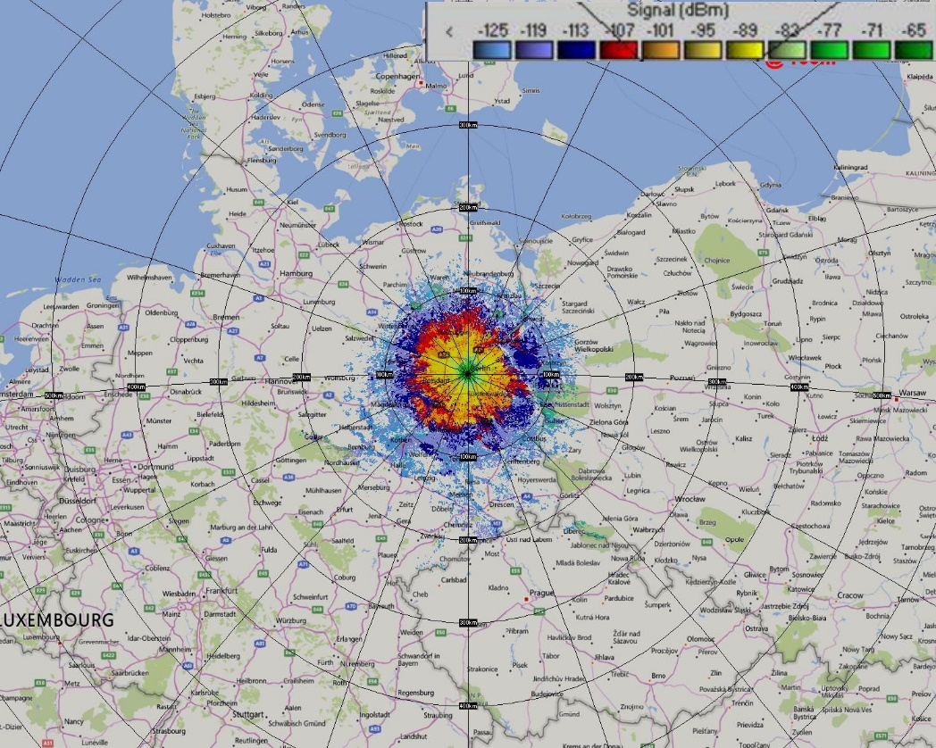

Figure 1: Coverage area AMS transmitter with 1 W output to isotropic radiator at a height of 100 m

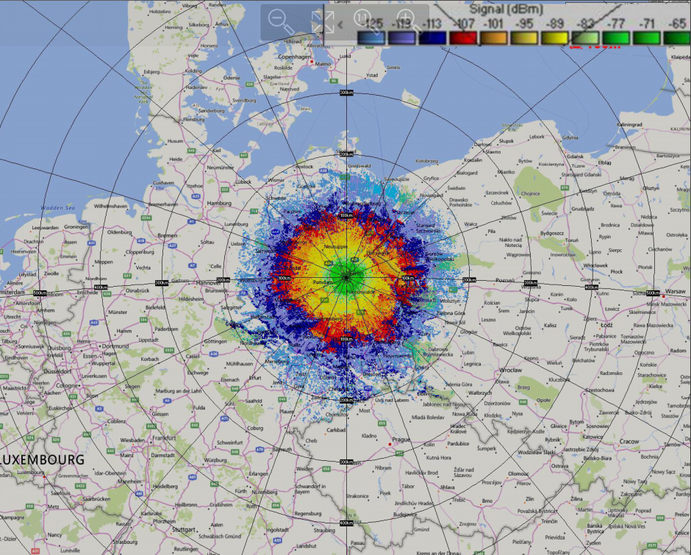

Figure 2: Coverage area AMS transmitter with 1 W output to isotropic radiator at a height of 500 m

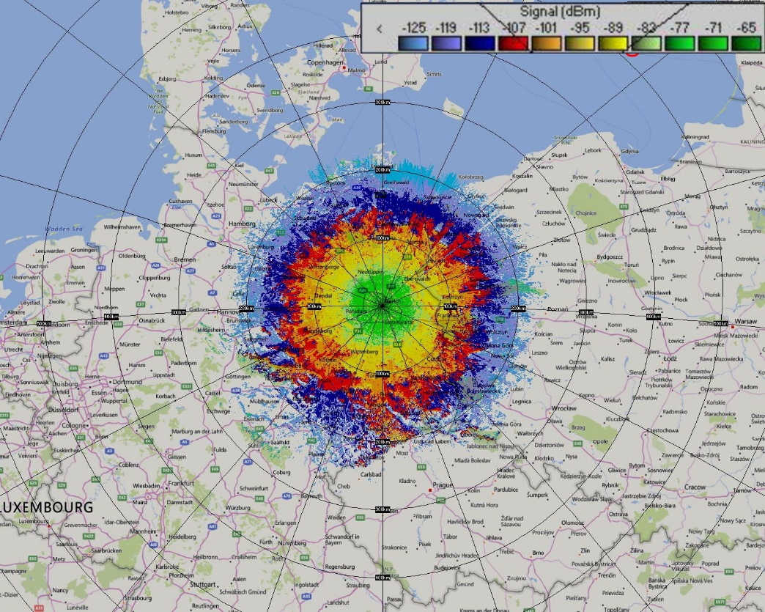

Figure 3: Coverage area AMS transmitter with 1 W output to isotropic radiator at a height of 1000 m

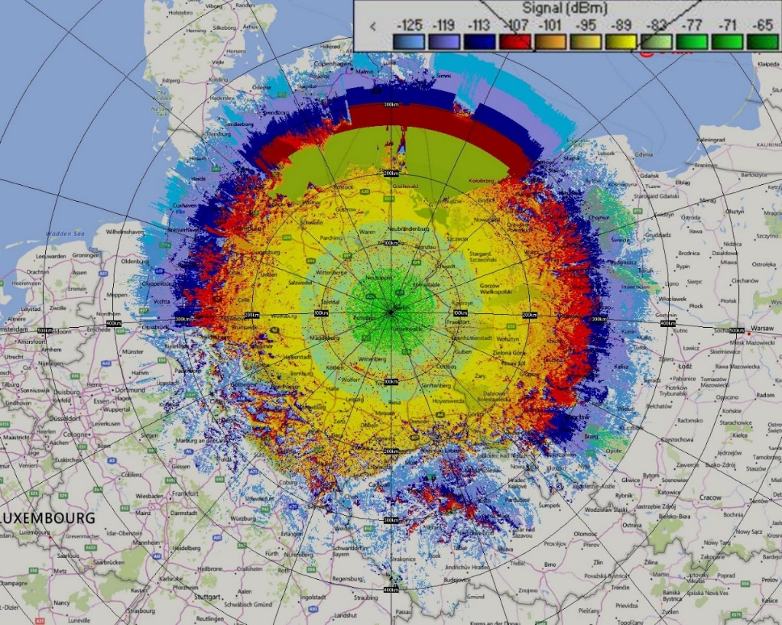

Figure 4: Coverage area AMS transmitter with 1 W output to isotropic radiator at a height of 5 km

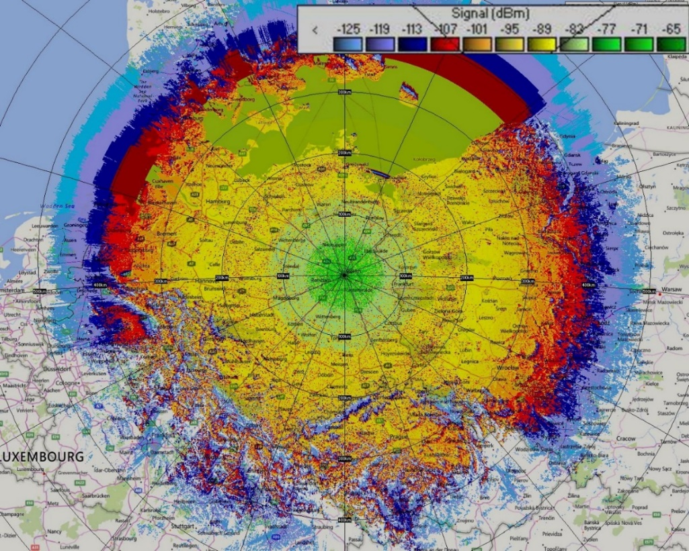

Figure 5: Coverage area AMS transmitter with 1 W output to isotropic radiator at a height of 10 km

# Signal levels from amateur radio stations at the location of the AMS receiver

From the geometric relationships shown in Figure 6 you get the height H of the AMS aircraft above the ground at a given height h of the transmitting antenna of the radio amateur over the ground and known angle β between the two locations

 (4)



Figure 6: Geometric constellation amateur radio transmitter - AMS receiver

For average amateur radio stations in the range 144-146 MHz, the following configuration has been assumed:

Transmitter 100 watts

Transmitting antenna 13 dBi, 10 m above ground

horizontal polarization

3 dB vertical opening angle: 40°

Transmission level: 63 dBm

From the geometrical context of Figure 6 and the consideration of the respective free space damping, the following values result for the AMS receiver in the minimum height H for the radio horizon to the amateur radio transmitter:

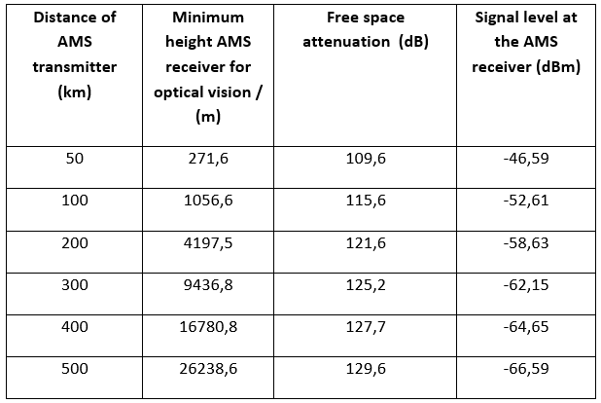

Table 1: Level values at the AMS receiver as a function of altitude above ground and minimum altitude for radio seeing an average amateur radio transmitter with 63 dBm transmission level

A common directional antenna for 144 MHz with 13 dBi gain usually has a vertical opening angle of 40°. At this angle, the antenna gain of the main lobe is 3 dB lower than 0 ° vertical opening angle (= main beam direction). Compared to the radiation parallel to the ground, a vertical angle range of 40°/2, i.e. 20°, must be taken into account, in which the transmitter also covers the sky with at least half the radiation power.

The height H' which reaches the upper 3 dB limit at the location of the AMS receiver also results from the geometric relationships in Figure 6:

 (5)

The corresponding values for H' are already at a distance of 50 km at 24.6 km and thus significantly above the maximum assumed altitude of the AMS aircraft of 10 km. Therefore, by increasing the altitudes of the AMS aircraft no decoupling and thus reducing the mutual interference is possible.

# final evaluation

Use of the frequency range of 144-146 MHz by both non-safety-related air radio AMS and by the amateur radio service is not possible without strong mutual interference. Even with a low altitudes AMS device, with an assumed 1 watt EIRP, ranges of several hundred km distance from the transmitter are covered with high field strengths. At 10,000 m altitude, the coverage area has a radius of more than 500 km.

In the reverse case, signals from a technically average amateur radio station at the receiver of the AMS aircraft are at such high levels that safe operation of the aircraft is not guaranteed. In metropolitan areas with their high density of amateur radio stations and most presumably also AMS flying objects, the scrambled disturbances on both sides will be even more pronounced.

For these reasons, the proposal to include the 2m band (144-146 MHz), which is allocated to the Amateur Radio Service worldwide in studies considering its use for AMS, should not be progressed.

1. The ITU assumes a modified earth radius of 8500 km.
2. Radio Mobile is available at [www.ve2dbe.com](http://www.ve2dbe.com) as freeware for non-commercial use (i.e. radio amateurs).