Project Team FM PT 48 |  |  | FM48(11)054
4th Meeting, 24-25 November 2011
Sophia-Antipolis / France
Date issued: | 23 November 2011
Source: | Deutsche Telekom
Subject: | Text for the new ECC Report on Broadband DA2GC
Group membership required to read? (Y/N): N

Summary:
This contribution contains text proposals for some sections - as defined in the outline provided by the Chairman - of the new draft ECC Report on Broadband Direct-Air-to-Ground Communications (Broadband DA2GC).

Proposal:
The text is proposed to be included in the new draft ECC Report on Broadband Direct-Air-to-Ground Communications (Broadband DA2GC).

Background:
At the last WG FM meeting, FM PT 48 proposed to develop a new ECC Report on Broadband DA2GC in which all relevant aspects, besides compatibility and sharing issues for which WG SE is responsible, could be described in detail. Elements for such an ECC Report were provided in Annex 7r1 of the FM PT 48 Progress Report (see FM48(11)043).
WG FM agreed that the ECC Report should be finalised by September 2012.
The PT FM48 Chairman provided an outline to be used as a basis for the development of this new draft ECC Report on Broadband Direct-Air-to-Ground Communications (Broadband DA2GC) and requested contributions for the different sections (see doc. FM48(11)050).

Draft ECC Report on Broadband DA2GC

0 EXECUTIVE SUMMARY

TABLE OF CONTENTS

LIST OF ABBREVIATIONS

... | ...

1 INTRODUCTION

key elements:
general description of Broadband DA2GC (IFE, ......),
terrestrial system, difference to satellite solutions,
example North America (see FM48(10)007r1, FM48(11)013, FM48(11)034)

...
Currently, there is no spectrum designated for broadband DA2GC in Europe. In order to allow European citizens and airlines to profit from the social and economic benefits of the implementation of such a system, a spectrum designation on a Europe-wide basis would be necessary. It should also be noted that in continental US an Air to Ground system has been successfully established with more than 1.100 commercial aircraft equipped so far.

2 DEFINITIONS

Aircraft Station (AS) | ...
Forward Link (FL)
Ground Station (GS)
Reverse Link (RL)
...

see also FM48(10)003 (ETSI SRDoc.)

3 OBJECTIVE

4 MOTIVATION AND SPECTRUM DEMAND FOR BROADBAND DA2GC

4.1 MOTIVATION FOR BROADBAND DA2GC

Mobile customers expect to be connected everywhere, every time, with all kind of mobile devices. The implementation of a broadband DA2GC system in Europe would enable to cover a currently almost uncovered area, namely onboard aircraft.
European airlines have great interest to offer internet services to their flight passengers in their continental fleets as soon as possible. The costs for the aircraft installation and maintenance are a key issue. In particular with regard to the antenna, a terrestrial solution has a clear advantage compared to satellite connection.
The air traffic within European area until 2014 is estimated to increase as shown in Figure 1. In general the annual growth rate is in the range of about 4 % on average during the last decades except of years with economic crises arising as in 2008/2009.

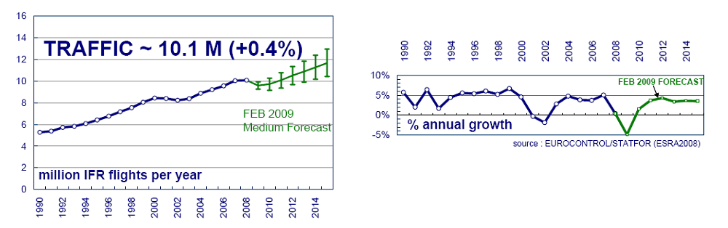
Figure 1: Forecast of European air traffic (source: Eurocontrol / 2008)

Latest air traffic statistics and forecasts from Eurocontrol confirm these forecasts. Studies on air passenger demand for onboard connectivity are not publicly available, but accessible presentations highlight that “air passenger demand for onboard connectivity will grow” and that “In-flight entertainment and connectivity will have an important influence on airline choice”.
About 66 % of the European air traffic consists of national or continental flights, i.e. the main part of the airline business. The addressable market in Europe for DA2G communication is currently consisting of about 160 airlines with more than 4 500 aircraft expected in 2014 (without business aviation). In general a strong increase in percentage of aircraft fleet equipped with internet connectivity solutions is expected during next years as exemplarily displayed in Figure 2. As a result of that market research more than 40 % of aircraft will allow APC services to their passengers up to 2016.

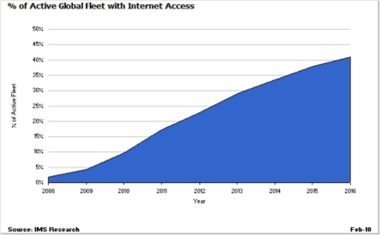
Figure 2: Expected percentage of aircraft (source: IMS Research / 2010)

Whereas especially in North America direct voice and data communication services for passengers from an aircraft to the ground are available, similar services are still not possible within Europe. An introduction of broadband DA2GC would not only increase Europe’s competitive position, it could also bring Europe into a leading position in this market segment, by achieving the following benefits to flight passengers, airlines, manufacturers as well as providers of broadband communications services:
- Increased economic efficiencies associated with the exploitation of greater economies of scale arising from the further harmonisation of spectrum management across CEPT.
- Increased investment and innovation in mobile services, including multimedia and phone services.
- Improved quality and coverage of mobile services.
- Increased competition and consumer choice in terms of the range of new innovative mobile services available.
- Improved efficiency for aviation industry through in-flight administrative communication services.

In the case that no frequency spectrum is going to be designated to broadband DA2GC in Europe, Airlines would be urged to choose a more expensive satellite connectivity solution for their continental aircraft fleets. This would lead to higher expenditures for European airlines and likely to higher prices for European air passengers.

4.2 SPECTRUM DEMAND FOR BROADBAND DA2GC

key elements:
spectrum demand in general, how many systems?, (competition and cooperation between different network operators / service providers), comparison with satellite systems,
see also FM48(11)043-Annex1r2 (section 5), FM48(11)024 (same as FM(11)091)
Paired spectrum of 2 x 10 MHz for FDD operation is considered necessary to cope with short- to medium-term demand. Unpaired spectrum for TDD operation (20 MHz) would also be an option, but it might be more complicated to identify a contiguous block of 20 MHz for TDD operation, see [3].

5 APPROPRIATE ECC REGULATION

key elements:
ECC Decision, harmonisation, (cross-border coordination),
Licensing (individual, light, exemption),
legal aspects (...),
one stop shopping (ECO)?

...
Network investment and deployment costs as well as aircraft equipment costs are high for broadband DA2GC, and the associated high technological and financial risks require economies of scale for such a system in the form of pan-European geographic coverage, so that they remain economically viable. In order to achieve a continental-wide coverage, a harmonised radio spectrum designation is essential. In addition, a European harmonised authorisation is considered necessary to provide the regulatory certainty that network operators and airlines require to invest in a broadband DA2GC system.
...
6 DETAILED SYSTEM DESCRIPTIONS

6.1 PROPOSAL FROM ETSI (TR 103 054 V1.1.1 (2010-07))

see FM48(10)003 and FM48(10)010 (ETSI System Reference Document)

key elements:
detailed system description (technology), QoS, specific spectrum needs, candidate bands, timeframe for equipment availability, system implementation (airline interest, operator commitment)

The broadband DA2GC system described in this chapter is based on the ETSI System Reference Document “Broadband Direct-Air-to-Ground Communications operating in part of the frequency range from 790 MHz to 5150 MHz” [1].

6.1.1 System description
This broadband DA2GC system constitutes an application for various types of telecommunications services, internet access and mobile multimedia services. It aims to provide access to broadband communication services during continental flights (via fixed or WiFi-based onboard connectivity network and/or via GSMOBA and in the future possibly also via 3G and/or 4G) on a Europe-wide basis. The overall end-to-end system architecture of the broadband DA2G communication system is illustrated in Figure 3. The request for spectrum is related to the direct air-to-ground radio solution.

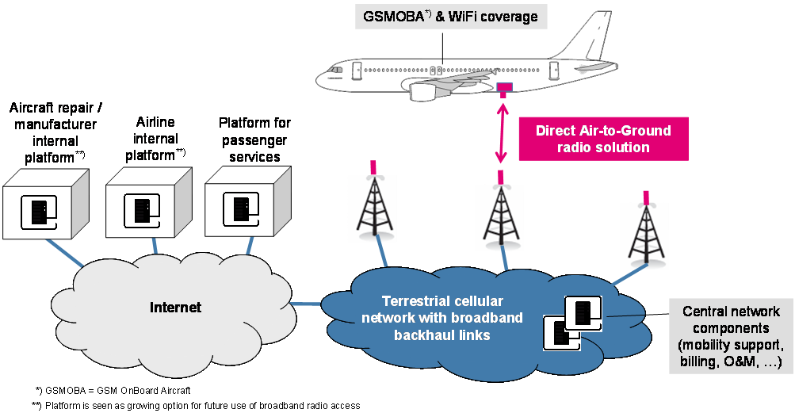
Figure 3: System architecture for broadband DA2G communication

The major building blocks of the end-to-end system architecture are:
- service related network infrastructure onboard the aircraft, e.g. WiFi coverage and GSMOBA (GSM OnBoard Aircraft is already standardized);
- DA2GC infrastructure onboard the aircraft (external antenna, modem, cabling, interface to on-board network);
- terrestrial radio access network for DA2GC with broadband backhaul links, which would preferably be based on existing infrastructure, but with modifications (e.g. with regard to antenna types and base station implementation) to establish high-performance radio links to aircraft in DA2G environment;
- mobile core network for session, mobility, subscriber and security management providing IP connectivity to external packet data networks (e.g. intranet, internet, IMS);
- central network components required for O&M, billing, etc. in the DA2GC network;
- various IP-based service delivery platforms e.g. for passenger services or for airline or aircraft repair / manufacturer internal applications.
Modern broadband wireless access technologies as specified for next generation mobile networks (NGMN) are a sound technological basis for such a broadband DA2GC solution, capturing mainly items 2) and 3) in the list above.
Therefore, this terrestrial broadband DA2GC system is based on the 3GPP LTE (also called E-UTRA) standard (Rel. 8 or higher), as described in more detail in ETSI TR 103 054. The user equipment (UE) would refer to the DA2G aircraft station (AS), and the base station (BS) would refer to the DA2G ground station (GS). An overview as well as an overall description of E-UTRAN is given in [2].
The general characteristics of the DA2GC RF and digital baseband signals are also based on the LTE specification. To adapt the LTE system functionalities to the DA2GC link specifics, some modifications are required. In particular synchronization algorithms as well as the maximum OBU Tx power are to be modified compared to terrestrial mobile radio usage in order to cope with high Doppler frequency shift caused by aircraft speed and large cell sizes. In addition the BS antenna adjustment has to be matched to cover typical aircraft altitudes between 3 and 12 km by up-tilt of vertical diagrams.
The main application field would be Air Passenger Communications (APC), e.g. WiFi or GSM based internet/company intranet access, data synchronization and voice communication. In addition the system could also support Airline Administrative Communications services (AAC). The envisaged broadband DA2GC system is not intended to be used for safety-relevant communications such as Air Traffic Control (ATC) and related services.

6.1.2 Quality of Service (QoS)
QoS for this broadband DA2GC system is be ensured due to the use of sophisticated mobile technology, namely the 3GPP LTE (also called E-UTRA) standard (Rel. 8 or higher). QoS is also supported by using spectrum with predictable frame conditions and suitable sharing/compatibility conditions.
...

6.1.3 Specific spectrum needs
In order to allow for the highest flexibility for ECC in the designation of suitable spectrum, the frequency range from 790 MHz to 5150 MHz is requested to be considered by the corresponding ETSI System Reference Document [1]. Spectrum above 6 GHz is not appropriate due to wave propagation aspects (e.g. increased path loss and Doppler shift).
The signal bandwidth depends on system characteristics (e.g. operating frequency, frequency reuse, spectrum efficiency) and service data rate required per aircraft and per cell/sector.
The spectrum demand for this broadband DA2GC system was derived from a summary of relevant factors to be essential to cope with future capacity demand as well as from results achieved by system performance evaluations [3].
As a result, paired spectrum of 2 x 10 MHz for FDD operation is considered necessary to cope with short- to medium-term demand. Unpaired spectrum for TDD operation would also be an option, but system performance would slightly suffer due to guard time intervals required for large cell sizes. Furthermore, TDD operation is expected to have greater impact for achieving compatibility with other radio services and thus requiring guard bands.

6.1.4 Candidate bands
A number of bands, in particular all those mentioned in the list of candidate bands (see Annex [FM48(11)049]) could be considered for this broadband DA2GC system.

1452-1492 MHz
Project Team FM50 shall assess, with the support of an impact analysis, which future use(s) of the 1452-1492 MHz band would be the most appropriate for CEPT. Broadband DA2GC is one of eight candidate applications.

1900-1920 MHz and 2010-2025 MHz
In a WG FM correspondence group it was, inter alia, discussed to use (parts of) the bands 1900-1920 MHz and/or 2010-2025 MHz to satisfy the spectrum demand of 20 MHz TDD or 2 x 10 MHz FDD - justified in document FM(11)091 and confirmed by WG FM (see document FM(11)202) - for Broadband DA2GC. The following options for Broadband DA2GC would be possible:
- Use of the band 1900-1920 MHz for TDD Broadband DA2GC (guard bands may be required);
- Pair 10 MHz within the band 1900-1920 MHz with 10 MHz within the band 2010-2025 MHz for FDD Broadband DA2GC (guard bands may be required); and use the remaining 15 MHz within 1900-1920 MHz and 2020-2025 MHz for video links and/or other SRDs (guard bands may be required);
Figure 4: FDD broadband DA2GC in the bands 1900-1920 / 2010-2025 MHz

ECC PT1 studied pairing of the bands 1900-1920 MHz and 2010-2025 MHz from a cellular mobile point of view (mass market). The absence of industry support was due to the increased complexity (additional bands) in UE design compared to very limited economic benefits for the cellular mobile community. The situation is totally different for Broadband DA2GC with equipment dedicated to these two bands only.

1980-2010 MHz and 2170-2200 MHz
It had been proposed to include the bands 1980-2010 MHz / 2170-2200 MHz in the list of candidate bands with the conclusion that these are not be included in the list right now but will further be discussed during future meetings.
The Commission published on 10 October 2011 a press release to announce a decision to help and coordinate the acceleration of the implementation of MSS services in the 1980 to 2010 MHz and 2170 to 2200 MHz frequency bands, noting that the two operators had been available 2 years time to build up their plans for pan-European service provision.
The Commission expresses inter-alia their view in the press release that so far no commercial MSS services available to end users have been into operation or detailed plans available and hence, the frequency resources considered as a scarce resource may also be subject to review in the future if not continuously not used by the two operators.

2300 – 2400 MHz
...

2400 – 2483.5 MHz
...

2483.5 – 2500 MHz
...

3400-3600 MHz
...
The following aspects are relevant for an implementation of broadband DA2GC within this band:
- The lower edge of the TDD band plan for MFCN (starting at 3400 MHz according to the Draft ECC Decision(11)HH which was developed by ECC PT 1 and has been under public consultation recently) may be more suitable for TDD Broadband DA2GC systems than blocks in the higher portion of the band. However, it might also be necessary to carry out adjacent band compatibility studies with regard to the Radiolocation Service below 3400 MHz.
- Spectrum within the duplex gap of the FDD band plan for MFCN, 3490-3510 MHz, may also be considered for TDD Broadband DA2GC systems.
- The lower duplex band of the FDD band plan for MFCN (uplink for MFCN) would be suitable for the Reverse Link for FDD Broadband DA2GC systems (Aircraft Station to Ground Station), because this band is considered to be less used for FSS Earth stations (space to Earth) within CEPT compared to spectrum above 3500 MHz.

3600 – 3800 MHz
...

5855 – 5875 MHz
...

5905 – 5925 MHz
...

6.1.5 Timeframe for equipment availability
This broadband DA2GC system delivers access to Internet / Telephone networks for aircraft passengers. Suitable connectivity systems (WiFi / GSMOB) onboard aircraft are already available on the market.
The access network of this broadband DA2GC system consists of a terrestrial radio access network. The baseline access technology is the 3GPP evolved packet system (E-UTRAN+EPC) that is already commercially available, known as LTE. DA2GC specific enhancements required correspond mainly to operational aspects, e.g. antenna up-tilt at the Ground Station (Base Station), and network management issues. Adaptations of the ground components are expected to be completed ten months after spectrum designation / authorisation. The build-up of the ground network which is assumed to last about one year could be started in parallel.
The Aircraft Station (AS) ) acts as a mobile station (MS) in this broadband DA2GC system. Compared to a MS used in a usual mobile network, increased output power is required due to the higher path loss (larger cell sizes) in the broadband DA2GC network. Also improved synchronization features, e.g. to compensate the high Doppler shift, will be implemented. Time necessary for manufacturing the specific aircraft installation kits and for the corresponding type approval is estimated to be about one and a half year.
Thus the service rollout with first aircraft can be expected about 18 months after the spectrum designation/authorisation. The estimated timeline for equipment availability for this broadband DA2GC system is illustrated in Figure 5.

Figure 5: Timeline for BDA2GC equipment availability

6.1.6 System Implementation
...
The flight density across European area for 2006 is presented on the left side of Figure 6. This figure also includes a long-term forecast for the year 2025.

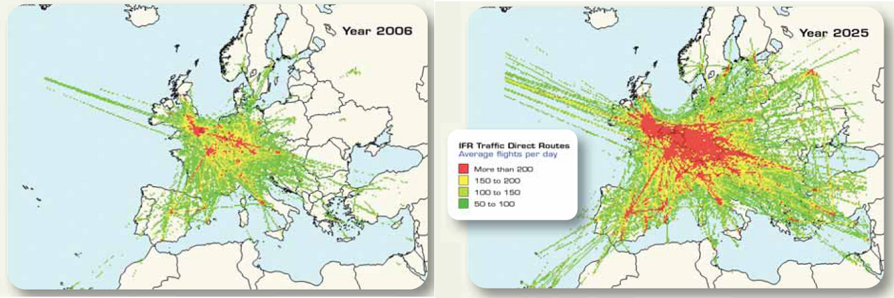
Figure 6: Growth of European flight density (source: Eurocontrol / 2007)

The density patterns in Figure 6 might be used to define basic rollout coverage scenarios for the terrestrial broadband DA2G communication network, which could be extended during the following years to cover main flight routes and areas in Europe and neighbouring countries according to increasing air traffic demand. Based on this flight density forecast, a coverage extension to North Africa and Middle East could also be considered, provided the same spectrum as harmonised in CEPT could be made available there.
...

6.2 PROPOSAL FROM LH SYSTEMS AG [Future ETSI System Reference Document xxx]

see FM48(11)023, FM48(11)017

key elements:
detailed system description (technology), QoS, specific spectrum needs, candidate bands, timeframe for equipment availability, system implementation (airline interest, operator commitment)

6.3 PROPOSAL FROM AERO3G [Future ETSI System Reference Document xxx ???]

see FM48(11)038

key elements:
detailed system description (technology), QoS, specific spectrum needs, candidate bands, timeframe for equipment availability, system implementation (airline interest, operator commitment)

7 OUTCOME OF COMPATIBILITY STUDIES [ECC Report xxx from SE PT 44]

8 CONCLUSIONS

ANNEX 1: LIST OF REFERENCE

[1] | ETSI TR 103 054 V1.1.1 (2010-07), System Reference Document, Broadband Direct-Air-to-Ground Communications operating in part of the frequency range from 790 MHz to 5150 MHz; FM48(10)003
[2] | ETSI TS 136 300: "LTE; Evolved Universal Terrestrial Radio Access (E-UTRA) and Evolved Universal Terrestrial Radio Access Network (E-UTRAN); Overall description; Stage 2 (3GPP TS 36.300)".
[3] | Document FM(11)091: Spectrum demand for Broadband Direct Air-to-Ground Communications (DA2GC) based on performance figures for a LTE-based DA2GC system.
[4]

