Project Team FM PT 48 |  |  | FM48(12)007
5th Meeting, 1-2 March 2012
Copenhagen / Denmark
Date issued: | 24th February 2012
Source: | Deutsche Telekom
Subject: | Additional Text for sections 6.1.4, 6.1.5 and 6.1.6 of the Draft ECC Report
Group membership required to read? (Y/N): N

Summary:
This document contains additional Text for sections 6.1.4, 6.1.5 and 6.1.6 of the Draft ECC Report. The additional text is marked in light blue.

Proposal:

Candidate bands
{→ see also section 4.3}
Basically, all candidate frequency bands discussed in section 4.3 could be considered for the implementation of this broadband DA2GC system. However, frequency bands currently not used or used only sparsely would be the much more favoured solution, both concerning compatibility with other radio applications as well as harmonised availability within an appropriate timeframe.
Regarding the candidate bands considered in section 4.3 this is in particular the case for the bands (in numeric order) 1452-1492 MHz, 1900-1920 MHz, and 2010-2025 MHz, and partly also for the band 3400-3500 MHz, but also for further bands not taken into account in section 4.3.

Timeframe for equipment availability
The baseline access technology of this broadband DA2GC system is the 3GPP evolved packet system (E-UTRAN+EPC) that is already commercially available, (Release 8) known as LTE, and higher releases, i.e. the ground station equipment is in conformity with 3GPP specifications. The RF unit would need to be adapted to the operational frequency. DA2GC specific enhancements required correspond mainly to operational aspects, e.g. antenna up-tilt at the Ground Station (Base Station), and network management issues. These modifications do not require standardisation efforts. Adaptations of the ground components are expected to be completed ten months after spectrum designation / authorisation. The build-up of the ground network which is assumed to last about one year could be started in parallel with the backhaul and site preparations.
The Aircraft Station (AS) acts as a mobile station (MS) in this broadband DA2GC system. Compared to a MS used in a usual mobile network, increased output power is required due to the higher path loss (larger cell sizes) in the broadband DA2GC network. Also improved synchronization features, e.g. to compensate the high Doppler shift, will be implemented. Time necessary for manufacturing the specific aircraft installation kits and for the corresponding type approval at aviation authorities is estimated to be about one and a half year.
Thus the service rollout with first aircraft can be expected about 18 months after the spectrum designation/authorisation. The estimated timeline for equipment availability for this broadband DA2GC system is illustrated in Figure 1.

Figure 1: Timeline for equipment availability for an LTE/SAE based broadband DA2GC system

Suitable connectivity systems (WiFi / GSMOB) onboard aircraft are already available on the market, used today for connectivity solutions via satellite or DA2G in the US. The data interface to the BDA2GC onboard unit – which acts as a modem - is usually Ethernet-based, using special cables and connectors.

System Implementation
The roll-out of this DA2GC network would be based on a hexagonal cell structure, taking into account real air traffic (position, height and direction of aircraft dependent on day time). As the number of aircraft equipped with DA2GC will be lower in the beginning the roll-out would start with a reduced number of ground stations covering large areas (up to 100 km cell radius) in order to provide a basic coverage. In areas with high aircraft density additional ground stations would be installed. Highly frequented routes over sea could be served by usage of directional high gain antennas.
The flight density across European area for 2006 is presented on the left side of Figure 2. This figure also includes a long-term forecast for the year 2025.

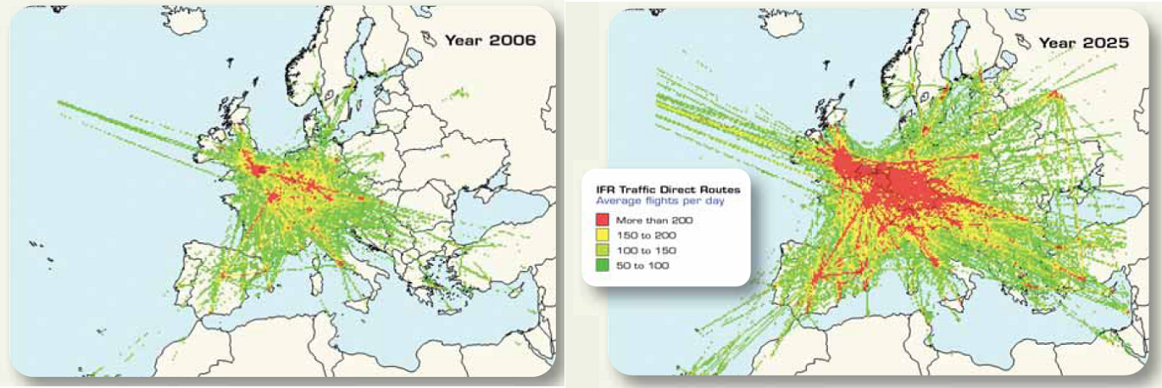

Figure 2: Growth of European flight density (source: Eurocontrol / 2007)

The density patterns in Figure 2 might be used to define basic rollout coverage scenarios for the terrestrial broadband DA2G communication network, which could be extended during the following years to cover main flight routes and areas in Europe and neighbouring countries according to increasing air traffic demand. Based on this flight density forecast, a coverage extension to North Africa and Middle East could also be considered, provided the same spectrum as harmonised in CEPT could be made available there.
The rollout of BDA2GC will start with about 200 to 250 ground stations, covering of the European area with higher density air traffic, followed by a successively development to enlarge coverage and density in very high traffic areas. In the final state, the ground network covering Europe will encompass 400 to 500 ground stations.
From an operational point of view it is reasonable to select a single operator / operator consortium for installing and running the DA2GC network. Cooperation with network operators in [almost] all CEPT countries will be necessary anyway to reach full pan-European coverage.

