FM50(11)030

FM PT 50 – Future use of 1452-1492 MHz
2nd Meeting of the FM PT 50
Rome, 20 - 22 September 2011
Date issued: 13 September 2011

Source: Sweden

Subject: Draft section 1 – Introduction to the 1452-1492 MHz

N
Password protection required? (Y/N) *

Summary
Proposed modifications to the section covering the description of candidate applications in 1452-1492 MHz.
Proposal
- Clarify the ECC procedure concerning a review of an ECC Decision.
- Modifications concerning S-DAB in general and satellite network filings in particular.

Draft introduction and section 1 of the ECC Report

Introduction

The L-band (1452-1492 MHz) is currently allocated for use by terrestrial and satellite digital audio broadcasting (DAB) services in most European countries
- Terrestrial segment: 1452–1479.5MHz (27.5MHz)
- Satellite segment: 1479.5–1492MHz (12.5MHz)

The use of the terrestrial segment of the L-band is governed by the Maastricht Special Arrangement, 2002, as revised in Constanţa in 2007. The Constanţa revision of the Maastricht agreement opens the band (originally identified for T-DAB) for mobile multimedia systems and provides a significant flexibility to administrations in terms of technology use in this band at a national basis. The satellite segment of the L-Band has been designated for use by Satellite Digital Audio Broadcasting Systems by ECC Decision (03)02.
Although the revision of the Maastricht agreement in Constanţa in 2007 extended the utilization of the band to mobile multimedia systems and allowed a more flexible utilization, and there are some countries that have provided authorisations for terrestrial sound broadcast in the Lband there are licenses given in some countries, the L-Band remains to this day, unused in most European countries as the appropriate usage had not emerged yet.
Despite the current situation, It should be noted that there is political interest within CEPT and a potential for having a harmonised solution for the use on this band across Europe. Consequently, the objective of the study presented in this ECC Report is to identify which future use(s) of the 1452-1492 MHz band would be the most appropriate for CEPT.

The following steps are considered in the study:
- Identification of objective and relevant criteria to assess the impact(s) of an implementation;
- Assessment of the relevant candidate applications according to the criteria;
- Identification whether further regulatory measures may be required to accommodate candidate applications, including the development of the least restrictive technical conditions for the application(s) retained, if appropriate.

[to be further developed as appropriate]

1. Description of the context of the study

1.1 Regulation within CEPT

The ITU Radio Regulations allocate the band 1452 – 1492 MHz to the Fixed, Mobile, Broadcasting and Broadcasting Satellite Service on a co-primary basis in all Regions with the exception of the mobile aeronautical service in Region 1. Several footnotes apply to the band. The extract from Article 5 of the Radio Regulations is given in Annex I.

The use of the band 1452 - 1492 MHz by the broadcasting satellite service, and by the broadcasting service, is limited to digital audio broadcasting. The band is subject to the provisions of Resolution 528 (WARC-92).
In some European countries, the use of the 1452 - 1492 MHz band is subject to footnote No. 5.342 related to the use by aeronautical mobile service on a primary basis exclusively for the purposes of aeronautical telemetry within the national territory.

In CEPT, the Maastricht Special Arrangement, 2002, as revised in Constanţa in 2007 MA02revCO07 Special Arrangement provides the technical and regulatory framework and the associated frequency plan for the introduction of terrestrial digital audio broadcasting (T-DAB) services in the frequency band 1452 - 1479.5 MHz. The MA02revCO07agreement as revised in Constanta in 2007 provides also flexibility to administrations to deploy terrestrial mobile multimedia in this band at a national basis. This is further described in CEPT Report 18 (see also Annex 2).
The ECC Decision ECC/DEC/(03)02 designates the frequency band 1479.5 - 1492 MHz for use by satellite DAB systems. This Decision shall be reviewed inter alia on the basis of market demand at least every 10 years according to Decides 2 of ECC Decision (03)02. However, according to the ECC Rules of Procedure (art. 12.4.1), each Decision shall be reviewed on a regular basis, but not later than every five years.

1.2 Description of the current use within CEPT

    - Broadcasting T-DAB and S-DAB

In most European countries, the 1452-1492 MHz band is currently identified for the use by terrestrial and satellite digital audio broadcasting (T-DAB and S-DAB) applications.

Relating to terrestrial T-DAB, most European countries have got one to three nation-wide T-DAB coverages in the MA02revCO07 Plan.

Relating to S-DAB, a review of the ITU-R database of satellite filings conducted on 22nd July 2011 provides a different result and shows that 7 CEPT administrations have a large number of active filings which inter alia include the band 1479.5-1492 MHz, as follows:
- France: 5, 3, 0 (coordination request, notification, Resolution 49 information)
- United Kingdom: 2, 0, 0
- The Netherlands: 3, 0, 0
- Luxembourg: 31, 0, 0
- Sweden: 2, 0, 0
- Turkey: 8, 0, 0
- Norway: 2, 0, 0

Only satellite networks in a limited range of the geostationary orbit (i.e. 15°W to 55°E) are considered, since they will have the possibility to cover a major part of Europe Satellite filings concerning coordination request, notification and Resolution 49 information were considered in this survey.

- Omni-directional receiving antennas will make future coordination very difficult, inter alia taking into account AFRIBSS at 21°E (USA). Hence, a list of coordination requests only does not give the full picture and has a limited value.
Only three filings from all CEPT countries combined have proceeded to the notification stage.
For no network at all, which is associated with a filing submitted by any CEPT country, Resolution 49 information has been provided.

None of the T-DAB and S-DAB usages have actually grown in the band as it has been shown by the Radio Spectrum Policy Group survey and Report on the future of digital audio broadcasting.

1.2.2 Other uses
There are some other systems in operation in few countries. In nine countries, the band is currently used by applications operated in services different from audio broadcasting: Fixed Service (6 countries), Mobile Service (3 countries), Ground and Wall probing Radar (1 country), Radio Astronomy (1 country), Aeronautical Mobile Service (aeronautical telemetry) (1 country). These uses are generally limited to sub-parts only of the 1452-1492 MHz band. Some of the countries indicated in their response to the ECC survey carried out in the late 2010 – early 2011 on the future use of the 1452-1492 MHz band that those mentioned different uses will continue until an already fixed date (1 country) or once digital radio will be implemented (2 countries) or until the band is used by multimedia services (1 country).
1.3 Current regulation and use outside CEPT

Many countries globally have aligned their plans on Europe by allocating the L-band to DAB services. As in Europe, there are currently no commercial terrestrial or satellite DAB services and the band remains largely unused. A number of countries have therefore been investigating the future use of the L-band. As examples:

- In Canada, Industry Canada’s ‘Consultation on the Spectrum Allocations and Spectrum Utilization Policies for the Frequency Range 1435-1525 MHz (L-Band)’ (http://www.ic.gc.ca/eic/site/smt-gst.nsf/eng/sf09751.html) considered that “with the convergence of fixed, broadcasting and mobile services over digital wireless platforms, a regulatory approach promoting flexible use of spectrum is increasingly important […]. Several countries that initially considered the band 1452-1492 MHz for DAB services have recently begun to re-farm the spectrum for a range of broadcasting and multimedia applications within the international regulations and allocations […]. The prospect of a wide range of services in the band 1452-1492 MHz being allowed by industrialized countries in Europe and elsewhere further underlines the risk for Canada of pursuing only the conventional DAB service in this band. Consequently, the current allotment plan developed for the DAB implementation may not be appropriate given the new technologies that could be deployed in this band. Broadband wireless technologies, which support multimedia applications, are developed based on a 5 MHz channel width”. The department proposed to “adopt a spectrum utilization policy allowing for flexible use of the spectrum to support a variety of services and technologies for subscription broadcasting, multimedia, fixed and mobile broadband applications.” […] to streamline the Canadian frequency allocations in the band 1452-1492 MHz and to give full flexibility and priority to terrestrial services [… and] to elevate the status of mobile service to co-primary with broadcasting and fixed services in the band 1452-1492 MHz”.

- In Africa, CRASA, which groups together the 14 Southern African Development Community (SADC) countries, highlighted in its latest Frequency Allocation Plan (FAP) (www.crasa.org/download.php?doc=doc_pub_eng64.pdf), its framework for the harmonisation across SADC on the use of the radio frequency spectrum, that: “T-DAB in the 1452-1492 MHz to be reconsidered: whereas this band was used for testing of T-DAB it was felt by the majority that this allocation is no longer required. The use of this band in the future should be further investigated and clarified.”
The table given in Annex 3 provides an overview of the usage of the band 1452 – 1492 MHz in a number of countries outside from CEPT.

ANNEX I

Extract of the Radio Regulations Article 5 for 1452-1492 MHz
Allocation to services
Region 1 | Region 2 |  | Region 3
1 452-1 492  FIXED  MOBILE except aeronautical  mobile  BROADCASTING 5.345  BROADCASTING-SATELLITE 5.208B 5.345  5.341 5.342 |  | 1 452-1 492  FIXED  MOBILE 5.343  BROADCASTING 5.345  BROADCASTING-SATELLITE 5.208B 5.345  5.341 5.344
5.208B* In the bands:
137-138 MHz,
387-390 MHz,
400.15-401 MHz,
1 452-1 492 MHz,
1 525-1 610 MHz,
1 613.8-1 626.5 MHz,
2 655-2 690 MHz,
21.4-22 GHz,
Resolution 739 (Rev.WRC-07) applies. (WRC-07)
5.341 In the bands 1 400-1 727 MHz, 101-120 GHz and 197-220 GHz, passive research is being conducted by some countries in a programme for the search for intentional emissions of extraterrestrial origin.
5.342 Additional allocation: in Armenia, Azerbaijan, Belarus, Bulgaria, the Russian Federation, Uzbekistan, Kyrgystan and Ukraine, the band 1 429-1 535 MHz is also allocated to the aeronautical mobile service on a primary basis exclusively for the purposes of aeronautical telemetry within the national territory. As of 1 April 2007, the use of the band 1 452-1 492 MHz is subject to agreement between the administrations concerned. (WRC-2000)
5.343 In Region 2, the use of the band 1 435-1 535 MHz by the aeronautical mobile service for telemetry has priority over other uses by the mobile service.
5.344 Alternative allocation: in the United States, the band 1 452-1 525 MHz is allocated to the fixed and mobile services on a primary basis (see also No. 5.343).
5.345 Use of the band 1 452-1 492 MHz by the broadcasting-satellite service, and by the broadcasting service, is limited to digital audio broadcasting and is subject to the provisions of Resolution 528 (WARC-92) *.
Annex II: Flexibility in MA02revCO07 Special Arrangement (1452 - 1479.5 MHz)

Introduction
MA02 Special Arrangement was reviewed in 2007 in order to allow for more flexibility and to allow the deployment of terrestrial mobile multimedia in the framework of the revised Arrangement MA02revCO07.
Flexibility built-in in the MA02revCO07 Special Arrangement enables the national administrations to take the approach that best suits their national requirements. The range of possibilities includes:
- T-DAB or enhanced radio services in accordance with the Ma02revCO07 Plan
- introduction of other terrestrial mobile multimedia systems that are compatible with the Plan by application of the envelope concept.
- introduction of terrestrial mobile multimedia systems that require larger bandwidth than
1.7 MHz (e.g. 5MHz). by aggregating T-DAB frequency blocks.
- any combination of the above

Aggregation of T-DAB blocks

The possibility to aggregate T-DAB blocks is reflected in a number of sections of the Arrangement which mentions the aggregated case and in particular in Annex 2 – section 5.3 which provides spectrum mask for two aggregated T-DAB frequency blocks.

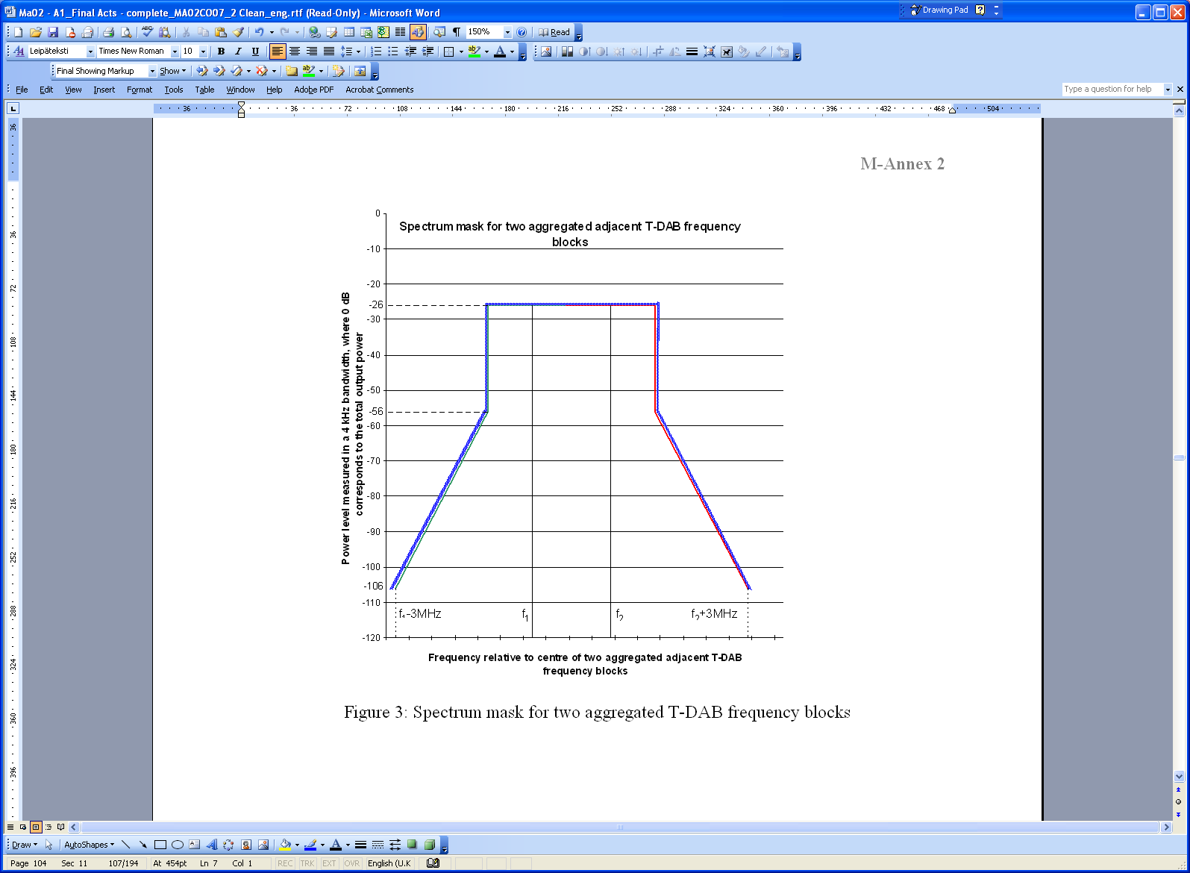
Figure XX: Aggregation of 2 T-DAB blocks

The Arrangement also allows for the aggregation of three or more T-DAB blocks. This concept was also considered while developing CEPT Report 18 in response to the Mandate on EU harmonisation of the band 1452-1479.5 MHz (lower part of L-band) to allow flexible use by mobile multimedia technologies. This CEPT Report provides technical background to the Special Arrangement and provides additional guidance in particular relating to the envelop concept and aggregation of blocks.

Envelop concept

The envelop concept and the possibility to use T-DAB Plan entries for terrestrial mobile multimedia was also introduced in the Arrangement through Article 2.4:
“
2.4 The T-DAB Plan entries may be used for terrestrial mobile multimedia services with characteristics that may be different from those appearing in the Plan but within the envelope of their T-DAB Plan entry or aggregate entries under the provisions of the Special Arrangement, and that their administrations agree that any such use will be afforded protection to the levels defined by the interfering field strengths as arising from their Plan entries, taking into account any relevant bilateral agreements.
”
CEPT Report 18 also provides guidance on the envelop concept in section 4.2.1.2.
The envelop concept allows the 1452 – 1479.5 MHz band to be used for mobile multimedia services provided that:
- the bandwidth of the proposed system is less than or equal to the T-DAB aggregated blocks bandwidth; and
- the proposed system shall neither claim more protection nor produce more interference than the T-DAB Plan entry

Channel Raster and Bandwidth
The associated frequency plan to the MA02revCO07 Arrangement uses 16 x 1.7 MHz T-DAB blocks. The Arrangement also includes regulatory provisions to add flexibility to the plan to allow a different use of a T-DAB plan entry and the possibility of operation of systems requiring a larger bandwidth. The following table provides the list of T-DAB blocks included in the Arrangement.

T-DAB block number | Centre frequency  (MHz) | Frequency range  (MHz)
LA | 1452.960 | 1452.192 - 1453.728
LB | 1454.672 | 1453.904 - 1455.440
LC | 1456.384 | 1455.616 - 1457.152
LD | 1458.096 | 1457.328 - 1458.864
LE | 1459.808 | 1459.040 - 1460.576
LF | 1461.520 | 1460.752 - 1462.288
LG | 1463.232 | 1462.464 - 1464.000
LH | 1464.944 | 1464.176 - 1465.712
LI | 1466.656 | 1465.888 - 1467.424
LJ | 1468.368 | 1467.600 - 1469.136
LK | 1470.080 | 1469.312 - 1470.848
LL | 1471.792 | 1471.024 - 1472.560
LM | 1473.504 | 1472.736 - 1474.272
LN | 1475.216 | 1474.448 - 1475.984
LO | 1476.928 | 1476.160 - 1477.696
LP | 1478.640 | 1477.872 - 1479.408
Table AYY: List of T-DAB blocks in MA02revCO07 Special Arrangement

Under the Arrangement it is also possible to aggregate adjacent blocks of 1.7 MHz in order that the total bandwidth could be used for mobile multimedia services with a wider bandwidth (i.e. greater than 1.7 MHz). Figure XY below shows how 3 x 1.7 MHz blocks could be aggregated into a 5.1 MHz block allowing for 5 MHz based technology to be deployed. As mentioned in the CEPT Report 18, the frequency band created by aggregation of individual T-DAB blocks can be used for wider bandwidth systems if the guard bands between those blocks can be used. This is possible if transmissions within the guard bands do not exceed the same limits as within each of the aggregated blocks as given by the blue line in the figure.

5 MHz
Figure XY: Example of aggregation of 3 T-DAB blocks aggregated into a 5.1MHz block (from [CEPT18])

The following figure indicates an example on how the 1.7 MHz blocks could be aggregated into 5.1 MHz blocks allowing the deployment of 5 MHz based technology. The centre frequencies of the new 5 MHz blocks are located at the centre frequencies of the existing blocks LB, LE, LH, LK and LN.
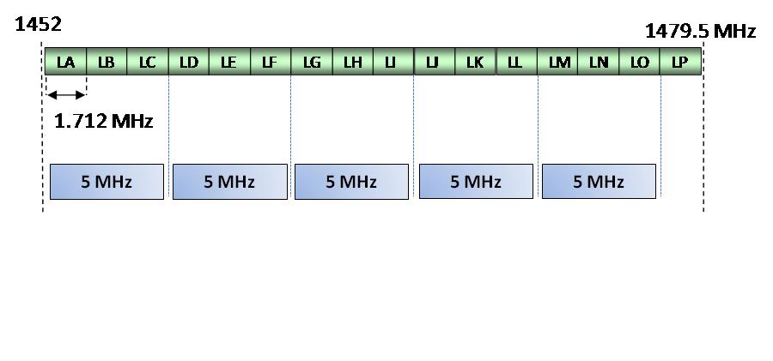
Figure XZ: Frequency raster for block aggregation in the band 1452 – 1479.5 MHz

Modification of the Plan
Administrations have also the possibility to modify the Plan in order to increase the number of coverage areas with two or three contiguous T-DAB blocks through Article 4.

ANNEX III
Overview of the usage of the band 1452 – 1492 MHz in a number of countries outside from CEPT

Country | Primary Services | Secondary Services | Note
Australia | Fixed, Mobile, Broadcasting, Broadcasting Satellite |  | http://www.acma.gov.au/WEB/STANDARD/pc=PC_2713
Brazil | Fixed, Broadcasting, Broadcasting Satellite |  | http://www.cft.gob.mx/wb/Cofetel_2008/Cofe_cnaf_4
Canada | Broadcast (T and S) Fixed | Mobile | http://www.ic.gc.ca/eic/site/smt-gst.nsf/vwapj/spectallocation-08.pdf/$FILE/spectallocation-08.pdf  Industry Canada is consulting on the adoption of ‘a spectrum utilization policy allowing for flexible use of the spectrum to support a variety of services and technologies for subscription broadcasting, multimedia, fixed and mobile broadband applications.’  http://www.ic.gc.ca/eic/site/smt-gst.nsf/eng/sf09751.html#band1452a
China | Fixed, Broadcasting, Broadcasting Satellite |  | http://files.radioscanner.ru/bands/files/document76/castoti_kitaa_2005.pdf
Hong Kong | Fixed |  | http://www.ofta.gov.hk/en/freq-spec/freq-allocations.pdf
India | Fixed, Mobile, Broadcasting, Broadcasting Satellite |  | http://www.wpc.dot.gov.in/DocFiles/3-NATIONAL%20FREQUENCY%20TABLE.DOC
Japan | 1452 – 1453 MHz: Fixed and Mobile  1453 – 1475.9 MHz: Mobile  1475.9 – 1492 MHz: Fixed and Mobile |  | http://www.tele.soumu.go.jp/e/adm/freq/search/share/plan.htm
Kenya | Broadcasting, Broadcasting Satellite |  | http://www.cck.go.ke/licensing/downloads/Kenya_TOFA_2008_Edition.pdf
Pakistan | Fixed, Mobile, Broadcasting, Broadcasting Satellite |  | http://www.pta.gov.pk/media/Pakistan_Table_of_Frequency_Allocations.pdf
South Korea | Fixed and Mobile |  | http://rapa.or.kr/frequency/english/3_Korean_Allocations_Tables.pdf
United States | Mobile (aeronautical telemetry) - aviation |  | http://www.ntia.doc.gov/osmhome/allochrt.html

http://rspg.groups.eu.int/consultations/consultation_futradio/rspg10_349_annex.pdf
See FM(11)038 Rev2.
* This provision was previously numbered as No. 5.347A. It was renumbered to preserve the sequential order.
* Note by the Secretariat: This Resolution was revised by WRC-03.
Note: this CEPT Report also contain considerations on Partial Revision of the MA02 Special Arrangement (section 4.2) and on Substantial Revision of the MA02 Special Arrangement (section 4.3) which may need to be considered by FM45.
Further information can be found in the CEPT Report 18.

