FM50(12)005
FM PT 50 – 4th meeting
Copenhagen, 11-12 January 2012
Date issued: 4 January 2012
Source: Sweden
Subject: Chapter 3 - draft section of the description of BDA2GC
N
Password protection required? (Y/N)

Summary
This document provides text for the draft section of the description of BDA2GC as one of the candidate applications. The text is based on Annex 7 to the minutes from the third meeting of FM PT 50.
Proposal
FM PT 50 is kindly invited to consider the proposals in this contribution.

3.7 Description of application seven: Broadband Direct-Air-to-Ground Communications (BDA2CG)
A broadband DA2GC system constitutes an application for various types of telecommunications services, such as internet access and mobile multimedia services. It aims to provide access to broadband communication services during continental flights The overall end-to-end system architecture of the broadband DA2G communication system is briefly illustrated in Figure 1. The request for spectrum is related to the direct air-to-ground radio solution.

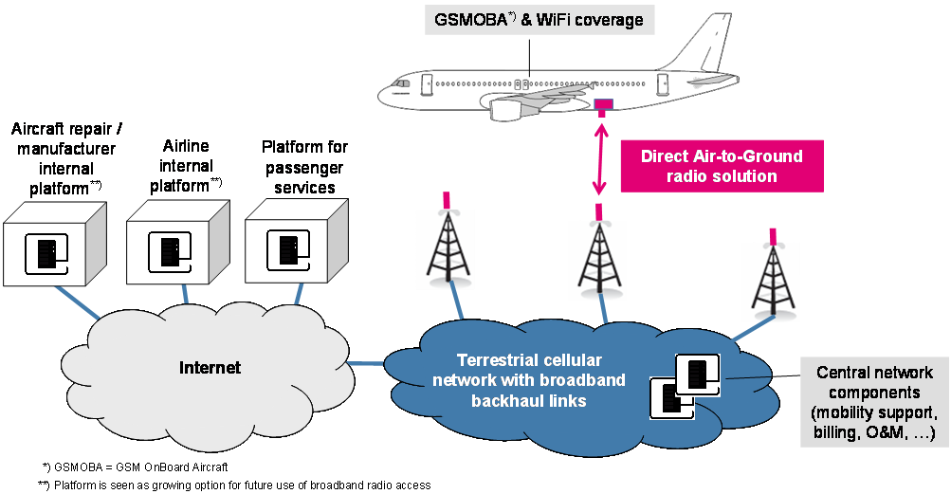
Figure 1: System architecture for broadband DA2G communication

One of the terrestrial BDA2GC systems under investigation is based on the 3GPP LTE (also called E-UTRA) standard (Rel. 8 or higher), as described in more detail in ETSI TR 103 054. There are also systems based up on UMTS and other techniques.. Some modifications are required for the LTE based system. In particular synchronization algorithms as well as the maximum OBU Tx power are to be modified compared to terrestrial mobile radio usage in order to cope with high Doppler frequency shift caused by aircraft speed and large cell sizes. In addition the BS antenna adjustment has to be matched to cover typical aircraft altitudes between 3 and 12 km by up-tilt of vertical diagrams. Ongoing investigations will determine whether further modifications are required.

The main application field would be Air Passenger Communications (APC) for entertainment purposes, e.g. WiFi or GSM based internet/company intranet access, data synchronization and voice communication. The envisaged broadband DA2GC system is not intended to be used for safety-relevant communications such as Air Traffic Control (ATC) and related services.

Justification
Mobile customers expect to be connected everywhere, every time, with all kind of mobile devices. The implementation of a terrestrial BDA2GC system in Europe could complement the already existing satellite based services which are currently being offered onboard aircraft. Some European airlines have great interest to offer internet services to their flight passengers in their continental fleets as soon as possible. The costs for the aircraft installation and maintenance are a key issue.

Currently, there is no spectrum designated for BDA2GC in Europe. In order to allow European citizens and airlines to profit from the social and economic benefits of the implementation of a terrestrial system, a spectrum designation on a Europe-wide basis would be necessary. It should also be noted that in continental US an Air to Ground system has been successfully established with more than 1.100 commercial aircraft equipped so far.
The band 1452-1492 MHz is an alternative for BDA2GC as it has a great potential for CEPT-wide harmonisation and offers enough bandwidth to cover the whole spectrum demand

Spectrum requirements
The spectrum demand for the BDA2GC system is derived from a summary of relevant factors to be essential to cope with future capacity demand as well as from results achieved by system performance evaluations.
WG FM agreed that for BDA2GC paired spectrum of 2 × 10 MHz for FDD operation is considered necessary to cope with short- to medium-term demand. Unpaired spectrum for TDD operation (20 MHz) would also be an option, but system performance would slightly suffer due to guard time intervals required for large cell sizes.
The whole spectrum requirement of 2 × 10 MHz of paired spectrum for FDD or 20 MHz of unpaired spectrum for TDD operation or a part of it may be satisfied in the 1452-1492 MHz band.

See ECC Report XYZ [currently being developed by FM48]

