 |  |  | FM PT50 |  |  |  | FM50(12)021
6th -9th March 2012, Mainz

Date issued: 28 February 2012

Source: EUTC and ESB

Subject: Candidate application: Smart utility networks
 | Password protected: yes |  |  | No | x

Summary:

There is a requirement for wireless data connectivity to be part of future smart utility networks. The mission-critical aspect of this application is distinct from general business and consumer telecommunications services and needs to be seen as a separate application

Proposal:

EUTC and ESB are requesting that an additional application – smart utility networks - is added to the considerations of FM PT50

Background

The EU 2020 agenda, EU Commission mandate M490 on standardisation for smart grids and the Commission Radio Spectrum Policy Programme’s call to look at the use of radio spectrum to contribute towards energy savings provide the background for this submission.

Introduction and the need for the application
Smart Utility communications is a special case of wireless digital terrestrial data communications.
This application has the following characteristics which set it distinct from general commercial and consumer applications and generate the need for a separate application:
- Provide an essential service to deliver safe and economical smart utility networks (energy grids – electricity and gas, water supply networks).
- Required resilience of the grid system (which depends on the communications network to operate effectively) which delivers essential services.
- Required confidence level for the priority of the communication for operational applications. That is, if certain smart grid communications were congested above a given level, the grid service would be impacted and could partially fail or fail over a wide area.
- Required deterministic propagation delays and or very short end to end propagation delays for some services (for example 10 ms maximum ‘end-to-end’ delay for electrical protection on some elements of the high voltage network).
- Investment cycles of equipment are long in comparison to consumer or general business applications. The main driver for this in the future is extremely high cost of end-point equipment replacement. This is due to the remote locations of the many end points, and the intrinsic hazards involved with utility operational locations. Thus provision for safe working necessarily adds very significantly to cost of changes.
- Service is required at remote and inaccessible locations frequently not served by other networks.
- Application data rates are low (seldom greater than 1 Mb/s) and projections do not indicate this changing significantly over time.

The wireless access aspect of the application is needed for the following reasons:
- To economically provide service to a large number of remote locations, many of which, for utility grids, are located remote from major areas of population.
- In order to meet the time-line of rollout required to achieve utility contribution to the EU 2020 agenda the use of wireless connectivity as the major part of the access method to the lower level (more numerous) end-points is required.
- Implementing smart utility grids requires communications services to be provided to many grid locations that are not served up to now with operational communications.

Typical service types, based on the electricity network case, for the smart utility application are shown in the table below.
Table 1: Typical service types for smart utility application

Service type | Description | Data rate | Comment
Data acquisition and control services (SCADA and related services) | Information is collected from the electrical network, generator units and major loads. Automatic control actions are communicated to maintain the system within required operational limits and to optimise network performance | 9.6 kb/s to 64 kb/s in general, with an increasing number of locations requiring higher data rates - up to 2 Mb/s. | In many cases these communications services are mission critical, loss of the service could result in power outages.  When power has been lost in a network due to a fault, SCADA systems enable the network to be reconfigured remotely to restore supplies to many customers within a few minutes without field workers having to visit sites.  In other cases loss of communications will cause sub-optimal grid performance thereby wasting energy.
Electrical protection | Communications services used to protect major parts of the electrical network in fault conditions | Typical data rate 64 kb/s | Failure of communications service could lead to damage to the electrical network

Architecture of the communications network for a smart utility network

A suitable architecture for the communications network consists of an access layer that provides narrowband access over a wide coverage area with many end points (for example corresponding closely to the two lowest layers of the pyramid in figure 1). This layer will generally be provided over a wireless network in non-urban areas. There will be significant country differences in the detail of how this is implemented.
Above this there is a “middle mile” communications system which aggregates narrow band service at collection points and also provides higher data rate (1 to 2 Mb/s) service to the middle layers of the utility network. A suitable wireless access technology is the best choice, from the point of view of cost and speed of roll-out, for a large proportion of this layer.
Finally there is a high bandwidth trunk layer that connects the “middle mile” access points together and also provides high data rate connectivity to the top layers of the utility network. This layer will generally be carried on a combination of fibre optic and point to point microwave radio links.

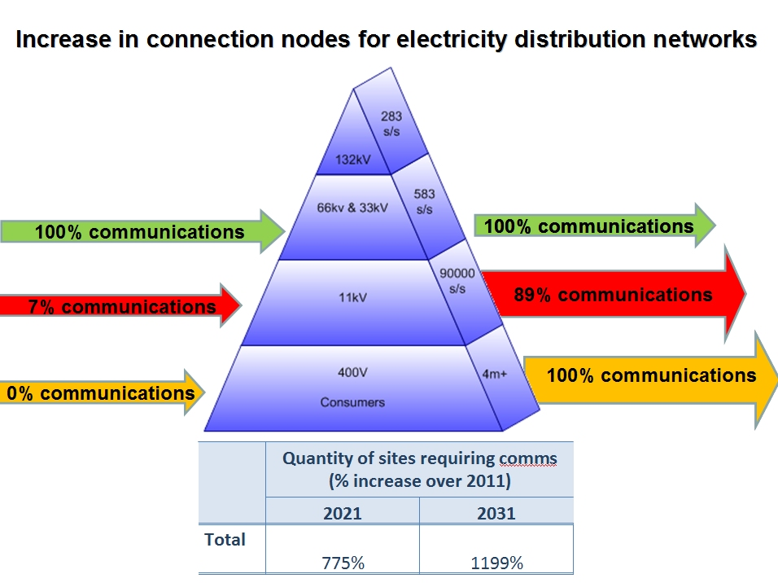

Figure 1: Increase in connection nodes

The context of smart utility networks and the importance of utility networks
The importance of smart grids is recognised by the European commission, for instance in mandate M490 on the development of standards for smart grids. It is recognised that increased performance and efficiency of energy grids and also better management of water resources are important issues for sustainable development.
EUTC commissioned a report into the socio-economic benefit of radio spectrum used by utilities to support their operations. This concluded that the socio-economic value of electricity is 50-150 times the direct price paid by the consumer, and that energy policy objectives for 2020 and beyond could only be delivered cost effectively if adequate radio spectrum is made available to support utility operations.

Possible wireless technologies for smart utility “middle mile”
Fixed microwave equipment is already available for L-band manufactured in accordance with existing ETSI specifications (this band was used for microwave fixed links in various countries prior to being allocated to broadcasting).
Equipment manufactured to the WiMAX standard is already deployed by utilities in similar bands in a number of countries, most notably the USA. The WiMAX Forum is currently developing a smart utility profile for equipment to be deployed in this band.

It is anticipated that LTE will be standardised for L-band with a public safety profile more appropriate to utilities than the general commercial profile.

A major issue with the resilience of general communications networks is their resilience in the case on mains power failure. Owing the fact that mains electricity supply is very reliable in developed countries, the lower access levels of major communications systems will frequently not continue to operate during an extended mains power failure. The reliability of mains electrical power is increasing over time, therefore it will not make business sense for typical consumer and business telecommunication services to increase their power resilience in the access network.
The EU 2020 agenda contains targets for Climate change and energy: greenhouse gas emissions 20% (or even 30%, if the conditions are right) lower than 1990, 20% of energy from renewables, 20% increase in energy efficiency - source European Commission, http://ec.europa.eu/europe2020/reaching-the-goals/targets/index_en.htm
The Socio-Economic Value of Radio Spectrum used by Utilities in support of their operations: Report by the Joint Radio Company Ltd on behalf of the European Utilities Telecommunications Council: 13 January 2012: http://eutc.org/fileshare/files/375/EUTC_Spectrum_Group_-_Meeting_Documents/Socio-economic_value_of_Spectrum_used_by_utilities.pdf or see http://www.eutc.org/

