FM50(11)037 Rev1

The wireless production tools “PMSE” are the backbone of any form of content and event production.

By implementation of the Digital Dividend
72 MHz of spectrum is for the primary user and the wireless production tools moved to lower frequencies. The remaining UHF Spectrum is packed and cannot carry the load for interference free productions any more. This is limiting the productivity of any form of production.

Solution: There is not one single band that can be the sole alternative for the loss of the 1st Digital Dividend. All alternative bands are needed and not a single one can be left outside of the scope. The L band is a significant part of this alternative and has been broad to the attention of CEPT/ECC and ETSI System Reference Document TR 102 546) since 2007.
This paper will describe the needs for PMSE for the L-Band (1452-1492 MHz).
- Introduction
Wireless microphones and other wireless production tools make a major contribution to Europe's political, cultural, social, and economic well-being.
They
- guarantee speech intelligibility for communications on political announcements, conferences and discussions.
- support national and international meetings for interpretation to enable people understanding each other.
- are major tools for news gathering, interviews, reporting.
- support cultural events like music, musical, theatre and shows and video and film productions.
- make education more efficient at universities, private and public enterprises.
Wireless production tools are workhorses for social and economic communications. They are about getting lost as more radio spectrum is intended to be sold for individual wireless connections. The spectrum PMSE can share as secondary user with a primary user like broadcast is getting smaller – too little is left for productions.
This will have significant negative consequences for communications and for cultural and creative industries cannot be accepted.
The solution:
- keep and maintain current achievement
- give additional spectrum to PMSE (Program Making and Special Events) in the L-Band.
The Digital Dividend
72 MHz of UHF spectrum between 790 and 862 MHz was already assigned in some countries will be made available in the rest of Europe in the near future for the use through IMT. These services cannot share their spectrum with PMSE, like terrestrial TV stations can.
This spectrum is/was the main field of activities for PMSE spectrum users in Great Britain, the whole of Scandinavia, Germany, Switzerland and Austria. All these PMSE users and the terrestrial broadcasters have now to arrange their services in the remaining spectrum 470 – 790 MHz. As the primary user has to clear the IMT spectrum as well he on his own will increase the density in the remaining spectrum 470 – 790 MHz already. It can be foreseen that the change of channel will also have an impact of the international frequency planning as cross border effects have to be taken into consideration.
Accordingly PMSE users will have to move into the 470 – 790 MHz spectrum as well. The remaining gaps are less than before, due to the higher density of the primary user. This limits productions already as can be seen in Appendix 1.
To secure all productions with PMSE the users need additional spectrum in other bands which have to have a similar physical quality.
The favourable wave propagation of UHF was also discovered by other services that have found that they can do their business in the UHF range with less installation compared to higher frequencies they already operate in. Because of this parts of the industry have set decision makers heavily under pressure to open this part of the UHF spectrum also for them and their service. In the end they succeeded because of the “golden” framework that was attached to it during the auctioning of the spectrum. This spectrum is lost for program/content production and distribution.
One has to acknowledge that the present and future results of WRC will have tremendous impact on the whole spectrum management. Recently broadcast and wireless productions have lost 72 MHz already! The density for these applications in the remaining spectrum has risen drastically. As L-Band is broadcast spectrum one has to take into account the development also in UHF. Both developments are linked to each other. Because of this some regulators have already assigned the L-Band to PMSE to guarantee future productions and also future development of this technology.

Fundamental need for the L-band
For daily productions 96 MHz of UHF TV band interleaved spectrum is needed. For common major events which take place at least about 5 times a month per country 270 MHz of interference free interleaved bandwidth is needed. For very big events like the Olympic Games and Championships even more spectrum is required. As a consequence of the first Digital Dividend there is only 320 MHz left and as once the DVB-T multiplexes are deducted only 214 MHz to 264 MHz of interleaved spectrum is available. PMSE is already at the limit of its possibilities. Please see also Appendix 1.
Additional spectrum between 1 GHz and 2 GHz is needed for PMSE equipment such as radio microphones, in-ear monitors, conference and interpretation equipment etc. CEPT report 32, noted: “PMSE demand for spectrum is expected to continue to rise in the medium term. Even if there was no reduction in the quantity of interleaved spectrum available for PMSE, users would eventually face increasing constraints in spectrum supply and the need to change the way that they used it. “

Higher demands of audio quality will increase the required bandwidth of a production

The current wireless systems deliver a resolution of 16bit. This is almost CD quality. This is suitable for live presentations and the majority of all other productions. HD-Sound demands more: Studios already have for their productions 24 or 32 bit resolution. They want this resolution direct from the wireless microphone. Higher resolution means more dynamics for the listeners. Being able to reproduce the dynamics of an event more detailed it will be more authentic for the listener – the level of excitement increases.
ECC regulations have taken already care of this demand by increasing the maximum allowed bandwidth for systems with higher resolution from 200 kHz to 400 kHz (24bit resolution) and 600 kHz (32bit resolution). It can be seen that just by switching to the 24 bit resolution the required amount of spectrum for a given production doubles! For 32 bit resolution it triples.
The professional production using PMSE must have the room – same as broadcast – to develop new technologies in order to follow the demands of content producers.

New Audio formats
The current standard formats are Mono or Stereo. These are still used for the majority of productions for radio or TV. For Movies, Film, certain TV shows and especially Sports Stereo productions do not fulfil the expectations of the viewers/listeners. Formats like 5.1 or 7.1 are common for these productions. These formats have been developed and made their way into the market in involve the viewer/listener more in to the program: in the cinema and even at home. No question: the systems for the cinemas are more complex compared to those people have at home. Even at home these new formats generate new acoustic atmosphere. Of course: these new formats need more equipment at the production frontend, more spectrum to transmit the increasing amount of signals.
5.1 and 7.1 are intermediate steps to a real spatial sound experience for the people at home. Similar to the broadcast format DVB-T that will change in the near future to DVB-T2. The next step on the Audio side is already in the development and can be experience by those that invested into it. This format offers a much more authentic 3D Audio experience than the mentioned and know formats like 5.1 and 7.1.
3D Audio is on the way to the market already: George Lucas presents already a film produced in this format, cinemas are being converted to this new format – this new format will make its way to the consumers, first on advanced level and later available for everyone. The 3D Audio format again requires more audio signals to be transmitted on the production side to deliver the higher spatial resolution for the listener – more spectrum is required!
One problem with new formats is: how can old material be adapted to this new format? One can remember: all the old records were available in Mono only. Today one can get these old one even in Stereo format. This is possible because the old Mono recordings were available in very high resolution, not compressed, and the sound engineers were able to extract Stereo signals out of it. This is one reason why studios want higher resolution from the microphones: to store the signals in highest resolution in order to be able to convert it according to the market needs. The Beatles recordings were done some 60 years ago. The production at that time – same like today – cost money. But it payed back manifold! Beatles Music and those of many other artists of that time, still sell today as it can be converted to today’s formats. We have to maintain this possibility: more spectrum is required!
PMSE needs the same room like all other wireless application to develop new formats for more exiting sound experiences!

Growing application
The wireless technology is already part of everyday use. There are several reasons for it: the required components come in one set – at an affordable price. These sets have been developed for the operation and use by non-technicians – ready for operation, plug and play. Since about 20 years there are loudspeaker systems in the market that have included all these components already. The user needs to plug in the mains cable of the loudspeaker, switch on his wireless microphone and is ready for operation. This described the use of small systems, which do not really need technical expertise for the operation.
The next level for the application of wireless production tools are international meetings or meetings where international guests participate. In this case the use of the wireless technology is essential for the organization and success of the meeting. In meetings of this kind in-ear monitoring is the normal – especially for the international guests and their counterparts.
Besides meetings also the entertainment industry expands. Due to the flexibility of wireless technology a site can be converted very fast in to a concert, theatre or musical venue. By using preconfigured wireless sets the amount of time consuming cabling is reduced to a minimum. The growth in this industry has two aspects: the presentations get more advanced to create more excitement in order to draw more visitors. In the end this means that the amount of used wireless links in growing. The other aspect is that because of the investment into touristic industry more touring concert, theatre and musical groups are on the road each and every day.

Growing meeting culture
Tourist activities are only one field of growth. Another very important one is the growing meeting and workshop culture. In a global world organizations have to align their activities with their employees. Industry is doing the same to qualify their employees for increasing competition, new technologies and want to bring up the motivation in their organization for more efficient operation. All this requires gathering people in one place to transport the messages.
As this is an investment all those that organize meeting of this kind want long term sustainability. For that reason a major amount is held outside the own facilities. Often in touristic interesting areas as the employees contribute a certain amount of their spare time for it. By this these meetings get a very attractive character – exactly this is wanted by the organizers.
It is common that in these meetings that one or more moderators speak to an audience supported by technical equipment. Again: wireless equipment is used to guarantee intelligibility no matter what the moderator is doing, where he is moving.
To serve this demand existing conference centres are expanding, new are built to create more attractivity in economically underdeveloped areas. Hotels expand their facilities as well: usually from 3-Stars upwards hotels provide meeting facilities. The more stars a hotel has the more developed this business is: up to large stages for corporate events of any kind. In this case wireless multichannel systems are used in the different halls of the hotel, often in parallel.

What are wireless production tools and what is the issue?
PMSE contains all type of wireless production tools for broadcast production and program making such as professional wireless microphone systems (PWMS), In-Ear –Monitor systems (IEM), wireless video cameras and other wireless video links, audio links, conference and interpretation systems, talk-back systems as well as lights and effects control, etc. The professional content and event production (news, interviews, conferences, elections, concerts, sport events, entertainment, houses of worship, etc.) require a certain amount of radio spectrum for their daily operations.
Live concerts, theatre, TV shows (most presenters use wireless microphones), major sport events (Grand Slam tennis events, Tour de France, Formuar1, The European soccer League and UEFA Champions League) all rely on using wireless systems. Major events such as Live 8 and the Olympic Games would be unable to exist in their current form without access to large quantities of interference free spectrum. PMSE equipment is using many different bands with many different applications. These different applications have different needs with regard to audio quality, audio latency, transmission range and others.
Wireless production tools have become part of everyday life as they guarantee speech intelligibility in any situation, are easy to handle, give full flexibility for set-up and use as well as save costs due to reduced set-up and break down time.
Listeners of audio productions cannot audible the quality difference between a wired and a wireless microphone. For them quality of both is equally. There are two main reasons:
    - The spectrum users for wireless production tools cooperate with the terrestrial TV broadcasters. TV is very reliable primary user which has provided so far sufficient interleaved spectrum and changes its frequencies only with long term notice. The gaps between TV transmitters are used for the assigned secondary user PMSE. PMSE can rely on these gaps for his services. For news gathering and all other productions in one location the spectrum users usually coordinate themselves since decades successfully. For medium and large productions they use a frequency coordinator to secure production quality.
    - The technical quality of wireless production tools is developed to fit the needs of high quality demands and for easy handling even for untrained users. Besides this large multichannel systems are operated in one venue – in close proximity, specialized accessories guarantee reliability even for this complex kind of application.
Due to the points mentioned above and despite the fact that wireless production tools are much more expensive than wired ones they have conquered the entire communication scene during the last decades.
Please note that the UHF TV band is because of its propagation model the core band for critical professional audio applications. The L-Band will help to ease off the problematic reduction of available PMSE spectrum and PSME applications, which are not that dependent on the UHF TV propagation model and can move to bands above 1 GHz.

PMSE in the UHF range can be used on stage, in the stage scenery, in the back stage area and in the audience in a reliable way. UHF can reliably pass through walls and people which e.g. allows interviews and activities from inside a crowd. Combined with the interference free spectrum is the major column of reliable PMSE operation.
Higher frequencies at 1400 MHz and up, which are about twice as high as the currently used ones, have certain limitations. The attenuation and absorption at these frequencies is significantly higher. For a lot of applications these higher frequencies cannot be used, especially for those operations which do not have a line of sight between the actor's transmitter and his receiver.
But certain services can be transferred to higher frequencies. All those which operate at really short distances like wireless links which are taken for presentations in small rooms, clubs, for lectures and presentations in front of small groups and all those links that have a line of sight for their operation.

Wave Propagation
Spectrum has, depending on the frequency used, different characteristics. For production as well as distribution of content the UHF spectrum is the workhorse. In this range the vast majority of all productions are done as well as the distribution to the consumers is organized. For the production of contend UHF allows with small energy of radiated power – all the units are battery operated – to cover distances of several 10 meters. This fulfils the demand of the producers. UHF productions are done in small and large environment – from meeting rooms, clubs and bars to churches, show stages and sport arenas. All this can be covered by PMSE even when the users of the equipment move in the audience during their interviews or performance. UHF has the ideal physical behaviour for PMSE. For this reason there will be always a need of a certain part of the UHF spectrum despite the fact that some of the PMSE services can be transferred to other spectrum – preferably the L-Band. There are technical reasons why the use of wireless microphones is for practical use limited at about 2.5 GHz.

Man Made Noise
The UHF spectrum still has relatively low man made noise which allow the interference free operation of PMSE in this field. With the little power of 50mW even very large stages and areas can be covered and activities inside an audience can be picked up. Certain systems have already negative influence on this level of man made noise: LED walls as well as digital transmission systems. This unwanted radio frequencies generated by these systems reduces the range of activity for PMSE. PMSE systems can only be use in close proximity to their antennas if interferers are operating in the same area. It seems that only little attention is paid to this.
PMSE can overcome the problems of unwanted RF by using spectrum that is higher than the current UHF range: the L-Band. Currently the man made noise in the L-Band is significant lower than in the UHF range. This is a positive effect of the higher frequencies in this range that compensates the attenuation losses caused by the higher frequency. But who can guarantee that the L-Band will be kept clear of man made noise?

Man made noise is also generated by digital systems in a spectrum if these systems do not use tight block edge masks. By this unwanted RF will increase the noise level in the spectrum.
Recently CEPT WG FM (11)177 has inquired a study on man made noise caused by MFCN – as it was started recently there are no results on hand.
Advance performance is provided by PMSE already: PMSE systems use since years more tight block edge masks. By this PMSE can pack a given spectrum interference free with much more links.
All these on-going and expected changes explain the overall growth of the PMSE application of about 12 % per year.

Long term Perspective for PMSE as preferred application
The primary broadcast service has moved into the spectrum below the auctioned one and the secondary user PMSE followed operating in the gaps between the TV stations. The remaining spectrum now is more packed as it was before. It will be packed even more as the primary user will expand its activities: the switch over from analogue TV to digital TV requires some years of simulcast operation to give the consumers a convenient, not painful, chance to adapt to this new technology. Digital TV will change its format again and again: in some countries the change from DVB-T to DVB-T2 is planned already. This means after the first simulcast phase there will be a second one and there will be more as there will be further technical development. The primary broadcast service has this given frequency range to develop its services. PMSE is secondary user and may only use gaps left by the TV transmitters. These gaps are becoming less. TV will develop further to HDTV and also 3DTV needs its spectrum for distribution. Again: loss of spectrum for PMSE users.
There is another disadvantage for PMSE: digital TV does not need the spectrum guard bands like analogue did in the past. So it may be that the digital TV fills the remaining UHF range with its program distribution links back to back and the spectrum is completely dried out for PMSE.
Again: PMSE needs a long term perspective especially as it has been pushed around into new spectrum just recently. Long term perspective for cultural operation is very important as significant part of the users of this technology are public financed and cannot change the equipment on a regular base due to financial restrictions – same is valid for commercial enterprises.

- Compatibility with the current regulatory framework
a) PMSE is a mobile service according to the definition of the ITU Radio Regulation
b) PMSE is compatible with MA02revCO07
The following figure shows an example of the current regulatory framework “T-DAB blocks according to MA02revCO07 Special Arrangement”:
*
Source: FM50_11_016_Annex_6

Assumption
The coordination of the DAB transmitters will release sufficient gaps. In these gaps PMSE can be operated.

Fundamental PMSE frequency arrangement
In a 1.7/5 MHz channel can up to 5/7 wireless microphones operate on an intermodulation-free frequency arrangement.

Example of improvement
In three neighbouring event locations an interleaved frequency arrangement can be used. In a 1.7/5 MHz channel up to 9/20 wireless microphones can operate.
The table shows the arrangement on interleaved location in the T-DAB “LA” block:
Main table | T-DAB  block number | Shifted  table 1 | T-DAB  block number | Shifted  table 2 | T-DAB  block number
1.452.192 | LA | 1.452.492 | LA | 1.452.792 | LA
1.452.592 | LA | 1.452.892 | LA | 1.453.192 | LA
1.453.092 | LA | 1.453.392 | LA | 1.453.692 | LA

Conclusion: Sharing the spectrum with PMSE is already proven in the UHF band where sharing the spectrum with the primary user is daily business. The efficient use of the spectrum through PMSE is given as it can arrange its services around the primary user easily. This high flexibility is given by the little occupied bandwidth of only 200 kHz by each operating device.
- Possibility to combine/share with other applications/uses
The L-band has been considered as an appropriate candidate band for radio microphones in CEPT Report 32 and ECC Report 121. Some CEPT countries plan to assign this band for radio microphones in order to compensate the loss of spectrum for PWMS as a consequence of the frequency band 790 - 862 MHz allocation to mobile/fixed communications networks (MFCN) Moreover Austria, Switzerland and Germany are mentioning PMSE as secondary user already in their national frequency plan.
2.1. PMSE and a new primary IMT service?
It is not favourable to have an application like IMT in the L-band; as IMT cannot share spectrum with other services (inflexibility = inefficient use of scarce spectrum). Additional capacity for IMT broadband services should be sought above 2 GHz as these frequencies are far more appropriate for higher data rates / bandwidth.
2.2. Sharing studies
ECC Report 121 carried out sharing studies between PMSE and T-DAB service. If a terrestrial primary service is allocated to this band, we believe that there is no dramatic change and only a few minor parameters need to be adjusted.
2.3. Our estimation of possibility to combine or share PMSE with other applications
- Mobile broadband not possible
- Mobile multimedia downlink not possible
- Hybrid broadcast to study
(including hybrid terrestrial/satellite network)
- PPDR to study
- BDA2GC to study
- PMSE excellent
- Terrestrial broadcasting excellent
- Satellite broadcasting to study

2.4 Delimitations
Spectrum for PMSE is not needed in any point of time and in the whole geographical area and therefore the ideal application to be combined with other uses.

Conclusion:
PMSE can easily cooperate with broadcasting services where it uses the gaps between carriers. As small gaps already give the PMSE the required spectrum various PMSE users can operate in these gaps in parallel without any interference. PMSE and broadcast practice since decades a fruitful symbiosis.

2.5 Applicability of PMSE for the L-Band
PMSE has 60 years’ experience in spectrum sharing. The special PMSE feature is the flexibility – it just requires sufficient gaps in the spectrum for operation. Whenever high-quality spectrum is available, this can be used. Thousands of events are produced so daily.
The reasons for this flexibility are:
- The little occupied bandwidth of 200 kHz allows many wireless links in parallel.
- The little radiated power of max. 50 mW is enough to cover even very large stages, but small enough that the same frequency can be used again about a block away in urban centres.
- The ability to switch the equipment to any given gap in the spectrum to use it for operation. PMSE has the wide switching bandwidth without loss in quality.
Please see also Appendix 4 for the density of PMSE links in urban centres.
The ECC Rep121 (provided by SE24) has clarified the situation for PMSE in the L-band. Therefore, some administrations have already added L-Band PMSE spectrum in there national frequency plan, such as Austria, Switzerland and Germany.
A new PMSE spectrum mask has improved compatibility with other users significantly. Besides that the density of users within the given spectrum can be increased without any negative effect. The PMSE manufacturers have done an advance performance.
Graph: APWPT
The picture above shows the transmitter mask of PMSE equipment. It can be seen that the new green mask offers more than 20 dB better performance on unwanted transmitter radiation above and below the carrier. In total the ratio of carrier to unwanted RF radiation is 80 dB or better. The density of services can be increased in the given spectrum: more users can use the same frequency range.
Conclusion:
PMSE can only interfere with other devices on its own carrier. The problem of wideband noise has been eliminated by the new mask.
2.6 Physical demands of wireless production tools
PMSE covers only short distances – mostly below 200 m. To achieve this at professional, interference-free quality the spectrum has to be free of incalculable other users and relatively free of man-made noise.
Due to these operational demands PMSE has moved from the 40 MHz range to the 200 MHz range and then to the UHF range.
The 40 MHz and 200 MHz range (VHF spectrum 174 – 223 MHz) have unpredictable interference sources. They are not used for professional productions any more. None of the main manufacturers has equipment for PMSE for these spectrums because it is not requested anymore.
Interferers in the named ranges are: computers, computer networks, energy saving bulbs, switching power supplies, devices with digital signal processing (DSPs) inside. More details in the Appendix 3: “Uncontrolled emissions causing interferences in the VHF and UHF bands.”
ECC CEPT report 32, noted: “PMSE demand for spectrum is expected to continue to rise in the medium term. Even if there was no reduction in the quantity of interleaved spectrum available for PMSE, users would eventually face increasing constraints in spectrum supply and the need to change the way that they used it. "
As mentioned above and proven by many independent sources the PMSE application will grow in the future as more wireless links will be used in productions and more applications will switch to wireless operation. This increases the use of links while the occupied bandwidth remains the same. The organizers of the 2008 Olympic Games in Beijing found out: There were about 30% more wireless links in use than in 2004 in Athens. They expect the same increase for the London Games in 2012.
Besides that the demand of studio productions in higher resolution of audio signals is already there: current resolution is 16 bit. More resolution means more required bandwidth. It is expected that today’s occupied bandwidth of 200 kHz will rise to 400 kHz for 24 bit resolution of Audio signals and to 600 kHz for 32bit resolution of Audio signals. The reason for the demand: studios operate already at 24 bit or 32 bit resolution and want the wireless production tools to deliver that quality.
Higher demands of audio quality will increase the required bandwidth of a production.
Spatial Audio has become part of advanced productions and has today the format of 5.1 or 7.1. New formats that need more channels are under development to generate an Audio experience that will match to visual effect of 3D TV. All these technologies need on the production side, especially for live productions, more links for more channels.
Live productions will be the bottleneck as the demand for higher Audio resolution and more channels for transmission will occupy more spectrum. In the mid-term planning the required spectrum for professional production will increase and, if the demand from the production side will increase as predicted, even more.

- Timeframe for availability of equipment on a large scale - status of standardization
- On the market available PMSE equipment supporting VHF, UHF and the 1800 MHz duplex gap. Therefore the manufacturers have all the necessary technology components. Planning security must be guaranteed by a reliable frequency allocation and the manufacturers will be able to bring L-Band products into the market with short notice.
- The required product standard was established in 2007 (ETSI-EN300422).

- Extent (maximisation) of social and economic benefits
The "front end" technology PMSE allows far-reaching effects. PMSE is the key-technology to produce the content for all kind of media. Thus PMSE have the same social and economic benefit as those applications intend to “spread” contents.
Below are listed some PMSE applications:
- Broadcast (e.g. Terrestrial, satellite and Internet broadcasting, TV and Radio)
- Political and religious events
- Event production: public, commercial, private
- Movie, Film and Video production
- Art and Culture (Musicals are impossible without PMSE)
- Leisure activities (e.g. Local recreation areas, Wellness, Discotheques)
- Journalistic work
- Sport events – all kind
- Events in associations, institutions
- Conference and interpretation, meetings, presentations
- Training and education (also Internet-based)
- Free and flexible news gathering
- Product marketing (for example in the context of industrial fairs)
To describe the economic and social value of the cultural and creative sectors one has to refer to 2 main studies from EUROSTAT and the KEA. They give a detailed overview in certain cultural sectors. Most of the activities are using PMSE for performing, communication, broadcasting and recording.
Even when it is difficult to compare the different numbers both studies attest the high value of the cultural and creative industries for economic benefit in Europe.

Employment
The EUROSTAT statistics shows that 3.6 Mio. people are employed in the selected cultural sectors film, video, TV, music recording and publishing; programming and broadcasting; Creative arts and entertainment and libraries, archives, museums and other cultural activities. This is a total of 1.7 % of total employment in the EU. In comparison in the telecom sector only 1.17 Mio. people were employed

Turnover
The cultural & creative sector generated a turnover of more than € 654 billion in 2003.
It contributes to 2.6% of the EU GDP in 2003. The growth of the cultural & creative sector in Europe from 1999 to 2003 was 12.3% higher than the growth of the general economy.
During the same period the turnover in telecom services was about € 421 billion.
It can be estimated that the development in the following years has been equal for both sectors.
One conclusion can be drawn:
The telecom industries do to not have a bigger share in the economic development in Europe than the cultural and creative industries. "Europe's cultural and creative industries offer a real potential to respond to these challenges thereby contributing to the Europe 2020 strategy and some of its flagship initiatives such as the Innovation Union, the Digital Agenda, tackling climate change, the Agenda for new skills and new jobs or an industrial policy for the globalisation era". To secure this contributing economy and give it room to grow in a reliable way PMSE should become a future user in the L-Band.

Cultural activities
There is a demand of cultural offers: "In 2006, about 45 % of Europeans aged 25–64 years declared having participated in cultural activities such as going to the cinema, attending live performances and visiting cultural sites at least once in the last 12 months."
Conclusion:
PMSE as front end technology is the solid base for manifold cultural, social and economic growth in the European Community.

- Potential for economy of scale
Need and potential for harmonisation within and outside CEPT
The Plum study gives an impressive outlook on the future possibilities of coordinated cultural activities.
Graph: Plum study 2011
Further considerations are possible for this basis. These do not consider only IMT.
Conclusion: The L-Band is the fantastic opportunity to coordinate culture activities worldwide in a harmonised spectrum.
As can be seen from the map: Europe would be far ahead with this approach. With this coordination as economy of scale the pricing for the required production equipment will decrease – productions will benefit.

Appendix 1 – today’s usage of PMSE at large events

Spectrum usage at the Eurovision Song Contest
Measurement of the DKE, the German commission for Electrical, Electronic and Information technology within DIN (German Standard Institute) and VDE (the Association for Electrical, Electronic & Information Technologies)
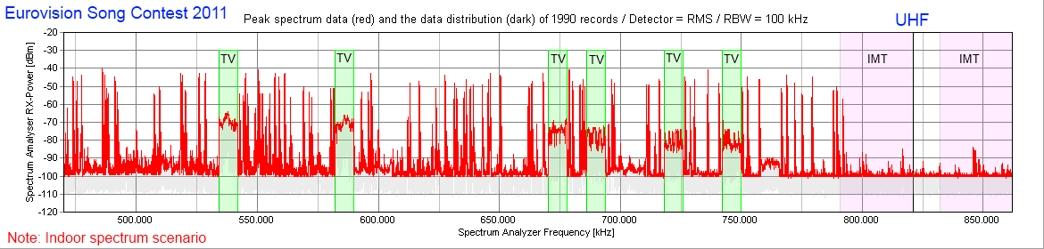
Fig 1: measurements taken during the event Note: Light green blocks are local active DVB-T transmitter
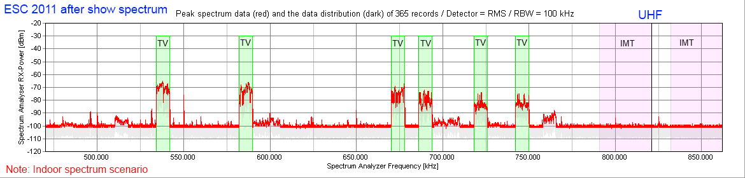
Fig 2: measurements taken after the event.
The figure shows on the horizontal axis the frequency range 470 to 865 MHz and on the vertical axis the measured level of the different spectrum users. Clearly visible are the DVB-T carriers. 7 of them were recorded inside the venue and the one on the far right had a low level as a consequence of wall attenuation. The frequencies of the radio microphones and the IEM’s used at this event are nicely arranged between the DVB-T carriers. As the bandwidth of these systems is much smaller in comparison to the DVB-T carrier the systems appear as lines and not as a clearly visible DVB-T block.
The figure shows that the white spaces in the range of 470 to 790 MHz are almost completely filled with transmissions. It should be noted that at the location of the measurement antenna not all PMSE systems in use could be measured.
Above 790 MHz the spectrum is allocated to IMT services as a result of the Digital Dividend. The producers of this event would not take the risk of interference to this production by operating above 790 MHz. The detected signals above 790 MHz are most likely audio or talk-back links as they are not as critical as wireless microphones to broadcast content.
It should be noted the measurements took place on the evening of the event itself. All of the equipment was active approximately 4 weeks prior to the main event due to the number of rehearsals that were required. From a viewing perspective the Eurovision Song Contest is the second largest live broadcast event in the world (with a tremendous turnover for IMT on SMS services as a consequence). It is surpassed only by the FIFA world cup final at which very significant quantities of PMSE equipment are also used.
We enjoyed a great European event:
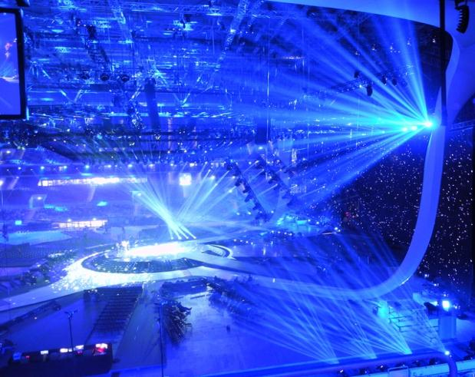
Eurovision Song Contest 2011 Düsseldorf Germany (Photo: APWPT)

Spectrum use at German State elections
Elections are events of national, sometimes even international, activities. Mainly news companies from the public and private sector build up mobile TV and Radio studios to report from the event and get known politicians to their microphones and cameras for interviews and statements. Besides these companies there are various magazines, newspapers and private reporters that try to make their own investigations and interviews and sell it later to one of the interested companies.
Since 2008 the DKE, the German Commission for Electrical, Electronic and Information technology of DIN (German Standard Institute) and VDE (the Association for Electrical, Electronic & Information Technologies) is documenting the spectrum use at these events and publishes reports on it.
Germany has 16 States; at a legislative period of four years there are about four elections a year! In 2012 there are seven State elections.
As an example of the spectrum activities during these elections the election in Hamburg in 2008 and 2011 will be presented in the following. It should be noted that the election in 2008 was a regular one – the one in 2011 was brought forward due to termination of the ruling coalition. Because of that none of the producing companies had allocated production budget for this event. This could be seen at the set-up already: the space taken by all those production companies was only one third compared to the space in 2008.
So one would easily estimate by this that the amount of material in use would also be about one third; also the amount of wireless links in use. The following picture shows the comparison between wireless links in use in 2008 and 2012.
Comparison of coordinated audio links:
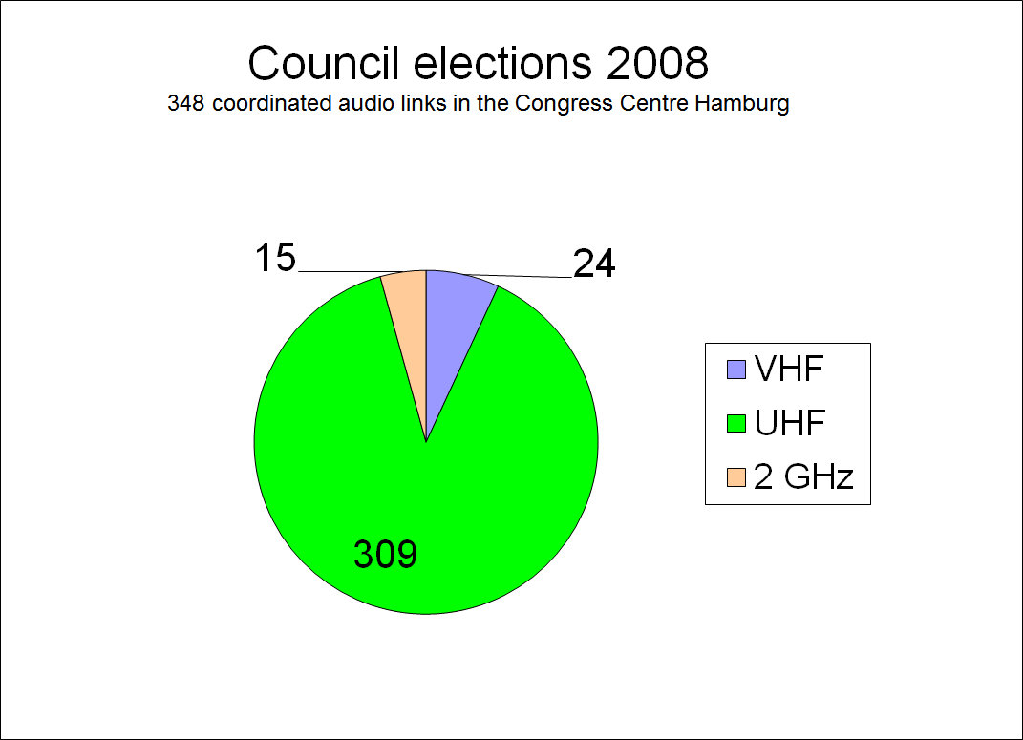 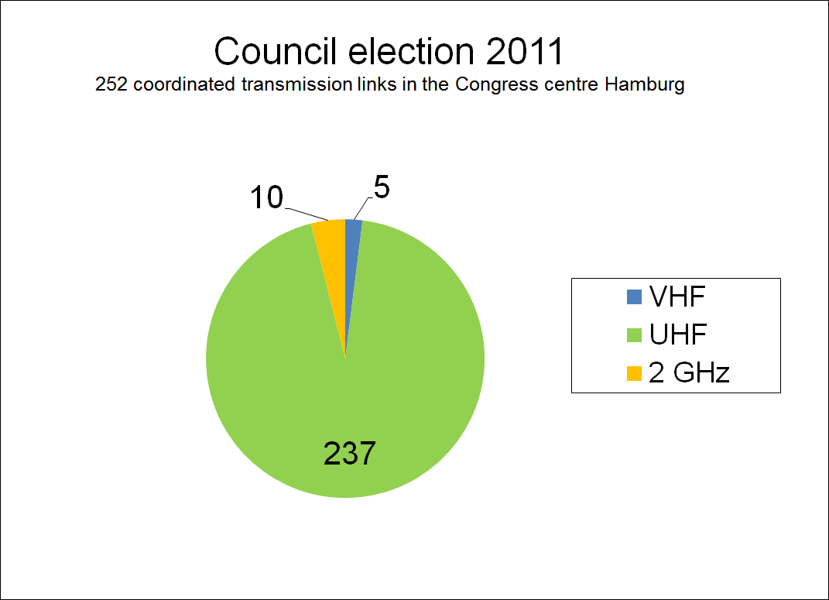
Source: DKE WG 731.0.8 2011: The proportionate UHF transceiver usage grows
The NDR, North German TV Station, coordinated the use of wireless equipment for the election: in 2008 there were 309 links in use in the UHF range – in 2012 there were 237 Links in use in the UHF range.
Three things can be seen by this:
  - the size of the production is not an indication for the use of wireless links. By having all the installations on only one third of the space as on the previous election it could be expected to have about 100 links operating. The 237 links in use are 77% of those used in 2008!
  - wireless links reduce production costs and they almost tapped the full potential to reduce these cost by using more wireless links than before. This shows already a trend. They we will have to face when the pressure on production costs will further grow.
  - some production companies made joint ventures with other to reduce the production costs and share certain facilities to do their job.
The spectrum scan comparison of 2008 and 2012 also shows a trend:
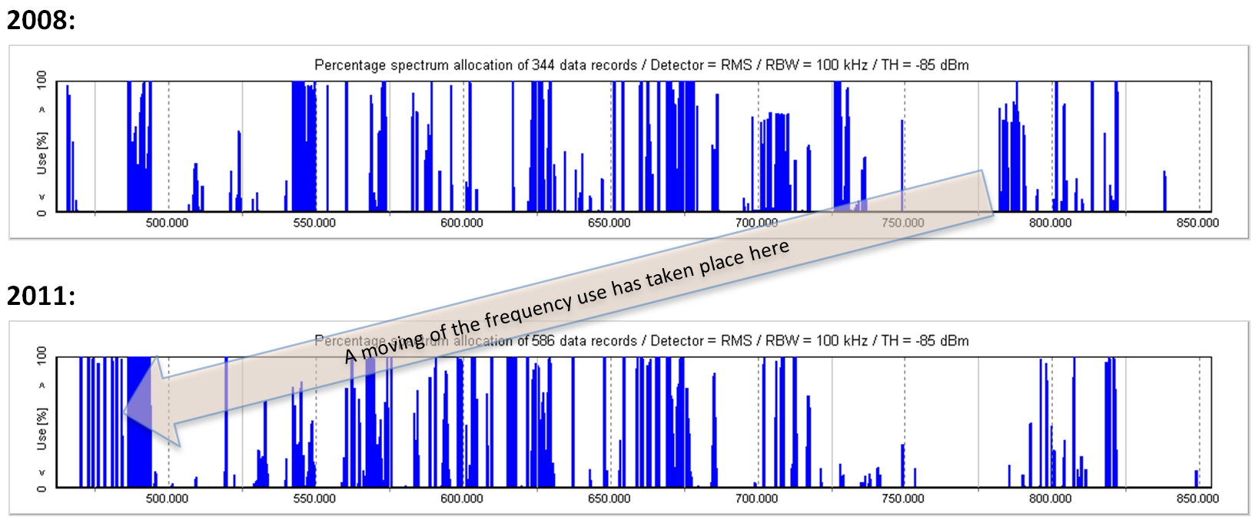 Source: DKE WG 731.0.8
In Germany the spectrum above 790 MHz is sold already and first test systems are on air. As Hamburg has no areas in which fast internet is not available the IMT companies had no rural areas where they had to install LTE first – they could right away start in the centre of the city. For this reason, just to avoid unwanted interference, there were only a few links left in the spectrum above 790 MHz; not productions links – communication links. The majority of the spectrum users have moved into the spectrum below 790 MHz.
It can also be seen that at the election evening the spectrum above 790 MHz was not used by IMT.
The following graph shows the unused gaps in the remaining UHF spectrum – the unused frequency gaps between the primary user DVB-T and the PMSE device in use and gives a comparison between 2008 in blue colour and 2011 in red colour:
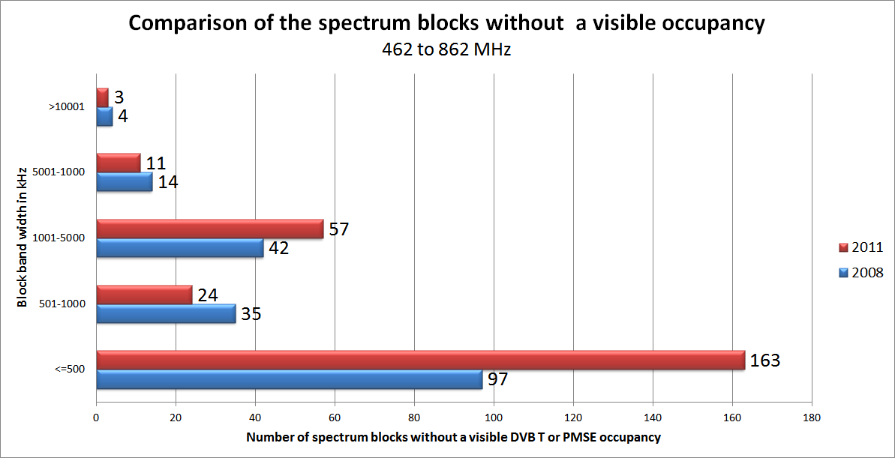 Source: DKE WG 731.0.8
It could be seen that there was a significant increase in the very small unused frequency gaps: it went up from 97 to 163 in 2012. The reasons for these gaps are the guard bands that were taken to protect the wireless links in the spectrum of higher user density (72 MHz was cut off). By the increase of the small unused frequency gaps the really bigger ones were reduced. A god example how efficient the secondary users are able to organize themselves in an efficient way.

Sports – Soccer Champions League /UEFA Cup
Details of the Event
Soccer is the most popular sports in Europe and always draws millions of spectators when it comes to top class games. In general the Champions League Final and UEFA Cup Final are held on neutral ground: not in the country of one of the playing teams – this final was held in Istanbul. This is another example for an event of national interest – any failure in organization and technical performance has to be avoided!
Because of the high interest the major TV stations and production companies of the European countries send their teams to the final to give their national interested audience details, interviews and comments to the game as they expect it.
By this there are multiple teams operating in the station in parallel with their production equipment. There is one central point responsible for coordination the whole production. This production office usually appoints a coordinator to organize the use of wireless equipment; main focus are the wireless links and in ear monitor systems for the reporters/commentators and their teams.
At this event there were more than 200 links of wireless microphones operating. Besides that about 60 wireless In-Ear monitoring systems for the individual production coordination.
The picture below shows the opening ceremony. At the lower part of the picture, in the foreground, the reporters had their positions, the screens make it easy to identify some of these positions – also a few cameras can be seen.
These reporters give comments for the spectators back home. It is done mostly by a wireless microphone because it gives the freedom to change position. Some teams also have additional reporters at the rim of the field for interviews – also with wireless microphones. These reporters are directed by the commentators which integrate the interviews into their comments: The instructions to these reporters at the fields rim are given through an in-ear monitor link.
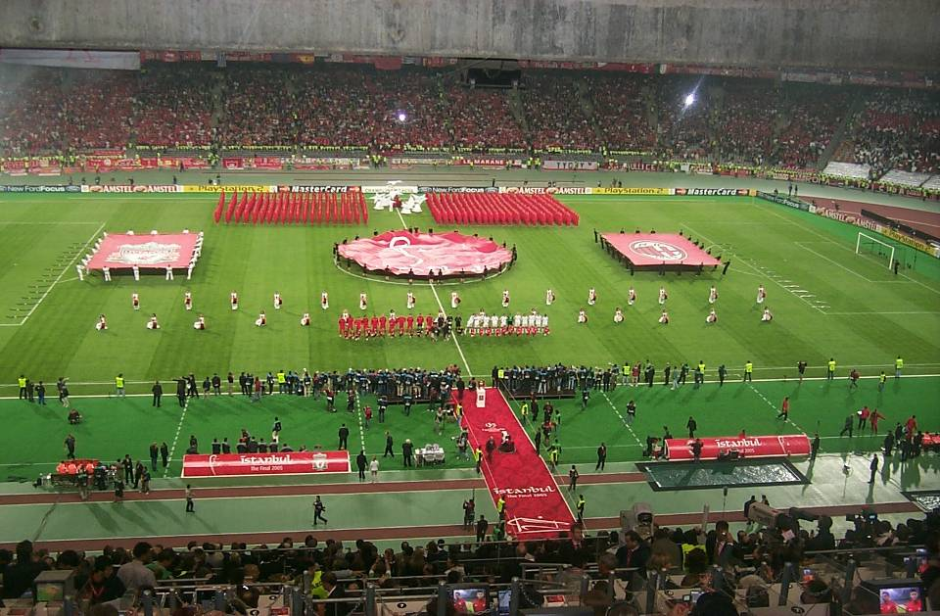 Istanbul Championsleague Final 2007 Source: DKE WG 731.0.8
Shown on this picture below is the situation almost at the end of the technical rehearsal, first spectators are already entering the stadium. During this rehearsal all the wired and wireless links are set-up, inspected, checked and tested.
On the left a broadband measuring antenna is installed to monitor the activities in the spectrum from 350 MHz up to 3 GHz.
On the right the spectrum analyser shows the UHF Spectrum from 470 – 870 MHz. It can be seen that it is almost fully occupied. The very little gaps on the right of the monitored spectrum were spares.
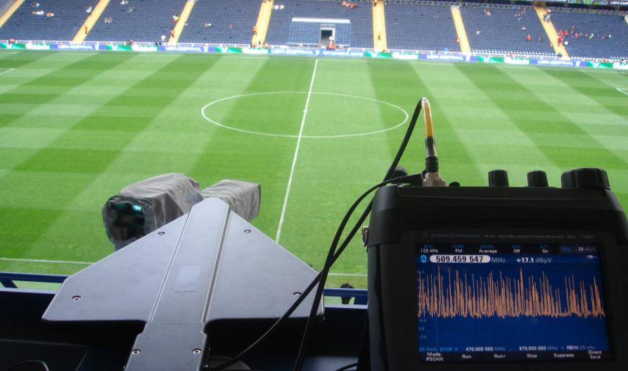
Istanbul UEFA Cup Final 2009 Source: DKE WG 731.0.8
The wireless links are not operated at their maximum range of operation. Because of that the signals at the receiving antennas are relatively strong. Also the distances between the operating transmitters are relatively high compared to TV shows, Musical, Theatre, ENG use etc. By this the usual intermodulation calculation for very save operation is not taken into consideration: the spectrum is packed up to the maximum with wireless links to fulfil the needs of all participating nations – in order not to be blamed to specially support certain users.
By monitoring the set-up of the various teams also uncoordinated wireless links were switched on, or sets were not adjusted to the right frequency. From the prominent position, as shown on the photo, all links switched on can be seen and can be accessed. By this it could be found out easy and fast who and where someone was not operating according to the agreements. These operator/teams were contacted to align their equipment.
It is important to note that this can only be achieved with analogue equipment!
If in the near future digital equipment will dominate the scene one can recognise a second user on the same frequency only as interference! It will not be possible to listen to the signal and find out who is using it – by getting closer to the user, listening to his signal, one can easily identify the noise around or the user’s voice and address him.
The regulators and manufacturers of wireless production tools should think of finding a solution for this problem: an identifier code on the signal or even a location information would be helpful.
The image below gives an impression on the controls of the frequency coordinator. This is to monitor the spectrum activities to detect critical constellations. On the left the spectrum analyser can be seen monitoring a section of the UHF spectrum – the lower range at about 450 MHz. The active antenna on the right delivers the signal for the spectrum analyser with focus on the UHF range only.
The computer in the middle of the picture shows a list of all those links that were assigned to reporting or production teams.
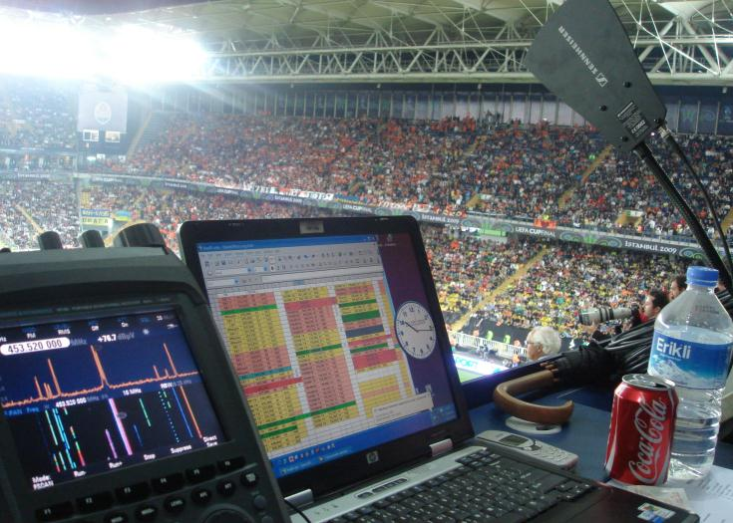
Istanbul UEFA Cup Final 2009 Source: DKE WG 731.0.8
Also to mention is the security system that plays a major roll at events like this where the risk is very high that fanatic followers of the two teams get too close to each other. The security system has to inform and direct all those involved to avoid incidents – it was said that there were about 3.000 policemen plus ambulance, fire brigade etc.
The communication system was built up in several rings, more than 12, to be prepared for receiving and sending messages in cases of emergency, when the system is running at maximum capacity. Several hundred “walkie-talkies” were in the field with the security teams – said was about 400. The screen of the spectrum analyser on the left shows the activities at about 450 MHz: normal activities, no emergency!
This sport event is not an exception it is a normal event as it happens in urban centres very often. It shows again the intensive use of the UHF spectrum: there is no free space left! Any spectrum reduction will hit the production companies, public and private broadcasters, and the lack of exiting reports will be recognised by the viewers and listeners.
Appendix 2 – Economic potential of PMSE applications

This estimation of the German economy potential generated in the professional event production by wireless production tools was collected by APWPT in 2008:
Category | Sales size | Explanation | Source
Sales volume of the enterprises of professional light, sound and event technology | 3.5 bn. € | The VPLT (10) has around 1.100 members with more than 10.000 employees. The rental companies of wireless radio systems are among others included. | Association information of the VPLT (7)
Concert and event market | 3.873 bn. € | 79.4 million visitors | GFK study 2007 (3)
Total turnover of the event economy | 66.7 bn. €  of this  31.7 bn. €  directly into the event-  centres | - 2.8 m. organizing actions for more than 331 m. visitors.  - 6200 conference and event venues  - 1 m. jobs of the line of business generated  - 30.000 people directly employees of event centres indoor  - 3.000 trainees/a | Meeting and event barometer (4)
Classic advertising editions in result of fairs and events | 12.8 bn. € | These are 18% of the complete marketing charges of the economy. Altogether, the advertising market of Germany contains a complete volume of 71.6 bn. €. | Stage report 11.08 (9)
Culture and creative economy | 128 bn. €  (Estimate 1)  ------------------  60 bn. €  (Estimate 2) | - 227000 enterprises  - 1 m. employed person  --------------------------------  There are about million people working for 210.000 enterprises in the culture and creative economy. | Initiative culture and creative economy (10)  --------------------------  Initiative of the representative for culture and media and the BMWT (6)
Category | Sales size | Explanation | Source
Theatre enterprise | 3 bn. € | Gives approx. 500 theatre enterprises including the free theatres in Germany. These employ 60.000 employees; have approx. 40 m visitors and generate a complete sales volume of almost 3 bn. €. | Information of the German's Stage Associtation and the  Federal Association of the Theatres and Orchestras (5)
Hardware sale of  wireless microphones and  wireless instrument | 65 m. € | Since all market relevant suppliers take part in IMIS, this number corresponds 5% to the complete trade sales volume in Germany. | IMIS (1), 2007
Total sales volume caused by trade mentioned above and its results (2)  (Minimum volume.) | 130 m. € | The SOMM (1) estimates five times of the trade sales for the events generated and the supplies needed for it | IMIS (1), 2007
Public broadcast | 2.68 bn. €  Gross value product in the  Year 2006 (8) |  | Goldmedia study 2008 (8)
Private broadcast | 2.75 bn. €  Gross value product in the  Year 2006 (8) | In the year 2006 (11):  - Annual sales volume approx. 8.3 bn. €  - 23.000 employee | Goldmedia study 2008 (8)

Sources and assumptions:
- IMIS (international musical instruments industry statistics) is the market statistics of the supplier sales lifted up by the Society of Music Merchants (SOMM) in Germany. Since the calculation in the trade shows an average factor, the numbers of IMIS can be projected onto trade sales.
- The projection "only" contains the consequences from appearances in the area of stage technique (stage making/exposure to sonic waves/lights), its periphery (special buildings, change or modification of a further operations technology in the environment of the event by use of radio engineering) and the concomitants of these events which have superficially to do nothing with a the technical putting into action like vehicles and whose business, catering, tourism.
- GFK study in 2007 to the consumerism of the concert and event visitors in Germany in the order of the federal association of the event economy (idkv).
- Meeting and event barometer is, made every year this of European association the event cent reindeer (EVVC), the German head office for tourism (DZT) and the German Convention Bureau (GCB).
- Theatre statistics 2006/2007 of the German stage organization.
- Federal Government "strengthens" the Federal Government's culture and creative economy information (government online 09.05.2008).
- Information of the association for light, clay and event technology (VPLT).
- The Goldmedia study 2008 "variety by a private broadcast" in the order association private broadcast and tele-media (VPRT).
- The stage report is a business to business report of the “AktivMedia Marketing- und Medienkommunikation GmbH” which publishes the current news from the area of show and stage production monthly.
- In the context of its initiative culture and creative economy the Federal Government has ordered an examination to the culture and creative economy. The first intermediate results were discussed in an expert workshop in the Federal Ministry of economy and technology on October 27th, 2008. The parliamentary permanent secretary with the Federal Minister for economy and technology, Dagmar G. Wöhrl:
"The culture and creative economy has a sales volume after estimates in height about 128 bn . in the year 2007 euro obtains. This has grown by more than 3 per cent compared with the year 2006 with that. The number of the enterprise and the employed persons also has increased further: employed persons are working in this economic sector 227.000 enterprise and 1 m. . by now. These are very positive results, this one the economic meaning of the culture and creative economy again emphasize"
Altogether, the culture and creative economy contain eleven sectional markets. The nine sectional markets have music economy, book market, art market, film industry, broadcast economy, representative art, design economy, architecture market and press market to be classed with the culture economy. The two sectional markets in addition are advertising market as well as included Games industry/software as creative industries.
Contractors of the research report are the office for culture economy research, Cologne (KWF), Prognos AG, Berlin, and the enterprise Creative business Consult (CBC), Bremen.

Appendix 3: Uncontrolled emissions causing interferences in the VHF and UHF bands

Example of interference in the UHF-TV band caused by video walls
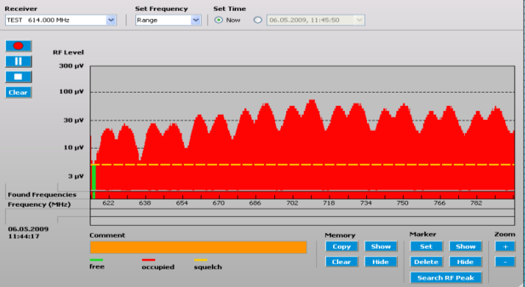
Eurovision Song Contest 2009, typical PMSE receiver scan screen Source: DKE WG 731.0.8
The picture shows the UHF range of 614 till 800MHz on the horizontal axis and on the vertical axis the level measured by a radio microphone receiver used on the venue (Eurovision Song Contest, Moscow, 2009), showing the high interference level of the video wall. The noise levels were between 5 and 80 µV. At these noise levels, the use of wireless microphones is not free of interferences, even at short distances.
During the event a variety of video walls were used and the picture below gives an impression of the size.
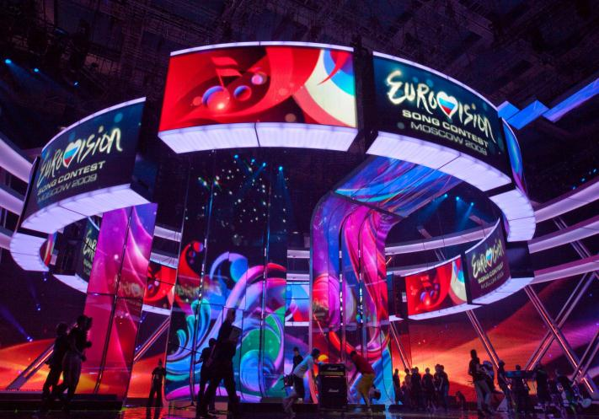
Eurovision Song Contest 2009 Source: DKE WG 731.0.8

Example of interference in the VHF TV band
The following measurement was executed during regional elections in 2010 in Magdeburg, Germany as part of frequency monitoring and the picture gives an impression on noise levels.
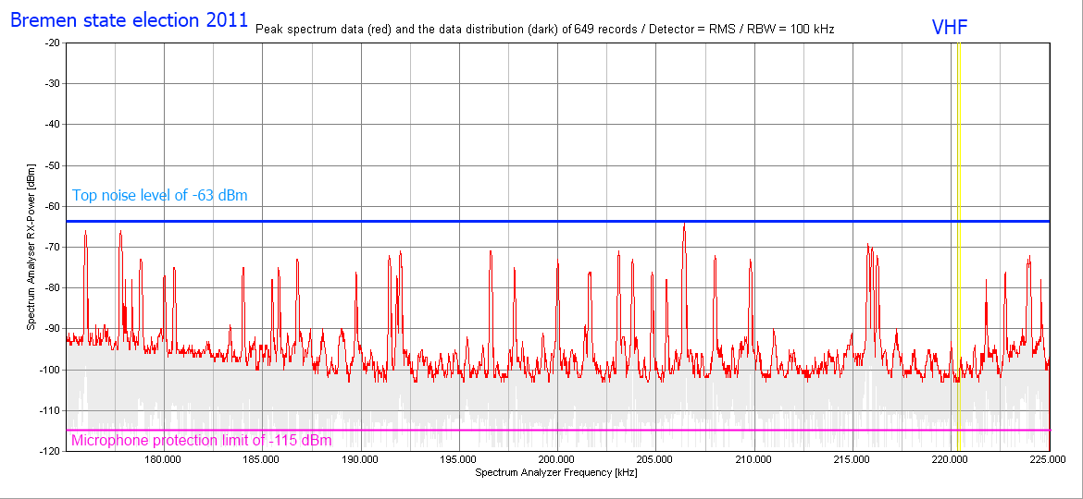
Typical VHF-noise floor at large professional event production Source: DKE WG 731.0.8
On the horizontal axis the monitored spectrum between 175 till 225MHz is shown. On the vertical axis the RF level at the measurement antenna in dBm. 70 dBm equals 70 µV. The red line indicates the maximum sensitivity of the radio microphone receiver at the level of -115 dBm. From the identified levels the conclusion can be drawn the noise exceeds the -115 dBm threshold about 30 dB typically with peaks up to 50 dB. The red line with the peaks shows the measured noise levels. Relevant to the interpretation of the noise level peaks is the fact that they are on -70 dBm which equals 70 µV. With such a high noise level at the receiving antenna of a radio microphone system, the noise will overload the signal from the radio microphone and will become clearly audible.
The reliable interference free deployment of wireless microphones cannot be guaranteed. This is the main reason why VHF systems are seldom used nowadays and all the main manufacturers of wireless equipment not have VHF systems in their portfolio.
All the devices in use have the CE mark – meaning they fulfil the rules for mains powered devices – they are not classified as transmitters! But the regulation does not take into consideration that a lot of these units are used in very close proximity – so the unwanted RF adds up.
Both examples, that one of the UHF interfering video wall as well as the one of the VHF range, show that national regulators and the European Commission must find rules and regulations that avoid unwanted RF in the spectrum. Save Our Environment means also Save Our Spectrum.
From the wireless equipment side it should be known: the more wireless digital services go on air the more man-made-noise will be generated. This in consequence will again raise the level for transmission to get the required carrier to noise ratio. By the intensive use of mobile wireless equipment – with their too small antennas – the field-strength for reception at the user has risen in the last years – and will rise further.

Appendix 4: PMSE density in urban centres
The German Federal Network Agency has made a study on the spectrum requirements of PMSE for daily productions. This study was presented in October 2008 and focused on the centre of Berlin, Germany. The study focused on following known users of wireless links: these are public buildings where wireless links are used like the house of parliament, the upper house of parliament, their press centre, universities, radio and TV studios, theatres, musicals, operas, media houses. The map gives an overview of these users and their location in the city. The dotted circle shows that they are all in close proximity: at a radius of about 500m.
The study also took into consideration the operating terrestrial TV stations.
Result of the study was that PMSE needs for daily productions – not for large scale events like the mentioned European Song Contest – a spectrum of 96 MHz. Free spectrum aside DVB-T.
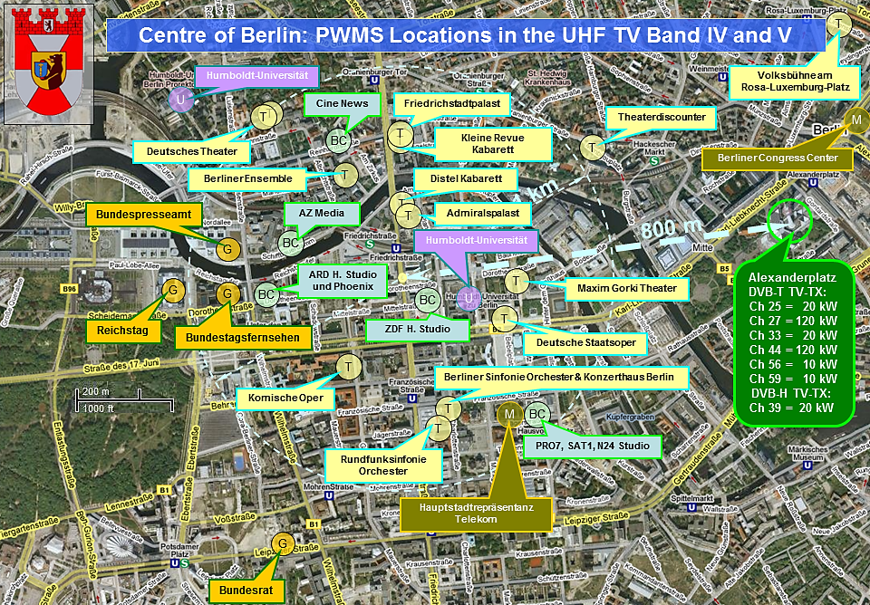
Typical microphone density in the Berlin hotspot Source: DKE WG 731.0.8
The study did not take into consideration a lot of other potential PMSE users that are not so prominent and are not necessary known by the public. Those should be mentioned here as they are active anyway and have to offer their services:
- Hotels it is fact that hotel offer meeting and conference facilities. Hotels from 3-Stars upwards usually have these facilities for their guests. They are potential users of wireless presentation technology. The density of this user group was documented for Berlin-Mitte by standard accessible internet portals. Details can be found under: „Berlin Mitte hrs Hotels“ and „Berlin Mitte map 24 Hotels. The search was on hotels with three stars and more. Only thise hotels that were available on the day of the search are shown: the list is not complete!
- Banks and Insurance Companies these companies have presentation and training facilities and are potential users of wireless presentation tools: wireless microphones, In-Ear Monitor Systems and interpretation systems. The search was on „Berlin Mitte Banken“ and „Berlin Mitte Versicherungen“. The list is not complete!
- Churches and Community Centres these meeting centres use wireless technology to increase the speech intelligibility in their facilities. The search was on „Berlin Mitte Kirchen und Gemeinden“. The list is not complete.
The list of potential users of wireless production technology is not complete. Missing are the facilities of the political parties with their meeting and conference rooms, multipurpose halls and conference centres, courts, community parliaments and councils, museums, galleries and exhibitions, Art centres, clubs and bars with their live entertainment, sport facilities, fitness studios, public and private universities and education centres etc.
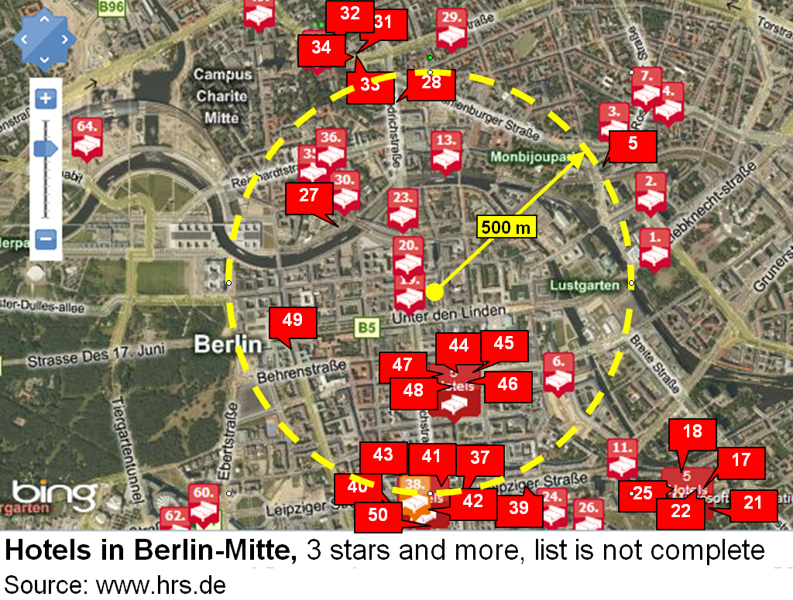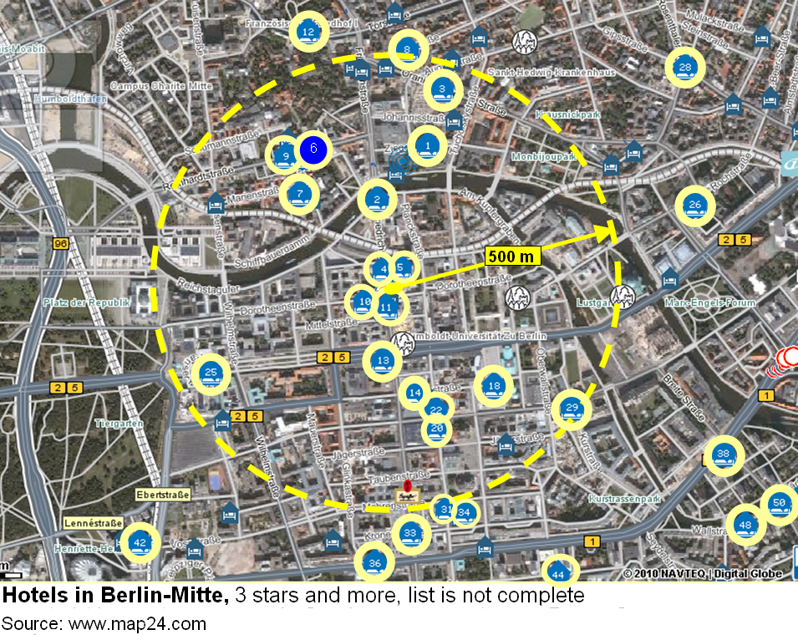
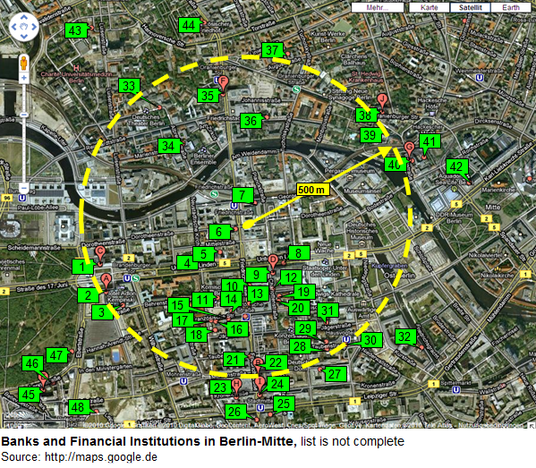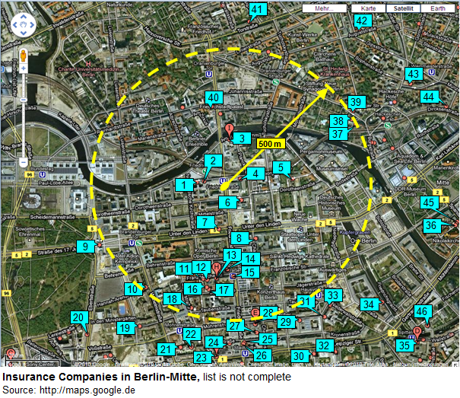
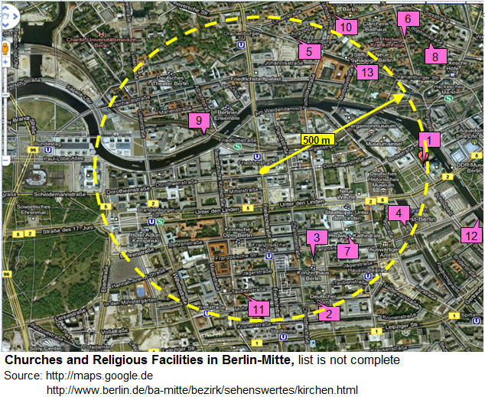
Currently all these services, those mentioned in the study and those listed here can offer and operate their wireless equipment. Besides that the ENG teams also find enough space for their operations without interfering with other services. It is expected that there will be interference when LTE goes on air in the 800 MHz range. Most professional users are aware of it and act already; semi-professionals will have unpleasant experiences.
It can be seen already that further reduction of spectrum will harm the community as there will not be enough room for them to operate in parallel.
The situation is the same for other urban centres in Europe as similar studies on the PMSE use were done as well.

About the APWPT
The “Association of Professional Wireless Production Technologies” is an international non-profit organisation, which is representing the needs of all users of the Programme Making & Special Event (“PMSE”) sector.
Members of APWPT include PMSE organisations, users and manufacturers. The APWPT directly and indirectly represents far over 25,000 members of the PMSE community in Europe and beyond. PMSE is crucial on a daily basis for the production of content that has received world-wide acclaim and continues to attract a global audience. A vast array of organisations are reliant on radio spectrum for the production of content for Performing Arts, Broadcasting, News Gathering, Independent Film and TV Production, Corporate Events, Concerts, Night Venues, Sports Events, Churches, etc. In addition, other sectors that utilise the current UHF spectrum include the Health Service, Education, Local Government, Political Programming and Conferencing.
For more information about the goals and achievements of the APWPT please visit our website at www.apwpt.org

Eurostat cultural statistics 2011 edition, http://epp.eurostat.ec.europa.eu/cache/ITY_OFFPUB/KS-32-10-374/EN/KS-32-10-374-EN.PDF
KEA European Affairs: The Economy of Culture in Europe. Study provided for the European Commission. October 2006 http://ec.europa.eu/culture/key-documents/doc873_en.htm
Eurostat cultural statistics 2011 edition, Table 4.2 http://epp.eurostat.ec.europa.eu/cache/ITY_OFFPUB/KS-32-10-374/EN/KS-32-10-374-EN.PDF
Tab 1 http://epp.eurostat.ec.europa.eu/cache/ITY_OFFPUB/KS-SF-08-038/EN/KS-SF-08-038-EN.PDF.
KEA, P.61
Tab 1 http://epp.eurostat.ec.europa.eu/cache/ITY_OFFPUB/KS-SF-08-038/EN/KS-SF-08-038-EN.PDF.
GREEN PAPER Unlocking the potential of cultural and creative industries COM(210) 183, P. 2 http://ec.europa.eu/culture/documents/greenpaper_creative_industries_en.pdf
Eurostat, P 161

