
[INSERT DATE].
To:

Members of FM Project Team (PT) 50 “L Band”

Invitation to the FM PT50 Meeting (#7) in London; 22nd (14:00) to 25th (16:00) May 2012.
Dear FM PT50 member.
Ofcom (the UK communications regulator) has the pleasure of inviting you to the seventh PT50 meeting, to be held at its offices in London, starting on 22nd May (at 14H00) to 25 May 2012 (finishing no later than 16H00). PLEASE NOTE TIMES ARE UK TIME WHICH IS 1 HOUR BEHIND CET.
The venue of the meeting will be:
Room 1.10/1.09
Ofcom
Riverside House
2a Southwark Bridge Road
London SE1 9HA
You are requested to register at your earliest convenience but not later than 15 May 2012 The online registration form can be found at:
http://www.cept.org/ecc/groups/ecc/wg-fm/fm-50/client/meeting-calendar/event-registration?meetingid=311
You may need to define or update your ECC profile, in order to register for the meeting.
Wireless LAN facilities will be provided in the meeting room. However, this requires an individual authorisation, prior to use. It is therefore essential that you register for the meeting, to enable Ofcom to organise your LAN access in advance. Without registration, it could take at least a day to provide you with access.
If any problems are encountered, please do not hesitate to contact me:
I look forward to meeting you in London.
Yours faithfully,

Stephen Talbot (Mr)
On behalf of Ofcom.
Location:
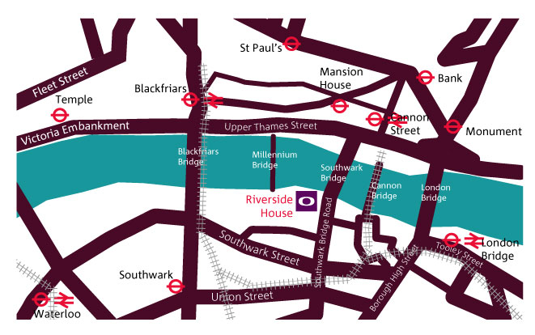
The location of Ofcom can be found here.
Maps of the London Underground network can be found here.
Details of hotels in the vicinity of Riverside House can be found here. Unfortunately we are unable to negotiate preferential rates.
(The internet links provided are for information. Ofcom is not responsible for the content)
There are no parking facilities at Ofcom and a congestion charge is payable for driving in central London. You are therefore strongly advised against driving to the Ofcom building.
The nearest underground (i.e. Metro) stations to Ofcom are; London Bridge, Cannon Street and Mansion House.
 | If you are arriving by Eurostar train to St Pancras station, the most convenient way is to catch the London Underground line “Northern Line” to London Bridge station. Ofcom is a 10 minute walk from London Bridge Station (approximately 30 minutes).

 | For flights, technically London City Airport is the closest to Ofcom. London Heathrow, London Gatwick, London Stansted and London Luton have similar travelling times (where you use public transport) to Ofcom. However you should note that both Stansted and Luton are much considerably further out, from the centre of London, than Gatwick and Heathrow.

 | From London City Airport, there is an over-ground connection to central London by the Docklands Light Railway http://www.tfl.gov.uk/gettingaround/9441.aspx. On arrival at Bank station, you can walk to Ofcom or you can make your way to the London Underground (i.e. Metro) and the “Northern Line” to London Bridge station. Ofcom is a 10 minute walk from London Bridge Station (approximately 1 hour).

There is a train line that travels across London (North - South) that connects to both London Gatwick and London Luton airports to central London. Ofcom is a 10 minute walk from either Blackfriars station or London Bridge station. Details of this connection can be found at; http://www.firstcapitalconnect.co.uk/ (approximately 1 hour 15 minutes).

From Heathrow there is a choice of both over-ground and underground services. The Over-ground Heathrow Express http://www.heathrowexpress.com/Home terminates at “Paddington” in West London and several underground changes are required to get to London Bridge station (“Circle” or “District” Line). Ofcom is a 10 minute walk from London Bridge Station (approximate journey time: 1 hour 15 minutes). The underground “Piccadilly Line” can be taken, with a change to the “Jubilee Line” needed at “Green Park” station The “Jubilee Line” will take you to London Bridge station. Ofcom is a 10 minute walk from London Bridge (approximately 2 hours).

From Stansted you will need to take the Stansted Express http://www.stanstedexpress.com. This will take you into “Liverpool Street” station. Here you should take the “Circle Line” in a clockwise direction and get off at “Cannon Street” station. Ofcom is a 5-7 minute walk from there (approximately 1 hour 45 minutes).

