 |  |  | FM50(12)34
FM50 – M6
Bologna, Italy, 3-5 April 2012
Date issued: | 28 March 2012
Source: | UMTS Forum
Subject: | Satellite Broadcasting application – Need for clear data on the satellite
N
Password protection required? (Y/N)

Summary:
Satellite Broadcasting (S-DAB) is one of the candidate applications which were proposed for the use of the band 1452-1492 MHz. The band has been allocated for satellite broadcasting for 10 years in CEPT and has not been used until now which clearly suggests that this application is not likely to bring the band into use any time soon. Nevertheless, FM50 will have to conduct an impact assessment for this application. Among the criteria used for this assessment is the ‘timeline for the application deployment’. In this paper, we stress the key importance of ensuring that the information provided on the S-DAB satellite is clearly defined, in particular which satellite is proposed to be used: AFRISTAR or a new satellite based on a CEPT filing, the CEPT filing which is proposed to be used, satellite launch date, coverage, capacity, business partners, and other relevant parameters.

Proposal:
It is proposed that FM50 takes into acount the following information relative to the ‘Satellite Broadcasting’ application in the table on the criteria ‘timeline for application deployment and develop it further in order to ensure that comprehensive information is provided in the ECC Report for proper impact assessment.
 | Satellite Broadcasting
Band designation | Existing ECC DEC(03)02
Technical conditions | Existing technical conditions in ECC DEC(03)02 and ITU Radio Regulations
Licensing | Option 1: existing AFRISTAR (WorldSpace) satellite at FCC satellite position 21°E.  - Launched in 1998 with an expected lifetime of 15 years i.e. end of lifetime by 2014.  - Coverage: two very wide beams covering CEPT countries.  Option 2: a new satellite using a CEPT satellite filing:  - CEPT Satellite Filing Number XXX. This CEPT satellite filing should not expire prior to 2014 otherwise the satellite cannot be coordinated with AFRISTAR, taking into account the coverage of the later and that the receivers are omnidirectional.  For both options: Is a pan-European selection process proposed as in the MSS 2 GHz case? How would the licensing of the satellite systems work? How is the licensing of the terrestrial component done and under which timeframe?
Standardisation | TBD
Equipment | TBD
Operational deployment | Option 1: AFRISTAR. Taking into account the wide beams of the exiting satellite and that the beams are centered over Africa, satellite broadcasting coverage can be provided to [X] CEPT countries while offering [Y] radio channels per country  Option 2: New satellite would be deployed in [20YY]

Background:
It is highly important in the context of the impact assessment of the future use of the band 1452-1492 MHz to gather clear information about the satellite which is proposed to be used to deliver S-DAB services in CEPT. During FM50 discussions, two proposals have been made. One was considered the use of AFRISTAR satellite which is located at the FCC orbital position 21°E. Another proposal was to use a new satellite based on a CEPT filing. The public information (http://www.satbeams.com/footprints?beam=5971_) indicates that AFRISTAR satellite has a very wide coverage over Europe and thus provides limited capacity for broadcasting across CEPT countries. At the same time, it prevents another new satellite to use the spectrum prior of being decommissioned, as the receivers are omnidirectional and it is quite impossible to coordinate a satellite with European coverage while having AFRISTAR on orbit. Public information (http://en.wikipedia.org/wiki/AfriStar) also suggests that the expected lifetime for AFRISTAR is 2013/2014, which means that the CEPT satellite filing which would potentially be used for the new satellite should not be expired prior to 2014. All this information needs clarification by satellite broadcasting proponents in the context of FM50 work.

AFRISTAR EAST BEAM (http://www.satbeams.com/footprints?beam=5971)
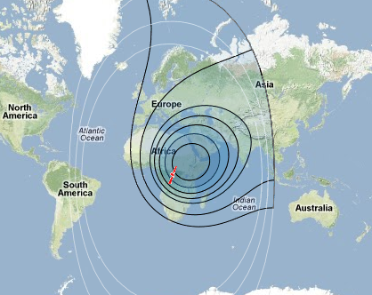
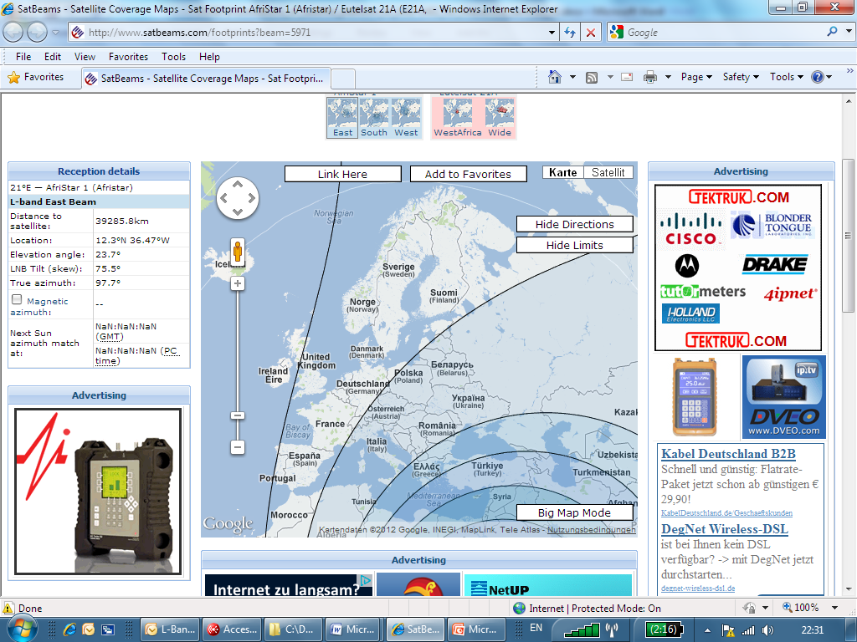
EIRP Levels
Relative to main beam
-4dB
-6dB
-8dB
-13dB
-18dB
AFRISTAR – EAST BEAM

AFRISTAR WEST BEAM (http://www.satbeams.com/footprints?beam=5971 )

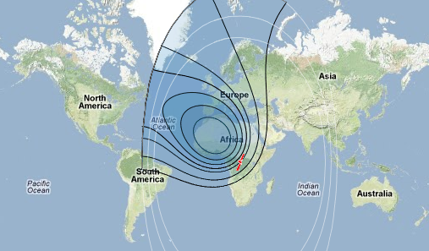

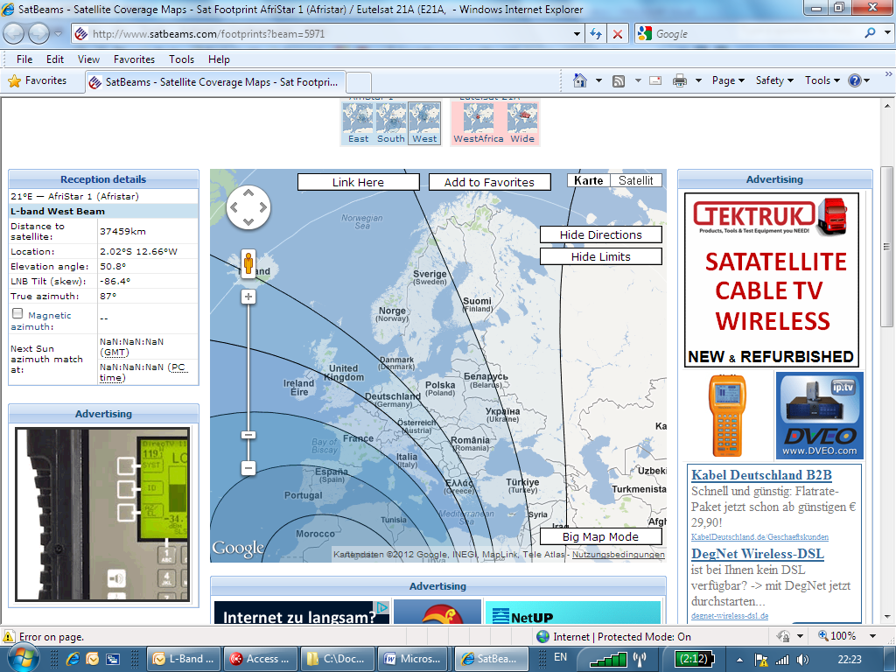
-2dB
-4dB
-6dB
-8dB
-13dB
-18dB
AFRISTAR – WEST BEAM
EIRP Levels
Relative to main beam
Main beam

