FM50(12)038
FM PT50 – M5
Mainz, 6-9 March 2012
Date issued: 2012-02-28
Source: Sweden
Subject: The use of MA02revCO07 spectrum masks for non T-DAB applications
N
Password protection required? (Y/N)

Summary:
The document raises some questions for discussion concerning the use of the spectrum masks in MA02revCO07 for both in-band and out-of-band protection and compatibility.
Proposal:
FM PT50 is invited to consider this document in its further work with chapter 4 of the draft ECC report.

Background:
Drafting group 4 recognised already at the fourth meeting of FM PT 50 in Helsinki that there might be a need to look closer to the spectrum masks in Annex II of MA02revCO07 when assessing compatibility with the Special Arrangement.

The use of MA02revCO07 spectrum masks for non T-DAB applications

Introduction
In Annex II of MA02revCO07 a frequency arrangement for 1.7 MHz wide channels and their associated centre frequencies (see Table 2 of Annex II) is provided. A candidate application requiring a greater bandwidth may still be able to use this frequency arrangement taking into account the possibility to aggregate the 1.7 MHz channels. Therefore, at least in theory, the candidate applications requesting larger bandwidths could use the aggregation of 1.7 MHz contiguous channels.

However, irrespective of bandwidth, the spectrum mask of a candidate application must comply with the spectrum masks in Annex II to be able to share the same frequency band with a T-DAB based application (or another application fulfilling the spectrum masks in Annex II).

In order to achieve a rough idea of how feasible a sharing, based on the MA02revCO07 spectrum mask, the compliance between this mask and spectrum masks for LTE, HSPA and DVB-T2 are provided as examples.

Extracts from MA02revCo07 Annex II
In Annex II the out-of-band spectrum masks for two cases are provided. See Figure 1 below.

Figure 1 Out-of-band spectrum masks for a T-DAB transmission signal

The out-of-band radiated signal in any 4 kHz band shall be constrained by one of the masks defined in Figure 1.
- Case 1 - “sensitive case”: The solid line mask shall apply to T-DAB transmitters operating in areas critical for adjacent channel T-DAB to T-DAB interference, and in any case when it is necessary to protect other services operating on adjacent frequencies on a primary basis.
- Case 2 - “non-critical case”: The dashed line mask shall apply to T-DAB transmitters in other cases.

When using a single T-DAB frequency block the radiated signal in any 4 kHz bandwidth should be constrained by the mask defined in Figure 2 based on the out of band spectrum mask defined by Case 2 in Figure 1.

Figure 2 Spectrum mask for a single T-DAB frequency block (defined by Case 2)
When using three T-DAB frequency blocks the radiated signal in any 4 kHz bandwidth should be constrained by the mask defined in Figure 3 based on the out of band spectrum mask defined by Case 2 in Figure 1.

Figure 3 Spectrum mask for three T-DAB frequency blocks (defined by Case 2)

However, contracting Administrations may elect to apply a mask based on the out of band spectrum mask defined by Case 1 in Figure 1 and also to apply independently the Case 1 or Case 2 masks at either band edge of a T-DAB frequency block. The same approach could also be applied for aggregated blocks.

Sharing example for an LTE based application
Some of the candidate applications consider LTE as the underlying radio interface for the application. Therefore it could be worth examining to what extent the LTE spectrum masks comply with the spectrum masks in Annex II of MA02revCO07.

1.4/1.7 MHz

- LTE: Minimum requirements for Wide Area Base Stations (Category B) 1.4 MHz channel bandwidth (E-UTRA bands > 1GHz) with an EIRP of 61 dBm/1.4 MHz
- T-DAB: Spectrum mask (Case 2 - “non-critical”) for 1 T-DAB frequency block with an EIRP of 61 dBm/1.54 MHz

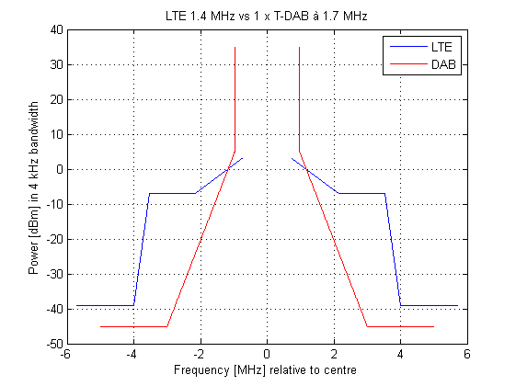
Figure 4 Comparison of spectrum masks for a 1.4 MHz LTE signal and 1 x T-DAB

The out-of-band emission for LTE is much higher than for T-DAB for a similar in band power.

5/5.1 MHz

- LTE: Minimum requirements for Wide Area Base Stations (Category B) 5 MHz channel bandwidth (E-UTRA bands > 1GHz) with an EIRP of 61 dBm/5 MHz
- T-DAB: Spectrum mask (Case 2 - “non-critical”) for 3 T-DAB frequency block with an EIRP of 61 dBm/5.14 MHz

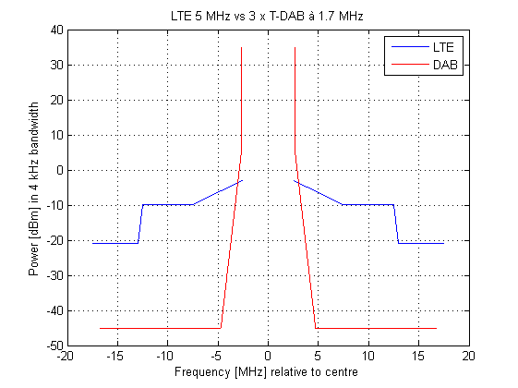
Figure 5 Comparison of spectrum masks for 5 MHz LTE signal and 3 x T-DAB

About the same result is achieved for a 5 MHz LTE signal compared with the T-DAB spectrum mask for three contiguous blocks as was the case for a 1.4 MHz LTE signal compared with the T-DAB spectrum mask for one block on the previous page.

Sharing example for an HSPA based application
A few candidate applications also consider HSPA as the underlying radio interface for the application. Therefore it could be worth examining to what extent the HSPA spectrum masks comply with the spectrum masks in Annex II of MA02revCO07.

5/5.1 MHz

- HSPA: Minimum requirements for Base Stations with an output power ≥ 43 dBm in a 5 MHz channel bandwidth with an EIRP of 61 dBm/5 MHz
- T-DAB: Spectrum mask (Case 2 - “non-critical”) for 3 T-DAB frequency block with an EIRP of 61 dBm/5.14 MHz

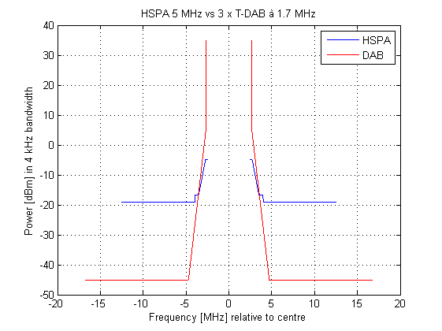
Figure 6 Comparison of spectrum masks for 5 MHz HSPA signal and 3 x T-DAB

The out-of-band emission for HSPA is higher than for T-DAB for a similar in band power but not as high as for LTE.

Sharing example for a DVB-T2 based application
A future broadcast application in this frequency band could most probably be based on DVB-T2 (instead of T-DAB). In the ETSI specification for DVB-T2 no regulatory spectrum mask is provided. However in the implantation guidelines for DVB-T2 a comparison with the regulatory spectrum mask in the GE06 Agreement is made. But the spectrum masks in GE06 Agreement are only provided for 7 and 8 MHz bandwidths. For that reason the following comparison between the theoretical DVB-T2 spectrum (OFDM spectrum without additional filtering) and the spectrum mask in Annex II of MA02revCO07.
DVB-T2 allows many different FFT sizes and guard intervals affecting the spectrum, as well as the extended bandwidth. The combination of 8k FFT and a guard interval fraction of 1/8 are often taken as references. For that reason the combination is selected also in this example. Further there is an option to choose between normal and extended bandwidth for the DVB-T2 signal. Both results are provided.

5/5 MHz

- DVB-T2: FFT size 8k, Guard interval fraction 1/8, Normal & Extended bandwidth
- T-DAB: Spectrum mask (Case 2 - “non-critical”) for 3 T-DAB frequency block with an EIRP of 61 dBm/5.14 MHz

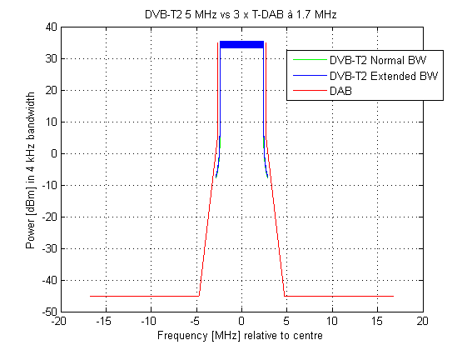
Figure 7 Comparison of spectrum masks for a 5 MHz DVB-T2 signal and 3 x T-DAB

Within the bandwidth corresponding to number of carriers x carrier separation the DVB-T2 signal seems to comply with the spectrum mask for three aggregated adjacent T-DAB frequency blocks, for both normal and extended bandwidth.

In the DVB-T2 standard, no specific requirements are set in terms of the spectrum characteristics after amplification and filtering, since it is considered to be more appropriately defined by the relevant national or international authority, depending on both the region and the frequency band in which the DVB-T2 system is to be deployed.

It is also envisaged that the DVB-T2 mask should be adapted to the specific requirements in each operational band. Due to this the DVB-T2 standard does not give any information about the requirements on spectrum characteristic in the 1452-1492 MHz frequency band. As there is no defined requirement for the out of band region for DVB-T2 in this specific frequency band it is not considered meaningful to include this region in the mask. DVB-T2 is therefore only represented by the unfiltered output signal for the bandwidth corresponding to number of carriers x carrier separation in Figure 7.

ETSI EN 302 755 V1.2.1 (2011-02)
http://www.dvb.org/technology/standards/a133_DVB-T2_Imp_Guide.pdf
8192 x 0.6975 kHz = 5.7143 MHz
ETSI EN 302 755 V1.2.1 (2011-02)

