FM50_12_032 Annex 8

ECC Report <No>

Report title (Arial 12pt)
Month YYYY (Arial 9pt bold)
(last updated: Month YYYY) (Arial 9pt)

Executive summary (style: heading 1)
Body text (style: ECC Paragraph)
(advice: the Executive Summary should provide a short and concise explanation on the purpose of the respective ECC Report and should clearly indicate the covered subjects to which it applies. In addition, it should clearly explain the application of the document.)

TABLE OF CONTENTS

0 Executive summary (style: heading 1) 2
1 Introduction 4
2 Definitions (optional section) 4
3 heading (style: Heading 1) 4
3.1 Heading 2 (style: heading 2) 4
3.1.1 Heading 3 (style: Heading 3) 4
3.1.1.1 Heading 4 (style: Heading 4) 4
3.2 Example of bulleted lists 4
3.3 Example of numbered/bulleted lists 4
3.4 Example of numbered/lettered lists 4
3.5 Examples of figures and tables 4
4 Conclusions 4
ANNEX 1: heading (style: ECC annex - heading1) 4
ANNEX 2: List of reference 4

LIST OF ABBREVIATIONS

Least Restrictive Technical Conditions - Principles
A technology and service neutral regulatory framework is implemented through the definition of Least Restrictive Technical Conditions (LRTCs) applicable to a band. The definition of LRTC allows to harmonise the technical conditions applicable to a band (and potentially enables equipment to benefit from economies of scale) while allowing flexibility at national level, as it is being done for instance for the 800 MHz spectrum (Digital Dividend).
The definition of LRTCs is based on the principle that they solely address the technical compatibility issues:
- Case of adjacent frequency interference within a given geographical area of operation (in band and out-of-band interference)
- Case of co-frequency interference in adjacent geographical areas of operation

The development of LRTCs should consider, where necessary, existing international and/or regional agreements. The LRTC developed in CEPT were based so far on the consideration of the compatibility of adjacent frequency interference within a given geographical area of operation.
LRTC enables authorised users of the band to deploy any application, provided such deployment respects the technical conditions set out in the LRTC. This kind of regulatory regime provides clear conditions of co-existence for users of other frequency blocks in the same band as well as users in adjacent frequency bands. The emissions allowed at block/band edges are stable and well known over time. Operators and regulators also benefit from the maximum possible flexibility to determine the use(s) of the band.

ECC experience with LRTCs
The ECC has a significant experience in the development of LRTCs. LRTCs have been developed for several applications in several bands.
The CEPT Report 19 [ref] studied the applicability of LRTCs and developed LRTCs applicable to frequency bands addressed in the context of WAPECS in a number of bands (in particular 3.4-3.8 GHz and 2500-2690 MHz). The report notes, inter alia, that coexistence between two WAPECS blocks using the same frequency in geographically separated areas can for instance be determined by the use of field strength, and that a frequency separation of 5 MHz is needed between an FDD uplink block or unsynchronised TDD block with another TDD block operating in the same geographical area.
The CEPT Report 30 [ref] developed LRTCs for both Electronic Communication networks (ECNs), PMSE applications and low power applications in the band 790-862 MHz. It should be noted that the CEPT Report 30 [Editorial, add reference] relied on studies and conclusions from the CEPT Report 23 [Editorial, add reference] and CEPT Report 29 [Editorial, add reference] which were studying the general coexistence issues in the band 470-862 MHz.
The CEPT Report 39 [ref] developed LRTCs for Electronic Communication networks (ECNs) and low power applications in the 2 GHz bands (i.e. in the bands 1920-1980 MHz paired with 2110-2170 MHz as well as in the bands 1900-1920 MHz and 2010-2025 MHz).

The ECC Report 131 [ref] studied the coexistence issues between terminals deployed under LRTCs in the band 2500-2690 MHz.

From the above Reports, it can be noted that:
- Block Edge Masks (BEMs) combined with a harmonised band plan are the preferred option, and the only option selected so far, to implement LRTCs, i.e.to control adjacent frequency interference (both within the band and at the edge of the band);
- CEPT Report 19 indicated that the aggregate PFD model or field strength is suitable to address scenarios related to co-frequency compatibility in geographically different service areas. However, this was not implemented up to now.
- Establishing LRTCs rely on the selection of a reference system (network scenario, receiver performance, etc). However, BEMs have been developed for high level groups gathering a large number of applications. It is likely that LRTCs for co-frequency sharing can be developed for such high level groups. This is detailed in the following section.

It is not the purpose of this Report to establish the technical detail of appropriate LRTCs however a general LRTC framework can be derived from past CEPT experience in developing BEMs.

CEPT has some experience in developing BEM, however, the practical experience relating to the implementation of this concept is still limited [ECC PT1(11)119 Annex 12 – Position paper on LRTC feedback / see also the ECC PT1 work programme at http://eccwp.cept.org/default.aspx?group=17 - 800_2600_3500MHz_1_C].

Possible sets of LRTC to be developed
By reviewing the applications under consideration, it can be established that the platforms that deliver those applications are either satellite-based, terrestrial-based or airborne-based.
Table 1: Platform to deliver the applications under considerations
Candidate Application | Satellite  + Terrestrial Component | Terrestrial | Airborne
Terrestrial Broadcasting |  | ■
Mobile Broadband |  | ■
Mobile multimedia downlink |  | ■
Satellite Broadcasting | ■
[Satellite-based mobile multimedia downlink] | ■
[Satellite-based mobile broadband] | ■
Programme Making and Special Events (PMSE) |  | ■
Public Protection and Disaster Relief (PPDR) |  | ■
Broadband Direct-Air-to-Ground Communications |  |  | ■

The following sections provide an overview of the LRTCs to be considered in order to cover the applications under consideration in the framework of FM50. The merging of some of these LRTCs should be considered when practicable (for example the LRTC for BDA2GC could be similar to the LRTC for one of the terrestrial applications).

Terrestrial Systems
The past CEPT studies on LRTCs have identified a number of cases where the development of BEMs is straightforward, while on the contrary identifying a number of cases that would require specific measures (e.g. restricted blocks, stringent BEMs). Such cases are in particular related to the adjacent frequency operation of FDD and TDD networks within the same geographical area.
This has led to the following classification of applications:
- ECN’s Downlink (DL) (including broadcast) to receivers with high directionality and/or high gain (e.g. fixed). For such applications, the corresponding target received field strength is low. None of the applications studied in this report are targeting this kind of deployment scenario.
- ECN’s DL (including broadcast) to mobile receivers with low directionality and/or low gain (e.g. vehicular or handheld devices for on-the-move, nomadic or stationary use). For such applications, the corresponding target received field strength is high enough to enable reception at ground level to receivers with low gain antennas. This category includes terrestrial broadcasting, downlink of Mobile broadband, Mobile multimedia downlink (MMD) and downlink of Public Protection and Disaster Relief (PPDR).
- ECN’s Uplink (UL) and low power applications (e.g. handheld devices for on-the-move, nomadic or stationary use). This category includes uplink of mobile broadband (if applicable), Programme Making and Special Events (PMSE) and uplink of Public Protection and Disaster Relief (PPDR).
At this stage, only the second case and third case described above seem to be relevant for the studies undertaken in the framework of FM50.
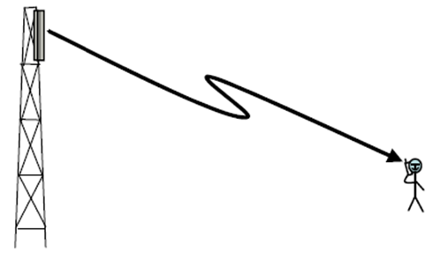
- ECN’s DL (including broadcast) to fixed receivers and ECN’s DL (including broadcast) to mobile receivers result in different LRTCs
Note: add picture with a car
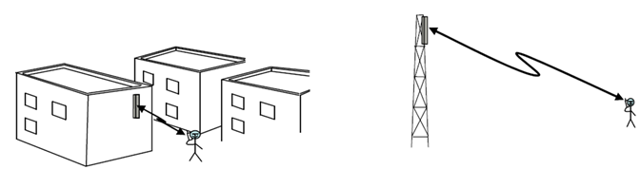
- In case of duplex communications, two sets of LRTCs are required. One for DL and one for UL

Satellite and terrestrial component
Unlike some bands identified for satellite use, which are shared with other services, the band 1452 – 1492 MHz is not subject to any in-band pfd limits. In addition a CEPT Decision exists, at a purely regulatory level, that limits the use of satellite (in the ECC Decision ECC/DEC/(03)02
Satellite Digital Audio Broadcasting systems is referred to) to the band 1479.5-1492 MHz. If in-band pfd limits were applicable, these would be reflected in ITU-R RR Article 21. However satellite use in the band 1452 – 1492 MHz is subject to out-of-band pfd limits. Here the limits, for emissions into adjacent bands from in-band emissions in 1452 – 1492 MHz, are detailed in ITU-R Resolution 739.
Previous study work, in CEPT, had been carried out to address compatibility between S-DAB and T-DAB in adjacent bands and between S-DAB and PMSE. Further compatibility studies may have to be carried out depending on the outcome of FM50 work with a view to developing an LRTC for satellite if relevant.

In the development of the LRTC for the terrestrial component, similar approach as for the Terrestrial Systems should be considered, as appropriate.

BDA2GC
The compatibility studies between DA2GC and LTE were performed for the band 3400-3600 MHz. The evaluations results state that in principle a LTE-based DA2GC system can co-exist with a terrestrial mobile radio system with similar characteristics in the adjacent channel. This is primarily true if FDD mode operations are considered for both systems. No additional guard band between the channel block edges is required in that case.
For TDD or mixed FDD/TDD mode operations the main problem to be solved is the decoupling of the antennas of the DA2GC GS and the LTE BS (eNodeB) which requires sufficient isolation in space and/or frequency or alternatively the usage of different sites for the systems. According to the current version of ECC Decision ECC/DEC/(11)06 both FDD and TDD arrangements for MFCN (including IMT/IMT-A systems) in the band 3400 – 3600 MHz are possible in European countries. Therefore, even with an implementation of DA2GC in FDD mode, frequency guard bands of about 5 MHz (in principle below as well as above the DA2GC spectrum) would be required for deployment at least in countries with TDD arrangement for terrestrial IMT/IMT-A.
Further compatibility studies may have to be carried out depending on the outcome of FM50 work with a view to developing an LRTC for BDA2GC if relevant.
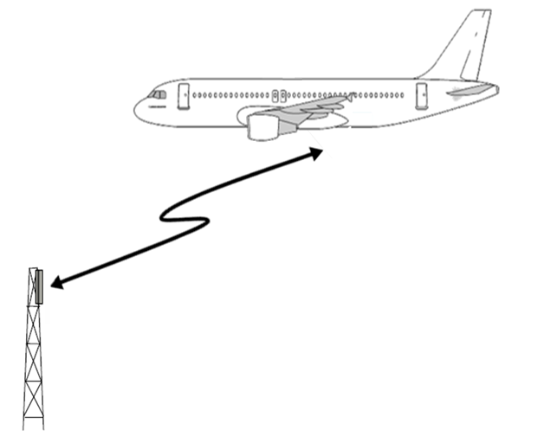
- BDA2GC

Reference systems
In order to establish compatibility criteria for systems operating in the band, it may be necessary to make some assumptions about likely systems in the band. The expression of minimum technical restrictions will be linked to a given set of assumptions generally identified through a market analysis.
For each band (or sub-band) one or more reference systems can be identified, based on the market analysis of most likely systems for that band (typically through research and consultation with interested parties).
LRTCs to date have consisted of the combination of:
- A harmonised band plan,
- Generic Block Edge Masks for adjacent frequency use (both within the band and at the band edges), enabling co-existence within a group of applications deployed in the same service area.
- Restricted Block Edge Masks for co-existence between groups of applications.

Initial Considerations on LRTC for Terrestrial system

Possible Band plan(s)
It will be up to ECC to decide to retain parallel band plans or to select a preferred band plan and abrogate the MA02revCO07 band plan. In the previous studies on the 800 MHz band, the preferred band plan was adopted in ECC/DEC/(09)03 [ref] while the channeling arrangement from GE06 was maintained.
The adoption of 5 MHz block size has been used for the development of LRTCs in other bands. This 5 MHz block size does not seem to be limiting, although other options may be considered depending on the outcome of FM50 work.
Technologies with smaller channel bandwidth would not be excluded by the selection of a 5 MHz block size. A 5 MHz block size may however not be optimal for the deployment of technologies based on 1.7 MHz. A channel raster of 5.1 MHz (3x1.7 MHz – see CEPT Report 18) may be better for such technologies but will not enable 5 MHz channel applications to use the full spectrum range.
Although, two candidate band plans are still under consideration, it will be appropriate the final aim is to identify a single preferred band plan in order to facilitate the achieve harmonization toward in CEPT to the maximum extent possible.
The proposed band plans are illustrated in the figures below:
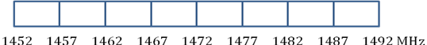
- Possible band plan for 1452-1492 MHz band based on 5 MHz block size

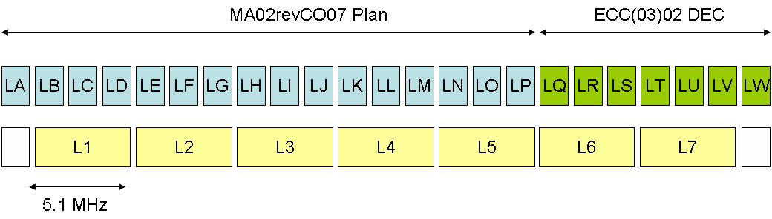
- Possible band plans for 1452-1492 MHz band based respectively on 1.7 MHz and 5.1 MHz block size

Compatibility of band plan options

Compatibility of band plan options with Terrestrial Broadcasting
Terrestrial broadcasting is expected to correspond to three different sets of technologies:
- Narrowband technologies (T-DAB, T-DMB, DAB-IP, SDR),based on 1.7 MHz bandwidth.
- Flexible bandwidths technologies (DVB-T2 Base, DVB-T2 Lite, DVB-T2 xxx, DVB-SH), that can adapt to bandwidth ranging from 1.7 MHz up to 8 MHz.
- Wideband Technologies (DVB-H), that can be deployed on blocks between 5 and 8 MHz.

Narrowband technologies are best deployed under the current Maastricht Plan based on 1.7 MHz allotments. A 5.1 MHz band plan can accommodate such technologies but flexibility in regional allocation of channels is lost, especially for cross border allocation. A 5 MHz band plan can also accommodate these technologies. In such a case, some T-DAB channels could overlap two 5 MHz blocks without using them completely, which leads to the similar flexibility restrictions as a 5.1 MHz band plan.
Flexible technologies can be deployed on all three types of band plans (1.7 MHz, 5 MHz and 5.1 MHz). However, the requirement for larger capacity when transmitting anything else than radio (e.g. video, multimedia, data intensive applications) indicates a strong incentive to adopt technologies transmitting on channel bandwidth larger than 1.7 MHz. In such a case, a 5.1 MHz band plan limits the number of available 5 MHz carriers in Europe to 7, while a 5 MHz band plan is optimal and allow a full use of the range, enabling 8 carriers of 5MHz bandwidth.
Wideband technologies cannot be deployed on a 1.7 MHz band plan. A 5.1 MHz band plan limits the number of available 5 MHz carriers in Europe to 7, while a 5 MHz band plan is optimal and allow a full use of the range, enabling 8 carriers of 5MHz bandwidth.

Compatibility of band plan options with mobile broadband and mobile SDL
Mobile broadband and Mobile SDL are supported by technologies operating on channels multiple of 5MHz.
Mobile broadband and Mobile SDL cannot be deployed over a 1.7 MHz band plan.
A 5 MHz band plan is optimal as it offers 8 blocks of 5 MHz which can enable the efficient use and maximization of the overall spectrum available in the band 1452-1492 MHz. In addition, it also corresponds to 4 lots of 10 MHz, satisfying both the requirement of a minimum 10 MHz bandwidth per operator and the opportunity to accommodate 4 mobile operators in the band in a number of markets. The availability of only 7 blocks of 5 MHz in a 5.1 MHz band plan will not allow to achieve this objective.

Compatibility of band plan options with PMSE
Current PMSE technologies are narrowband, operating typically on a 200 kHz bandwidth. However, PMSE applications are not deployed in a 200 kHz channel. The requirement for absence of interference implies that PMSE requires guardband between their carrier and services in adjacent channels. Furthermore, most professional PMSE application require multiple parallel audio channels leading to overall bandwidth requirements much larger than just a number of 200 kHz channels. PMSE applications operate currently in channels with typical bandwidth of either 6 or 8 MHz (one UHF TV channel).
Therefore, a 1.7 MHz band plan would be extremely inefficient for PMSE as the number of guardbands required would be multiplied considerably.
A 5.1 MHz band plan would lead to 7 blocks potentially available for PMSE operation on a secondary basis.
A 5 MHz band plan is optimal as it leads to 8 blocks potentially available for PMSE operation on a secondary basis.

Compatibility of band plan options with PPDR

PPDR applications are projected to be based on technologies such as LTE, i.e. technologies with 5 MHz bandwidth.
PPDR applications therefore cannot be deployed over a 1.7 MHz band plan. A 5 MHz band plan would be optimal to satisfy national needs for PPDR ad-hoc and temporary applications.

Summary of advantages and drawback of band plan options
The table below summarises the potential for candidate band plans to accommodate each technology proposed to support the terrestrial candidate applications.
Application | Technology | 1.7 band plan | 5.1 MHz band plan | 5 MHz band plan
Terrestrial Broadcasting | T-DAB, T-DMB, DAB-IP, SDR | ++ | + | +
 | DVB-H, | -- | = | ++
 | DVB-T2 Base, DVB-T2 Lite, DVB-T2 xxx, DVB-SH | = | = | ++
Mobile Broadband | UMTS, HSPA+, LTE, WiMAX | -- | = | ++
Mobile SDL | HSPA+, LTE-Advanced | -- | = | ++
PMSE |  | - | = | +
PPDR | Proposals based on mobile broadband technologies | -- | = | ++
- Ability of the band plan options to accommodate terrestrial candidate applications, based on proposed technologies

Optimisation of the use of the spectrum
Spectrum is a limited resource which use should be optimised. The selection of a band plan is an important aspect of this optimisation. Three band plan options have been considered in the band 1452-1492 MHz, based on respectively 1.7, 5 and 5.1 MHz blocks.
The 5 MHz plan uses efficiently the entire 40 MHz bandwidth and thus maximizes spectrum availability. There is 0 MHz unused.
The 1.7 MHz plan uses a total bandwidth of 39.1 MHz. There is 0.9MHz unused and cannot accommodate most of applications based on broadband technologies.
The third band plan based on 5.1 MHz blocks uses a total of 35.7 MHz. There is 4.3MHz unused (Note: only 35 MHz would be usable for most applications, see table 1. 5 MHz fragmented spectrum remain unused).

Generic BEM
A generic BEM ensures coexistence between applications belonging to the same group of applications, i.e. ECNs DL vs ECNs DL and ECNs UL vs ECNs UL. In previous CEPT studies, such a generic BEM was typically derived from considerations of the Spectrum Emission Masks of the reference system for the group of applications. In the case of the Generic BEM for the 1452-1492 MHz band for ECNs DL, a generic BEM derived from the Maastricht Agreement SEM could represent a suitable reference.
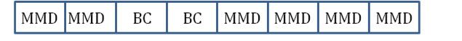
- Example of mixed allocations between MMD (Mobile Multimedia Downlink) and Broadcast (BC) at national level
In previous CEPT studies on the generic BEM for ECNs UL and low power applications, were implying a maximum in-band power, with no further constraints applied.
Appropriate CEPT reviews may be needed to verify these initial (as well as additional) considerations about the suitability of these candidate Generic BEMs.

Restricted BEM
The coexistence of ECNs DL and ECNs UL usually require the adoption of restricted blocks, on which restricted BEMs apply, as illustrated in the Figure below.
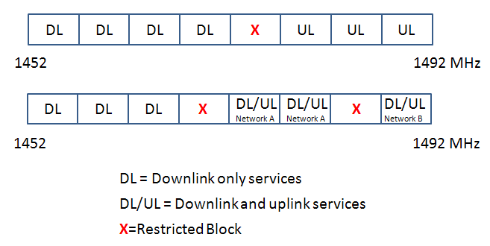
- Example of mixed allocations between DL and DL/UL blocks, including resulting restricted blocks
These two Figures are illustrative examples. Requirements for restricted blocks have to be assessed on a case by case basis.
In such restricted blocks, the maximum in-band power is limited and the reception sensitivity may be degraded due to interference from adjacent DL blocks. The CEPT Report 19, 39 and ECC Report 131 [References] have studied extensively these restricted blocks and provide an adequate corresponding regulatory framework.

The coexistence between high power broadcasting networks and low power ECNs has been studied in particular in the CEPT Report 23, 29 and 30 [ref]. The main conclusions are that: - The most difficult coexistence scenario is between ECNs UL and low power applications on one hand and broadcast to fixed receivers on the other hand and - Coexistence between low power ECNs DL and high power broadcast networks is mainly governed by the reception mode of the broadcast transmission (see CEPT Report 23 [ref]).
ECC Report 161: “Additional Considerations relating to the L-band and the MA02revCO07”
ECC Report 121: “Compatibility studies between professional wireless microphone systems (PWMS) and other services/systems in the bands 1452-1492 MHz, 1492-1530 MHz, 1533-1559 MHz also considering the services/systems in the adjacent bands (below 1452 MHz and above 1559 MHz)”

