FM50(12)044_Annex 4

ECC Report <No>

Report title (Arial 12pt)
Month YYYY (Arial 9pt bold)
(last updated: Month YYYY) (Arial 9pt)

Executive summary (style: heading 1)
Body text (style: ECC Paragraph)
(advice: the Executive Summary should provide a short and concise explanation on the purpose of the respective ECC Report and should clearly indicate the covered subjects to which it applies. In addition, it should clearly explain the application of the document.)

TABLE OF CONTENTS

0 Executive summary (style: heading 1) 2
1 Introduction 4
2 Definitions (optional section) 4
3 heading (style: Heading 1) 4
3.1 Heading 2 (style: heading 2) 4
3.1.1 Heading 3 (style: Heading 3) 4
3.1.1.1 Heading 4 (style: Heading 4) 4
3.2 Example of bulleted lists 4
3.3 Example of numbered/bulleted lists 4
3.4 Example of numbered/lettered lists 4
3.5 Examples of figures and tables 4
4 Conclusions 4
ANNEX 1: heading (style: ECC annex - heading1) 4
ANNEX 2: List of reference 4

Note on the Table of Contents (delete after reading)
This is automatically styled and compiled from the headings, subheadings and page numbers from the document that follows. To update the Table of Contents move cursor within the table and press F9.

LIST OF ABBREVIATIONS

Description of the candidate applications, including spectrum needs
Editorial note 1: Numbering of tables, figures, annexes, and references needs to be verified.

Editorial note 2: The proposals from document 028 by Germany are not reflected. They should be considered once the content of this section becomes stable.

The following candidate applications are considered:
- Terrestrial broadcasting
- Mobile broadband
- Mobile supplemental downlink
- Satellite Digital Audio Broadcasting (S-DAB)
- Programme Making and Special Events (PMSE)
- Broadband Public Protection and Disaster Relief (PPDR) for temporary and local use
- Broadband Direct-Air-to-Ground Communications (BDA2GC)

application one: Terrestrial broadcasting

Description
Terrestrial broadcasting is a digital terrestrial system for distribution of audio and video content in a one-to-many mode to fixed, portable, handheld and mobile receivers. In many countries terrestrial broadcasting is one of the principal means for access to radio and TV services by the general public.
The main features of terrestrial radio and TV services are:
- Universal availability
  - coverage often exceeds 98% of the population
  - delivery to secondary receivers
  - support for services for people with disabilities

- High QoS
- predictable and consistent across the whole service area
- independent of the number of simultaneous viewers and listeners
- control over QoS and the user experience

- Efficiency
- technically and cost efficient delivery to large audiences

- Flexibility
- possible delivery to fixed, portable and mobile reception conditions
- support to free-to-air reception or conditional access, or both
- supports public service as well as commercial broadcasting model
- coverage adapted to the service requirements (national, regional or local)

- Mass market platform
- widely supported by manufacturers, network operators, broadcasters, regulators and the public

- Competition
- promotes competition even in those markets that are dominated by other delivery platforms

Terrestrial broadcasting networks can be implemented by means of different systems, in particular the DAB and DVB families of standards and SDR, as indicated in the table 1 below:
Table 1: Examples of terrestrial broadcasting systems
System | Required block/channel bandwidth | Related Standards
T-DAB | 1.7 MHz | ETSI – EN 300 401  ETSI – TR 101 496-3
T-DMB | 1.7 MHz | ETSI – EN 300 401  ETSI – TS 102 428
DAB-IP | 1.7 MHz | ETSI – EN 300 401  ETSI - ES 201 735
SDR  (terrestrial deployment) | 1.7 MHz | ETSI - TR 102 525  ETSI - TS 302 550  ETSI - TS 302 551-1  ETSI - TS 302 551-2
DVB-H | 5, 6, 7 or 8 MHz | ETSI – TR 102 377
DVB-T2 Base  DVB-T2 Lite  DVB-T2 xxx | 1.7, 5, 6, 7, 8 and 10 MHz | ETSI – TR 102 831  ETSI – EN 302 755  ETSI – EN 300 744
DVB-SH  (terrestrial component) | 1.7, 5, 6, 7, 8 and 10 MHz | ETSI – EN 302 583  ETSI – TS 102 594

Further information about terrestrial broadcasting standards can be found in Annex 5.

Justification
Demand for terrestrial broadcasting services both radio and TV is growing in most countries in CEPT. It is reflected in a growing number of radio and TV channels that have come on-air in the recent years and in a growing viewing and listening time. In additional to national and international services there is an increasing demand for local broadcasting, in particular for local radio programmes.
While the FM radio is still the most popular radio platform the capacity limits of band II have been reached in many countries and this constrains further developments. Digital radio has been introduced in a number of countries in the VHF band III. However, this band may not be available in all countries and/or may not be sufficient to satisfy the future requirements, in particular for local radio services. This is why the L-band is important for the future development of digital radio in some countries.
The L-band will also facilitate the delivery of advanced multimedia services which are provided to the consumers in addition to the traditional radio and TV programmes.
Furthermore, there is a growing market demand for non-linear broadcasting services, both audio and video (e.g. time-shifted, personalized, on-demand, interactive and second screen services). L-Band is well suited for the provision of such non-linear services, in particular if terrestrial broadcasting is combined with wireless broadband technologies.
Joint initiatives between broadcasting and mobile industries are emerging that would enable further convergence in order to enable the full range of broadcasting and multimedia services in the future. The L-band offers an opportunity for implementation of such innovative approaches.
Finally, demand has been expressed for the deployment of the subscription-based radio services in the L-band on the basis of the above mentioned SDR specification. Implementation in Europe would require taking into account the variety of languages, cultural specificities and different coverage that compose the European countries. In this respect, the L band is adequate (see also section 4.1) to anchor the deployment of national, independent subscription radio services. For instance, the existing regulation offers an option for any country to deploy subscription services according to individual needs, if and when required. This, in turn, would provide scope for further economies of scale through a harmonised use in Europe and for convergence with other services (notably with free-to-air radio).
It should be noted that broadcasting services in L-band have already been implemented in some European countries (see section 1.2.1 and Annex 3).

Spectrum requirements
The spectrum requirement for terrestrial broadcasting applications is the frequency band 1452-1479.5 MHz which allows terrestrial broadcasting to be implemented in those countries where market demand exists.

application two: Mobile broadband

Description
Mobile broadband is a terrestrial radiocommunication system that, by means of connected base stations and mobile station devices, is able of communicating in mobile situations in one or two directions providing various services and applications to end users, including mobile internet, e-entertainment, e-education, e-health and e-learning.
The trend in consumer devices with smartphones, tablets and dongles has changed the user behaviour in such a way that the traffic is becoming more IP based and asymmetric in terms of download and upload ratio. Users download more data than they upload. Current spectrum allocations are usually symmetrical for the mobile broadband platform.
Mobile broadband applications could be provided by either FDD (frequency division duplex) with in-band or out-band pairing or TDD (time division duplex) systems. In case of FDD systems the maximum of 40 MHz potentially available in the L-band is considered not to be sufficient for a viable eco-system for in-band pairing.
Some examples of mobile broadband systems and their required bandwidths are provided in the table below. Which technology route to take will depend on a variety of factors depending on the operator, the availability of alternative spectrum, geography, demography and local conditions.
Table 2: Examples of mobile broadband standards
Standard | Required block/channel bandwidth | Related specifications
UMTS/HSPA+ | 5, 10 MHz  (in-band carrier aggregation) | 3GPP Release 6 to 8
LTE | 5, 10, 15 and 20 MHz | 3GPP Release 8 and 9
UMTS/HSPA+ | 5,10, 15, 20 MHz  (carrier aggregation across bands) | 3GPP Release 9, 10 and beyond
LTE-Advanced | 1.4, 3, 5, 10 and 20 MHz  (and higher values up to 100 MHz by carrier aggregation across bands) | 3GPP Release 10 and beyond
WiMAX | 5, 10 MHz | IEEE 802.16-2004  IEEE 802.16e-2005
CDMA revB | 1.25, 5, 10, 15, 20 MHz (by carrier aggregation, up to 15 carriers) | 3GPP2 C.S0024-B  TIA/EIA/IS-856-B. Rev. B

Mobile broadband technologies are described in details in Annex 6.

Justification
Within a few years time, data services are expected to be accessed more often from smartphones than from desktop computers for the provision of a variety of bandwidth-intensive services (banking, shopping, multimedia content, education, social media, e-health). As a result, data traffic over mobile networks is expected to grow considerably in the coming years. Spectrum availability for mobile broadband will therefore be key in order to cope with the consumers demand by expanding the network capacity and coverage.
The need for additional spectrum for mobile broadband is recognized at European level by both RSPG and CEPT.
The L-band is within the working range of the current cellular networks used by the mobile broadband systems which could have a positive impact on the equipment design and cost. The propagation characteristics of the band makes it a good complement to frequency bands already available.

Spectrum requirements
Broadband mobile data services are currently deployed over 5 MHz and 10 MHz wide channels with UMTS/HSPA+ and over 10, 15 and 20 MHz wide channels with LTE. The market request for increased network download speed has led to the current deployment of systems operating over larger bandwidths (10 MHz, 20 MHz, 40 MHz, etc.) through the introduction of multi-carrier and multi-band aggregation. In this context, bandwidths lower than 5 MHz is not appropriate for significant improvement of speeds and user experience while bandwidths of 5, 10 MHz and more would appropriately complement carriers in other frequency bands. The attractiveness of 1452-1492 MHz band deployment for an operator is linked to the possibility of deploying a network for at least 10 MHz (TDD or in one direction in case of FDD) of capacity to make network investments justifiable.
The success of a frequency bands depends on the emergence of an eco-system, i.e. on a significant terminal market supporting the band. Such a market usually occurs when a band is harmonised on a large basis and when most operators have deployed networks in a band. At the opposite, if only one operator is using a specific technology/frequency band in a country, it would struggle to produce equipment. There are typically 3 or 4 Mobile Network Operators in European countries.
The band 1452-1492 MHz would be offering 40 MHz to augment the capacity of mobile broadband networks which is regarded to be a minimum amount of spectrum required, in particular assuming 3-4 operators within the band.

application three: Mobile SUPPLEMENTAL downlink

Description
Mobile Supplemental Downlink (Mobile SDL ) is a feature within a mobile broadband system, which by means of base station transmitters in the network, is able using unpaired spectrum to provide a supplemental downlink capacity to carry efficiently comprehensive text, voice, images, sound and video content in unicasting, multicasting and/or broadcasting mode to mobile devices.
Convergence is often referred to as a key technological evolution in the digital society, and the practical application is now materializing with the convergence of mobile broadband, fixed and broadcasting service offerings. The driving factor seems to be the requirement for rich multimedia and internet content carried to and from mobile devices. Multimedia content is consumed in various forms such as real time broadcast content, high definition audio/video streaming, podcasts, file casts, on-line gaming, social networking and apps downloading and is provided by a multitude of players under several different business models.
The data based traffic over mobile broadband networks is predicted to increase rapidly over the coming years driven by mobile multimedia usage with a particular evolution towards asymmetrical traffic and therefore an increasing demand for downlink capacity.
3G/4G mobile technologies have already evolved to support traffic asymmetry and the efficient delivery of mobile multimedia services (UMTS/HSPA 3GPP specification Release 9 and beyond, LTE-Advanced 3GPP specification Release 10 and beyond) with Mobile SDL using multi-bands and multi-carriers aggregation capabilities. As highlighted in Table 3, UMTS/HSPA supports from 5 MHz to 40 MHz channel bandwidth aggregation and LTE-Advanced supports from 5 MHz to 100 MHz channel bandwidth aggregation in the downlink in multiple bands including the L-band.
LTE (3GPP specification Release 9 and beyond) also includes evolved Multimedia Broadcast and Multicast Services capabilities (eMBMS) which would enable to deliver rich mobile multimedia content to users using SDL spectrum in a flexible manner. It allows the mobile broadband network to switch dynamically from a unicast to a broadcasting mode on a cell basis to very efficiently address users demand for live or on-demand content and other multimedia services.
Table 3: Mobile broadband standards supporting Mobile SDL
Standard | Aggregated downlink Bandwidth | Related specifications
UMT/HSPA+ | Up to 40 MHz(using carrier aggregation across bands) | 3GPP Release 9 and beyond
LTE-Advanced | Up to 100 MHz (using carrier aggregation across bands) | 3GPP Release 10 and beyond
LTE eMBMS | Up to 20 MHz | 3GPP Release 9 and beyond
Note: Mobile broadband technologies are described in details in Annex6.

A mobile broadband network implementing a Mobile SDL uses a wider channel for the downlink than for the uplink, by bonding the usual downlink of the paired mobile bands (800 MHz, 900 MHz, 1.8 GHz, 2.0 GHz, 2.6 GHz) with a supplemental downlink channel(s) as show in Figure 1.
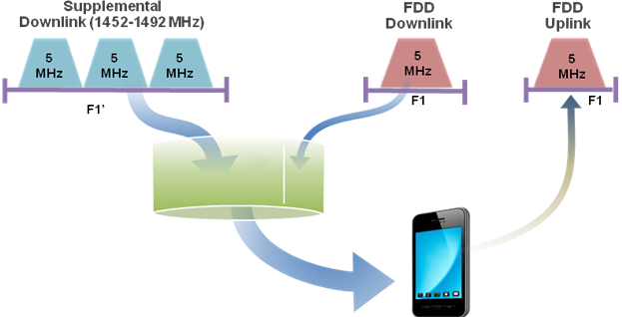

Figure 1: A Mobile Supplemental Downlink

Justification
The convergence of several service offerings (internet, broadcasting, and other multimedia based service offerings) on mobile devices, such as smartphones and tablets, is leading to an ever growing asymmetry of the overall mobile data traffic. Measurements in today’s mobile networks clearly confirm the asymmetrical nature of the data traffic with consumers downloading considerably more than they upload data and multimedia content. The current usages of data services on smartphones will be more common than on desktop computers within a few years time. Smartphones and tablets, as well as laptops using dongles will drive usage of video and hence lead to considerable growth of the mobile data traffic.
A high proportion of this data traffic is already mobile multimedia. Moreover, multimedia is expected to account for a rising proportion of traffic in future. The downlink to uplink ratios seem likely to widen towards 10:1 as the proportion of video traffic in networks grows. The use of the 1452-1492 MHz for Mobile SDL provides additional downlink capacity next to the bands used for mobile applications up to now, enables higher user data rates and supports a greater number of users, all of which will enhance the user experience and increase consumers demand for capacity (see Annex 6, figure A6-2 extracted from document FM50(11)019).
The L-band is within the operational range of the current cellular spectrum used by mobile broadband systems and its implementation will have a marginal impact on the equipment (base stations, chipsets, devices) design and cost. In addition, the L-band offers favourable propagation properties for coverage allowing consumers in urban, suburban as well as rural areas to cost efficiently access enhanced mobile services.

Spectrum requirements
Users in mobile networks are demanding increasingly higher peak data rates and enhanced quality of service. Operators are deploying next generation networks supporting larger bandwidth, typically 10 MHz, 15 MHz, 20 MHz, etc., to cope with these demands. In this context, and in order to support the requirement for significant increase of data speeds and user experience, access to bandwidths of 10 MHz, 15 MHz or 20 MHz etc. in the band 1452 – 1492 MHz is therefore required to appropriately supplement related deployments in other mobile bands from several mobile operators. In addition, interest of the band 1452 – 1492 MHz for Mobile SDL use by operators is linked to the opportunity of having access to a frequency block of at least 10 MHz for SDL deployments to make network investments justifiable. Notably, a one frequency block of 5 MHz per operator would not be sufficient to support advanced services such as higher definition video based multimedia content.
Furthermore, the success of a frequency band arrangement depends on the emergence of an eco-system with high equipment market penetration, including both base stations and devices, supporting usages in this band. This requires that the band is harmonised (in order to ensure its availability in a sufficient number of countries) and large enough (in order to accommodate multiple operators, which would through competition trigger growing demands). On the contrary, if the band is not harmonized in full (less than 40 MHz) and only one operator would be able to use the band in a country, then such operator would struggle to find mass market cost efficient equipment. Therefore, the full 40 MHz in the band 1452 - 1492 MHz will accommodate multiple operators and therefore drive economy scale to the benefits of consumers.
Taking into account the need of at least 10 MHz per operator (see above) in a competition environment with several operators able to access the 1.4 GHz band and the requirement for economies of scale, in large bandwidth devices and infrastructure, a harmonised channelling arrangement for Mobile SDL across the whole band 1452 – 1492 MHz is deemed essential. Such a channelling arrangement should be designed for eight frequency blocks of 5 MHz each as usual for mobile bands (with the possibility to aggregate at least two adjacent blocks), subject to LRTC while enabling terrestrial UMTS/LTE SDL deployment i.e. base station to devices communication direction. A firm decision will convey a clear signal to the mobile broadband and broadcasting content industries on the availability of a sufficient harmonised capacity (40 MHz) for economically sustainable business cases in the band 1.4 GHz, still leaving the choice to administrations to potentially accommodate in part of the band any specific national need for other applications.

application four: Satellite DIGITAL AUDIO BROADCASTING (S-DAB)

Description
Satellite broadcasting is one of the principal means for access to thousands of radio and TV services by the general public in many countries across the globe. Satellites play a major role in ensuring complete coverage,. In those cases, such offer complements the basic terrestrial offer, which may not be available everywhere. Alternatively, satellite can also offer new channels that are not available on terrestrial-only networks. As demonstrated by the digitization of TV services, digital satellite can play an important role enabling the deployment of new digital technologies and services.
Where satellites are used in combination with complementary terrestrial networks, a “hybrid” system is created. Such a hybrid system consists of the satellite component and its associated terrestrial component(s). The complementary terrestrial networks can be used for the retransmission of content also available on the satellite (for instance to improve the reception quality in areas without line of sight to the satellite, especially important in a mobile environment) and/or to provide access to additional content (eg, local or on-demand content).
Satellite Digital Audio Broadcasting (S-DAB) is a satellite-enabled system for the digital broadcasting of a wide variety of audio content to fixed and mobile receivers (including portable, handheld and vehicular). S-DAB systems are expected to transport a mix of “subscription-based” and “free-to-air” services. Free-to-air services may be public services or commercial services for a large audience. A basic encryption could still be employed also in the case of free-to-air services in order to ensure copyright protection.
Three main modes of S-DAB operation can be distinguished:
- As a standalone satellite component (i.e, without complementary terrestrial component);
- As the satellite component of a hybrid solution with complementary terrestrial broadcasting networks operating in the spectrum used by the satellite across CEPT;
- As a standalone satellite component, complementing nationally licensed terrestrial broadcast networks.
The specific mode of operation (and content) may vary from country to country, depending on national regulations and the competitive situation. A hybrid service using the second mode of operation (operating in the 2.3 GHz band) has accumulated over 22 millions of paying subscribers in North America, with annual revenue in excess of 3 billion US dollars. A large proportion of new cars sold in North America is equipped with a satellite radio enabled receiver.
The main features of S-DAB services are:
- Universal availability
  - coverage up to 100% of the territory under line-of-sight conditions
  - support for services for people with disabilities, where required

- High QoS
  - predictable and consistent across the whole service area
  - independent of the number of simultaneous viewers and listeners
  - control over QoS and the user experience

- Efficiency
  - spectrally, technically and cost efficient delivery to large audiences

- Flexibility
  - possible delivery to fixed, portable and mobile reception conditions
  - support for free-to-air reception or conditional access, or both
  - supports public service as well as commercial broadcasting model
  - access adapted to the service requirements (international, national and regional)

- Mass-market platform
  - widely supported by manufacturers, satellite network operators, broadcasters and regulators

- Competition
  - promotes competition even in those markets that are dominated by other delivery platforms

S-DAB networks can be implemented by means of different technologies, in particular the DVB-SH and SDR standards families, as indicated in the table 4 below:
Table 4: Examples of satellite broadcasting technologies
Technology | Supported block/channel bandwidth | Related Standards
SDR | 1.7 – 12.5 MHz | ETSI - TR 102 525  ETSI - TR 102 604  ETSI - TS 302 550-1-1  ETSI - TS 302 550-1-2  ETSI - TS 302 550-1-3
DVB-SH | 1.7, 5, 6, 7 and 8 MHz | ETSI – EN 302 583  ETSI – TS 102 594  ETSI – TR 102 377

Further information about satellite broadcasting standards can be found in Annex 5.

Justification
With demand for digital audio broadcasting services growing in many countries in CEPT, satellites can play a role in extending coverage and population reach of existing and new audio content. S-DAB could thus provide digital audio broadcasting solutions not only in countries where L-Band is important because of lack of alternative spectrum, but also as an enabler of new and innovative audio content offers.
Demand has been expressed for the deployment of feature-rich free-to-air and subscription-based radio services. Implementation in Europe would require taking into account the variety of languages, cultural specificities and different coverage that compose the European countries. In this respect, the L band is adequate to complement the deployment of national, independent subscription radio services. For instance, the existing regulation offers an option for any country to deploy subscription services according to individual needs, if and when required. This, in turn, would provide scope for further economies of scale through a harmonised use in Europe and for integration with other services (notably with free-to-air radio).
Furthermore, there is a growing market demand for non-linear broadcasting services (e.g. time-shifted, personalized, on-demand, interactive and second screen services). L-Band is well suited for the provision of such non-linear services. The L-band offers an opportunity for implementation of such innovative approaches.
The success of a frequency band depends on the emergence of an eco-system, i.e. on a significant terminal market supporting the band. Such a market usually occurs when a band is harmonised on a large basis and when sufficient operators and service providers have deployed networks and are offering affordable and attractive content and services in a band. At the opposite, if only few operators are using a specific technology or frequency band within CEPT, they may struggle to get affordable access to equipment.
SDR chipsets for the L-Band are already available, which could have a positive impact on the equipment design for S-DAB.
Furthermore, the propagation characteristics of the L-band are favourable for S-DAB.

Spectrum requirements
The spectrum requirements are primarily determined by the number of audio channels that are needed to create attractive content packages for different markets. Operations in the US, as well as comparable pay-TV benchmarks indicate that a minimum of about 50 - 60 channels is required per key national market in order to create a sufficiently diverse package. Taking into account different markets in Europe, the restrictions imposed by ITU Resolution 528 with respect to S-DAB in the band 1452 – 1492 (effectively limiting S-DAB to the upper 25 MHz anywhere in the world, which would impact satellite transmissions in the direction of non-CEPT countries), and the ability to respond in a flexible manner to spectrum uses across CEPT, a harmonised channelling arrangement enabling S-DAB across the upper 25 MHz of the band 1452 – 1492 MHz is deemed essential. Technologies to be used for S-DAB are flexible enough to cope with existing or new harmonized band plans. The L-Band 1452 – 1492 MHz is the only frequency band below 3 GHz allocated to the broadcasting satellite service.

Application five: Programme Making and Special Events (PMSE)
3.5.1 Description
The term Programme Making and Special Events applications (PMSE) is a widespread term gathering various radio applications used for SAP/SAB, ENG, SNG, OB in public or private events for perceived real-time presentation of audiovisual information. The communication links are also used in the production of programmes, such as talk-back or personal monitoring of sound-track.
The definitions of SAP/SAB and ENG/OB are set out as follows:
SAP: Services Ancillary to Program making (SAP) support the activities carried out in the making of “program”, such as film making, advertisements, corporate videos, concerts, theatre and similar activities not initially meant for broadcasting to general public.
SAB: Services Ancillary to Broadcasting (SAB) support the activities of broadcasting industry carried out in the production of their program material.
ENG: Electronic News Gathering (ENG) is the collection of video and/or sound material by means of small, often hand-held wireless cameras and/or microphones with radio links to the news room and/or to the portable tape or other recorders.
SNG: Satellite News Gathering (SNG) are applications similar to ENG using satellite radio communication channels.
OB: Outside broadcasting (OB) is the temporary provision of programme making facilities at the location of on-going news, sport or other events, lasting from a few hours to several weeks. Mobile and/or portable radio links are required for wireless cameras or microphones at the OB location. Additionally, radio links may be required for temporary point to point connections between the OB vehicle, additional locations around it, and the studio.

Table 4: Technical terms of audio transmission systems that are part of PMSE
Application | Max bandwidth | Max ERP
Wireless microphones and  in-ear monitor systems | 200 / 400 / 600 kHz per link | 50mW
Wireless conference and interpretation systems | 20 MHz (in one block) | 100mW

Wireless conference and interpretation systems are used in houses of parliament, courts, at banks and insurance companies, multipurpose halls, hotels, conference centres, industry meeting and discussion rooms as well as designed board rooms or historical meeting places that do not allow installations etc. These systems are very often combined with wireless microphone systems and in-ear monitor systems for those that lead through a presentation or discussion.

The current wireless microphone systems both analogue and digital deliver a resolution of 16 bit. This is almost CD quality. This is suitable for live presentations and the majority of all other productions. HD-Sound demands more: Studios already use for their productions 24 or 32 bit resolution and wish to use it direct from the wireless microphone too. Higher resolution means more dynamics for the listeners. ECC regulations are compatible with this demand through increasing the maximum allowed bandwidth from 200 kHz to 600 kHz. It can be seen that just by switching to the 24 bit resolution the required amount of spectrum for a given production doubles, for 32 bit resolution it triples.
Whereas in the past professional wireless microphone systems could not use bands above 1 GHz due to technical issues modern professional systems can operate above 1 GHz for certain applications.
3.5.2 Justification
Section 3.1 of ECC's Strategic Plan mentions that the identification of appropriate frequency bands for PMSE is one of the main challenges of ECC to be solved within the next remaining three years due to the fact, that “in the course of implementing the digital dividend affected applications supporting programme making and special events (PMSE) are likely to be refarmed. Providing appropriate and sufficient resources to PMSE is crucial for that sector.” This is also in line with the EU policy objective to support the creative and cultural activities. The ECC established project team FM 51 to address the spectrum requirements for PMSE. However, the mandate of FM 51 excludes to consider the band 1452-1492 MHz for the applications under its mandate, pending the result of FM 50.
Already in 2007 the ETSI SRDoc TR 102546 requested access to the L-Band for the future development of PMSE. Besides that ETSI updated the spectrum mask above 1 GHz in the technical standard for audio PMSE (EN 300 422). Based on these ETSI statements manufacturers have invested already to provide technology for this range.
The necessary spectrum harmonization of PMSE wireless production systems will require a long term effort from ECC and relevant CEPT Administrations at national level, but ECC has to face this challenge of coordinating the spectrum need of PMSE in Europe and as far as possible on a worldwide basis.
The L-Band could potentially be available to audio PMSE across Europe and beyond on a secondary basis. [Editorial note: the reference to the PLUM Study - FM50(11)019, page 9].
The density of users of audio PMSE applications in the currently available spectrum has risen in the course of implementing the digital dividend and as a result of the switch-over from analogue to digital TV. Future evolution of terrestrial digital TV may further limit the spectrum available for audio PMSE in the UHF band (e.g. simulcast of DVB-T and DVB-T2, HDTV, 3DTV) noting that PMSE is a secondary user and may only use gaps left by the TV transmitters.
At the same time the need for spectrum is increasing steadily because of the increasing demand for production quality, new audio formats and the growth of the number of concurrent PMSE users in a given event. This may lead to the situation where peak spectrum demand will not be possible to satisfy within the exiting spectrum.
Some applications currently operating in the UHF band could be moved to the L-band, provided that they accept the related operational constraints. Man-made noise in the L-Band is lower than in the UHF range while the wave propagation characteristics in the L band are not as favourable.
The amount of spectrum required to operate wireless microphones in a given event is not a linear function of the number of microphones, but more a geometrical or exponential function (see Annex 7) For example, assuming devices compliant with standards EN300 422 and operating in the UHF band, the operation of 22 devices requires typically 20 MHz of spectrum, while the operation of 32 devices requires typically 40 MHz.

3.5.3 Spectrum requirements

PMSE applications are successfully operating in interleaved spectrum alongside primary users and would benefit from having access on a secondary basis to the L-Band from 1452 to 1492 MHz.

Application six: Broadband PPDR for temporary and local use

Description
Public Protection and Disaster Relief (PPDR) radiocommunication systems are defined (by ITU-R) as:
Radiocommunications of Public Protection (PP) used by responsible agencies and organizations dealing with maintenance of law and order, protection of life and property, and emergency situations.
Radiocommunications of Disaster Relief (DR) used by agencies and organizations dealing with a serious disruption of the functioning of society, posing a significant, widespread threat to human life, health, property or the environment, whether caused by accident, nature or human activity, and whether developing suddenly or as a result of complex, long-term processes.
National narrowband PPDR networks using the TETRA or TETRAPOL technology are in operation in many European countries using the 390-395 MHz/380-385 MHz band harmonized for narrowband PPDR applications (ECC/DEC(08)05). Various studies and surveys have been made in an attempt to define the PPDR organisations future need of broadband applications. The users see a demand for a number of broadband applications in their future daily work, as well as in emergency crises situations. When translated to frequency bandwidth requirements, a minimum spectrum of 2 × 10 MHz below
1 GHz is believed to be necessary to cover the identified needs.
In addition to the identified need for permanent spectrum for broadband PPDR, studies done on the initiative of the one administration show an additional need for spectrum for temporary use. In order to allow the PPDR applications for the usage of additional capacity to transmit real-time video of the site of operation or medical telemetry etc. it has been considered to provide these applications with an extension at the site of operation. The spectrum requirements for temporary and local usage are mainly driven by the need to address significant incidents where this additional capacity is required. The PPDR devices will need to be capable of operating in both the permanent and temporary spectrum bands. During temporary use for PPDR the spectrum will not be accessable to any other users. Appropriate mechanisms to ensure priority access for PPDR users to the temporary bands are to be defined.

Justification
Section 3.3 of ECC’s Strategic Plan mentions that the overall demand for PPDR spectrum is one of the main challenges of ECC to be solved within the next remaining three years. Until now no other frequency band is designated for the use by broadband PPDR applications. The ECC established project team FM PT49 to address the spectrum requirements for PPDR.
Some administrations identified the need for temporary and local PPDR networks with spectrum requirements outside those currently used for PPDR. The L-band could accommodate these needs.
The above mentioned studies show that in case of significant incidents the following applications require higher capacity than that which can be provided by the permanent PPDR networks:
- local mobile data transfer
- local high speed moving picture transfer
- local infrared high speed moving picture transfer
- local thermal imaging cameras
- local operation surveillance
- local unmanned remote controlled vehicles carrying surveillance cameras

Spectrum requirements
Investigations undertaken by one CEPT country on high speed data communication demands and needs for PPDR and its possible realisation in the radio spectrum have been carried out in 2010 and 2011. [Editorial note: include the references to the studies].
The calculations have been done on the basis of LTE - but not prejudging LTE or excluding any other standard at this point of time.
The needed bandwidth for temporary and local PPDR high speed data communications is 15 MHz as indicated in one of the above mentioned studies [Editorial note: include a reference to the WIK study]. This requirement is primarily considered for a pan-European deployment.

Application seven: Broadband Direct-Air-to-Ground Communications (BDA2GC)

Description
A broadband DA2GC system constitutes an application for various types of telecommunications services, such as internet access and mobile multimedia services. It aims to provide access to broadband communication services during continental flights on a Europe-wide basis. The overall end-to-end system architecture of the broadband DA2G communication system is illustrated in Figure 2. The request for spectrum is related to the direct air-to-ground radio solution.

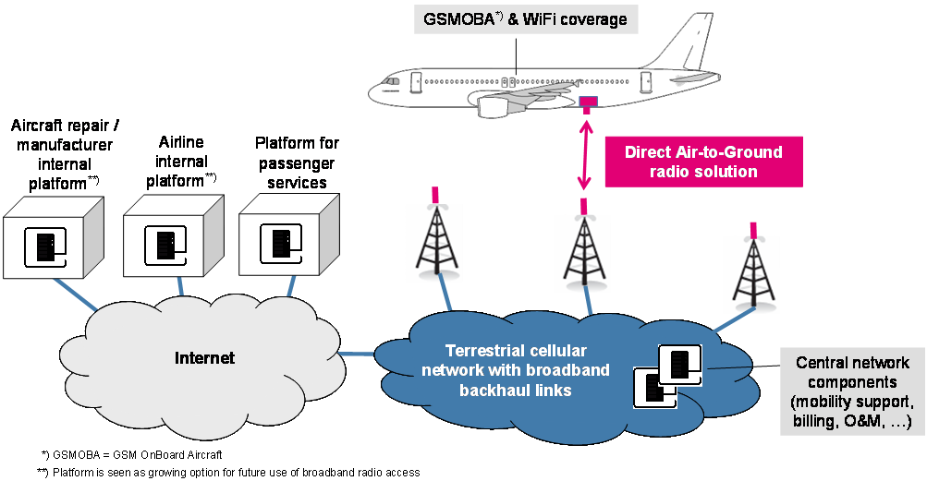
Figure 2: System architecture for broadband DA2G communication
The BDA2GC system under consideration in this Report is based on the 3GPP LTE (also called E-UTRA) standard (Rel. 8 or higher), as described in more detail in ETSI TR 103 054. The general characteristics of the DA2GC RF and digital baseband signals are also based on the LTE specification. To adapt the LTE system functionalities to the DA2GC link specifics, some modifications are required. In particular synchronization algorithms as well as the maximum OBU Tx power are to be modified compared to terrestrial mobile radio usage in order to cope with high Doppler frequency shift caused by aircraft speed and large cell sizes. In addition the BS antenna adjustment has to be matched to cover typical aircraft altitudes between 3 and 12 km by up-tilt of vertical diagrams. Ongoing investigations will determine whether further modifications are required.
The main application field would be Air Passenger Communications (APC), e.g. WiFi or GSM based internet/company intranet access, data synchronization and voice communication. In addition the system could also support Airline Administrative Communications services (AAC), e.g. flight data, crew scheduling and lodging information, aircraft supply requirements (catering etc.), miscellaneous crew information and requests for medical assistance. The envisaged broadband DA2GC system is not intended to be used for safety-relevant communications such as Air Traffic Control (ATC) and related services. It should also be noted that in continental US an Air to Ground system has been established with more than 1.300 commercial aircrafts equipped so far [Editorial note: reference(s) to be provided by DT].
There are other proposals in Europe for BDA2GC systems to be used in ISM bands using different technologies (see also section 3.7.3).

Justification
Mobile customers expect to be connected everywhere, every time, with all kind of mobile devices. A terrestrial BDA2GC system in Europe is proposed to be an alternative to the already existing satellite based services. A number of European airlines have great interest to offer internet services to their flight passengers in their continental fleets as soon as possible. The costs for the aircraft installation and maintenance are a key issue.
A forecast from Eurocontrol published in October 2011 estimates 11.5 million movements according Instrument Flight Rules (IFR) in Europe in 2017. This is 21% more than in 2010. Studies on air passenger demand for onboard connectivity are currently not publicly available.
Currently, there is no spectrum designated for BDA2GC in Europe. In order to allow European citizens and airlines to derive social and economic benefits of the implementation of such a system, a spectrum designation on a Europe-wide basis would be necessary.

Spectrum requirements
The spectrum demand for the BDA2GC system is derived from a summary of relevant factors to be essential to cope with future capacity demand as well as from results achieved by system performance evaluations.
WG FM agreed that for BDA2GC paired spectrum of 2 x 10 MHz for FDD operation is considered necessary to cope with short- to medium-term demand. Unpaired spectrum for TDD operation (20 MHz) would also be an option, but system performance would slightly suffer due to guard time intervals required for large cell sizes. CEPT is looking to designate in total 20 MHz for BDA2GC.
The whole spectrum requirement of 2 x 10 MHz of paired spectrum for FDD or 20 MHz of unpaired spectrum for TDD operation or a part of it may be satisfied in the 1452-1492 MHz band.

- Extract of the Radio Regulations Article 5 for 1452-1492 MHz

- Flexibility in MA02revCO07 Special Arrangement (1452 - 1479.5 MHz)

- L-band utilisation in some CEPT countries (updated information compared to the ECC survey conducted in December 2010 – January 2011)

- Overview of the use/regulations of the band 1452 – 1492 MHz in a number of countries outside from CEPT

- Broadcasting standards
  - Terrestrial broadcasting
T-DAB / T-DMB
Terrestrial Broadcasting using the Eureka 147 family of standards (T-DAB)
The DAB system is a sound broadcasting system intended to supersede the existing analogue amplitude and frequency modulation systems.
It has been designed for terrestrial and satellite as well as for hybrid and mixed delivery.
It is now in regular service in many European countries and throughout the world.
DAB and DAB+ offer an identical consumer experience centred on radio, with text, slideshow, EPG and other multimedia features. DAB offers eight to ten radio services within a 1.5 MHz multiplex whilst DAB+ (using HE AACv2) can accommodate up to 20–30 radio services in the same spectrum. DMB is primarily a mobile TV platform, sharing the same multiplex and carrier structure as DAB, but it can be used for a visual radio service with similar multimedia properties to DAB and DAB+.
Single frequency networks are commonly built to provide wide area coverage with great spectrum efficiency. Multi-frequency networks, allowing more localised content, are also provided with comprehensive service following mechanisms to allow mobile and handheld receivers to retune automatically when travelling between coverage areas.
DAB, DAB+, DMB-radio and DMB-tv services may all be present in the same DAB multiplex.
Typical services carried by a DAB multiplex are:
• Audio programs
• Video programs
• Slideshow (SL)
• Dynamic text (DL)
• Traffic information (TPEG)
• Multimedia object delivery

DAB-IP
The use of IP tunnelling provides DAB with a mechanism for the adaptation of Internet services to DAB and is also a key component for DAB services using two-way interaction with personal DAB as specified in TS 101 736. The use of IP tunnelling enables the use of IP as a common network layer protocol, end-to-end, for DAB data services. The IP tunnelling through DAB is unidirectional. The tunnel is created from the packet mode encoder on the transmitting side, to the packet mode decoder on the receiving side, of the DAB system.
This system, commonly called DAB-IP, can provide data services including mobile television, to handheld devices. When coupled with a return channel it allows the downlink of multimedia services.
The benefits of the DAB family of standards:
• Easy programme selection
• Improved reception
• Programme-associated data
• Information services
• Targeted music or data services
• Wide choice of receivers
• Lower transmission costs for broadcasters

DVB-H
DVB-H is a technical specification for the transmission of digital TV to handheld receivers such as mobile telephones and PDAs. Published as a formal standard (EN 203 204) by ETSI in November 2004, it is a physical layer specification designed to enable the efficient delivery of IP-encapsulated data over terrestrial networks. The creation of DVB-H, which is closely related to DVB-T, also entailed modifications of some other DVB standards dealing with data broadcasting, Service Information, etc. It can be used as a bearer in conjunction with the DVB-IPDC systems layer specifications or alternatively with the OMA BCAST specifications.
In March 2008 the European Commission endorsed DVB-H as the recommended standard for mobile TV in Europe, recommending EU member states to encourage its implementation., However, commercial deployment has not been successful. ..

DVB-T2 - Base
DVB-T2 is the follow-up system of the digital terrestrial transmission (DTT) system DVB-T. It offers higher efficiency, robustness and flexibility. It introduces the latest modulation and coding techniques to enable highly efficient use of the terrestrial spectrum for the delivery of audio, video and data services to fixed, portable and mobile devices. These new techniques make DVB-T2 much more efficient than previous DTT systems. Possible bandwidths for the DVB-T2 operation are 1.7, 5, 6, 7, 8 and 10 MHz.
As with its predecessor, DVB-T2 uses OFDM (orthogonal frequency division multiplex) modulation with a large number of sub-carriers delivering a robust signal. Just like DVB-T, DVB-T2 also offers a range of different modes, making it a very flexible standard. Several options are available in areas such as the number of carriers, guard interval sizes and pilot signals, so that the overheads can be optimised for any target transmission channel.
An important new element of DVB-T2 are Multiple Physical Layer Pipes (MPLP) which allow separate adjustment of the robustness of each delivered service within a channel to meet the required reception conditions (e.g. in-door or roof-top antenna). It also allows transmissions to be tailored such that a receiver can save power by decoding only a single service rather than the whole multiplex of services. Furthermore Future Extension Frames (FEF) allow the standard to be compatibly enhanced in the future. FEF are basically placeholders for new services which are not supported by the already existing receiver population. An existing receiver will detect the FEF and not decode its content. New receivers may access the FEF and provide additional services.

DVB-T2-Lite
DVB-T2-Lite is the first additional transmission frame type making use of the FEF approach. It is an additional profile that was introduced in July 2011 to even better support mobile as well as portable TV and also to allow for cost-reduced implementation. The new profile is defined as a subset that adds two additional LDPC code rates to the main DVB-T2 specification. Since only elements relevant for mobile and portable reception have been included in the DVB-T2-Lite subset and the data rate is restricted to 4 Mbit/s per PLP, the implementation complexity has been reduced by 50%. The FEF mechanism allows that
DVB-T2-Lite and DVB-T2-Base can be transmitted in a same RF channel.

DVB-T2-xxx
DVB-T2-Lite will not be the last additional profile for DVB-T2. The DVB technical group is currently working on an additional profile which will add new technologies to T2-lite. At this moment in time it is too early to predict which new elements will be added, however it can be assumed that MIMO will be a part of the new profile. According to the current schedule this new profile will be finalised by the end of 2011 and will provide the most sophisticated air interface for mobile TV.
  - 2. SDR
ETSI’s SDR standard is a transmission standard (see also section 3.5.) that has been developed for the provision of high quality and high availability digital radio and associated data services to wireless receivers. The standard foresees the deployment of terrestrial and satellite broadcast networks, which may be combined to form “hybrid” systems.
The standard specifies the L band as the main candidate band for its deployment. In this band, terrestrial SDR networks (1.7 MHz carrier bandwidth) can be rolled out:
• in the 1452-1579.5 MHz sub band, in compliance with the MA02revCO07 Arrangement (envelope concept), and/or
• in the 1479.5-1492 MHz sub band, in compliance with the ECC/DEC/(03)02 S-DAB Decision, as part of an SDR hybrid system (see also section 3.5)
Its flexibility enables to mix in a same carrier independent (with different QoS as necessary), linear and non-linear services and free-to-air as well as conditional access (subscription) services.
Today, the SDR standard is contemplated for the deployment of subscription radio services in Europe.
  - 3. Satellite broadcasting
DVB-SH
DVB-SH is a hybrid satellite/terrestrial system that allows the use of a satellite to achieve coverage of large regions or even a whole country. DVB-SH is a transmission system standard designed to deliver video, audio and data services to vehicles and handheld devices. In areas where direct reception of the satellite signal is not possible, a terrestrial gap filler can be used seamlessly to provide coverage. It is designed to use frequencies below 3 GHz. The system and waveform specifications have been published as ETSI standards (TS 102 584, TS 102 585 and EN 302 583).

- Mobile broadband and MOBILE supplemental downlink standards
The 3GPP has been producing the Technical Specifications and Technical Reports for the technologies that support mobile broadband since 1998. The success of 3GPP technologies is easily understandable when acknowledging that the number of UMTS subscriptions has passed the 1 billion mark in January 2012.
While 3GPP technologies were focusing solely on 5 MHz bandwidth until the release 8 of the 3GPP standards, the 3GPP has become the focal point for mobile systems beyond 3G by standardising technologies supporting increasing bandwidth. From 3GPP Release 10 onwards, 3GPP is compliant with the latest ITU-R requirements for IMT-Advanced ’Systems beyond 3G’. The standard now allows for operation at peak speeds of 100 Mbit/s for high mobility and 1 Gbit/s for low mobility communication.
The 3GPP technologies (HSPA+ and LTE) have also evolved to support very large badnwidth through the aggregation of carriers across bands. This concurrent dual/multiple band operation is available from the release 9 of HSPA and release 10 of LTE onwards. An overview of the support of wide bandwidth and interband carrier aggregation is provided in the figure A6-1 below.
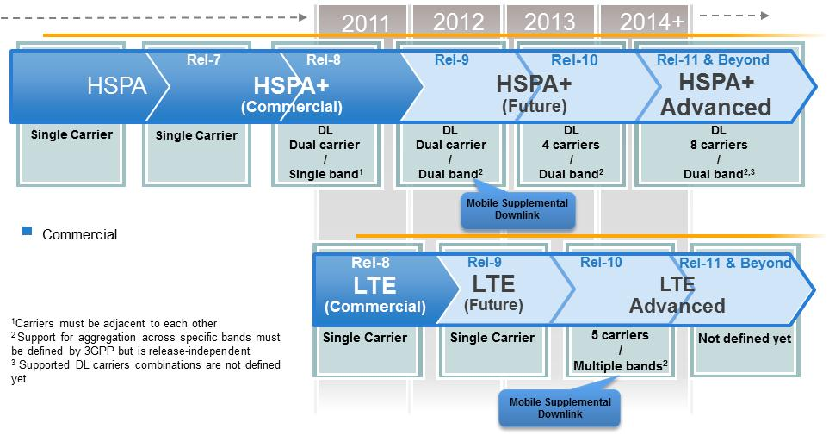
- Support for increased bandwidth and inter-band carrier aggregation in 3GPP standards
Figure A6 -2: Results of simulation of performance of an L-band Supplemental Downlink (SDL) for bursty applications (c.f. FM50(11)19)
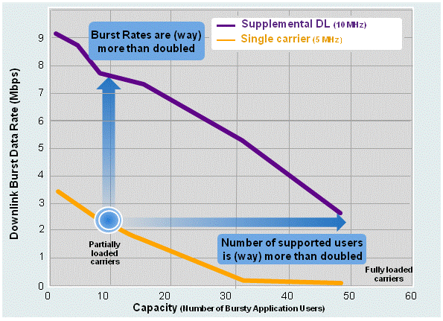
- L-band Supplemental Downlink (SDL)

- Technical information on PMSE

The following graphics shows the required spectrum as a function of number of microphones operating concurrently at the same location.
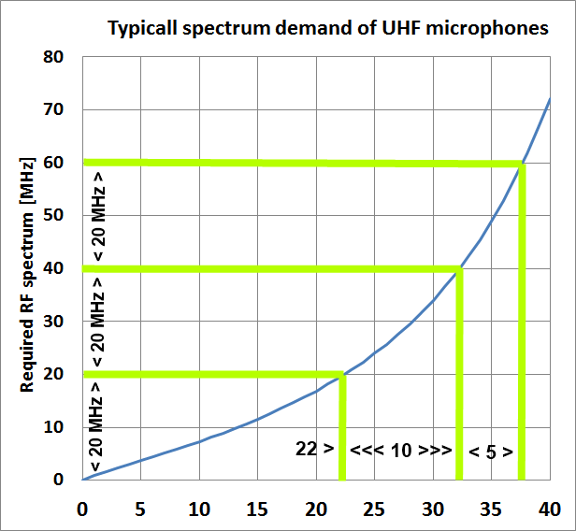
- The required spectrum as a function of the number of microphones
Example: in 20 MHz of a given spectrum 22 wireless microphones can operate in parallel at the required level of transmission security for professional productions. The exponential rise of spectrum demand is caused by intermodulation that is generated when transmitters operate in close proximity. Due to the physical intermodulation and the very little radiated power this intermodulation effect has to be taken into consideration when designing interference free multichannel systems for productions. It shows an almost linear rise below 25 microphones and a strong spectrum demand above The use of the full 1452-1492 MHz band by audio PMSE would therefore allow the deployment of about 32 additional wireless microphones, compared to the existing solutions.
[Note: The above figure and the text should be updated to refer to the L-Band.]

- List of referenceS
- ECC Report 125: Guidelines for the implementation of impact assessment
- ECC Report 002: SAP/SAB (Incl. ENG/OB) - Spectrum use and future requirements
- ECC Report XYZ [currently being developed by FM48]
- CEPT Report 18: In response to the Mandate on EU harmonisation of the band 1452-1479.5 MHz (lower part of L-band) to allow flexible use by mobile multimedia technologies
- ECC/DEC/(03)02: The designation of the frequency band 1479.5-1492MHz for use by Satellite Digital Audio Broadcasting systems
- ECC Report 121: Compatibility studies between Professional Wireless Microphone Systems (PWMS) and other services/systems in the L band
- CEPT Report 32: "Technical considerations regarding harmonisation options for the digital dividend in the European Union"
- Directive 2009/140/EC [Note: How much of the title do you need see below?]

According to the Directive 2009/140/EC “flexibility in spectrum management and access to spectrum should be increased through technology and service neutral authorisations to allow spectrum users to choose the best technologies and services to apply in frequency bands declared available for electronic communications services in the relevant national frequency allocation plans in accordance with Community law (the ‘principles of technology and service neutrality’). The administrative determination of technologies and services should apply when general interest objectives are at stake and should be clearly justified and subject to regular periodic review.”

ETSI standard (TR 102 525, TS 102 550, TS 102 551-1, TS 102 551-2)
ETSI TR 103 054
In January 2007 the ETSI-System Reference Document TR 102 546 extended the existing "tuning ranges" for audio PMSE identified in EN 300 422
- ETSI - TR 102 525: Functionalities, architecture and technologies
- ETSI - TS 102 550: Outer Physical Layer of the Radio Interface
- ETSI - TS 102 551: Inner Physical Layer of the Radio Interface
The required product standard was established in 2007 (ETSI-EN 300 422).
ETSI standards (TS 102 584, TS 102 585 and EN 302 583)

See for example: www.obs.coe.int/about/oea/pr/mavise_juin2011.html
See Report ITU-R M.2243
See Document RSCom 12-06.
See document FM50(11)019.
Programme Making includes the making of a programme for broadcast, the making of a film, presentation, advertisement or audio or video recordings, and the staging or performance of an entertainment, sporting or other public event.
A Special Event is an occurrence of limited duration, typically between one day and a few weeks, which take place on specifically defined locations. Examples include large cultural, sport, entertainment, religious and other festivals, conferences and trade fairs. In the entertainment industry, theatrical productions may run for considerably longer.
For further information see the ECC Report 002
For further information see the EN 300 422
See: ECC’s Strategic Plan, section 3.1: http://www.cept.org//files/1051/ECC/About%20ECC/ECC%20Strategic%20plan/ECC%20Strategic%20Plan%20rev%204.pdf
New audio formats require higher resolution, not compressed, from the microphones for storing the signals in highest resolution in order to be able to convert it according to the market needs. The current standard formats (mono or stereo) no longer fulfil the expectations of the listeners. Formats like 5.1 or 7.1 are common for today’s productions. They need more equipment at the production frontend and more RF spectrum to transmit the increasing amount of signals. Audio 5.1 and 7.1 are intermediate steps to a real spatial sound experience for the people at home. The next step on the audio side is as format which offers a much more authentic 3D Audio experience.
Reference to the study by German ministry to be included
“ECC has received several request for addressing requirement for Public Safety and Security (PSS) wireless communication systems (e.g. from ETSI and from PSCE Forum). The safety and security community needs access to wideband and broadband services such as video and has specific requirements in terms of priority, availability or security. Spectrum harmonization of PSS wireless communication systems will require a long term effort from ECC and relevant CEPT Administrations at national level, but ECC has to face this challenge of facilitating public safety and security operations in Europe. CEPT ECC shall consider future requirements for access to spectrum for PPDR, the need for harmonization of use and shall identify resources accordingly.”
See: ECC’s Strategic Plan, section 3.3: http://www.cept.org//files/1051/ECC/About%20ECC/ECC%20Strategic%20plan/ECC%20Strategic%20Plan%20rev%204.pdf
A press release on trial flight: http://www.telekom.com/media/company/107626
http://www.eurocontrol.int/statfor/public/subsite_homepage/homepage.html
See document FM50(12)017_Air_passenger_survey_results at http://www.cept.org/ecc/groups/ecc/wg-fm/fm- 50/client/meeting-documents; 2012; M5 – 6-9 March; Input documents
See Minutes of the 73rd WG FM Meeting, FM(11)202_Minutes of 73WGFM_Lille_2011: The amount of spectrum for this radio application is considered independent from the number of system proposals.
Source: UMTS Forum
Source: Qualcomm
The wireless microphones are assumed to operate in accordance with EN300 422.

