 |  |  |  |  |  |  | FM50(12)050
7th Meeting of FM50
22-25 May 2012, London, United Kingdom

Date issued: 16 05 2012

Source: APWPT

Subject: L-Band spectrum use - maximization for PMSE
 | Password protected: yes |  | No |  | x

Summary

The frequently asked question is how many links of PMSE equipment can operate in parallel in the L-Band is answered including the explanation of the technical background: 224 links can be operated in parallel. This is given if PMSE has the L-Band on exclusive user base and no other service operates in that range. If this is not given further investigation have to be made.

Proposal

FM50 is kindly invited to consider our information in the chapter 4 drafting group.
Our aim is an improvement in the consolidation of the ECC report.

Background

The L-Band may become a valuable resource for the use of wireless microphones and in-ear monitor systems as 72MHz of spectrum was lost already in the UHF Band. The L-Band can compensate parts of this loss and can also give the UHF Band a certain relief from PMSE usage. Besides that it will also support the expansion of the application PMSE, annual growth is about 15%, and the demand for improved sound quality (HD-Sound).

The question that is asked frequently: how many links can operate in parallel in the L-Band, in the range 1.452 – 1.492 MHz?

Any production has to be free of interference to find pleased listeners. One source of interference is caused by intermodulation which is generated in any wireless system when it operates in close proximity of other systems. As intermodulation can be calculated the system design takes care of the effect and uses only reliable frequencies which guarantee no unwanted noise in the audio signal.

The following graph shows a typical arrangement of carriers in a multichannel system of wireless microphones:

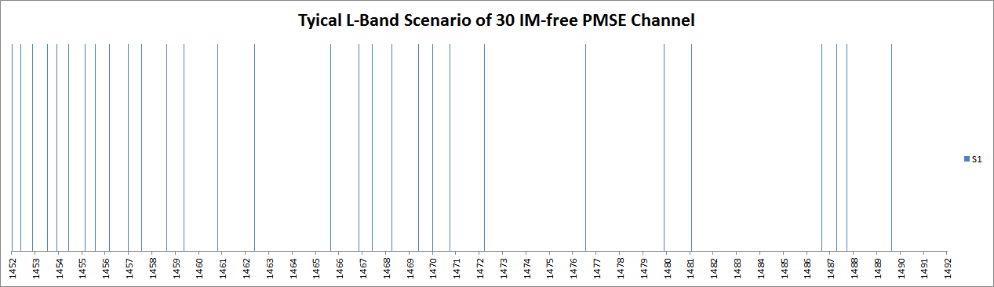

It can be seen that thirty carriers of this system are arranged in non-regular spacing.

A venue usually consists of different locations in which different events take place in parallel: in a conference centre there are different halls and rooms with different events using wireless equipment, same in hotels with their meeting facilities, in universities with their lecture halls, in entertainment centres with their various stages, also in exhibition halls with the booths of the exhibitors last not least at political and sport events where several ENG Teams operate in parallel in different areas.

All these events in one venue have one thing in common: they are separated by walls of by a certain distance. Separation by room, house walls or ceilings usually gives a signal attenuation of more than 15dB in addition to the path loss. Taking this into account the intermodulation of the system shown above will be very low in the neighbour room or neighbour venue. This allows taking the same set of frequencies for the neighbour venue, but shifting all the frequencies by the same amount. Optimizing this process will deliver the following result and will give the answer to the above asked question “how many links can operate in parallel in the L-Band:

224 links can operate in parallel in one venue.

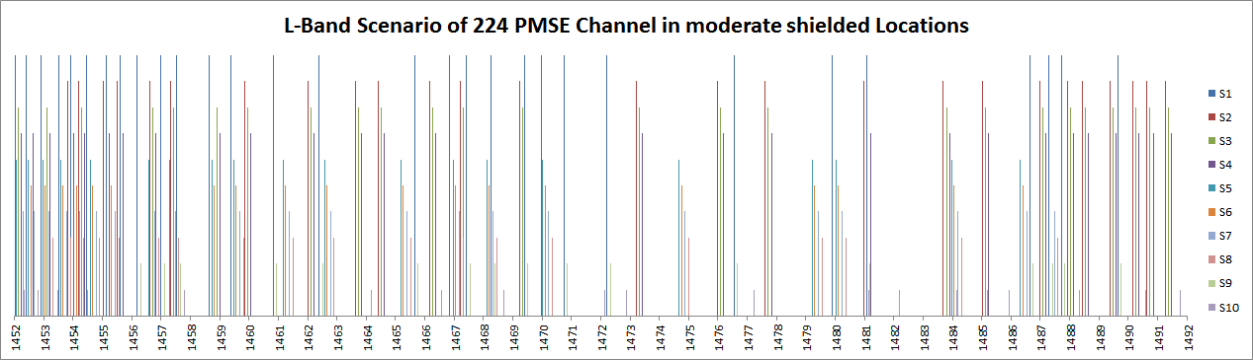

The calculation result shown above was done for standard equipment.

As shown in the graph above these locations a named S1, S2, S3 etc. The colours assigned to these locations can be found in the graph that shows the frequencies in the L-Band from left to right. By shifting the frequencies to higher ones there will come the point where one of these frequencies exceeds the upper limit of the L-Band range. These frequencies have to be left out.
This is the reason why the 10 different venues shown on the right of the graph have a different set of frequencies for the use in that location: some venues have more, some fewer frequencies.

The carriers in the graph have different level. The one with the highest level is the venue which is the reference, from which one can look to the signals of the neighbour venues. The difference in level of the other locations indicates the attenuation the signals experience on the way to the reference location.

Each of the venues on its own have intermodulation free frequencies, but there is a risk of interference if the wanted carrier falls below the intermodulation frequency level of one of the venues. This can only happen if one of the wireless microphones leaves its venue. For high quality productions there is no alternative than intermodulation free arrangement of a set of frequencies as shown in the first graph.

It has to be mentioned that this scenario as described above will work outdoors only if the distances between the venues delivers a signal attenuation of more than 15dB.

The system as described above is proven by practical application in everyday operation in the UHF range – for the venues as named above. This is usually done by the professional frequency coordinator who takes all the important parameters into account.

It needs to be mentioned that the use of PMSE with extended bandwidth, 400kHz or 600kHz, will reduce the maximum number of wireless links that can be used in one venue and a mixed scenario.

