  Project Team FM PT 52 |  |  | FM52(15)13
12th Meeting, 4-5 May 2015
ECO, Copenhagen
Date issued: | 15 April 2015
Source: | Spain
Subject: | LSA Demonstration carried out in the Mobile World Congress, Barcelona
Group membership required to read? (Y/N):

Summary:
Spain has submitted previous contributions to PT 52 at the occasions of PT 52 meetings in January 2015 (web and physical meetings). It was indicated that a LSA demonstration was being planned to be shown at the Mobile World Congress, Barcelona (March 2015).
This contribution provides information on the demonstration carried out by the Spanish Secretariat of State of Telecommunications and for the Information Society (SETSI), with the support of the company RED Technologies.

Proposal:
No proposal. Document for information.
Background:
The demonstration carried out by SETSI and RED technologies, was the latest stage within the studies being undertaken on the feasibility and conditions for implementation of LSA approach in Spain.
Contributions FM52(15)Web1-1 and FM52(15)05 include relevant information on the study conducted by Spain: assumptions for the study, statistical data about current PMSE deployment, deployment scenarios, typical sharing conditions and protection criteria as well as impact (results of the study). It takes into account the existing video PMSE use of the band including all types of video links and all types of use.
An example of implementation has been carried out at the ocassion of Barcelona MWC which is here reported.
A separate study is being carried out regarding the sharing conditions with respect to Government telemetry applications in Spain.

The LSA theoretical assessment
Doc FM(15)05 provides details on the Spanish study that is being undertaken. The study aimed to identifying spectrum current usage and its potential availability for mobile broadband services in Spain in the 2.3 - 2.4GHz band based on ASA/LSA on a shared basis with video PMSE. It takes into account the existing video PMSE use of the band including all types of video links and all types of use. Here a brief report on the outcomes of the theoretical study is reminded.
The deployment density of an MFCN system (urban area) can be used to assess the impact switching-off the mobile network (LTE Base Station) as per an exclusion zone (geographical separation) defined for typical PMSE video links (i.e. cordless and portable). It can be noted that switching off an LTE Base Station (BS) will consequently force any LTE User Equipment (UE) under the control of that BS to switch to another cell i.e. neighbor cell on the same frequency and/or another frequency of the same BS with the result of respecting the exclusion zone.
An exclusion zone is proportionally larger to a protection zone when both zones are defined to achieve the same protection criteria. Only the implementation differs. Therefore we have limited the impact assessment to the exclusion zone case.
Propagation
Computations were done using “Extended Hata” propagation model that takes into account antenna heights with 95% victim system reliability and for a co-frequency situation (2350 MHz).
Cell density
We use 1 macro cell (3 sectors) for 4320 pop (or 1 micro cell for 540 pop or 8 micro cells per macro) as a maximum cell density deployment, with 30% penetration rate (effective covered urban population under 2.3GHz band) deployed over 3 mobile networks / 3 frequency blocks / 3 mobile network operators.
For a city such as Barcelona with an average population density of 15,926 inhabitants per square kilometre (2008), we have around 0.36 macro cell per km² per operator (15,926 x 30% x 1/3 x 1/4320)
Scenario A: Cordless camera
For cordless camera equipped with video link for the case of co-channel coexistence (geographical separation) overlapping on one single mobile network operator:
In the worst case scenario, with 95% victim system reliability & antenna directions aligned, an exclusion zone (urban area) with a radius of around 3 km is required (ECC Report 172) will result switching off up to 6.8 LTE BS (0.36 x 3 x 2 x Pi) covering maximum 30,000 pop.
In the typical case scenario with a median coupling loss & receiver antenna facing 20° away, an exclusion zone (urban area) with a radius of around 1 km is required (ECC Report 172) => switching off up to 2.26 LTE BS (0.36 x 1 x 2 x Pi) covering maximum 10,000 pop.
Scenario B: Portable video link
For portable video link for the case of co-channel coexistence (geographical separation) overlapping on one single mobile network operator:
Scenario B.1 (worst case) with 95% victim system reliability & antenna directions aligned, an exclusion zone (urban area) with a radius of around 25 km is required (ECC Report 172) => switching off up to 56 LTE BS (0.36 x 25 x 2 x Pi) covering maximum 240,000 pop.
Scenario B.2 (typical case) with a median coupling loss & receiver antenna facing 20° away, an exclusion zone (urban area) with a radius of around 3 km is required (ECC Report 172) => switching off up to 6.8 LTE BS (0.36 x 3 x 2 x Pi) covering maximum 30,000 pop.

From the above provisional assessment regarding the exclusion zones, it can be noted that further studies are necessary regarding capacity requirements and operations (like for example, whether the switching off of several channels would still allow continuity of service for the MFCN in other remaining unused channels).

Demonstration
The objective of this demonstration at GSMA Mobile World Congress 2015 in Barcelona was to demonstrate LSA options facilitating sharing between Mobile Services (as the LSA Licensee) and PMSE video links (as the Incumbent) both using the 2.3 GHz band.
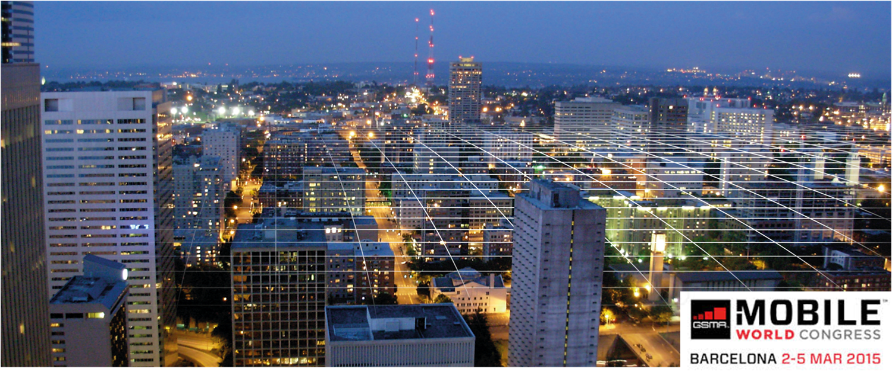
The demonstration was based on the Spanish study on the coexistence of PMSE video links with Mobile Services done by SETSI (Spanish regulator) in collaboration with RED Technologies (released in January 2014) and reported to the latest CEPT FM PT 52 technical work on LSA.
The demonstration showcased the LSA architecture under definition in ETSI with an LSA Repository, an LSA controller and a simulated TD-LTE Mobile Network (Macro to small cells).
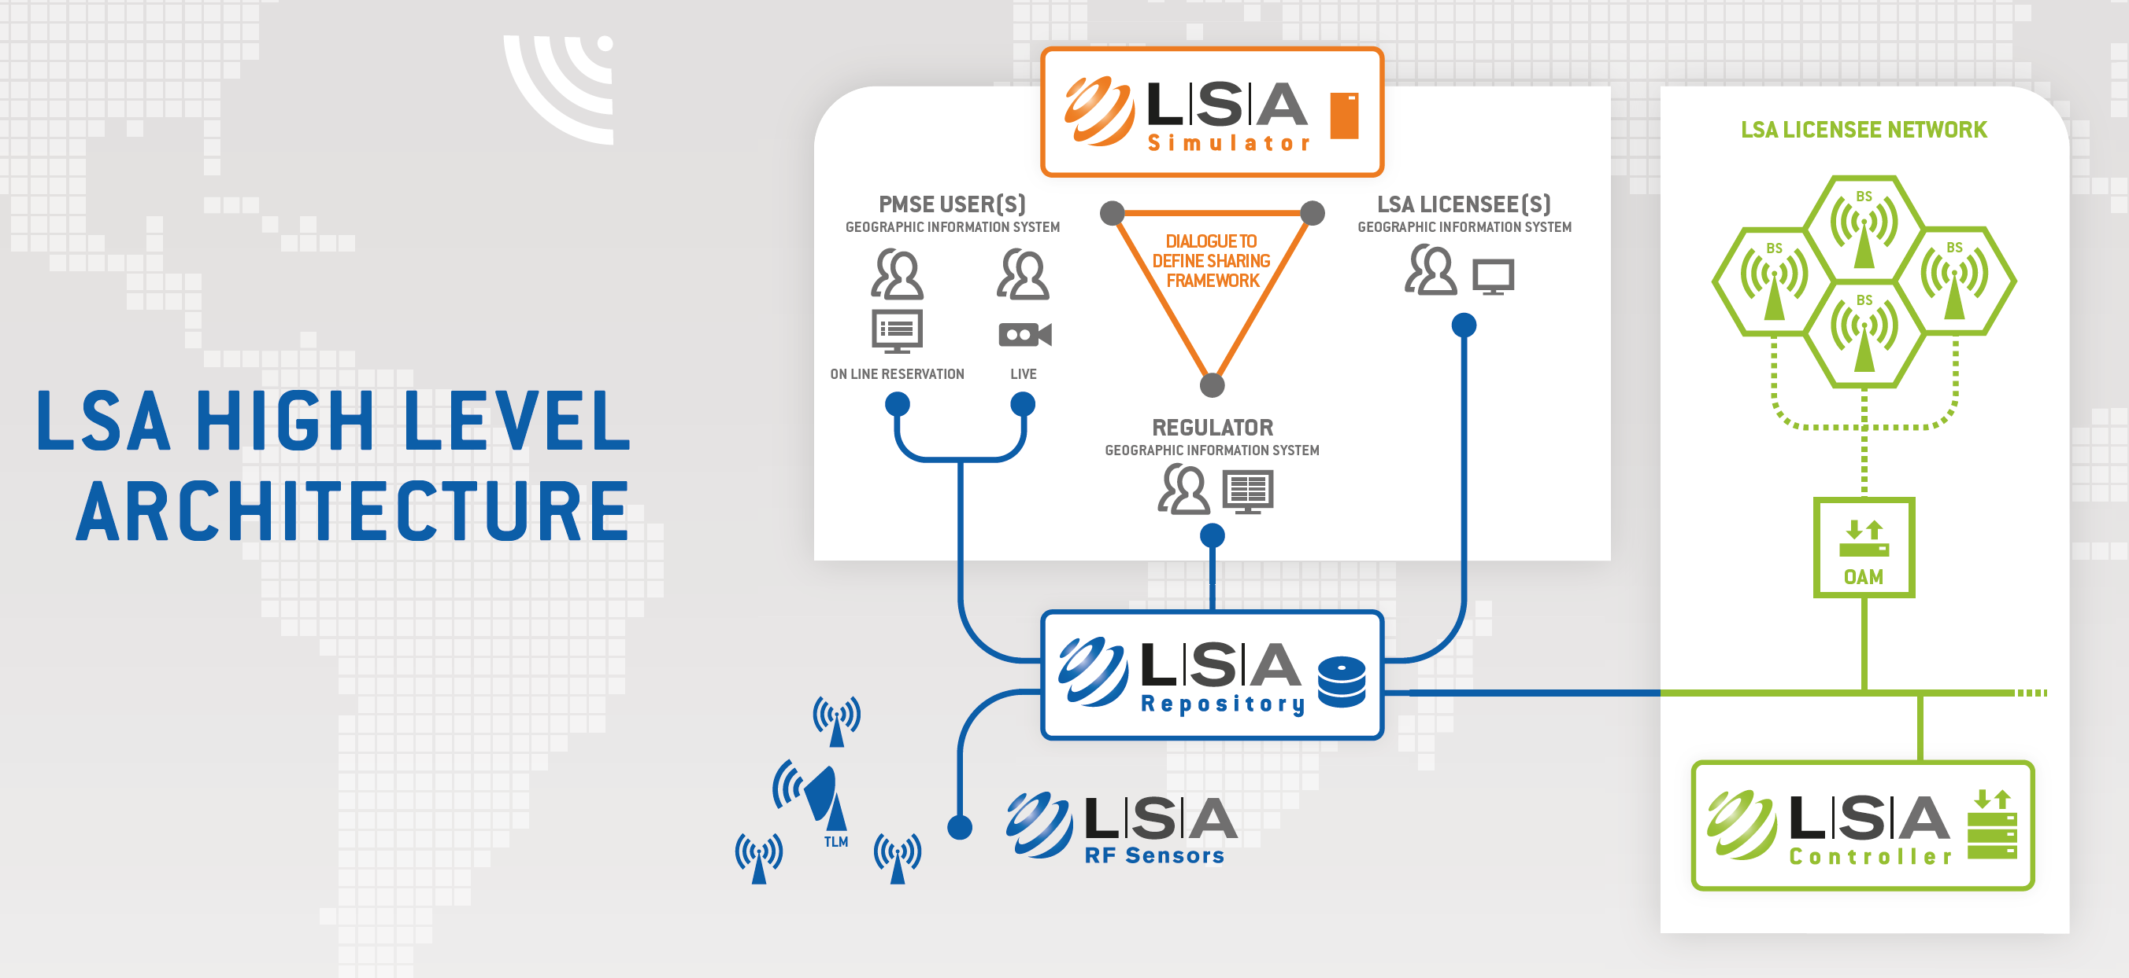
The LSA repository was localized and configured with a Spanish radio environment map for working in Barcelona and its region. LTE base stations (macro cells to small cells) were simulated.
LSA operations with PMSE consisted in spectrum vacation scenarios using an on-site ENG (Electronic News Gathering) cordless camera together with an integrated LSA remote control to illustrate live video broadcasting combined with dynamic spectrum vacation and LTE cell shutdown.
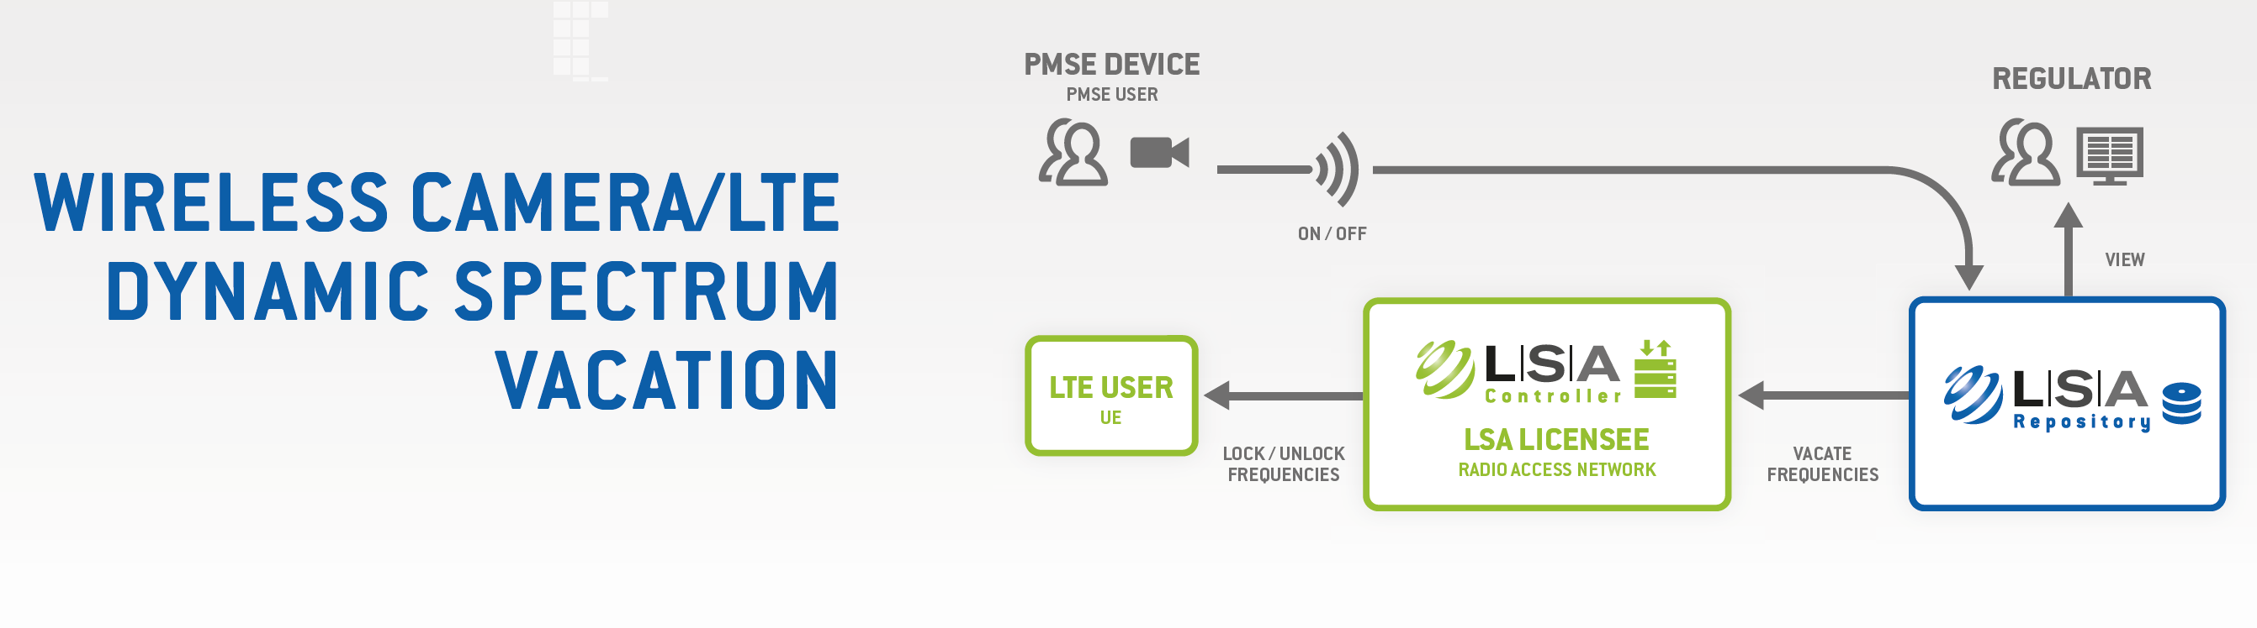
,
The radio environment maps shown on the LSA Repository provided close to reality exclusion zones.
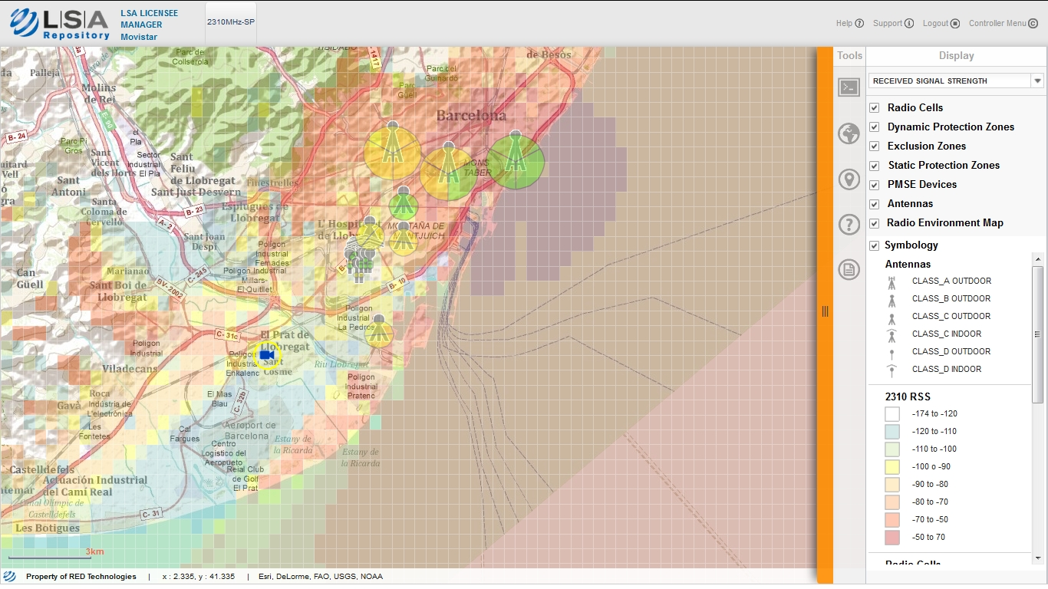
When the cordless camera was on, the LSA remote control sent a message to the LSA Repository and the affected LTE stations started to shut down. And the other way around was applicable when the camera released the spectrum.
A panel of 9 large screens displayed different views such as live broadcasting, LSA repository - Regulator view, LSA Repository - MNO view and the Mobile Network TD-LTE cells via LSA Controller Manager. Professional cordless camera operating a PMSE Video Link equipped with LSA PMSE Remote Control was also deployed on site.


