Radiocommunication Study Groups | 
Source: Document 1A/TEMP/106(edited) | Annex 1 to  Document 1A/311-E
Source: Document 1A/TEMP/106(edited) | 12 July 2010
Source: Document 1A/TEMP/106(edited) | English only
Annex 1 to Working Party 1A Chairman's Report
working Document toward a Preliminary
Draft New Report ITU-R SM.[PLT + 80 MHz]
Impact of power line telecommunication systems on radiocommunication
systems operating in the VHF and UHF bands above 80 MHz
(Question ITU-R 221-1/1)

CONTENTS

Page
1 Introduction 4
2 Characteristics of radio-frequency emission from PLT Systems in the VHF
and UHF bands 5
3 Radio system characteristics, protection criteria, and impact of PLT systems on radiocommunication systems in the VHF and UHF bands 5
3.1 Broadcasting 5
3.2 Amateur and amateur-satellite 5
3.2.1 Background noise levels in the 144-148 MHz band 5
3.2.2 Characteristics of amateur stations in the 144-148 MHz band 5
3.2.3 Protection requirements 6
3.2.4 Conclusion 6
3.3 Maritime mobile service including Global Maritime Distress and Safety System
(GMDSS); aeronautical mobile service and radiodetermination service 6
3.3.1 Initial maximum tolerable value of interference for systems operating in
maritime and radiodetermination services 9
3.4 Land mobile 9
Page
3.5 Radioastronomy 9
3.6 Fixed 9
3.7 Mobile-satellite service (MSS) and radionavigation-satellite service (RNSS) 9
3.7.1 Frequency bands 9
3.7.2 Protection criterion 10
3.7.3 System parameters 10
3.8 Meterological-satellite 11
3.9 Space research 11
3.10 Space operation 11
4 Potential means for preventing or eliminating interference 11
5 Overall conclusions 11
Annex 1 - Noise radiation and propagation considerations in the VHF and UHF bands 11
A1.1 Detailed analysis of mode conversion at the switch branch 11
A1.1.1 Mixed-mode scattering matrix of a balanced transmission line unilaterally
loaded with a stub in series 12
A1.1.1.1 Theoretical formulations 12
A1.1.1.2 Results 15
Annex 2 - Analyses of potential interference in the VHF and UHF bands 21
A2.1 Interference to VHF/UHF radio systems from harmonics of power line telecommunication systems operating in the VHF bands between 80 and 200 MHz 21
A2.1.1 Domestic radio systems 21
A2.1.2 Conclusion 22
A2.2 Compatibility between Aeronautical Radio and PLT in-house devices in the frequency range 30 MHz-380 MHz 22
A2.2.1 Compatibility analysis for interferences in aeronautical radio 23
A2.2.2 Calculation of interference threshold for PLT due to aeronautical requirements 23
A2.2.2.1 Compatibility model 23
A2.2.2.2 Assumptions 24
A2.2.2.3 Calculation 25
A2.2.3 Calculation of power flux-density caused by limits provided by PLT
system standards 26
A2.2.4 Comparison of interference threshold required for airborne receiver and
interference caused by PLT systems 28
A2.2.5 Conclusions 29
A2.3 PLT aggregation model applicable for aircraft radiocommunication and
radionavigation systems 29

Page
Annex 3 - Radio-frequency emissions from PLT systems in the VHF and UHF bands 30
A3.1 Introduction 30
A3.2 Radio-frequency emission measurements from PLT systems 30
A3.2.1 Institut für Rundfunktechnik GmbH (IRT) measurements of PLT modems 30
A3.2.1.1 Overview of the measurements 30
A3.2.1.2 PLT performance 31
A3.2.1.3 Measuring of frequency spectrums 32
A3.2.1.4 Interference radiation of the Belkin PLT modem “Powerline Gigabit”
F5D4076-S v1 37
A3.2.1.5 Field strength with horizontal polarization 39
A3.2.1.6 Field strength with vertical polarization 40
A3.2.1.7 Conclusion from the IRT measurements 41
A3.2.2 Communication Research Centre (Canada) measurements of PLT modems 41
A3.2.2.1 CRC measurement procedure and conducted emission results 41
A3.2.2.2 Conclusions from the CRC measurements 44
A3.2.3 CBS Broadcasting and National Public Radio (NPR) measurements of a
“Gigabit” PLT modem 44
A3.2.3.1 Measurement procedure 44
A3.2.3.2 Conducted emission measurement results for the Belkin “Gigabit
Powerline HD” F5D4076-S v2 PLT modem 45
A3.2.3.3 FM receiver interference from the Belkin “Gigabit Powerline HD”
F5D4076-S v2 PLT modem 48
A3.2.3.4 Conclusions from the CBS/NPR measurements 49
Annex 4 - Design examples of PLT technology using the VHF and UHF bands 50

1 Introduction
As part of the studies on the compatibility between radiocommunication systems and high data rate telecommunication systems using electricity power supply or telephone distribution wiring (Question ITU-R 221/1), this Report covers the use of the radio spectrum and associated protection requirements of radiocommunication services in respect to impact of power line telecommunications (PLT) in the VHF and UHF bands. It complements Report ITU-R SM. 2158 which already provides information and guidance for the frequency bands from the LF bands up to about 80 MHz.
Recent developments of PLT technology show that PLT Systems can use frequencies going far beyond 80 MHz. Future technological developments may even make the use of frequencies in the UHF bands possible for PLT.
There are presently two main families of PLT applications:
− Access PLT whose target market is the last mile (i.e., 1.2 km) between the electricity supply substation and the subscriber and could therefore an alternative means of access to the telecommunication local loop.
− Indoor PLT whose aim is to distribute signals (coming for example from access PLT from DSL or even from data sources within homes and without connection to an access network) to the mains electricity socket outlets inside buildings.
According to the information available, frequencies above 80 MHz are currently only used by indoor PLT systems.
The recently approved ITU-T Recommendation G. 9960 on “Unified high-speed wire line based home networking transceivers − Foundation” contains a physical layer specification for such PLT systems using frequencies up to 200 MHz. It should be noted that there are already indoor PLT systems on the market which use frequencies going up to about 300 MHz or even beyond.
Such PLT indoor systems potentially offer transmission rates of several hundred Mbit/s via the normal electrical power wiring inside every building. HD-film streaming and online-gaming in the home are applications which may require such transmission rates. The implementation of such PLT systems and their technical characteristics can vary considerably.
Because electrical power lines are not designed for the transmission of high data rate signals, PLT signals on electrical power lines have the potential of causing interference to radiocommunication services.
RR No. 15.12 requires that: “Administrations shall take all practicable and necessary steps to ensure that the operation of electrical apparatus or installations of any kind, including power and telecommunication distribution networks, but excluding equipment used for industrial, scientific and medical applications, does not cause harmful interference to a radiocommunication service and, in particular, to a radionavigation or any other safety service operating in accordance with the provisions of these Regulations”“.

2 Characteristics of radio-frequency emission from PLT systems in the VHF and UHF bands
[TBD]

3 Radio system characteristics, protection criteria, and impact of PLT systems on radiocommunication systems in the VHF and UHF bands

3.1 Broadcasting
With respect to unintentional emissions in the broadcasting bands above 30 MHz, the total aggregate interference to the broadcasting service should at no time and nowhere exceed one per cent of the total receiving system noise power.

3.2 Amateur and amateur-satellite
The only amateur band in the 80-200 MHz range is the 144-148 MHz band (144-146 MHz in ITU Region 1). As well as being heavily used for relatively local coverage by analogue FM and related modes, supported in most countries by an extensive network of repeaters, this band has literally a world-wide scope in supporting long-distance communication at very low (and even negative) signal/noise ratios. It is these weak-signal applications that require interference protection, although the other forms of communication will also benefit.
Amateur weak-signal communication at VHF is making systematic use of transient modes of propagation such as extended troposcatter and reflections from aurora, meteor trails and the moon, which other services generally dismiss as ‘unreliable’ and are therefore receiving relatively little professional attention. In contrast, amateurs are using these modes of propagation for communication over distances 1 000 km and more, while moon-bounce communication spans all three ITU Regions. This type of operation uses SSB and Morse in a similar manner to HF, but makes more regular use of extremely weak and fading signals, often at signal/noise ratios down to 0 dB and using special protocols to capture information from any brief enhancements. Newer digital modes are now capable of communication at 10-20 dB below the audible threshold.
These unique features make amateur VHF weak-signal communication extremely sensitive to any increase in the background noise level. The degree of protection required is comparable to radio astronomy.

3.2.1 Background noise levels in the 144-148 MHz band
Recommendation ITU-R P.372-10 establishes that, in ‘quiet rural’ areas, background noise at these frequencies is dominated by sky noise, particularly from the Sun which appears as a quasi-point source, and from our own galaxy (the Milky Way), which appears as a broad belt of strong emission. From Recommendation ITU-R P.372, the median noise figure for galactic noise is about 0 dB relative to kTb and from equation (8) in Recommendation ITU-R P.372, this corresponds to a field strength of −21.6 dBμV/m.

3.2.2 Characteristics of amateur stations in the 144-148 MHz band
For this kind of VHF weak-signal operation, a well equipped amateur station aims to have a receiving system noise figure that is dominated by external noise, so the receiver itself may have a noise figure of less than 1 dB with feeder loss of under 1 dB. High-gain beam antennas are always used, with forward gains as high as 15 to 20 dBd and correspondingly narrow beamwidths. The receiver noise floor would be equivalent to a level at the antenna of 28 nV in a 3 kHz bandwidth: with a dipole antenna in free space, this would correspond to a field strength of −21 dBμV/m.

It must be noted again that communication routinely takes place using signals at the noise floor; and with digital modes, 10-20 dB below it. With weak and fading signals, it may only be possible to transfer data during occasional peaks of improved signal/noise ratio, so the duration of these peaks is of critical importance. Even a small increase in the external noise floor can dramatically reduce the amount of time available for the transfer of data.

3.2.3 Protection requirements
To provide no more than a 0.05 dB degradation in the received SNR, which is consistent with the requirements of other services in this frequency range, the radiation from PLT, both at its fundamental and at harmonics falling in the 144-148 MHz band needs to be lower than the system noise floor by some 20 dB: i.e. measured at the antenna main lobe, it should be less than −41 dBμV/m. It is fair to assume that the amateur antenna should be separated from the PLT installation by 10 metres; but amateur stations are installed in home properties, so greater separation distances should not be assumed.

3.2.4 Conclusion
To provide adequate protection to weak-signal operations by the amateur services in the 144-148 MHz frequency range, radiation from PLT devices and installations should not exceed −41 dBμV/m at a distance of 10 metres, in a 3 kHz bandwidth.

3.3 Maritime mobile service including Global Maritime Distress and Safety System (GMDSS); aeronautical mobile service and radiodetermination service
From the perspective of the radiocommunication services under the purview of Working Party 5B, WP 5B notes the particular problems of protecting airborne radiocommunication and radionavigation systems from a dense population of sources of radio-frequency radiation from the ground.
Several studies confirm that noise from PLT devices can produce noise 20-40 dB higher than background noise, even up to levels comparable with the required minimum field strength for radiocommunication services. No explanation is offered why PLT devices should be allowed to inject extraneous noise into the environment at levels considerably greater than properly established standards and practice. In previous ITU-R studies, a 1% increase in noise temperature is reserved for the aggregate of all interference from other sources. As a result, it may be appropriate for Working Party 1A to study whether some portion of the allowed 1% increase in noise temperature should be used as the limit for the aggregate of all unintentional radiators, such as PLT devices, to aeronautical and maritime services, in particular, recognizing their safety of life applications.
It is not clear to WP 5B how a “silicon mask” and “toolkit” that are included in the specification of ITU-T Recommendation G.9960 for regulatory purposes can be effective. Even if the capability to restrict power or frequency use were used, what would be its effectiveness when there is free circulation of this type of equipment? There is no certainty that restrictions (if any) made by one Administration will be applicable or relevant to another. Based on studies to date, WP 5B is not convinced that notching provides an adequate level of protection.
Working Party 5B considers that there is a need for Working Party 1A to investigate the level of aggregate interference from PLT devices. The effect of aggregation will be most severe on airborne radiocommunication and radio navigation systems because of the large area in view and the fact that aeronautical services have largely been planned on the basis of exclusive use of the bands allocated to the aeronautical mobile services and the aeronautical radionavigation service. The new work stream in WP 1A on the topic of power grid management using PLT connectivity and the continuing work in ITU-T WP 1/15 on ITU-T Recommendation G.9960, lead together to the conclusion that, rather than having around 30% penetration with 2 to 4 modems per household for broadband connectivity (see section A.2.4.3 of Report ITU-R SM.2158), many items of electrical equipment are expected to incorporate PLT chips for the purposes of power grid management.
Working Party 5B concludes that the intent and methodology of the PDNR fails to recommend a method consistent with established EMC standards or limits for developing protection requirements, that should be met by sources of unintended radiation, such as from PLT devices.
Regarding the information on the protection requirements for aeronautical radiocommunication and radionavigation systems, WP 5B advises that the material included in Report ITU-R SM.2057 on ultra-wideband devices, may serve as an initial reference. However, noting the suggested limit above of 1% for the allowed increase in noise temperature, a table of protection requirements has been adapted, which is provided in Table 1.
Working Party 5B further notes that during the work on ultra wideband devices, two aggregation models were used to calculate the aggregated level of ultra wideband signals at the body of an aircraft for a given aircraft altitude, ultra wideband device density and radiated power. Both models provided the same results. For the purposes of carrying out an assessment of aggregate levels of PLT interference at an aircraft hull, WP 5B recommends that WP 1A consider the use of the model described in section 3.1.2.2.1 of Report ITU-R SM.2057 and editorially adjusted for PLT, attached in Annex 2 to this document (Section A2.3) as being the more convenient for assessing the cumulative impact of PLT devices.
A summary of protection requirements supplementing those given in Report ITU-R SM.2057 for applications in the maritime mobile service and the radiodetermination service is given in Section 3.3.1 below.
Annex A2.2 contains a study dealing with the compatibility of aeronautical mobile and aeronautical radionavigation services and PLT systems in the frequency range of 30 to 380 MHz.

Table 1
Initial maximum tolerable value of interference for systems operating in aeronautical services
Signal level to be protected at the receive antenna
System |  | Frequency band | Receiver location | Minimum level of desired signal |  | Required D/U (Note 1) | Receiver bandwidth | Aviation safety margin | Multiple technology limit | Initial maximum tolerable value of interference
 |  | Frequency band | Receiver location | (µV/m) | (dBm) | (dB) | (kHz) | (dB) | (dB) | (dBm/Hz)
ILS Localizer |  | 108-112 MHz | Airborne | 40 | −86 | 20 | 30 | 6 | 20 | −177
ILS Glideslope |  | 328.6-335.4 MHz | Airborne | 400 | −76 | 20 | 42 | 6 | 20 | −168
GBAS |  | 108-117.975 MHz | Airborne | 215 | −72 | 26 | 14 | 6 | 20 | −165
VOR |  | 108-117.975 MHz | Airborne | 90 | −79 | 20 | 36 | 6 | 20 | −171
VHF Comms | 25 kHz | 117.975-137 MHz | Airborne | 75 | −82 | 20 | 16 | 6 | 20 | −170
VHF Comms | 25 kHz | 117.975-137 MHz | Ground | 20 | −93 | 20 | 16 | 6 | 20 | −181
VHF Comms | 8.33 kHz | 117.975-137 MHz | Airborne | 75 | −82 | 20 | 5.6 | 6 | 20 | −165
VHF Comms | 8.33 kHz | 117.975-137 MHz | Ground | 20 | −93 | 20 | 5.6 | 6 | 20 | −177
VHF Comms | VDL Mode 2 and 3 | 117.975-137 MHz | Airborne | 75 | −82 | 20 | 8 | 6 | 20 | −167
VHF Comms | VDL Mode 2 and 3 | 117.975-137 MHz | Ground | 20 | −93 | 20 | 16 | 6 | 20 | −181
VHF Comms | VDL Mode 4 | 108-137 MHz | Airborne | 75 | −81 | 20 | 5.56 | 6 | 20 | −165
VHF Comms | VDL Mode 4 | 108-137 MHz | Ground | 20 | −93 | 20 | 6 | 6 | 20 | −177
NOTE 1 − Value taken here are the Intra System D/U ratio or in the case of Radar the System I/N ratio and are provided as an initial value.

3.3.1 Initial maximum tolerable value of interference for systems operating in maritime and radiodetermination services
Maritime VHF receivers − 154-174 MHz
Recommendation ITU-R M.489-2 provides that:
− the reference sensitivity should be equal to or less than 2.0 µV, e.m.f., for a given reference signal-to-noise ratio at the output of the receiver;
− the adjacent channel selectivity should be at least 70 dB;
− the spurious response rejection ratio should be at least 70 dB;
− the radio-frequency intermodulation rejection ratio should be at least 65 dB;
− the power of any conducted spurious emission, measured at the antenna terminals, should not exceed 2.0 nW at any discrete frequency. In some radio environments lower values may be required.
Automatic identification of ships (AIS) receivers
AIS receivers operate on two frequencies, 161.975 and 162.025 MHz, for the purpose of meeting a wide range of marine safety and security objectives developed by IMO, which include managing ship movements along congested shipping lanes, collision avoidance, improving the SAR response to distress incidents, protecting against oil pollution and maintaining a secure environment for ships and ports.
− AIS minimum receiver sensitivity specification level (for a 20% permitted error rate) = −107 dBm;
− typically, AIS base stations have a receiving sensitivity of −115 dBm or better.

3.4 Land mobile
[TBD]

3.5 Radio astronomy
The radio astronomy service (RAS) has a frequency allocation in the band 150.05-153 MHz on a primary basis in some Regions and countries, where RR footnote No. 5.149 applies. This band is used for continuum observations (i.e., total power mode) only, and the interference threshold level detrimental to the RAS is given in Recommendation ITU-R RA.769 to be −194 dB(W/m²) and/or −259 dB(W/m²/Hz). The equivalent electric field value is given in Report ITU-R RA.2131 to be −48.2 dB(μV/m) in 2.95 MHz bandwidth.

3.6 Fixed
[TBD]

3.7 Mobile-satellite service (MSS) and radionavigation-satellite service (RNSS)
Working Party 4C reviewed the frequency allocations for the mobile-satellite service and the radionavigation-satellite service below 200 MHz and provided the following information.

3.7.1 Frequency bands
Below 200 MHz, there are four bands allocated to the mobile-satellite service (MSS) or the radionavigation-satellite service (RNSS):
− the band 137-138 MHz is allocated to the MSS in the space-to-Earth direction;
− the band 148-150.05 MHz is allocated to the MSS in the Earth-to-space direction;
− the band 149-9-150.05 MHz is allocated to the RNSS;
− the bands 161.9625-161.9875 MHz and 162.0125-162.0375 MHz are allocated to the MSS in the Earth-to-space direction (see RR No. 5.227A).

3.7.2 Protection criterion
Working Party 4C understands that, as a good spectrum engineering practice, Working Party 1A will seek to ensure that radiations produced by PLT devices will be kept to the minimum technically achievable levels. This being said, Working Party 4C considers that, for radiations as those produced by PLT devices, a ΔT/T criterion of 1% is the permissible level of interference into MSS or RNSS receivers (either space-borne, airborne or on the ground). This criterion is generally used within ITU-R in similar cases.

3.7.3 System parameters
The detailed system parameters of MSS systems using the bands 137-138 MHz and 148-150.05 MHz are contained in Annex 2 of Recommendation ITU-R M.1184-2 “Technical characteristics of mobile satellite systems in the frequency bands below 3 GHz for use in developing criteria for sharing between the mobile-satellite service (MSS) and other services”. For ease of use by Working Party 1A, the following two tables summarize the relevant system parameters required to ensure the protection of MSS receivers from PLT radiations.
Table 1
Characteristics of mobile earth station receivers in the band 137-138 MHz
Receiving mobile earth station antenna gain (dBi) | 5.7 | 0.5 | −3 | 3
Receiving mobile earth station antenna pattern | Omnidirectional | Omnidirectional | Omnidirectional | Omnidirectional
Receiving mobile earth station noise temperature (K) | 4 467 | 813 | 66 | 1 565
Receiving mobile earth station deployment | Worldwide | Worldwide | Worldwide | Worldwide
Receiving mobile earth station polarization | RHCP | RHCP | LHCP | RHCP
Table 2
Characteristics of MSS satellite receivers in the band 148-150.05 MHz
Receiving satellite altitude (km) | 950 | 775 | 800 | 893 | 1 000
Receiving satellite antenna gain (dBi) | −2 | 0 | 0 | 5.6 | 6
Receiving satellite antenna pattern | Isoflux | Toroidal | 10 log (cos 2 θ) | 10 log (cos 2 θ) | Isoflux
Receiving satellite noise temperature (K) | 309 | 400 | 1 000 | 1 480 | 940
Receiver polarization | Linear | Linear | RHCP | LHCP | Linear
With regard to the RNSS allocation in the 149.9-150.05 MHz band, the following characteristics are extracted from the ITU database and correspond to existing systems operating in this band:
− RNSS receiving earth station antenna gain: 0 dBi;
− RNSS receiving earth station antenna pattern: omnidirectional;
− RNSS receiving earth station noise temperature: 200 K;
− RNSS receiving earth station deployment: worldwide.

3.8 Meteorological-satellite
[TBD]

3.9 Space research
[TBD]

3.10 Space operation
[TBD]

4 Potential means for preventing or eliminating interference
[TBD]

5 Overall conclusions
[TBD]

Annex 1
Noise radiation and propagation considerations
in the VHF and UHF bands

A1.1 Detailed analysis of mode conversion at the switch branch
The switch branches consisting of ceiling lights and wall switches commonly found in domestic power-line wirings are highly unbalanced at radio-frequency range, and they convert the differential-mode signals into the common-mode or antenna currents that cause the radiated emissions from the power line. Although these facts are well recognized among radiocommunication community, they seem poorly recognized in PLT community. In the subsection 2.1.4.3 of Report ITU-R SM.2158, it is shown that the differential and common modes are strongly coupled over a broad spectral range, not just at a resonance frequency, based on the theoretical analysis which models a series short stub as an unbalanced phase shifter. Although the essential physical mechanism of the mode conversion is well represented in the phase shifter model, more general analyses would be desirable. Also when the wall switch is turned off, the switch branch constitutes a series open stub which may not be modelled as a phase shifter. Instead the branch terminated by a cold light bulb with a resistance as low as a few ohms was modelled as a series short stub in the previous analysis. General series stub analysis that treats both short and open stubs would be desirable.
In the followings, such general analysis of series stubs is given based on a recent study.

A1.1.1 Mixed-mode scattering matrix of a balanced transmission line unilaterally loaded with a stub in series

A1.1.1.1 Theoretical formulations
Unilateral series stub circuits in which an open or a short stub made of a balanced transmission line is inserted in series with the one side of the other balanced transmission line as shown in Fig. 1 have been theoretically analysed. Their mixed-mode scattering matrices have been derived to reveal the distinct mode-conversion characteristics.
Power line telecommunications (PLT) feed RF signals into the odd mode of power line network inside the house. Since switch branch circuits consisting of ceiling lights and single-pole wall switches form unilateral series stubs, the theory is useful in predicting EMC problems caused by PLT systems using the HF and/or VHF regions.

FIGURE 1  A balanced transmission line unilaterally  loaded with a series stub | FIGURE 2  A balanced transmission line  which constitutes a stub
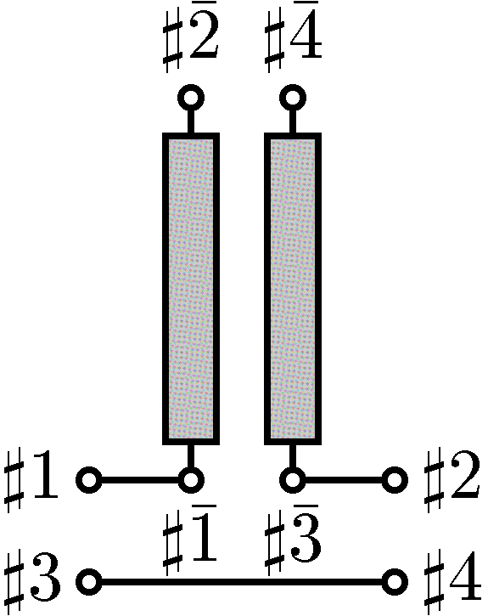  (a) A series short stub (b) A Series open stub | 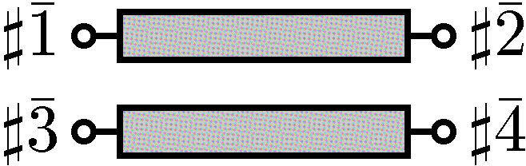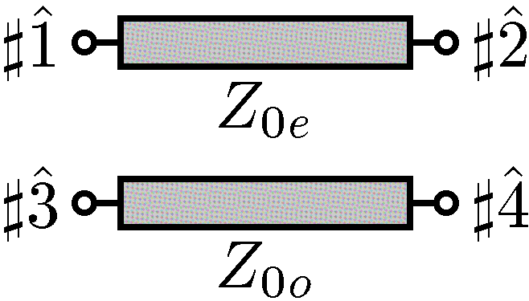  (a) coupled lines (b) even-odd modes

Two conductors of a balanced transmission line in Fig. 2 (a) which constitutes a stub in Fig. 1 are coupled. The even and odd modes are decoupled and can be treated independently as shown in Fig. 2 (b). The even mode and the odd mode have the following impedance matrices respectively,
where Z_{0e} and Z_{0o} denote the characteristic impedances of the even and the odd modes, φ_{e} and φ_{o} denote the phase rotations of the even and the odd modes through the stub, i.e., φ_{e}=β_{e}l and φ_{o}=β_{o}l for a lossless transmission line of the length l. For a transmission line with loss, they are replaced with φ_{e}=β_{e}l(1-jα_{e}/β_{e}) and φ_{o}=β_{o}l(1-jα_{o}/β_{o}) for given propagation constants γ_{e}=α_{e}+jβ_{e} and γ_{o}=α_{o}+jβ_{o}.

Then the voltages and the currents of the mode terminals in Fig. 2 (b) are connected as follows,

The transformation matrix between a pair of input (or output) physical terminals in Fig. 2 (a) and the corresponding mode terminals in Fig. 2 (b) is given by,
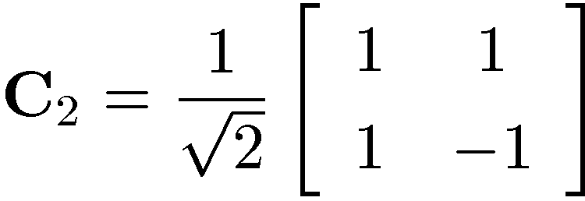
The transformation matrix between all physical terminals and all mode terminals is given by,
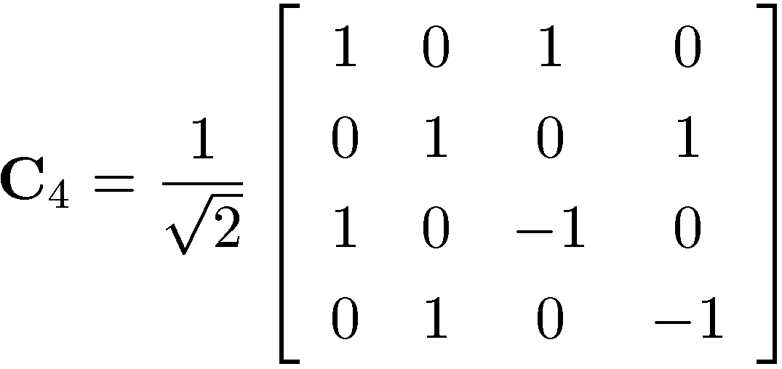
The impedance matrix of the mode terminals of the transmission line in Fig. 2 (b) is given by,
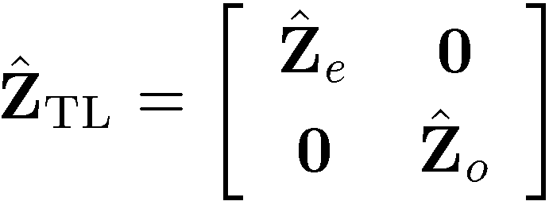
Therefore the impedance matrix of the physical terminals of the transmission line in Fig. 2 (a) is calculated to be,
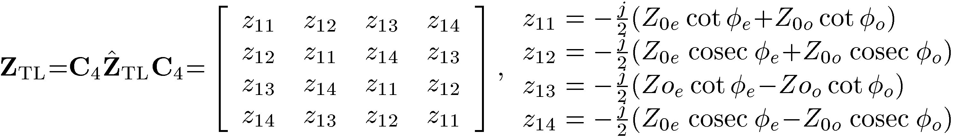
In the case of a short stub in Fig. 1 (a), the terminal conditions are given by,
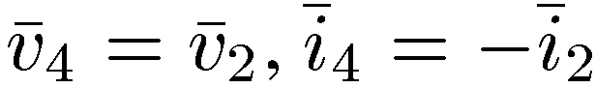
Therefore the input and output voltages and currents have the relationship,
which can be expressed by the impedance matrix,
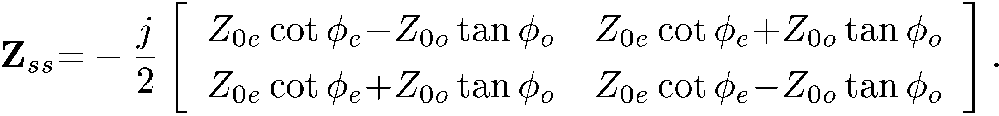
In the case of an open stub in Fig. 1 (b), the terminal condition is given by,
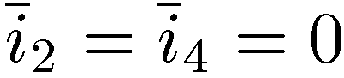
Therefore the input and output voltages and currents have the relationship,

which can be expressed by the impedance matrix,
Figure 3
Analysis with virtual shunt resistance to the ground
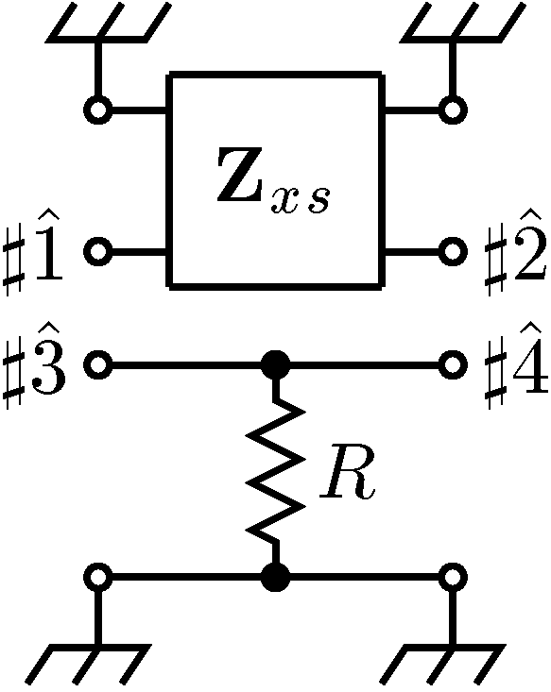

To analyse a transmission line unilaterally loaded with a series stub as shown in Fig. 1, the other conductor is grounded through the resistance R as shown in Fig. 3. Then the impedance matrix of the conductor is given by,
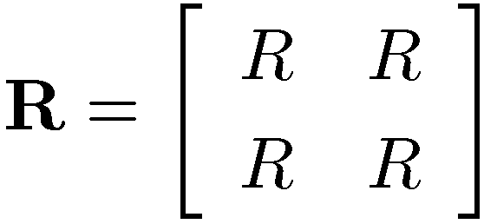
and the impedance matrix of the whole circuit in Fig. 3 is given by,
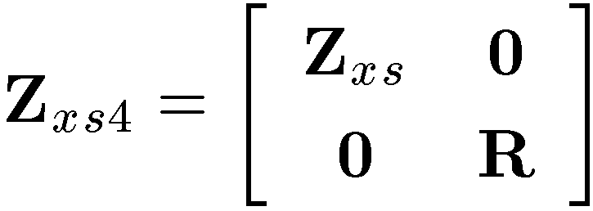
where subscript is x=o for an open stub and x=s for a short stub. It is translated into the mixed-mode impedance matrix,
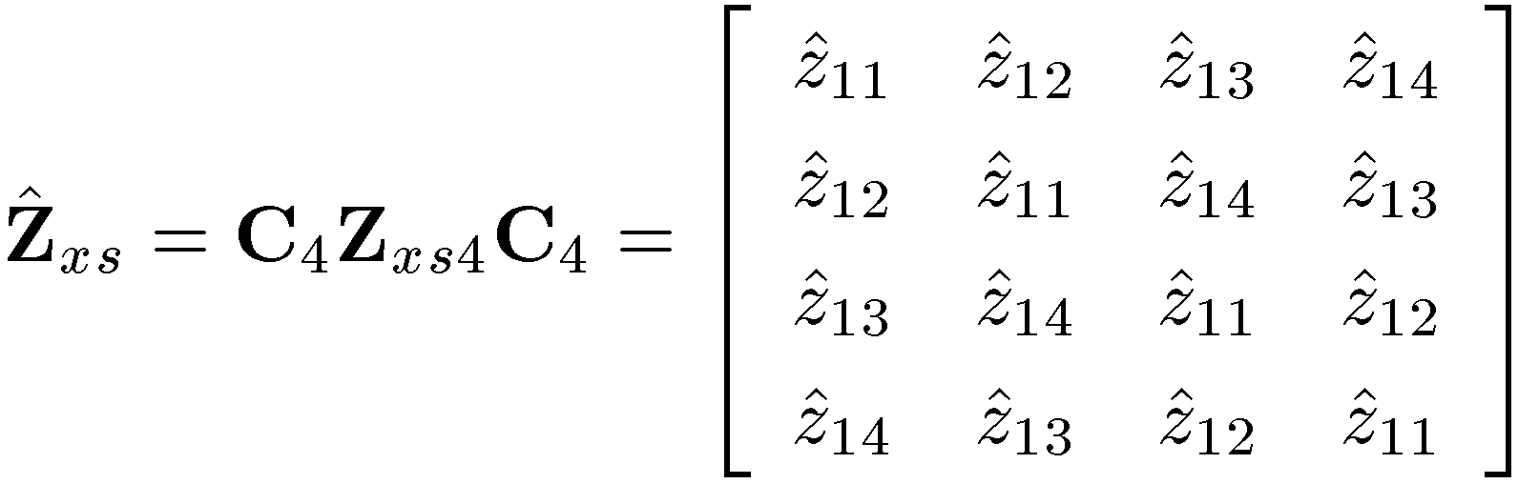
The mixed-mode scattering matrix of the series stub circuit shown in Fig. 1 is calculated by taking the limit,
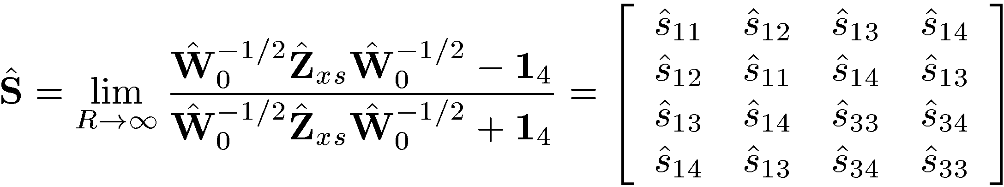
where:
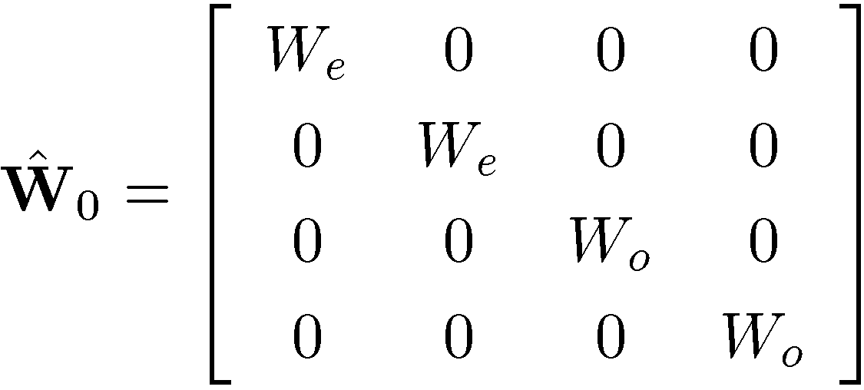
W_{e} and W_{o} denote the reference impedances of the even and the odd modes respectively, and 1₄ is the identity matrix of four dimension.

A1.1.1.2 Results
The mixed-mode scattering matrix elements of a transmission line unilaterally loaded with a series short stub are given as follows,
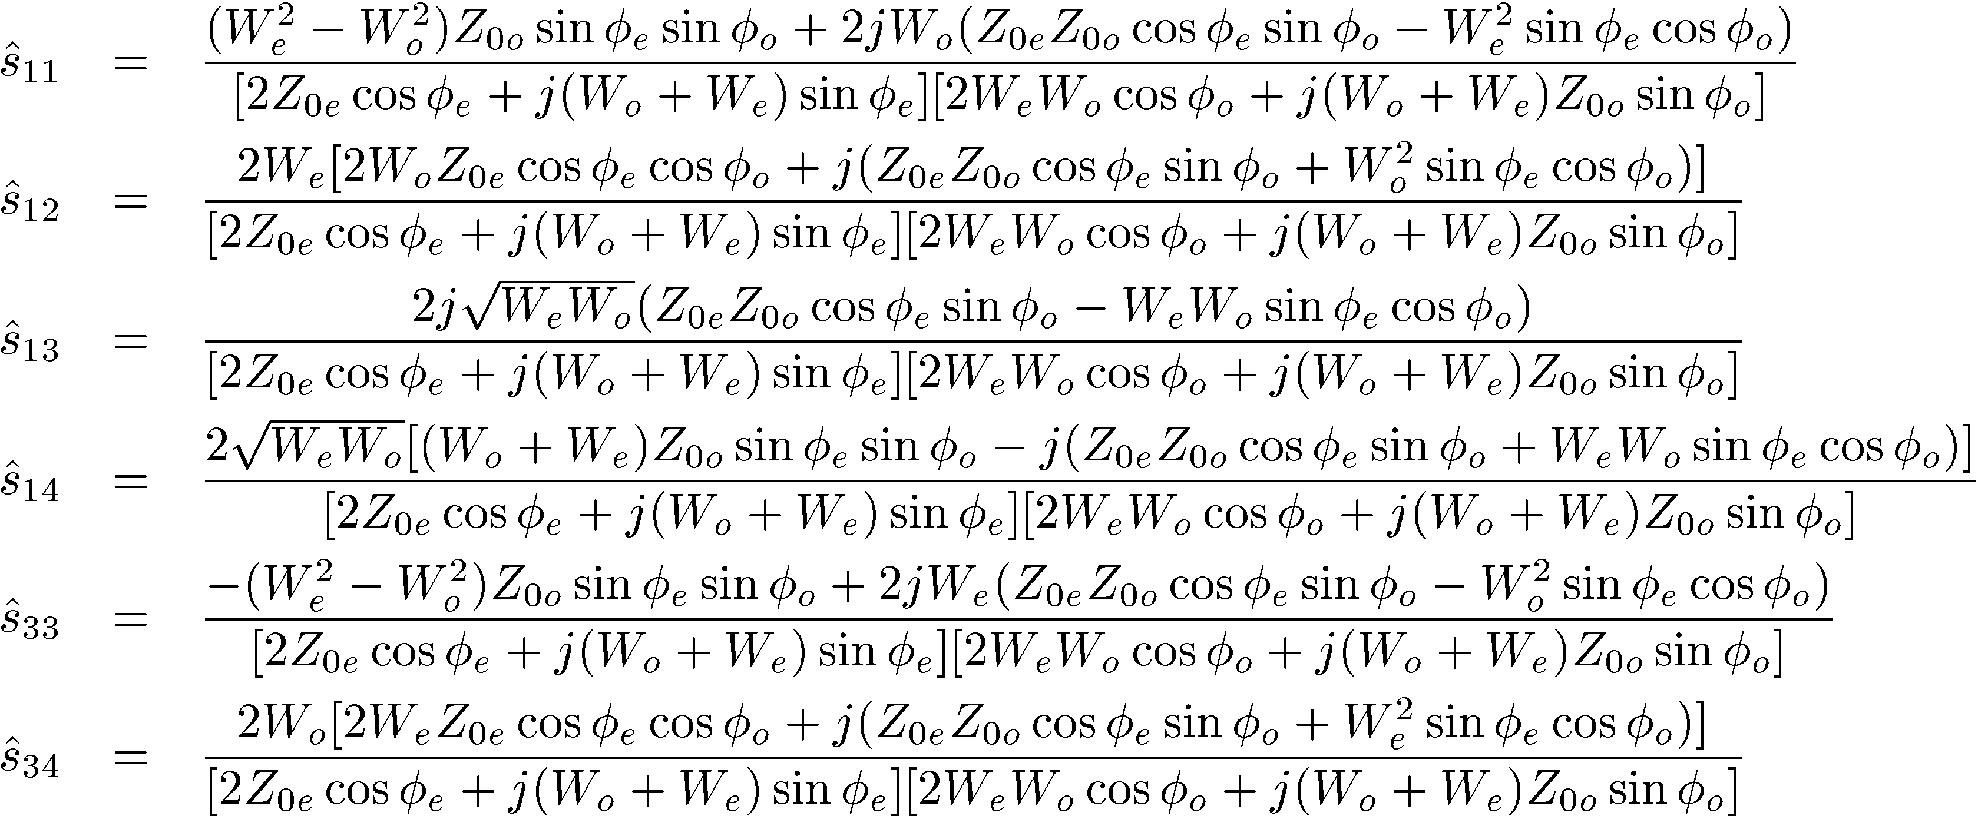
where s₁₁=s₂₂ are even-mode reflections, s₁₂=s₂₁ are even-mode transmissions, s₁₃=s₃₁=s₂₄=s₄₂ are backward mode-conversions, s₁₄=s₄₁=s₂₃=s₃₂ are forward mode-conversions, s₃₃=s₄₄ are odd-mode reflections, and s₃₄=s₄₃ are odd-mode transmissions. Z_{0e} and Z_{0o} denote the characteristic impedances of the even and the odd modes, φ_{e} and φ_{o} denote the phase rotations of the even and the odd modes, W_{e} and W_{o} are the reference impedances of the even and the mode ports, respectively. They are the most general expressions.
The mixed-mode scattering matrix of a series open stub is obtained by substituting φ_{o}+π/2 into φ_{o} of the above expressions while φ_{e} is intact. Therefore the general expressions for a series open stub are omitted for brevity.
In the following, the reference impedances are chosen to be equal to the characteristic impedances, i.e., W_{e}=Z_{0e} and W_{o}=Z_{0o}, so that there is no false reflection at the interfaces and no artifact resonance. Then the mixed-mode scattering matrix elements of a series short stub are given by,
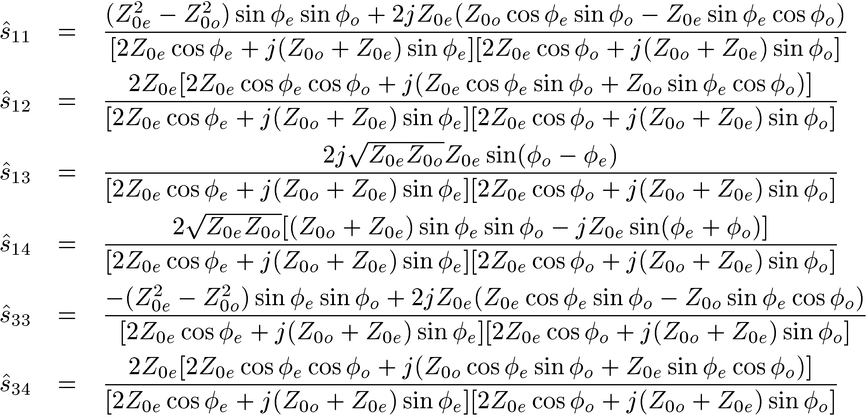
The above expressions are general enough when the same two conductor lines are used for both a stub and the transmission lines around the stub.
The losses of the transmission line can be incorporated as the imaginary part of the phase rotations. For example, the even-mode loss can be incorporated as φ_{e}=β_{e}l(1-jα_{e}/β_{e}) if the even-mode propagation constant is given by γ_{e}=α_{e}+jβ_{e.}
The simplest case
If we let Z_{0e}=Z_{0o} and φ_{e}=φ_{o}, then the scattering matrix elements of a series short stub become:
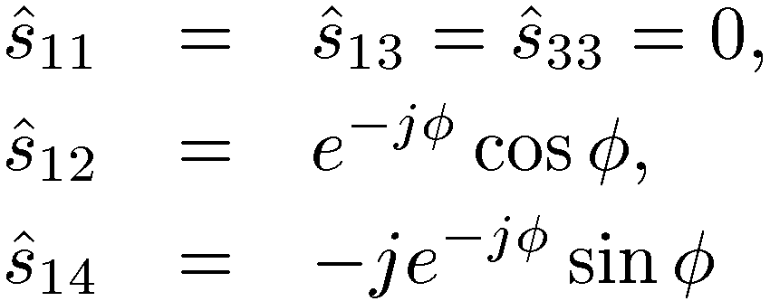
which reproduce the description in subsection 2.1.4.3 of Report ITU-R SM.2158 based on the simple phase shifter model. Since Z_{0e}=Z_{DM}/2 and Z_{0e}=2Z_{CM}, the above conditions coincide with Z_{CM}=Z_{DM}/4.
Numerical results
In the followings, various numerical examples are calculated using the general expressions for both series short stubs and series open stubs to study the effects of characteristic impedances, mode dispersion (phase velocity difference between the even and the odd modes) and/or loss. In Figs. 4 through 9, the horizontal axis is the odd-mode phase rotation φ_{o} divided by π. At the center (0.5) of the horizontal axis, φ_{o} = π/2. If the stub length l corresponds to a quarter wavelength of the odd-mode at the frequency f₀, then φ_{o} = β_{o}l = πf/2f₀. Therefore the horizontal axis is regarded as f/2f_{0,} the frequency f normalized by 2f₀, and the center (0.5) represents f = f₀.
The vertical axis is the absolute value of the mixed-mode scattering matrix elements. As far as mode conversions at the stub are concerned, only s₁₃=s₃₁ (red curves) which represent inter-mode forward scatterings and s₁₄=s₄₁ (magenta curves) which represent inter-mode backward scatterings are relevant. Other elements represent reflections or transmissions within the same modes.

FIGURE 4  A series short stub (lossless) with various  characteristic impedances  Note that s₁₃=0, |s₁₁|=|s₃₃|, |s₁₂|=|s₃₄ since φ_{e}=φ_{o} | FIGURE 5  A series open stub (lossless) with various  characteristic impedances
Z_{0e}=Z_{0o}, φ_{e}=φ_{o}=φ | Z_{0e}=Z_{0o}, φ_{e}=φ_{o}=φ (all degenerated)
Z_{0e}=4Z_{0o}, φ_{e}=φ_{o}=φ | Z_{0e}=4Z_{0o}, φ_{e}=φ_{o}=φ
Z_{0e}=12Z_{0o}, φ_{e}=φ_{o}=φ | Z_{0e}=12Z_{0o}, φ_{e}=φ_{o}=φ
Z_{0e}=16Z_{0o}, φ_{e}=φ_{o}=φ | Z_{0e}=16Z_{0o}, φ_{e}=φ_{o}=φ

FIGURE 6  A series short stub with mode dispersion  and/or loss (Z_{0e}=Z_{0o}) | FIGURE 7  A series open stub with mode dispersion  and/or loss (Z_{0e}=Z_{0o})
Lossy even-mode φ_{e}=φ_{o}=φ, α_{e}/β_{e}=0.05 | Lossy even-mode φ_{e}=φ_{o}=φ, α_{e}/β_{e}=0.05
Mode-dispersive, Lossy even-mode  φ_{e}=1.1φ_{o}=1.1φ, α_{e}/β_{e}=0.05 | Mode-dispersive, Lossy even-mode  φ_{e}=1.1φ_{o}=1.1φ, α_{e}/β_{e}=0.05
Mode-dispersive φ_{e}=1.1φ_{o}=1.1φ | Mode-dispersive φ_{e}=1.1φ_{o}=1.1φ

FIGURE 8  A series short stub with mode dispersion  and/or loss (Z_{0e}=12Z_{0o}) | FIGURE 9  A series open stub with mode dispersion  and/or loss (Z_{0e}=12Z_{0o})
Lossy even-mode φ_{e}=φ_{o}=φ, α_{e}/β_{e}=0.05 | Lossy even-mode φ_{e}=φ_{o}=φ, α_{e}/β_{e}=0.05
Mode-dispersive, Lossy even-mode  φ_{e}=1.1φ_{o}=1.1φ, α_{e}/β_{e}=0.05 | Mode-dispersive, Lossy even-mode  φ_{e}=1.1φ_{o}=1.1φ, α_{e}/β_{e}=0.05
Mode-dispersive φ_{e}=1.1φ_{o}=1.1φ | Mode-dispersive φ_{e}=1.1φ_{o}=1.1φ

A1.1.1.3 Conclusions
The general expressions for the mixed-mode scattering matrix elements of a balanced transmission line unilaterally loaded with a stub in series have been formulated. The simple unilateral phase shifter model of a series short stub used in the analysis in subsection 2.1.4.3 of Report ITU-R SM.2158 has been verified as the simplest case of the general expressions. The general expressions for the mixed-mode scattering matrix elements which represent inter-mode scatterings between even and odd modes and the numerical calculations under various conditions suggest that the even and the odd modes are strongly coupled over a wide range of spectrum, not just at the frequencies where the stub length corresponds to a multiple of the quarter wavelength of the odd-mode.
The results suggest that the even-mode currents as large as the odd-mode signal currents are generated in domestic power-line wirings which usually contain as many switch branches as the number of rooms and that the power spectral density of the odd-mode signal must be regulated as low as that of the even-mode.

Annex 2
Analyses of potential interference in the VHF and UHF bands

A2.1 Interference to VHF/UHF radio systems from harmonics of power line telecommunication systems operating in the VHF bands between 80 and 200 MHz
The study of protection requirements of radio services in the range up to 80 MHz from the effects of PLT has been extensively carried out. However, there so far appears to have been little consideration of the effects of the harmonics of PLT systems on VHF and UHF radio systems.

A2.1.1 Domestic radio systems
Several radio systems operating in the 88-800 MHz range are used in domestic situations. These include as well as amateur radio, broadcast radio and television, paging, personal alarms for the elderly or incapacitated persons, medical implant monitoring and medical implant control.
The field strengths required by such systems varies over a very wide range, as does the level at which harmful interference can occur. Further, it has been shown (Ref 1) that intermodulation in the mains distribution system can reduce the depth of spectral notches provided in the PLT system, and non-linearities (such as the ‘rusty bolt’ effect) will also result in the generation of harmonics. From PLT systems operating up to 200 MHz, the harmonics will be probably not be much of a problem above about 500 MHz, but sensitive systems operating below that may well suffer harmful interference.
The amateur services operating in the 220 MHz band in Region 2, and additionally, the amateur and amateur-satellite services in the 432 MHz band in all regions, are particularly likely to be affected by such harmonics: sensitivities down to the order of −40 dBμV/m are used in these services. However, the antennas are usually external to the building and frequently some distance away, so a separation of 10 metres from the PLT distribution network is not an unreasonable assumption. A wall attenuation of 10 dB is also usually assumed.
Broadcast services generally have reasonably large field strengths available, even indoors. This has, of course, led to the use of poor antennas, often indoors and very close to mains wiring, so that the possibility of interference becomes relatively high.

Other services likely to be affected include medical implants, operating in the 401 to 406 MHz band following the guidelines in Recommendation ITU-R SA.1346. Such devices are of increasing importance in the field of ‘eHealth’, especially in view of the health costs of serving an increasingly ageing population. In this case, devices operate indoors, in close proximity to the mains − indeed, ‘programmers’ as the fixed units are known, will almost certainly be mains powered, and thus see a high level of PLT signal (including intermodulation products and harmonics) on their mains leads, and thus radiated to their antennas.
To avoid interference to the primary user (meteorological aids), a sophisticated ‘Listen Before Talk’ mechanism is mandated in the product standards for these equipments, e.g. EN301 839, requiring a threshold of as low as +11 dBμV/m, above which transmission is inhibited. Thus interference from the PLT exceeding this level will prevent the programmer from initiating communication with the implant. A spacing of 30 cm between the radiating mains wiring and the programmer is quite likely, and thus a loss of 30 dB less than in the amateur case may be expected. Without the benefit of the wall attenuation that the amateur station can expect, or the possible advantages in terms of rejection by antenna radiation pattern, the protection requirements for the medical implants in terms of radiated PLT power can be seen to be very similar to those required by the amateur services.
Although VHF paging services are not quite as popular as once was the case, they are still used, as in many situations, they are cheaper than using alternatives such as cellular telephones. Mainly operating in the VHF region, they will be subject to harmonic and fundamental interference from PLT equipment operating up to 200 MHz.
Personal alarms operating in either the VHF or 400 MHz region are used by the elderly and disabled, especially those living alone or in sheltered accommodation to call for assistance in the case of an emergency. Because the transmitters have to be small and light − frequently worn attached to a neckband − and have small and inefficient antennas as well as powers of only a few milliwatts, receiver sensitivities are of necessity high. The case of someone collapsing such that the body is over the antenna will give an appreciable increase in attenuation, but again, the receiver will be close to the mains wiring, and the wanted signal received signal strength may well be as low as 0 dBμV/m.

A2.1.2 Conclusion
Although the level of harmonics and intermodulation products falling outside the operational frequency band of a PLT system may be expected to decrease with frequency, the effects of equipment mains leads becoming resonant with a resultant increase in the local field strength is much more likely to occur than at lower frequencies. It has been shown that the level of protection required by the amateur and amateur satellite services at VHF/UHF from the fundamental and harmonics of PLT systems is similar to that required by other systems likely to be found in the domestic environment, the communications failure of which, caused by harmful interference from PLT emissions, could have serious consequences.

A2.2 Compatibility between Aeronautical Radio and PLT in-house devices in the frequency range 30 MHz-380 MHz
For broadband communications within low voltage AC mains grids and in-house installations, some PLT equipment uses the frequency range up to 300 MHz.
This compatibility analysis focuses on the protection of radio reception for airborne receivers in the aeronautical radio service using the frequency range 30 to 380 MHz.
The compatibility requirements at the airborne receiver for the aeronautical services in the frequency range 80 to 380 MHz are listed in section A2.2.5.1. Applying these requirements results in an interference threshold to be met by PLT (section A2.2.5.2). To show whether these limits can be met by PLT, the maximum power spectral density as defined in the various PLT systems for above 30 MHz was converted into radiated power/field strengths from buildings which carry PLT broadband communications, in section A2.2.5.3. In section A2.2.5.4 it is shown to which extent PLT may interfere with the aeronautical receiver.

A2.2.1 Compatibility analysis for interferences in aeronautical radio
BNetzA has performed extensive measurements in 2000 on digital cable signals to determine the “wanted minimum field strength” required by VHF COM, UHF COM, VOR, ILS LOS and VDL Mode 2). These values can be converted into the “maximum permissible interference field strengths at the airborne receiver” by applying the system dependent C/I. The values are listed in Table 1.
Table 1
Compatibility requirements at the airborne receiver for COFDM signals measured
by a quasi-peak (QP) detector having a bandwidth of 120 kHz
 | Wanted minimum field strength | C/I | Maximum permissible interference field strength
VHF COM  8.3 kHz Raster  117.975-137 MHz | 16 dB(µV/m) | 10 dB | 6 dB(µV/m)
VHF COM  25 kHz Raster  117.975-137 MHz | 16 dB(µV/m) | 10 dB | 6 dB(µV/m)
UHF COM  25 kHz Raster  230-380 MHz | 24 dB(µV/m) | 7 dB | 21 dB(µV/m)
VOR  40 kHz Raster  108-117.975 MHz | 39 dB(µV/m) | 13 dB | 26 dB(µV/m)
ILS −LOC  40 kHz Raster  108.1-111.95 MHz | 32 dB(µV/m) | 9 dB | 23 dB(µV/m)
VDL Mode 2  118-138 MHz | 39 dB(µV/m) | 9 dB | 30 dB(µV/m)

A2.2.2 Calculation of interference threshold for PLT due to aeronautical requirements

A2.2.2.1 Compatibility model
To assess possible interference to airborne receivers due to aggregate effects from PLT sources the compatibility model from ECC Rep 024 Annex 7 is used. This model considers the summation effects of a specific interferer surface in relation to the interferer density (interferer per square kilometre). The geometry is sketched in Fig. 1. The receiver in the aircraft sees an increased area of the apparent noise due to the aggregation.
figure 1
Model for determination of the aggregate effect of interference
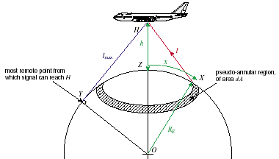

For single interference which hits the receiver directly (free space propagation), the path length l can be determined by:
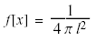
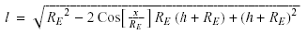
Where the values of and are physically constrained by the Earth curvature:
and respectively
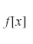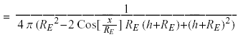
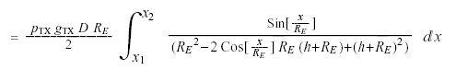
and, for the normalized form:
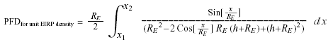

A2.2.2.2 Assumptions
To illustrate the impact on the airborne receiver, Berlin and its statistical data were used as example:
The city has an area of 900 km²; the average area for a building is 1.16*10⁻³ km². 40% of the area is covered with buildings (360 km²), so you have 860 buildings/km². On average a building has 6 flats that mean 5 200 interferer/km². As an assumption 10% of the flats are featured with broadband internet access via PLT, the interferer are reduced to

500 interferer/km². Not all PLT modems will be used at the same time. For that point we reduce the interferer density by 50%. That means, the interferer density is about 250 interferer/km² for a city like Berlin.

A2.2.2.3 Calculation
Using the maximum permissible interference field strength in Table 1, the permitted power flux-density, PFD, at the receiver can be calculated:
where:
PFD: power flux-density in W/m²;
E: maximum permissible interference field strength field in V/m.
By using the compatibility model described in section 3.1 the permitted radiating power of one PLT noise source can be calculated then.

h: flight altitude in km;
R_{E}: Earth’s radius in km;
G_{TX}: antenna gain of an isotropic source;
D: interferer density in interferer/km²;
PFD: power flux-density in W/m².
The calculations also were made for the flight altitudes 300 m, 1 000 m and 10 km. The difference between 300 m and 10 km is only 2 dB which means the flight altitude is irrelevant for the consideration.

The results for the altitude of 1 km and interferer density of 250 interferer/km² are summarized in the following Table 2. This table contains the maximum permissible interference field strength from Table 1, the calculated maximum PFD determined at the airborne receiver and the resulting maximum permissible radiating power of one PLT noise source at the ground.
Table 2
Maximum permissible radiating power of one PLT noise source measured by a quasi-peak (QP) detector
having a bandwidth of 120 kHz
 | Maximum permissible interference field strength at the airborne receiver | PFD  Maximum permissible power flux-density at the airborne receiver | PTX  Maximum permissible radiating power of one PLT noise source
VHF COM  8.3 kHz raster  117.975-137 MHz | 6 dB(µV/m) | 0.0106 pW/m² | −80 dBm / 10 dB(pW)
VHF COM  25 kHz raster  117.975-137 MHz | 6 dB(µV/m) | 0.0106 pW/m² | −80 dBm / 10 dB(pW)
UHF COM  25 kHz raster  230-380 MHz | 21 dB(µV/m) | 0.334 pW/m² | −65 dBm / 25 dB(pW)
VOR  40 kHz Raster  108-117.975 MHz | 26 dB(µV/m) | 1.056 pW/m² | −60 dBm / 30 dB(pW)
ILS-LOC  108.1-111.95 MHz | 23 dB(µV/m) | 0.529 pW/m² | −63 dBm / 27 dB(pW)
VDL Mode 2  118-138 MHz | 30 dB(µV/m) | 2.653 pW/m² | −56 dBm / 34 dB(pW)

The values for the maximum permissible radiating power of one PLT noise source vary for the different services between 10 and 34 dBpW.

A2.2.3 Calculation of power flux-density caused by limits provided by PLT system standards
The maximum power spectral density is standardized for PLT devices for in-house communications, e.g. by ITU-T and IEEE.
Table 3
Maximum power spectral density by different organizations
 | maximum power spectral density for PLT devices above 30 MHz
Amendment 1 to ITU-T Rec. G.9960 | −85 dBm/Hz (RMS)
Draft standard IEEE P1901 | −85 dBm/Hz (AV)
For noise-like communication signals, the relation between the readings of the measurement receiver obtained from different detectors is the following:
a) peak (PK) 0 dB reference value
b) quasi peak (QP) −2 dB
c) root mean square (RMS) −10 dB
d) average (AV) −12 dB
In the following calculation a maximum transmit PSD level of −85 dB/Hz (RMS) is used. The maximum power spectral density is assumed to be constant for frequencies above 30 MHz. The conversion into the aggregated radiated field strength at 10 m from the building (measured with a peak detector) was performed by the same method (finite-element modelling) as already described in a previous contribution on the compatibility between HF aeronautical Mobile radio and PLT.
Assuming an isotropic antenna, the field strength can be converted into power by:
where:
E: field strength in dBµV/m;
P_{t}: power in dBm;
d: distance in km.
The same assumptions as in section 3 were used: an interferer density of 250 interferer/km² and a flight altitude of 1 km.
Table 4
Maximum power flux-density at the airborne receiver
Maximum power spectral density for PLT devices above 30 MHz | Aggregated radiated field strength at 10 m distance from the building | Aggregated power corresponding to the field strength | PFD  Aggregated power flux-density at the airborne receiver
−85 dBm/Hz (RMS) | 33 dBµV/m (PK) | 4 nW (PK) | 3.903 pW/m² (PK)

In Table 4 it can be seen that a PLT device, with a maximum power spectral density of
−85 dBm/Hz (RMS), causes a radiation of a field strength of 33 dBµV/m measured with a peak detector.

A2.2.4 Comparison of interference threshold required for airborne receiver and interference caused by PLT systems
The maximum permissible interference field strength and power flux-density at the airborne receiver are listed in Table 2. The corresponding aggregated power flux-density at the airborne receiver radiated by PLT is contained in Table 4. This value is converted into the maximum radiated field strength at the airborne receiver.
The permissible field strength and PFD (see section 2) are compared with the radiated values (see section 4) in the following Table 5. For better comparison the peak values used for the PLT interference in Table 4 are referred to quasi peak in following considerations, i.e. reduction of 2 dB.
Table 5
Comparison of maximum permissible and aggregated radiated field strength at the airborne receiver
and margin required for protection (all values given in terms of QP)
 | Maximum permissible interference field strength | Maximum permissible power flux-density | Aggregated radiated field strength | Aggregated radiated power flux-density | Margin required for protection
VHF COM  8.3 kHz raster  117.975-137 MHz | 6 dB(µV/m) | 0.0106 pW/m² | 30 dBµV/m | 2.512 pW/m² | −24 dB
VHF COM  25 kHz raster  117.975-137 MHz | 6 dB(µV/m) | 0.0106 pW/m² | 30 dBµV/m | 2.512 pW/m² | −24 dB
UHF COM  25 kHz raster  230-380 MHz | 21 dB(µV/m) | 0.334 pW/m² | 30 dBµV/m | 2.512 pW/m² | −9 dB
VOR  40 kHz Raster  108-117.975 MHz | 26 dB(µV/m) | 1.056 pW/m² | 30 dBµV/m | 2.512 pW/m ² | −4 dB
ILS-LOC  108.1-111.95 MHz | 23 dB(µV/m) | 0.529 pW/m² | 30 dBµV/m | 2.512 pW/m² | −7 dB
VDL Mode 2  118-138 MHz | 30 dB(µV/m) | 2.653 pW/m² | 30 dBµV/m | 2.512 pW/m² | 0 dB

The last column in Table 5 shows the margin which is needed to reduce the interference caused by PLT devices. Assuming a maximum power spectral density for PLT devices of −85 dBm/Hz (RMS), a reduction of 24 dB would be necessary for the VHF systems. The margins vary between 0 and −24 dB depending on the system.
These calculations were made for an interferer density of 250 interferer/km². The correction depends linearly on the interferer density (see also Document 1A/157).
Table 6
Interferer density correction values
Interferer density (interferer/km²) | Correction value
50 | 7 dB
100 | 4 dB
150 | 2 dB
200 | 1 dB
250 | 0 dB
300 | −1 dB

A2.2.5 Conclusions
Assuming a maximum power spectral density for PLT devices of −85 dBm/Hz (RMS) as currently defined e.g. in amendment 1 to ITU-T Recommendation G.9960, all investigated aeronautical radio systems in the frequency range above 80 MHz, except VDL Mode 2, would be interfered at the airborne receiver by PLT. The concerned systems are VHF COM, UHF COM, VOR and ILS LOC.
The margin required for protection of the aeronautical systems reaches up to 24 dB for the VHF systems. Or with other words, the maximum power spectral density for PLT has to be reduced by this margin.

A2.3 PLT aggregation model applicable for aircraft radiocommunication and radionavigation systems
Assuming free-space path loss the minimum coupling loss can be translated into a minimum separation distance for a single source using the following formula:
where:
L_{bf} = Free-space basic transmission loss (dB);
f = Frequency in MHz;
d = distance in km.
Aggregating all of the single point source can be achieved using the following formula
where:
A = average aggregate interference in (watts per unit bandwidth);
W_{eirp} = equivalent average PLT device EIRP (watts per unit bandwidth);
λ = wavelength (meters);
Gr = victim receiver antenna gain;
ρ = average density of PLT emitters (emitters per meter²);
R_{e} = effective earth radius (meters);
R = radius of the observed zone or the radio horizon;
h = height of the receive antenna above the ground (meters);
H = Re(1-cos(R/R_{e}).

Annex 3
Radio-frequency emissions from PLT systems
in the VHF and UHF bands

A3.1 Introduction
This Annex addresses the impact on radiocommunication services from unintentional emissions of wired-telecommunication systems including Power Line Telecommunication (PLT) Systems and the criteria required for protection. Initially, PLT systems operated at frequencies bands below 30 MHz and so the resulting radiation was also in these bands. Unfortunately, increased use is being made of mains electrical wiring for the transmission of wideband data. Mains electrical wiring is, typically, neither designed nor engineered for the transmission of wide bandwidth data and incidental radiation from the wiring is a consequence. Any broadcast receiver operated in the vicinity of a mains conductor carrying PLT will perceive this radiation as an increase in the noise floor and inhibit the receiver’s ability to resolve low level signals. The introduction of ITU-T Recommendation G.9960 has extended the frequency of PLT operation to 200 MHz. Despite the limitations suggested by ITU-T Recommendation G.9960, measurements of PLT devices reveal that emissions occur well beyond 200 MHz. These findings and the impact on radiocommunication services are summarized in this Report.
This Annex is supplemented with data from analyses, laboratory tests, field tests, and various measurement programmes that can be found in Reports ITU-R SM.2158 and ITU-R SM.2157.

A3.2 Radio-frequency emission measurements from PLT systems

A3.2.1 Institut für Rundfunktechnik GmbH (IRT) measurements of PLT modems
This section provides technical information concerning the performance and the radiation characteristics of some PLT systems. The information includes the results of initial measurements of spectrum usage of modern Power Line Telecommunications (PLT) modems carried out at the IRT), the central research and development institution of the public service broadcasting organizations in Germany, Austria and Switzerland. The information is intended to assist in the assessment of interference stemming from PLT devices.

A3.2.1.1 Overview of the measurements
The typical frequency range for the two power line telecommunication technologies currently used throughout Europe is 2-30 MHz for Homeplug AV and 2-32 MHz for UPA (Homebone, DS2). Frequency notching is used to minimize interference to emission within the frequency bands used by amateur radio operators. In addition, the transmit power in various frequency ranges is reduced by approx. 30 dB in order to reduce interference with other users in these parts of the frequency spectrum. The most recent generation of chip sets, which is oriented towards the future G.hn standard or the G.9960 recommendation, also occupies the spectrum between 50 and 300 MHz. Measurements of spectrum usage of these, in total, three PLT technologies, in particular by a representative of mediaxtream, the newest Gigabit chip set from Gigle, aim to capture the utilization levels on the power lines as well as possible radiation levels. It remains to be clarified to what extent interference or adverse effects may occur in the broadcast bands due to the use of the PLT adapters.

A3.2.1.2 PLT performance
Despite the fact that the identical Intellon INT6300 chip set is used in the products by Allnet, Devolo, and Zyxel and the identical DS2 DSS9010 chip set in the products by AcBel and Conceptronic, differences in performance can be detected. The determined measured values show very good performance of all power line devices operating in accordance with the transmission control protocol (TCP). Even at a distance of 22 meters and different current phases, data rates of 50 to 74 Mbit/s are achieved, that, for example, allow for the streaming of two HD signals while still having sufficient reserve to manage a transfer rate of 10 Mbit/s for other purposes. The adapters by Allnet, Devolo, and Zyxel as well as adapters by AcBel and Conceptronic have a nominal maximum transmission rate of 200 Mbit/s, which equals a maximum user data transfer rate of approx. 80 Mbit/s. The Belkin Gigabit Powerline HD adapters with the mediaxtream chip set by Gigle (GGL541) have to be individually analysed since they are the only ones with a Gigabit network connection and have a nominal maximum transmission rate of 1 000 Mbit/s. Under real operating conditions, the maximum user data transfer rate may be significantly lower. Nevertheless, in using the 50-305 MHz spectrum, the Gigle GGL541 chip set enables a clearly faster data transfer rate than the chip sets from Intellon (2-30 MHz) and DS2 (2-32 MHz). Belkin adapters were able to demonstrate this, for example, at a distance of 2.3 meters. At “shorter distances” the performance of the Gigle chip set outperforms the Intellon and DS2 chip sets by a factor of 3.5. At a distance of 22 meters, the performance of the Belkin adapters deteriorates. Starting at a line length distance of approx. 10 meters or with higher attenuation between the two Belkin adapters, the devices only operate in the Homeplug AV spectrum (lower frequency band: 2-30 MHz). The data throughput of 50 Mbit/s is then approx. 30 percent lower than that of the Intellon and DS2 adapters.
Table 1 tabulates the technical characteristics of power line adapters measured. Three pairs of the Powerline standard Homeplug AV by the manufacturers Allnet, Devolo, and Zyxel as well as two UPA devices by AcBel and Conceptronic were tested. As a third version, the new Gigabit Powerline adapters by Belkin were tested and reported herein; they are the only ones with a maximum nominal transmission rate of 1 000 Mbit/s.
Table 1
Specifications of tested power line adapters
 | 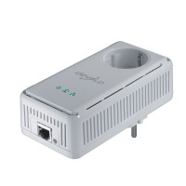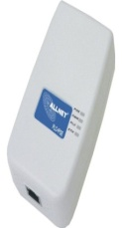 |  | 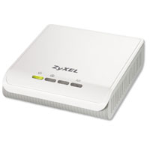 | 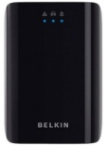 | 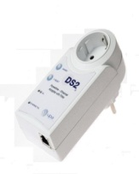 | 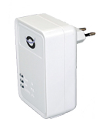
Manufacturer | Allnet | Devolo | Zyxel | Belkin | AcBel | Conceptronic
Product | Allnet ALL168203 | Devolo dLAN  200 Avplus | Zyxel PLA-400 v2 | Belkin Gigabit Powerline HD | AcBel DH10PF | Conceptronic Homeplug 200 Mbps
Homeplug standard | Homeplug AV |  |  | HPAV  mediaxtream  (G.9960) | UPA
Transmission speed (nominal) | 200 Mbit/s |  |  | 1 000 Mbit/s | 200 Mbit/s
Spectrum | 2-30 MHz |  |  | 2-30 MHz  50-300 MHz | 2-32 MHz
Protocols | CSMA/CA |  |  | CSMA/CA  TDMA MAC | TDMA MAC
Modulation | OFDM - 1155 carrier,  1024/256/64-QAM, QPSK, BPSK |  |  |  | OFDM - 1536 carrier
Safety | 128Bit AES via keystroke or software |  |  | 128Bit AES  via keystroke | 168 bit 3DES
Activation via software | Yes |  |  | No | No | Yes
LEDs | Power  Powerline Link  Ethernet Link |  |  | Powerline Link  Ethernet Link  Safety | Status  Ethernet  Access Point | Power  Powerline Link  Ethernet Link
Power supply | AC 110-240 V  50/60 Hz | AC 100-240 V  50/60 Hz |  | n/a | AC 110-240 V  50/60 Hz | AC 110-230 V  50/60 Hz
Firmware  can be updated | Yes |  |  | Yes | Yes TFTP | Yes
Configuration  software | Yes |  |  | No | No | Yes
Power consumption | 3.5 W (max.)  1.9 W in idle mode | 3 W (max.)  2.6 W in idle mode | 4.2 W (max)  3 W in idle mode | 5.8 W (max.)  4 W in idle mode | 6.5 W (max.)  5.5 W in idle mode | 7.2 W (max.)  5.7 W in idle mode

A3.2.1.3 Measuring of frequency spectrums
For the realization of the measurements, one lead of the power cable that was transmitting the data traffic was placed in a R&S MDS 21 absorbing clamp and the remaining leads were left outside (ref. Fig. 1). The attenuation of the measuring clamp is indicated with 17 dB in the range between 30-1 000 MHz; therefore this value has to be added to the indicated levels in order to determine the correct HF level on the power line. Representative of the Powerline standard, AcBel, Allnet and Belkin devices were used for the measurements. A data transfer that pushed the devices to their performance limits was generated between two identically built Powerline adapters. During the active performance measurement, the spectrum analyser FSEA recorded the frequency spectrum.
Figure 1
Measuring set-up with absorbing clamp

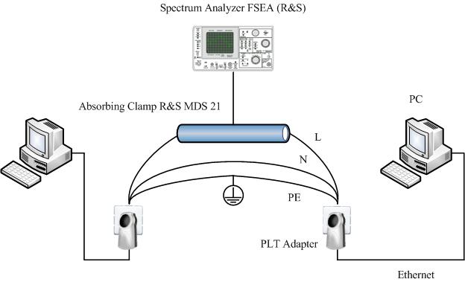
Figure 2
On-air signals and background noise at measuring site visible are (inter alia):
SW, FM (87,5-108 MHz, DAB (around 215 MHz))

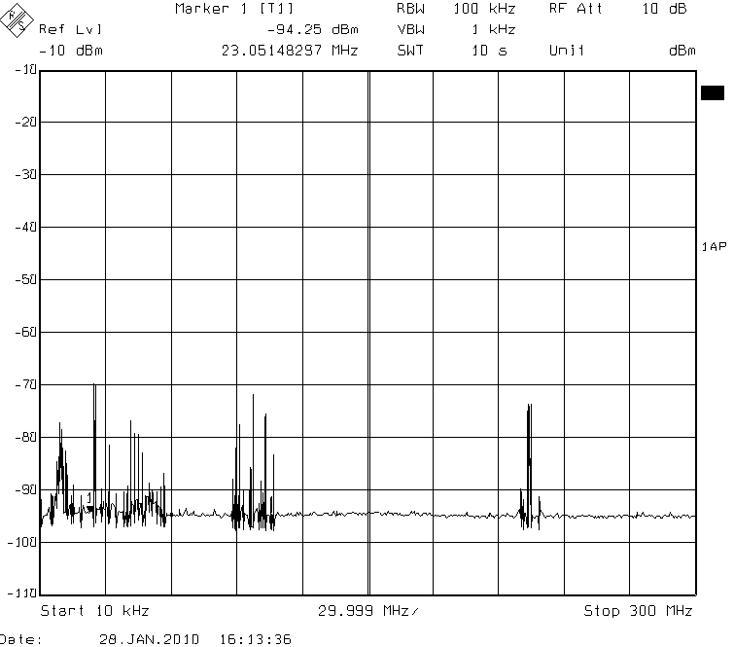
Figure 3
Power spectrum of AcBel UPA in idle mode and for maximum data throughput

UPA (AcBel DH10PF)
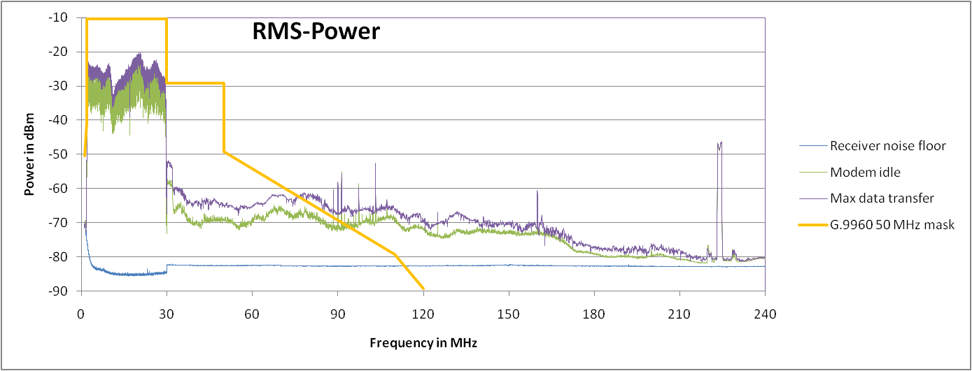
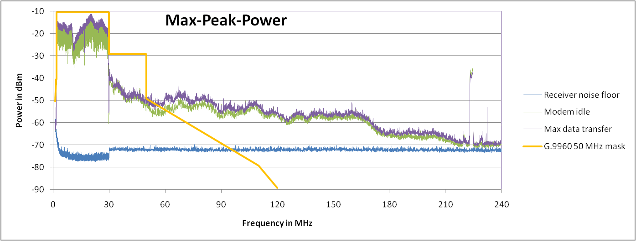

According to the manufacturer, Powerline adapters in compliance with the UPA standard use a frequency range of 2-32 MHz. The spectrum analysis, however, shows (ref. Fig. 3) that UPA still generates spectral components beyond 32 MHz up to almost 190 MHz, although clearly lowered by approx. 50 dB. The levels in the actual working range are approx. −15 dBm (attenuation of the absorbing clamp included).

Figure 4
Power spectrum of Allnet Homeplug AV in idle mode and for maximum data throughput

Homeplug AV (Allnet ALL 168203)
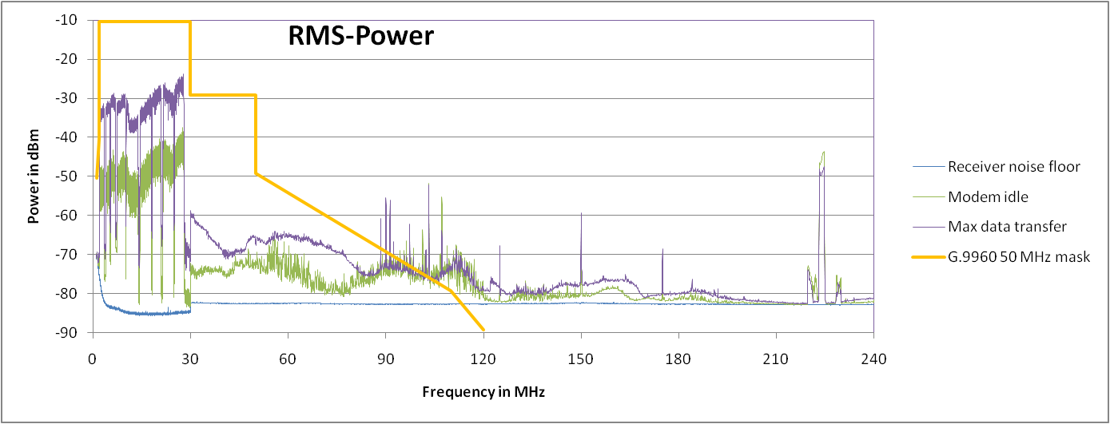
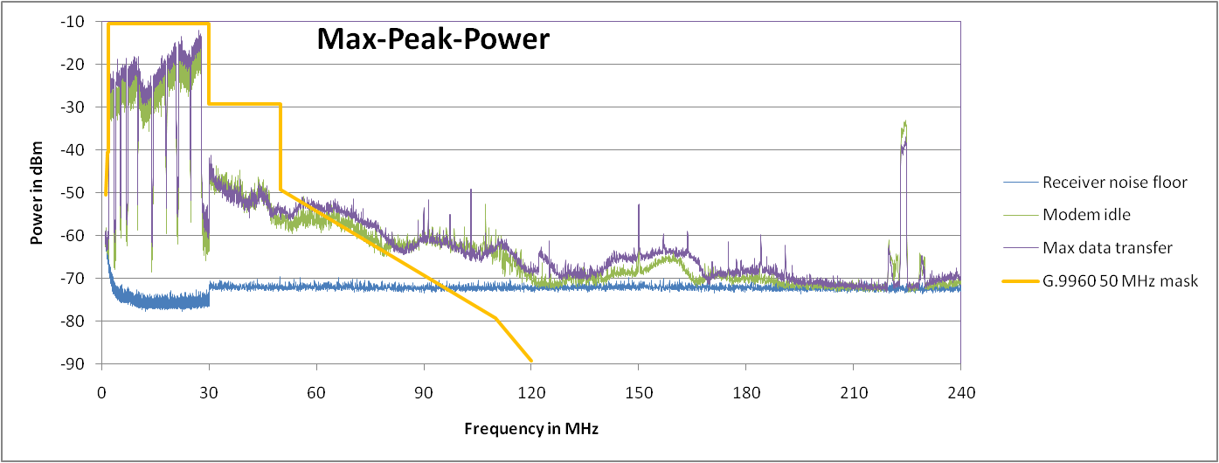

According to the manufacturer, Powerline adapters in compliance with the Homeplug AV standard use a spectrum of 2-30 MHz. Although Homeplug AV and UPA indicate the same maximum transmission rate of 200 Mbit/s, their frequency spectrums differ. Homeplug AV has similarly high levels in the lower frequency range; the levels of the higher spectral components, however, are lower than those in UPA devices (ref. Fig. 4). Spectral components range up to approx. 70 MHz.

Figure 5
Power spectrum of the Belkin adapter in idle mode and for maximum data throughput

Mediaxtream − G.9960 (Belkin Gigabit Powerline HD)
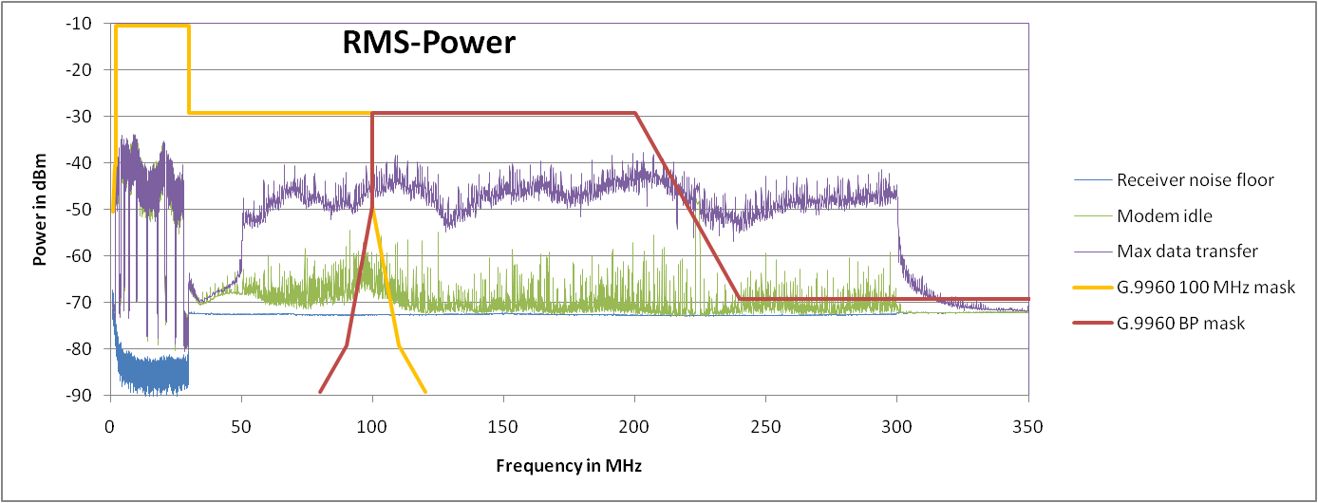
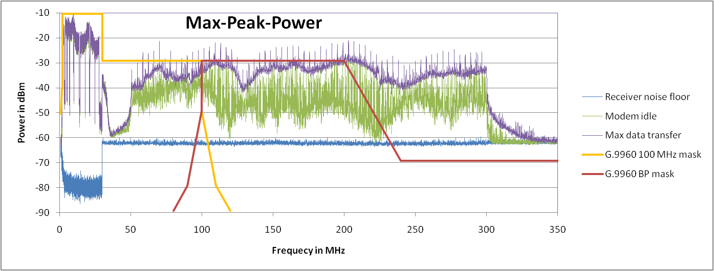

According to the manufacturer, Powerline adapters with mediaxtreme chip sets (in compliance with G.hn / G.9960 standard) can communicate in the frequency range of 2-30 MHz (HPAV) and 50-300 MHz. However, the simultaneous use of both spectrums is not (yet) possible. In the case of a data transfer with several TCP connections, it became clear that the communication between two adapters takes place in the 50-305 MHz spectrum range (upper band), see Fig. 5. The levels in this frequency range are approx. 25-30 dB lower than those of the devices from AcBel and Devolo (2-30/32 MHz). Despite the communication in the upper band, powerline devices in compliance with the mediaxtream − G.9960 standard simultaneously show spectral components in the lower band.

A3.2.1.4 Interference radiation of the Belkin PLT modem “Powerline Gigabit” F5D4076-S v1
Two mains extension leads, each with a 1.5 m long power cable, were connected left and right to a mains extension lead connected to the mains wall socket (230 V), allowing for the two extensions to be placed at a distance of 3m on a table (ref. measurement setup in Fig. 6). The Belkin modems were plugged into the outer sockets and connected with two notebooks. Then, data with a net rate of up to 250 Mbit/s (TCP) were transmitted by using the IxChariot software tool. A Schwarzbeck UBAA 9114 antenna was placed at a distance of 3m and a height of 1.5 m. The horizontally and vertically polarized field strength was captured in the 30-320 MHz frequency range. The measurements were taken with the EMC test receiver R&S ESPI. The settings of the test receiver were as follows:
− Measuring bandwidth: 120 kHz
− Measuring step: 40 kHz
− Measuring time: 100 ms
− With pre-amplifier
− Attenuation: 10 dB
− Measuring detectors: Peak and RMS (root mean square)
Figure 6
Set-up for the interference radiation measurements

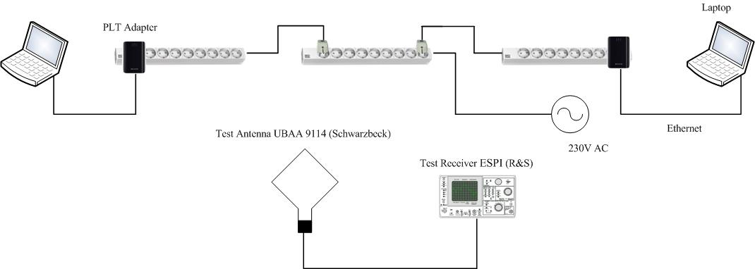

The conversion rate (antenna factor) of the broadband antenna UBAA9114 was entered into the receiver as a value table depending on the reception frequency in order, for the measuring results, to be directly recorded in dBµV/m. During two measuring runs the peak value and RMS value of the field strength were measured for each frequency. Measurements with a quasi-peak value detector were not made because such a measuring run would take many hours for a single measurement value. Instead, the quasi-peak value detector was intentionally used to replicate the influence of impulse interferences on the human ear during reception of an analog radio program. Except for the FM band, interference above 30 MHz has its effect on digital services for which the interference effect can be better described with RMS and peak values.

Following field-strength values were measured and recorded in horizontal and vertical polarization:
− System noise of the measuring receiver (lower reference of measuring system).
− Environmental noise.
− Interference with modems in idle mode.
− Interference with modems during data transfer with up to 250 Mbit/s gross data rate.
As upper reference, the limits given in Table 6 of Standard EN 55022 (April 2007) are entered in the diagrams. The limit values are indicated in quasi-peak values. Quasi-peak values are usually lower than the peak values, but in any case higher than the RMS values.

A3.2.1.5 Field strength with horizontal polarization
Figure 7
Peak values of the horizontally polarized field strength in dBµV/m

The blue line in Fig. 7 represents the smallest measurable field strength that equals the measuring receiver’s system noise. The red line represents the course of the environmental noise (man-made noise) in absence of the modems. Since the measurements were made at the IRT, where many electrical and electronic systems are operating, the environmental noise is rather high (red line); below 150 MHz it is even above the upper limit value line. The peaks of the field-strength values in the 87.5-108 MHz range match the FM signals, those around 220 and 229 MHz range match the DAB signals that can be received at the IRT.
When the modems are switched on, the interference field strength increases, as indicated by the green line. During data transfer, the interference field strength again climbs, indicated by the violet line. Above 130 MHz, the level of the interference field strength caused by the modems is some dB above the environmental noise; this means the measured values are correct. The peak values of the modems’ interference during data transfer as well as in idle mode are in excess of the limit values of up to approx. 20 dB.
Figure 8
RMS (Root Mean Square) values of the horizontally polarized field strength in dBµV/m

The RMS values in Fig. 8 are approx. 10 dB lower than the respective peak values for permanent interference such as the system noise of the test receiver (blue) and the interference of the modems in operation (violet). The interference of the modems in idle are pulsed, which explains why the different peak value vs. RMS values increased (green lines). The RMS values of the interference of the modems during data transfer are in part also above the limit values.

A3.2.1.6 Field strength with vertical polarization
Figure 9
Peak values of vertically polarized field strength in dBµV/m

The values in Fig. 7 also apply for the field-strength values in Fig. 9. The DAB signals at 220 MHz and 229 MHz are higher since they are transmitted at a vertical polarization. The peak values of the modems’ interference during data transfer as well as in idle mode are above the limit values in the entire frequency range.
Figure 10
RMS values of the vertically polarized field strength in dBµV/m

The comment on Fig. 8 also applies to Fig. 10. The RMS values of the modems’ interference during data transfer touch the limits in the 30 to 200 MHz range, the quasi-peak values are above this range at any rate.

A3.2.1.7 Conclusion from the IRT measurements
The spectral measurements made on the PLT adapters “Powerline Gigabit” F5D4076 S by Belkin on the one hand show the occupation of frequencies up to 305 MHz, which includes the FM band as well as the DAB band. On the other hand, the interference measurements show that interference due to the modems is stronger than the EN 55022 standard allows in the 30-300 MHz frequency range. One possible solution would be the use of frequency notching in the affected bands. The manufacturer of the mediaxtream chip set, Gigle, has already offered such consequential actions in case of appropriate feedback.

A3.2.2 Communication Research Centre (Canada) measurements of PLT modems
The Communications Research Centre (CRC, Canada) evaluated a total of eight commercially-available PLT devices representing the various PLT standards. These devices were readily available in the United States of America, Canada, and Japan. The test measurement details and results can be found in the report “Measurements of EM radiation from in-house Power Line Telecommunication (PLT) devices operating in a residential environment − Field Test Report”, Communications Research Centre (Canada), 24 March 2009 at URL: http://www.nabanet.com/nabaweb/members/pdf/itur/CRCReport.pdf or see the Attachment to the Annex of Document 6A/160. A summary is available in Report ITU-R SM.2158. The tests included measurements up to 110 MHz in order to determine the impact of the PLT devices on the FM broadcasting band.

A3.2.2.1 CRC measurement procedure and conducted emission results
The measurement of the test bed noise floor from 50 kHz to 110 MHz is shown in Fig. 11. The figure illustrates that the electrical line test setup acted as an antenna that captured signals from other radiocommunication systems. The spikes between 85 MHz and 108 MHz are from local FM radio stations, while other spikes at other frequencies were intermittent and probably caused by other radiocommunication systems. It was necessary to take this into account when looking at the conducted emission results.
The results for PLT devices 2, 3 and 6 are shown in Figs. 12, 13, and 14 respectively. The blue curve shows the conducted signal during data transfer and the green curve (generally, the lower trace) shows the conducted signal in the idle mode. As can be seen in the figures, the signal level in idle mode does not exceed the signal level in data transfer mode. Additionally, the devices tested don’t operate identically in idle mode. PLT devices 2 and 3 were transmitting occasional carriers to keep the channel open and synchronized, while device 6 was constantly transmitting its full signal bandwidth.
Figure 11
Conducted measurements test setup noise floor
Figure 12
Conducted power from Device 2 (HD-PLC standard)

Figure 13
Conducted power from Device 3 (Homeplug AV standard)
Figure 14
Conducted power from Device 6 (UPA standard)

A3.2.2.2 Conclusions from the CRC measurements
These results illustrate that even if the PLT device is not transmitting data, the device is actively generating emissions. It is also observed that even if the PLT device operates below 30 MHz, the device has emissions at least 20 dB above the noise floor up to 110 MHz.

A3.2.3 CBS Broadcasting and National Public Radio (NPR) measurements of a “Gigabit” PLT modem
CBS Broadcasting and National Public Radio (NPR) conducted a series of measurements at the NPR Labs similar to those of IRT described in Section 2.1 above. Measurements of conducted emissions were made from a pair of Belkin “Gigabit Powerline HD” F5D4076-S v2 PLT modems.

A3.2.3.1 Measurement procedure
A pair of Belkin “Gigabit Powerline HD” PLT modem adapters (Model: F5D4076-S v2) were connected with a two-wire 1.8 meter extension cord and placed within a shielded test box as illustrated in Fig. 15. The shielded box provided AC power line filtering and RF coaxial connections. The PLT adapters were connected to a desktop computer and an Ethernet router to a server. File transfers were initiated from the server to the computer.
An Anritsu spectrum analyser Model MS2721A was used to record the frequency spectrum. The spectrum analyser settings were as follows (unless otherwise noted):
− Resolution bandwidth (RBW): 1 MHz
− Number of measurement steps: 551\
− Without preamplifier
− Attenuation: 0 dB
− Measurement detector: Peak
− Trace: Max hold.
A double wire loop provided coupling from the hot side of the power line to the spectrum analyser. The following results illustrate the signal power as a function frequency as measured by the spectrum analyser.
Figure 15
Measurement setup using a shielded box

A3.2.3.2 Conducted emission measurement results for the Belkin “Gigabit Powerline HD” F5D4076-S v2 PLT modem
Fig. 16 illustrates the signals being carried by the power line between two Belkin “Gigabit Powerline HD” PLT modems (Model: F5D4076 S v2) in the idle state (no data being transferred). It is noted that the adapters have a substantial output up to 300 MHz as was reported by IRT. However, the emissions extend well beyond 300 MHz up to 930 MHz with an additional signal obvious at 1 970 MHz.
Figure 16
Conducted emission from a pair of Belkin “Gigabit Powerline HD” PLT modems (Model: F5D4076-S v2) −
Note that emissions occur up to 1 GHz and beyond at 1.9 GHz (RBW: 3 MHz, Reference level: −30 dBm)

Fig. 17 illustrates the conducted emissions from a pair of Belkin “Powerline Gigabit” PLT modems (Model: F5D4076-S v2) up to 200 MHz with the PLT modems in the idle state (no data being transferred). The upper trace (black) is compared to the noise floor (lower trace in red) of the shielded test box. Note that the PLT modems have substantial emissions up to 27 MHz and again above 70 MHz.

Figure 17
Conducted emissions from a pair of Belkin “Powerline Gigabit” PLT modems (Model: F5D4076-S v2) over a frequency range up to 200 MHz. The upper trace (black) represents the emission of modems while idle
(no data transfer); the lower trace (red) illustrates the noise floor of the shielded test box

Fig. 18 illustrates the conducted emissions from a pair of Belkin “Powerline Gigabit” PLT modems (Model: F5D4076-S v2) up to 200 MHz with the PLT modems in the active state (data being transferred). The upper trace (black) is compared to the noise floor (lower trace in red) of the shielded test box. Note that the PLT modems have additional emissions between 27 MHz and 70 MHz.

Figure 18
Conducted emissions from a pair of Belkin “Powerline Gigabit” PLT modems (Model: F5D4076-S v2) over a frequency range up to 200 MHz. The upper trace (black) represents the emission of modems while active
(data transfer); the lower trace (red) illustrates the noise floor of the shielded test box

A3.2.3.3 FM receiver interference from the Belkin “Gigabit Powerline HD” F5D4076-S v2 PLT modem
Since it has been clearly shown that the PLT modems will radiate at frequencies well above 27 MHz, a test was performed using a Sony “boombox” FM broadcast receiver in the vicinity of the PLT devices. Fig. 19 illustrates the conducted emissions from a pair of Belkin “Powerline Gigabit” PLT modems (Model: F5D4076-S v2) at a single frequency of 88.1 MHz. The spectrum analyser shows a single sweep as the modems transition from an idle state to an active state (data transfer).
The impact of the PLT interference on the FM broadcast receiver is an annoying and unacceptable “motor-boating” in the audio output. The impulse rate at idle, shown on the left half of the sweep, was approximately 40 per second, which increased during data transfer as shown in the right half.

Figure 19
Conducted emission over a one second interval from a pair of Belkin “Powerline Gigabit” PLT modems (Model: F5D4076-S v2) at a single frequency of 88.1 MHz in the FM broadcast band. The interference is exhibited
as a “motor boating” effect in the audio output
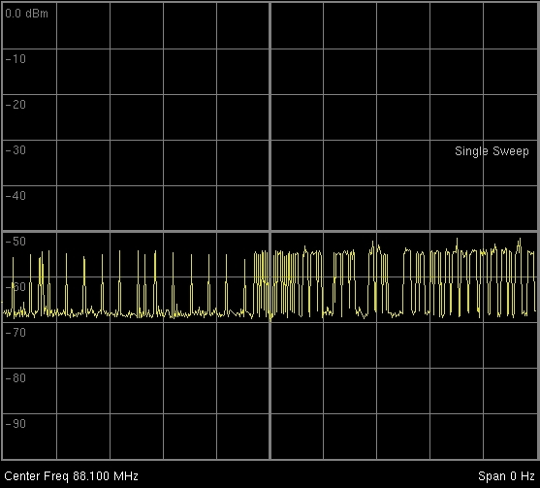

A3.2.3.4 Conclusions from the CBS/NPR measurements
The CBS Broadcasting and National Public Radio (NPR) series of measurements at the NPR Labs confirm the results obtained by IRT. The Belkin “Gigabit Powerline HD” F5D4076-S v2 PLT modem clearly has emission throughout the radio-frequency spectrum below 1 000 MHz. Furthermore, it is the view of NABA that ITU-T Recommendation G.9960 provides no interference protection to radiocommunication services from these emissions.

Annex 4
Design examples of PLT technology using the VHF and UHF bands

[TBD]

RR Nos. 15.12.1 and 15.13.1 In this matter, administrations should be guided by the latest relevant ITU-R Recommendations.”
M. Kitagawa and T. Ohira, “Mixed-mode scattering matrix of a balanced transmission line unilaterally loaded with a stub in series − Pencil-and-paper formulation −”, IEICE Tech. Rep. MW (July 2010).
ECC Report 024 (2003), PLT, DSL, Cable Communications (including Cable TV), LANs and their effect on Radio Services, http://www.erodocdb.dk/doks/doccategoryECC.aspx?doccatid=4&alldata=1.
ITU-R, Document 1A/157, Compatibility between HF aeronautical Mobile radio and PLT In-house devices, 2009, Germany.
CENELEC EN 55022: 2006; Information technology equipment − Radio interference characteristics − Limits and methods of measurement (CISPR 22: 2005 (modified)).

