

ECO Guidelines

on

the use of GoToMeeting platform

European Communications Office
November 2011
Table of Contents

Introduction
1. Web-casting
1.1 An alternative solution for web-casting
2. Web-conferencing
3. Virtual participation in physical meetings and workshops
4. Supplementary information
Introduction

These ECO Guidelines have been developed in response to the task given to ECO by the 24th ECC meeting (26-30 October 20009, Skopje, FYR of Macedonia) on the issue of the implementation of electronic working methods in the ECC working process.

The Guidelines are particularly aimed at assisting ECC entities within the 2-year trial period of implementation of the following virtual participation methods:
- web-casting,
- web-conferencing, and
- virtual participation in physical meetings.

The proposed solution is based on the GoToMeeting platform (www.gotomeeting.com) which includes:
  - A GoToMeeting application suitable for web-conferencing with up to 25 virtual participants, and
  - A GoToWebinar application suitable for web-casting of seminars and workshops and virtual participation in physical meetings with up to 1000 virtual participants (subject to the bandwidth of the connection line to the Internet and other limitations).

The GoToMeeting platform was chosen by the Office during the internal evaluation phase (October – December 2009) as the preferred one out of a number of similar software platforms currently available on the market.
The Office’s preference for the GoToMeeting platform is based on the following considerations:
- GoToMeeting appears to meet the major requirements to the virtual participation methods formulated by WG RA, first of all a high level of security and reliability;
- GoToMeeting seems to be the easiest one to start using almost without training due to its simple and user-friendly interface;
- neither administrative rights nor additional software (such as ActiveX or Java) are required to install and use GoToMeeting, however a permission from the IT department may be needed for the software installation;
- technical and user support of GoToMeeting has shown it to be responsive and efficient;
- GoToMeeting has been used within ETSI for some time and has proved to be an efficient tool for online-meetings; there has also been a number of successful trials of GoToMeeting within WGSE in November and December 2009;
- GoToMeeting is free of charge for participants; expenses for using it within the ECC are quite modest and can be covered by the Office.

These “ECO Guidelines on the use of GoToMeeting platform” have been developed based on the limited experience gained by the Office during the internal evaluation phase and are therefore subject to further review based on the feedback from the ECC groups.
- Web-casting

The Internal ECC Report on “Implementation of Electronic Working Methods (EWM) in the ECC working process” defines web-casting in the following way:
“Web-casting is an electronic working method where a meeting is broadcast over the Internet. The remote viewers have real time access to the sound and possibly the video of the meeting, but they cannot intervene during the meeting, that is this method does not allow for any interaction.”

The GoToWebinar application (as one of the two components of the GoToMeeting platform) is an efficient tool for web-casting implementation. It appears to be equally suitable for web-casting of meetings of ECC groups and seminars/workshops (should the format of a meeting/workshop allow for virtual participants to intervene, see the guidance in section 3 of these Guidelines).

The typical situation for using the GoToWebinar is a relatively big number of participants (up to 1000, subject to the bandwidth of the connection line to the Internet and other limitations) who cannot attend a meeting in person but would like to follow it remotely.

It is necessary that registration of virtual participants takes place prior to the beginning of a meeting. This can be done by including in the invitation to a meeting (or the announcement of a seminar/workshop on the ECO website) information on the scheduled meeting’s web-casting and a separate registration link for virtual participants.

Once the list of virtual participants has been reviewed and approved by the chairman of the relevant ECC group or by the person responsible for the registration to a seminar/workshop, an invitation containing the link and, optionally, the password for connection to the web-casting can be created through the GoToWebinar user interface (by an ECO expert or by the chairman/presenter advised by an ECO expert) and sent out to the approved virtual participants by e-mail.

A new event (GoToWebinar session) will automatically be added to the Outlook calendars of the organizer who has created the invitation and of the participants who have accepted it.

Virtual participants should ensure that the necessary software is installed on their PCs prior to the beginning of a meeting. It can either be installed in advance from www.gotomeeting.com or by clicking on the link enclosed in the invitation to virtual participants (for installation instructions and security related issues please refer to the “IT-security related information” below).

Shortly before the beginning of a meeting, the organizer should log in on his/her PC to one of the ECO accounts (advised by an ECO expert) and start the scheduled GoToWebinar session. The microphone system in the meeting room should be connected to the organizer’s PC. Either the whole screen or a relevant application (e.g. a document or a presentation) should be chosen on the organizer’s PC for web-casting.

Once the organizer has started a session, virtual participants (attendees) should be able to connect to the web-casting by clicking on the link which was sent to them in the invitation e-mail and, optionally, entering the password.

The organizer should be able to see the list of attendees who have joined the session. By default setting, they join with muted microphones in order to prevent intervention in the discussion as web-casting does not allow for this option.

Since virtual participants will only be able to follow the document/presentation displayed on the organizer’s PC (as well as to listen to the discussion), it is recommended that they have another laptop nearby with all other documents on the agenda uploaded to that laptop in advance.

+

For installation instructions and security related issues please refer to “IT-security related information”:

To get familiar with the GoToWebinar user interface please refer to:
- GoToWebinar organizer quick reference guide
- GoToWebinar attendee quick reference guide

All questions of a technical nature related to the installation and use of GoToWebinar should be addressed to the Office (it@ero.dk).
  - An alternative solution for web-casting

A web-camera can be installed, preferably in the ceiling of a meeting room at the distance of 3-5 m from the screen on which the documents will be displayed, and connected to the Internet. The microphone system and, optionally, the speakers in the meeting room should be connected to that web-camera. Alternatively, the web-camera can transmit sound taken from ‘the air’ through the built-in microphone.

The link to the web-camera can be published in the invitation to a meeting/seminar. The username and the password necessary to get connected to the web-casting can be distributed to the closed group of approved virtual participants.

Both the bandwidth of the Internet connection line and the limitation of the web-camera through which the web-casting will be exercised should be considered when defining the maximum number of virtual participants. Compression of the video stream which is being transmitted over the Internet can be set up using the web-camera software. There should be a balance between the quality of the picture and the bandwidth used for the web-casting. At the ECO premises, up to 20 participants (depending on the chosen audio/video settings) can simultaneously follow web-casting through the ECO web-camera.

In the ECO web-camera the built-in microphone is disabled, so physical participants have to activate the normal meeting room microphones to transmit the voice to the web-camera by wire which is then web-casted over the Internet. This ensures a high quality of the transmitted voice as well as it prevents transmitting talks of the participants near the web-camera during coffee-breaks.

It is recommended to display on the screen the message “Next session is scheduled to start at hh:mm” during the breaks between the sessions (for the benefit of the virtual participants).

There is also an “incoming” voice function in the ECO web-camera, which means that virtual participants can speak through the meeting room speakers if they press the small “mic” button in the window of the web browser. To avoid any accidentally transmitted sound from virtual participants, there is a switch box on the chairman’s table which allows either activating (ON) or deactivating (OFF) this optional function.

It is recommended that a network web-camera with similar or better characteristics than those of the ECO web-camera (Axis 211A network camera) is used for web-casting of meetings.

It should be noted that virtual participants have the opportunity to record a web-cast, either by clicking on the record button in the web browser (in case of web-casting through the ECO web-camera) or by using a third party software.
- Web-conferencing

The Internal ECC Report on “Implementation of Electronic Working Methods (EWM) in the ECC working process” defines web-conferencing in the following way:
“A web-conference is a meeting where the participants are not located together in a physical meeting room. It is similar to teleconferencing, except that the communications are Internet based and that software may be used to share meeting documents in real time.”

The GoToMeeting application (as one of the two components of the GoToMeeting platform) is an efficient tool for web-conferencing implementation. It appears to be suitable for meetings of lower level ECC groups with a limited number of participants (normally up to 10, the maximum being 25) which do not adopt final decisions (should the number of participants exceed 25, the GoToWebinar can be used instead). The GoToMeeting tool may also be used by the steering groups of ECC entities where discussion with a number of documents in the background prevail over drafting activity.

It is possible either to connect to a GoToMeeting session using a PC equipped with microphone and speakers (headset is highly recommended) or by calling in the session using an ordinary telephone. Combination of these two methods is also possible (e.g. using a PC for sharing documents online while listening and speaking via a telephone).

It is necessary that the organizer of a web-conference knows all the participants and their e-mail addresses in advance since the participants receive the link and, optionally the password, to join a GoToMeeting session in an e-mail invitation. Such an invitation is created by an ECO expert or by an organizer logged in to one of the ECO accounts (advised by an ECO expert) through the GoToMeeting user interface. A new event (GoToMeeting session) is automatically added to the Outlook calendar of the organizer and the participants who have accepted the invitation.

Participants of a web-conference should ensure that the necessary software is installed on their PCs prior to the beginning of a meeting. It can either be installed in advance from www.gotomeeting.com or by clicking on the link enclosed in the invitation to the web-conference (for installation instructions and security related issues please refer to the “IT-security related information” below).

Shortly before the beginning of a web-conference, the organizer should log in on his/her PC to one of the ECO accounts (advised by an ECO expert) and start the scheduled GoToMeeting session. Either the whole screen or a relevant application (e.g. a document or a presentation) should be chosen on the organizer’s PC for sharing with the participants.

Once the organizer has started the session, other participants should be able to connect to it by clicking on the link which was sent to them in the invitation e-mail and, optionally, entering the password. Alternatively, they can join the session by using an ordinary telephone, dialling the number and entering the PIN code included in the invitation. In this case a calling participant will be charged a fee for a long distance telephone call. It is therefore recommended to additionally include local toll dial-in numbers when scheduling a web-conference, so that the attendees joining via telephone could use them instead of the main telephone number.

- Calling in the session does not exclude the possibility to share documents with other participants within the same GoToMeeting session.
Once joined the session, a participant should identify himself/herself. It is also advisable saying ‘hello’ to others joining so they could check their connections both ways.

It is recommended that those using speakers + microphone instead of a headset should keep their microphones off (click on the green icon showing a mike on the user’s Control Panel) at all times except when they participate in the discussion. This would prevent a background noise from being heard by all participants.

It is also a good idea, in particular when you are using a PC for the first time, to test the connection with the meeting organizer in advance of the actual start of the meeting. In case it shows any signs of malfunction, you can always call in the session through an ordinary telephone, preferably using the local dial-in number, when the meeting starts. Otherwise (if your connection is stable and of good quality) you can avoid additional telephone charges for you company/organization by using a PC instead of a telephone.

In case of a small meeting (8-10 persons sitting around a table, with a few others being virtual participants), it is important to put the microphone away from the speakers; ideally they should be on different ends of the table, with the microphone's sensitivity properly tuned.

An organizer should be able to see the list of participants who have joined the session. He/she can also mute/unmute chosen participants.

Through the GoToMeeting user interface, an organizer can either give control over the shared application/screen to any of the participants or temporarily make another participant the organizer, so he/she could share his/her screen/application with other participants (e.g. present his/her documents) (for details please refer to “GoToMeeting attendee quick reference guide” and “GoToMeeting organizer quick reference guide” below).

A participant of a GoToMeeting session cannot request the floor as there is no “raise hand” button as in the GoToWebinar application. Instead one has either to intervene in the discussion by voice or send a text message (using Chat box).. A text message can be sent either circularly or to a chosen participant/organizer.

It is recommended that organizers periodically invite participants to express their views as it may be difficult for some participants to intervene without seeing physically other participants (as is the case in physical meetings).

Since participants in a web-conference will only be able to follow the document/presentation displayed on the organizer’s PC (as well as to listen to the discussion), it appears to be convenient having another laptop nearby with all other documents on the agenda uploaded to that laptop in advance:

+

It is recommended that web-conferences (web-meetings) of formally existing ECC groups be added to the ECO calendar (on the ECO website) for better visibility of activities (see some examples in the ECO Calendar below):
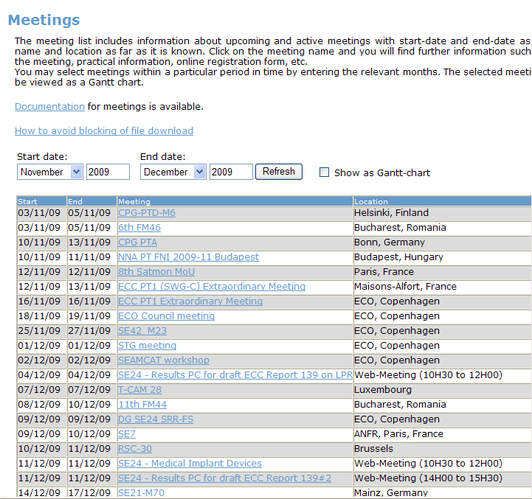

It is also a recommendation of the Office to handle documents for on-line meetings in the same manner as those for ordinary physical meetings (i.e. by means of creating a separate meeting documents folder for a web-meeting of an ECC group on the ECO Meeting Document Server):
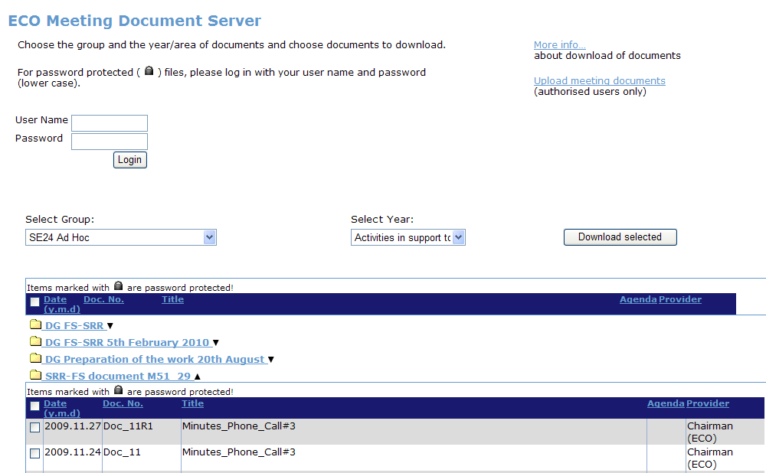

For installation instructions and security related issues please refer to “IT-security related information”:

To get familiar with the GoToMeeting user interface please refer to:
- GoToMeeting organizer quick reference guide
- GoToMeeting attendee quick reference guide

All questions of a technical nature related to the installation and use of GoToMeeting should be addressed to the Office (it@ero.dk).

- Virtual participation in physical meetings and workshops

The Internal ECC Report on “Implementation of Electronic Working Methods (EWM) in the ECC working process” defines virtual participation in physical meetings in the following way:
“This method gives the possibility to participate in a physical meeting from a remote location. In this case, virtual participants can actually intervene in the meeting by a voice and possibly a video connection.”

The GoToWebinar application (as one of the two components of the GoToMeeting platform) can be used for the implementation of virtual participation in physical meetings and workshops, as it allows both to follow the event remotely and to provide feedback directly to the meeting room.

GoToWebinar provides for a relatively big number of virtual participants (up to 1000, subject to the bandwidth of the connection line to the Internet and other limitations).

It is necessary that registration of virtual participants takes place prior to the beginning of a meeting/workshop. This can be done by including information on the scheduled GoToWebinar session and a separate registration link for virtual participants in the invitation and the meeting calendar of the corresponding group.

Once the list of virtual participants has been reviewed and approved by the chairman of the relevant ECC group or by the person responsible for the registration to a seminar/workshop, an invitation to virtual participants containing the link and, optionally, the password can be created through the GoToWebinar user interface (by an ECO expert or by other authorised person advised by an ECO expert) and sent out to the approved virtual participants.

Depending on the way of distributing the invitation, a new event (GoToWebinar session) can be automatically added to the Outlook calendar of the organizer who has created the invitation and the participants who have accepted it.

Virtual participation in physical meetings of relatively large groups

Virtual participation in physical meetings of relatively large groups can be implemented by means of the GoToWebinar application and requires an assistant, preferably sitting next to the chairman, who is well familiar with the software. The audio system (speakers and table microphones) in the meeting room shall be connected to the assistant’s PC to allow for two-way audio communications between the physical meeting and virtual participants. Optionally, a web-camera can be provided either through a direct IP-address or through a GoToMeeting application in order to allow for an overview of the meeting room for virtual participants.

A block-diagram below describes the proposed virtual participation system. ECO guides for chairmen, chairman’s assistant and attendees provide detailed instructions on how to set up and use the system.
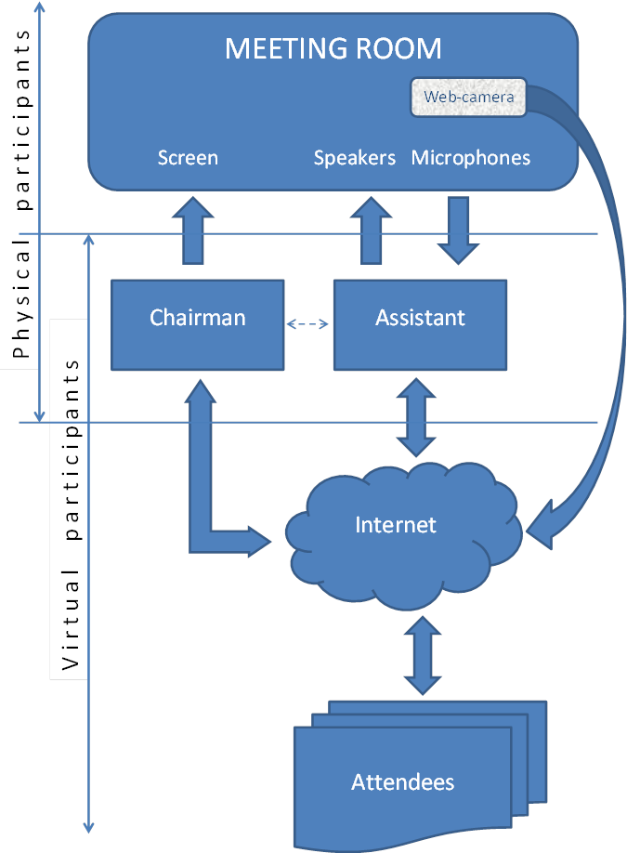

ECO Guides on virtual participation:

Virtual participation in workshops (webinars)

Before the day of a scheduled Webinar (Web-based Seminar) the organizer should allow some time to practice the Webinar and include any other Webinar organizers and/or panelists. The Practice mode allows organizers to run an unlimited number of practice sessions before the scheduled session start time.

Shortly before the beginning of a workshop, the organizer should log in on his/her PC to one of the ECO accounts (advised by an ECO expert) and start the scheduled GoToWebinar session. Before starting the broadcast, the organizer and, optionally, other invited organizers and panellists will be joined in a sub-conference in order to organize themselves.

The microphone system in the meeting room as well as the speakers should be connected to the organizer’s PC. Either the whole screen or a relevant application (e.g. a document or a presentation) should be chosen on the organizer’s PC for sharing with the virtual participants (attendees).

There are three categories of virtual participants in GoToWebinar (with different options available to the different categories):
  - attendee;
  - panellist;
  - organizer.

The “raise hand” option is only available to attendees (if allowed by the organizer) while only (other) organizers and panellists can be privileged by the organizer to take control over keyboard&mouse and only the current presenter (who is either an organizer or a panellist) can show his/her screen to others. Only organizers can send circular text messages (via Question Panel) to all attendees. Attendees, if allowed by the organizer, can send their written questions or comments to the organizer. Only organizers can see all questions and answers, set question priority and assign questions to other organizers and panellists who are usually subject-matter experts.
Once the organizer has started the session, attendees should be able to connect to it by clicking on the personal link which was sent to them when they registered to the webinar and, optionally, entering the password.

The organizer should be able to see the list of attendees who have joined the session. By default setting, they join with muted microphones, so they cannot interfere in the discussion without permission from the organizer who can unmute a chosen attendee (up to 25 attendees can be unmuted at any one time) and give him/her the floor.

Attendees can request the floor by clicking on the ‘raise hand’ button in the GoToWebinar user’s Control Panel. The request will be visible to the organizers or the current presenter (who is either an organizer or a panellist).

In addition, GoToWebinar has ‘Questions & Answers’ mode, speaking privileges and polling features (for details please refer to the GoToWebinar quick reference guides (below). Polls can be created in advance or in-session on the fly. After a poll has been closed, the organizer can choose to show the results immediately or at a later time during the session.

Practical Recommendations for webinars

The following recommendations for further improvement of the quality of ECC webinars have been developed by the Office and further reviewed and updated by WGRA (21st meeting, Ljubljana, Slovenia, 14-17 September 2010):
- announcements of ECC webinars which are posted on the ECO website may also be placed on the administrations’ websites should they wish to publicize webinars to the relevant experts and to general public;
- guidance on how to participate in the webinar as well as clear feedback channel (e.g. e-mail address) should be indicated in the information about the webinar;
- presentation should be preferably developed using fonts which are not too small;
- the presenter should be requested to speak more slowly and clearly than he/she usually does;
- the connection should be checked before the webinar start with an assistant who should be one of the virtual participants;
- before getting started, go to Audio setup and ensure that microphone and speakers are working properly;
- participants should be advised that the volume can be adjusted either by using the ‘Master Volume’ icon in the right bottom corner of the screen or through the volume control on the loud speakers;
- all participants shall be muted during the presentation to avoid the noise in the background;
- it should be announced at the beginning that the Q&A session will take place after the presentation has been made (unless the presenter wishes otherwise);
- remote participants should be informed that they can put their questions forward in writing in the course of the presentation; alternatively, they will be able to ask questions during the Q&A session by pressing the “raise hand” button;
- after the presentation has been made, the presenter should be advised whether any written questions have been asked; he/she can either:
  - pick up one of the written questions;
  - unmute one of the virtual participants who have “raised hand” and give him/her the floor (remember to mute the person again);
  - take a question from the floor;
- only one remote participant should be unmuted at the same time.

For installation instructions and security related issues please refer to “IT-security related information”:

To get familiar with the GoToWebinar user interface please refer to:
- GoToWebinar organizer quick reference guide
- GoToWebinar attendee quick reference guide

All questions of a technical nature related to the installation and use of GoToWebinar should be addressed to the Office (it@ero.dk).

- Supplementary information

The Office recommends that future organizers of GoToMeeting and GoToWebinar sessions should consider using at the beginning of their sessions brief presentations developed by GoToMeeting in order for participants to familiarize with the attendee interface:

Introductory presentation of GoToMeeting for participants:

The organizers can review the notes below for a click-by-click suggested script when presenting the slides to participants.

Notes
The GoToMeeting attendee interface is made up of two parts. The Viewer Window is where attendees see the presenter’s screen. The Viewer Window can be resized by clicking and dragging the lower right corner. The Control Panel is where attendees can interact with organizers.

Click 1, 2 and 3:
- Clicking the arrows on the Grab Tab opens and closes the Control Panel.

Click 4:
- Audio pane provides audio information. If the organizer has given attendees a choice, there are two options. Attendees joined via VoIP (Use Mic & Speakers) need speakers to hear and a microphone to speak if unmuted.

Click 5 and 6:
- Attendees joined via telephone must enter their Audio Pin on their telephone keypad so that organizers can unmute them if needed.

Click 6:
- Attendees can communicate with organizers and other attendees through the Chat box (if enabled by the organizer).

Click 7:
- In the View menu, uncheck “Auto-Hide the Control Panel” if attendees want their Control Panel to remain open.

Introductory presentation of GoToWebinar for participants:

Notes
The GoToWebinar attendee interface is made up of two parts. The Viewer Window is where attendees see the presenter’s screen. The Viewer Window can be resized by clicking and dragging the lower right corner. The Control Panel is where attendees can interact with organizers.

Click 1 and 2:
- Clicking the arrows on the Grab Tab opens and closes the Control Panel.

Click 3:
- Audio pane provides audio information. If the organizer has given attendees a choice, there are two options. Attendees joined via VoIP (Use Mic & Speakers) need speakers to hear and a microphone to speak if unmuted.

Click 4 and 5:
- Attendees joined via telephone must enter their Audio Pin on their telephone keypad so that organizers can unmute them if needed.

Click 6:
- Attendees can communicate with organizers through the Questions box. This is also where answers and broadcast messages are received.

Click 7:
- Clicking the hand icon on the Grab Tab raises and lowers attendee’s hand.

Click 8:
- In the View menu, uncheck “Auto-Hide the Control Panel” if attendees want their Control Panel to remain open.

The following link can also be used by future organizers of GoToMeeting and GoToWebinar sessions in order to review some videos on how to make their meetings easy and efficient.
The Office, however, cannot guarantee that the above link will be operational in future and therefore these videos should be seen as optional material available at the time of issue of this revision of the “ECO Guidelines on the use of GoToMeeting platform”.

