Radiocommunication Study Groups | 
Source: Document 5B/698  PT46(11)INFO 055 | Document 5B-3/TEMP/003-E
Source: Document 5B/698  PT46(11)INFO 055 | 20 June 2011
Source: Document 5B/698  PT46(11)INFO 055 | English only
Working Group 5B -3 Maritime
preliminary Draft New Recommendation
ITU-R M.[500 kHz-16 QAM]
This document describes the technical characteristics of a MF radio system used in the maritime mobile service operating in the 500 kHz. It is proposed that it be promoted to a Preliminary Draft New Recommendation.

A TEMP document is proposed be presented to WP-5B for attachment to the 5B Report.

Radiocommunication Study Groups
Source: Documents 5B/698 | Document 5B/TEMP/xxx-E
Source: Documents 5B/698 | 20 June 2011
Source: Documents 5B/698 | English only
Working Party 5B
(WG 5B-3 Maritime)
PRELIMINARY DRAFT NEW RECOMMENDATION ITU-R M.[500 kHz-16 QAM]
Characteristics of a digital system for broadcasting maritime safety and security related information from shore to ship in the 500 kHz band

Scope
The Recommendation describes the technical characteristics of a MF radio system used in the maritime mobile service operating in the 500 kHz band for digital broadcasting of maritime safety and security related information from shore to ship.
The ITU Radiocommunication Assembly,
considering
- that high speed data broadcast from shore to ships will enhance operational efficiency and maritime safety;
- that the existing MF Maritime Safety Information (MSI) systems have limited capacity;
- that the development of the e-Navigation system by the International Maritime Organization (IMO) will increase the demand for data transmission from shore to ship;
- that the 500 kHz band has the potential to provide good coverage for a digital system;
noting
- that the Report ITU-R M.2201 gives the basis on how this system works,
recommends

- that the operational characteristics for the broadcasting of maritime safety and security related information should be in accordance with Annex I,

- that the system architecture of the broadcasting system for maritime safety and security related information should be in accordance with Annex II,

- that the technical characteristics and modem protocol for digital data transmission from shore to ships in the 500 kHz band should be in accordance with Annex III;

Annex I
Operational characteristics
The system uses a time slot allocation which should be coordinated by IMO, similar to NAVTEX system.

The 500 kHz digital system offers a broadcast transmission of any kind of message from shore to ships with possibility of encryption.

1 Type of Messages
Any broadcasting message should be provided by a secure and controlled source.
Several type of messages can be broadcasted like:
  - safety of navigation,
  - security,
  - piracy,
  - search and rescue,
  - meteorological messages,
  - piloting or harbour messages,
  - Vessel Traffic System (VTS) files transfer,
  - etc…

2. Broadcast Modes

2.1 General Broadcast
These messages are broadcasted for the attention of all ships.

2.2 Selective Broadcast
These messages are broadcasted for the attention of a group of ships or in a specific navigation area.

2.3 Dedicated Message
These messages are addressed to one ship, using the Maritime Mobile Service Identity (MMSI).

Annex II
System architecture

1 The Broadcast Chain
The 500 kHz digital broadcast system is organized upon 5 vectors:
  - System of Information and Management (SIM):
    - collect and control all kinds of information,
    - create message files to be transmitted,
    - create transmitting programme according to message files priority and need of repetition,
  - Shore Network:
    - assures the transportation of the message files from sources to the transmitters,
  - Shore Transmitter:
    - receive the message files from SIM,
    - translate message files to Orthogonal Frequency Division Multiplexing (OFDM) signal,
    - transmit RF signal to the air (antenna),
  - Transmission Channel:
    - Transport the 500 kHz RF signal,
  - Ship Receiver:
    - demodulate the RF OFDM signal,
    - reconstruct the message files,
    - sort and make the message files available for the dedicated equipments according to the message files applications.

Figure 1 shows the diagram of the broadcast chain.
Figure 1
500 kHz Broadcast Chain Block Diagram
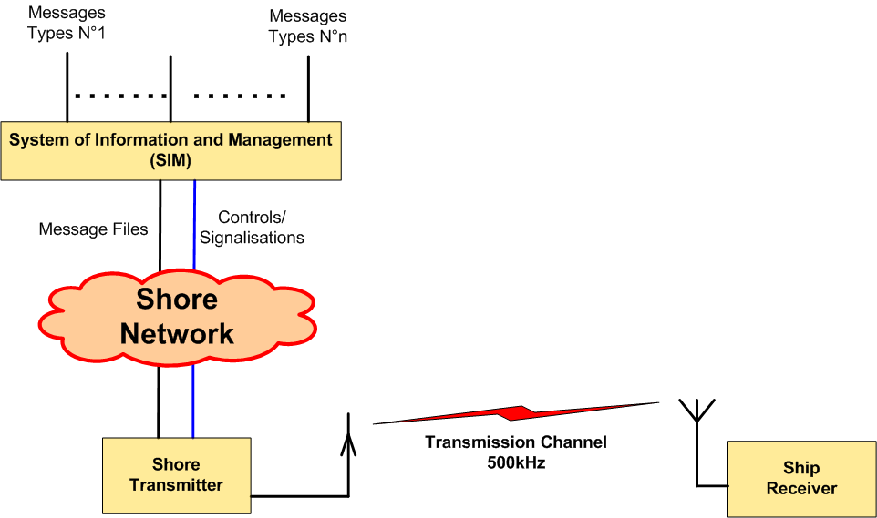

1.1 System of Information and Management (SIM)
The System of Information and Management (SIM) term includes:
  - all the sources that deliver file messages (e.g: meteorological office, safety and security organisations, etc…),
  - the file multiplexer which is an application running on a server,
  - the file multiplexer manager,
  - the shore transmitter manager.
All the sources are connected to the file multiplexer through a network.
Figure 2 shows the general diagram of the System of Information and Management (SIM).
Figure 2
System of information and Management (SIM) Block Diagram

1.1.1 File Multiplexer
The file multiplexer:
  - take delivery of the message files from the data sources,
  - encrypt the message files if asked,
  - format the file messages with recipient information, priority status and time validity,
  - send the message files to the transmitter.

1.1.2 File Multiplexer Manager
The file multiplexer manager is a man machine interface that enables the user to:
  - have a look at the message files coming from any source,
  - specify the priority and periodicity of the any message file,
  - specify the recipient of any message file,
  - manage the file message encryption,
  - etc…
Some of these functionalities may be automated. As an example, the priority and the periodicity of a message may be selected according to the source it comes from or the source may specify the priority in the message.

1.1.3 Shore Transmitter Manager
The Shore Station Manager is a Man Machine Interface connected to the transmitter through the network; it makes it possible to supervise all the transmitter status:
  - transmit acknowledgment,
  - alarms,
  - effective transmit power,
  - synchronisation report,
  - etc…
and to change the parameters of the transmitter:
  - transmit power,
  - OFDM parameters (pilot subcarriers, error coding, etc…),
  - transmission schedule,
  - etc…

1.2 Shore Network
The shore network can be broadband link, low data rate link or local file sharing.

1.3 Shore Transmitter Description
A coastal transmitting station would consist of:
  - One local server connected to a protected access,
  - One OFDM modulator,
  - One 500 kHz amplifier,
  - One transmit antenna with matching unit,
  - One GNSS receiver or atomic clock for synchronization,
  - One monitoring receiver with its antenna.

1.3.1 Shore System Architecture
The Figure 3 shows the block diagram of a 500 kHz digital transmitter.

Figure 3
500 kHz Transmitter Functionnal Block Diagram
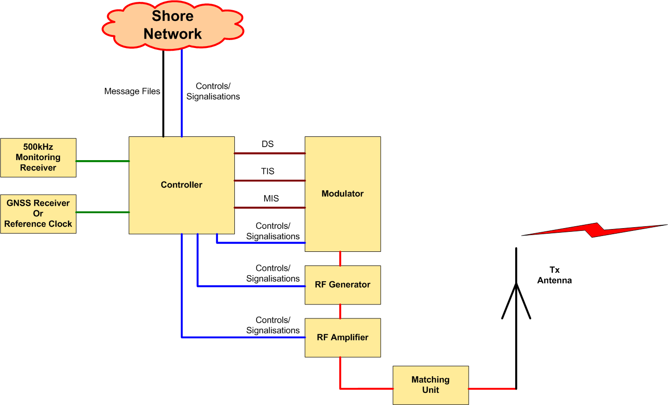

1.3.2 Controller
This unit receives some piece of information:
  - message files from SIM (System of Information and Management),
  - GNSS or reference clock for synchronization,
  - 500 kHz signal from monitoring receiver,
  - 500 kHz modulator and transmitter signalisations.
The function of the controller is:
  - to check if the frequency band is free before transmit,
  - to synchronize all signals on the coast station from synchronisation clock,
  - to control the transmission parameters, time and schedule,
  - to format the message files to be transmitted (split files into packets).

1.3.3 Modulator
Figure 4 shows the diagram of the modulator.

Figure 4
500 kHz Modulator Functionnal Block Diagram

1.3.3.1 Input Streams
In order to operate, the modulator need 3 input streams:
  - Modulation Information Stream (MIS),
  - Transmitter Information Stream (TIS),
  - Data Stream (DS).
Theses streams are transcoded and then placed on the OFDM signal by the cell mapper.

1.3.3.1.1 Modulation Information Stream (MIS)
This stream is used to provide information about:
  - the spectrum occupancy,
  - the modulation for Transmission Information Stream and Data Stream (4, 16 or 64 QAM),
This MIS stream is always coded on 4 QAM subcarriers for good demodulation into the receiver.

1.3.3.1.2 Transmitter Information Stream (TIS)
This stream is used to provide information to the receiver about:
  - error coding for Data Stream (should be different for surface wave propagation at day time and for surface + sky wave propagation at night time),
  - identifier of the transmitter,
  - date and time.
This TIS stream can be coded on 4 or 16 QAM.

1.3.3.1.3 Data Stream
It contains the message files to transmit (these message files were previously formatted by the file multiplexer).

1.3.3.2 Error Encoding
The error correction scheme depends on the wished robustness of the coding.
The code rate is the ratio between useful and raw data rate, it illustrates the transmission efficiency and can vary from 0.5 to 0.75 depending on the error correction schemes and modulation patterns.

1.3.3.3 OFDM Generation
The 3 streams (MIS, TIS and DS) are formatted:
  - encoding,
  - energy dispersal,
A cell mapper organizes the OFDM cells with the formatted streams and the pilot cells. The pilot cells are transmitted for the receiver to estimate the radio channel and synchronise on the RF signal.
An OFDM signal generator creates the OFDM base band according to the output of the cell mapper.

1.3.4 500 kHz RF Generator
A 500 kHz RF Generator transpose the base band signal to 500 kHz RF signal.
An amplifier brings the RF signal to the desired power.

1.3.5 RF Amplifier
The function of this stage is to amplify the 500 kHz signal from the Generator output to the necessary level to obtain the whished radio coverage.
The OFDM transmission introduces a crest factor on the RF signal. This crest factor must stay in the range 7 to 10 dB at amplifier output for a correct Modulation Error Rate (MER).

1.3.6 Transmit Antenna with Matching Unit
The RF amplifier is connected to the transmit antenna through the impedance matching unit.

1.3.7 GNSS Receiver or atomic reference clock
The clock is used to synchronize the local controller.

1.3.8 Monitoring Receiver
The monitoring receiver checks that the frequency is free before transmission and offers possibility to check the transmission.

1.4 Transmission Channel: Radio Coverage Estimation
The coverage could be calculated based on Recommendations ITU-R P.368-9. and ITU-R P.372-10. See Report ITU-R M.2201 for an example.

Annex III
Technical characteristics

1 Modulation Principle
The system uses Orthogonal Frequency Division Multiplexing (OFDM) which is a modulation technology for digital transmissions.

1.1 Introduction
The bandwidth of the radio transmission channel is divided in the frequency domain to form subcarriers.
The radio transmission channel occupancy is organized in the time to form OFDM symbols.
An OFDM cell is equivalent to one subcarrier in one OFDM symbol.

FIGURE 5
OFDM Introduction
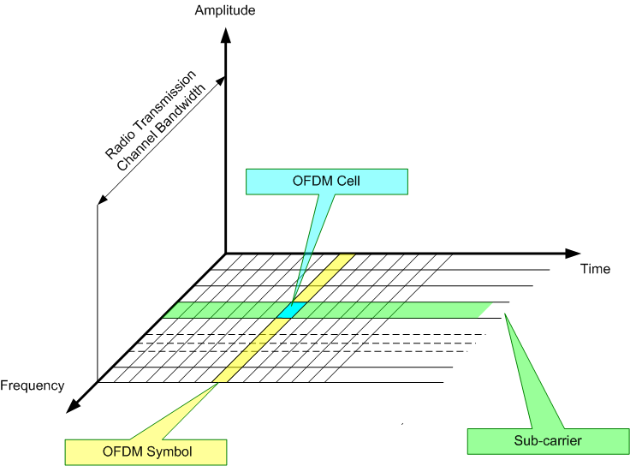

1.2 Principle
The OFDM uses a large number of closely-spaced (41.66 Hz) orthogonal sub-carriers to obtain high spectral efficiency to transmit data. These sub-carriers are frequency-spaced (Fu = 1/Tu), where T_{U} is the OFDM symbol duration.
The phases of sub-carriers are orthogonal one to each other’s to enhance signal diversity caused by the multipath, especially in long distance.
A guard interval (Td) is inserted in the OFDM symbol to reduce multipath effect, thus reducing the inter-symbol interference.
The OFDM symbol duration is Ts = Tu+Td
The OFDM symbols are then concatenated to make an OFDM frame.
The OFDM frame duration is Tf.

Figure 6
Spectral Representation of an OFDM Frame
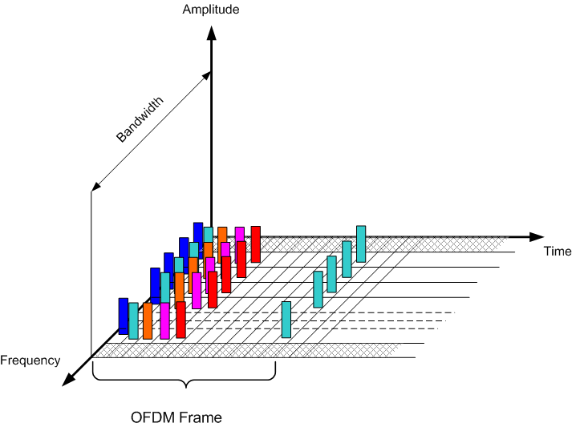

Figure 7
Temporal Representation of an OFDM Frame
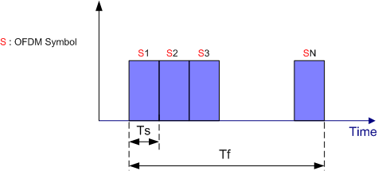

1.3 Modulation
Every sub-carrier is modulated in amplitude and phase (QAM: Quadrature Amplitude Modulation).
Modulation patterns can be either 64 states (6 bits, 64-QAM), 16 states (4 bits, 16-QAM), or 4 states (2 bits, 4-QAM),

The modulation pattern depends on the wished robustness of the signal.
Figure 8, 9, 10
4, 16, 64 QAM Constellation

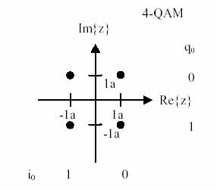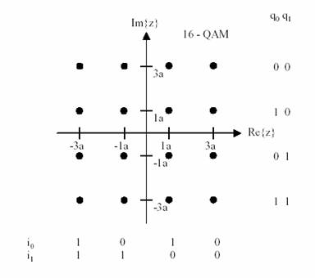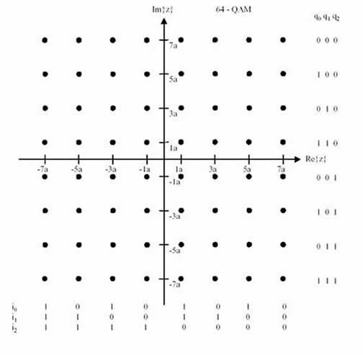

1.4 Synchronization
In order to allow a good demodulation of each sub-carrier, radio transmission channel response must be determined for each sub-carrier and equalization should be applied. For this, some of the sub-carriers of the OFDM symbols may carry pilot signals.
The pilot signals allow the receiver to:
  - detect if a signal is received,
  - estimate the frequency offset,
  - estimate the radio transmission channel.
The number of pilot signals depends on the wished robustness of the signal.

Figure 11
Pilot OFDM Signal

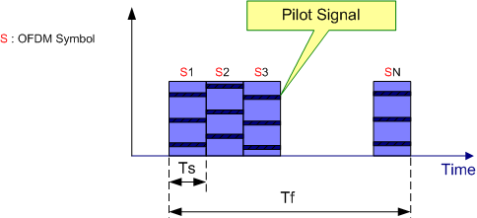

In the first symbol of each OFDM frame, any subcarriers are used as time reference for the receiver to synchronise.

Figure 12
Synchronization Symbol

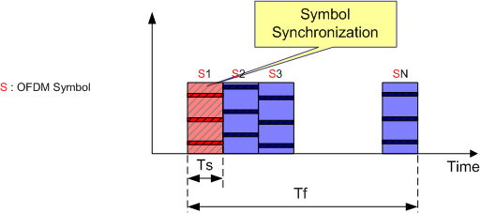

1.5 Spectral Occupancy of RF Signal

Figure 13
Spectral Occupation of RF signal with Bandwidth F = 10KHz
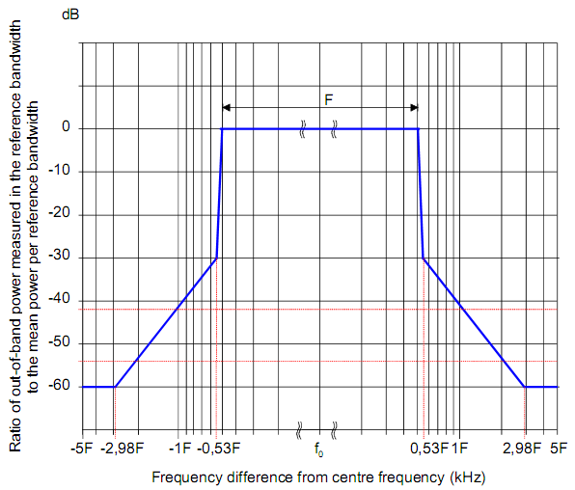

2 Estimated Usable Data Rate
In the 10 kHz channel bandwidth with 500 kHz propagation, the raw data rate available for the Data Stream (DS) is typically around 25 kbps with 16 QAM signal.
The number of subcarriers that hold data can be varied in order to adjust the channel protection. The higher the channel protection is (protection against multipath, fading, delay, etc…), the lower the number of useful subcarriers is.
Error coding must then be applied to the raw data rate to obtain the usefull data rate (code rate 0.5 to 0.75), the useful data rate is then between12 and 18 kbps.
The higher the code rate is, the higher the useful data rate is but the more affected the radio coverage is.

3 Ship Receiver

3.1 Ship Receiver Description
The ship receiver block diagram is shown in Figure 14.
A typical 500 kHz digital receiver is composed of several basic blocks:
  - reception antenna and GNSS antenna,
  - RF front end,
  - demodulator,
  - files demultiplexer,
  - controller,
  - power supply.

FIGURE 14
Receiver Logical Diagram
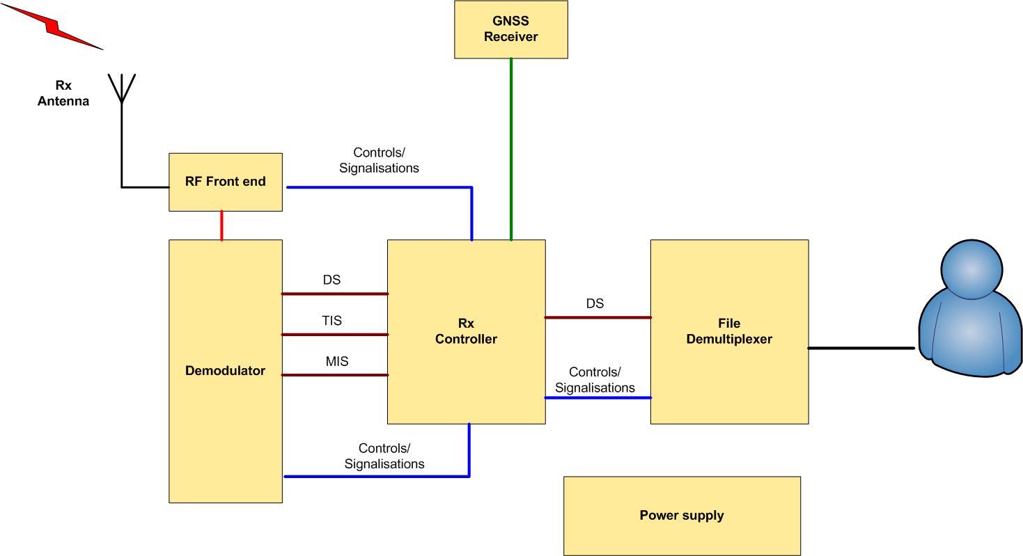

3.1.1 Reception Antenna and GNSS Antenna
The 500 kHz receiving antenna can be an H field antenna (recommended on a noisy ship) or an E field antenna.
A GNSS antenna (or connection to the existing ship GNSS receiver) is also needed in order to obtain the ship position.

3.1.2 RF Front End
This block includes the RF filter, RF amplifier and base band output.
High sensitivity and high dynamic range are necessary.

3.1.3 Demodulator
This stage demodulates the base band OFDM signal and recreates the data stream that holds the transmitted message files.
It implements:
  - time/frequency synchronisation,
  - channel estimation,
  - automatic modulation discovery,
  - error correction.
The receiver should be able to detect modulation parameters automatically:
  - 16 or 64 QAM,
  - subcarriers scheme,
  - type of error coding,
  - etc…
In addition to the Data Stream (DS), it reports the information filled in the Transmitter Information Stream (TIS) and Modulation Information Stream (MIS). Furthermore, it reports complementary information about the channel like:
  - estimated SNR,
  - BER,
  - MER,
  - etc…

3.1.4 File Demultiplexer
The file demultiplexer
  - receive the message files from the controller,
  - verify that the message files are to its attention (type of Broadcast Mode),
  - decrypt the message files if needed/able,
  - make the message files available for the terminal application that will use the message files,
  - delete the out-of-date message files.
Depending on the final application, the message file can be:
  - stored on an on board server accessible through the ship network,
  - directly sent to the final application.
A man machine interface should be available in order to display the dedicated messages and to configure the interface with the application dedicated on board devices (e.g. e-navigation) and manage the ship board permissions (ship identification, encryption). This interface may be a dedicated application running on an external computer while the receiver may be a black box device.

3.1.5 Controller
The controller
  - Extract the message files from the Data Stream (DS) (merge packets into files),
  - interprets the Transmitter Information Stream (TIS) and Modulation Information Stream (MIS) and the other pieces of information given by the demodulator,
  - collects the information from the file demultiplexer
    - total number of decoded message files,
    - number of available message files,
    - error event (e.g. decrypt errors),
    - etc…
A man machine interface may be available in order to display check the reception parameters.

3.1.6 Power Supply
The main supply must be adapted to the main power on the ship

4 Ship Receiver Performance Specifications
These assumed ship receiver specifications are set out below with the objective to obtain minimum SNR for a good OFDM demodulation (16 QAM or 64 QAM)

Table 1
Ship Receiver Performance Specifications
Frequency band | 495 to 505 kHz
Adjacent Channel Protection | > 40 dB @ 5 kHz
Noise Factor | < 20 dB
Usable Sensitivity for BER = 10⁻⁴ after error correction | < -100 dBm
Dynamic | > 80 dB
Minimal usable RF field  (with adapted receiving antenna) | - dBµV/m

5 Glossary

BER | Bit Error Rate
DS | Data Stream
GMDSS | Global Maritime Distress and Safety System
GNSS | Global Navigation Satellite System
IMO | International Maritime Organization
ITU | International Telecommunication Union
LF | Low Frequency
MF | Medium Frequency
MER | Modulation error Rate
MIS | Modulation Information Stream
NM | Nautical Mile
OFDM | Orthogonal Frequency Division Multiplexing
PEP | Peak envelop Power
RMS | Root Mean Square
SIM | System of Information and Management
SNR | Signal to Noise Ratio
TIS | Transmitter Information Stream

________________________

