Radiocommunication Study Groups | 
Source: Documents 5B/617 Annex 34, 5B/627,5B/660  PT46(11)INFO 056 | Document 5B-3/TEMP/004-E
 | 20 June 2011
 | English only
Working Group 5B -3 Maritime
WOrking Document towards a preliminary Draft New Report ITU-R M.[EXCHANGE-MARITIME-INFOS] on Near Real Time Exchange of Maritime Domain Information

This working document on near real time exchange of maritime domain information was revised.
A TEMP document is proposed be presented to WP-5B for attachment to the 5B Report.

Radiocommunication Study Groups
Source: Documents 5B/617 Annex 34, 5B/627,5B/660 | Document 5B/TEMP/xxx-E
Source: Documents 5B/617 Annex 34, 5B/627,5B/660 | 20 June 2011
Source: Documents 5B/617 Annex 34, 5B/627,5B/660 | English only
Working Party 5B
(WG 5B-3 Maritime)
Working Document toward a Draft New Report M.[EXCHANGE-MARITIME-INFOS] on Near Real Time Exchange of Maritime Domain Information

1 Introduction
The effort to enable administrations to improve their response to disaster has been fundamental to the origins of the International Telecommunication Union. Today Administrations are keenly aware that public safety issues, environmental protection, and economic impact benefit from enhanced maritime domain information.
In the case of maritime traffic, Automatic Identification System (AIS) has been assisting safety of navigation. AIS is backwards compatible with digital selective calling systems, allowing shore-based GMDSS systems to inexpensively establish AIS operating channels and identify and track AIS-equipped vessels, and is intended to fully replace existing DSC-based transponder systems. AIS has the ability to provide immediate and accurate contact between vessels. To help with the coordination of vessel identity AIS users use the same Maritime Mobile Service Identity (MMSI) numbers assigned to the vessel for GMDSS purposes.
After several years of product development and standardization work through international organizations, the AIS-SART was adopted into the Global Maritime Distress & Safety System (GMDSS) regulations as an alternative to the Radar-SART. The effective date for that substitution was 1st January 2010.
Moving beyond the shipping regime, today new sensors are capable of predicting adverse weather and identifying potential environmental hazards to assist administrations in protecting their populace, ecological balance, and economic viability.

2 Maritime domain cooperation
AIS based systems foster cooperation between administrations in the maritime domain.
Examples of AIS maritime systems exchanging data are:
• IMO AIS (Automatic Identification Systems) as source data;
• Marine Traffic Network (Automatic Identification Systems) as source data;
• IALA NET (International Association of Marine Aids to Navigation and Lighthouse Authorities) using AIS as source data.
Examples of non-AIS maritime systems exchanging data are:
• IMO LRIT (Long-Range Identification and Tracking System);
• IMO Electronic Marine Highway (Malacca Straits).
This Report identifies the various efforts toward creating open standards systems which:
• enable economies to better control their maritime domain and related issues;
• share AIS data as equal partners among participating administrations regardless of size and benefit;
• provide a common focus for safety, security, commerce and environmental protection.
[Editor’s note: Further research on ship reporting systems such as AUSREP or AMVER, the potential of AIS via satellite, and future developments of LRIT via HF, need to be included in order to make the report more complete.]

3 Maximize transparency of vessels in the maritime domain
All maritime administrations recognize benefits from maximize transparency of vessels in the maritime domain.
From coordination of Search and Rescue efforts to Accident Investigation and Environmental Monitoring of Territorial Waters, data provided from AIS has significant value.
Table 1 shows the reporting intervals of the AIS messages that are currently approved.
TABLE 1
Selected reporting intervals for AIS messages (Reference Recommendation ITU-R M.1371)
[Editor’s note: The table may/could be divided up into Class A and Class B AIS platforms, and clearly specify “CSTDMA” since the SOTDMA can be slightly different, and since the static information is not identical between Class B and Class A ships. For example, Class B vessels may not have a Call sign allocated.]
AIS platform | Reporting interval
Static information: | 6 min interval/upon request
Mobile Maritime Service Identity (MMSI)
IMO number (if assigned)
Call sign
Name
Length and beam
Ship location of AIS
Voyage information: | 6 min interval/upon request
Where (not a real field)
Destination/ETA
Cargo
Dynamic information:
(Position, course, speed, heading)
Base station | 10 s interval (10 s nominal)
Class A ship | 2 s to 3 min interval (approximately 7 s average) (see Table 4)
Class B ship (the true heading is optional for Class B CSTDMA ships) | 5 s to 3 min interval (30 s nominal)
Search and rescue aircraft | 10 s interval
Aid to navigation | 3 min interval
Dependent on speed and course change | At anchor: 3 min  Slow moving: 0-14 knots: 3 1/3 s to 10 s  Fast moving > 14 knots: 2 s - 6 s
Safety and administrative messages | As required
Data message | As required

4 Open maritime data sharing via Maritime Safety & Security Information System
A cooperative programme, Maritime Safety & Security Information System (MSSIS) was initiated as a data exchange tool fostering cooperation.
This system openly shares, non-classified AIS data globally to enhance safety, security, commerce and environmental protection.
Agreement allows sharing of non-classified AIS data, real-time, between international domestic users through an internet-based, password-protected, exchange portal.
The data is by design, not owned or controlled by any single administration.
The system displays unaltered AIS data streams.

4.1 Infrastructure of MSSIS
MSSIS currently serves as the data feed and basis for numerous sophisticated applications.
Information sharing on a global scale:
• provides a Common Operational Picture (COP) with regional partners;
• low cost: Commercial off the Shelf (COTS) equipment;
• technically simple;
• insurance and Commercial benefits.

4.2 Data gathering
The various sources of data gathering currently include shore-based, waterborne and airborne AIS receiving units.

4.3 Data distribution
Network connectivity based on international standards:
• TCP & UDP, client and server connections;
• serial connections;
• NEMA, AIS, OTH-Gold, XML.
Lookup/Link with external databases.
Advance data logging and playback.
• multi-day playback of specific ship/ receive stations;
• snap shot files.
Vessel search.
Guard zones – Dynamic, static, user defined.
ETA, Closest point of approach, dead reckoning.
Chart and aerial photo overlay.

4.4 Components in MSSIS operations sites

4.4.1 AIS receivers
• Identifies and locates vessels broadcasting AIS signal.

4.4.2 RADAR (optional)
• Easily fused into the AIS network to add precise locating data.

4.4.3 UHF/VHF radios (optional)
• Aids in the identification process.

4.4.4 DATA sharing network
• Secured commercial AIS data network among partner nations.

4.5 Implementation of MSSIS
Based on US Department of Transportation developed software.
• gathers local AIS data and/or displays the MSSIS Maritime Domain Awareness picture;
• vessel traffic management;
• oil spill modelling display;
• accident investigation;
• buoy positioning;
• network monitoring;
• analysis tool.

4.6 Systems derived from MSSIS
Pilot support:
• pilot display;
• hydrographic survey.

4.7 Technical support for MSSIS

4.8 Future improvements of MSSIS concept

4.9 MSSIS Participant’s Agreement
Table 2 – List of MSSIS participating nations (As of June 09 – 56 Nations).
Table 3 – List of nations in preliminary stages (As of June 09 – 13 Nations).

4.10 Advantages and disadvantages
Advantages
Detect anomalies in AIS data and alert watchstander based on pre-determined criteria.
Capabilities
• AIS Lloyds Validation
− Validates the reported AIS contact against the Lloyds MIU reference database for validity of the reported data (e.g. IMO).
• AIS Consistency Validation
− Checks for multiple AIS contacts reporting duplicate data, e.g. two contacts with the same name or IMO number.
• AIS Area of Interest
− Checks for AIS contacts reporting themselves entering/in a defined area.
• AIS Geographical Proximity
− Checks for AIS contacts reporting themselves close to a defined point.
• AIS ETA Discrepancy
− Calculates whether the contact, following a straight line, can get from the current location to the reported destination by the reported ETA.
• AIS Routing
− Calculates a ship’s anticipated route based on destination and previous routes taken.

4.11 Summary
MSSIS provides coastal and island nations throughout the world the opportunity to partner with each other to enhance maritime safety and security.
TABLE 2
Administrations participating in MSSIS
ALBANIA | GEORGIA | URUGUAY
AUSTRALIA | GERMANY | PERU
BAHRAIN | GHANA | POLAND
BELGIUM | GREECE | PORTUGAL
BENIN | ICELAND | ROMANIA
BULGARIA | IRELAND | SAO TOME AND PRINCIPE
CAMEROON | ISRAEL | SENEGAL
CANADA | ITALY | SERBIA
CAPE VERDE | IRAQ | SINGAPORE
CHILE | JAMAICA | SLOVENIA
CROATIA | JORDAN | SPAIN
DENMARK | LITHUANIA | TUNISIA
DJIBOUTI | MALTA | TURKEY
DOMINICAN REP. | MAURITANIA | UKRAINE
ESTONIA | MONTENEGRO | UNITED KINGDOM
FINLAND | MOROCCO | UNITED STATES
FRANCE | MOZAMBIQUE | YEMEN
GABON | NETHERLANDS
GAMBIA | NORWAY

TABLE 3
Administrations in preliminary stages of adoption of MSSIS
ARGENTINA
BRAZIL
COLOMBIA
COSTA RICA
ECUADOR
INDIA
JAPAN
MEXICO
NEW ZEALAND
PHILIPPINES
SWEDEN
SOUTH AFRICA
TIMOR LESTE

[NOTE - Final verification of participating administrations should be completed prior to August 2011.]

5 Maritime traffic network (Marine Traffic)
An academic centric, open, community-based project which includes a web site component.
IMIS Hellas of Athens Greece designs, implements and hosts the service MariWeb. The Service provides information about the current geographical positions of ships, as well as other related information, whenever available, such as the ships’ characteristics, their destination, the estimated time of arrival, photographs, port traffic statistics, etc.
This network provides free real-time information to the public, about ship movements and ports, mainly across the coast-lines of Europe and N. America.

5.1 Infrastructure of Maritime Traffic Network
Similar to MSSIS currently serves as the data feed and basis for numerous sophisticated applications.
Information sharing on a global scale:
• provides a Common Operational Picture (COP) with regional partners;
• low cost: Commercial off the Shelf (COTS) equipment;
• technically simple;
• insurance and Commercial benefits.

5.2 Data gathering

5.3 Data distribution
The provided information on vessels position and identity originate directly from the vessels, which transmit this information through public radio frequencies, according to the “Automatic Identification System” (AIS). The information collected and published may contain errors, due to the intrinsic limitations of radiocommunications (e.g. limited coverage, interference, attenuation, special weather conditions, etc.) due to an erroneous configuration of the AIS devices on board, due to negligent data entry by the vessel’s crew, due to an erroneous position received by the vessel’s GPS and due to other factors beyond the control of the Provider.
Vessel positions may be up to one hour old or incomplete. Data is provided for informational reasons only and is not related by any means to the safety of navigation.
Receive email/SMS alerts on your mobile phone whenever a vessel enters or leaves a port.
– Receive email alerts whenever a vessel is detected in our network.

5.4 Components in Marine Traffic operations sites

5.5 Implementation of Marine Traffic

5.6 Systems derived from Marine Traffic

5.7 Technical support for Marine Traffic

5.8 Future improvements of Marine Traffic concept

5.9 Marine Traffic Participant’s Agreement
The project is currently hosted by the Department of Product and Systems Design Engineering, University of the Aegean, Greece.

5.10 Advantages and disadvantages

5.11 Summary

6 International Association of Marine Aids to Navigation and Lighthouse Authorities AIS data sharing network (IALA NET)
IALA-NET demonstrator is a near real-time AIS data exchange service, provided via the Internet, with a capacity for storage of AIS data for statistical purposes. It is a worldwide service available only to National Competent Authorities who provide the AIS data from their own country. It is noted that some administrations report that the demonstrator system is very slow.
Several private/commercial companies already monitor maritime traffic on a global scale. However, traffic monitoring includes security, safety, protection of the marine environment and traffic organization missions. These functions governmental responsibilities and the information used by the authorities in charge of these functions should not be dependent solely on the private sector.

6.1 Infrastructure of IALA NET

6.2 Data gathering

6.3 Data distribution
The global sharing of broadcast information, such as AIS data, is a golden opportunity to initiate new channels of cooperation amongst maritime nations fostering a greater sense of community, through fair and equal access to the sum of information available.

6.4 Components in IALA NET operations sites

6.5 Implementation of IALA NET
IALA-NET will develop a computer network data base to facilitate the collaborative collection and distribution of ship-generated AIS data through a password-protected Internet website. It is anticipated that IALA-NET will establish three server centres to strengthen the system redundancy and its availability. The centres will be evenly spaced in time-zones, enabling load balancing between the centres and the more readily availability of service, maintenance and helpdesk personnel somewhere in the world 24 hours a day.
IALA-NET will receive from and provide to the National Competent Authorities AIS data from all SOLAS ships carrying AIS as mandatory equipment pursuant to regulation 19, Chapter V of the SOLAS Convention. Consequently, a National Competent Authority participating in IALA-NET is deemed to agree to contribute and receive the said AIS data. However, National Competent Authorities are entitled to limit AIS data for ships that do not fall under the SOLAS regulation 19 Chapter V.

6.6 Systems derived from IALA NET

6.7 Technical support for IALA NET

6.8 Future improvements of IALA NET concept

6.9 IALA NET Participant’s Agreement

6.10 Advantages and disadvantages

6.11 Summary

7 Long-Range Identification and Tracking System (LRIT)
The Long-Range Identification and Tracking (LRIT) system provides for the global identification and tracking of ships.
The obligations of ships to transmit LRIT information and the rights and obligations of Contracting Governments and of Search and rescue services to receive LRIT information are established in regulation V/19-1 of the 1974 SOLAS Convention.

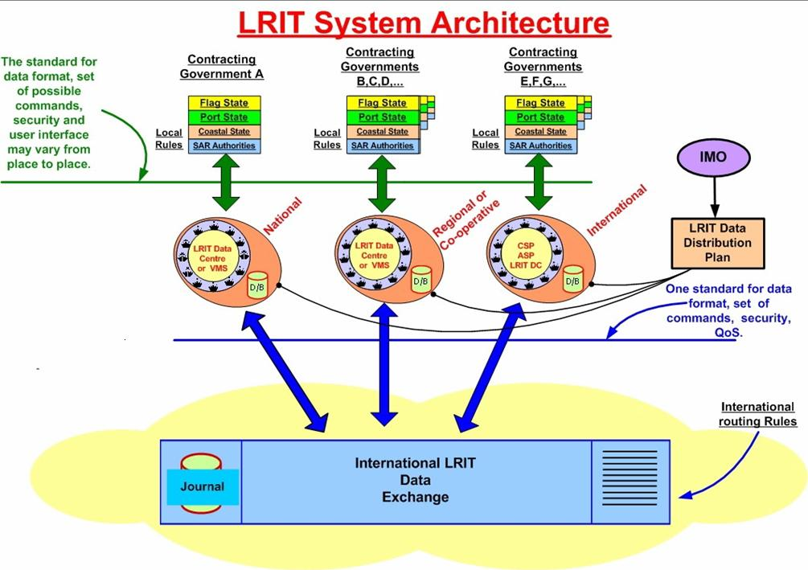

7.1 Infrastructure of LRIT
The LRIT system consists of the ship-borne LRIT information transmitting equipment, the Communication Service Provider(s), the Application Service Provider(s), the LRIT Data Centre(s), including any related Vessel Monitoring System(s), the LRIT Data Distribution Plan and the International LRIT Data Exchange. Certain aspects of the performance of the LRIT system are reviewed or audited by an LRIT Coordinator acting on behalf of all Contracting Governments.
LRIT information is provided to Contracting Governments to the 1974 SOLAS Convention and Search and rescue services entitled to receive the information, upon request, through a system of National, Regional, Cooperative and International LRIT Data Centres using the International LRIT Data Exchange.
Each administration should provide to the LRIT Data Centre it has selected, a list of the ships entitled to fly its flag, which are required to transmit LRIT information, together with other salient details and should update, without undue delay, such lists as and when changes occur. Ships should only transmit the LRIT information to the LRIT Data Centre selected by their administration.

7.2 Data gathering
The LRIT information ships will be required to transmit include the ship's identity, location and date and time of the position. Several distinctions between LRIT and AIS, include range and LRIT polling capability. Where AIS is a broadcast system LRIT is both scheduled and responsive to Data Centre requests.

7.3 Data distribution
Data derived through LRIT will be available only to the recipients who are entitled to receive such information and safeguards concerning the confidentiality of those data have been built into the regulatory provisions. SOLAS Contracting Governments will be entitled to receive information about ships navigating within a distance not exceeding 1 000 nautical miles off their coast.
LRIT information is provided to Contracting Governments and Search and rescue services entitled to receive the information, upon request, through a system of National, Regional, Cooperative and International LRIT Data Centres, using where necessary, the LRIT International Data Exchange.
A ship must transmit position reports using Long-Range Identification and Tracking (LRIT) equipment that has been type-approved by their administration. For example, to be type-approved by the United States Coast Guard, LRIT equipment must meet the requirements of IMO Resolutions A.694 (17), MSC.263 (84), and IEC standard IEC 60945 (Incorporated by reference, see Sec. 169.15).

7.4 Implementation of LRIT
A ship's LRIT equipment must transmit position reports at 6-hour intervals unless a more frequent interval is requested remotely by an LRIT Data Centre.
LRIT Data Centres are implemented via a wide range of options:
• fully outsourced LRIT service;
• self-hosted LRIT service;
• combination of self-hosted and outsourced LRIT services.

7.5 Systems derived from LRIT

7.6 Technical support for LRIT

7.7 Future improvements of LRIT concept

7.8 LRI Participant’s Agreement

7.9 Advantages and disadvantages

7.10 Summary

8 IMO Marine Electronic Highway (Malacca Straits) (MEH)
The Marine Electronic Highway (MEH) is envisioned to be a regional network of marine information technologies linked through the electronic navigational charts (ENCs) and electronic chart display and information systems (ECDIS). The availability of differential global positioning system (DGPS) is a key parameter. All of this will exist in the context of an integrated bridge system.
The Marine Electronic Highway is the integration of maritime safety technologies and marine environment management and protection with precision navigation as its backbone.
The goal of the MEH is to establish a regional mechanism in the Straits of Malacca and Singapore for enhanced maritime safety and marine environment protection with a sustainable financial component in a co-operative arrangement with the three littoral States of Indonesia, Malaysia and Singapore and partnership with the Republic of Korea, the International Hydrographic Organization (IHO), the International Association of Independent Tanker Owners (INTERTANKO) and the International Chamber of Shipping (ICS). The Project should be appraised as a technological network and cooperative partnership that could bring about the realization of Article 43 of the United Nations Convention on the Law of the Sea (UNCLOS 1982).

8.1 Infrastructure of MEH
The Straits of Malacca and Singapore together form the main seaway connecting the Indian Ocean (via the Andaman Sea) with the South China Sea. The Straits, as it is also known and situated between Sumatra and the Malay Peninsular, are approximately 1,000 kilometres long, 300 kilometres wide at the north-west entrance, and just 12 kilometres at the south-east entrance. Despite their difficult navigational features and a high level of local traffic engaged in barter trade and fishing, the Straits are the shortest and hence the preferred shipping route between the Indian Ocean and the South China Sea, and for oil tankers trading between the Persian Gulf areas and the East Asian countries. This is due to the presence of services, active ports, and the fact that the two alternative routes (i.e., Lombok-Makassar Strait and Sunda Strait) will add considerable time to the length of voyage.

8.2 Data gathering
Precision navigation is the backbone of the marine electronic highway upon which relevant maritime and environmental systems would be integrated with the ENCs-ECDIS as the geospatial platform. Precision navigation would include onshore, sea-based and ship-based facilities from which information and data flow into the network.
The wide adoption of digital technology in the shipping sector has enhanced navigation, for example the use of transponders such as an automatic identification system (AIS) and onboard access to the Internet. With AIS, real time information can be automatically provided to and/or received from appropriately equipped shore facilities or other ships such information as the ship's identity, type, position, course, speed and navigational status.
With enhanced AIS, hydrographical and oceanographic data (e.g., currents and depth, tides and sea state) including weather information can be transmitted and/or received which can greatly ease ship movement in restricted or congested waterways as well as during inclement conditions (e.g., improving the situational awareness of mariners). Currently, AIS is mainly used for exchange of basic ship information.

8.3 Data distribution
Singapore's Vessel Traffic Information Service (VTIS) has been in operation since 1990. This is a comprehensive radar and computer-based vessel traffic system covering the Singapore Strait and can show the positions of up to 1,000 vessels at a time. Malaysia has a radar and vessel traffic monitoring system, commissioned in 1998 and covers the entire Malacca Strait. Also in 1998, a DGPS station was installed by Singapore as well as released for commercial use, the official Singapore ENCs, which is fully compliant with international standards. A DGPS station installed in 2001 by Malaysia in Lumut, Perak but later decommissioned. However, DGPS Broadcasting Stations have been established by Malaysia in Kuantan, Bagan Datuk, Melaka and Kuala Besar. Malaysia has also installed around 16 AIS Stations through the Straits’ coast parallel to the TSS. Indonesia plans to install DGPS and AIS facilities on the Sumatra coast, which are currently in the pipeline for implementation.

8.4 Components in MEH operations sites
Project Components and Activities
The Project has five components. The total Project cost is US$17.85 million, of which US$8.3 million will be financed by the Global Environment Facility, US$6.0 million by private sector participants (ship-owners), and US$2.7 million by the three littoral states and US$0.85 million was a grant from the Republic of Korea through the Ministry of Land, Transport and Maritime Affairs. The International Maritime Organization (IMO) manages all components of the project whereas the Republic of Indonesia will execute the Tide and Current Facilities of Component 2.
Component 1 MEH System Design, Coordination and Operation
This component provides for project management by the IMO on behalf of the participating states, coordination of the design, development and operation of the MEH demonstration system and also provides for key technical inputs to the project. The main functions will be performed by the staff of a Project Management Office (PMO), which will operate under the responsibility of the IMO. The PMO will be located on the island of Batam, Indonesia, almost directly across the Straits from Singapore. It will be co-located with Indonesian Government’s Directorate General of Sea Transport’s field station provided and serviced by the Government of Indonesia.
The major tasks under this component are:
System Planning and International Maritime Organization Management
(a) Management of the operational aspects of the Project.
(b) Development of a system for the management and on-line access and storage of data and information, including links to the MEH Data Centers and financial and economic assessments.
(c) Development of criteria and measurable indicators for Project performance assessment, including the carrying out of a baseline survey to compile and analyze data and information covering a period of about thirty years up to the inception of the Project, as a basis for evaluation of the impact of the MEH system.
Project Management Office
(a) Strengthening the capacity of the staff of the Project Management Office, including relevant training.
(b) Establishment of MEH Data Centers in the Republic of Indonesia, Malaysia and the Republic of Singapore, including provision of relevant training to the staff of the MEH Data Centers in operation and management of the MEH system and in data handling and exchange.
Project Steering Committee Support
Organized project management and technical review by the Project Steering Committee (PSC), the Technical Committees (TCs) and the Working Groups (WGs)
Component 2 MEH System Development
This component provides for the production of the navigational information on which the MEH system will be based, and its incorporation into survey generated Electronic Navigation Chart. The activities comprise the following sub components:
Navigational and Hydrographic Facilities
Install and operate tidal and current equipment on the Republic of Indonesia’s coast of the Strait of Malacca, including provision of relevant maritime navigational facilities.
Hydrographic Survey
Carry out of a multi-beam hydrographic survey within the Traffic Separation Scheme of the Straits of Malacca and Singapore.
Electronic Navigation Charts
Production of high resolution ENC for the Project Area, including provision of ENC software licenses to the Republic of Indonesia and to Malaysia.
Information Exchange System
Establishment of a MEH information exchange system, including data servers, data exchange protocols and training of staff in data exchange, which is part of the MEH Data Centers.

Component 3 - Ship-board Equipment and Communications
Carry out of testing of the demonstration MEH system by about 160 ships fitted with type-approved electronic chart display and information systems, including internet connectivity. This component will be implemented in cooperation with the owners of at least 160 large oil tankers and container ships that regularly transit the Straits that will be facilitated by two major ship owner representative organizations, INTERTANKO and ICS. Detailed and timely feed-back on the performance of the MEH system onboard the ships will be provided to the Data Centres, which will later be evaluated by independent experts, including assessing the costs, benefits and legal/financial feasibility of expanding it to cover the entire Straits (refer also to Component 5).
Component 4 - Marine Environment Protection
This component will be executed jointly by institutions in the littoral States that are responsible for marine navigation and environmental management and the IMO and will consist of the following activities:
Oil Spill and Sand Wave Models
Carry out of a modeling and analyses of: (i) the likely movement of oil spills originating in the Project Area, and (ii) the sand wave formation and movement in the Project Area.
Sensitive Area Mapping
Research and development of options for providing real-time geo-referenced environmental protection information to mariners navigating in the Straits of Malacca and Singapore and for conservation and coastal resources management and mapping of sensitive areas.
Emergency Response Systems
Carry out of simulated oil and chemical spill emergency response exercises to determine the cost-effectiveness and efficiency of the MEH system in the event of chemical and oil spill incidents from ships.
Component 5 - Information Dissemination, Evaluation and Scale-Up Plan
This component will be managed by the IMO through the PMO, and will produce the following outputs:
Website and Publicity
Production and dissemination of information through the Internet on the MEH system, including technical reports, progress reports and a newsletter, and carrying out of national and regional workshops and seminars to provide information and seek feedback on the benefits and applicability of the MEH system.
Evaluation
(a) Assessment of the cost and benefits of the establishment and use of the MEH system in terms of maritime safety and marine environment protection, including (i) the development of criteria and measurable indicators for the socio-economic assessment of the MEH system, and (ii) the carrying out of a socio-economic survey to evaluate the benefits of the MEH system;
(b) (i) Carrying out of an assessment of the technical functionalities of the MEH system, including system performance, (ii) Carrying out of a continuous monitoring of new and potential technologies that could be linked to the MEH system or enhance its performance, including the carrying out of technical evaluations on the new technologies to determine their suitability, value added contribution, enhancing performance and cost effectiveness,
(c) Carrying out of an assessment of the MEH system, including institutional and legal aspects, and
(d) Consolidation of the technical, institutional, legal, financial and economic assessments of the MEH system, including the implementation of the Project, and development of a managing tool blueprint.
System Development
Carry out of marketing strategies to package and market the MEH system and its marine information and other products, and the services it could provide.

8.5 Implementation of MEH
The Mandatory Ship Reporting System, STRAITREP, which came into force on 1 December 1998, requires designated vessels to report via VHF voice radio communication, to the marine authorities of the littoral States when transiting the Malacca and Singapore Straits. Vessels entering the operational area submit reports containing information such as the name of ship, its call sign, IMO identification number (if available), position, hazardous cargo and deficiencies of the ship that could affect normal navigation. The Straits of Malacca and Singapore covered by the STRAITREP is divided into nine sectors, each with assigned VHF channel. STRAITREP provides information to vessels about specific and critical situations on traffic movements that could potentially cause problems as well as other pertinent information on safety of navigation.
In the Straits of Malacca and Singapore, shore-based facilities to monitor ship movement passing through either in transit or calling port have been established. These facilities rely on various modalities of communications (e.g., radar, radio and satellite) and are essentially coordinated by a network of computer systems as in the case for Malaysia and Singapore.

8.6 Systems derived from MEH
None identified at this time

8.7 Technical support for MEH
Permanent Members – Project Steering Committee (PSC)
Indonesia – Ministry of Environment
Malaysia – Marine Department, Peninsular Malaysia
Singapore – Maritime and Port Authority
Secretariat
International Maritime Organization (IMO)
Partners
Ministry of Land, Transport and Maritime Affairs (MLTM), Republic of Korea
International Hydrographic Organization (IHO)
International Association of Independent Tanker Owners (INTERTANKO)
International Chamber of Shipping (ICS)
Potential Partners
Potential partners of the Project (subject to the approval of the PSC) would include private sector partners such as technology providers like those engaged in digital technology and telecommunications and in the environment sector. Again subject to PSC approval, user States and interested organizations can also participate in the Project. These potential partners could be involved in capacity building and technical assistance as well as in the development of various products and services of the MEH system, including but not limited to online and real time communications and data exchanges, packaging and marketing. The status of any actual additional partners would be decided by the PSC.

8.8 Future improvements of MEH concept
However, future development could include other relevant information such as weather data. Thus, information flow could be real time, forecast, archive data, and monitoring/time lag data. Development in this area will certainly provide the impetus to realize the establishment of a MEH system.

8.9 MEH Participant’s Agreement
The three littoral States of Indonesia, Malaysia and Singapore have, and continue to show, a strong commitment to navigational safety and environmental management of the Straits. Each country has ratified the 1982 UNCLOS and the International Convention of the Prevention of Pollution from Ships, 1973, as modified by the Protocol of 1978 relating thereto (MARPOL Convention), in addition to other international instruments developed and implemented by the International Maritime Organization (IMO) dealing with navigational safety and pollution prevention and control. Also, the three countries are signatories to the Tokyo Memorandum of Understanding on Port State Control, involving inspection of vessels for validation of International Oil Pollution Prevention Certificates. This means that environmental threat from pollution, particularly oil, could be minimized if safety of navigation is enhanced.
Activities undertaken by the three littoral States to improve navigational safety and enhance marine pollution prevention and response have been substantial with the majority of the funding for navigational safety borne by the littoral States.
Sustainable financing mechanisms, obligations associated with accession or ratification of international conventions, protocols, agreements and treaties, legal, institutional and administrative arrangements and political considerations are the non-technical aspects of the MEH that will have to be identified, assessed and taken into account in the establishment, operation and sustainability of the MEH system.

8.10 Advantages and disadvantages
[Editor’s note: to be compiled]

8.11 Summary
Whilst e-Navigation is the “harmonisation of marine navigation systems and supporting shore services driven by user needs”, the marine electronic highway is envisaged to be a technological network of integrated maritime safety technologies and marine environment management and protection systems bringing about improved performance, new capabilities and innovative applications.

9 AIS data sharing and vessel tracking (AISHub)
The main goal of AISHub.net is to become a raw NMEA AIS data sharing centre and valuable data source for all enthusiasts and professionals interested in development of AIS related software.
Everybody who wants to receive the data from all available sources in real time has to share his own feed with the other AISHub members. We do not set any restrictions and all members are free to decide how to use the data - they can keep it for themselves, share it with other AIS sites or even use it for commercial projects

9.1 Infrastructure of AIS Hub
The following graphic indicates the participating sites in the AIS Hub.
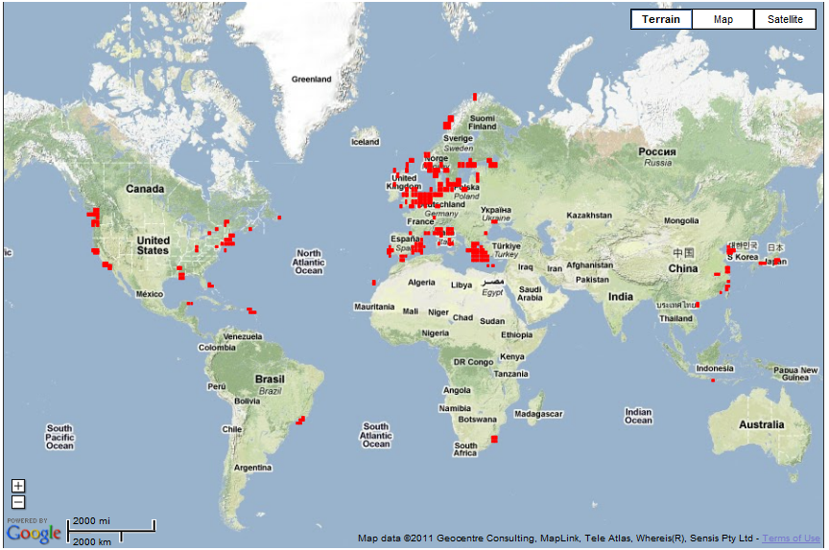

9.2 Data gathering

9.3 Data distribution

9.4 Components in Marine Traffic operations sites

9.5 Implementation of AISHub
The interface provides search for a particular ship by name, IMO or MMSI number, visualization of the ship track for last 72 hours, distance calculation etc.

9.6 Systems derived from AISHub
VT Explorer is a AIS viewer application which provides a graphic visualiztion of AIS targets onto electronic charts. The first version was developed by Astra Paging Ltd. in 2006 and distributed among the customers of commercial AIS vessel tracking service VT Explorer.
Here you can find a special edition of VT Explorer designed for all members of AISHub. Only AISHub members have their personal account for accessing AISHub data via VT Explorer. Non-AISHub members can still try VT Explorer for free but with reduced coverage area.
VT Explorer (AISHub edition) retrieves AIS tracking data on regular time intervals from the AISHub server. The vessels are shown with different symbols depending on their type, course and speed. For example yellow colour is used for general cargo vessels, orange - for tanker vessels and green - for passenger vessels. All data about individual vessels are accessible by a single mouse click and presented in an easily accessible way. Compared to similar web-based products, VT Explorer does not require fast Internet connection and provides fast operation even on low-end computer hardware.

9.7 Technical support for AISHub

9.8 Future improvements of AISHub concept

9.9 AISHub Participant’s Agreement

9.10 Advantages and disadvantages

9.11 Summary

_______________

e-Navigation is the harmonized collection, integration, exchange, presentation and analysis of maritime information onboard and ashore by electronic means to enhance berth to berth navigation and related services, for safety and security at sea and protection of the marine environment. (IMO NAV 53).
International Association of Marine Aids to Navigation and Lighthouse Authorities (IALA).

