SE19(14)51

Questionnaire on MIMO technology for Fixed Service
Group: SE 19
Submission dates: 02-06-2014 - 15-08-2014
Introduction:
There is an increasing interest in MIMO technology for fixed links being seen from network operators and manufacturers alike. Therefore further information/clarification is required on the regulatory framework to encourage investment in and deployment of this technology.
At its 66th meeting, WGSE endorsed the approach by SE19 to develop a questionnaire on MIMO for fixed links.
In this questionnaire MIMO is referred to as transmitting different signals on the same polarisation and the same channel on separate antennas, i.e. MIMO is referred here to the technology on spatial multiplexing as opposed to XPIC (cross polar interference cancellation) using polarisation multiplexing. This questionnaire only focuses on MIMO.
Administrations of the CEPT are invited to complete the questionnnaire before the 15-08-2014.
Questions:
Question 1: Do you currently allow the deployment of MIMO technology on licensed Fixed Service point to point links?
Switzerland | yes
Croatia | yes
Denmark | yes
Netherlands | no
Germany | no
United Kingdom
Norway | yes
Lithuania | yes
Sweden | yes
Czech Republic | yes
Austria | yes
Slovenia | yes
PORTUGAL | yes
Ireland | no  Note: Ireland responded not at present, but also indicated that although these links could potentially be deployed, for example, within the licence exempt 5.8 GHz band (i.e., 5725 – 5875 MHz). Further information on this band can be found in Table 3 of ComReg document 02/71R9, which is available at the following link: http://www.comreg.ie/_fileupload/publications/ComReg0271R9.pdf
Hungary | yes
Slovak Republic | no
Estonia | yes
Russian Federation | yes
Bosnia and Herzegovina | no
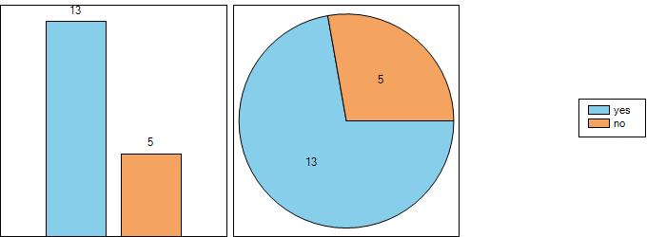

Question 1.1:
 | If yes, what extra (if any) information do you request from the applicant prior to process the licensing request? | In addition, what specific requirements do you place on a MIMO link?
Switzerland | none.  The fees for MIMO are currently under study , MIMO will probably be charged at the same costs as SISO | We would just note that it is a MIMO link
Croatia | We request information regarding antennas used for the deployment of the link | N/A
Denmark | None | None
Norway | Height of antenna | under consideration
Lithuania | no extra information is requested | we do not place any specific requirements on MIMO link
Sweden | Indication of MIMO/XPIC is required in order to validate the application form. The handling officers need the information to select correct equipment configuration prior to interference analysis. | No additional requirements at the moment.
Czech Republic | At this moment, two or more (with respect to MIMO level) individual authorizations are necessary for one MIMO link. It is possible to assign same frequency for same link if user requires. Antenna height, Tx power and antenna type is requested for each authorization. | No other specific requirements are required.
Austria | None | None
Slovenia | Information about radio equipment and antenna data. | Requirements as recommended by ETSI.
PORTUGAL | Yes, however, at present, we have not granted any license for a MIMO point-to-point radio link.  The applicant shall provide information concerning MIMO radio equipment and antennas that intended to be used for this purpose. | None, for the moment.
Hungary | For the time being we do not have a prohibitive regulation with regard to the PP MIMO but have not defined any specific requirements for the use of this technology, yet because we do not have information that it is really applied by the service providers. | See the previous point.
Estonia | We have not had any MIMO requests so far. | No specific requirements.
Russian Federation | -- | --
Question 2: For successful operation of a LoS MIMO link, antenna separation is an important parameter. Do you believe that this information is needed prior to accepting the application for licensing?
Switzerland | no
Croatia | yes
Denmark | yes
Netherlands | yes
Germany | yes
United Kingdom
Norway | yes
Lithuania | no
Sweden | no
Czech Republic | yes
Austria | yes
Slovenia | yes
PORTUGAL | yes
Ireland | yes  Ireland answered yes, as some links, particularly those potential LOS MIMO links operational in the lower frequency fixed link bands (e.g., 6 GHz), may require significant separation between antennas. This may, however, not be the case in the upper frequency bands (e.g., 38 GHz), where transmitting antennas for a LOS MIMO link may only be separated by a relatively negligible distance. Notwithstanding this opinion, however, ComReg considers that further studies are required before a firm viewpoint can be settled upon.
Hungary | no
Slovak Republic | no
Estonia | no
Russian Federation | yes
Bosnia and Herzegovina | yes
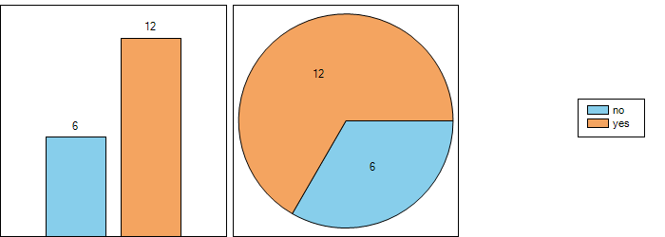

Question 2.1: if yes, would it be subsequently quoted on the granted license ?
Croatia | Yes
Denmark | No
Netherlands | No
Germany | Yes
Norway | Yes
Czech Republic | Yes
Austria | Yes
Slovenia | Yes
PORTUGAL | No
Ireland | Yes
Russian Federation | No
Bosnia and Herzegovina | Yes
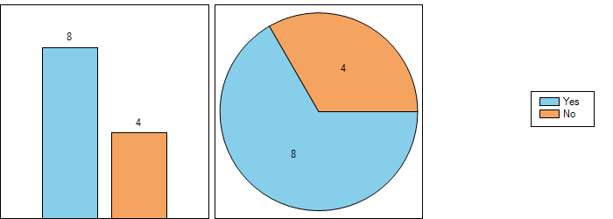
In 2004, SE19 highlighted the following 2 possible licensing options for administrations national consideration (see the minutes of meeting 24 of SE19 in 2004, doc. SE19(04)min24): Option 1: To licence a whole multi-antenna installation as a single FS stations, prescribing the frequency, total EIRP, allowed polarisations, and so on. In this case it would be up to the operator to use split antennas using the allowed polarisation and appropriately reducing the EIRP per antenna so that the overall EIRP limit is met; Option 2: To licence each antenna individually, prescribing individual emission parameters for each antenna.
Question 3: In realtion to the above paragraph, which option (if any) are you applying?
Switzerland | Option 1
Croatia | Option 1
Denmark | Option 1
Netherlands | Option 2
Germany | Option 2
United Kingdom
Norway | Other, please provide further information in the remarks fields below
Lithuania | Option 1
Sweden | Option 2
Czech Republic | Other, please provide further information in the remarks fields below
Austria | Option 1
Slovenia | Option 2
PORTUGAL | Option 1
Ireland | Other, please provide further information in the remarks fields below  Although no option is being applied in Ireland at present, ComReg is of the view that there may be arguments for application of both options, depending upon the frequency band being considered for deployment of LOS MIMO links. For example, each transmitting antenna of a MIMO fixed link system operating in the lower frequency bands may need to be licensed separately, given the larger separation distances between antennas, whereas this requirement may not be necessary in the upper fixed link bands, where both antennas could potentially be mounted on one mast.
Hungary | Other, please provide further information in the remarks fields below
Slovak Republic | Option 1
Estonia | Option 1
Russian Federation | Other, please provide further information in the remarks fields below
Bosnia and Herzegovina | Other, please provide further information in the remarks fields below
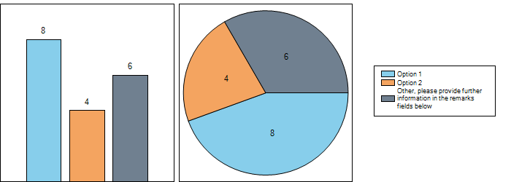
Question 4: Do you anticipate additional interference analysis requirement to be carried out because of the two (or more) parallel co-channel transmission paths?
Switzerland | Yes
Croatia | No
Denmark | Yes
Netherlands | Yes
Germany | Yes
United Kingdom
Norway | Yes
Lithuania | No
Sweden | No
Czech Republic | Yes
Austria | No
Slovenia | No
PORTUGAL | No
Ireland | Yes. ComReg believes that further study needs to be carried out in order to gauge more fully the potential risks associated with the licensing of MIMO links - until this has been done, the potential for interference from two or more transmitters in a LOS MIMO fixed link system remains , at present, largely unknown.
Hungary | No
Slovak Republic | No
Estonia | No
Russian Federation | Yes
Bosnia and Herzegovina | Yes
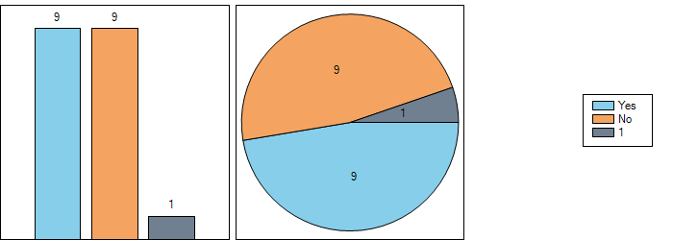
Question 5: Is the deployment of MIMO accepted for all fixed service bands?
Switzerland | no
Croatia | yes
Denmark | yes
Netherlands | yes
Germany | yes
United Kingdom
Norway | yes
Lithuania | yes
Sweden | yes
Czech Republic | yes
Austria | yes
Slovenia | yes
PORTUGAL | yes
Ireland | no  Not presently – further consideration needs to be given to this in the future, taking into account, for example, how congested a band currently is and the specific spectral propagation properties of the band in question.
Hungary
Slovak Republic | yes
Estonia | yes
Russian Federation | yes
Bosnia and Herzegovina | yes
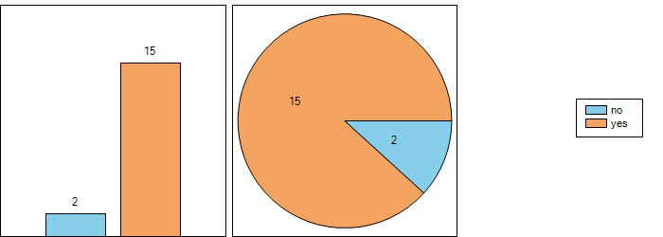
Question 5.1: if no, which are the bands where MIMO is allowed?
Switzerland | Frequencies above 13 GHz are making sense (Because of antennas separation distance)
Ireland | The deployment of MIMO technology on licensed fixed point to point links is not currently permitted in Ireland. Further consideration needs to be given to this in the future, taking into account, for example, how congested a band currently is and the specific spectral propagation properties of the band in question.
Question 6: MIMO is potentially more spectrally efficient as it only uses one channel. How do you charge for a MIMO link, when compared to a single transmitter link?
Switzerland | Is currently under study , MIMO will probably be charged at the same costs as SISO
Croatia | It would be charged the same, since the fee for one FS link, as defined within remark in Q3, is calculated by the spectrum used. Additional capacity acquired with the usage of MIMO is the benefit for the operator.
Denmark | We charge the same amount as for a standard link.
Netherlands | Improved spectrum efficentcy is not an issue for license costs. Each single link will need a license.
Germany | The current German regulatory framework requires a licensing fee and an annual frequency usage contribution for each transmitter taken into operation.
United Kingdom
Norway | No additional fee for a second system with the same frequency, bandwidth and polarization as paid for earlier between the same sites.
Lithuania | Amount depends only on frequency band and channel spacing. There is no difference whether it is a MIMO link or not.
Sweden | Currently there is an annual license fee for frequencies below 10 GHz (EUR67/transmitter) and a lower annual license fee for frequencies over 10 GHz (EUR44/transmitter/year), channel bandwidth and/or modulation format is not taken into consideration today. The license fee for MIMO links will also be on a per transmitter basis.
Czech Republic | One MIMO link is represented by two or more individual authorizations. Operator is charged per each authorization.
Austria | Currently, there is no differentiation in our Fee Ordinance. For the facilitation of MIMO usages a clarification of the relevant technical parameters to be used for the calculation of fees could be necessary.
Slovenia | Radiofrequency system has two transmitter and receiver units, two antennas, two licences and two charges. Depending on development of technology it might be changed in future.
PORTUGAL | We will be charged a MIMO link under the same manner that a single transmitter radio link.
Ireland | MIMO links are not currently licensed in Ireland. Subsequent to further study being carried out which more accurately determines the spectral efficiency of such systems, ComReg may then be in a position to determine an appropriate charging mechanism.
Hungary | It will be considered later.
Slovak Republic | We assume that we will consider it as a single channel.
Estonia | No difference.
Russian Federation | The calculation method to charge for the use of radio-frequency spectrum in the Russian Federation provides no option of cost reduction for MIMO fixed stations. The charge calculation for MIMO fixed stations is similar to a single transmitter link.
Bosnia and Herzegovina | In BH regulative, the fee calculation is based on bandwidth and charged with no respect to throughput or polarization (single, dual). Introduction of MIMO might affect this in direction of changes in regulative.
Question 7: Do you have additional information, outside the frequency assignment, on further restrictions to deploy MIMO link (e.g. separate construction permits for additional antenna, etc…) which may be considered similar to space diversity links?
Switzerland | In Switzerland a separate construction permits for each additional antenna is necessary
Croatia | N/A
Denmark | No
Netherlands | Mimo technology is a new development. It may well be that for practical reasons additional restrictions could be considered if needed.
Germany | Additional conditions which could restrict the use of MIMO are currently not a subject of regulation. BNetzA intends to check the planned MIMO antenna seperation because its legal responsibility for a spectrumefficient use of frequencies.  A legal verifying was started regarding the licensing fee in case of MIMO applications to reward the boost in spectrum efficiency.
United Kingdom | UK is monitoring the developments on the studies on use of MIMO fixed links within Europe with interest. However, to date there has been no direct interest or plans expressed regarding the implementation of MIMO technology in the centrally managed and coordinated fixed link bands in the UK. Therefore, assignment of fixed links using MIMO technology is not available in the centrally managed and coordinated point-point fixed link bands in the UK. Facilitation of MIMO fixed links within the auctioned bands (e.g. 28GHz band) would be a matter for the licensee, within the terms of their license.
Norway | No
Lithuania | no
Sweden | No, PTS have a very pragmatic approach and have no desire to put any unnecessary limiting conditions onto deployment of MIMO radio links.
Czech Republic | No.
Austria | No further information available in respect to telecommunication issues.
Slovenia | No additional restrictions. Requirements as recommended by ETSI.
PORTUGAL | We have not additional information concerning the deployment of MIMO point-to-point radio links.
Ireland | Not at present, but should MIMO links be catered for in the future, all necessary licensing conditions will be imposed in order to optimise spectrum efficiency and, further, protect existing operational links within the relevant bands from interference.  It should be noted that, in aiding with further studies related to the deployment and operation of MIMO links, ComReg is amenable to making its radio spectrum available under Test and Trial Ireland.  Test and Trial Ireland enables the further study of new and emerging wireless technologies, and ComReg is of the opinion that this scheme may provide a practical opportunity for furthering the study of MIMO LOS fixed links. For further information on the test and trial licensing scheme, the test and trial webpage can be accessed at the following link:  http://www.testandtrial.ie/
Hungary
Slovak Republic | We do not intend any further restrictions to deploy MIMO link. In case of MIMO link we will only require information about numbers of antennas in application form. But it will have no impact on permission
Estonia | No.
Russian Federation | No, but this information may be requested from operator, if necessary.
Bosnia and Herzegovina | We do not since we have not commenced detailed analysis on introduction f MIMO technique –experiences gathered in other administrations once shared will be welcomed and constructive.

