 |  | SE43(11)50

11th meeting of SE43
Lisbon, 19 – 21 September 2011
Date issued: | 15 September 2011
Source: | APWPT
Subject: | Technical considerations on the protection of PMSE
Summary: | The document below describes a technical approach with the goal to calculate a PMSE protection zone.
Proposal: | We ask SE43 to consider this document and copy it to the actual working document.
Background: | SE43 has been tasked by WGSE to continue the work on definition of technical and operational requirements for the operation of White Space Devices in the band 470-790 MHz taking into account Chapter 11 of ECC Report 159.

Technical CONSIDERATIONS ON THE PROTECTION OF PMSE

[Addition to 1.1 of the working document; we suggest to copy this page to 1.1 of actual working document]

The implementation of sensing technologies to manage WSD interference to PMSE systems is more difficult than with other incumbent users, due to the fact that wireless microphone systems are quite different. The PWMS transmitter and PWMS receiver are in different locations and both can be moving. The victim, i.e. the PWMS receiver cannot be sensed since it does not emit a signal. It is also obvious that the WSD transmission area must not be larger than the achievable sensing area, i.e. there is a need to balance between WSD RF output power and sensing capabilities. This is complicated by the fact that the distance between the WSD and the PWMS receiver could be much shorter than the distance between the WSD and the corresponding PWMS transmitter that must be detected. In addition, the signal paths are different, and one or both of them may be obstructed.
Obstruction of the PWMS receiver has a direct influence on the Quality of Service (QoS) as PWMS has a 100% duty cycle and the QoS is related to a high audio quality. The QoS would become 0%.
It is considered the WSD will be a data transmitting device and if the WSD signal is obstructed this interfrenece will only degrade the QoS in reducing the time of up- and download. The QoS will stay about 100%.

Picture xxx: Scenario: WSD RF output power higher than WSD sensing range.

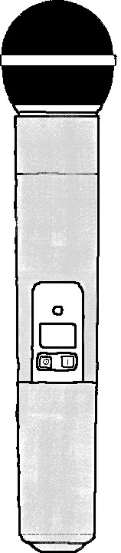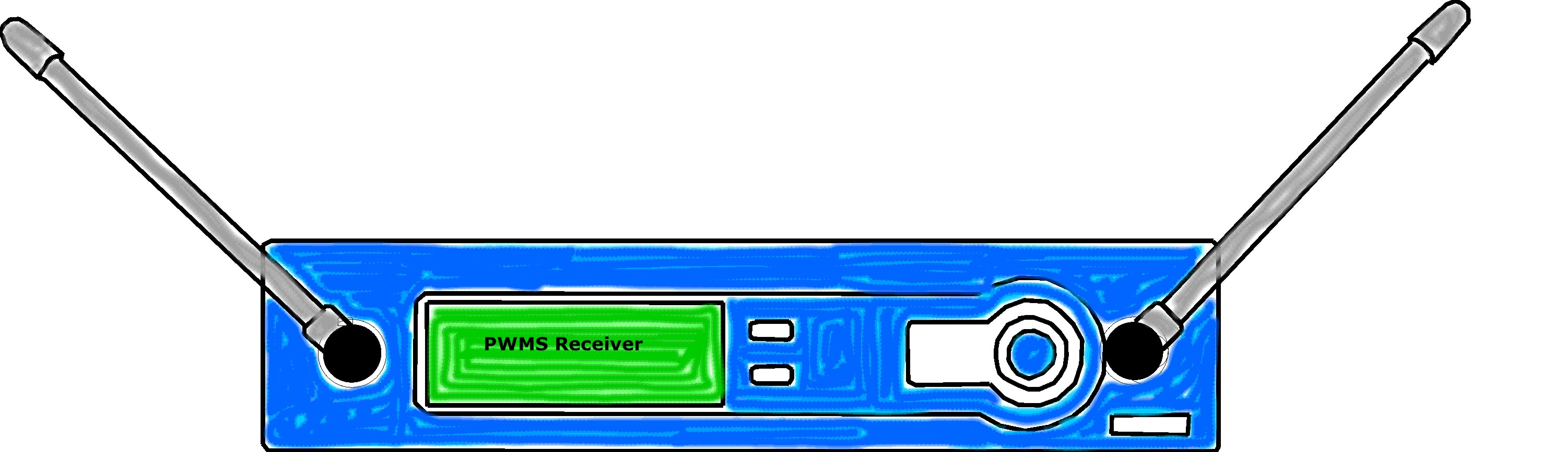
WSD sensing range
WSD RF power higher than sensing range
interference
with PWMS Rx
(If WSD sensing range is lower than WSD transmission range, interference to incumbent services is likely)

[The following text is suggested to be copied into the actual working document with adding a new section for PMSE]

X Technical CONSIDERATIONS ON THE PROTECTION OF PMSE

x.x PMSE Protection Zone

As current sensing technologies may not be reliable enough to protect PSME services this section is focussing on the database concept and the required calculation method / algorithm for protecting PMSE services.

The studies in Report 159 showed that there are many variables with regard to the RF propagation model. Therefore it is suggested to follow a simplified model based on the free space path propagation:

$$a_{0}=20∙log∙\frac{4∙π∙d}{\text{λ}}$$

$a_{0}$ = attenuation [dB]
$d$ = distance [m]
$\text{λ }$ = wavelength [m]

If a greater distance than 400 m is calculated the HATA model could be the alternative model.

If it is known that there is a wall between PMSE and WSD a wall loss of 6 - 20 dB is added. (Report 159 uses values between 6 dB and 20 dB; typically 6 dB are used)

The amount of attenuation $a_{0}$ to protect PMSE in the UHF-TV band need to follow the PMSE receiver curve below, i.e. any emission (including out-of-band emission), of the WSD shall stay below the blue line: (Source: Report 159)

Picture xx: PWMS receiver protection mask

Legend:
Horizontal value = f [MHz]
Vertical value = RF ERP [dbm]

The actual needed protection zone is calculated with various factors:

WSD RF output power
- The emissions of the WSD are the main factor in calculating the protection zone.
- Also (included within the emissions category), the occupied bandwidth and “flatness” of the WSD emission might be considered; e.g. if the WSD power is spread relatively uniformly across a certain percentage of the TV channel, what is mostly important is the amount of which falls within the receiver passband as shown above. In general, the ratio is in the neighbourhood of a 14-16 dB reduction in interference power.

Geolocation data accuracy
- The inaccuracy of the WSD geolocation data need to be added to the protection zone in m.
WSD moving parameters
- With moving WSD an additional risk distance is required– or the need to check with the database more frequently.
Another possibility is that the WSD receives a working area – before leaving it the database need to be contacted.
- If a WSD is moving quickly, e.g., in a vehicle, both the database and the WSD need to be able to update quickly enough to enable the database to base its decisions on accurate positional information.
- Therefore a fixed WSD transmission is easier to predict.

PMSE location / antennas
- The receiving antennas of the respective PMSE receiver need to be notified in the database, which can be a specific location (on stage) or a location area (more than one PMSE antenna is used to cover a greater area).
- Depending the PMSE antenna, which is used the antenna gain could be added to the calculation (directional polar pattern).
- PMSE input data in the database supporting asks for fast response time
(ENG team acts within minutes)

Therefore the mathematics are:

$$WSD E.R.P.\left(GPS location\right)=PMSE receiver protection mask \left[-dBm value\right]+a_{0}+ wall loss [typ.6 dB]- GPS accuracy mismatch-WSD moving parameter$$

$WSD E.R.P.\left(GPS location\right)=$ The allowed RF power E.R.P. at a specific location
$PMSE receiver portection mask=$ Protection mask, see picture xx above
$a_{0}=$ Attenuation free space path model
$GPS accuracy mismatch=$ Accuracy of the WSD GPS
$WSD moving parameter=$ Depending on the movement speed

x.x Overall RF noise floor

As UHF-TV band will be congested with more RF devices there is the need to control the overall noise floor, i.e. the out-of-band emissions need to be observed and restricted.
With the introduction of new technologies such as WSD artefacts as a result of aggregated noise will influence the use of wireless microphones drastically. Therefore it is necessary the out of band emissions of WSD should be carefully observed and restricted. The maximum tolerated adjacent to a wireless microphones carrier need to be below -56dBm at 500kHz of the center frequency of the PWMS Tx (the exact distances and levels are determined by the PWMS Rx protection mask)

