 |  | SE43(11)62
11th Meeting of SE43
Lisbon, 19-21 September 2011
Date issued: | 16th September 2011
Source: | Italy
Subject: | Feasibility of autonomous operation of WSDs using sensing

It is proposed a revised version of Section1 (Feasibility of autonomous operation of WSDs using sensing (in response to Item A2)) of the Working Document on further definition of technical and operational requirements for the operation of white space devices in the band 470-790 MHz (SE43_11_40A1_Annex_1).
Editorial revisions were needed to adapt the text to the terminology agreed by the group.

working document on further definition of technical and
operational requirements for the operation of white space devices in the band 470-790 MHz

Feasibility of autonomous operation of WSDs using sensing
(in response to Item A2)

Practical assessment of autonomous WSD operation
Autonomous operation of WSDs using sensing has been studied by theoretical work, simulations and by practical implementations. Trials have been performed to verify the performance also in the field.
All this work has shown that a reasonable -120 dBm performance can be achieved at the sensing receiver input at ideal conditions taking into account specific DTT-transmission characteristics. The key challenge is antenna and sensor integration into the device and it is obvious that the strictest sensing requirements cannot be met using a single device and especially single shot decisions. However by collecting more samples, position information and combining the results from several devices better results could be expected.
Single device single snapshot detection is too unreliable due antenna gain minima, interference, and fading to protect incumbent users. Just tightening of sensitivity requirement does not help, because IM products cause desensitization, masking, and false alarms, thus reducing available capacity for white space devices. Methods like geo location databases have to be used for reliable operation. Collaborative sensing averages antenna gain and radio propagation problem. However presented trade-offs between sensitivity in sensor linearity requirement and sensitivity has to be taken into account in algorithm development.
The details of practical implementation and field tests are presented in Annex A1.

Cooperative sensing
A single-device spectrum sensing is very difficult to be realized in an efficient and effective way. There are easy techniques from a computational point of view that either require a deep and a priori knowledge on the signal to be detected (i.e. matched filter), or are very susceptible to noise or false alarm induced by other secondary transmissions (i.e. energy detector). Several sensing algorithms have been proposed as to improve the performance and solve the above issues, but they are extremely demanding from a computational point of view, like the cyclostationary feature detection which analyses the correlation characteristics of the detected signal.
In order to require a low computational level and obtain good detection performance, cooperation among WSDs is the most effective approach. This section compares the energy detection performance of a single-device with the energy detection performance under a cooperative sensing in term of false-vacancy-detection and false-occupancy-detection probabilities.
It needs to be noted that the detection performance can be defined from different perspectives:
- WSD operation: Both false-vacancy-detection and false-occupancy-detection probabilities need to be minimized;
- Protection of incumbent services/systems: The probability of false-vacancy-detection needs to be minimized, whereas the probability of false-occupancy-detection has no influence on the incumbent service/system protection.

Single-Device energy sensing
The block diagram of the energy detector is shown in Figure 1.1, where s(t) is the primary user signal, n(t) the AWGN noise, h(t) the channel time-varying gain and x(t) the signal received at the WSD front-end. The input band-pass filter removes the out-of-band noise by selecting the center frequency f_{s} and the bandwidth of interest W. This is followed by a squaring device to measure the energy and an integrator which determines the observation interval T. Finally, the output is compared to a decision threshold, in order to decide whether the signal is present (H₁) or not (H₀).
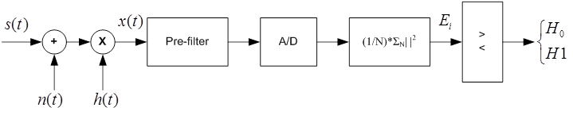
Figure 1.1 Energy Detector block diagram

The detection performance is evaluated in terms of probability of false-vacancy-detection (i.e. the probability of erroneously identifying a channel as available) versus the probability of false-occupancy-detection (i.e. the probability that a channel is identified as occupied while it is available).
The energy detector provides best performance for higher values of N, i.e. the number of observed symbols; in this case the detector measures higher values of energy, thus being able to counterbalance worse channel conditions like low SNR or high shadowing standard deviation in case of a lognormal channel. Obviously the performances are also better for high SNR values. This detection is extremely easy from a computational point of view, but is deeply affected by bad channel conditions, and it cannot provide reliable detection performance even on AWGN channels with SNR=0 dB.

Cooperative energy detection
In order to increase the detection performance, a p-out-of-L cooperative scheme has been used. According to this scheme, if among the L cooperating WSDs at least p detect a signal on that channel, then the Fusion Center which collects the sensed data (Figure 1.2), marks the channel as occupied and informs all the devices of this channel state. Note that in the literature, it has been found that the optimal value of p is L/2 [1]. Different optimal values of p can be found according to the scenario. For example, in case a lower false-vacancy-detection is more important, the optimal value of p can be different from L/2, as well as from the optimal value that decreases the probability of false-occupancy detection.
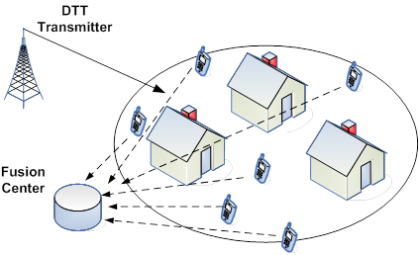
Figure 1.2 Cooperative detection scenario

The performance of the cooperative energy detector on AWGN, Rayleigh and Lognormal channels are provided in Figures 1.3-1.5, and are compared to the performance of Single-Device detection in the same scenario. In these figures we are considering L/2 as the optimal value of p. Of course, the gain introduced by cooperation is much more evident for good channel conditions (i.e. high SNR in the figures), but even for bad conditions the gain is remarkable.
For the sake of briefness, we consider a fixed number of observed symbols N, varying the SNR value. However, it is worthwhile highlighting that, as stated above, higher values of N always increase the detection performance.
In Figure 1.6 we show the effect of increasing the number of cooperating WSDs. The performance significantly increases for larger values of L, but it should be considered that it is not feasible to increase that number at will, as the WSDs require a cognitive channel to communicate the sensed data to the Fusion Center. Even if a dedicated channel is used, when L is too high there would be too much overhead introduced. A possible solution might be using a hybrid cooperative-distributed approach, in which WSDs cooperate among themselves in clusters, i.e. the decision is taken within the WSDs of a cluster.
Figure 1.3 Single-Device versus optimum cooperative detection on an AWGN channel with N=4.
Figure 1.4 Single-Device versus optimum cooperative detection on a Lognormal channel with N=4
and σ_{log}=3.9 dB.
Figure 1.4 Single-Device versus optimum cooperative on a Rayleigh channel with N=4.
Figure 1.6 Optimum cooperative detection on an AWGN channel for different values of L, with SNR=-3 dB and N=4.

[1] W. Zhang, R. K. Mallik, and K. B. Letaief, “Optimization of Cooperative Spectrum Sensing with Energy Detection in Cognitive Radio Networks,” IEEE Trans. Wireless Commun., vol. 8, no. 12, Dec. 2009.

