 |  | SE43(11)65

11th meeting of SE43
Lisbon, 19 – 21 September 2011

Date issued:
Source: | INdT
Subject: | Reference spatial geometries between WSDs and DTT-Rxs for the calculation of the maximum permitted WSD EIRP.
Summary: | This contribution addresses issue B1 of section 11 of ECC Report 159: Identification of a common set of the parameters defined in the methodology to calculate location specific WSD power level. It proposes the consideration of the probability of occurrence of spatial geometries between WSDs and DTT-Rxs for the definition of a reference configuration used to calculate the maximum WSD transmit power. The effect of cumulative interference is not addressed in this analysis. It can be considered a posterior over the reference configuration.
Proposal: | To create a new Annex about reference geometries in the working document and to include sections 1 to 4 of this document to provide additional information about the impact of the density of DTT-Rxs, in the methodology to calculate the WSD maximum permitted EIRP.
Background: | In documents SE43(11)32 and SE43(11)33 a discussion about the impact of adopting fixed reference geometries concerning WSD transmitters and DTT receivers to calculate WSD power limits has been started. In this document, this topic is further investigated.

Password protection required? (Y/N) | N

ATTACHMENT
- Introduction
Location of digital terrestrial television receivers (DTT-Rxs) is information not available to any database. Then, it is impossible to determine the actual separation distance, and consequently the exact propagation loss between white space devices (WSDs) transmitters and DTT-Rxs. For this reason, the calculation of WSD power limits is based on reference spatial geometries for WSDs and DTT-Rxs. In ANNEX 6 of ECC Report 159 and in some contributions to SE43 Group, deterministic reference configurations in terms of propagation loss between WSDs and DTT-Rxs are considered for different scenarios. Figure 1, Figure 2 and Figure 3 show examples of those scenarios.
The intent is to protect the incumbent service by limiting WSD emissions based on such reference configurations. However, deterministic configurations represent specific situations that may not be appropriate to any real-world scenario. It can happen that the WSD power is limited by a reference configuration with low probability of occurrence. In this case, one provides unnecessary protection to the incumbent service and the available spectrum is sub-utilized. On the other hand, a deterministic reference configuration may also allow harmful interference in some situations.

Mobile DTT reception at 1.5 m agl
2 m
1.5 m
1.5 m
WSD
DTT
-34.72 dB
Figure 1 – Reference geometry (reference total loss) considering portable DTT-Rx and portable WSD.
P
IB
Fixed rooftop DTT
reception
TV
-
57.72 dB
Fixed WSD
10 m
-
16 dB
+9.15
dBi
H-polar
Slant-polar
20m
Figure 2 – Reference geometry (reference total loss) considering fixed DTT-Rx reception and fixed WSD.
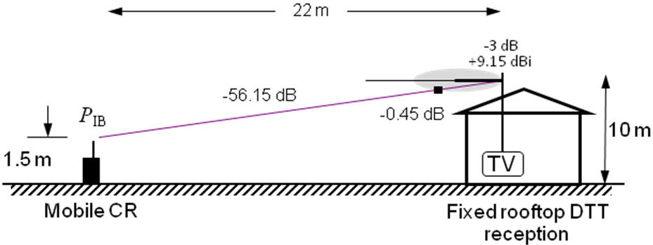
Figure 3 – Reference geometry (reference total loss) considering fixed DTT-Rx reception and portable WSD.
The consideration of the probability of occurrence of spatial geometries between WSDs and DTT-Rxs for the definition of a reference configuration is proposed. The approach takes into account information about DTT-Rx density and WSD antenna directivity.
Only the probability of occurrence of the lowest total loss between WSDs and DTT-Rxs for each spatial configuration is used to define reference configurations, since it is the lowest total loss that limits the permissible WSD power. Fixed WSDs with directional antennas are also considered. Antenna directivity provides substantial improvement on the maximum permitted power levels. The analysis is presented in the following with the help of numerical simulations.
The minimum requirements for the deployment of this approach at the geo-location database are:
- Availability of information about the DTT-Rx density by pixel (or an estimate considering an average density in the area, which could be defined according to the environment type – urban, suburban, rural);
- Communication of the type of WSD antenna, if directional or not.
- Simulation methodology

The purpose of this document is to consider the probability of occurrence of spatial geometries between WSDs and DTT-Rxs for the definition of a reference configuration used to calculate the maximum WSD transmit power. Following the methodology described in Report 159, in which the maximum allowed EIRP in a pixel is limited by the lowest value out of all, i.e. it is limited by the lowest value of total loss (path loss + antenna radiation pattern) between WSD transmitters and DTT-Rxs, we define the probability of occurrence of a reference geometry as the probability of occurrence of the lowest total loss in a pixel, considering all possible geometries.
The simulation consists in evaluating statistics of the possible scenarios inside a $100 m ×100 m$ pixel divided in small 1 m² area units (mini-pixels) as shown in Figure 4. No minimum separation distance between WSDs and DTT-Rxs is considered in simulations. In each realization, the DTT-Rxs are distributed randomly inside the pixel, considering a faraway DTT-Tx. It is considered that a WSD is placed in every mini-pixel, then the total loss is calculated considering the worst link between WSD and DTT-Rx, i.e. the link that has the lowest total loss ( path loss + antenna attenuation / discrimination ). An example is shown in Figure 4, where a WSD is considered to be placed in the highlighted mini-pixel. The link marked in red shows the considered total loss for that mini-pixel. In each realization, all mini-pixels are analyzed in order to calculate the probability of a given configuration. It is important to mention that this study evaluates the geometries between WSDs and DTT-Rx and not the effect of cumulative interference due to multiple WSDs.

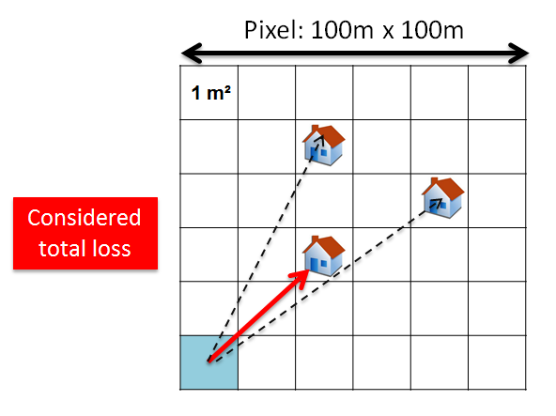
Figure 4 - Calculation of statistics of possible scenarios.

The DTT-Rxs are distributed inside the pixel according to a given density. Two types of DTT-Rxs are considered:
- Fixed DTT-Rx - Antenna at 10 m agl. with attenuation diagram defined by ITU-R BT.419-3;
- Portable DTT - Omnidirectional antenna placed at 1.5 m agl.
Regarding the WSDs, two categories are considered:
- Fixed WSD – Antenna at 10 m agl. with attenuation diagram defined by ITU-R F. 1336-2; an omnidirectional antenna is also considered;
- Portable WSD – Omnidirectional antenna at 1.5 m agl.

Our analysis is concentrated on the configurations that limit the WSD transmit power, i.e., the fixed WSD – fixed DTT-Rx and the portable WSD – portable DTT-Rx.

- Deployment scenario
  - Fixed WSD transmitter, fixed DTT-Rx – dense scenarios
The first scenario considers fixed DTT-Rxs and fixed WSDs at the roof top. They correspond to real-world scenarios as the two neighbor regions in Munich, Germany, illustrated in Figure 5. Albeit being neighbor regions, they present different densities of houses. Considering one DTT-Rx per house in such regions (100 m x 100 m pixels), the density of DTT-Rxs in each region is shown in Table 1. For the sake of comparison, the average density of DTT-Rxs in Germany is approximately 143 DTT-Rx/km².
Table 1 – Density of DTT-Rxs in Region I and Region II.
 | Region I | Region II
DTT-Rx / pixel | 25 | 10
DTT-Rx / km² | 2500 | 1000

In simulations performed over pixels with the topology of Regions I and II, it is assumed that the antennas are pointed to the DTT transmitter. In order to evaluate the importance of the WSD direction of transmission to the calculation of the maximum permitted WSD power, three distinct situations are considered to the fixed WSD – fixed DTT-Rx configuration:
- Worst case: WSD antenna is omnidirectional, i.e. the pattern loss is minimal.
- Mean case: Uniform distribution of WSD transmission direction, with angular direction varying in the interval [0, 360] degrees.
- Best case: Antennas of WSDs pointed to the DTT transmitter, direction known at the geolocation database.
The total loss is calculated as the DTT antenna attenuation + free space path loss, for $f_{MHz}=650$:
$$PL_{FS}=32.45+20\log_{10}\left(f_{MHz}\right)+20\log_{10}\left(d_{km}\right) \left[dB\right]$$
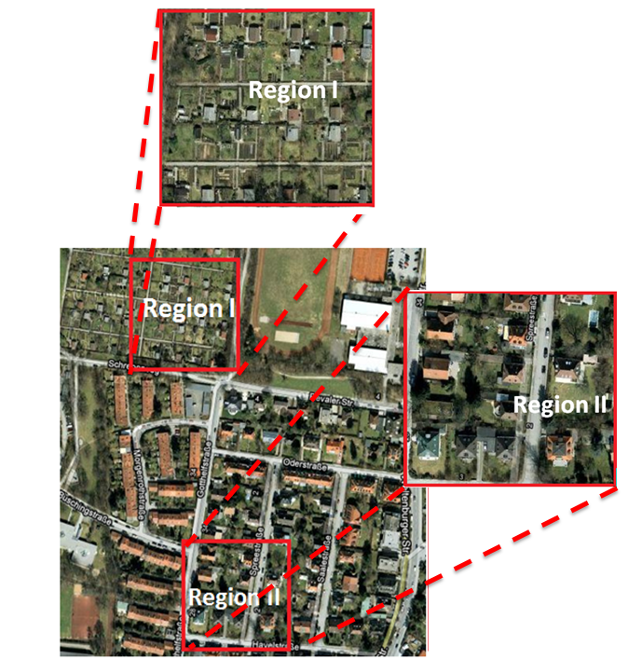
Figure 5 - Two examples of 100 m x 100 m pixels in Munich, Germany.
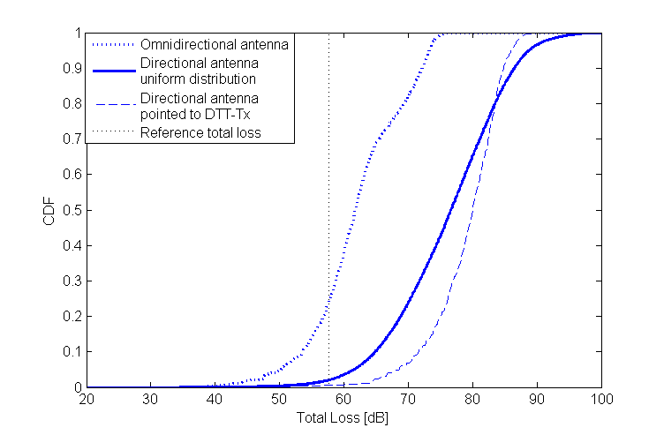
Figure 6 - Cumulative distribution of reference total loss in Region I.

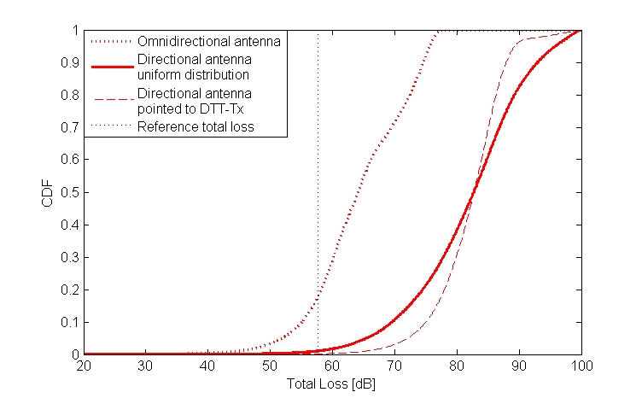
Figure 7 - Cumulative distribution of reference total loss in Region II.
Figure 6 and Figure 7 show the cumulative distribution of reference total loss for Regions I and II, respectively. Omnidirectional WSD antennas are the worst case, since it is not possible to explore selective attenuation. For directional antennas, the cumulative distribution of reference total loss shows a decrease of the probability of occurrence of lower values. The deterministic reference geometry in this scenario is given in Figure 2 where the total loss is 57.72 dB. It corresponds to the 2nd percentile in Region I and less than the 1st percentile in Region II. The “best case”, in where WSD antennas are pointed to the DTT-Tx, one observes the lowest probability of occurrence of low total loss values in a pixel.
The presented results are coherent with the expectation regarding the impact of the density of DTT-Rxs and the directivity of WSD antennas on the total loss distribution.
- Considering the DTT-Rx density and the direction of the WSD transmission in reference geometries
Last section showed that the probability of occurrence of the reference values of total loss varies with the density of DTT-Rxs and with the direction of the WSD transmission. In this section, we take a statistical approach in order to propose the use of the additional information – WSD transmission direction and density of DTT-Rxs – in the calculation of the maximum permitted WSD transmit power.
Using the simulation methodology described in Section 2 for fixed WSD, four DTT-Rx densities are considered: 2, 10, 25 and 35 DTT-Rx per pixel. In this case, DTT-Rxs are uniformly distributed within a 100 m X 100 m pixel area. Cumulative distributions of total loss for these DTT-Rx densities are shown in Figure 8, Figure 9, Figure 10 and Figure 11.
Figure 8 is related to an area with low density, a rural scenario for example. If the WSD antenna has no directivity, the reference geometry in ECC Report 159 for this scenario, shown in Figure 2, corresponds to the 4th percentile of the cumulative distribution of reference total loss. If the directivity of the WSD antenna is considered, this geometry corresponds to less than 0.3% of reference geometries. Table 2 summarizes the results for the four densities evaluated.
Table 2 - Probability of the Total Loss being less than the one of the deterministic reference geometry in Figure 2 according to the density of DTT receivers in a pixel
 | Values below 57.72 dB ( % )
Density of DTT-Rx | Omnidirectional antenna | Directional antenna with random azimuth | Directional antenna pointed to DTT-Tx
2 | 4% | 0.3% | 0.05%
10 | 17% | 0.1% | 0.02%
25 | 28% | 2% | 0.5%
35 | 32% | 4% | 0.7%

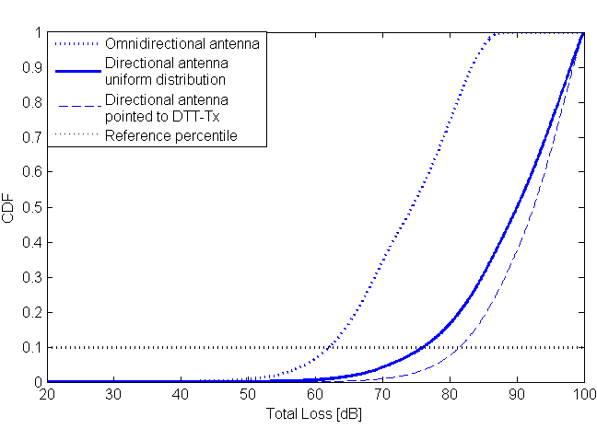 | 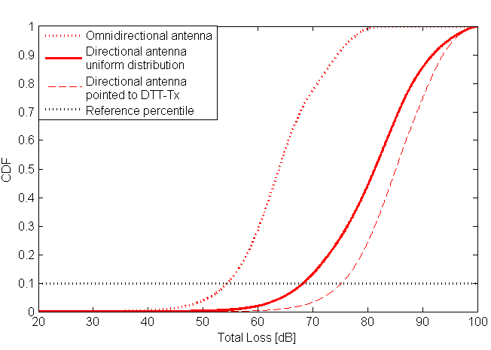
Figure 8 - Cumulative distribution of total loss inside a pixel considering fixed DTT-Rx, fixed WSD, 2 DTT-Rx/pixel. | Figure 9 - Cumulative distribution of total loss inside a pixel considering fixed DTT-Rx, fixed WSD, 10 DTT-Rx/pixel.
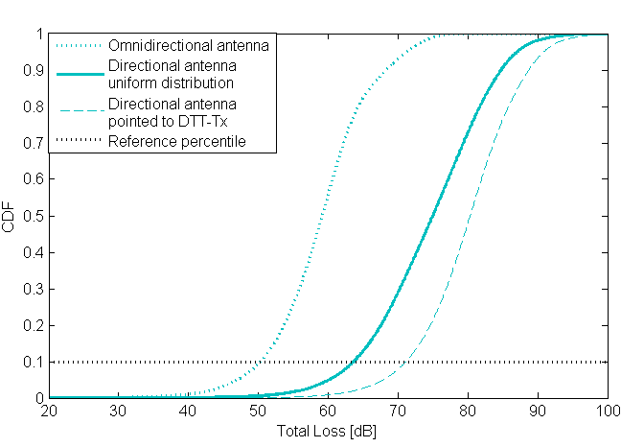 | 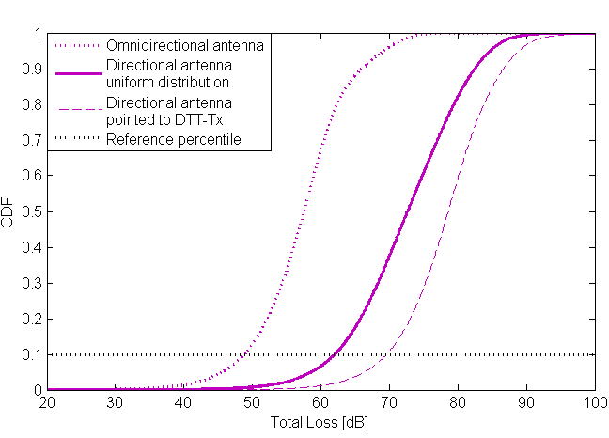
Figure 10 - Cumulative distribution of total loss inside a pixel considering fixed DTT-Rx, fixed WSD, 25 DTT-Rx/pixel. | Figure 11 - Cumulative distribution of total loss inside a pixel considering fixed DTT-Rx, fixed WSD, 35 DTT-Rx/pixel.

Considering the simulation results presented in Figure 8 to Figure 11, we propose that reference values of total loss used to calculate the maximum WSD permitted power consider the densities of DTT-Rxs in a given pixel. Furthermore, we propose that information about the directivity of the WSD antenna is considered if available.
It is proposed to adopt a reference percentile in the cumulative distribution curve of total loss, according to the density of DTT receivers. Table 3 shows the total loss value corresponding to the 10th percentile of the CDF curve (fixed WSD). The highlighted values represent the cases where the total loss is lower than the total loss in the deterministic reference in Figure 2.
Table 3 – Total loss values considering the 10th percentile, fixed WSD.
 | 10th percentile
Density of DTT-Rx / pixel | Total loss [dB] Omnidirectional antenna | Total loss [dB]  Directional antenna with random azimuth | Total loss [dB]  Directional antenna pointed to DTT-Tx
2 | 62.1 | 76.1 | 81.5
10 | 54.5 | 68.4 | 75.3
25 | 50.4 | 63.7 | 71.2
35 | 48.9 | 62 | 69.6
For the sake of comparison, the second set of simulations considers portable WSD and fixed DTT-Rx. Density of DTT-Rxs are the same considered in the previous simulation. The results are presented in Figure 12. In this case, WSD antenna is omnidirectional, and because of the difference between the DTT height and the WSD height, it is necessary to also consider the elevation pattern of the DTT antenna. This explains the different behavior of the CDF curves with respect to the results previously presented.
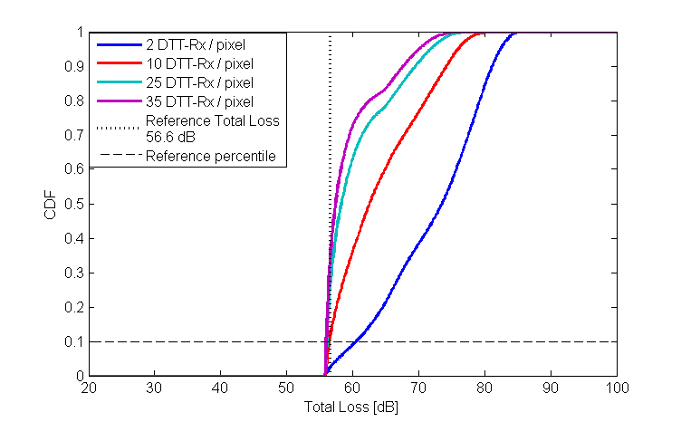
Figure 12 - Cumulative distribution of total loss inside a pixel considering, portable WSD, and the following densities of DTT-Rx/pixel: 2, 10, 25 and 35.
The third set of simulations considers portable DTT-Rx and portable WSD. Since no antenna directivity is present, the evaluation of reference geometries takes into account only the density of DTT-Rxs.
Three densities are considered in the evaluation: 10, 100 and 750 DTT-Rx per pixel. The last case is an extrapolation to consider a very dense pixel. The reference geometry is defined for a minimum separation distance of 2 m, leading to a total loss of 34.72 dB. The cumulative distribution curves of the total loss shown in Figure 13, and the results summarized in Table 4 do not consider a minimum separation distance between the WSD and the DTT-Rx.
Table 4 – Probability of the total loss being less than the one of the deterministic reference geometry in Figure 1 according to the density of DTT receivers in a pixel
DTT-Rx / pixel | Values below 34.72 dB ( % )
10 | 0.6 %
100 | 5 %
750 | 35%
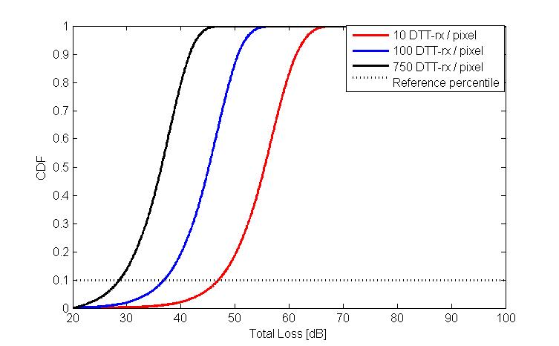
Figure 13 – Cumulative distribution of total loss inside a pixel considering portable DTT-Rx and portable WSD.
Table 5 – Total loss values considering the 10th percentile, portable WSD.
Density of DTT-Rx / pixel | Total loss [dB]  10th percentile
10 | 47
100 | 36.9
750 | 28.7

The variation observed in total loss values for different densities shows the importance of considering this parameter when calculating the maximum EIRP permitted for WSDs.

- Conclusions
This contribution has discussed the use of deterministic geometries between WSDs and DTT-Rxs in the methodology to calculate the location specific WSD power level. It was shown that deterministic reference geometries are not suitable to all situations, since it does not take into account relevant aspects like DTT receivers’ density and WSD antenna directivity in the calculation of the maximum power.
The influence of the two aforementioned aspects on the cumulative distribution of the reference total loss between WSDs and DTT-Rxs was evaluated through several simulations. It was shown that directional WSD antennas reduce the probability of occurrence of low values of total loss. Moreover, lower DTT-Rx densities cause the same effect.
Therefore, it was proposed to use a percentile in the cumulative distribution curve of total loss to define a reference configuration (loss value), over which the maximum WSD transmit power is determined. This procedure permits to consider information about the density of DTT-Rxs and the directivity of WSD antennas in the calculation of the WSD power limits. It defines variable reference configurations based on the distribution of total loss for specific scenarios.

INdT (Nokia Institute of Technology) is a non-profit research and development institute founded by Nokia in Brazil.
Considered antenna gain is 0 dBi.
Televisions per capita - http://www.nationmaster.com/graph/med_tel_percap-media-televisions-per-capita. Population density - http://en.wikipedia.org/wiki/Demographics_of_the_European_Union
It is emphasized that no minimum separation distance between WSD transmitter and DTT-Rx is considered.

