 |  | SE43(11)66

11th meeting of SE43
Lisbon, 19 – 21 September 2011

Date issued:
Source: | INdT
Subject: | Strategies to calculate the maximum permitted WSD EIRP.
Summary: | This work presents and compares different strategies to calculate the location specific WSD power levels based on the methodology of ECC Report 159, documents submitted in the 9th and 10th SE43 meetings, and distinct protection criteria. This document proposes to adapt the degradation in location probability according to the quality of the DTT signal in a given location. The use of reference values of total loss between WSDs and DTT-Rx, that take into account the density of receivers in a given pixel and the WSD antenna directivity, are also discussed in this document to evaluate the impact of this information in the WSD power limits. The maximum WSD EIRPs obtained with the different strategies are compared.
Proposal: | It is proposed to include the content of the attachment in the working document in section 3.
Background: | CEPT SE 43 group addressed the identification of a common set of the parameters to calculate location specific WSD Power as a topic that requires immediate further studies (issue B1 of section 11 of ECC Report 159).  In the 9th meeting of SE43, document SE43(11)12 addressed this topic and included $I/N ≈ -3 dB$ as a protection criterion to set the maximum WSD EIRP. In the 10th meeting, document SE43(11)33 suggested the division of the DTT coverage area in layers, where the criterion of maximum degradation in location probability would be applied in order to calculate the maximum WSD EIRP.  This document also considers a probabilistic approach of reference geometries between WSDs and DTT-Rxs, based on results presented in document Reference spatial geometries between WSDs and DTT-RXs for the calculation of the maximum permitted WSD EIRP.
Password protection required? (Y/N) | N

ATTACHMENT
- Protection Criteria
To determine the maximum permitted EIRP for WSDs, it is necessary to ensure that the defined protection criteria are respected. When assessing the interference caused by a WSD into the broadcasting service, two quantities are important:
- The degradation of the coverage quality of DTT service due to the interference;
- The degradation of the ability of the DTT receiver in discriminating the desired signal from interference signals;
Next sections present a background and references that discuss some protection criteria considering the DTT planning and the presence of WSD interference.

    - Protection Ratio

Protection ratio is the minimum value of the signal-to-interference ratio required to obtain a specified reception quality under specified conditions at the receiver input. It depends on both transmitter and receiver characteristics.

    - Overloading Threshold

Overloading threshold is defined as the interfering signal level expressed in dBm, above which the receiver begins to lose its ability to discriminate against interfering signals at frequencies differing from that of the wanted signal, i.e. the receiver has a non-linear behavior.

    - Degradation in location probability
Degradation in location probability is a measure of the degradation in the DTT service due to the presence of interference. The DTT location probability is defined as the probability with which a DTT receiver would operate correctly at a specific location.
At the coverage edge, in the absence of noise and interference from other DTT transmitters, the location probability can be calculated as:
$$LP=\operatorname{Pr}\left( E_{w}≥ E_{min}\right)$$
where $E_{w}$ is the wanted field strength and $E_{min}$ is the minimum field strength required for the operation of the DTT receiver. At the edge of the coverage area, DTT systems are planned to have LP = 95%, which corresponds to a reference value of median field strength,${ E}_{wmed-ref}$. Figure 1 shows the relationship between these quantities.
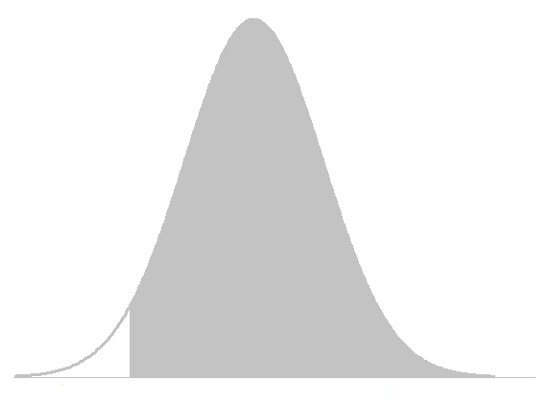
$$E_{wmed_ref}$$
$$E_{min}$$
95%
Figure 1 - Median field strength of the wanted signal for LP=95%.
In the presence of interference, the location probability is calculated as:
$${LP}_{WSD}=\operatorname{Pr}\left( E_{w}≥ E_{min}+E_{i}\right),$$
where $E_{i}$ is the interference field strength. The degradation in location probability is the degradation observed in (1) due to presence of WSD interference, and can be written as:
$${ΔLP=LP-LP}_{WSD}.$$
ECC Report 159 comments that location probability degradation is a highly suitable metric for specifying regulatory emission limits for WSDs operating in DTT frequencies (Sec. 4.3.4.2). Although this report specifies a methodology to calculate the location probability and location probability degradation, it does not specify the permitted values of $ΔLP.$
    - Interference to noise ratio
Another protection criterion is to limit the total interference caused by WSDs in relation to the system noise power.
Recommendation ITU-R BT. 1895 recommends that the total interference at the receiver from all radiations and emissions without a corresponding frequency allocation in the Radio Regulations should not exceed one per cent of the total receiving system noise power. Limitation of interference into the broadcast service is thus considered by defining $I/N ≤ -20 dB$ for all radiations and emissions without a corresponding frequency allocation in the Radio Regulations.

- Methodology
Report 159 proposes a methodology to calculate the WSD EIRP levels based on the degradation in the broadcasting service. Sections below address the technical considerations taken into account to the calculation of the maximum EIRP power limits for WSDs according to ECC Report 159 - Annex 6. Methodology consists of the following steps, also summarized in Figure 2:
- Calculate the location probability considering no interference from secondary system;
- Calculate the location probability considering the presence of WSD;
- Define the maximum accepted interference caused by WSDs into the DTT service according to the selected protection criteria;
- Use a reference geometry concerning the positioning of WSD transmitter and DTT receiver;
- Calculate the maximum permitted WSD EIRP for the reference geometry.
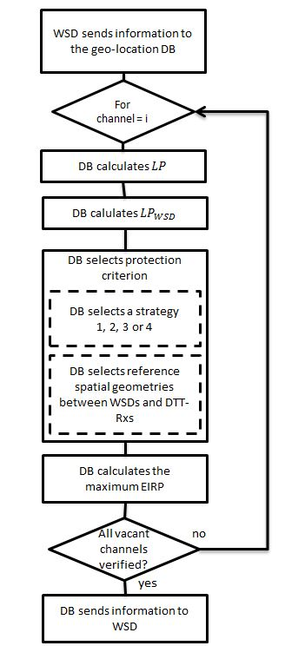
Figure 2 – Flowchart of the determination of maximum allowed EIRP for WSDs.

The current document presents a set of results regarding WSD EIRP levels using different protection criteria to the calculation of the maximum acceptable interference to the DTT service. Furthermore, this contribution also addresses the impact of different reference geometries between WSDs and DTT-Rxs on the maximum permitted power.

- Calculation of the maximum permitted interference in the primary service

The maximum permitted interference at the DTT receiver varies with the chosen protection criteria. In the following, the simulation methodology is presented, as well as the four different strategies to protect the DTT service and to calculate the maximum EIRP WSD levels.

  - Simulation methodology
The simulation methodology is based on Monte Carlo simulations where the DTT wanted signal and the interference from the WSD are modeled as random variables with normal distribution as follows:
$E_{w} [dBμV/m] \sim N\left(E_{wmed}, σ_{S}=5.5\right)$ is the field strength of the wanted signal at the DTT receiver, with mean $E_{wmed}$ and standard deviation $σ_{w}$;
$E_{i} [dBμV/m] \sim N\left(E_{imed}, σ_{I}=3.5\right)$ is the field strength of the interference at the DTT receiver, with mean $E_{imed}$ and standard deviation $σ_{I}$.
Table 1 summarizes the parameters used in the simulation concerning two types of DTT receivers. For each value of $E_{wmed}$, the location probability is calculated over 1,000 trials and 1,000 signal samples per trial. The results of location probability in the absence of interference, Equation (1), are shown in Figure 3 and Table 2 for portable and fixed DTT receivers.
Table 1 - Simulation parameters
Type of DTT receiver | $$E_{wmed_{ref}}$$  $$[dBμV/m]$$ | $$E_{min}$$  $$[dBμV/m]$$ | Co-channel protection ratio PR(0)[dB] | 1st adj. channel protection ratio $PR\left(Δf_{1}\right)$[dB] | 2nd adj. channel protection ratio $PR\left(Δf_{2}\right)$[dB]
Fixed | 56.21 | 47.16 | 21 | -30 | -40
Portable | 61.21 | 52.16 | 19 | -30 | -40

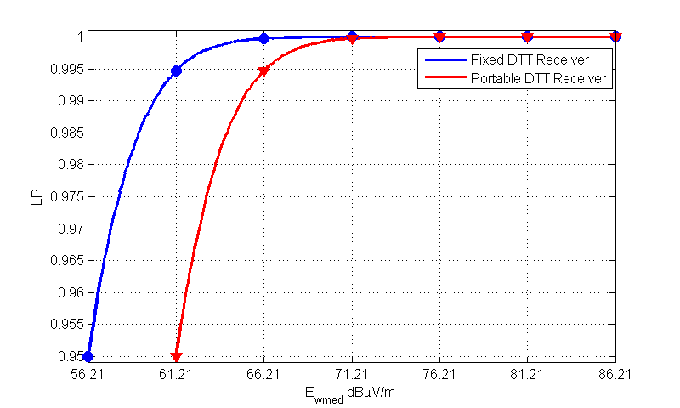
Figure 3 - Location Probability in the absence of interference, considering fixed and portable DTT reception.

Table 2 - Location probability in the absence of interference.
$$E_{wmed}$$ | Location Probability  Fixed DTT-Rx (%) | Location Probability  Portable DTT-Rx (%)
$E_{wmed_{ref}}$* | 95 | 95
$$E_{wmed_{ref}} + 1 dB$$ | 96.61 | 96.6
$$E_{wmed_{ref}}+ 2 dB$$ | 97.78 | 97.76
$$E_{wmed_{ref}} + 3 dB$$ | 98.57 | 98.58
$$E_{wmed_{ref}} + 4 dB$$ | 99.1 | 99.14
$$E_{wmed_{ref}} + 5 dB$$ | 99.47 | 99.47
$$E_{wmed_{ref}} + 6 dB$$ | 99.69 | 99.69
$$E_{wmed_{ref}} + 7 dB$$ | 99.82 | 99.83
$$E_{wmed_{ref}} + 8 dB$$ | 99.9 | 99.9
$$E_{wmed_{ref}} + 9 dB$$ | 99.95 | 99.95
$$E_{wmed_{ref}}+ 10 dB$$ | 99.97 | 99.97
$$E_{wmed_{ref}} + 11 dB$$ | 99.99 | 99.98
$$E_{wmed_{ref}} + 12 dB$$ | 99.99 | 99.99
$$E_{wmed_{ref}} + 13 dB$$ | 100 | 100
$$E_{wmed_{ref}} +…$$ | … | …
$$E_{wmed_{ref}} + 30 dB$$ | 100 | 100
* $E_{wmed_{ref}}=56.21 dBμV/m$ for fixed DTT-Rx and $E_{wmed_{ref}}=61.21 dBμV/m$ for portable DTT-Rx.
The second step in the methodology is to calculate the new value of location probability considering the interference from WSD in the co-channel for appropriate values of protection ratio in the calculation of $E_{imed}$.
Location probability depends on the value of $E_{wmed}$. In Figure 4, location probability curves are shown for four different values of $E_{wmed}$ and two types of DTT receivers. Results are obtained for the edge of the coverage area – where the median field strength is $E_{wmed-ref}$ – and closer to the DTT transmitter, where the $E_{wmed}$ is: $E_{wmed-ref}+10 dB$,$E_{wmed-ref}+20 dB$ and $E_{wmed-ref}+30 dB$. As the value of $E_{wmed}$ increases, the necessary interference to cause the same degradation in location probability also increases.
For a given location (or DTT signal strength), each value of $E_{imed}$ leads to a different degradation in location probability. The maximum permitted degradation has not been defined yet, but it is a parameter that may vary according to the pixel environment, the density of DTT-Rxs in a given area, and the distance from the DTT transmitter. This topic is further investigated in Sections 3, 4 and 5.
Curves shown in Figure 4 only consider co-channel operation. Figure 5 shows an example of the location probability at the edge of the coverage area considering the protection ratio for the 1st and 2nd adjacent channels shown in Table 1.
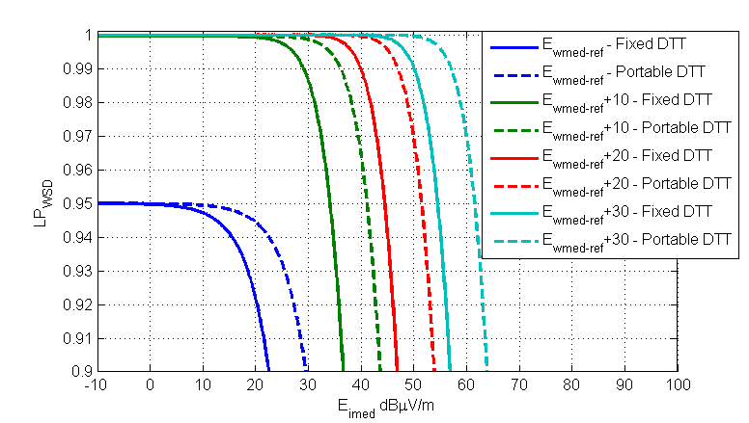
Figure 4 - Location probability with co-channel WSD interference and different values of $E_{wmed}$ for portable and fixed DTT reception.
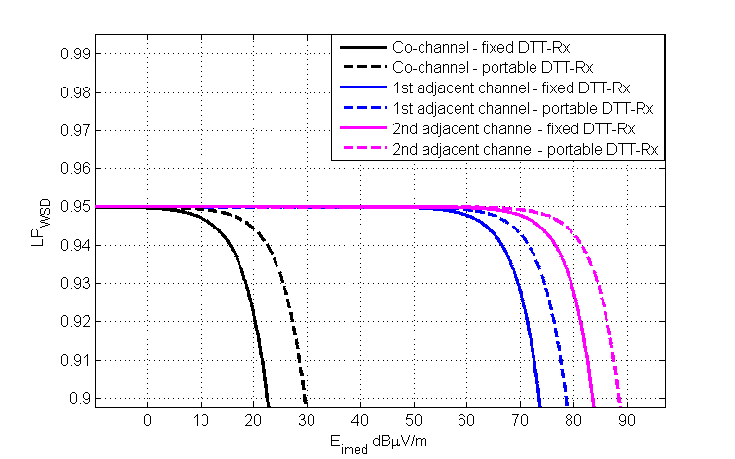
$$PR\left(0\right)-PR(Δf_{1})$$
$$PR\left(0\right)-PR(Δf_{2})$$
Figure 5 - Location probability with adjacent channel interference from fixed WSD at the edge of the coverage area for portable and fixed DTT reception.
  - Strategies to calculate the maximum permitted interference field strength
In order to determine the maximum permitted interference to be caused to a DTT receiver, the next step is to select a protection criterion and a strategy to define maximum permitted powers in different regions within the coverage area. In this section four different strategies are discussed.
- Strategy 1 simultaneously considers two protection criteria over the DTT coverage area: the maximum interference-to-noise ratio and the maximum degradation in location probability;
- Strategy 2 divides the DTT coverage area in layers and apply a unique value of degradation in location probability in each layer. Overloading thresholds are respected;
- Strategy 3 uses the concept of layers presented in strategy 2, and varies the value of degradation in location probability according to thresholds of the wanted DTT signal strength. Overloading thresholds are respected;
- Strategy 4 varies the value of degradation in location probability according to the value of the wanted signal field strenght in each location within the DTT coverage area. Overloading thresholds are respected.

    - Strategy 1: Two layers
The first strategy, proposed in document SE43(11)12, considers two protection criteria that divide the coverage area in two layers.
- The first area – that goes from the edge of the coverage area up to a region where $E_{wmed}$ is $E_{wmed-ref}+10 dB$ – has the interference limited by the protection criterion $ΔLP=0.1\%$.
- The second area – which comprises the remaining part of the coverage area – has as limiting protection criterion $\frac{I}{N}=-3dB$ ( this criterion corresponds to $ΔLP≈0.1\%$ for $E_{wmed-ref}+10 dB$ ).
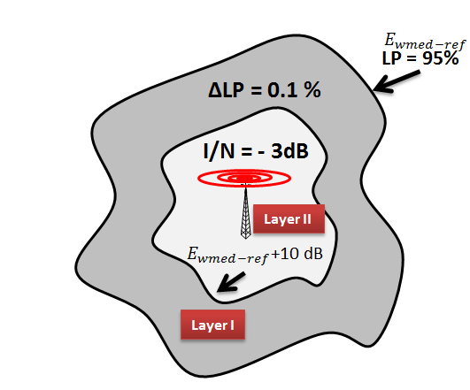
Figure 6 - Two layers strategy proposed in document SE43(11)12.
Using this strategy, the maximum $E_{imed}$ in Layer 1, varies according to the value of $E_{wmed}$, and in Layer 2, the maximum interference is fixed. These values are show in Table 3 for co-channel operation and in Figure 7 for adjacent channel operation, considering only one transmitting WSD.
Table 3 – Maximum $E_{imed}$ according to the protection criteria of Strategy 1.
Region | $$E_{wmed}$$ | Maximum $E_{imed} [dBμV/m]$  Fixed DTT-Rx | Maximum $E_{imed} [dBμV/m]$  Portable DTT-Rx
Layer I | $$E_{wmed_{ref}}$$ | 5.6 | 12.6
Layer I | $E_{wmed_{ref}} + 1$ dB | 7.2 | 14.0
Layer I | $E_{wmed_{ref}}+ 2$ dB | 8.6 | 15.5
Layer I | $E_{wmed_{ref}} + 3$ dB | 10.3 | 17.3
Layer I | $E_{wmed_{ref}} + 4$ dB | 11.9 | 18.8
Layer I | $E_{wmed_{ref}} + 5$ dB | 13.6 | 20.7
Layer I | $E_{wmed_{ref}} + 6$ dB | 15.4 | 22.6
Layer I | $E_{wmed_{ref}} + 7$ dB | 17.4 | 24.2
Layer I | $E_{wmed_{ref}} + 8$ dB | 19.2 | 26.1
Layer I | $E_{wmed_{ref}} + 9$ dB | 21.1 | 28.1
Layer I | $E_{wmed_{ref}}+ 10$ dB | 22.9 | 29.6
Layer II | $${E_{wmed}>E}_{wmed_{ref}}+ 10 dB$$ | 22.9 | 29.6
* $E_{wmed_{ref}}=56.21 dBμV/m$ for fixed DTT-Rx and $E_{wmed_{ref}}=61.21 dBμV/m$ for portable DTT-Rx.

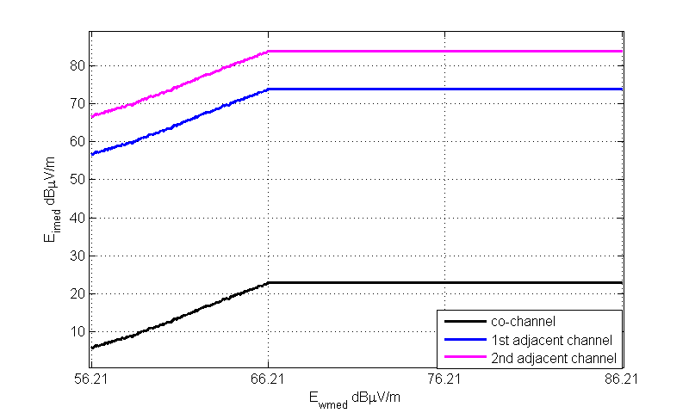
$$PR\left(0\right)-PR(Δf_{1})$$
$$PR\left(0\right)-PR(Δf_{2})$$
Figure 7 – Maximum permitted $E_{imed}$ considering fixed WSD, according to the protection criteria of Strategy 1.

Although this strategy maintains a level of interference to noise ratio, it is important to stress that it limits the maximum interference that a WSD can cause to the DTT receiver by the degradation in location probability at the location where the DTT field strength is $E_{wmed_{ref}}+ 10 dB$, and the location probability is 99.97%. In regions closer to the DTT transmitter, where the DTT field strength is higher and $LP$ reaches 100%, the necessary interference to degrade the location probability is higher.
Therefore, Strategy 1 imposes severe limits to the maximum WSD EIRP because of the maximum $I/N$ protection crioterion. The following strategies also take into account specific studies on the impact of interference on DTT receivers and on DTT reception quality in areas closer to the DTT transmitter, where the wanted DTT signal is higher and the permitted interference is expected to be so.
    - Strategy 2: Multi-layers
Strategy 2 has been proposed in document SE43(11)33 based on the location probability degradation. The strategy is characterized by:
- Division of the coverage area in multiple layers, where each layer is defined by the median field strenght at its edges. This means that $E_{wmed}$ is inside the i^{th} layer if ${E_{wmed-ref}+(i-1)Δ≤E}_{wmed}<E_{wmed-ref}+iΔ$, where $Δ$ depends on the accuracy of information available at the database;
- Inside each layer, use of the location probability degradation $ΔLP$ at the external edge as protection criterion until the interference level reaches the overloading threshold.
Figure 8 shows the division of the coverage area in layers according to the received $E_{wmed}$. Figure 9 shows the relationship between $E_{imed}$ and $E_{wmed}$ for fixed DTT reception and fixed WSD transmission with $ΔLP=0.1\%$ and layers of $Δ=5 dB$ wide. Table 4 shows the maximum $E_{imed}$ for both fixed and portable DTT reception.
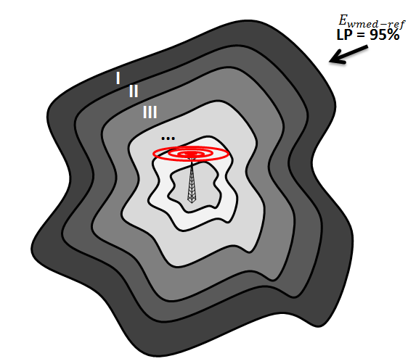
Figure 8 - Multiple layers strategy proposed in document SE43(11)33.
From the values of Table 4, one observes the gains of Strategy 2 over Strategy 1 (Table 3). In Strategy 1, the power values are limited by the values of the third layer in Strategy 2. Considering the values of layer VI, for example, the increase in the permitted interference with Strategy 2 is 17.1 dB for a fixed DTT-Rx and 17.4 dB for a portable DTT-Rx. In this example, the maximum value of $E_{wmed}$ considered was $E_{wmed-ref}+25 dB$, but it is possible to consider higher values, since the values of interference are bellow the overloading threshold, as it will be dicussed in section 3.
It is also possible to consider other values of $Δ$, according to the accuracy of the location estimation provided by the WSD to the geo-location database. One example of this configuration is shown in Figure 10 for $Δ=2.5$ dB. As the value of $Δ$ decreases, the curve of maximum permitted $E_{imed}$ is aproximated to the curve when no layers are defined. The advantage of using layers is to protect even more the primary service, by limiting the maximum interference by the value of $E_{wmed}$ at the external edge of the layer. Therefore, the use of layers gives a margin for the selection of the reference value of $E_{wmed}$ used to calculate the maximum interference allowed.
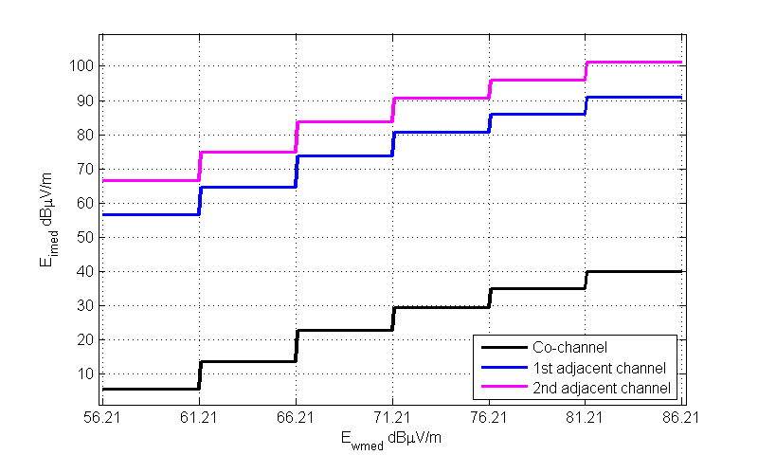
$$Δ=5 dB$$
Figure 9 – Maximum permitted $E_{imed}$ considering fixed WSD and fixed DTT, according to the protection criteria of Strategy 2 and $Δ=5 dB$.

Table 4 – Maximum $E_{imed}$ according to the protection criteria of Strategy 2.
Region | $E_{wmed}$at the edge of the layer | Maximum $E_{imed} [dBμV/m]$  Fixed DTT-Rx | Maximum $E_{imed} [dBμV/m]$  Portable DTT-Rx
Layer I | $$E_{wmed-ref}$$ | 5.6 | 12.6
Layer II | $$E_{wmed-ref}+5 dB$$ | 13.6 | 20.7
Layer III | $$E_{wmed-ref}+10 dB$$ | 22.9 | 29.6
Layer IV | $$E_{wmed-ref}+15 dB$$ | 29.3 | 36.4
Layer V | $$E_{wmed-ref}+20 dB$$ | 34.7 | 41.8
Layer VI | $$E_{wmed-ref}+25 dB$$ | 40.0 | 47.0
* $E_{wmed_{ref}}=56.21 dBμV/m$ for fixed DTT-Rx and $E_{wmed_{ref}}=61.21 dBμV/m$ for portable DTT-Rx.

At the database, the calculation of the maximum power using this strategy could be summarized in the following algorithm:
- The WSD sends it’s location to the geo-location database;
- For each vacant channel:
    - From the location information, the database estimates $E_{wmed}$;
    - The database maps the WSD location into a layer;
    - For a specific value of $ΔLP$, the database calculates $E_{imed}$;
    - From $E_{imed}$, the database calculates the maximum permitted WSD EIRP, according to a reference geometry between WSDs and DTT-Rxs.
- The database sends the information about the channel and the maximum EIRP to the WSD.
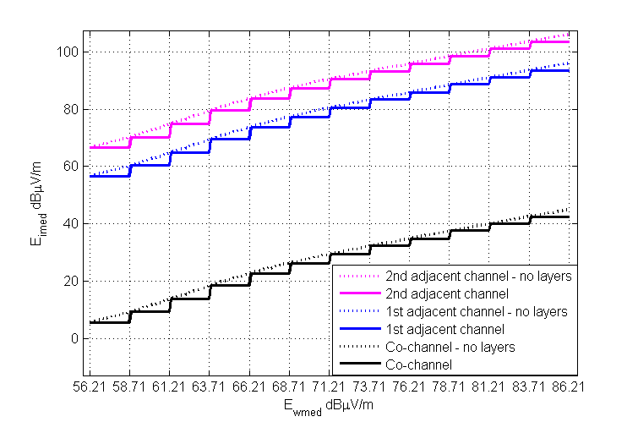
$$Δ=2.5dB=2.5 dB$$
Figure 10– Maximum permitted $E_{imed}$ considering fixed WSD and fixed DTT, according to the protection criteria of Strategy 2 and$Δ=2.5 dB$.
    - Strategy 3: Multi-layers and Flexible $ΔLP$
Strategy 2 considers the same value of degradation in location probability in the entire DTT coverage area. Considering the variation of the location probability with the value of $E_{wmed}$, shown in Figure 3, we propose to adapt the maximum degradation in each layer according to the value of location probability, i.e. we propose to increase the permitted degradation taking into account the quality of the DTT signal in a given location.
Strategy 3 consists of the following steps to define the maximum permitted $E_{imed}$:
- Divide the coverage area in multiple layers, where each layer is defined by the median field strenght at its edges. This means that $E_{wmed}$ is inside the i^{th} layer if ${E_{wmed-ref}+(i-1)Δ≤E}_{wmed}<E_{wmed-ref}+iΔ$, where $Δ$ depends on the accuracy of information available at the database;
- For each layer, select a value of degradation in location probability $ΔLP$ at the external edge according to the minimum acceptable $LP$, to be identified by regulatory entities.
- Inside each layer, use of the specific location probability degradation $ΔLP$ as protection criterion until the interference level reaches the overloading threshold.

This strategy is based on thresholds selected at the database to trigger the variation of the maximum permitted degradation in location probability. While Strategy 2 proposed the use of a unique degradation value within the coverage area, this strategy varies the value of $ΔLP$ according to the quality of the DTT signal in the current location. For example, a degradation of 1% at the coverage edge where $LP=95\%$, may be too severe to the quality of the DTT service. The same degradation in a region where the location probability is close to 100% is not as harmful to the primary system. The idea is to use location probability thresholds to trigger the variation of the maximum permitted degradation. The database algorithm for this strategy can be summarized as follows:
- The WSD sends it’s location to the geo-location database;
- For each vacant channel,
    - The database translates the WSD location into a layer;
    - From the mapped layer, the database selects a value of $ΔLP$based on DTT planning and LP thresholds.
    - The database calculates $E_{imed}$ for the selected $ΔLP$;
    - From $E_{imed}$, the database calculates the maximum permitted WSD EIRP, according to a reference geometry between WSDs and DTT-Rxs.
- The database sends the information about the channel and the maximum EIRP to the WSD.

As an example, consider the four $LP$ thresholds for the maximum permitted $ΔLP$ given in Table 5. The curves of $E_{imed}$ for each level of $ΔLP$ according to Strategy 3 are shown in Figure 11 as a function of $E_{wmed}$.
Table 5 – Examples of $LP$ thresholds for adaptive $ΔLP$.
LP threshold | Maximum permitted $ΔLP$
98.5% ≤ LP < 99.0% | 0.5%
99.0% ≤ LP < 100% | 1%
LP = 100% | 2%
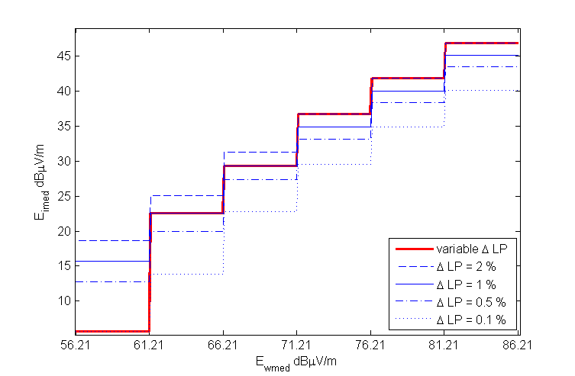
$$6.9 dB$$
$$13dB=2.5 dB$$
Figure 11 – Maximum $E_{imed}$ at the co-channel according to different values of $ΔLP$ – fixed WSD and fixed DTT-Rx.
Table 6 – Maximum $E_{imed}$ according to the protection criterion of Strategy 3.
Region | $E_{wmed}$at the edge of the layer | Maximum $E_{imed} [dBμV/m]$  Fixed DTT-Rx | Maximum $E_{imed} [dBμV/m]$  Portable DTT-Rx
Layer I | $$E_{wmed-ref}$$ | 5.6 | 12.6
Layer II | $$E_{wmed-ref}+5 dB$$ | 22.6 | 29.7
Layer III | $$E_{wmed-ref}+10 dB$$ | 29.3 | 36.3
Layer IV | $$E_{wmed-ref}+15 dB$$ | 36.8 | 43.7
Layer V | $$E_{wmed-ref}+20 dB$$ | 41.9 | 48.9
Layer VI | $$E_{wmed-ref}+25 dB$$ | 46.9 | 53.9
* $E_{wmed_{ref}}=56.21 dBμV/m$ for fixed DTT-Rx and $E_{wmed_{ref}}=61.21 dBμV/m$ for portable DTT-Rx.

The advantage of this strategy is to better explore the variation in the quality of the DTT signal, while meeting the protection requirements and providing aditional protection to DTT receivers due to the division in layers. The gains in terms of higher permitted interference of Strategy 3 over Strategy 2 can be observed by comparing Tables 4 and 6, or the curves for $ΔLP =0.1\%$ and for variable $ΔLP$ in Figure 11. These gains come from the higher level of $ΔLP$ in Strategy 3 for some layers.

    - Strategy 4: Flexible $ΔLP$
Strategy 4 is a combination of the methodology proposed in ECC Report 159 to calculate the maximum permitted interference with the variation of the maximum $ΔLP$ proposed in Strategy 3. It consists of the following steps to define the maximum permitted $E_{imed}$:
- Select the level of location probability degradation $ΔLP$ according to the level of $LP$ at the location provided by the WSD.
- Use the selected $ΔLP$ value as protection criterion until the interference level reaches the overloading threshold.
Figure 12 illustrates the curves of $E_{imed}$ as a function of $E_{wmed}$ for the values of $ΔLP$ given in Table 5. Table 7 shows values of $E_{imed}$ obtained by Strategy 4 for several values of $E_{wmed}$. The gains in terms of higher permitted inerference obtained by Strategy 4 specifically over Strategy 3 are due the possibility of taking the actual value of $E_{wmed}$ to calculate $E_{imed}$ in the place of to limit the value of $E_{wmed}$ to the one at the external edge of the layer as in Strategies 2 and 3.

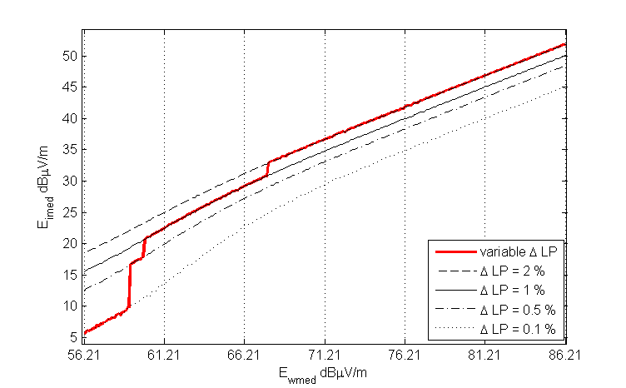
LP$≤$98.5%
LP $≤$99.0%
LP$<$100%
LP=100%
Figure 12 – Maximum $E_{imed}$ at the co-channel according the protection criteria of Strategy 4, considering fixed DTT receiver and fixed WSD.
The database algorithm for Strategy 4 is summarized in the following:
- The WSD sends it’s location to the geo-location database;
- For each vacant channel,
    - The database translates the WSD location into a value of LP, according to the DTT planning;
    - The database selects a value of $ΔLP$based on DTT planning and LP thresholds;
    - The database calculates $E_{imed}$ for a value of $ΔLP$;
    - From $E_{imed}$, the database calculates the maximum permitted WSD EIRP, according to a reference geometry between WSDs and DTT-Rxs.
- The database sends the information about the channel and the maximum EIRP to the WSD.

Table 7 - Maximum $E_{imed}$ according to the protection criteria of Strategy 4.
$$E_{wmed}$$ | Maximum $E_{imed} [dBμV/m]$  Fixed DTT-Rx | Maximum $E_{imed} [dBμV/m]$  Portable DTT-Rx
$$E_{wmed-ref}$$ | 5.6 | 12.6
$$E_{wmed-ref}+2.5 dB$$ | 9.1 | 16.3
$$E_{wmed-ref}+5 dB$$ | 22.4 | 29.5
$$E_{wmed-ref}+7.5 dB$$ | 26 | 33
$$E_{wmed-ref}+10 dB$$ | 29.2 | 36.2
$$E_{wmed-ref}+12.5 dB$$ | 34 | 40.9
$$E_{wmed-ref}+15 dB$$ | 36.6 | 43.6
$$E_{wmed-ref}+17.5 dB$$ | 39.2 | 46.2
$$E_{wmed-ref}+20 dB$$ | 41.9 | 48.9
$$E_{wmed-ref}+22.5 dB$$ | 44.3 | 51.3
$$E_{wmed-ref}+25 dB$$ | 46.9 | 53.9
$$E_{wmed-ref}+27.5 dB$$ | 49.3 | 56.3
$$E_{wmed-ref}+30 dB$$ | 51.8 | 58.8
* $E_{wmed_{ref}}=56.21 dBμV/m$ for fixed DTT-Rx and $E_{wmed_{ref}}=61.21 dBμV/m$ for portable DTT-Rx.

    - Maximum permitted interference

After the calculation of the maximum $E_{imed}$, it is necessary to verify if the interference caused by WSDs is sufficient to overload the DTT receivers. The overloading occurs when the receiver loses its ability to discriminate between the wanted signal and the interference, i.e., when the interference is higher than the overloading threshold. The interference at the receiver can be calculated as:
$$I_{\left[dBm\right]}={E_{imed}}_{\left[dBμV/m\right]}-20\log_{10}\left(f_{\left[MHz\right]}\right)-77.2+\left(PR\left(0\right)-PR\left(Δf\right)\right) .$$

The maximum interference must be limited by reference values of overloading thresholds, i.e.:
$I_{\left[dBm\right]}<overloading threshold- G_{a}$,

where $G_{a}$ is the DTT-Rx antenna gain.
Overloading thresholds used in the following are given in Table 8. These values were selected among the ones presented in Tables 5b and 7b of ECC Report 148. Antenna gains are $G_{a}=9.15$dB for fixed DTT-Rx and $G_{a}=2.15$ dB for portable DTT-Rx.
Table 8 – Overloading thresholds [dBm]
 | Fixed DTT-Rx |  | Portable DTT-Rx
 | 1st adjacent channel | 2nd adjacent channel | 1st adjacent channel | 2nd adjacent channel
Fixed WSD | -13 | -7 | -18 | -12
Portable WSD | -22 | -25.5 | -27 | -30.5

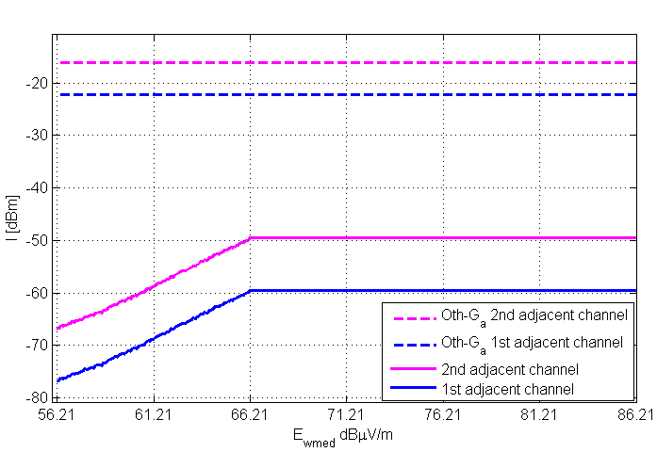 | 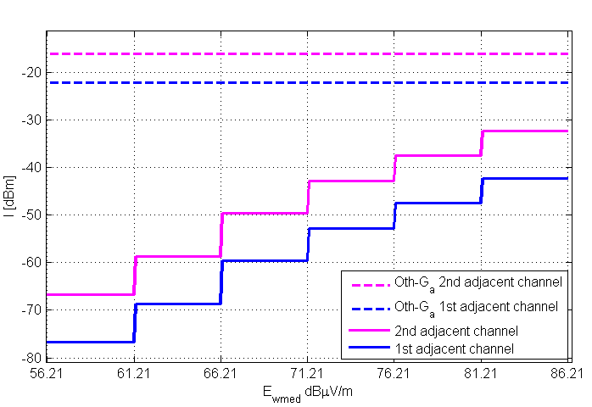
Figure 13 - Maximum $I_{\left[dBm\right]}$ according the protection criterion of Strategy 1, considering fixed DTT receiver and fixed WSD. | Figure 14 - Maximum $I_{\left[dBm\right]}$ according the protection criterion of Strategy 2, considering fixed DTT receiver and fixed WSD.
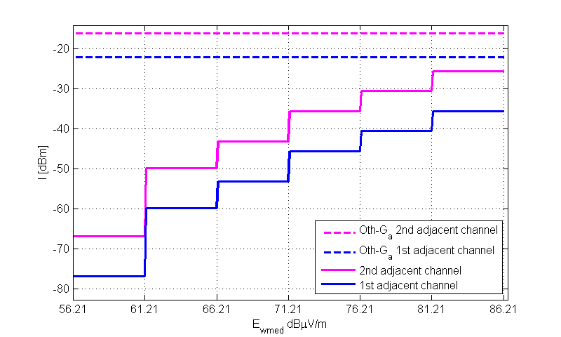 | 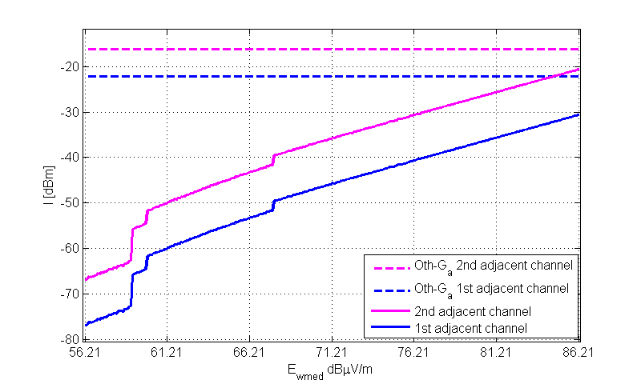
Figure 15 - Maximum $I_{\left[dBm\right]}$ according the protection criterion of Strategy 3, considering fixed DTT receiver and fixed WSD. | Figure 16 - Maximum $I_{\left[dBm\right]}$ according the protection criterion of Strategy 4, considering fixed DTT receiver and fixed WSD.

Figure 13, Figure 14, Figure 15 and Figure 16 show the maximum permitted values of interference with the variation of $E_{wmed}$ for Strategies 1, 2, 3 and 4, respectively. Fixed DTT reception and fixed WSD are considered. As can be observed, the maximum interference defined by the four strategies is not sufficient to overload the DTT receivers in the considered range of $E_{wmed}$. However, when a portable DTT is interfered by a portable WSD, the overloading threshold is reached by some strategies inside the range $E_{wmed-ref}≤E_{wmed}≤E_{wmed-ref}+30 dB$. This situation is illustrated in Figure 17, Figure 18, Figure 19 and Figure 20 for Strategies 1, 2, 3 and 4, respectively, where the overloading threshold is reached and limits the maximum permitted interference.

Note: It is important to highlight that overloading thresholds and protection ratios play a key role on the definition of WSD power limits, since the actual interference at DTT receivers is strongly dependent on these parameters. Overloading thresholds and protection ratios depend on characteristics of WSD transmitters and DTT receivers. Further investigation is needed to define reference values for both. Values taken in this analysis are illustrative. Furthermore, it is suggested an additional margin on the value of overloading threshold, to increase the protection of DTT receivers.

Maximum permitted interference for different combinations of DTT and WSD types are shown in Table 9. In this table, interference values limited by the overloading threshold are highlighted.

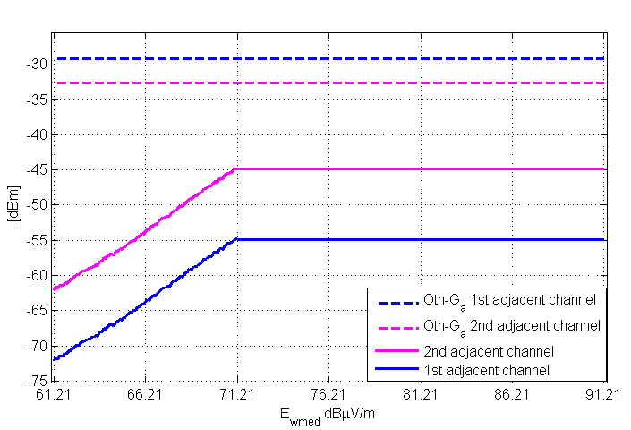 | 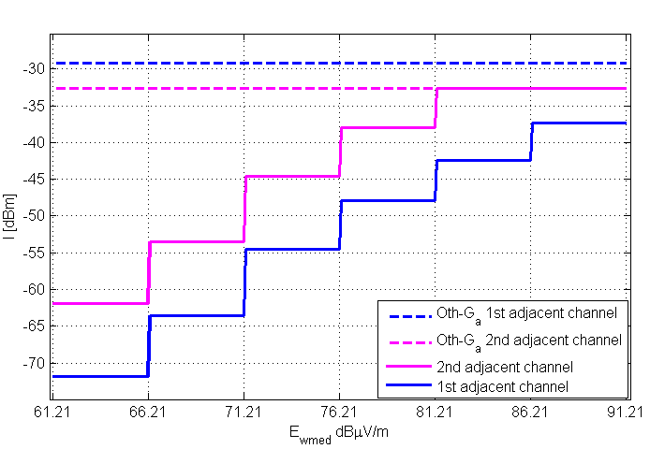
Figure 17 - Maximum $I_{\left[dBm\right]}$ according the protection criterion of Strategy 1, considering portable DTT receiver and portable WSD. | Figure 18 - Maximum $I_{\left[dBm\right]}$ according the protection criterion of Strategy 2, considering portable DTT receiver and portable WSD.
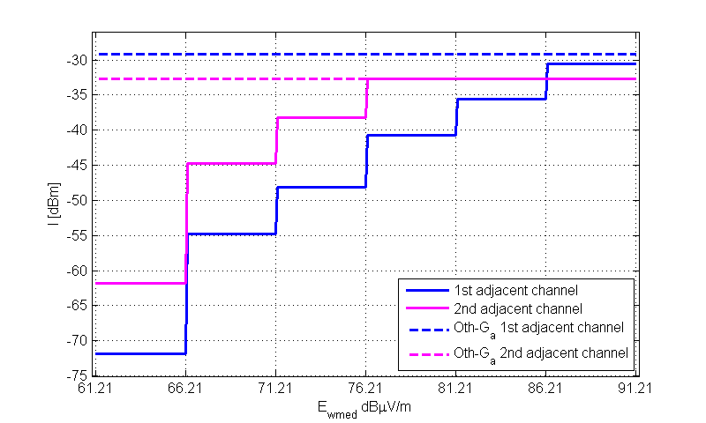 | 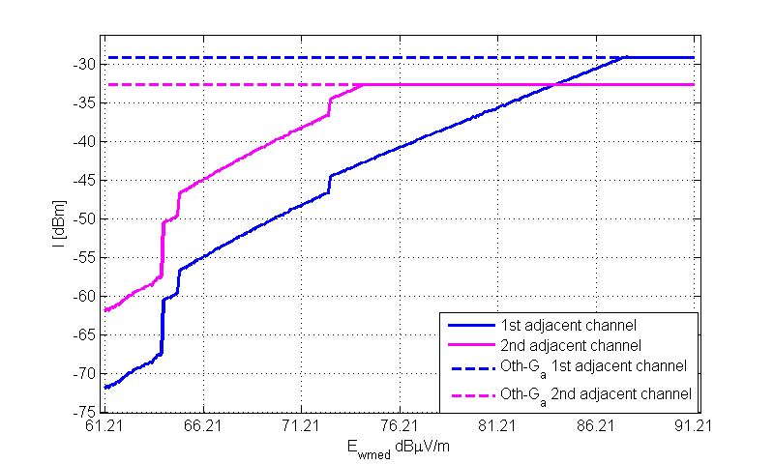
Figure 19 - Maximum $I_{\left[dBm\right]}$ according the protection criterion of Strategy 3, considering portable DTT and portable WSD. | Figure 20 - Maximum $I_{\left[dBm\right]}$ according the protection criterion of Strategy 4, considering portable DTT receiver and portable WSD.

Table 9 – Maximum interference, $I_{\left[dBm\right]}$, for different combinations of DTT-Rx and WSD types, strategies of maximum WSD power calculation and layers.
Fixed DTT and Fixed WSD
Layer | 1st adjacent channel |  |  |  | 2nd adjacent channel
Layer | Strategy 1 | Strategy 2 | Strategy 3 | Strategy 4 | Strategy 1 | Strategy 2 | Strategy 3 | Strategy 4
$$E_{wmed-ref}$$ | -76.86 | -76.86 | -76.86 | -76.86 | -66.86 | -66.86 | -66.86 | -66.86
$$E_{wmed-ref}+5 dB$$ | -68.86 | -68.86 | -59.86 | -59.86 | -58.86 | -58.86 | -49.86 | -49.86
$$E_{wmed-ref}+10 dB$$ | -59.56 | -59.56 | -53.16 | -53.16 | -49.56 | -49.56 | -43.16 | -43.16
$$E_{wmed-ref}+15 dB$$ | -59.56 | -53.16 | -45.66 | -45.66 | -49.56 | -43.16 | -35.66 | -35.66
$$E_{wmed-ref}+20 dB$$ | -59.56 | -47.76 | -40.56 | -40.56 | -49.56 | -37.76 | -30.56 | -30.56
$$E_{wmed-ref}+25 dB$$ | -59.56 | -42.46 | -35.56 | -35.56 | -49.56 | -32.46 | -25.56 | -25.56
Portable DTT and Fixed WSD
Region | 1st adjacent channel |  |  |  | 2nd adjacent channel
Region | Strategy 1 | Strategy 2 | Strategy 3 | Strategy 4 | Strategy 1 | Strategy 2 | Strategy 3 | Strategy 4
$$E_{wmed-ref}$$ | -71.86 | -71.86 | -71.86 | -71.86 | -61.86 | -61.86 | -61.86 | -61.86
$$E_{wmed-ref}+5 dB$$ | -63.76 | -63.76 | -54.76 | -54.76 | -53.76 | -53.76 | -44.76 | -44.76
$$E_{wmed-ref}+10 dB$$ | -54.86 | -54.86 | -48.16 | -48.16 | -44.86 | -44.86 | -38.16 | -38.16
$$E_{wmed-ref}+15 dB$$ | -54.86 | -48.06 | -40.76 | -40.76 | -44.86 | -38.06 | -30.76 | -30.76
$$E_{wmed-ref}+20 dB$$ | -54.86 | -42.66 | -35.56 | -35.56 | -44.86 | -32.66 | -25.56 | -25.56
$$E_{wmed-ref}+25 dB$$ | -54.86 | -37.46 | -30.56 | -30.56 | -44.86 | -27.46 | -20.56 | -20.56
Fixed DTT and Portable WSD
Region | 1st adjacent channel |  |  |  | 2nd adjacent channel
Region | Strategy 1 | Strategy 2 | Strategy 3 | Strategy 4 | Strategy 1 | Strategy 2 | Strategy 3 | Strategy 4
$$E_{wmed-ref}$$ | -76.86 | -76.86 | -76.86 | -76.86 | -66.86 | -66.86 | -66.86 | -66.86
$$E_{wmed-ref}+5 dB$$ | -68.86 | -68.86 | -60.06 | -60.06 | -58.86 | -58.86 | -50.06 | -50.06
$$E_{wmed-ref}+10 dB$$ | -59.56 | -59.56 | -53.26 | -53.26 | -49.56 | -49.56 | -43.26 | -43.26
$$E_{wmed-ref}+15 dB$$ | -59.56 | -53.16 | -45.66 | -45.66 | -49.56 | -43.16 | -35.66 | -35.66
$$E_{wmed-ref}+20 dB$$ | -59.56 | -47.76 | -40.56 | -40.56 | -49.56 | -37.76 | -34.65 | -34.65
$$E_{wmed-ref}+25 dB$$ | -59.56 | -42.46 | -35.56 | -35.56 | -49.56 | -34.65 | -34.65 | -34.65
Portable DTT and Portable WSD
Region | 1st adjacent channel |  |  |  | 2nd adjacent channel
Region | Strategy 1 | Strategy 2 | Strategy 3 | Strategy 4 | Strategy 1 | Strategy 2 | Strategy 3 | Strategy 4
$$E_{wmed-ref}$$ | -71.86 | -71.86 | -71.86 | -71.86 | -61.86 | -61.86 | -61.86 | -61.86
$$E_{wmed-ref}+5 dB$$ | -63.76 | -63.76 | -54.96 | -54.96 | -53.76 | -53.76 | -44.96 | -44.96
$$E_{wmed-ref}+10 dB$$ | -54.86 | -54.86 | -48.26 | -48.26 | -44.86 | -44.86 | -38.26 | -38.26
$$E_{wmed-ref}+15 dB$$ | -54.86 | -48.06 | -40.76 | -40.76 | -44.86 | -38.06 | -32.65 | -32.65
$$E_{wmed-ref}+20 dB$$ | -54.86 | -42.66 | -35.56 | -35.56 | -44.86 | -32.66 | -32.65 | -32.65
$$E_{wmed-ref}+25 dB$$ | -54.86 | -37.46 | -30.56 | -30.56 | -44.86 | -32.65 | -32.65 | -32.65

- Reference geometries between the WSD and the DTT-Rx
After determining the maximum permitted interference according to the strategies presented in Section 3, and appropriate values of overloading thresholds, the maximum WSD EIRP can be calculated. In order to determine the WSD transmit power limits, it is necessary to consider reference geometries according to the type of DTT-Rx and WSD. In Annex 6 of ECC Report 159, some reference scenarios are suggested. Document SE43(11)12 suggests five reference scenarios with different geometries between WSDs and DTT-Rxs, summarized in Table 10.
Table 10 - Link parameters for different scenarios.
Scenario | Distance [m] | Polarization discrimination [dB] | Rx Antenna discrimination [dB] | Tx antenna attenuation [dB] | Total Loss [dB]
Portable WSD @1.5m  to Fixed DTT @10m | 22 | - | 0.45 | - | 56.6
Portable WSD @10m  to Fixed DTT @10m | 20 | - | - | - | 54.72
Portable WSD @1.5m  to Portable DTT @1.5m | 2 | - | - | - | 34.72
Fixed WSD @10m  to Fixed DTT @10m | 20 | 3 | - | - | 57.72
Fixed WSD @10m  to Portable DTT @1.5m | 20 | - | - | 10 | 65.45
In document Reference spatial geometries between WSDs and DTT-RXs for the calculation of the maximum permitted WSD EIRP a different approach is proposed, where reference total losses are defined based on the probability of occurrence of geometries between WSDs and DTT-Rxs inside a pixel for the calculation of WSD power limits. This approach takes into account the density of DTT-Rxs, and antenna attenuation/discrimination is considered following ITU recommendations ITU-R F.1336-2 and ITU-R BT.419-3. Tables 11 and 12 summarize the total loss values corresponding to the 10th percentile of the cumulative distribution over the losses that limit the WSD transmit power. The worst combinations of WSD and DTT types (highlighted in Table 10) are considered with different densities.
Table 11 - Total loss for fixed WSD transmission, fixed DTT-Rx.
Density of DTT-Rx | Total loss [dB] - 10th percentile
2 | 76.1
10 | 68.4
25 | 63.7
35 | 62
Table 12 - Total loss for portable WSD transmission, portable DTT-Rx.
Density of DTT-Rx | Total loss [dB] - 10th percentile
10 | 47
100 | 36.9
750 | 28.7
- Calculation of the maximum permitted WSD EIRP
The maximum EIRP is calculated as:
$$EIRP_{\left[dBm\right]}=I_{\left[dBm\right]}+LOSS.$$
Tables 13 and 14 show the maximum permitted WSD EIRPs for the 1st and the 2nd adjacent channels in different locations inside the DTT coverage area according to the four presented strategies. Different reference scenarios in terms of total loss are considered. Table 13 shows results for fixed WSD, fixed DTT-Rx, while Table 14 is regarded to portable WSD, portable DTT-Rx.

Table 13 - Maximum permitted WSD EIRP [dBm] for fixed WSD and fixed DTT-Rx.

Reference total loss = 57.72 dB
Region | 1st adjacent channel |  |  |  | 2nd adjacent channel
Region | Strategy 1 | Strategy 2 | Strategy 3 | Strategy 4 | Strategy 1 | Strategy 2 | Strategy 3 | Strategy 4
$$E_{wmed-ref}$$ | -19.14 | -19.14 | -19.14 | -19.14 | -9.14 | -9.14 | -9.14 | -9.14
$$E_{wmed-ref}+5 dB$$ | -11.14 | -11.14 | -2.14 | -2.14 | -1.14 | -1.14 | 7.86 | 7.86
$$E_{wmed-ref}+10 dB$$ | -1.84 | -1.84 | 4.56 | 4.56 | 8.16 | 8.16 | 14.56 | 14.56
$$E_{wmed-ref}+15 dB$$ | -1.84 | 4.56 | 12.06 | 12.06 | 8.16 | 14.56 | 22.06 | 22.06
$$E_{wmed-ref}+20 dB$$ | -1.84 | 9.96 | 17.16 | 17.16 | 8.16 | 19.96 | 27.16 | 27.16
$$E_{wmed-ref}+25 dB$$ | -1.84 | 15.26 | 22.16 | 22.16 | 8.16 | 25.26 | 32.16 | 32.16
2 DTT-Rx/ pixel – Directional antenna, random azimuth (Total loss = 76.1 dB)
Region | 1st adjacent channel |  |  |  | 2nd adjacent channel
Region | Strategy 1 | Strategy 2 | Strategy 3 | Strategy 4 | Strategy 1 | Strategy 2 | Strategy 3 | Strategy 4
$$E_{wmed-ref}$$ | -0.76 | -0.76 | -0.76 | -0.76 | 9.24 | 9.24 | 9.24 | 9.24
$$E_{wmed-ref}+5 dB$$ | 7.24 | 7.24 | 16.24 | 16.24 | 17.24 | 17.24 | 26.24 | 26.24
$$E_{wmed-ref}+10 dB$$ | 16.54 | 16.54 | 22.94 | 22.94 | 26.54 | 26.54 | 32.94 | 32.94
$$E_{wmed-ref}+15 dB$$ | 16.54 | 22.94 | 30.44 | 30.44 | 26.54 | 32.94 | 40.44 | 40.44
$$E_{wmed-ref}+20 dB$$ | 16.54 | 28.34 | 35.54 | 35.54 | 26.54 | 38.34 | 45.54 | 45.54
$$E_{wmed-ref}+25 dB$$ | 16.54 | 33.64 | 40.54 | 40.54 | 26.54 | 43.64 | 50.54 | 50.54
10 DTT-Rx/ pixel – Directional antenna, random azimuth (Total loss = 68.4 dB)
Region | 1st adjacent channel |  |  |  | 2nd adjacent channel
Region | Strategy 1 | Strategy 2 | Strategy 3 | Strategy 4 | Strategy 1 | Strategy 2 | Strategy 3 | Strategy 4
$$E_{wmed-ref}$$ | -8.46 | -8.46 | -8.46 | -8.46 | 1.54 | 1.54 | 1.54 | 1.54
$$E_{wmed-ref}+5 dB$$ | -0.46 | -0.46 | 8.54 | 8.54 | 9.54 | 9.54 | 18.54 | 18.54
$$E_{wmed-ref}+10 dB$$ | 8.84 | 8.84 | 15.24 | 15.24 | 18.84 | 18.84 | 25.24 | 25.24
$$E_{wmed-ref}+15 dB$$ | 8.84 | 15.24 | 22.74 | 22.74 | 18.84 | 25.24 | 32.74 | 32.74
$$E_{wmed-ref}+20 dB$$ | 8.84 | 20.64 | 27.84 | 27.84 | 18.84 | 30.64 | 37.84 | 37.84
$$E_{wmed-ref}+25 dB$$ | 8.84 | 25.94 | 32.84 | 32.84 | 18.84 | 35.94 | 42.84 | 42.84
25 DTT-Rx/ pixel – Directional antenna, random azimuth (Total loss = 63.7dB)
Region | 1st adjacent channel |  |  |  | 2nd adjacent channel
Region | Strategy 1 | Strategy 2 | Strategy 3 | Strategy 4 | Strategy 1 | Strategy 2 | Strategy 3 | Strategy 4
$$E_{wmed-ref}$$ | -13.16 | -13.16 | -13.16 | -13.16 | -3.16 | -3.16 | -3.16 | -3.16
$$E_{wmed-ref}+5 dB$$ | -5.16 | -5.16 | 3.84 | 3.84 | 4.84 | 4.84 | 13.84 | 13.84
$$E_{wmed-ref}+10 dB$$ | 4.14 | 4.14 | 10.54 | 10.54 | 14.14 | 14.14 | 20.54 | 20.54
$$E_{wmed-ref}+15 dB$$ | 4.14 | 10.54 | 18.04 | 18.04 | 14.14 | 20.54 | 28.04 | 28.04
$$E_{wmed-ref}+20 dB$$ | 4.14 | 15.94 | 23.14 | 23.14 | 14.14 | 25.94 | 33.14 | 33.14
$$E_{wmed-ref}+25 dB$$ | 4.14 | 21.24 | 28.14 | 28.14 | 14.14 | 31.24 | 38.14 | 38.14
35 DTT-Rx/ pixel – Directional antenna, random azimuth (Total loss = 62 dB)
Region | 1st adjacent channel |  |  |  | 2nd adjacent channel
Region | Strategy 1 | Strategy 2 | Strategy 3 | Strategy 4 | Strategy 1 | Strategy 2 | Strategy 3 | Strategy 4
$$E_{wmed-ref}$$ | -14.86 | -14.86 | -14.86 | -14.86 | -4.86 | -4.86 | -4.86 | -4.86
$$E_{wmed-ref}+5 dB$$ | -6.86 | -6.86 | 2.14 | 2.14 | 3.14 | 3.14 | 12.14 | 12.14
$$E_{wmed-ref}+10 dB$$ | 2.44 | 2.44 | 8.84 | 8.84 | 12.44 | 12.44 | 18.84 | 18.84
$$E_{wmed-ref}+15 dB$$ | 2.44 | 8.84 | 16.34 | 16.34 | 12.44 | 18.84 | 26.34 | 26.34
$$E_{wmed-ref}+20 dB$$ | 2.44 | 14.24 | 21.44 | 21.44 | 12.44 | 24.24 | 31.44 | 31.44
$$E_{wmed-ref}+25 dB$$ | 2.44 | 19.54 | 26.44 | 26.44 | 12.44 | 29.54 | 36.44 | 36.44

Table 14 - Maximum permitted WSD EIRP [dBm] for portable WSD and portable DTT-Rx.
Reference total loss = 34.72dB
Region | 1st adjacent channel |  |  |  | 2nd adjacent channel
Region | Strategy 1 | Strategy 2 | Strategy 3 | Strategy 4 | Strategy 1 | Strategy 2 | Strategy 3 | Strategy 4
$$E_{wmed-ref}$$ | -37.14 | -37.14 | -37.14 | -37.14 | -27.14 | -27.14 | -27.14 | -27.14
$$E_{wmed-ref}+5 dB$$ | -29.04 | -29.04 | -20.24 | -20.24 | -19.04 | -19.04 | -10.24 | -10.24
$$E_{wmed-ref}+10 dB$$ | -20.14 | -20.14 | -13.54 | -13.54 | -10.14 | -10.14 | -3.54 | -3.54
$$E_{wmed-ref}+15 dB$$ | -20.14 | -13.34 | -6.04 | -6.04 | -10.14 | -3.34 | 2.07 | 2.07
$$E_{wmed-ref}+20 dB$$ | -20.14 | -7.94 | -0.84 | -0.84 | -10.14 | 2.06 | 2.07 | 2.07
$$E_{wmed-ref}+25 dB$$ | -20.14 | -2.74 | 4.16 | 4.16 | -10.14 | 2.07 | 2.07 | 2.07
10 DTT-Rx/ pixel – (Total loss = 47 dB)
Region | 1st adjacent channel |  |  |  | 2nd adjacent channel
Region | Strategy 1 | Strategy 2 | Strategy 3 | Strategy 4 | Strategy 1 | Strategy 2 | Strategy 3 | Strategy 4
$$E_{wmed-ref}$$ | -24.86 | -24.86 | -24.86 | -24.86 | -14.86 | -14.86 | -14.86 | -14.86
$$E_{wmed-ref}+5 dB$$ | -16.76 | -16.76 | -7.96 | -7.96 | -6.76 | -6.76 | 2.04 | 2.04
$$E_{wmed-ref}+10 dB$$ | -7.86 | -7.86 | -1.26 | -1.26 | 2.14 | 2.14 | 8.74 | 8.74
$$E_{wmed-ref}+15 dB$$ | -7.86 | -1.06 | 6.24 | 6.24 | 2.14 | 8.94 | 14.35 | 14.35
$$E_{wmed-ref}+20 dB$$ | -7.86 | 4.34 | 11.44 | 11.44 | 2.14 | 14.34 | 14.35 | 14.35
$$E_{wmed-ref}+25 dB$$ | -7.86 | 9.54 | 16.44 | 16.44 | 2.14 | 14.35 | 14.35 | 14.35
100 DTT-Rx/ pixel – (Total loss = 36.9 dB)
Region | 1st adjacent channel |  |  |  | 2nd adjacent channel
Region | Strategy 1 | Strategy 2 | Strategy 3 | Strategy 4 | Strategy 1 | Strategy 2 | Strategy 3 | Strategy 4
$$E_{wmed-ref}$$ | -34.96 | -34.96 | -34.96 | -34.96 | -24.96 | -24.96 | -24.96 | -24.96
$$E_{wmed-ref}+5 dB$$ | -26.86 | -26.86 | -18.06 | -18.06 | -16.86 | -16.86 | -8.06 | -8.06
$$E_{wmed-ref}+10 dB$$ | -17.96 | -17.96 | -11.36 | -11.36 | -7.96 | -7.96 | -1.36 | -1.36
$$E_{wmed-ref}+15 dB$$ | -17.96 | -11.16 | -3.86 | -3.86 | -7.96 | -1.16 | 4.25 | 4.25
$$E_{wmed-ref}+20 dB$$ | -17.96 | -5.76 | 1.34 | 1.34 | -7.96 | 4.24 | 4.25 | 4.25
$$E_{wmed-ref}+25 dB$$ | -17.96 | -0.56 | 6.34 | 6.34 | -7.96 | 4.25 | 4.25 | 4.25
750 DTT-Rx/ pixel – (Total loss = 28.7 dB)
Region | 1st adjacent channel |  |  |  | 2nd adjacent channel
Region | Strategy 1 | Strategy 2 | Strategy 3 | Strategy 4 | Strategy 1 | Strategy 2 | Strategy 3 | Strategy 4
$$E_{wmed-ref}$$ | -43.16 | -43.16 | -43.16 | -43.16 | -33.16 | -33.16 | -33.16 | -33.16
$$E_{wmed-ref}+5 dB$$ | -35.06 | -35.06 | -26.26 | -26.26 | -25.06 | -25.06 | -16.26 | -16.26
$$E_{wmed-ref}+10 dB$$ | -26.16 | -26.16 | -19.56 | -19.56 | -16.16 | -16.16 | -9.56 | -9.56
$$E_{wmed-ref}+15 dB$$ | -26.16 | -19.36 | -12.06 | -12.06 | -16.16 | -9.36 | -3.95 | -3.95
$$E_{wmed-ref}+20 dB$$ | -26.16 | -13.96 | -6.86 | -6.86 | -16.16 | -3.96 | -3.95 | -3.95
$$E_{wmed-ref}+25 dB$$ | -26.16 | -8.76 | -1.86 | -1.86 | -16.16 | -3.95 | -3.95 | -3.95

A general remark from Tables 13 and 14: the density of DTT-Rxs and the consideration of a probabilistic reference scenario (a percentile of the total loss that limits the WSD transmit power) have a strong impact on the maximum permitted WSD EIRP provided by each of the four presented strategies. This indicates that the density of DTT-Rxs, when available, is important information to be taken into account to the calculation of WSD power limits.

As expected from their presentation in Section 3.2, Strategies 1, 2, 3 and 4 have an increasing level of flexibility on the determination of the maximum WSD EIRP levels. The difference between Strategies 3 and 4 is not assessable by results shown in Tables 13 and 14, because the two strategies provide the same WSD power level for locations corresponding to edges of layers (in Strategy 3).

- Conclusions

This document presented methodologies to calculate the maximum permitted WSD EIRP based on the methodology suggested in ECC Report 159, and different strategies to calculate the maximum permitted interference. The division of the coverage area in layers defined by the value of $E_{wmed}$ in each location reduces the complexity of the database operation and gives additional protection to the DTT service, since the protection criterion is considered over the external edge of the layer.

It was also suggested the use of different values of location probability degradation $ΔLP$ in different locations within the coverage area of the DTT service, exploring the variation of the location probability in the absence of interference. Examples of maximum permitted WSD EIRP calculation were shown considering the variation of $ΔLP$ from 0.1% up to 2%, and respecting overloading thresholds for each type of DTT-Rx.

The use of a probabilistic approach to reference geometries between WSDs and DTT-Rxs, that takes into account the density of DTT-Rxs in a pixel, was proposed based on results of document Reference spatial geometries between WSDs and DTT-RXs for the calculation of the maximum permitted WSD EIRP. The impact of the density of receivers in a pixel on the maximum WSD EIRP was shown, considering both portable and fixed DTT-Rx. Effects of cumulative interference were not considered.

INdT (Nokia Institute of Technology) is a non-profit research and development institute founded by Nokia in Brazil.

