 |  | SE43(11)86
12th Meeting of SE43
14-16 December 2011
Date issued: | 9 December 2011
Source: | EBU
Subject: | Coverage Assessment of Broadcasting Services

Summary

B/W counting is applied in many European countries both in terms of network planning and as part of the licenses for terrestrial broadcasting networks when checking coverage obligations. But also for the purpose of analysing the interference imposed by one broadcasting service onto another one, B/W counting is employed in different countries in Europe.

Nevertheless, it is also quite common to use proportional counting when a more refined analysis is required. This applies especially to situations where detailed information about the number of people or households expected to be impaired is sought. In particular, in the case of non-broadcasting services interfering broadcasting services proportional counting proves to be the preferred method of analysing the coverage and interference calculations.

SE43 is currently discussing different proposals concerning the level of additional interference that could be imposed by WSD without causing unacceptable impairment of the incumbent broadcasting service. The assessment of the impact of additional interference depends on the counting method as is demonstrated for two real transmitters located in Baden-Württemberg, Germany. It is shown that B/W counting will give rise to significantly underestimating the interference impact.

Furthermore, since any given transmitter will always provide fixed, portable outdoor and portable indoor reception in respective overlapping areas it is necessary to analyze the interference impact of WSD for all these reception modes in parallel.

Proposal:

To discuss the above issue in SE43 with the aim to confirm that proportional counting is the preferred method of analysing coverage and interference calculations. It is also proposed to confirm that since any given transmitter will always provide fixed, portable outdoor and portable indoor reception in respective overlapping areas it is necessary to analyze the interference impact of WSD for all these reception modes in parallel.

 | EBU TECHNICAL

... December 2011

Coverage Assessment of

Broadcasting Services

1 Introduction

Assessing the impact of interference from broadcasting or other telecommunication services into the broadcasting services is carried out on the basis of some simple principles. Even though these principles are widely known for a very long time and are permanently applied on a daily basis, there seem to be different perceptions with regard to the interpretation of certain elements of the methodology. This becomes in particular important in relation to the introduction of new non-broadcasting services in the broadcasting frequency bands.

Currently, there are several proposals on the table how much additional interference could be borne by the incumbent broadcasters without impairing their services. Depending on the way the coverage assessment of the broadcasting service is actually carried out the conclusions on the impact of additional interference might be significantly divers. This short note tries to shed some light on the issue and in particular elaborates on the differences of views and their implications.

Irrespective of the reception mode for which a given broadcasting transmitter has been planned for, different receiving conditions can be encountered throughout the coverage area of this transmitter. That means that for example around a transmitter which is intended to provide fixed reception, there will always be (smaller) areas where portable outdoor and portable indoor reception is feasible. This is known to broadcasters and constitutes an integral part of their network planning strategy. As consequence, broadcasters need to protect all these reception modes throughout the respective coverage areas. Therefore, this document covers fixed, portable outdoor and portable indoor reception in parallel.

2. Elements of Coverage Assessment

Different countries have different regulatory frameworks when it comes to issuing licenses for spectrum usage. Public Service Broadcasters (PSB) usually have special coverage obligations that in the first place bind them to provide their services throughout the entire territory of their country, in other words they have to cover 100 % of the area. Further obligations are quite often associated to the coverage of a high percentage of the population if not all the population. Broadcasters have to provide evidence if these objectives are met. To this end, coverage calculations are performed in order to determine the covered area or the portion of the population that is covered.

The following elements are crucial in the process of evaluating the achieved coverage:
- Target Coverage Area

In particular PSBs are obliged to cover a given target area, such as an entire country or a region thereof completely, i.e. a 100 % coverage of the target area has to be achieved. For commercial broadcasters this is usually different. However, in general there is an obligation to cover a certain area or to achieve specified population coverage within a given area.
- Planning Parameters and Planning Approaches

Calculations are carried out in order to design the transmitter networks to comply with the regulatory constraints. These calculations rest on an agreed planning methodology including wave propagation models (e.g. ITU-R Rec. P.1546), service and protection requirements (e.g. link budgets, protection ratios, receiving conditions, etc.) and methods to derive parameters that allow a meaningful quantification of the service quality at a given location (e.g. location probability).
- Coverage Calculation

In order to determine the coverage of a given network, wave propagation models are employed to predict the field strength of wanted and interfering fields at given locations. However, the spatial resolution for all wave propagation models used in broadcasting planning is limited. This means that reliable field strength predictions can obviously only be given for points separated by a minimum distance of 100m. Under special conditions a resolution of 50m can be reached.

However, it is known that the field strength varies over a distance of 100m in a characteristic way due to shadow fading. Since this variation cannot be predicted as a consequence of the limited resolution of the wave propagation models at hand, statistical methods are employed to capture this behaviour. To this end, the target coverage area is subdivided into a set of small pixel areas. These pixels can have different sizes depending on the granularity of the coverage analysis and the resolution of the wave propagation model. Typical values are 100 m * 100 m up to 1000 m * 1000 m. For each of the pixels a field strength value is predicted with the help of the wave propagation model at hand. The variation of the field strength throughout the pixel area is assumed to follow a defined distribution function (usually log-normal). The mean value of the distribution is assumed to be equal to the predicted field strength value for this pixel. Further assumptions on the standard deviation of the distribution are made. Then, the probability is calculated that a given minimum field strength or a certain ratio between wanted and interfering fields is exceeded. This probability corresponds to the location probability for that pixel. It has to be interpreted as the fraction of locations within the pixel area in which the broadcasting service can be received without problems.
- Coverage Assessment

For each broadcasting service a required location probability is defined that has to be reached in each pixel. Typical values for this required location probability are 99% (mobile reception), 95% (portable reception) or 70% (fixed reception). After the calculation of the location probability for all pixels in the target coverage area, each pixel is classified either as being covered or not being covered. The label “being covered” is attached if the calculated location probability in a pixel is equal or larger than the required location probability. If it is less than the required value then the pixel is considered as not being covered. Based on these individual decisions the coverage obligation, i.e. full coverage of the target area, is analysed. There are at least two different approaches for this. In both cases the values of location probabilities of the pixels are modified according to given criteria.
  - Approach 1: B/W counting

The location probabilities of the pixels are either set to one or zero, depending on whether they are labelled as covered or not covered.
  - Approach 2: Proportional counting

The location probability of all pixels not covered is set to zero. The others are left unchanged.

After the modification of the location probabilities of the pixels all location probabilities are averaged over the entire set of pixels constituting the target coverage area. This gives the total area coverage.
- Population Coverage

A further level of coverage analysis is often carried out or even demanded by the licenses issued by national regulators. This refers to calculating the fraction of covered population. To this end, a population data base has to be employed from which a number of inhabitants living within the area of a pixel can be deduced. Hence, each pixel is associated with a corresponding number of people. Sometimes, instead of inhabitants the number of households is used. The results are different then, however, the principle of the analysis remains the same. Again, the two approaches mentioned above can be used.
  - Approach 1: B/W counting

If the location probability of a pixel is one then the number of inhabitants associated with this pixel is attached to the pixel. If the location probability of a pixel is zero then the number of people for that pixel is set to zero as well.
  - Approach 2: Proportional counting

If the location probability of a pixel is zero then the number of people for that pixel is set to zero as well. If the location probability is not zero than the number of people covered people in this pixel is calculated by multiplying the number of people of the pixel with its location probability.

In both approaches the numbers of inhabitants associated after the modifications are summed to give the total number of inhabitants covered throughout the target coverage area.

3. Examples

In order to evaluate the impact of applying Approach 1 or 2 to assess the coverage for a given situation three different scenarios are discussed in the following. The three scenarios are:
- Scenario 1 (Reference):

This scenario corresponds to a single transmitter without any additional interferers. Actually, this constitutes the reference scenario to which all following scenarios are compared to. The required location probability LP_{req} = 0.95 is used in order to determine if a pixel is covered or not.
- Scenario 2:

This scenario allows the addition of interference to Scenario 1 in the sense of reducing the location probability in each pixel by 1% while keeping the required location probability LP_{req} at the same value as in Scenario 1, i.e. LP_{req} = 0.95.
- Scenario 3:

This scenario is the same as Scenario 2 apart from the fact that the location probability in each pixel is reduced by 0.1% only while still using the required location probability LP_{req} = 0.95.

Investigations have been carried out for two main transmitters of SWR in the Federal State of Baden-Württemberg in Germany, namely the transmitters Stuttgart-Frauenkopf and Waldenburg.

The location probabilities for each pixel were calculated on the basis of a more sophisticated wave propagation model (IRT-2D), terrain data and morphologic data (different types of clutter leading to different correction factors). Notwithstanding from the frequency assignments for both transmitters in the GE06 Plan, both transmitters have been set to an e.r.p. of 50 kW, an omni-directional antenna and UHF channel 42. No other interfering transmitters have been considered which means that this is basically a noise-limited study. Other transmitters could be included without any problem, but then it would be necessary to make assumptions about the details of the interference landscape which will not add anything to the conclusions.

Starting from these settings the location probabilities for fixed reception, portable outdoor and portable indoor reception have been calculated. In all cases 95% has been used as the threshold location probability. The spatial resolution was set to 200 m which means pixels of 200 m * 200 m result. The existing population data base which refers to a resolution of 50 m, was mapped to the 200 m resolution. Then, the coverage assessment analysis as described in section 2 has been applied to each of the six different cases, i.e. fixed, outdoor and indoor for Stuttgart and Waldenburg, respectively. The results are given in the following sections in terms of a plot of the calculated location probability and a table containing the figures for area coverage, population coverage and population loss. The reference for the latter is Scenario 1 – Approach 1, i.e. the case of no additional interference evaluated by applying Approach 1 (B/W counting) for counting covered pixels and population.

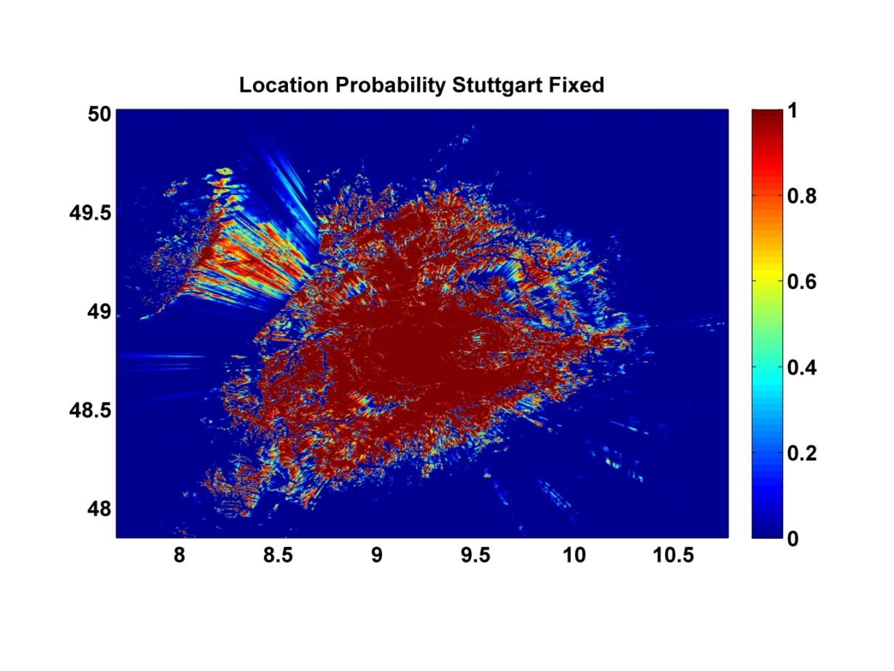
3.1 Stuttgart Fixed Reception

Figure 1: Location probability for transmitter Stuttgart-Frauenkopf under fixed receiving conditions. The axes show the geographical coordinates.

Stuttgart Fixed Reception
total number of covered pixels: 223024
 | total area covered | covered population | population loss
Scenario 1 (Reference), B/W counting | 1 | 3562753 | 0
Scenario 2, (ΔLP = 1.0%), B/W counting | 0.9748 | 3506327 | 56426
Scenario 3, (ΔLP = 0.1%), B/W counting | 0.9976 | 3557681 | 5072
Scenario 1 (Reference), proportional counting | 0.9952 | 3552046 | 10707
Scenario 2, (ΔLP = 1.0%), proportional counting | 0.9614 | 3463081 | 99672
Scenario 3, (ΔLP = 0.1%), proportional counting | 0.9919 | 3543667 | 19086

Table 1: Total area coverage, population coverage and population loss for the case of Stuttgart – fixed reception. Population losses reference to Scenario 1 (Reference).

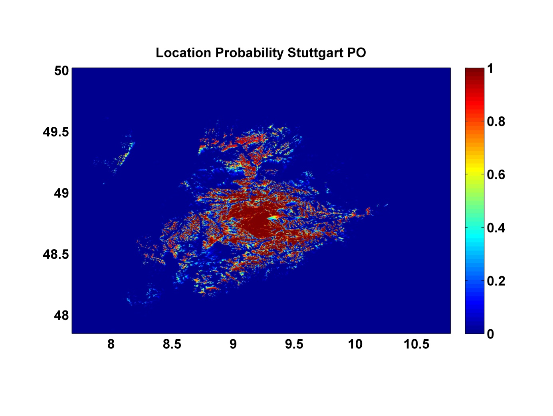
3.2 Stuttgart Portable Outdoor Reception

Figure 2: Location probability for transmitter Stuttgart-Frauenkopf under portable outdoor receiving conditions. The axes show the geographical coordinates.
Stuttgart Portable Outdoor Reception
total number of covered pixels: 47877
 | total area covered | covered population | population loss
Scenario 1 (Reference), B/W counting | 1 | 1347530 | 0
Scenario 2, (ΔLP = 1.0%), B/W counting | 0.9570 | 1318884 | 28646
Scenario 3, (ΔLP = 0.1%), B/W counting | 0.9953 | 1344043 | 3487
Scenario 1 (Reference), proportional counting | 0.9912 | 1341281 | 6249
Scenario 2, (ΔLP = 1.0%), proportional counting | 0.9406 | 1300736 | 46794
Scenario 3, (ΔLP = 0.1%), proportional counting | 0.9857 | 1336622 | 10908

Table 2: Total area coverage, population coverage and population loss for the case of Stuttgart – portable outdoor reception. Population losses reference to Scenario 1 (Reference).

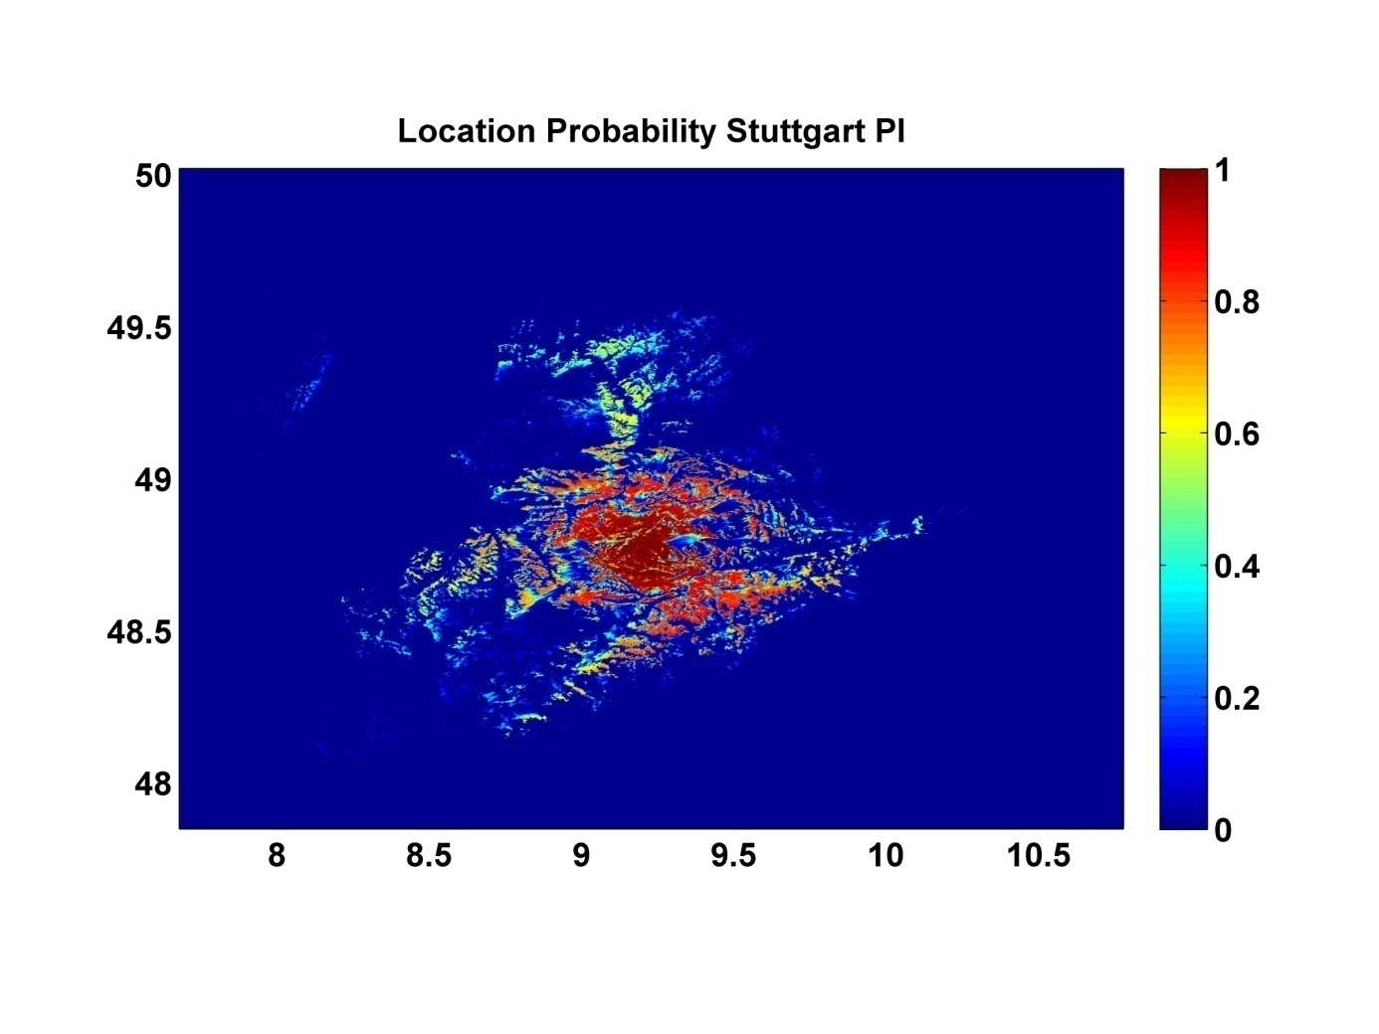
3.3 Stuttgart Portable Indoor Reception

Figure 3: Location probability for transmitter Stuttgart-Frauenkopf under portable indoor receiving conditions. The axes show the geographical coordinates.

Stuttgart Portable Indoor Reception
total number of covered pixels: 9602
 | total area covered | covered population | population loss
Scenario 1 (Reference), B/W counting | 1 | 714338 | 0
Scenario 2, (ΔLP = 1.0%), B/W counting | 0.8445 | 659083 | 55255
Scenario 3, (ΔLP = 0.1%), B/W counting | 0.9859 | 710078 | 4260
Scenario 1 (Reference), proportional counting | 0.9802 | 705541 | 8797
Scenario 2, (ΔLP = 1.0%), proportional counting | 0.8233 | 646174 | 68164
Scenario 3, (ΔLP = 0.1%), proportional counting | 0.9659 | 700782 | 13556

Table 3: Total area coverage, population coverage and population loss for the case of Stuttgart – portable intdoor reception. Population losses reference to Scenario 1 (Reference).

3.4 Waldenburg Fixed Reception
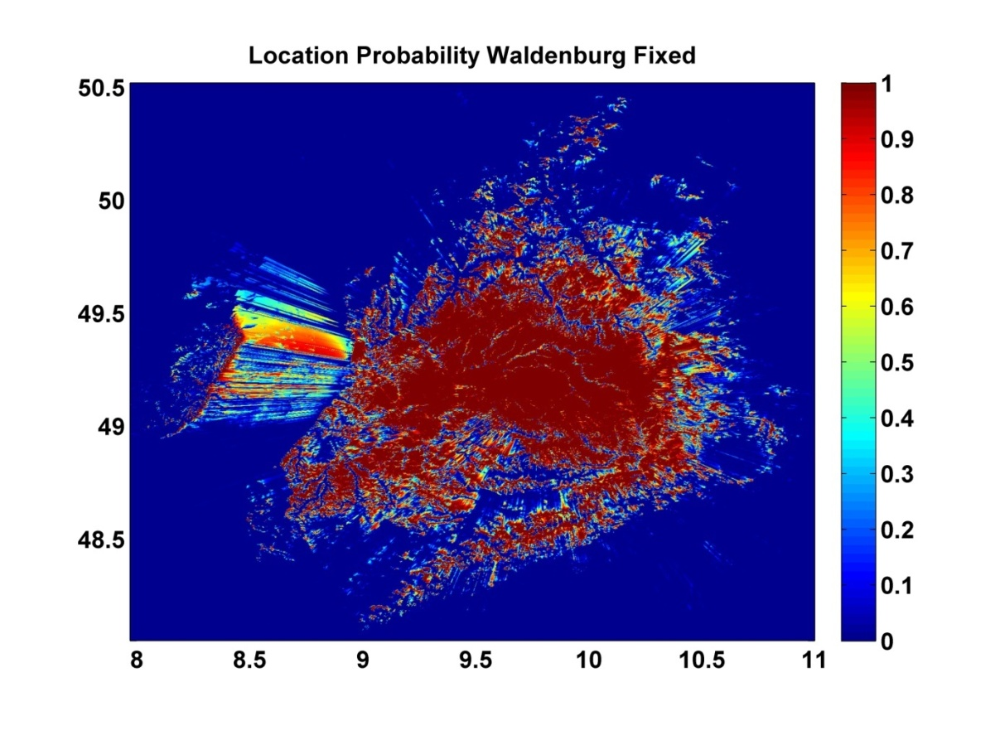
Figure 4: Location probability for transmitter Waldenburg under fixed receiving conditions. The axes show the geographical coordinates.

Waldenburg Fixed Reception
total number of covered pixels: 226962
 | total area covered | covered population | population loss
Scenario 1 (Reference), B/W counting | 1 | 1580656 | 0
Scenario 2, (ΔLP = 1.0%), B/W counting | 0.9754 | 1524807 | 55849
Scenario 3, (ΔLP = 0.1%), B/W counting | 0.9978 | 1574518 | 6138
Scenario 1 (Reference), proportional counting | 0.9952 | 1569629 | 11027
Scenario 2, (ΔLP = 1.0%), proportional counting | 0.9620 | 1501048 | 79608
Scenario 3, (ΔLP = 0.1%), proportional counting | 0.9922 | 1562220 | 18436

Table 4: Total area coverage, population coverage and population loss for the case of Waldenburg – fixed reception. Population losses reference to Scenario 1 (Reference).
3.5 Waldenburg Portable Outdoor Reception
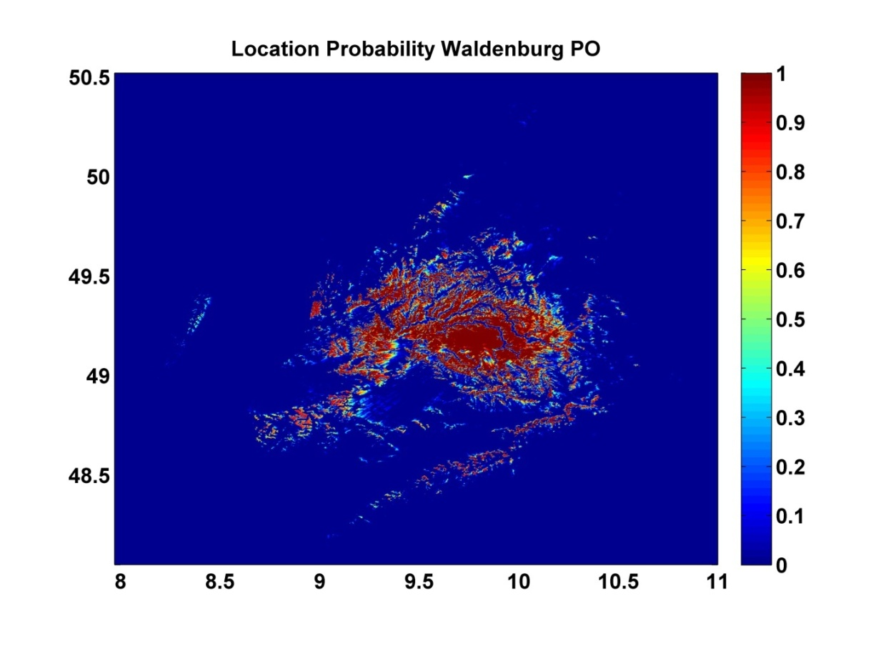
Figure 5: Location probability for transmitter Waldenburg under portable outdoor receiving conditions. The axes show the geographical coordinates.
Waldenburg Portable Outdoor Reception
total number of covered pixels: 46831
 | total area covered | covered population | population loss
Scenario 1 (Reference), B/W counting | 1 | 170104 | 0
Scenario 2, (ΔLP = 1.0%), B/W counting | 0.9495 | 161792 | 8312
Scenario 2, (ΔLP = 0.1%), B/W counting | 0.9951 | 169481 | 623
Scenario 1 (Reference), proportional counting | 0.9892 | 168615 | 1489
Scenario 2, (ΔLP = 1.0%), proportional counting | 0.9315 | 159059 | 11045
Scenario 3, (ΔLP = 0.1%), proportional counting | 0.9836 | 167854 | 2250

Table 5: Total area coverage, population coverage and population loss for the case of Waldenburg – portable outdoor reception. Population losses reference to Scenario 1 (Reference).
3.6 Waldenburg Portable Indoor Reception
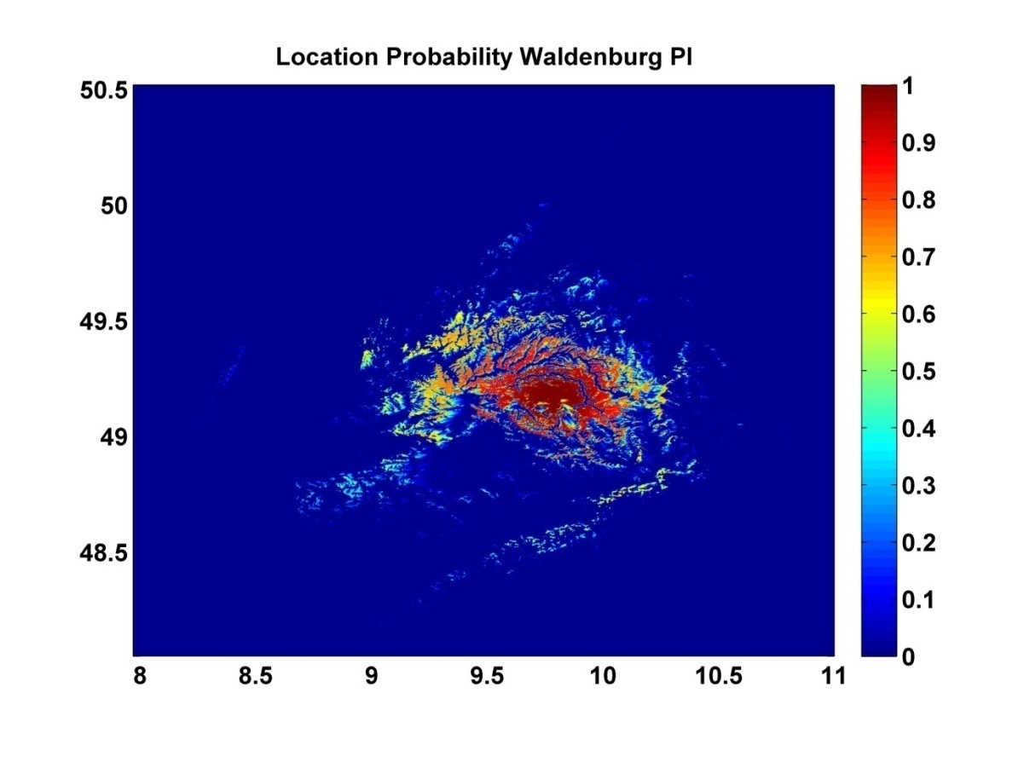
Figure 6: Location probability for transmitter Stuttgart-Frauenkopf under portable indoor receiving conditions. The axes show the geographical coordinates.
Waldenburg Portable Indoor Reception
total number of covered pixels: 8479
 | total area covered | covered population | population loss
Scenario 1 (Reference), B/W counting | 1 | 47497 | 0
Scenario 2, (ΔLP = 1.0%), B/W counting | 0.8706 | 40251 | 7246
Scenario 2, (ΔLP = 0.1%), B/W counting | 0.9857 | 46414 | 1083
Scenario 1 (Reference), proportional counting | 0.9823 | 46616 | 881
Scenario 2, (ΔLP = 1.0%), proportional counting | 0.8500 | 39297 | 8200
Scenario 3, (ΔLP = 0.1%), proportional counting | 0.9677 | 45540 | 1957

Table 6: Total area coverage, population coverage and population loss for the case of Waldenburg – portable indoor reception. Population losses reference to Scenario 1 (Reference).
4 Discussion

B/W counting (Approach 1) is applied in many European countries both in terms of network planning and as part of the licenses for terrestrial broadcasting networks when checking coverage obligations. But also for the purpose of analysing the interference imposed by one broadcasting service onto another one, B/W counting is employed in different countries in Europe.

Nevertheless, it is also quite common to use proportional counting when a more refined analysis is required. This applies especially to situations where detailed information about the number of people or households expected to be impaired is sought. In particular, in the case of non-broadcasting services interfering broadcasting services proportional counting proves to be the preferred method of analysing the coverage and interference calculations. For example, in the UK, the regulator Ofcom has used this technique to estimate the number of households that will lose DTT services when LTE mobile services are deployed in the band 790 – 862 MHz. The approach is described in the Ofcom report “Assessment of LTE 800MHz Base Station Interference into DTT Receivers”.

SE43 is currently discussing different proposals concerning the level of additional interference that could be imposed by WSD without causing unacceptable impairment of the incumbent broadcasting service. Part of these proposals target at defining a certain acceptable degradation of the location probability within each pixel of the coverage area of the broadcasting service. However, as the analysis of the examples provided in this document clearly show care has to be taken when assessing the interference impact of WSD.

It has to be born in mind that any interference imposed on broadcasting services planned for a particular reception mode has an immediate impact on other reception modes at the same time as well. Obviously, broadcasters are interested to protect all these reception modes at the same time.

Within the concept of allowing a certain degradation of the location probability the interference potential of WSD is primarily determined by the actual value of this degradation. However, in order to assess the magnitude of this impact it is necessary to apply proportional counting. B/W counting will significantly underestimate the impairment of the broadcasting service.

Seen from a practical point of view, the primary reason for not employing better resolutions is that the difference in the predicted field strength values between two points separated by less than a distance of 100m or 50m is negligible.
The calculations of the location probabilities have been carried out by Gerd Grötzinger, SWR, with the help of the frequency and network planning tool FRANSY.
http://stakeholders.ofcom.org.uk/binaries/consultations/dtt/annexes/lte-800-mhz.pdf

