 |  | SE43(11)91

12th meeting of SE43
Cambridge, 14 – 16 December 2011
Date issued: | 13 December 2011
Source: | INdT
Subject: | Impact of different levels of degradation in location probability inside a pixel
Summary: | In this document, the impact of different levels of WSD EIRP (defined by distinct values of $ΔLP$) in the performance of the DTT receiver is analysed in terms of the signal-to-interference ratio, considering distinct geometries between interferer WSD and interfered DTT receiver. The maximum EIRP values, obtained through simulations for distinct levels of degradation in location probability, are compared with measurements presented in document SE43(11)36. The analysis indicates that there is room for $ΔLP$ values higher than 0.1% without harmful interference to DTT service.
Proposal: | To consider the possibility of using multiple acceptable/agreed degradations in location probability as protection criterion to the DTT service.
Background: | In the 11th SE43 meeting, document SE43(11)66 proposed strategies to calculate the maximum permitted WSD EIRP based on an adaptive degradation in location probability. Values of degradation in location probability higher than 0.1%, used as examples, were questioned during the meeting as causing harmful interference to the DTT service. This document further investigates the impact of distinct values of degradation in the performance of a DTT receiver inside a pixel.
Password protection required? (Y/N) | N

ATTACHMENT
- Introduction
The presence of a WSD in channels adjacent to that used by primary systems, the DTT service for example, will inevitably reduce the original location probability. During the 10th and 11th meetings of SE43, different protection criteria were discussed, including protection ratios, overloading thresholds and different levels of accepted degradation in location probability. The impact of those protection criteria in the maximum WSD EIRP was presented in document SE43(11)66, but some questions were raised about the real degradation that those values would cause in the performance of DTT receivers located around the WSD.

This contribution further investigates the impact of different levels of $ΔLP$ in terms of the degradation caused in a DTT receiver placed at the reference geometry and on the remaining locations within the pixel area. In Section 2, a brief overview of the ECC methodology to calculate the WSD maximum permitted EIRP is presented. Section 3 analyzes the impact of distinct $ΔLP$s in terms of the signal-to-interference ratio observed in a DTT receiver placed in reference geometries, and how the presence of a WSD interferer affects the rest of the pixel. Section 4 presents the comparison of the calculated power values (for different $ΔLPs$) with real power values presented in the measurement report (document SE43(11)36) presented in the 10th meeting of SE43. Conclusions are given in Section 5.

- Simulation methodology and parameters
This section recalls the methodology presented in ECC report 159 to calculate the maximum permitted EIRP. This methodology can be summarized in the following steps:
- Calculate the location probability considering no interference from secondary system;
- Calculate the location probability considering the presence of WSD;
- Define the maximum accepted interference caused by WSDs into the DTT service according to the selected protection criteria.
- Use a reference geometry regarding the positioning of WSD transmitter and DTT receiver;
- Calculate the maximum permitted WSD EIRP for a reference geometry.

The methodology presented in report 159 is based on Monte Carlo simulations, assuming that both the wanted DTT signal and the interfering WSD signal can be modeled as Gaussian random variables, and on a set of parameters regarding the type of WSD and type of DTT receiver. The main parameters used in the results presented in this document are summarized in Table 1:
Table 1 - Simulation parameters (from ECC Report 159 and ECC Report 148)
Type of DTT receiver | $$E_{wmed_{ref}}$$  $$[dBμV/m]$$ | $$E_{min}$$  $$[dBμV/m]$$ | Co-channel protection ratio PR(0)[dB] | 1st adj. channel protection ratio $PR\left(Δf_{1}\right)$[dB] | 2nd adj. channel protection ratio $PR\left(Δf_{2}\right)$[dB]
Fixed | 56.21 | 47.16 | 21 | -30 | -40
Only the fixed DTT reception will be considered.

- Signal to interference ratio at the reference geometry

In the methodology proposed in ECC Report 159, it is assumed that the geo-location database will have information about the planned median field strength, $E_{wmed}$, with a suitable resolution, for example, an area of $100 m ×100 m$ called pixel. Based on this information and on WSD and DTT receiver characteristics, it is possible to calculate the maximum $E_{imed}$, median interference field strength, associated with that value of $E_{wmed}$ considering an acceptable level of degradation defined by regulators. Inevitably, any value of $E_{imed}$ will degrade DTT receivers’ performance.

In digital systems, the performance of receivers is usually evaluated in terms of a bit-error-rate, and consequently a value of signal to noise ratio (or signal to interference ratio). The methodology proposed in ECC Report 159 considers a value of required signal-to-interference ratio when determining the maximum permitted EIRP, so that a target bit error rate is satisfied. This value, known as protection ratio ($PR$), is the minimum signal-to-interference ratio required at the receiver input to a specified reception quality. Since the protection ratio depends on characteristics of the interfering device (adjacent channel leakage ratio), and on characteristics of the interfered device (adjacent channel selectivity), each combination of WSD type and DTT receiver type will have different values of protection ratio. In ECC Report 148, studies about protection ratios and overloading thresholds for DTT receivers under LTE interference are presented. Values used in this contribution are close to those that protect 90% of the receivers analyzed in Report 148.

In the following, numbers obtained by simulations about the probability of the signal-to-interference ratio (SIR) at the DTT receiver being lower than the reference value of protection ratio are shown. The mean values of SIR are summarized in Table 2, obtained as $E_{wmed}-E_{imed}$, where $E_{imed}$ corresponds to the $ΔLP$.

Table 2 – Mean SIR values considering distinct values of $ΔLP$, for fixed and portable DTT receivers.
$$E_{wmed}$$ | Fixed DTT receiver
 | $$ΔLP=0.1\%$$ | $$ΔLP=0.5\%$$ | $$ΔLP=1\%$$
$$E_{wmed-ref}$$ | 50.61 | 43.71 | 40.71
$$E_{wmed-ref}+5 dB$$ | 47.61 | 41.31 | 38.81
$$E_{wmed-ref}+10 dB$$ | 43.31 | 39.01 | 36.91
$$E_{wmed-ref}+15 dB$$ | 41.91 | 38.11 | 36.41
$$E_{wmed-ref}+20 dB$$ | 41.51 | 37.91 | 36.21
$$E_{wmed-ref}+25 dB$$ | 41.21 | 37.81 | 36.11
All mean SIRs shown in Table 2 are higher than the respective values of protection ratio (Table 1). However, as both the wanted DTT signal and the WSD interfering signal are modeled as random variables, it is necessary to consider their distributions in order to calculate the probability of the SIR being less than the required protection ratio.

To have a representative set of results, simulations were performed with 100,000 samples for each of 100 realizations of the simulation. Figure 1 and Figure 2 show the probability of SIR being lower than the desired protection ratio, i.e. the probability with which the reception quality of a DTT receiver placed at the reference geometry is degraded for $ΔLP=0.1\%, 0.5\%$ and $1\%$.
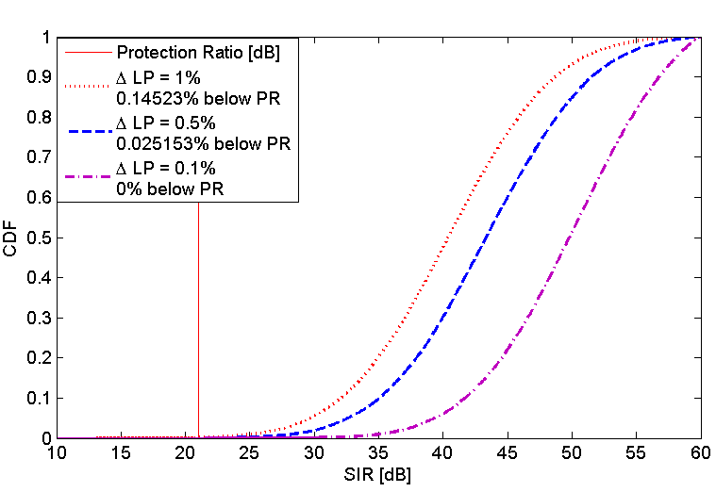 | 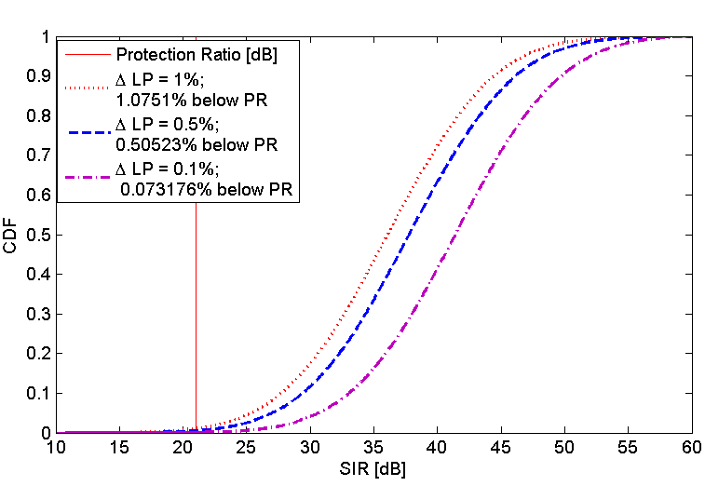
Figure 1 – CDF of SIR (fixed DTT receiver and fixed WSD) considering different degradations in location probability at $E_{wmed}=E_{wmed_{ref}}$, for a receiver located at the reference geometry. | Figure 2 – CDF of SIR (fixed DTT receiver and fixed WSD) considering different degradations in location probability at $E_{wmed}=E_{wmed_{ref}}+20 dB$, for a receiver located at the reference geometry.
Curves shown in Figure 1 and Figure 2 are in accordance with results presented in Table 2, where the mean value of SIR for each $E_{wmed}$ is shown. In these examples, the values of standard deviation of the wanted signal, $σ_{s}$, and standard deviation of the interfering signal, $σ_{i}$, are respectively 5.5 dB and 3.5 dB.

At the edge of the coverage area, $E_{wmed}$ is low when compared with the values achieved in inner regions. Therefore, the interference level corresponding to a given $ΔLP$ is lower in the coverage edge than in inner regions. At $E_{wmed}=E_{wmed}+20 dB$, for instance, the higher interference level decreases the SIR. However, the probability of $SIR≤PR$ at the reference geometry remains low for $0.1≤ΔLP≤1$. Other results are presented in Table 3 for different field strengths and values of degradation in location probability.

Table 3 - Percentage of SIR samples below the protection ratio, considering a fixed WSD and a fixed DTT receiver placed at the reference geometry for different degradations in location probability.
% of SIR samples below the protection ratio
$$E_{wmed} [dBμV/m]$$ | $$ΔLP=0.1\%$$ | $$ΔLP=0.5\%$$ | $$ΔLP=1\%$$
$$E_{wmed-ref}$$ | 0 | 0.025153 | 0.14523
$$E_{wmed-ref}+5 dB$$ | 0.002059 | 0.085166 | 0.29214
$$E_{wmed-ref}+10 dB$$ | 0.037178 | 0.31223 | 0.74409
$$E_{wmed-ref}+15 dB$$ | 0.069206 | 0.41418 | 0.96119
$$E_{wmed-ref}+20 dB$$ | 0.073176 | 0.50523 | 1.0751
$$E_{wmed-ref}+25 dB$$ | 0.099188 | 0.55822 | 1.0862

Besides the impact on the performance of a DTT receiver placed at the reference geometry, it is important to analyze how the WSD reduces the overall performance of DTT receivers inside a pixel by considering receivers placed not in the reference geometry. Then, the probability of $SIR≤PR$ is evaluated in cases where DTT receivers are placed in different positions regarding the WSD. This analysis is performed at two locations: at the edge of the coverage area and at a distance to the DTT transmitter that corresponds to $E_{wmed}=E_{wmed_{ref}}+25 dB$.

Figure 3 and Figure 4 show the probability of $SIR≤PR$ as a function of the distance between the WSD transmitter and the DTT receiver. In this case, 20 m corresponds to the distance in the reference geometry. As expected, the probability of $SIR≤PR$ decays with the transmitter-receiver distance, since the interference caused by the WSD is attenuated.

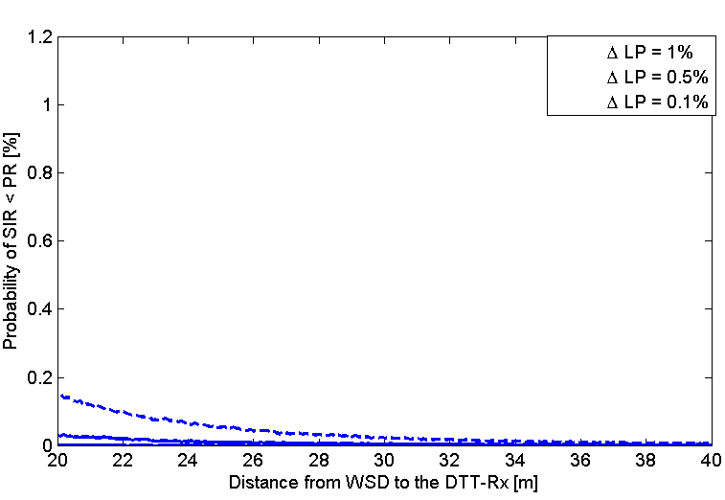 | 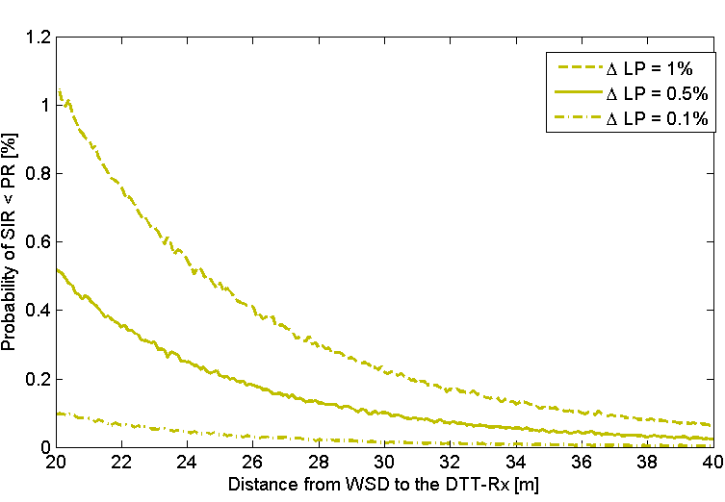
Figure 3 – Probability of $SIR≤PR$ at the edge of coverage area, as a function of the distance between the WSD and the DTT receiver, and of the desired $ΔLP$ at the reference geometry. | Figure 4 – Probability of $SIR≤PR$ for $E_{wmed}=E_{wmed_{ref}}+25 dB$, as a function of the distance between the WSD and the DTT receiver, and of the desired $ΔLP$ at the reference geometry.
It is also important to mention that results above were obtained for a WSD placed in front of a DTT receiver, i.e., no antenna attenuation is considered. For the sake of comparison, Table 5 shows the additional loss (with respect to the reference geometry for a fixed WSD transmitter and a fixed DTT receiver) as a function of the distance and the angle mismatch between the WSD transmitter and the DTT receiver antennas. The additional loss in Table 5 corresponds to the decrease in the interference defined to the reference geometry, e.g., even at 20 m of the WSD transmitter, if there exists 30° mismatch between the directions of maximum gain of the WSD and the DTT receiver antennas, then the interference perceived at the DTT receiver is 4 dB less than that at the reference geometry (0° mismatch). The same effect is observed for a DTT receiver placed at 11.7 m from the reference geometry and with antenna directly pointed to the WSD transmitter antenna.

Table 5 - Loss [dB] as a function of the distance from the reference geometry and the angle between the directions of maximum gain of the WSD transmitter and the DTT receiver antennas (Recommendation ITU-R BT. 419-3).
Additional loss [dB]  (regarding the loss for reference geometry) | Distance [m]  (from the reference geometry) | Angle [degrees]  (for a transmitter-receiver distance of 20 m)
1 | 2.5 | 22.5°
2 | 5.2 | 25°
3 | 8.3 | 27.5°
4 | 11.7 | 30°
5 | 15.6 | 32.5°
It can be concluded from the analysis above that the degradation caused by the transmission of a WSD is attenuated with the distance and/or with the angle mismatch between the WSD transmitter and the DTT receivers. Therefore, it should be taken into account that the limitations imposed to the WSD transmission relates, in practice, to the protection of the DTT receivers at the reference geometries. DTT receivers in other positions are less affected by the WSD interference.

- Comparison with measurements

After analyzing the impact of WSD transmission in terms of signal-to-interference ratio inside a pixel, maximum EIRP values obtained by simulations for different levels of $ΔLP$ are compared to results obtained through a measurement campaign reported by document SE43(11)36, presented in the 10th meeting of SE43. Roughly, the maximum WSD EIRPs were obtained by collecting the power levels just before the errors start to appear on the DTT picture. Maximum power values (measured $P_{WSD}$) were taken for different channels and values of $E_{wmed}.$The reference geometry used in the study considered a fixed DTT receiver interfered by a portable WSD located 22 m away, and the resulting path loss, FSL, was also measured. From the results of $P_{WSD}$ and FSL, it was possible to calculate the protection ratio, PR, for each scenario. Table 7 summarizes the results.

Table 6 – Summary of the results presented in Doc. SE43(11)36.
WSD  Channel | Coverage Edge |  |  | $E_{wmed_{ref}}$ + 10 dB |  |  | $E_{wmed_{ref}}$ + 18 dB
WSD  Channel | FSL  [dB] | PR  [dB] | Measured  $P_{WSD}$[dBm] | FSL  [dB] | PR  [dB] | Measured  $P_{WSD}$[dBm] | FSL  [dB] | PR  [dB] | Measured  $P_{WSD}$[dBm]
N | -55.6 | 19.7 | -50 | -55.6 | 16.2 | -36.5 | -55.6 | 17.7 | -30.0
N-1 | -55.5 | -31.4 | 1.7 | -55.5 | -33.2 | 13.3 | -55.5 | -25.9 | 12.8
N-2 | -55.4 | -44.1 | 15.2 | -55.4 | -38.4 | 18.7 | -55.4 | -33.2 | 20.5
N-3 | -55.3 | -47.5 | 18.3 | -55.3 | -40.6 | 21.5 | -55.3 | -35.4 | 23.0
N-4 | -55.1 | -48.4 | 18.9 | -55.1 | -51.9 | 32.5 | -55.1 | -49.0 | 36.4
N+9 | -56.6 | -51.1 | 20.9 | -56.6 | -53.7 | 33.8 | - | - | -
Taking as reference the analysis presented in the aforementioned document, in which the measured maximum WSD EIRPs were compared with the ones obtained by simulations with the strategy proposed in document SE43(11)12, we now compare the measured EIRPs with the ones obtained by simulations for distinct values of $ΔLP$. The maximum WSD EIRPs are calculated by converting the $E_{imed}$obtained for each value of $ΔLP$to an isotropic power, and by adding the path loss, LOSS:

${EIRP}_{\left[dBm\right]}={E_{imed}}_{\left[dBμV/m\right]}-20\log_{10}\left(f_{\left[MHz\right]}\right)-77.2-PR+LOSS$ .

Table 7, Table 8 and Table 9 present the measured and calculated maximum WSD EIRPs for $ΔLP=0.1\%, 0.5\%$ and $1\%$. These values are compared, and a margin (difference between them) is calculated.

Table 7 - $ΔLP=0.1\%.$
 |  | Maximum WSD EIRP at the edge of the coverage area |  |  | Maximum WSD EIRP considering $E_{wmed_{ref}}$ + 10 dB |  |  | Maximum WSD EIRP considering $E_{wmed_{ref}}$ + 18 dB
WSD  Channel | Freq  [MHz] | Simulation | Measured | Margin | Simulation | Measured | Margin | Simulation | Measured | Margin
WSD  Channel | Freq  [MHz] | [dBm] | [dBm] | [dB] | [dBm] | [dBm] | [dB] | [dBm] | [dBm] | [dB]
N | 610 | -71.6 | -50.0 | 21.6 | -54.4 | -36.5 | 17.9 | -44.6 | -30.0 | 14.6
N-1 | 602 | -20.5 | 1.7 | 22.2 | -5.0 | 13.3 | 18.3 | -1.0 | 12.8 | 13.8
N-2 | 594 | -7.8 | 15.2 | 23.0 | 0.2 | 18.7 | 18.5 | 6.3 | 20.5 | 14.2
N-3 | 586 | -4.4 | 18.3 | 22.7 | 2.4 | 21.5 | 19.1 | 8.5 | 23.0 | 14.5
N-4 | 578 | -3.5 | 18.9 | 22.4 | 13.7 | 32.5 | 18.8 | 22.1 | 36.4 | 14.3
N+9 | 682 | -0.8 | 20.9 | 21.7 | 15.5 | 33.8 | 18.3 | - | - | -
Average margin  [dB] |  | - | - | 22.3 | - | - | 18.4 | - | - | 14.3
Table 8 - $ΔLP=0.5\%$.
 |  | Maximum WSD EIRP at the edge of the coverage area |  |  | Maximum WSD EIRP considering $E_{wmed_{ref}}$ + 10 dB |  |  | Maximum WSD EIRP considering $E_{wmed_{ref}}$ + 18 dB
WSD  Channel | Freq  [MHz] | Simulation | Measured | Margin | Simulation | Measured | Margin | Simulation | Measured | Margin
WSD  Channel | Freq  [MHz] | [dBm] | [dBm] | [dB] | [dBm] | [dBm] | [dB] | [dBm] | [dBm] | [dB]
N | 610 | -64.8 | -50.0 | 14.8 | -50.1 | -36.5 | 13.6 | -41.1 | -30.0 | 11.1
N-1 | 602 | -13.7 | 1.7 | 15.4 | -0.7 | 13.3 | 14.0 | 2.5 | 12.8 | 10.3
N-2 | 594 | -1.0 | 15.2 | 16.2 | 4.5 | 18.7 | 14.2 | 9.8 | 20.5 | 10.7
N-3 | 586 | 2.4 | 18.3 | 15.9 | 6.7 | 21.5 | 14.8 | 12.0 | 23.0 | 11.0
N-4 | 578 | 3.3 | 18.9 | 15.6 | 18.0 | 32.5 | 14.5 | 25.6 | 36.4 | 10.8
N+9 | 682 | 6.0 | 20.9 | 14.9 | 19.8 | 33.8 | 14.0 | - | - | -
Average margin  [dB] |  |  |  | 15.5 |  |  | 14.1 |  |  | 10.8
Table 9 - $ΔLP=1\%.$
 |  | Maximum WSD EIRP at the edge of the coverage area |  |  | Maximum WSD EIRP considering $E_{wmed_{ref}}$ + 10 dB |  |  | Maximum WSD EIRP considering $E_{wmed_{ref}}$ + 18 dB
WSD  Channel | Freq  [MHz] | Simulation | Measured | Margin | Simulation | Measured | Margin | Simulation | Measured | Margin
WSD  Channel | Freq  [MHz] | [dBm] | [dBm] | [dB] | [dBm] | [dBm] | [dB] | [dBm] | [dBm] | [dB]
N | 610 | -61.8 | -50.0 | 11.8 | -48.1 | -36.5 | 11.6 | -39.4 | -30.0 | 9.4
N-1 | 602 | -10.7 | 1.7 | 12.4 | 1.3 | 13.3 | 12.0 | 4.2 | 12.8 | 8.6
N-2 | 594 | 2.0 | 15.2 | 13.2 | 6.5 | 18.7 | 12.2 | 11.5 | 20.5 | 9.0
N-3 | 586 | 5.4 | 18.3 | 12.9 | 8.7 | 21.5 | 12.8 | 13.7 | 23.0 | 9.3
N-4 | 578 | 6.3 | 18.9 | 12.6 | 20.0 | 32.5 | 12.5 | 27.3 | 36.4 | 9.1
N+9 | 682 | 9.0 | 20.9 | 11.9 | 21.8 | 33.8 | 12.0 | - | - | -
Average margin  [dB] |  |  |  | 12.5 |  |  | 12.1 |  |  | 9.1
As expected, for higher $ΔLPs$, the margin between measured and calculated WSD EIRPs is lower. However, even for the highest considered degradation, $ΔLP=1\%$, the margin is never below 9.1 dB. This means that even using a transmit power more than 9 dB above the power defined as limit to $ΔLP=1\%$, no errors are observed in the DTT receiver placed at the reference geometry. It is expected that DTT receivers in positions other than the reference geometry are even more protected.

- Conclusions

This document presents an analysis of the impact of different levels of degradation in location probability on the protection of the DTT service inside a pixel. It considers:

- The reception degradation, in terms of signal-to-interference ratio, observed for a fixed DTT receiver located at the reference geometry in distinct locations within the area of coverage;
- The reception degradation, in terms of signal-to-interference ratio, observed for fixed DTT receivers outside the reference geometry;
- The margin between the maximum EIRP values calculated using ECC Report 159 methodology for different values of $ΔLP$, and values obtained through measurements, presented in document SE43(11)36.

In general lines, it was shown that the effects of the WSD transmission on the DTT reception are attenuated with the distance between the WSD transmitter and the DTT receiver, as well as with the mismatch between the direction of the main gain of their antennas. Some measurements also indicate that the DTT service is protected even with more relaxed protection criteria. This should be taken into account to avoid the adoption of over-conservative criteria to the protection of the DTT service.

INdT (Nokia Institute of Technology) is a non-profit research and development institute founded by Nokia in Brazil.

