CEPT Administrations and Members of the Spectrum Engineering Working Group 43 (WG SE43)

Invitation:

13th SE43 Meeting
Conservatoire National des Arts et Métiers (CNAM), 20-22nd March 2012

Dear Sir/Madam,
The ANFR (Agence Nationale des Fréquences) and CNAM (Conservatoire National des Arts et Métiers) have the pleasure of inviting you to attend the 13rd SE43 Meeting, which will be held at the CNAM premises, from the 20th to 22nd of March 2012. The meeting will start on Tuesday 20th of March at 9h30 and will end on Thursday 22nd of March no later than 16h00.
Delegates are kindly requested to register no later than 16th March 2012 via the following link:
http://www.cept.org/ecc/groups/ecc/wg-se/se-43/client/meeting-calendar/event-details?meetingid=410
The list of participants can be consulted by using the following link:
http://www.cept.org/ecc/groups/ecc/wg-se/se-43/client/meeting-calendar/event-participants?meetingid=410
You will soon be able to find the agenda and supporting documents on the following link:
http://www.cept.org/ecc/groups/ecc/wg-se/se-43/client/meeting-documents
We are looking forward to welcoming you in Paris.
Yours faithfully,

Jean Yves Montfort
Deputy Director, DPSAI
---------------------

Logistics
If you need an individual invitation or any other additional information, please contact the ANFR DPSAI Secretariat (Ms. Alexia Litt or Ms. Jocelyne Morel) at the following e-mail address: secretariat_dpsai@anfr.fr
Tel. Ms. Alexia Litt: +33 1 45 18 72 09
Tel. Ms. Jocelyne Morel : +33 1 45 18 72 08
Address
The meeting will take place at:
Conservatoire national des arts et métiers (CNAM)
Salon d’Honneur – (Access 39, 1st floor)
2, Rue Conté 75003 Paris, France
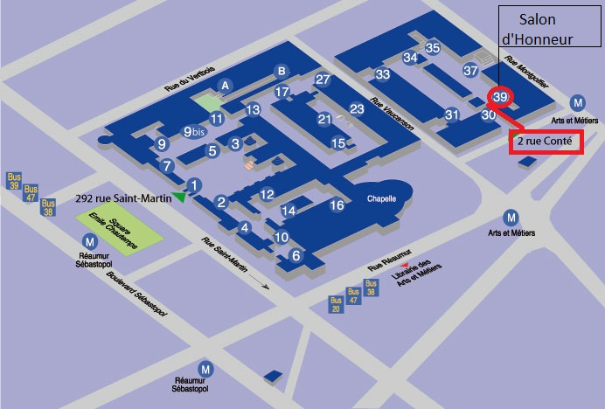
Accommodation and transportation
Participants are kindly requested to make their own travel and/or accommodation arrangements. In particular, we advise to book any hotel close to metro station “Arts et Métiers” or to metro lines 3 or 11.
In the following link you will find information about public transportation in Paris :
http://www.ratp.fr/

_____________________________

