 |  |  | SE43(12)13
13th meeting of SE43
Paris, 20 - 22 March 2012
Date issued: | 13 March 2012
Source: | MicroData
Subject: | Method to calculate TVWS spectrum by using GE06 assignments and allotment Plans
N
Password protection required? (Y/N)

Summary:
This contribution proposes one more case study to be added into Annex 5 of the working document "Further definition of technical and operational requirements for the operation of white space devices in the band 470-790 MHz".
This case study was presented in previous SE43 meeting, document SE43(11)80. The methodology has been further developed e.g. calculations have been performed with 2km by 2km raster. The proposed text has also been shortened to fit in the Annex 5.
Proposal:
It is proposed that SE43 discusses the content of this contribution and adds this case study to Annex 5 of the complementary report to ECC Report 159 on "Further definition of technical and operational requirements for the operation of white space devices in the band 470-790 MHz".
Background:
SE43 has been tasked by WGSE to define technical and operational requirements for the operation of cognitive radio systems in the white spaces of the UHF broadcasting band (470-790 MHz) to “ensure the protection of incumbent radio services/systems and investigate the consequential amount of spectrum potentially available as ‘white space’”.

Complementary Report to ECC Report 159,
ANNEX 5: Case studies on white space spectrum availability
A5.4 Finland
The study of the WSD capacity in Finland is based on GE06 Plan assignments and allotments and Finnish Communications Regulatory Authority's (FICORA) station database which includes additions to the GE06 Plan. The GE06 Plan assignments and allotments of the neighbouring countries were taken into account and protected. The noise limited coverage areas and allotments for fixed reception (RPC1) were protected. Co- and adjacent channels to DTT inside DTT coverage areas were not allowed for WSD.
A5.4.1 Method used for White Space calculations
The noise limited DTT station coverage areas and allotments are protected with selected protection criteria. The DTT coverage areas and WSD interferences are calculated by using Recommendation ITU-R P.1546-1 method. Effective heights of WSD stations are calculated by using GTOPO30 terrain height data. One percent of time is used in WSD interference calculations. The use of DTT receiving antenna discrimination is optional.
The main steps of the method are as follows:
- the noise limited coverage areas of all GE06 assignments and FICORA stations are calculated,
- the WSD test point coordinate file with specified distance increment is created,
- WSD parameters, ERP and antenna height, are specified
- calculation is performed in all test points and channels
- WSD transmissions on co- and adjacent channels (N+1, N-1) are not allowed in the coverage areas of channel N to be protected,
- WSD interferences in the nearest DTT coverage and allotment area points are calculated,
- If the interference is below the specified protection criteria the point is accepted for WSD
A5.4.2 Example of WS capacity calculations
In the example WS-stations with ERP 36 dBm and antenna height of 30 meters were used. The interfering field strength was calculated at reception height of 10 meters and DTT receiving antenna discrimination was used. The used WSD to DTT protection was 44 dB, 21 dB co-channel protection ratio plus13 dB combined location variation plus 10 dB combined multiple interference and safety margin.
The distance between WSD test points was selected as 2 km, total number of test points was 91075. Channels 22-60 were included, channel 21 is not in DTT use in Finland.
Figure 1 shows the map of the numbers of WSD channels.
Figure 2 shows the average number of WSD channels as a function of WSD to DTT protection.
Figure 3 shows an example of WSD channel map.
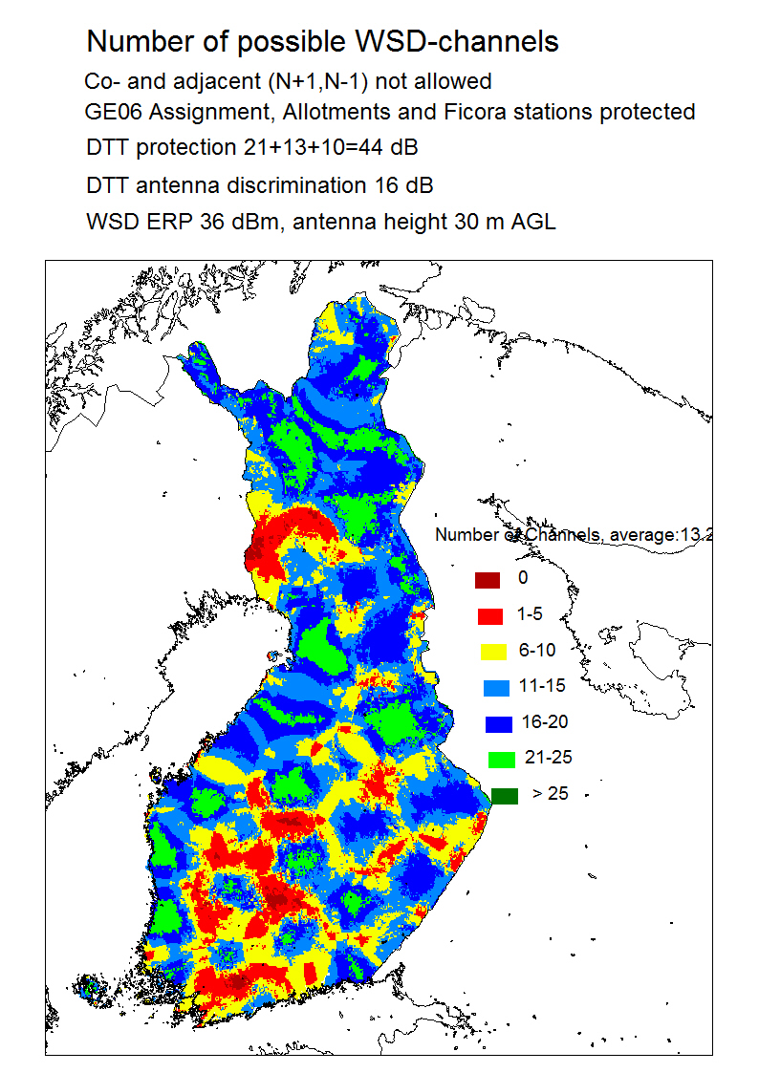
Figure 1: Calculation result, number of WSD channels in Finland
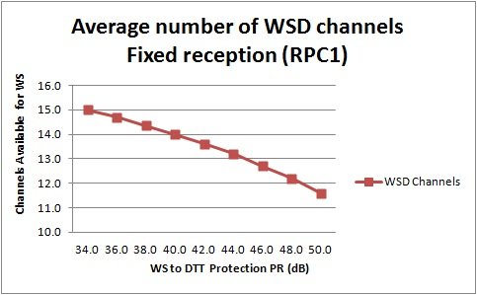
Figure 2: Average number of WSD channels

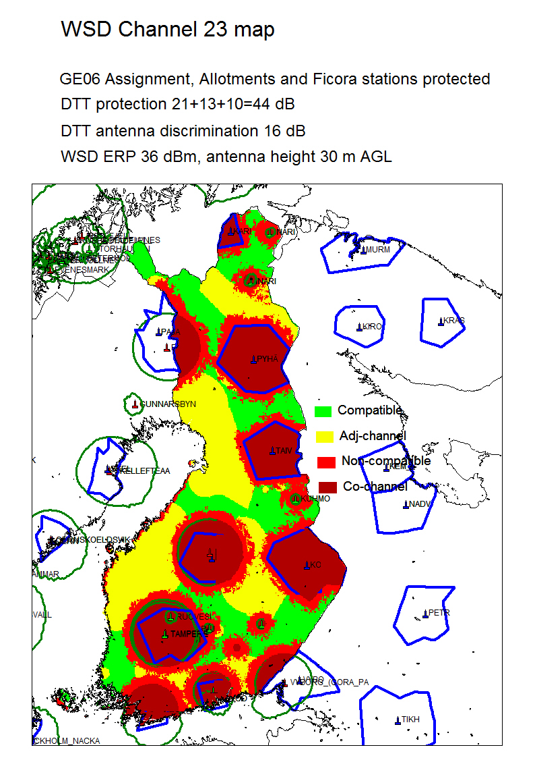
Figure 3: Example of WSD channel map

