SE43(12)19
ECC Report <No>

(Includes EBU proposals of modifications)
Complementary Report to ECC Report 159 on
further definition of technical and operational requirements for the operation of white space devices in the band 470-790 MHz
Month YYYY (Arial 9pt bold)
(last updated: Month YYYY) (Arial 9pt)

Executive summary
Body text (style: ECC Paragraph)
(advice: the Executive Summary should provide a short and concise explanation on the purpose of the respective ECC Report and should clearly indicate the covered subjects to which it applies. In addition, it should clearly explain the application of the document.)

TABLE OF CONTENTS

0 Executive summary 2
1 Introduction 6
2 WSD technical characteristics (Issues A1, A2, A3, B2) 7
2.1 Summary on previous studies 7
2.2 Classification of WSDs (Issue A1) 7
2.2.1 Use cases of WSDs 7
2.2.2 Parameters of WSDs 9
2.3 Fixed maximum permitted power limits for WSDs (Issue B2) 9
2.3.1 General thoughts 10
2.3.2 Approaches to set the fixed maximum power for WSDs 10
2.3.3 Assumptions on maximum permitted e.i.r.p. limits based on the incumbent service/system protection requirements 11
2.3.3.1 Statistical approach 11
2.3.3.2 Receiver overloading 11
2.3.4 Assumptions on maximum permitted e.i.r.p. limits based on the WSD usage requirements 12
2.4 Autonomous operation of WSDs using sensing (Issue A2) 12
2.4.1 Practical assessment of autonomous WSD operation 12
2.4.2 Cooperative sensing 12
2.4.2.1 Single-device energy sensing 13
2.4.2.2 Cooperative energy detection 13
2.5 Minimum required adjacent channel leakage ratio for WSDs (Issue A3) 16
3 Technical considerations on the protection of the broadcasting service (Issues B1, B3) 17
3.1 Summary on previous studies 17
3.2 Determination of maximum e.i.r.p. limits for autonomous WSDs (Issue B3) 20
4 Technical considerations on the protection of PMSE (Issues C1, C2, C3, C4) 21
4.1 Summary on previous studies 21
4.2 Digital PMSE (Issue C3) 21
4.3 Performance (protection ratios and overloading thresholds) measurements of PMSE receivers (Issue C1) 21
4.3.1 Impact of WSD ACLR performance on PMSE protection ratios 25
4.3.2 PMSE Receiver Overload Characteristics 26
4.3.3 Consideration of PMSE transmitter IMD 26
4.4 PMSE signal sensing: application scenarios and channel models (Issue C2) 26
4.5 Usability of beacon signals (Issue C4) 26
4.6 Usability of combined (sensing and geo-location) approach (Issue C4) 26
5 Technical considerations on the protection of ARNS (Issue E1) 27
5.1 Summary on previous studies 27
5.2 ARNS deployment scenarios (Issue E1) 27
6 Technical considerations on the protection of services in the bands adjacent to 470-790 MHz (Issue F1) 28
6.1 Summary on previous studies 28
6.2 Protection of mobile service in the band 450-470 MHz (Issue F1) 28
6.2.1 Protection of TETRA TEDS 25 kHz 28
6.2.1.1 Assumptions and scenarios (§ 6.1.1 of WD1) 28
6.2.1.2 Results (§ 6.1.2 of WD1) 30
6.2.2 Protection of CDMA PAMR 31
6.2.2.1 Scenarios 31
6.2.2.2 Interference criteria 32
6.2.2.3 Parameters of WSD used for simulations 32
6.2.2.4 Parameters of CDMA network used for simulation 33
6.2.2.5 Results 34
6.3 Protection of mobile service in the band 790-862 MHz (Issue F1) 35
6.3.1 Common assumptions 35
6.3.1.1 WSD system (interferer) 35
6.3.1.2 Mobile system (LTE) 35
6.3.1.3 LTE UE selectivity 35
6.3.2 Interference modeling 37
6.3.2.1 MCL analysis 37
6.3.2.2 Monte Carlo simulation 37
6.3.3 Scenarios 37
6.3.3.1 Scenario 1: WSD deployed as wide area base station 38
6.3.3.2 Scenario 2: portable WSD or user-deployed access point 38
6.3.3.3 Scenario 3: WSD deployed as fixed mounted CPE 38
6.3.4 Calculation results 38
6.3.4.1 MCL analysis 38
6.3.4.2 Monte-Carlo simulations 38
7 Protection of terrestrial cable head-end receivers within the broadcasting service area (requested by WG SE) 39
8 Amount of white space spectrum potentially available for WSDs in the band 470-790 MHz (Issue H1) 40
8.1 Summary on previous studies 40
8.2 Result of studies (WD2) 40
9 Conclusions 47
ANNEX 1: Link budget calculations to derive e.i.r.p. values for white space devices 48
ANNEX 2: WSD fixed maximum power limits’ calculation based on overload threshold 51
ANNEX 3: Example spectrum sensor implementation and field test results 54
ANNEX 4: PMSE protection measurements in helsinki city theatre 63
ANNEX 5: case studies on white space spectrum availability 68
ANNEX 6: Calculations with SEAMCAT on interference assessment 79
ANNEX 7: List of reference 88

Note on the Table of Contents (delete after reading)
This is automatically styled and compiled from the headings, subheadings and page numbers from the document that follows. To update the Table of Contents move cursor within the table and press F9.

LIST OF ABBREVIATIONS

Abbreviation | Explanation (style: Arial 10pt bold red (colour values RGB: 210, 35, 42)
CEPT | European Conference of Postal and Telecommunications Administrations
ECC | Electronic Communications Committee
<abbr> | <explanation – edit the table as necessary>

Introduction
Cognitive radio systems (CRS) may be deployed in the “white spaces” of the frequency band 470-790 MHz provided no additional interference to incumbent services is generated by such a deployment. This is to be ensured trough utilization of different cognitive techniques including spectrum sensing, geo-location database and beacon transmissions.
In response to an increased interest among its members and their industry in the possibilities potentially provided by white space devices (WSDs), CEPT developed ECC Report 159 [1] where appropriate technical and operational requirements for such devices in the band 470-790 MHz have been formulated. However, recognizing the preliminary nature of some elements used in the first studies, the innovative nature of cognitive techniques and the ongoing research and industry activities in this field, ECC Report 159 listed a number of technical and regulatory issues requiring further consideration.
This CEPT report is intended to complement ECC Report 159 with additional technical investigations required to facilitate development of the regulation for WSDs in the band 470 - 790 MHz. It needs to be noted here that the issue of the geo-location database, being also complementary to ECC Report 159, is considered in a separate report [2].

WSD technical characteristics (Issues A1, A2, A3, B2)

Summary on previous studies
ECC Report 159 identified a range of possible deployment scenarios for WSDs and, in the absence of specific system characteristics related to WSDs, sets up some key assumptions in order to perform first sharing studies. The assumptions are not intended to restrict industry flexibility to innovate in using white spaces.
In particular, ECC Report 159 foresees at least three broad categories of WSDs:
- Personal/portable devices, which are envisaged to be of such a size that they can be carried by individual users, much in the manner of mobile phones or personal media players;
- Non-portable devices, built in flat panel TVs, personal video recorders and other appliances, which are designed to remain primarily in one place;
- Public/private access points operating in a similar manner as today’s WiFi access points or providing a gateway to the Internet.
Deployment scenarios considered in the studies within ECC Report 159 were constructed with respect to propagation and sharing assumptions and do not necessarily represent actual use cases:
- Deployment either indoor or outdoor;
- Deployment either at low antenna height or mounted high. Two representative heights are assumed: 1.5m for low antenna height terminals, and 10 or 30 m for access points or base stations.
The exact transmission technology or technologies to be used by WSDs could not be determined at the time ECC Report 159 was developed. However, since the OFDM family of technologies seemed to represent the most efficient and reliable transmission, it was reasonable to assume this type of technology for the purpose of the first sharing studies. This allowed to use the values provided in ECC Report 148 regarding the protection ratios and overloading thresholds for interference from LTE into DVB-T.
Three main techniques have been proposed to assist WSDs in finding unoccupied channels:
- With spectrum sensing, WSDs try to detect the presence of the protected incumbent services in each of the potentially available channels. Spectrum sensing essentially involves conducting a measurement within a candidate channel, to determine whether any protected service is present. One of the key parameters for spectrum sensing is the sensing threshold.
- In the geo-location database approach, WSDs would measure their geographical location and consult a “geo-location” database to determine which frequencies they can use at their location (i.e. the location which they have indicated to the database).
- Beacons are signals which can be used to indicate that particular channels are either in use by protected services or vacant.

Classification of WSDs (Issue A1)

Use cases of WSDs
ETSI TR 102 907 describes use cases for the operation of Reconfigurable Radio Systems within White Spaces in the UHF 470-790 MHz frequency band. The use cases are categorized according to their intended functionality (internet access, machine-to-machine connectivity, etc) and operational range (short/mid/long). These use cases and related parameters are informative and do not prejudge future studies and real deployments.
A number of potential, technology related use cases are under discussion in different European projects. The use cases differentiate according to the services (WiFi, LTE, PPDR, etc) to be provided via white space spectrum. Depending on the service its operational range could be varying from a few metres to a few kilometres viable for urban, suburban and rural coverage.
CEPT broadly classifies different use cases for WSDs into broadband and narrowband applications. Thus the following representative use cases can be considered:
- WSDs to provide indoor Internet access from an access point to a user equipment with an operational range of up to 50 m (the required operational distances might be reduced due to wall/floor penetration). Indoor access point can provide a limited outdoor coverage. Possible configurations are shown in
Figure 1.

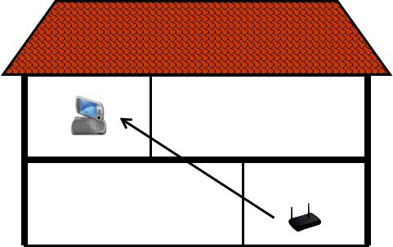 | 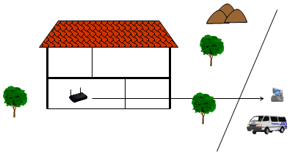
Figure 1: Indoor wireless access
- WSDs to provide outdoor Internet access from a base station to a user equipment with an operational range of up to 10 km. Different scenarios can be envisaged ranging from (i) providing mobile/portable broadband Internet coverage provision from access points to the public places in the street to (ii) delivering a broadband Internet signal from a base station to fixed installations within and beyond a village or a campus. This equipment is expected to be installed by a professional. A possible configuration is shown in Figure 2.

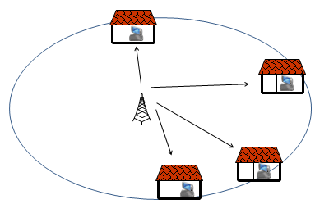
Figure 2: Outdoor wireless access

WSDs to provide machine-to-machine or device-to-device communication for both short and long ranges. Some possible configurations are shown in Figure 3.

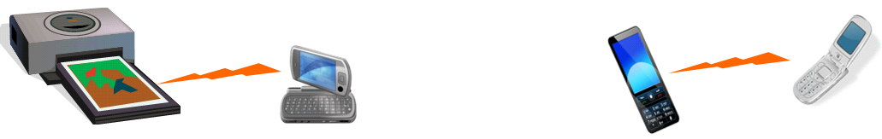
Figure 3: Machine-to-machine connectivity (from Figure 18 of ETSI TR 102 907)

Parameters of WSDs
The parameters assumed for different WSD use cases considered by the CEPT as examples are listed in Table 1and Table 2 for outdoor and indoor applications, respectively. The parameters for outdoor WSDs are set by analogy with today’s cellular systems. Similarly, the parameters for indoor WSDs are set by analogy with today’s WiFi wireless communication systems. The link budget calculations to derive the power values are detailed in Annex 1.

Table 1: Examples of outdoor WSDs parameters
Parameter | Base station | User equipment[the title may be changed | M-to-M
Date rate (Mbps) | 1-10 | 0.128-2 | 0.5
Transmission bandwidth (MHz) | 5-8 | 0.360-5 | 1
Receiver noise figure (dB) | 4-7 | 5-7 | 5-7
Antenna gain (dBi) | 7-8 | 0-14 | 12
Maximum range (m) | 10'000 | 10'000 | 20'000
e.i.r.p. (dBm) | up to 36 | up to 27 | 14.7

Table 2: Examples of indoor WSDs parameters
Parameter | [Base station] [the title may be changed] | [User equipment] [the title may be changed] | Access point [the UE may need to be added]
Date rate (Mbps) | 10 | 4 | 100
Transmission bandwidth (MHz) | 8 | 8 | 22
Receiver noise figure (dB) | 5 | 5 | 7
Antenna gain (dBi) | 0 | -4 | [12] [to be checked]
Maximum range (m) | 15 | 15 | 50
e.i.r.p. (dBm) | 13.8 | 4.8 | 18

Fixed maximum permitted power limits for WSDs (Issue B2)
ECC Report 159 stipulates that
"In some of the geo-location database usage models it may not be necessary for administrations to define, assume or mandate a fixed value for the maximum permitted e.i.r.p. for WSDs. However, Administrations may still decide to assume or mandate maximum permitted e.i.r.p. of WSDs considering their usage and the DTT implementations they are protecting. "
This section addresses the possibility to set up fixed maximum permitted power limits for WSDs .

General thoughts
It is understood that for a WSD controlled by a geo-location database, the power levels on which the device is allowed to transmit in a given geographical location, will be determined by the database taking into account the cross-border issues. This determination is to be made either on the basis of the protection requirements for incumbent services/systems on co- and adjacent channels in the vicinity of the WSD location or on the basis of the regulation established in the country the device is located. The database can be used to communicate either of those values to the WSDs.
Some administrations have indicated their preference to set up fixed maximum power limits for WSD’s to ensure that the device power is bounded in case of a database malfunction resulting, for example, in the allowance to transmit with not justified high power levels. It is also believed that the device power limitation will also help different WSDs to access the spectrum in case when this access is not coordinated. Additional technical argument of setting a fixed power limit include the risk of overload of the DTT receiver in presence of a high interfering signal level and the EMC issue with DTT receivers and cable networks using the same channels as the WSD.
It needs to be noted that operational requirements to WSDs (see § 9.3 of ECC Report 159) define the situations when the device does not possess sufficient information regarding the frequencies and power levels to be used in a given geographical location. Generally speaking, a WSD should be in compliance with one or a combination of the following requirements shown in options 1 - 3 below:
1. It cannot transmit above the location specific power determined by the database on the basis of incumbent service/system protection in a particular geographical location;
2. It cannot transmit above the maximum allowable power set by the regulation for secondary services/systems of a country the device operates;
3. It cannot transmit at a power level above the fixed maximum power for this device category.

Under a correct operation, the maximum power that a WSD will transmit will be determined by the choices made with respect to the options 1 – 3 listed above in the national regulations.
The following considerations are important here to note:
- If regulators choose to implement the fixed maximum level(s) highlighted in options 2 and 3 above, in some locations the allowed transmit power could be restricted by the fixed limit to a lower value than what would be possible from the incumbent protection point of view. The lower the fixed limit, the more often it dominates and restricts the WSD transmission and operational range. The higher the fixed level, the less it acts as a protection measure.
- Some thought will need to be given to how high to set the fixed maximum power limit, with regard to setting the optimum power level that does not restrict the operation of WSD’s in an unnecessary manner, but could still act as a protection measure. If the limits are decided based on some generic predefined device classes or categories there would be a risk that in the future there would need to be device categories that have not been taken into account, such categories that would require different limits. Furthermore, devices in different categories would in a certain location have different maximum power limits, whereas the incumbent protection requirements are the same for all devices in the same location.
When the geo-location databases are implemented, also their reliability and protection measures should be carefully considered. The correctness of the information to be sent to the WSD’s must be ensured. This relates the correctness of the input information to the database, correctness of the algorithms, reliability of the hardware, proper testing, chosen security measures etc.

Approaches to set the fixed maximum power for WSDs
There could be three approaches foreseen to set the fixed maximum power for WSDs:
- Database approach
Under this approach the fixed maximum power value for different WSDs categories is stored in the database, which is in charge to communicate this value to the WSD’s if it appears to be as an absolute minimum of three power levels listed above.
This approach gives freedom to administrations to adjust the fixed maximum power depending on national circumstances. Furthermore, it does not restrict the development of devices or applications as the devices could easily adapt to national restrictions and even their possible changes.
- Hardware approach
Under this approach the fixed maximum power limit is set at the hardware level by WSD manufactures. This could mean that either all devices would have one common maximum output power limit or per device category there would be a maximum limit, implemented by the hardware. Conformance guidance for devices to meet the requirements for maximum permitted e.i.r.p. levels for the different categories of WSD would need to be included in an appropriate harmonised standard.
One problem with this approach is the need to define and treat the device categories. Furthermore, if the requirement would have to be implemented by device hardware, it would have to be known during the device design and manufacturing. Thus changes to the limits could not be done afterwards. If this case would be country specific, it could not be implemented in devices in any economic manner as there would have to be different hardware implementations for each country that the device is going to operate in.
- Software approach
Some or all WSDs could have limits set by software. The overall limits could be fetched from a secure configuration database related to the spectrum management system. This approach might have secured access to modify the configuration data set and have checks of transmission parameters in several places both in the spectrum management system and white space devices. This kind of approach may be extended to have a network including terminals with hardware or software limitations.

Assumptions on maximum permitted e.i.r.p. limits based on the incumbent service/system protection requirements

Statistical approach
One possibility to derive the limits could be that location specific max output power(s) are calculated for each device category, noting their foreseen characteristics, over a chosen representative area(s), using selected algorithms to restrict the statistical degradation of the reception location probability by, for example 0.1%.
This would give representative WSD transmit power values in each pixel over a representative area.. [NOTE: it is not clear what this means – what is to be done with the “cumulative distribution of the values”, i.e how is the distribution supposed to be used to protect BC? If it is simply used to “fix an eirp limit”, how is this related to DTT protection??]
Based on this approach a fixed limit could be determined by an administration, either a general limit, or limits for the foreseen device categories, which do not restrict the operation of the WSD’s but would still act as an extra protection measure.

Receiver overloading
The limit derived from the overload threshold of the DTT receiver is independent of the level of the wanted signal and therefore could be suitable as a general fixed limit. However, as it depends on the interference scenario, there would be specific limit for each WSD type.
Annex 2 shows a method to derive the WSD maximum power limit based on overload threshold of the DTT receiver. Table B of the annex contains an example of the calculated WSD maximum power limits based on the overload thresholds listed in the same annex.
As the overload threshold depends on the offset between the WSD and the DTT channel, it results that the maximum power limit also depends on this offset. The geolocation database could be used to select the suitable figure depending on the actual channel usage at the WSD location.

Assumptions on maximum permitted e.i.r.p. limits based on the WSD usage requirements
It is possible to derive fixed maximum power limits for WSDs on the basis of their classification with related operational ranges. CEPT administrations may decide to use in this case the power values for different WSDs categories listed in Section 2.2 of the report (Table 1and Table 2).
This method is simple from the value derivation point of view, but it is not based on the protection criteria for incumbents, and this may limit WSD use cases or technologies that may be able to share with incumbent services.

Autonomous operation of WSDs using sensing (Issue A2)

Practical assessment of autonomous WSD operation
Autonomous operation of WSDs using sensing has been studied by theoretical work, simulations and by practical implementations. Trials have been performed to verify the performance also in the field.
All this work has shown that a -120 dBm performance can be achieved at the sensing receiver input at ideal conditions taking into account specific DTT-transmission characteristics. The key challenge is antenna and sensor integration into the device and the strictest sensing requirements (a -140 dBm performance would be required to meet all sensing requirements) cannot yet be met using a single device and especially single shot decisions. However by collecting more samples, position information and combining the results from several devices better results could be expected.
Single device single snapshot detection is at present too unreliable due antenna gain minima, interference, and fading to protect incumbent users. Simply tightening the sensitivity requirement does not help, because IM products cause desensitization, masking, and false alarms, thus, as a secondary consequence, reducing available capacity for white space devices. Methods like geo location databases have to be used for reliable operation. Collaborative sensing reduces the antenna gain and radio propagation problem. However trade-offs between sensitivity in sensor linearity requirement and sensitivity has to be taken into account in algorithm development.
The details of practical implementation and field tests are presented in Annex 3.
As already highlighted in ECC Report 159 the reliability of detection of the incumbent user signal in the close vicinity of the WSD can be improved by taking into account appropriate hidden node margins, i.e. by lowering the detection threshold. However, it remains an issue as to how to determine autonomously the absence of the incumbent user signal at any given distance from an incumbent user coverage area. If the latter issue is solved (currently there is no indication about such a possibility) the WSD transmission area should not go beyond the area for which the sensing information is valid.

Cooperative sensing
A single-device spectrum sensing is very difficult to be realized in an efficient and effective way. There are easy techniques from a computational point of view that either require a deep knowledge on the signal to be detected (i.e. matched filter), or are very susceptible to noise or false alarm induced by other secondary transmissions (i.e. energy detector). Several sensing algorithms have been proposed as to improve the performance and solve the above issues, but they are extremely demanding from a computational point of view, like the cyclostationary feature detection which analyses the correlation characteristics of the detected signal.
In order to require a low computational level and to obtain good detection performance, cooperation among WSDs is the most effective approach. This section compares the energy detection performance of a single-device with the energy detection performance under a cooperative sensing in terms of false-vacancy-detection and false-occupancy-detection probabilities.
In needs to be noted that the detection performance can be defined from different perspectives:
- WSD operation: Both false-vacancy-detection and false-occupancy-detection probabilities need to be minimized;
- Protection of incumbent services/systems: The probability of false-vacancy-detection needs to be minimised, whereas the probability of false-occupancy-detection has no influence on the incumbent service/system protection.
It needs to be further noted that the additive value of cooperative sensing is only realised when at least two devices of the cooperative sensing network are within the transmission zone of the incumbent user. If only one device senses within the transmission zone, the cooperative sensor is acting as a single sensing device and no gain in detection performance is realised.

Single-device energy sensing
The block diagram of the energy detector is shown in Figure 4, where s(t) is the primary user signal, n(t) the AWGN noise, h(t) the channel time-varying gain and x(t) the signal received at the WSD front-end. The input band-pass filter removes the out-of-band noise by selecting the center frequency f_{s} and the bandwidth of interest W. This is followed by a squaring device to measure the received energy and an integrator which determines the observation interval T. Finally, the output is compared to a decision threshold, in order to decide whether the signal is present (H₁) or not (H₀).

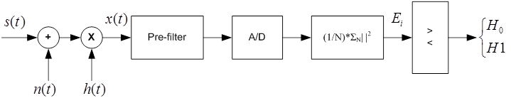
Figure 4: Energy Detector block diagram
The detection performance is evaluated in terms of probability of false-vacancy-detection (i.e. the probability of erroneously identifying a channel as available) versus the probability of false-occupancy-detection (i.e. the probability that a channel is identified as occupied while it is available). [[NOTE: How is the “evaluation” to be evaluated? In other words, FV vs. FO by itself doesn’t say very much]] As the main goal of the WSD sensing capability is the protection of DTT reception, the emphasis in the “detection performance evaluation” is the ability to maximally reduce the likelihood of false-vacancy- detection.
The energy detector provides better performance for higher values of N, i.e. the number of observed symbols: in this case the detector measures higher values of energy, thus being able to counterbalance worse channel conditions like low SNR or high shadowing standard deviation in case of a lognormal channel. Obviously the performances are also better for high SNR values. This detection is extremely easy from a computational point of view, but is deeply affected by bad channel conditions, and it cannot provide reliable detection performance even on AWGN channels with SNR=0 dB. This isn’t sufficient to detect weaker DTT signals, which also should be protected

Cooperative energy detection
In order to increase the detection performance, a p-out-of-L cooperative scheme has been used. According to this scheme, if among the L cooperating WSDs at least p detect a signal on that channel, then the Fusion Center which collects the sensed data (Figure 5), marks the channel as occupied and informs all the devices of this channel state. Note that in the literature, it has been found that the optimal value of p is L/2 [W. Zhang, R. K. Mallik, and K. B. Letaief, “Optimization of Cooperative Spectrum Sensing with Energy Detection in Cognitive Radio Networks,” IEEE Trans. Wireless Commun., vol. 8, no. 12, Dec. 2009]. Different optimal values of p can be found according to the scenario. For example, in case a lower false-vacancy-detection is more important, the optimal value of p can be different from L/2, as well as from the optimal value that decreases the probability of false-occupancy detection.
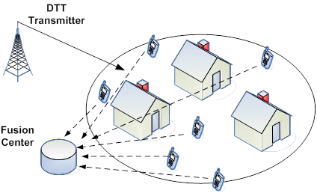
Figure 5: Cooperation detection scenario
The performance of the cooperative energy detector on AWGN, Rayleigh and Lognormal channels are provided in Figure 6 - Figure 8, and are compared to the performance of Single-Device detection in the same scenario. In these figures we are considering L/2 as the optimal value of p [NOTE: Perhaps an optimal value of “p” for lower false-vacancy-detection should be used]. Of course, the gain introduced by cooperation is much more evident for good channel conditions (i.e. high SNR in the figures), but even for bad conditions the gain is remarkable. [NOTE: Why ‘remarkable’?. Looking at Fig 6, for the SNR = -12 dB the improvement is max 5% and apparently gets smaller for lower values of SNR. It is not clear that SNR = -12 dB is the lowest signal level to be ‘detected’]
For the sake of briefness, we consider a fixed number of observed symbols N, varying the SNR value. However, it is worthwhile highlighting that, as stated above, higher values of N always increase the detection performance.
In Figure 9 we show the effect of increasing the number of cooperating WSDs. The performance significantly increases for larger values of L, but it should be considered that it is not feasible to increase that number at will, as the WSDs require a cognitive channel to communicate the sensed data to the Fusion Center. Even if a dedicated channel is used, when L is too high there would be too much overhead introduced. A possible solution might be using a hybrid cooperative-distributed approach, in which WSDs cooperate among themselves in clusters, i.e. the decision is taken within the WSDs of a cluster.
[NOTE: It should be made clear what the parameter is in the following Figures. For example in Figure 6, passing from left to right following the red curve, what is changing as the FO probability is increasing? Is the WSD sensitivity increasing or the ...??]

Figure 6: Single-device versus optimum cooperative detection on a Rayleigh channel with N=4

Figure 7: Optimum cooperative detection on an AWGN channel for different values of L, with SNR=-3 dB and N=4
Figure 8: Single-device versus optimum cooperative detection on a Rayleigh channel with N=4

Figure 9: Optimum cooperative detection on an AWGN channel for different values of L, with SNR=-3 dB and N=4
A “CONCLUSION” is needed …. [Is there significant improvement in weak signal conditions? If not, the reader should not be left with any false impressions]

Minimum required adjacent channel leakage ratio for WSDs (Issue A3)
(no inputs so far)

Technical considerations on the protection of the broadcasting service (Issues B1, B3)

Summary on previous studies
The studies presented in ECC Report 159 addressed a method for calculating an appropriate sensing threshold method and the corresponding maximum emission limits for WSD under various configurations.
The sensing thresholds were derived for a limited number of scenarios using the methodology developed within ECC Report 159 and taking into account a range of potential DTT receiver configurations. Some of the values obtained (being in the range from -91 to -155 dBm depending on the DTT planning scenario) appear to be extremely challenging to implement using current technologies. Moreover, in some scenarios, even these low values for the detection threshold do not guarantee a reliable detection of the presence/absence of the broadcasting signals at a distance corresponding to the interference potential of a WSD.
This led to the conclusion that, the sensing technique investigated, if employed by a stand-alone WSD (autonomous operation), is not reliable enough to guarantee protection of nearby DTT receivers using the same or adjacent channel. Therefore, the use of a geo-location data base and to avoid possible interference to DTT receivers appears to be the most feasible option. In addition it was concluded that in cases where the use of a geo-location database can provide sufficient protection to the broadcast service, sensing is not required. There may be some potential benefit in using a combination of sensing and geo-location database to provide adequate protection to DTT receivers but these benefits would need to be further considered.
However, ECC Report 159 suggested that if future technological developments show that the autonomous operation of WSD is reliable, then a method to determine the maximum WSD e.i.r.p. limits (under the constraint of having to avoid harmful interference to primary receivers) based on sensing results may be studied. This issue is explored in the following section.

Dependency of location probability on antenna installations and reception modes
The calculation of the location probability during network planning of broadcasting services is carried out on the basis of several assumptions forming a special framework. One element is the consideration of the receiving conditions. Usually, it is distinguished between reception modes such as fixed, portable outdoor and portable indoor reception. These are characterized by certain parameters describing the receiver performance including the antenna characteristics. Making a calculation for fixed reception means to employ a certain standard configuration.
However, listeners and viewers of broadcasting programmes are not obliged to use receivers and antenna installations as they are assumed for the calculation of the location probability as a measure for the quality of service. It is well-known fact that inside the coverage area of a transmitter that for example was planned for fixed reception, two aspects are important for broadcasters in their attempt to protect their services. These are:
- Moving from the coverage edge of a transmitter that was planned for fixed reception towards the transmitter site, first portable outdoor and later portable indoor become feasible due to the increasing field strength provided. As a matter of fact, listeners and viewers are making use of these reception modes.
- Furthermore, at the same time the excess of field strength closer to the transmitter site allows to receive broadcasting services with a fixed reception antenna installation which has only poor performance due to mis-alignment of the antenna with respect to the transmitter location or signal degradation due to unprofessionally installed antenna feeds.

If these conditions would be taken into consideration when calculating the location probability for a given pixel then lower values would result than derived on the basis of the standard configuration used for planning purposes. Additional interference imposed by WSD might not have a great impact on standard receiving conditions. However, listeners and viewers enjoying broadcasting content under the conditions described above could have to cope with significant service quality degradation.
Thus, in practice more than one location probabilities would need to be associated with any given pixel in principle in order to grasp all these situations. This means that if a broadcasting service is planned according to given conditions such as planning for fixed reception, then inside the coverage area for a given pixel a high location probability may be found, e.g. even 100%. But using different receiving conditions for the same pixel under else equal conditions may result in a significantly lower location probability.

Coverage Assessment of Broadcasting Services
Assessing the impact of interference from broadcasting or other telecommunication services into the broadcasting services is carried out on the basis of some simple principles. Even though these principles are widely known for a very long time and are permanently applied on a daily basis, there seem to be different perceptions with regard to the interpretation of certain elements of the methodology. This becomes in particular important in relation to the introduction of new non-broadcasting services in the broadcasting frequency bands.
Irrespective of the reception mode for which a given broadcasting transmitter has been planned for, different receiving conditions can be encountered throughout the coverage area of this transmitter. That means that for example around a transmitter which is intended to provide fixed reception, there will always be (smaller) areas where portable outdoor and portable indoor reception is feasible. This is known to broadcasters and constitutes an integral part of their network planning strategy. As consequence, broadcasters need to protect all these reception modes throughout the respective coverage areas.
Different countries have different regulatory frameworks when it comes to issuing licenses for spectrum usage. Public Service Broadcasters (PSB) usually have special coverage obligations that in the first place bind them to provide their services throughout the entire territory of their country, in other words they have to cover 100 % of the area. Further obligations are quite often associated to the coverage of a high percentage of the population if not all the population. Broadcasters have to provide evidence if these objectives are met. To this end, coverage calculations are performed in order to determine the covered area or the portion of the population that is covered.
The following elements are crucial in the process of evaluating the achieved coverage:
- Target Coverage Area
In particular PSBs are obliged to cover a given target area, such as an entire country or a region thereof completely, i.e. a 100 % coverage of the target area has to be achieved. For commercial broadcasters this is usually different. However, in general there is an obligation to cover a certain area or to achieve a specified population coverage within a given area.
- Planning Parameters and Planning Approaches
Calculations are carried out in order to design the transmitter networks to comply with the regulatory constraints. These calculations rest on an agreed planning methodology including wave propagation models (e.g. ITU-R Rec. P.1546), service and protection requirements (e.g. link budgets, protection ratios, receiving conditions, etc.) and methods to derive parameters that allow a meaningful quantification of the service quality at a given location (e.g. location probability).
- Coverage Calculation
In order to determine the coverage of a given network, wave propagation models are employed to predict the field strength of wanted and interfering fields at given locations. However, the spatial resolution for all wave propagation models used in broadcasting planning is limited. This means that reliable field strength predictions can only be given for points separated by a minimum distance of 100m. Under special conditions a resolution of 50m can be reached.
It is known that the field strength varies over a distance of 100m in a characteristic way due to shadow fading. Since this variation cannot be predicted as a consequence of the limited resolution of the wave propagation models at hand, statistical methods are employed to capture this behaviour To this end, the target coverage area is subdivided into a set of small pixel areas. These pixels can have different sizes depending on the granularity of the coverage analysis and the resolution of the wave propagation model. Typical values are 100 m * 100 m up to 1000 m * 1000 m. For each of the pixels a field strength value is predicted with the help of the wave propagation model at hand. The variation of the field strength throughout the pixel area is assumed to follow a defined distribution function (usually log-normal). The mean value of the distribution is assumed to be equal to the predicted field strength value for this pixel. Further assumptions on the standard deviation of the distribution are made. Then, the probability is calculated that a given minimum field strength or a certain ratio between wanted and interfering fields is exceeded. This probability corresponds to the location probability for that pixel. It has to be interpreted as the fraction of locations within the pixel area in which the broadcasting service can be received without problems.
- Coverage Assessment
For each broadcasting service a required location probability is defined that has to be reached in each pixel. Typical values for this required location probability are 99% (mobile reception), 95% (portable reception) or 70% (fixed reception). After the calculation of the location probability for all pixels in the target coverage area, each pixel is classified either as being covered or not being covered. The label “being covered” is attached if the calculated location probability in a pixel is equal or larger than the required location probability. If it is less than the required value then the pixel is considered as not being covered. Based on these individual decisions the coverage obligation, i.e. full coverage of the target area, is analysed. There are at least two different approaches for this. In both cases the values of location probabilities of the pixels are modified according to given criteria.
- Approach 1: B/W counting
The location probabilities of the pixels are either set to one or zero, depending on whether they are labelled as covered or not covered.
- Approach 2: Proportional counting
The location probability of all pixels not covered is set to zero. The others are left unchanged.
After the modification of the location probabilities of the pixels all location probabilities are averaged over the entire set of pixels constituting the target coverage area. This gives the total area coverage.
- Population Coverage
A further level of coverage analysis is often carried out or even demanded by the licenses issued by national regulators. This refers to calculating the fraction of covered population. To this end, a population data base has to be employed from which a number of inhabitants living within the area of a pixel can be deduced. Hence, each pixel is associated with a corresponding number of people. Sometimes, instead of inhabitants the number of households is used. The results are different then, however, the principle of the analysis remains the same. Again, the two approaches mentioned above can be used.
- Approach 1: B/W counting
If the location probability of a pixel is one then the number of inhabitants associated with this pixel is attached to the pixel. If the location probability of a pixel is zero then the number of people for that pixel is set to zero as well.
- Approach 2: Proportional counting
If the location probability of a pixel is zero then the number of people for that pixel is set to zero as well. If the location probability is not zero than the number of people covered people in this pixel is calculated by multiplying the number of people of the pixel with its location probability.
In both approaches the numbers of inhabitants associated after the modifications are summed to give the total number of inhabitants covered throughout the target coverage area.
B/W counting (Approach 1) is applied in many European countries both in terms of network planning and as part of the licenses for terrestrial broadcasting networks when checking coverage obligations. But also for the purpose of analysing the interference imposed by one broadcasting service onto another one, B/W counting is employed in different countries in Europe.
Nevertheless, it is also quite common to use proportional counting when a more refined analysis is required. This applies especially to situations where detailed information about the number of people or households expected to be impaired is sought. In particular, in the case of non-broadcasting services interfering broadcasting services proportional counting proves to be the preferred method of analysing the coverage and interference calculations.

Determination of maximum e.i.r.p. limits for autonomous WSDs (Issue B3)
(no inputs so far)

[NOTE ANACOM: I think this item is not foreseen to be analyzed soon, since it is related to the “future technological developments”. Taking into account the current state-of-art of the WSD it will be difficult to get any complete and agreed analysis about this subject until next SE43 meeting]

[Comment: If no studies are provided, the whole § 3 needs to be taken out from the report]

Technical considerations on the protection of PMSE (Issues C1, C2, C3, C4)

Summary on previous studies
Spectrum sensing is considered within ECC Report 159 as a problematic approach for the protection of PMSE systems from WSD interference. Taking into account the range of potential PMSE deployment scenarios, the studies showed that there was a great level of variability in the derived sensing thresholds. Temporal fading caused by multipath propagation is likely to be one of the main factors affecting the ability of WSDs to use sensing as a viable technique to protect PMSE systems from interference. In some cases, taking account of this type of fading may lead to a very low detection threshold, far below the WSD receiver noise floor, which would make this technique quite impractical. This points to a need for further study of the propagation characteristics of PMSE systems operating in various configurations and specifically on ways for any WSD utilising spectrum sensing to cope with temporal fading.
Although not considered in all details within ECC Report 159, the disable beacon concept, where the detection by the WSD of the beacon implies that the channel is occupied and therefore not available may be an approach which can help to overcome some of difficulties highlighted in relation to implementing sensing. Additional information would be needed from the industry to further consider aspects related to the implementation of this technique and its impact on the efficient use of the spectrum.
Use of a geo-location database was considered within ECC Report 159 as the most feasible approach considered so far for the protection of PMSE.

Digital PMSE (Issue C3)
PMSE equipments that make use of digital techniques are now emerging and the performance characteristics require further study. The technical characteristics of these systems vary and are in general proprietary to the manufacturer. Typical parameters are listed below:
Audio coding: 100kb/s, typ.
Modulation: pi/4: DQPSK, MSK, FSK
RF Emissions: EN 300422
IF bandwidth: 200 kHz
Noise Figure: 7dB typ.
Receiver Noise floor: -114dBm
Sensitivity: >-95dBm
Digital PMSE systems for PWMS applications conform to the same emission standard, EN 300422, as the analogue FM devices. Initial measurements suggest the receiver ACS performance and the associated protection ratios are similar to those for analogue FM systems. Details of the protection performance based on the measurement of two systems are included in this document.

Performance (protection ratios and overloading thresholds) measurements of PMSE receivers (Issue C1)
A measurement campaign was conducted under the auspices of the WISE-project (White space test environment for broadcast frequencies) in two different theatres in Helsinki to study the performance of PMSE equipment in the presence of WSD interference. A brief description of the campaign and its findings is provided in Annex 4.
[Ed. Note: Introductory paragraph is required to introduce the study below]
The proposed approach for protecting PMSE receivers requires information on the protection ratio performance of the receiver. The protection ratios are a function of the technical characteristics of the WSD interferer and the selectivity and overload performance of the PMSE receiver. The characteristics of the WSD signals are not yet covered by any European harmonized standards and are subject to change as the technology develops.
To provide some indication of the expected PMSE receiver performance, experimental measurements have been conducted using a range of candidate WSD interferers. The candidate interfering signals have been used to assess the performance of a range of PMSE receivers including digital (QPSK, FSK), analogue FM and IEM devices. Initial results are shown for LTE FDD interferers (UE and BS), operating at 3 data traffic levels. The protection ratios for 6 types of interfering signal are shown in Figure 10 - Figure 15. Two wanted signal levels have been used, -30dBm and -80dBm. The wanted signal frequency, F_{c,} was chosen for each receiver to be in the centre its specified operating bandwidth. The interfering signal was swept in 5MHz steps from F_{c} -30MHz to F_{c} +30MHz and in 1MHz steps from F_{c} -10MHz to F_{c} +10MHz.
[Ed. Note: In order to use the data on the graphs below, these graphs need to be tabulated. However, in view of the different approach adopted for the measurements and their interpretation from the one used in ECC Report 148, it may appear difficult to prepare such a representation]

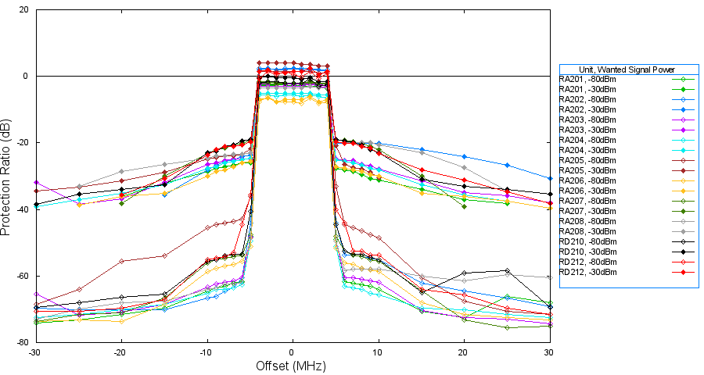
Figure 10: Protection Ratio for LTE BS Interference 100% Traffic
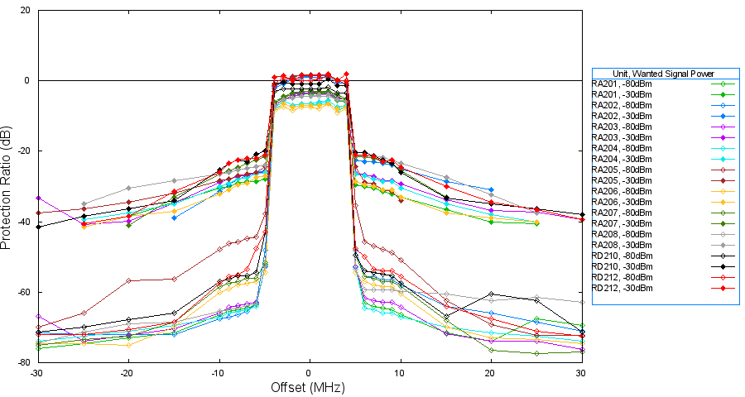
Figure 11: Protection Ratio for LTE BS Interference 50% Traffic

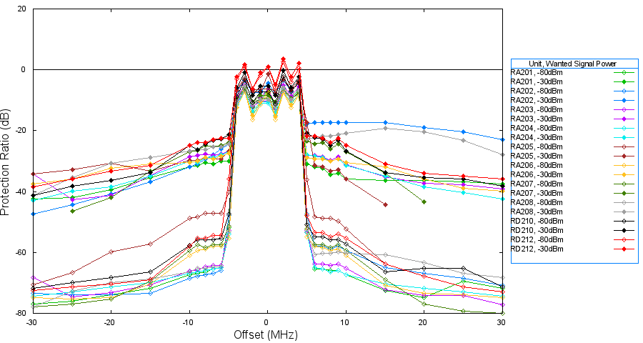
Figure 12: Protection Ratio for LTE BS Interference Idle (no traffic)
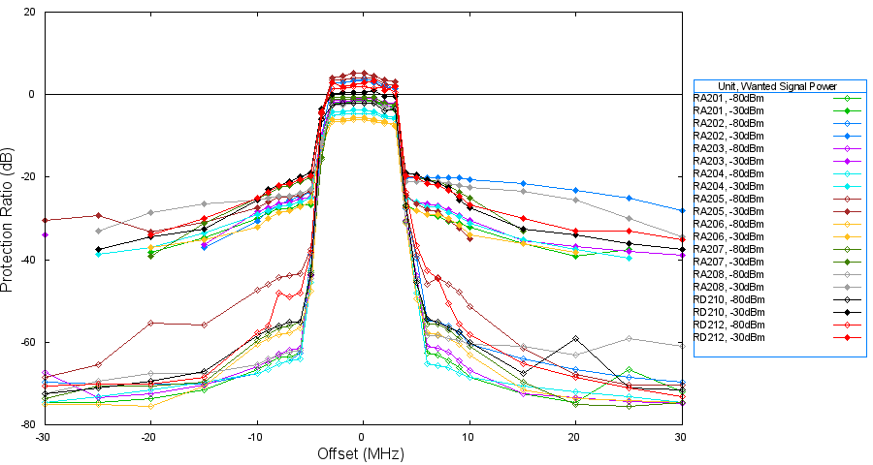
Figure 13: Protection Ratio for LTE UE Interference 100% Traffic
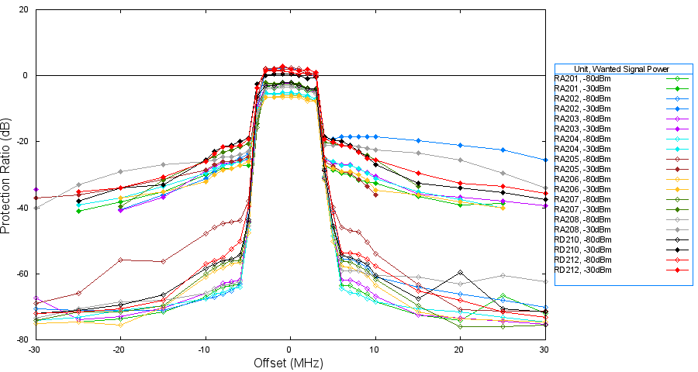
Figure 14: Protection Ratio for LTE UE Interference 50% Traffic
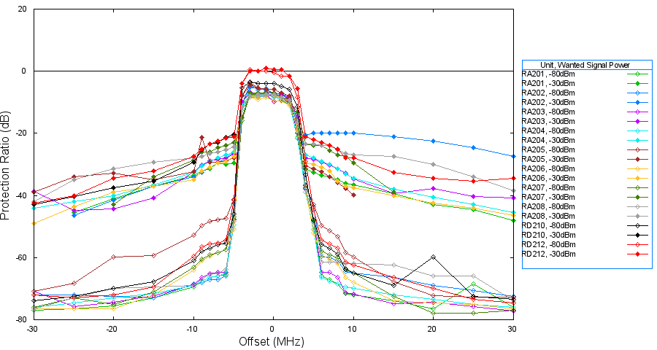
Figure 15: Protection Ratio for LTE UE Interference Idle (no traffic)

[Ed. Note: Additional data for IEM receivers, WIMAX, WiFI and M2M interference will be added when available]
The results show that protection ratio values for both the high and low power wanted signals are different; the worse adjacent channel protection ratio for the -30dBm wanted signal is as a result of the receiver being overloaded (both wanted and interfering signal powers are large in this case).
Results show that the adjacent channel (+-10MHz) minimum protection ratio is better than 55dBm for the non-overloaded case, irrespective of the waveform used. The worst co-channel protection ratio is around 6dB.
The precise characteristics of a licensed PMSE receiver at a protected location are unlikely to be known. It is recommended that the envelope of the performance characteristics should be used, taking into account the performance of all receivers Suggested C/I values for geo-location database construction are listed in
Table 3.
Table 3: Envelope of PMSE receiver protection ratio performance
Frequency Offset | WSD type | PMSE C/I
|ΔF|<+5MHz | CPE / UE / BS | [6 dB]
5MHz < |ΔF| <10MHz | CPE / UE / BS | [-40dB]
10MHz < |ΔF| | CPE / UE / BS | [-50dB]

Impact of WSD ACLR performance on PMSE protection ratios
The actual protection ratio required is a function of the selectivity of the victim PMSE receiver and the adjacent channel power emitted by the interfering WSD device.
The protection ratio measurements presented were made using a signal generator to emulate interference from a WSD. The adjacent channel leakage ratio (ACLR) of the signal generator was as good as 83dB for an offset of >10MHz, almost certainly better than the ACLR performance that would be achieved by a WSD. Commercial WSD devices are expected to exhibit reduced ACLR performance. The protection ratios to be applied in the database should be adjusted to reflect the actual ACLR performance of the WSD. The protection ratio data can be adjusted to take into account the actual ACLR performance of the WSD, by estimating the PMSE receiver ACS
(1)
This derived value of the DTT ACS will then be used to determine the appropriate co-channel and adjacent channel protection ratios for PMSE for WSDs that may have different ACLR characteristics.
The co-channel protection ratio of the PMSE receiver is not a function of ACLR and can assumed to be still PR₀. By inverting equation 1 the corrected adjacent channel protection ratio, PR′(Δf) can be derived:
(2)
In this way, the protection ratio for PMSE with respect to a WSD with its own particular ACLR, can be calculated on a case by case basis.

PMSE Receiver Overload Characteristics
Protection of PMSE receivers requires consideration of both the protection ratio performance and the overload characteristics of the receiver. Measurements suggest the typical PMSE overload level will range from [ -20 to 0dBm ].
The proposed I/N method and the indicative protection ratios suggest that the eirp limit for the WSD will tend to be determined by the selectivity considerations.

Consideration of PMSE transmitter IMD
Typical PMSE transmitters are also limited by reverse IMD issues, and the event planning of FM systems involves careful consideration of IMD performance. The reverse IMD performance of WSDs will require further study and appropriate technical standards to manage this type of interference that can potentially cause damage to both PMSE and other licensed services in the 470-790MHz band. This has not been treated in this document but is an important issue requiring further study.

PMSE signal sensing: application scenarios and channel models (Issue C2)
(no inputs so far)

Usability of beacon signals (Issue C4)
(no inputs so far)

Usability of combined (sensing and geo-location) approach (Issue C4)
(no inputs so far)

Technical considerations on the protection of ARNS (Issue E1)

Summary on previous studies
Preliminary considerations were provided in ECC Report 159 on the relevance of the sensing and geo-location techniques for the protection of ARNS. However, a need for some additional information on the ARNS deployment considerations was pointed out in order to perform an appropriate analysis.

ARNS deployment scenarios (Issue E1)
(no inputs so far)
(compatibility studies need yet to be performed)

Technical considerations on the protection of services in the bands adjacent to 470-790 MHz (Issue F1)

Summary on previous studies
Two different methodologies for deriving suitable protection for the Mobile Services in the bands adjacent to 470 – 790 MHz were proposed in ECC Report 159. Both methodologies were not fully developed and required further studies to be carried out.

Protection of mobile service in the band 450-470 MHz (Issue F1)

Protection of TETRA TEDS 25 kHz

Assumptions and scenarios (§ 6.1.1 of WD1)
The band 450-470 MHz is predominantly expected to be used by PMR/PAMR applications, including TETRA and its evolution, which have to be protected with respect to the introduction of WSD operating in the UHF band between 470-790 MHz.
The interference scenario is generally represented by different systems or devices, which operate in adjacent bands over the same geographical areas, as exemplified in Figure 16, where several WSDs, whose possible position is marked with X, share the same area as a mobile network.
WSDs may cause potentially harmful interference towards the incumbent services operating in the lower adjacent band. The proposed methodology to assess potential harmful impact of WSDs is based on Monte Carlo simulations, where victim receivers are randomly generated inside the simulation areas.
Link budget assessments both for wanted signals and interferers allow the evaluation of possible performance degradation. Adjacent channel interference is computed taking into account ACLR (Adjacent Channel Leakage Ratio), which describes out-of-band emissions of the interfering transmitter, and ACS (Adjacent Channel Selectivity), which describes the selectivity of the victim receiver (see Figure 17).
Depending on the channel arrangement and duplexing techniques the most critical link has to be identified. In Figure 18, it is shown an example where, due to the channel arrangement, the downlink of the incumbent service must be considered for protection. In this case the mobile user equipment (UE) is the victim, which receives both the wanted signal from the mobile base station and the interferer signal(s) from WSDs.
Parameters and requirements that must be considered in order to evaluate performance degradation may vary according to the specific system or service to be protected.
The overloading effect due to multiple WSDs can also be assessed.

Figure 16: Cellular layout (different colours are used for different frequencies).
In the inner part of the area several WSDs operate, whose possible position is marked with X

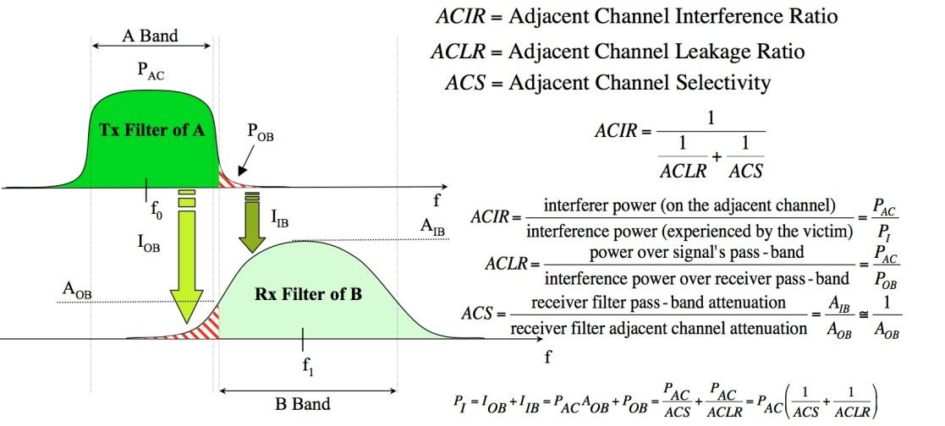
Figure 17: Assessment of adjacent channel interference

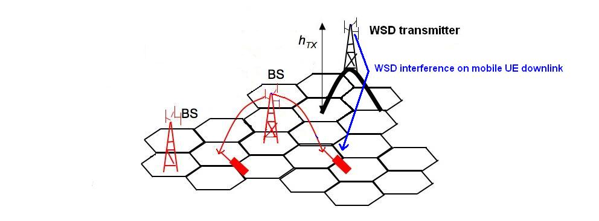
Figure 18: Example of mobile UE as victim receivers (downlink)

Results (§ 6.1.2 of WD1)
A first example considering the coexistence between TEDS 25 kHz with WSDs is provided. It has also to be noted that currently the 450-470 band is used by many analog PMR systems, partially switching to DMR.
A TEDS mobile network composed of 54 base stations deployed in a regular hexagonal layout has been taken into account. In order to avoid border effects, only the innermost 15 base stations have been analysed and, in the identified area, it is assumed that a WSD network is deployed for applications such as wireless access (see Figure 1); a maximum number of 35 WSDs is considered.
TEDS downlink has been identified as the most critical link due to the FDD channel arrangement and WSDs are assumed to operate immediately above 470 MHz, with 5 MHz channel bandwidth. Systems characteristics and simulation parameters are summarized in Table 4.
Table 4: Main simulation parameters
TEDS 25 kHz characteristics
Cell radius | 5 Km
Simulation area | 60x48 Km²
Operating frequency | 469.9875 MHz
Total number of base stations (BSs) | 54
Number of TETRA BSs in central area | 15
Cluster size | 7
BS antenna height | 30 m
BS antenna gain | 12 dB
BS transmitted power | 28 dBm
Number of User Equipments (UEs) generated for each Monte Carlo simulation | 200
UE antenna height | 1.5 m
UE Tx antenna gain | 0 dB
UE transmitted power | 27.5 dBm
WSD characteristics
Transmitter power | 33 dBm
Antenna height | 10 m
Antenna pattern | Omnidirectional in azimuth
Antenna gain | 9 dBi
Operating frequency | 472.5 MHz
Total number or WSDs | 35

TEDS UE receiver mask is derived from [ETSI EN 300 392-2, “Terrestrial Trunked Radio (TETRA); Voice plus Data (V+D); Part 2: Air Interface (AI)”, European Standard (Telecommunication Series), v 2.3.2, March 2001], whereas WSD SEM is assumed equal to SEM for LTE base stations [CEPT Report 148, “Measurements on the performance of DVB-T receivers in the presence of interference from the mobile service (especially from LTE)”, Final Report by the Electronic Communication Committee (ECC) within the European Conference of Postal and Telecommunications Administrations (CEPT), Marseille, June 2010] (see Figure 19). The derived masks are needed to evaluate adjacent channel interference.

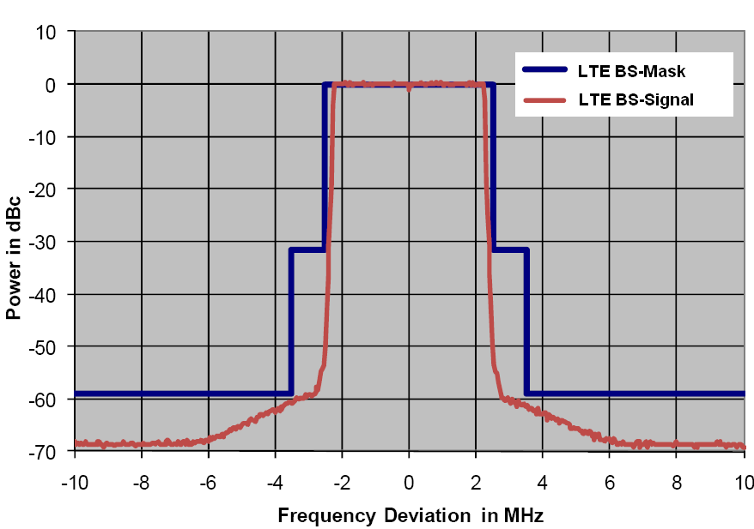
Figure 19: TEDS UE receiver mask and WSD SEM
Performance degradation is assessed considering both wanted and unwanted power received by the TEDS UE, whose positions are randomly generated by means of a Monte Carlo simulation.
TEDS requirements are given in terms of C/Ic (signal to co-channel interference ratio), C/Ia (signal to adjacent channel interference ratio) and receiver blocking power [ETSI EN 300 392-2, “Terrestrial Trunked Radio (TETRA); Voice plus Data (V+D); Part 2: Air Interface (AI)”, European Standard (Telecommunication Series), v 2.3.2, March 2001] [CEPT Report 104, “Compatibility between mobile radio systems operating in the range 450-470 MHz and Digital Video Broadcasting-Terrestrial (DVB-T) systems operating in UHF TV Channel 21 (470-478 MHz)”, Amstelveen, June 2007]. Numerical values are reported below:
- minimum C/Ic =19 dB;
- minimum C/Ia = -40 dB;
- receiver blocking= -40dBm.

Co-channel interference (Ic) includes both TEDS intra system interference and interference due to the imperfection of the WSDs transmitter. Adjacent channel interference (Ia) is specifically referred to the first 25 kHz adjacent channels below and above the operating band of the TEDS victim receiver. Receiver blocking power is then computed considering the interference generated by WSDs in all the adjacent channels but the first.
In order to gather information on the overloading effect of WSDs for the protection of TEDS, Monte Carlo simulations have been performed varying randomly the number of active WSDs (transmitters ON): all, one half, 1/5 and 1/12.
Simulations have highlighted that the most stringent constraint is represented by the requirement in terms of C/Ic. In Table 5 the estimated outage is reported. The overloading effect is also visible.
Table 5: Simulation results
Estimated outage for TETRA receivers (%)
All transmitters ON | Half of the transmitters ON | One fifth of the transmitters ON | One twelfth of the transmitters ON
1.16% | 0.87% | 0.67% | 0.56%

Protection of CDMA PAMR

Scenarios
[Ed.note: Simulations presented in § 6.2.2 will need to be amended with the results for different cell sizes and different emission technologies to be used by WSDs. RUS agreed to provided these additional simulations to the next meeting]
In the simulations CDMA mobile stations and portable WSD are randomly placed within the CDMA BS and fixed WSD service areas according to the uniform distribution. Fixed WSD is placed on the border of a CDMA cells. During the simulations, emission power of WSD had been gradually decreased until the tolerable level of capacity loss has been obtained. Once tolerable level is determined, maximum emission power for WSD is recorded. Calculations are done for three frequency offsets between channels of mobile network CDMA and fixed WSD (Figure 20). Only impact from fixed WSD on CDMA mobile units has been estimated.
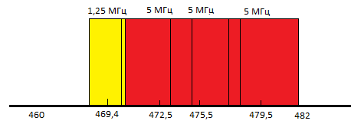
Figure 20: Frequency offsets of fixed WSD (red) and BS CDMA (yellow) [Ed.note: Change units into English]
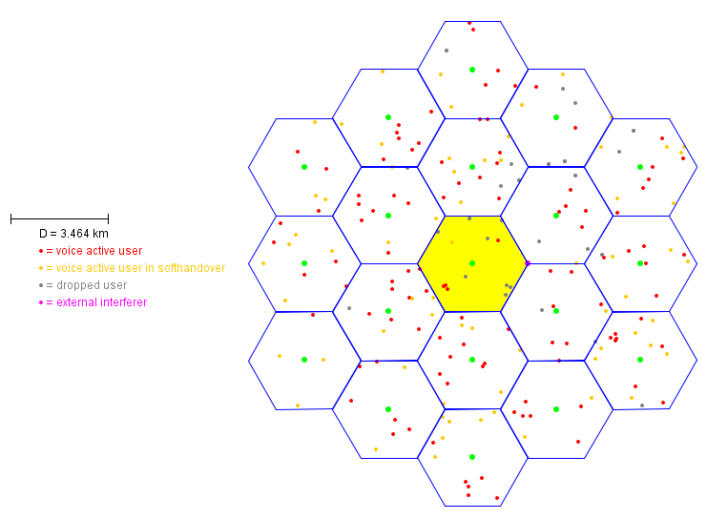
Figure 21: Scenario for assessment compatibility between WSD and CDMA networks

Interference criteria
Network capacity loss has been selected as the interference criteria in order to assess compatibility between CDMA and WSD. The calculations have been conducted for 1% and 5% network capacity loss.

Parameters of WSD used for simulations
Table 6: Interfering transmitter parameters (fixed WSD)

Parameter | Value
Carrier frequency (MHz) | 472.5 MHz, 475.5 MHz and 479.5 MHz
Antenna height (m) | 30
Antenna maximum Gain (dBi) | 17
Feeder losses (dB) | 3

Table 7: Wanted receivers parameters (portable WSD)
Parameter | Value
Antenna height (m) | 1.5
Antenna gain (dBi) | 0
Sensitivity (dBm) | -94

Emission mask of the fixed WSD (shown in Figure 22) has been taken in accordance with characteristics of WiMax systems in UHF for 5 MHz channel (CEPT Report 40, Annex 2). This assumption based on the fact that some of WSD standards use WiMax technology as a basis.
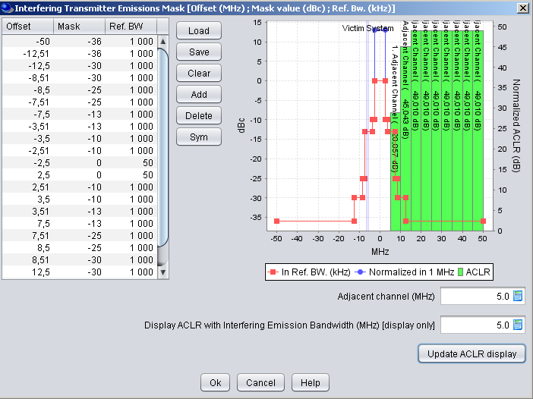
Figure 22: Emission mask of fixed WSD

The fixed WSD antenna with Horizontal and Vertical patterns has been taken from Recommendation ITU-R F.1336-2 for a 120 degrees sector antenna with a maximum gain of 17 dBi.

Parameters of CDMA network used for simulation
Characteristics of CDMA system have been taken in accordance with the ECC Report 99, Annex B. Parameters being used are presented in tables below.
Table 8: Parameters Assumed for CDMA PAMR Systems
Column title (style: Arial 10pt bold white) | Column 2 | Column 3
Channel Spacing | 1250 kHz | 1250 kHz
Transmit Power | 23 dBm | 40 dBm*
Receiver Bandwidth | 1250 kHz | 1250 kHz
Antenna Height | 1.5 m | 30 m
Antenna Gain | 0 dBi | 9 dBi
Active Interferer Density Range | Variable | variable
Receiver Static Sensitivity | - 117 dBm | - 124 dBm
Receiver Dynamic Sensitivity 75% system loading | - 107 dBm | - 113dBm
Power Control Characteristic | Used at SEAMCAT Simulation | Used at SEAMCAT Simulation

Table 9: Receiver Blocking for CDMA PAMR Systems
Frequency Offset | Mobile Station | BS
> 900 kHz | - 30 dBm | - 21 dBm

Results
Figure 23 presents the results of the simulations of the dependence of the mean capacity loss on the WSDs output power for three frequency offsets between the BS CDMA and fixed WSD.
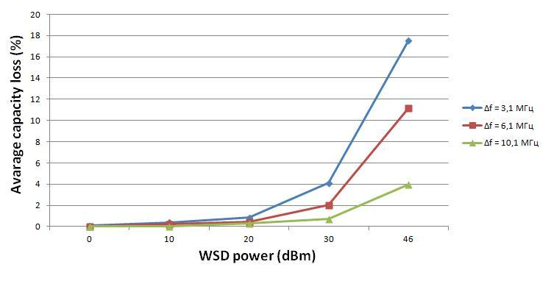
Figure 23: The impact of fixed WSD power on the CDMA reference cell capacity
If the capacity loss of 5 % is set, the maximum power for fixed WSDs operating in TV Channel 21 should be limited to 30 dBm, whereas 1% allowance for the capacity loss would limit the WSD power to 20 dBm.

Protection of mobile service in the band 790-862 MHz (Issue F1)

Common assumptions

WSD system (interferer)
The WSD system is assumed to use 8 MHz system bandwidth and time-division duplexing (TDD).
Out-of-band (OOB) emissions are assumed to be similar to the performance of LTE and are thus defined according to 3GPP specifications. For fixed mounted WSDs BS-like performance is assumed, for portable and user-deployed WSDs UE-like performance is assumed.
BS-like OOB emissions: ACLR1 = ACLR2 = 45 dBc, for larger frequency offsets spurious emissions -36 dBm/100 kHz.
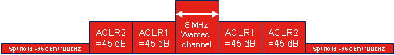
UE-like OOB emissions: ACLR1 = 30 dBc, for larger frequency offsets spurious emissions -36 dBm/100 kHz.

Note that the spurious emissions requirements are given as absolute powers and are thus independent from the in-band transmit power of the WSD. In cases where WSD spurious emissions fall into the victim wanted channel it is therefore possible that the maximum possible level of spurious emissions itself is limited by the combination of I/N threshold and coupling gain.
[Ed. Note: There was a suggestion that the mean power emission from the WSD in the spurious domain should not be fixed to the spurious emission limit (i.e. -36dBm/100kHz) but put at least 20dB below the spurious emission limit. This issue will need to be discussed further]

Mobile system (LTE)
The LTE system is modelled as a 10 MHz FDD system, downlink (BS transmit, UE receive) operating in 791-801 MHz. LTE UEs are assumed to have an omni antenna (0 dB gain), noise figure 6 dB, and are located at 1.5 m height above local ground. An inter-site distance (ISD) of 5000m is used.
[Ed. Note: The assumption on the inter-site disctance may need to be revisited in the later course of the investigations since results might be rather sensitive to this parameter.]

LTE UE selectivity
LTE UE selectivity determines how much energy the LTE UE takes in from within the TV band due to its non-ideal frequency selectivity. This selectivity consists of two main contributions; the selectivity by the RF frontend and the additional suppression by the duplex filter.
The RF selectivity for some frequency offsets can be estimated from the 3GPP ACS and blocking requirements (see 3GPP TS 36.101). The details of how this can be done have been explained in an earlier contribution (see Doc. SE43(10)88). The resulting numbers are illustrated in Figure 24. The ACS for the first 5 MHz outside the LTE wanted channel is 33 dB. The first in-band blocking requirement is to be tested at 10 MHz offset, and the required suppression is ~33 dB as well. At 15 MHz offset the second in-band blocking requirement implies a suppression of 45 dB, which can then assumed to be flat until a frequency offset of 60 MHz (first out-of-band blocking requirement).
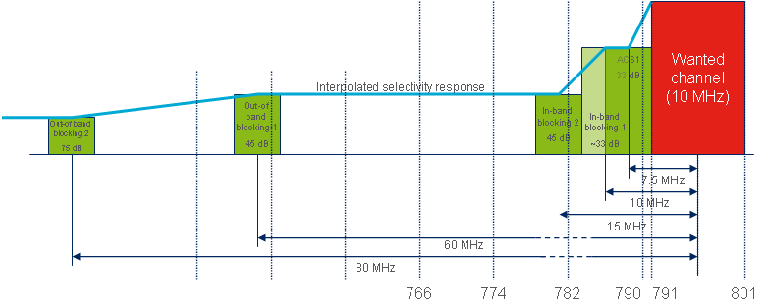
Figure 24: RF selectivity
Based on these values it is possible to calculate the ACS for the first couple of TV channels when interferers are using 8 MHz instead of 5 MHz bandwidth. For channels 56 to 59 this is straightforward; the ACS is 45 dB. For channel 60, the ACS has to be averaged over 33 dB for the upper 6.5 MHz of the channel, and 45 dB for the lower 1.5 MHz of the channel. This averaging is done according to
. (3)
Interference coming from the TV band will be additionally attenuated by the LTE UE’s duplex filter. It is difficult to estimate the duplexer performance from the existing 3GPP requirements, since those target at defining the suppression of the UE’s transmit frequency range (i.e. frequencies above 821 MHz), and current filter technology typically has asymmetric frequency responses (i.e. the shape of the filter response at frequencies above the passband is different from below the passband). In the absence of any better information, we propose to model the duplexer suppression with three different levels (called “low”, “medium” and “high” duplexer performance in the following) in order to represent the range of typical duplexers available today. The assumed duplexer suppression has to be summed up with the ACS due to RF selectivity as explained above, and the resulting total ACS figures are given in Table 10.
Table 10: ACS values used in simulations
 | RF selectivity | Duplexer | Duplexer
Ch. 60  782-790 MHz | 34 dB | 5, 7.5, 10 dB | 39, 41.5, 44 dB
Ch. 59  774-782 MHz | 45 dB | 25, 30, 35 dB | 70, 75, 80 dB
Ch. 58  766-774 MHz | 45 dB | 40, 50, 60 dB | 85, 95, 105 dB
Ch. 57  758-766 MHz | 45 dB | 40, 50, 60 dB | 85, 95, 105 dB
[Ed. Note: Other values for the isolation of duplexer were suggested for the purpose of the studies. This issue will need to be discussed further]

Interference modeling

MCL analysis
For MCL analysis it is proposed to consider WSD leakage into LTE UE wanted channel (according to assumptions on WSD ACLR and spurious emissions as described above), see the area marked in green in Figure 25, and LTE UE selectivity within the WSD wanted channel (according to total ACS (RF + duplexer) as shown in the table above) as indicated by the blue area in the figure below. Contributions from other frequency ranges (i.e. below the blue area, between blue and green area, and above green area) are neglected. This is equivalent to the approach that has been used for the MCL analysis results in ECC Report 159.
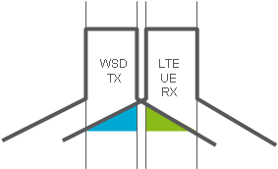
Figure 25: WSD leakage into LTE UE

Monte Carlo simulation
For Monte Carlo simulations (e.g. using SEAMCAT software) it is proposed to consider the full transmitter and receiver mask according to the general assumptions above. Contributions below the blue area and above the green area in the figure above are neglected, but contributions from frequencies between the blue and green areas are taken into account.
The I/N threshold should not be exceeded in more than 1% of the cases, i.e. the resulting I/N distribution should be read at 99%.
Each simulation is run with a certain WSD transmit power, which is then varied in consecutive runs in order to find the maximum WSD transmit power for which the given I/N threshold is just not exceeded.

Scenarios
[Ed.note: A figure demonstrating all three scenarios is required]
The range of deployment scenarios for WSDs considered for the scenarios encompasses:
- Wide area base station (mounted on a mast or on roof of higher building)
- Portable device or similar to WLAN access point (same height as LTE UE and potentially very short distance)
- fixed wireless access Customer Premise Equipment (CPE) (somewhat higher as LTE UE and has directional antenna)
Victim: typical LTE UE
[Ed. Note: Initial focus is on rural environments (influences choice of propagation model parameters), other area types possibly to be studied later if time permits.]

Scenario 1: WSD deployed as wide area base station
The WS BS antenna consists of three sectors with typical 120 degree antennas (ITU-R F.1336, average model) with 17 dBi gain in main direction, 30 m antenna height, 3 degree mechanical down-tilt.
However, for MCL analysis only one sector needs to be modelled. In this case a fixed geometry is considered where the distance between the victim and the interferer is assumed to be 20 m in the horizontal plane. Together with the antenna heights of 30 m for the WSD and 1.5 m for the LTE UE this means that the elevation angle at which the vertical antenna diagram of the WSD antenna has to be read is 52 degrees. According to ITU-R Recommendation F.1336 the suppression at this angle for a 120 degree sector antenna with 17 dBi max. gain (k-value = 0.7, peak model used) is 14.86 dB. COST-Hata propagation model is used to construct the link budget.
For Monte Carlo simulations, a WSD BS is assumed to be located at 2/3* inter-site distance of the LTE cell cluster. The power configured in the simulation tool should be interpreted as total site power, i.e. evenly distributed between the sectors of the site.

Scenario 2: portable WSD or user-deployed access point
An omni-directional antenna with 0 dBi gain is assumed for portable WSDs.
Both LTE UE and WSD UE antennas are assumed to be at 1.5 m agl leading to no additional suppression from the vertical antenna pattern of the WSD antenna.
For MCL analysis, a distance of 2 m is assumed between the victim and the interferer. For Monte Carlo simulation the WSD BS is assumed to be co-located with the centre site in the LTE cell cluster, interfering portable WSDs positioned randomly within a disc of [5,10,15] km radius around the serving WSD BS.
Recommendation ITU-R P.1411 or free space is used to construct the link budget between victim and interferer in both, MCL analysis and Monte Carlo simulation.

Scenario 3: WSD deployed as fixed mounted CPE
The WSD CPE is assumed to be mounted at 10 m height. The Yagi antenna according to ITU-R BT.419-3 with 10 dBi gain, always pointing to a serving BS location, is considered. No downtilt on the WSD antenna is assumed.
For MCL analysis a distance of 10 m in the horizontal plane is considered. This leads to an elevation angle of 40 degrees, which corresponds to a suppression of 7.32 dB.
For Monte Carlo simulation the WSD BS is assumed to be co-located with the centre site in the LTE cell cluster, interfering WSD CPEs are positioned randomly within a disc of [5,10,15] km radius around the serving WSD BS.
Recommendation ITU-R P.1411 or free space is used to construct the link budget between victim and interferer in both, MCL analysis and Monte Carlo simulation.

Calculation results

MCL analysis
[Ed.note: to be provided]

Monte-Carlo simulations
[Ed.note: to be provided]

Protection of terrestrial cable head-end receivers within the broadcasting service area (requested by WG SE)
In general, there are two interference scenarios based on either inclusion into or exclusion from the broadcasting service area. Figure 26 shows some typical scenarios with the cable head-end installations being both inside and outside the stations’ service area for residential terrestrial receivers.
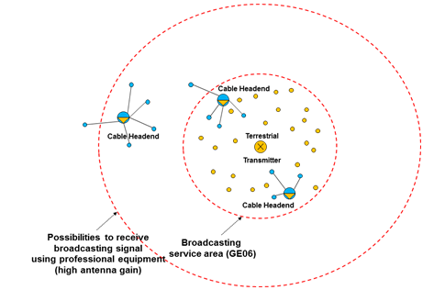
Figure 26: Typical scenarios for cable headend installations
It has been decided by the ECC that protection for cable head-end receivers outside the broadcasting service area should not be considered.
In many cases, the cable head-end will use an antenna with a high gain mounted high on a tower to receive TV station signals beyond the station’s service area for residential terrestrial receivers.
Regarding the cable head-end protection outside the broadcasting service area, this scenario is a national issue that an administration may wish to consider. For example, this can be achieved by definition of so-called exclusion zones around each cable head-end installation situated outside the broadcasting coverage area, and subsequent recording of these exclusion zones in the geo-location database.
Considering the cable head-end receivers within the broadcasting service area the following approach is applicable. ECC Report 159 defines the protection criteria for the broadcasting service for different reception modes and receiving environment. The technical and operational requirements to WSD are established to protect receivers within the GE06 service area. Understanding that cable head-end receivers are the receivers of terrestrial broadcasting services, it is reasonable to assume that their protection may be covered in a similar way as it was done for residential receivers in ECC Report 159.

Amount of white space spectrum potentially available for WSDs in the band 470-790 MHz (Issue H1)

Summary on previous studies
ECC Report 159 specifies that the amount of spectrum available for WSDs depends upon a number of factors including decisions on the level of protection given to the incumbent services and how well the WSD can cope with interference from these incumbent services and other WSDs.
The exact amount of available spectrum at any location will be dependent upon each national situation or circumstances (e.g. DTT planning configuration, PMSE use, Radio Astronomy use). The objectives of the study presented in ECC Report 159 were to provide a general methodology to assess the amount of spectrum potentially available and some examples of the technical parameters that will be required to protect incumbent services based on specific scenarios.

Result of studies (WD2)
Case study of Germany (Bavaria region) is provided in Annex 5 (§ 5.1).
Case study of the UK is provided in Annex 5 (§ 5.2).
Case study of Poland is provided in Annex 5 (§ 5.3).
[Ed. note: Some editorial work on the text below is required to format the material such it is suitable for inclusion into the report. In particular, only general considerations on the issue should be kept in the main body of the section, whereas the results of simulations for different case studies should be provided in the annexes. IRT agreed to provide a corresponding input to the next meeting]
[During the last 50 years the usage of the UHF bands by broadcasting services has been governed by two ITU Agreements, i.e. the Stockholm Plan 1961 (ST61) for analogue terrestrial television and the Geneva Plan 2006 (GE06) for digital terrestrial television. ST61 started with a situation where at every location in Europe only three channels were available and therefore three analogue TV programmes could be offered. In 2006 when ST61 was abrogated and replaced by GE06 many more analogue channels were on air across Europe. In big cities such as Berlin, Paris or London up to 25 analogue TV programmes could be received. In Rome the offer was even significantly more than 30 programmes. Even though the results of GE06 did foresee seven layers of DVB-T multiplexes everywhere, some European administrations indicated that they intend to go beyond that. As a consequence, it can be expected that more and more broadcasting services will be introduced over time thereby significantly decreasing the amount of available white spaces. Furthermore, any calculation of the amount of white spaces has to be understood as a snapshot in time only.
ECC Report 159 presents a requirement for additional studies on the amount and utility (e.g. possible capacity and data rates) of white space and their dependency on the relevant parameters (e.g. cross-border effects) as well as a sensitivity analysis with regard to protection requirements.
Based on this understanding, this document was being drafted in order to collect the new calculations, given the approved ECC Report 159, which provides some tools to determine WSD maximum transmit power, and considering that after the approval of the referred report, those tools were not yet used to get insight into real situations.
In particular, the methodology described in ECC Report 159 was used to estimate the amount of available channels in Germany. The results of this study are given in this document. An alternative methodology was also submitted to the attention of SE43. The proposed approach does not follow the methodology established in the course of the SE43 studies. Furthermore, a number of concerns were expressed regarding the simplifications accepted in this study.

Calculations From document SE43(11)28, the following methodology was used in order to investigate the maximum transmit power for WSD in UHF bands in real situations.
For estimating maximum transmit power it is required to have
- Methodology
- Parameters
- Assumptions
The methodology described in ECC Report 159, chapter 4.3.4. “EIRP limits in case of geo-location database operation” was used and started with field strengths and location probabilities for a broadcast only system (without WSD as interferers).
Field strength (E) and location probability (LP) were calculated with IRT’s frequency planning system FRANSY (which is used by public broadcasters in Germany, Austria and Switzerland to calculate the broadcast coverage, see Annex).
Figure 27 shows the flow chart that describes the procedure to calculate maximum WSD transmit power.

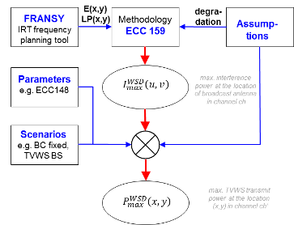
Figure 27 (Caption is missing)
- In the first step the maximum acceptable interference of an additional TVWS device at the location of a broadcast reception antenna $I_{max}^{WSD}\left(u,v,f\right)$ is calculated by using the simplification of ECC 159, ch. 4.3.4.2.1 (Gaussian random variables), see Annex X.
- Then, protection ratios and overload thresholds were taken from ECC report 148, see Annex X: “Parameters from ECC report 148”.
- The assumptions on possible distances between a TVWS transmitter at location (x,y) operating in channel ch’ (frequency f’) and the closest DVB-T receiver located at (u,v) and receiving channel ch (frequency f) to calculate maximum TVWS device transmit power, described in Annex X.
- The parameters and assumptions allow us to calculate maximum transmit power for the TVWS device:
$P_{max, PR}^{WSD}\left(x,y\right)= I_{max}^{WSD}\left(u,v\right)+PR\left(ch-ch'\right)+coupling gain$ (4)
- Coupling gain is determined by propagation loss, antenna gain, feeder loss…

Effect of overloading: upper threshold of transmit power
Digital Terrestrial TV receivers can be tuned to any channel between 470 and 862 MHz. To realize high sensitivity the first step in a TV receiver is a broad band amplifier. A very strong signal on any channel 21…69 may cause nonlinear behavior of the amplifier.
The overload threshold for the LTE base station signal according to ECC report 148 is between -19 dBm and -5 dBm.
Within the coverage area for fixed reception the shortest distance between TVWS device (BS) and rooftop aerial is assumed 30 m (Annex X). For this distance the coupling gain (transmitting into the cone of the antenna) for 650 MHz is -49 dB.
In most of the European nations it can be assumed that there is at least one broadcast coverage within n±9 of each channel at any location. Under this assumption the overload threshold in combination with the shortest possible distance between TVWS device and TV antenna determines an upper limit for the possible transmit power for TVWS device:
$P_{max, Oth}^{WSD}=O_{th}- coupling gain= -19 dBm+49 dB=30 dBm$ (5)
[NOTE: Equation 5 is too primitive: it does not take account of LP, e.g. protecting 95%.
- This value is the upper limit for fixed broadcast reception conditions and the advantageous values for downlink signals. For broadcast portable reception the DVB-T receiver may get closer to the BS, however due to the poorer antenna gain for dipole antenna vs. fixed rooftop antenna maximum transmit power is only slightly lower.
- For user terminal signals (UE) the overload thresholds are approx. 10 dB worse which reduces max. transmit power to 20 dBm.
- If portable DVB-T reception is possible then the pass loss reduces to -32 dB which, combined with TVWS UE, limits TVWS power to few dBm.
So before doing some detailed simulations it may be concluded that overload threshold defines an upper limit for transmit power and that even with the moderate values taken for the overload threshold base stations within portable reception areas may not be reasonably operated due to low maximum transmit power.
Estimating the amount of available TVWS in Bavaria

To estimate the amount of available channels in Germany, exemplarily Bavaria, the largest federal state of Germany, is considered:
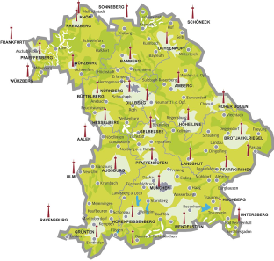
Figure 28: Caption is missing
Next figure shows a rectangle enclosing Bavaria. Black areas show broadcast coverage (>70% location probability) in channel 45 in all four corners and wide areas with no coverage (=WSD) in the center.
Figure 29: Caption is missing

Figure 30 shows results for the same channel 45 with colors:
Dark blue areas do not belong to Bavaria and so are not considered here. The bright blue areas are the coverage areas and are the same as the black coverage areas in Figure 29. The other colors indicate the reduction of TVWS depending on the safety distance (i.e. transmit power):
safety distances:
cyan: 1 km
green: 5 km
yellow: 10 km
orange: 20 km
Figure 30: Caption is missing
Cyan the areas which are no longer TVWS if safety distance = 1000 m
Green the areas which are no longer TVWS if safety distance = 5000 m
Yellow the areas which are no longer TVWS if safety distance = 10000 m
Orange the areas which are no longer TVWS if safety distance = 20000 m

In the considered channel 45 for Bavaria the amount of TVWS drops from 62% (safety distance =0) to approx. 10% for a safety distance of 15 km.

Figure 31: Caption is missing
Figure 32 shows the number of available channels between ch 40 and ch 60 if the safety distance is assumed to be 0 km (left) and 10 km (right). As expected the number drops significantly.

Figure 32: Caption is missing

Conclusions
These investigations were performed with moderate values for protection ratios, overload threshold, etc. Even with these moderate parameters results show that operation of WSD in areas where portable broadcast reception is possible, maximum transmit power is limited to below ~20 dBm (i.e. operational range of approx. 1 km).
- In areas with portable broadcast coverage TVWS might be used for low power transmit systems, like Wi-Fi, which would offer several advantages towards ISM bands:
- Better penetration characteristics allow improved in house LAN operation;
- ISM bands are overstrained esp. in dense urban areas, where TVWS usage could bring a significant release;
- If –for low transmit power- operation at channels adjacent to TV used channels is possible, there is a reasonable amount of TVWS available;

- In rural areas / isolated residential areas where it is possible to keep larger minimum distances between WSD base station transmitter and closest possible broadcast receiver, the downlink only (DO) concept could provide a reasonable means to provide broadband internet supply to area.
- Usually the download traffic is much higher than upload traffic, so using TVWS for downlink and mobile communication bands for uplink seems reasonable.
- Usually in rural areas wired broadband access is not available due to high infrastructure costs, so this TVWS usage is especially appropriate for rural areas.
A final remark is that these results indicate that TVWS usage is appropriate for Wi-Fi use to solve the problem of overload of ISM bands in urban and dense urban areas and could provide an affordable broadband internet access for rural areas, which is in line with the call of EU parliament for equal treatment of all regions within EU.]

Conclusions

- Link budget calculations to derive e.i.r.p. values for white space devices
  - WSD’s parameters
The parameters assumed for outdoor and indoor WSDs are listed, respectively, in Table 4.1 and 4.2 of Section 4.3.
The Shannon formula was used to compute the signal-to-noise ratio as a function of the transmission bandwidth and the data rate. It was then assumed that the WSDs are performing 2 dB off from the Shannon capacity bound.
  - Propagation calculations
The Okumura-Hata model for open land was used to calculate the path loss in outdoor scenario. The base station and user terminal were assumed to be at 30 m and 1.5 m height, respectively.
For indoor path loss calculations the model described in Recommendation ITU-R P.1238-6 was applied. It should be noted that this model is adopted for the assessment of the propagation characteristics of indoor radio systems between 900 MHz and 100 GHz. However, as the path loss difference between the frequency 900 MHz and, for example, the frequency 600 MHz is only about 3.5 dB, the usage of Recommendation ITU-R P.1238-6 was considered acceptable, at least, to a 1st order approximation. The distance power loss coefficient of 33 was used. The access point and the user terminal were assumed to be on the same floor (i.e. no floor penetration loss was considered).
The outdoor and indoor shadow fading statistics were assumed to be log-normal with the standard deviation of 5.5 dB. Gaussian confidence factor µ of 1.64 was used that relates to target location percentage of 95%. The shadowing margin related to the variation of the signal can be then calculated as dB.
  - Link budget assessment
Thermal noise power N_{T} is calculated using Boltzmann's equation:

N_{T} = kTB (6)
where k is the Boltzmann’s constant,
T is the temperature,
B is the receiver bandwidth.
Receiver inherent noise (noise figure) is used to compute the receiver noise floor N:
N = N_{T} + F (7)
where F is the noise figure.
With signal-to-noise ratio SNR the receiver sensitivity C is determined:
C = SNR + N (8)
In order to account for the increase in the thermal noise level caused by other interference sources an interference margin IM of 3 dB is further assumed.
With the path loss calculated over the expected operation range it becomes then possible to determine the required transmitter e.i.r.p.:
e.i.r.p = C + Lb + IM – Gi (9)
where Lb is the path loss including the shadow fading statistics,
Gi is the receiver antenna gain.
  - Results
Example The details of link budget calculations are given in Table 11 and Table 12 for outdoor and indoor WSDs, respectively. Note that in the outdoor link budget the data rate, signal to noise ratio and range can be traded so that with a higher data rate (for example 10 Mbps) a higher C/N is required and the range is reduced with the same e.i.r.p. Alternatively, an increased EIRP figure and/or increased antenna gain, could enable higher data rates to be achieved.

Table 11: Link budget calculations for outdoor WSD categories
Parameter | Base station | User equipment | M-to-M
Date rate (Mbps) | 1 | 0.128 | 0.5
Transmission bandwidth (MHz) | 8 | 0.360 | 1
Thermal noise (dBm) | -104.9 | -118.4 | -114.0
Receiver noise figure (dB) | 7 | 5 | 7
Receiver noise floor (dBm) | -97.9 | -113.4 | -107.0
Signal-to-noise ratio (Shannon + 2 dB) (dB) | -8.4 | -3.5 | 5.0
Receiver sensitivity (dBm) | -106.4 | -116.9 | -102.0
Interference margin (dB) | 3 | 3 | 3
Maximum operational range (km) | 10 | 10 | 20
Propagation loss (dB) | 139.5 | 139.5 | 121.7
Receiver antenna gain (dBi) | 0 | 8 | 12
Required e.i.r.p. (dBm) | 36.2 | 17.6 | 19.7
Required e.i.r.p. (mW) | 4118 | 57 | 93.5

Table 12: Link budget calculations for indoor WSD categories
Parameter | Base station | User equipment | Access point
Date rate (Mbps) | 10 | 5 | 100
Transmission bandwidth (MHz) | 8 | 4 | 22
Thermal noise (dBm) | -104.9 | -108 | -100.5
Receiver noise figure (dB) | 7 | 7 | 7
Receiver noise floor (dBm) | -97.9 | -101 | -93.6
Signal-to-noise ratio (Shannon + 2 dB) (dB) | 10 | 5 | 15.5
Receiver sensitivity (dBm) | -87.9 | -96 | -78.1
Interference margin (dB) |  |  | 3
Maximum operational range (km) | 0.015 | 0.015 | 0.05
Propagation loss (dB) | 52 | 52 | 93.1
Receiver antenna gain (dBi) | 0 | -4 | 0
Required e.i.r.p. (dBm) | 14.0 | 2.0 | 18.0
Required e.i.r.p. (mW) | 25.1 | 1.6 | 63

- WSD fixed maximum power limits’ calculation based on overload threshold

  - INTRODUCTION
EBU has proposed a Δ_{LP} = 0.1% criterion to limit the interference potential of WSDs to DTTB reception.
However this criterion is used with the location specific EIRP calculation taking into account the wanted signal level. This criterion allows the WSD EIRP to increase almost without limit as the WSD location is situated closer and closer to the DTTB transmitter.
Figure 33 shows how the allowed interfering field of a WSD can increase as we pass from the DTTB coverage edge (where the wanted field strength at 10 m receive antenna height for fixed reception is 56.21 dBµV/m) towards the DTTB transmitter (where the field strength may reach 100 dBµV/m or more), still limiting the degradation to location probability to 0.1% (ignoring the overload threshold, however).
Large increases in the interfering field will be due to high values of WSD transmit EIRPs which may lead to overloading effects in nearby DTTB receive installations. To avoid this type of situation, WSD EIRP limits must be set.
Figure 33: Eimed vs. Ewmed to achieve ΔLP = 0.1% in the 1st adjacent channel (PR = -30 dB)
[NOTE: the following has been transferred to the Annex 5 of the other Annex]

  - WSD EIRP LIMITS based on DTT overloading
It is shown in Annex 5 of the other Annex that the maximum WSD eirp can be limited by consideration of protecting the DTT receiver from overload, using the following equation:
P_{t} ≤ O_{th} – µ_{x%}σ_{wsd} + POL + DISC_{TV} + DISC_{WSD} – G_{a} + LOSS(d)
Using this Equation the maximum WSD EIRP limits are calculated for the Scenarios given in Annex 2 of the other Annex . We use the overload threshold values given in Table 13.
Table 13: 10th percentile O^{th} values taken from Tables 5b and 7b of ECC Report 148 (see extract in Annex 3 below)
Adjacent channel | DVB-T Oth for 64-QAM 2/3 DVB-T signal (dBm)
 | BS (constant average power) | UE (TPC off)
 | Fixed or Mobile DTTB reception | Fixed or Mobile DTTB reception*
1 | -13 | -23 (to -19)
2 | -8 | -46 (to -5)
3 | -19 | -47 (to -26)
4 | -13 | -44 (to -11)
5 | -8 | -43 (to -7)
6 | -6 | -41 (to -7)
7 | -5 | -39 (to -5)
8 | -5 | -35 (to -7)
9 | -6 | -32 (to -10)

*For each adjacent channel, the values in parenthesis are the minimum of the maximum values for the ‘can’ receivers and the ‘silicon’ receivers in Table 7b.

The results are presented in Table 14. The minimum EIRP for each Scenario is marked in yellow in each Scenario row in the Table. [NOTE: the Table has to be marked!]
Adjacent channel # | Scenario #
Adjacent channel # | UE* WSD (dBm) |  |  | BS WSD (dBm)
Adjacent channel # | #1 | #2 | #3 | #4 | #5 | #7** | #8
1 | 13.6 | 11.7 | -1.3 | 24.8 | 39.5 | 40.3 | 52.7
2 | -9.4 | -11.3 | -24.3 | 29.8 | 44.5 | 45.3 | 57.7
3 | -10.4 | -12.3 | -25.3 | 18.8 | 33.5 | 34.3 | 46.7
4 | -7.4 | -9.3 | -22.3 | 24.8 | 39.5 | 40.3 | 52.7
5 | -6.4 | -8.3 | -21.3 | 29.8 | 44.5 | 45.3 | 57.7
6 | -4.4 | -6.3 | -19.3 | 31.8 | 46.5 | 47.3 | 59.7
7 | -2.4 | -4.3 | -17.3 | 32.8 | 47.5 | 48.3 | 60.7
8 | 1.6 | -0.3 | -13.3 | 32.8 | 47.5 | 48.3 | 60.7
9 | 4.6 | 2.7 | -10.3 | 31.8 | 46.5 | 47.3 | 59.7
* The O_{th} values used relate to ‘TPC off’; with ‘TPC on’, the values of O_{th} become smaller and the corresponding values of ‘UE maximum EIRP’ become smaller by the same amount.
** Note: because the propagation path is greater than 40 m, σ_{wsd} = 5.5 dB was used.
Table 14: WSD UE and BS maximum EIRP levels (dBm)
  - DTTB ADJACENT CHANNEL CONFIGURATIONS
We assume that most areas will have from 4 to 7 (or more) DTTB multiplex coverages.
It can thus be expected that any given WSD frequency could have as many as 4 to 7 (or more) n^{th}-adjacent channel ‘neighbours’. This means that the maximum WSD power would be subject to the minimum of the relevant power restrictions indicated in Table 14.
Thus, WSD power limits should be based on the minimum limit in each column/Scenario (or set of related columns/Scenarios, e.g. Scenarios #1 & #2 and possibly #3, Scenarios #4 & #5, Scenarios #7 & #8).
  - CONCLUSIONS
The following conclusions refer to the results given in Table 14.
SCENARIOS #1 AND #2
Scenarios #1 and #2 correspond to WSD UE protection of fixed DTTB reception. Scenario #2 is about 2 dB more stringent than Scenario 1.To protect fixed DTTB reception in all adjacent channel configurations, a maximum -12.3 dBm UE power limit would have to be set.
SCENARIO #3
Scenario #3 corresponds to WSD UE protection of portable outdoor DTTB reception. Scenario #3 is about 15 dB more stringent than Scenario 2.To protect mobile DTTB in all adjacent channel configurations, a maximum -25.3 dBm UE power limit would have to be set.
SCENARIOS #4 AND #5
Scenarios #4 and #5 correspond to WSD BS (at 10 m height) protection of fixed and portable DTTB reception, respectively. Scenario #4 is up to 16 dB more stringent than Scenario #5.
To protect fixed DTTB reception in all adjacent channel configurations, a maximum 18.8 dBm BS power limit would have to be set.
To protect portable outdoor DTTB reception in all adjacent channel configurations, a maximum 34.5 dBm BS power limit would have to be set.
SCENARIOS #7 AND #8
Scenarios #6 and #7 correspond to WSD BS (at 30 m height) protection of fixed and portable DTTB reception, respectively. Scenario #7 is up to 12 dB more stringent than Scenario #8.
To protect fixed DTTB reception in all adjacent channel configurations, a maximum 34.3 dBm BS power limit would have to be set.
To protect portable outdoor DTTB reception in all adjacent channel configurations, a maximum 46.7 dBm BS power limit would have to be set.
A further restriction concerning Scenarios #7 an #8 is the following. If 30 m BS transmit antennas are foreseen, this type of usage should be restricted to rural areas. In urban environments, fixed DTTB receive antenna installations might also be foreseen at 30 m. In this case the WSD EIRP restrictions mentioned above for Scenario #6 would be the same as that calculated for Scenario #4.
Furthermore, with respect to Scenarios #5 and #8 when PO DTTB reception is to be protected, because of the portability of the mobile DTTB apparatus, the siting of such equipment can also be located at higher than 1.5 m (e.g. at 10 m or 20 m at the window of a high rise).
Another major concern is the overload situation in the channels outside of N ± 9. According to Tables 5b and 7b of ECC Report 159, for any given interference configuration, the overload threshold values are, in general, ‘relatively constant’ over the range N + 1 to N + 9 and N – 1 to N – 8. If this same behaviour extends much above channel N + 9 and/or below channel N – 8, then the adjacent channel WSD EIRP restrictions would have to cover this extended adjacent channel range as well. In other words, a WSD which wishes to use channel N + 12 within a channel N DTTB coverage area should be subject to the same EIRP limitations – at least this is a matter to be studied further.

- Example spectrum sensor implementation and field test results
  - Spectrum sensor implementation
    - Spectrum sensor embedded to a mobile device
In order to conduct field tests using a device with realistic form factor a spectrum sensor was embedded into a Nokia N900 mobile computer with all functionalities. The choice caused some extra challenges since the N900 has not been designed for a mobile TV receiver. Spectrum sensor hardware has been designed on a separate printed circuit board (PCB) and it has been equipped with hardware which enables to receive desired frequency bands and realize all spectrum sensor functionality, see Figure 34. Figure 35 shows the two complete signal paths that have been implemented on the PCB from an antenna element to a FPGA. Two separate RF frontend chips were required: one for UHF frequencies and one for IEEE802.11a/b/g (2.4/5.8 GHz). The used RF receivers are commercial RFIC and they are controlled by the FPGA. The analogue baseband data is digitized for the FPGA using two dual 10 bit AD converters operating at maximum rate of 80 MHz, depending on the system under detection. Feature detector algorithms for spectrum sensing have been implemented on the FPGA.
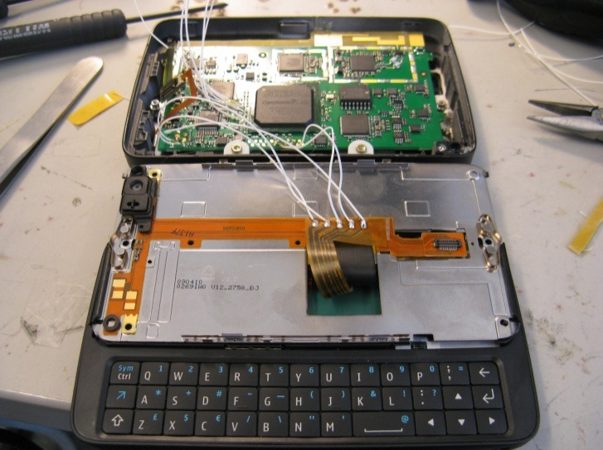
Figure 34: The spectrum sensor detector board inside N900 mobile phone.

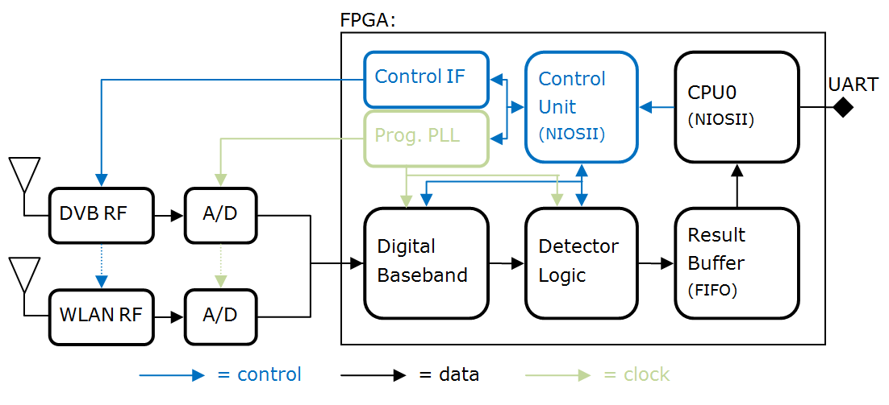
Figure 35: Blocks on the detector board.
Communication between sensor board and the mobile device is done using a universal asynchronous receiver/transmitter (UART). The data rate between the sensor board and mobile device is 1 Mbit/s.
The spectrum sensor board is located inside the display slider case of the device. A custom plastic riser, see Figure 36 was required between the display and the bottom of the case to allow sufficient space for the board. Sensor board is located just behind of the display and on top of the slider mechanic. The slider mechanic is made of metal, as is the background of the display element. To ensure sufficient antenna efficiency both antennas had to be placed to the fin of the plastic riser that is outside the metal frame. It should however be noted that this is only due to the fact that the device has not been designed for spectrum sensor use.
Antenna design, especially at UHF band, is the utmost challenge in a spectrum sensor design. Best efficiency can be achieved with external antennas but for consumer devices embedded antennas have become de facto solutions. Relative bandwidths of the both antennas, UHF and WLAN, are reasonably high. Size and the location of the antennas inside the mobile device limit their efficiency and matching as well as the surrounding mechanics. Sizes of the antennas has been tried to keep as small as possible without losing performance too much. Antenna miniaturization in a mobile device scale is more problematic for an UHF antenna due to its longer electrical (and physical) length compared to a WLAN antenna.
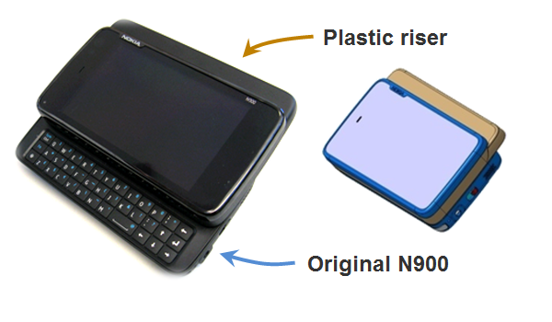
Figure 36: Spectrum sensor prototype implementation on N900 mobile phone.
    - System requirements related to spectrum sensing
Two very different kinds of target systems were addressed: DVB-T as an example of rather static TV primary system and 802.11a/g as an example of system having very dynamic traffic characteristics. Goal was to implement sensing strategy to measure both temporal and spectral characteristics of target systems. Another aspect was to measure spatial channel utilization in the field. We ended up in this phase to traditional channel numbering instead of generalized notation for cognitive radios in order to simplify control.
TV primary sensing requirement by FCC is -114 dBm sensitivity level averaged over a 6 MHz channel. This corresponds to -112.7 dBm averaged over a 8 MHz DVB-T channel. In order to measure UHF channel utilization, selected strategy is to make single detection per channel at each studied location. This requires quite low false alarm rate e.g. 1% and high probability of detection e.g. 99%. Excluding antenna losses, the sensor prototype presented in this work could reach these requirements with a sensing time of approximately 115 ms. However, for the longest detection time, i.e. 460ms, the headroom for antenna losses is only about 5dB.
In order to understand practical limitations of the platform and analyze filed test properly the prototype and its core entities were characterized both separately and as a complete system.
    - Antenna
Two antennas were implemented inside the presented mobile spectrum sensing device. For UHF frequencies a commercial antenna based on planar technology has been used. Dimensions of the antenna are 45 mm x 5 mm and it has been designed to work at frequency range from 470 to 750 MHz (DVB-H EU). Antenna for 802.11a/b/g has been realized as a wideband structure which covers frequency range from 2 to 6 GHz. It has been implemented directly to the same PCB than the spectrum sensor. It requires slightly more area than the UHF antenna (32 mm x 8 mm).
Both antennas were measured with and without the device mechanics to understand differences compared to conventional stand-alone antenna testing, and to evaluate actual performance in the field. Measurement results for the UHF antenna are presented in Figure 37 (left) and wideband antenna in Figure 37 (right). Deterioration of the efficiency of the UHF antenna due to mechanics is significant (6-8 dB) at low frequencies. The wideband antenna behaves better and its efficiency deterioration due to mechanics is only 1-2 dB over the whole band. The efficiencies of the antennas are -18-(-7)/-3/-6-(-4) dBs at UHF/2.4/5 GHz bands, respectively, depending on the specific channel. The results clearly indicate the issue of antenna performance at UHF band in small devices.
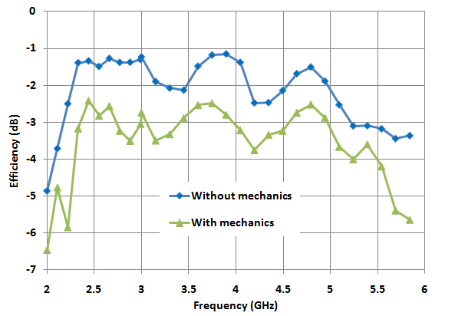
Figure 37: Efficiency of the UHF antenna (left) and for comparison the WLAN-antenna (right).
    - RF-parts
The used RF receivers are commercial RFIC and they are based on a direct-conversion architecture. Baseband filters are adjustable and they support several bandwidths used in different standards. Block diagrams of the receivers are presented in
Figure 38
. Typical noise figure (NF) of all receivers without front-end filter is around 4 dB depending on the band. Typical insertion-losses of front-end filter are 1.8 dB at UHF/2.4 GHz bands and 1.4 dB at 5 GHz band.

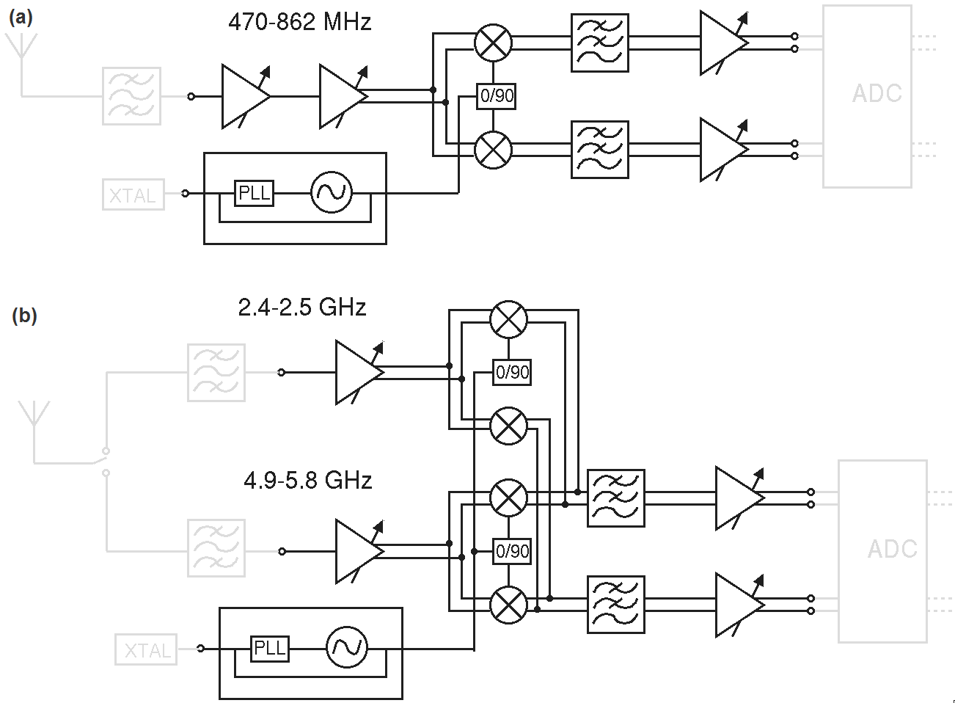

Figure 38: Block diagram of the UHF (a) and 802.11 a/b/g (b) receiver.
    - Detector
Detector core on the FPGA is developed from the FFT-based cyclostationary feature detector formerly presented by the authors in [1]. The structure of the detector is shown in Figure 39. The fixed-size-FFT implementation utilizes decimation after autocorrelation to control the detection time. Test for the presence of cyclostationary at given cyclic frequency (α) is performed from the FFT of the decimated autocorrelation signal.
Figure 39: Structure of the implemented cyclostationary feature detector.
In this implementation, the range of selectable decimation ratios is extended up to M=2048 to support longer detection times. Similarly, the maximum autocorrelation delay (τmax) is increased to 8192. The modifications were required to enable detection of very long OFDM symbols used in DVB-T signals. The detector implementation utilizes 16k logic elements, 406k memory bits and 84 9-bit multiplier elements. The figures are 10.2%, 13.7% and 14.6% of all available resources on the FPGA, accordingly.
Detector sensitivity was measured for a WLAN signal at 2.4 GHz ISM band and for a DVB-T signal at the UHF band. Parameters related to modulation, signal bandwidth and transmit frequency of both systems are summarized in Table 15. During the measurements, the antennas were bypassed and the signal generator was connected directly to the RF receiver inputs, therefore the results exclude any antenna effects. The RF receivers operate at maximum gain. Detection times for WLAN and DVB-T were set to 0.8 ms and 460ms, accordingly. False alarm rate is 5%.
Table 15: Specifications of the primary signals used in detector performance measurements.
 | WLAN | DVB-T
Modulation: | OFDM | OFDM
FFT-size (N_{FFT}) | 64 | 8192
Length of cyclic prefix (N_{CP}) | 16 | 1024
No. of non-zero subcarriers | 52 | 6817
Subcarrier modulation | 16-QAM | 16-QAM
Transmit frequency | 2437 MHz | 670 MHz
Bandwidth | 20 MHz | 8 MHz

The measured sensitivities are presented in Figure 40 (left) for DVB-T and in Figure 40 (right) for WLAN signal. DVB-T detection reaches 95% probability of detection when the received power is about -117 dBm, while for the WLAN detection received power of -102 dBm is required. Both figures are below the thermal noise floor. Figure 40 also show ideal simulation results for the same signals. The differences between simulated and measured probability of detections almost entirely match and are accounted by the non-zero noise figures of the RF receivers. The primary reason that DVB-T detection outperforms WLAN detection by such a large margin is the longer detection time that can be utilized in DVB-T detection. WLAN detection time is limited on the other hand by implementation, where larger FFT would be required to keep the cyclic frequency under the Nyquist frequency for larger decimation ratios, and on the other hand by duration of WLAN signal bursts which is already on the same scale with the detection time.
Figure 40: Measured DVB-T (left) and WLAN (right) probability of detection compared to simulated performance. Simulation utilizes ideal receiver (NF=0dB).
    - Platform Performance
Overall performance for the spectrum sensor hardware has been determined in the laboratory measurements. A 5 dB NF for UHF receiver path was measured at 660 MHz and it is only 1 dB more than NF of the pure UHF receiver. For dual-band 802.11a/b/g receiver, 5 dB and 6.5 dB NF at 2.427 and 5.130 GHz were measured, respectively. IIP3 of –10 dBm, -1 dBm and -1 dBm were measured for UHF, 2.4 and 5 GHz bands, respectively.
When combined with antenna results the overall sensitivity of the signal detection for DVB-T signals at UHF band will be from –100 to –108 dBm depending on the channel of interest. This is significantly higher than FCC requirements but shows feasible values for small devices if the integration time of the detection is kept reasonable. IIP3 of the UHF receiver with antenna corresponds 8 - (-3) dBm compared to 0 dB antenna in the field tests, At some channels platform noise caused by processors and other noisy components in the device will further deteriorate the performance. However, those could be mostly avoided with proper design when UHF band requirements will be taken into account initially in the design of the device and its mechanics. For WLAN OFDM signal detection, the sensitivities using parameters given earlier in this paper will be –101 and –98 dBm (2.4 /5 GHz) including the antenna.
  - Field measurements
Two sets of field tests were carried out in capital area in Finland. First measurement set was done mostly outdoors in urban Ruoholahti area in Helsinki. Two sensors were used, both using internal antennas. The measurement set consists of spectral samples from 37 different locations, shown in Figure 41. One spectral sample includes detection time, GPS location, band, channel, received signal strength in dBm and DVB-T detection statistics from UHF channels 34 to 60 (578 – 784 MHz). Detection time was set to 460 ms and detection statistics positive detection threshold to produce constant false alarm rate of 1%. Measured signal strengths are shown in Figure 42. Corresponding estimated probabilities of DVB-T detections on different channels are shown in Figure 43. There is DVB-H repeater in the area, detected on channel 35. Espoo TV transmitter station is transmitting on channels 32, 35, 44, 46, and 53.
Table 16: DVB-T transmitter parameters.
DVB-T transmitters | Espoo | Tallinn
Latitude: | 60.1778 | 59.4713
Lognitude: | 24.6403 | 24.8875
Mast heigth: | 313 m | 272 m
Transmission power: | 47 dBm | 42 dBm
Occupied channels | 32, 35, 44, 46, 53 | 45, 59, 64

TV transmissions on measurement range are detected with high probability. Channel 59 is occupied by Tallinn TV transmitter on average 78 km away. Open source Splat! [2] radio propagation calculation tool, using Longley-Rice Irregular Terrain Model [3] and NASA SRTM-3 Version 2 Elevation Models [4], was used for field strength estimation. Used transmitter parameters are shown in Table 16, receiver was assumed to be 3m above sea surface. Estimated field strength, shown in Figure 44 in Ruoholahti area is 20-60 dBµV/m. Field strength has large variation within 1 km radius in urban area. With measured prototype antenna efficiency of -7.5 dB, it corresponds -123 – (-83) dBm signal input power at the receiver. Taking measured detector sensitivity into account we end up 0.6 to 1 detection probability of Tallinn TV transmitter in Ruoholahti, Helsinki. Tallinn transmission on channel 45, adjacent to much stronger Espoo TV transmitter on channel 44 and 46, is masked and it cannot be detected. One must remember that transmissions from Tallinn are out of the reach for typical TV reception setups in Helsinki households.

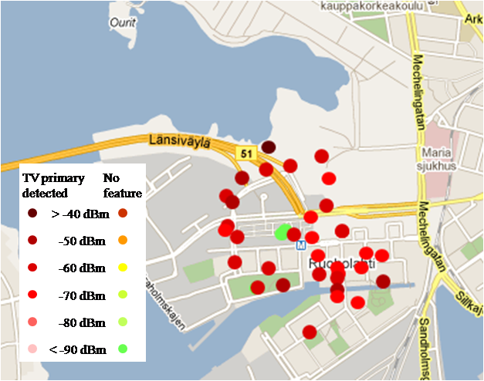
Figure 41: Measurements results on UHF channel 44 (658 MHz) in Ruoholahti, Helsinki.

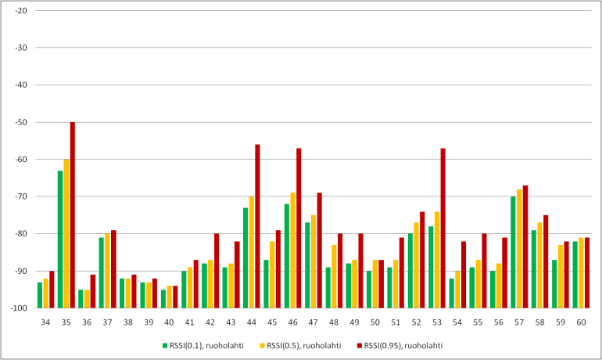

Figure 42: Received signal strength (RSSI[dBm]) upper limit for 10%, 50% and 95% of measured samples in Ruoholahti.

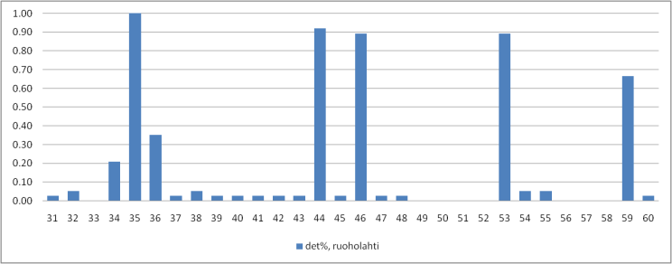
Figure 43: Measured probability of DVB-T detection, n = 37 per UHF channel, average distance to Espoo transmitter 15 km and 78 km to Tallinn transmitter.
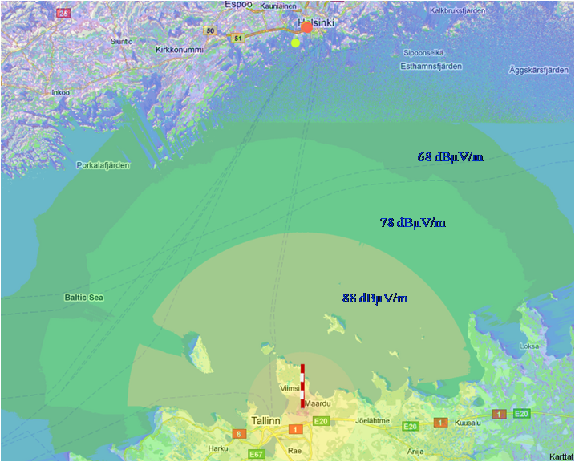

Figure 44: Simulated field strengths on UHF channel 59 (778 MHz) from Tallinn TV tower, distance to Helsinki 77 km.
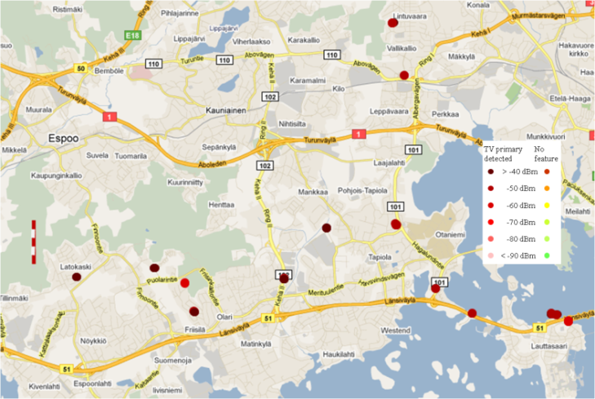
Figure 45: Results on UHF channel 44 (658 MHz) in Espoo, average distance to Espoo TV tower is 8 km.
Second set was measured outdoors in suburban Espoo and target was to evaluate performance of the spectrum sensor in the vicinity of strong TV transmitter. Measurements were done using two sensors one with internal antenna and another with external reference dipole. Measurement locations and results for occupied channel 44 (658 MHz) are shown in Figure 45. Measured signal power on occupied channels was from -65 dBm up to -32 dBm, when using external reference dipole, as shown in Figure 46. The RSSI[dBm] limits tell how many percent of measurement samples have smaller RSSI value than presented. Basically this presents values of observed cumulative distribution function with 10%, 50% and 95% probabilities. TV signal strength is from 10 to 30 dB more than in the Helsinki measurement set. Main difference between results measured using internal and external antennas is that antenna efficiency of internal antenna is on average 7.5 dB lower than external reference dipole. Results using internal antenna are shown in Figure 47. Difference in antenna efficiency means additional noise figure of 7.5 dB, which decreases sensitivity and increases linearity of receiver. In addition there is also device induced noise in internal antenna measurements.
Figure 48 shows the detection results over all channels with external and internal antennas. The antenna performance difference is very clear. Overall it can be seen that a high number of false detections happen due to the IM-products. There is also clear tradeoff between sensitivity and linearity. This is evident with the lower false alarm rate of the internal (lower gain, less signal power) antenna.

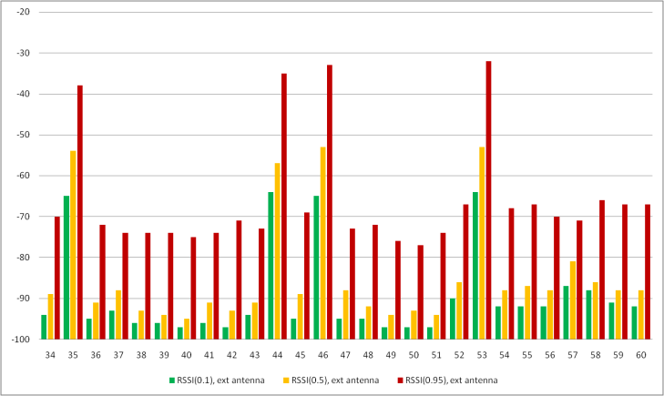
Figure 46: Received signal strength (RSSI[dBm]) with external antenna, upper limit for 10%, 50% and 95% of measured samples in Espoo.
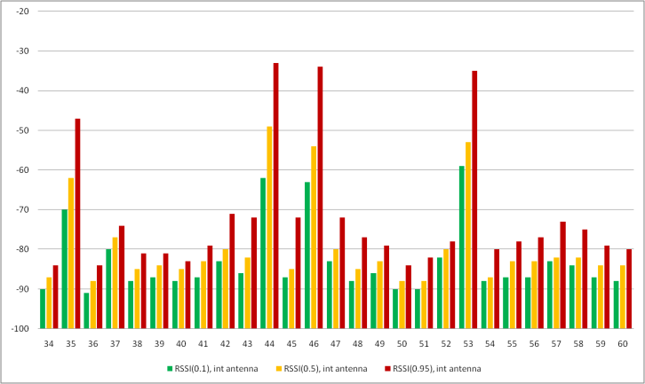
Figure 47: Received signal strength (RSSI[dBm]) with internal antenna, upper limit for 10%, 50% and 95% of measured samples in Espoo.
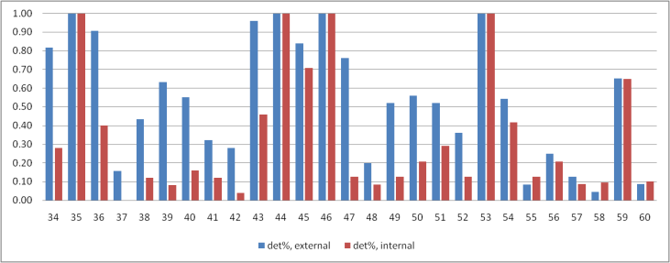
Figure 48: Measured probability of DVB detection, number of detections is 26 per channel, average distance to Espoo transmitter 9km and 78 km to Tallinn transmitter.

- PMSE protection measurements in helsinki city theatre
PMSE is an important topic in Finland currently as the devices have been operating in the 800 MHz band in past and now it has been decided that the band 792-862 MHz will be used for mobile application with LTE. Therefore all the PMSE-devices will have to be moved to the lower UHF-band covering 470-792 MHz. The basic idea in the campaign was to use a few devices operating in the new lower band around 600 MHz and install them in a real environment where the PMSE-equipment is usually deployed and then try to cause interference to them by a simulated WSD operating in the same or adjacent frequency. The WSD was then be moved to different locations inside and outside the test building and power level was be adjusted to cause interference. Some qualitative spectrum measurements were also performed at the WSD-locations to get an understanding how feasible sensing of the microphones would be.
A summary of the measurement campaign is given in this Annex.
  - Locations
Two theatres in Helsinki were used for the measurement campaign. The Helsinki City Theatre, located in Kallio, is the biggest theatre in Helsinki. The main building has been built in the 1960’s and is traditional concrete/steel construction. It has two stages, a big one with 947 seats and a smaller one with 400 seats. The Arena Theatre is a smaller 515 seat theatre nearby the main theatre. Arena is located in a larger brick building, which has been built in 1923. Figures of the theatres can be found in the measurement report.
  - Microphones
Two sets of analogue microphones were used in the measurements, altogether four microphones and two receivers. The purpose was to use microphones in real conditions and therefore the receivers were placed a realistic places in the theatres. In the main stage the receiver was placed in the centre of a light balcony above the audience. In the Arena theatre the receivers were placed on the balcony as well and close to the existing antennas. In both classes the microphone to receiver link was somewhat more demanding than with the existing installations. The microphone receivers were using small whip antennas attached directly to the receivers.
During the measurements it was found out that there is a big difference in the results depending how the microphones are used. The worst, but also realistic, case being the belt pack microphone attached to a person and the person moving in the stage. Therefore to get most realistic scenarios the microphones were attached to people and they were moving in the stage simulating the actors, even sometimes going behind the sets used for the plays.
  - WSD signals and measurement principle
The WSD signal was simulated with a constant OFDM-signal from a Pro Television PT5780 DVB-T signal generator and boosted with a power amplifier. This set up was chosen because we were interested especially in the uplink part. Also the signal bandwidth was 7.6 MHz filling the whole channel and covering all the microphone signals at once. WSD-signal generation principle is shown in Figure 49.
Figure 49: Block diagram of the WSD-signal generation
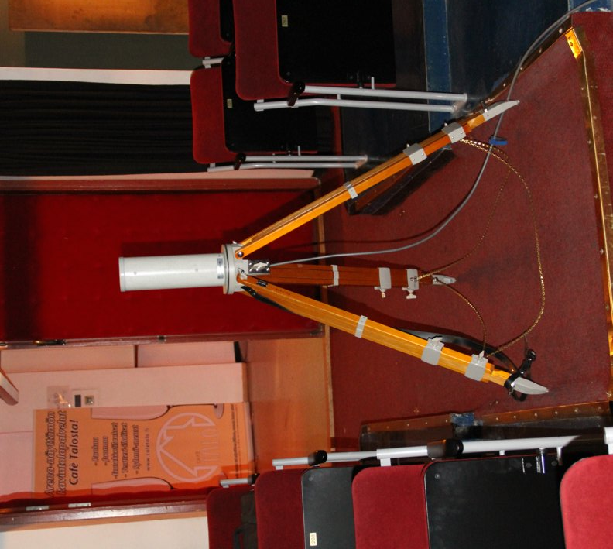
The measurements were done so that the WSD-power was increased until interference was heard in any of the used microphones, then the power level was decreased until no interference was observed and the attenuator reading was taken. Typical measurement situation is shown in Figure 50, where people can be seen on the stage with the microphones and other people observing the microphone receivers.

Figure 50: Typical measurement situation in the Arena theatre
Co-channel and adjacent channel cases were measured and location of the WSD interferer was varied both inside and outside of the theatres.
  - Spectrum measurements
To get better understanding of the microphone signals in a big theatre a spectrum measurement was done with the existing 800 MHz microphones during a musical where a large number of actors were performing simultaneously. Altogether 38 microphone channels were in use.
As can be seen the signals are not uniformly spread, but are in groups and even within the group not uniformly spaced. This is due to the performance optimization by minimizing the IM-products and internal interference. Typically the microphone signals are between -50 and -60 dBm when the players were at stage well placed, but dropping when moving out from the stage. Approximately 80 MHz of spectrum is used although not continuously.
Figure 51: Spectrum measurement during the performance. Span is from 780 - 870 MHz.
  - Summary of the results
The results of the measurement in the Arena theatre are summarised in Table 17.
Table 17: Summary of the results in the Arena theatre

Location of the measurement spots in the Arena theatre are shown in Figure 52.
Figure 52: Side and plan views of the Arena theatre and measurement spots
Summary of the results from the main theatre is shown in Table 18 and the location of the measurement spots is shown in Figure 53.
Table 18: Summary of the results in the main theatre

Figure 53: Measurement spots outside the main theatre

Figure 54: WSD interference and microphone spectrum at the microphone receivers
In both locations path losses between the WSD and microphone receiver were measured. In the Arena theatre this was done directly and in the main theatre based on the WSD Tx EIRP values and the power levels measured using R&S FSH spectrum analyser and biconical antenna close by the microphone receivers. An example of such a measurement is shown in Figure 54. Results are shown the respective places in Table 17 and Table 18.
During the measurements the microphone signals were monitored using the WSD antenna and spectrum analyser to get an understanding how difficult it would be to sense the microphones. In all locations the microphones were clearly visible in the spectrum.

- case studies on white space spectrum availability
  - Bavaria
[tbd by IRT]
  - UK (from Doc. 93)
    - Introduction
In the UK, UHF TV spectrum is planned as a multi frequency network (MFN) to allow regional variations across the country. Following DSO (digital switch over) six digital multiplexes will be broadcast across the 32 UHF channels retained for broadcast. In any particular region, up to 26 UHF channels, known as the “TV White Space” could potentially be made available for low power transmissions on a non-interfering basis to the primary DTT service.
The UK regulator Ofcom has stated its intentions to make the interleaved spectrum available on a licence-exempt basis to White Space Devices (WSDs). The spectrum will be available to the WSDs using geolocation databases. Proposals for the construction of this database have also been published and these follow the methodology developed in ECC 159. For this study a UK-wide database has been constructed using these rules and the resulting spectrum availability has been assessed.
The study considers the TV whitespace availability in the UK, taking into account the protection of fixed DTT reception. Preliminary assumptions regarding receiver performance have been made and the restrictions necessary to protect portable reception and PMSE assignments have not been considered.
    - Database Construction Method
The calculation is based on the detailed DTT coverage predictions made for the UK. The country is split into 100m by 100m squares, called pixels, and coverage predictions are made for each pixel. The DTT coverage is expressed in terms of location probability, which defines the percentage of locations within a given pixel that are predicted to receive a DTT service. WSD signals will always cause some interference and this will reduce the location probability.
In this study a 1% degradation in location probability has been permitted for a mobile WSD operating at 20m from a rooftop DTT antenna. This reference geometry used is that proposed in ECC159.
The UK is currently in the process of switching off analogue services and increasing the power of the DTT services. For this study, the analysis is based on the predictions for post switchover DTT coverage taking account the 1% time DTT interference from other parts of the network, including continental interference from international neighbours.
    - Database limitations
A number of simplifications have been made in the construction of the database and the following assumptions have been made.
- DTT reception on indoor antennas, including loft-mounted and portable set-top antennas, has not yet been protected.
- No allowance has yet been made for PMSE assignments.
- No margins have yet been added for interference aggregation from multiple WSDs operating in a pixel.
- Receiver saturation has not yet been modelled and low level receiver protection ratios from the Ofcom 2010 consultation have been used. WSD signals at greater frequency offsets from DTT will cause less interference. The WSD power has been capped at 30dBm, corresponding to a WSD interference level of -20dBm at the DTT receiver.
- DTT protection has been limited currently to a subset of the Digital Preferred Service Area (DPSA) layers. Typically only 1 or 2 transmitters will be protected in a given pixel.
    - Presentation of UK TV White Space Availability
White space availability can potentially support a diverse range of applications. This section describes the different approaches considered in presenting the availability of white space channels in the UK. It is useful to analyse the availability in the context of the intended application. In this study the white space availability is presented using three different approaches.
- The first approach presents the white space availability in terms of number of channels to a given percentage of the populated UK land area (considered on a pixel by pixel basis). This type of analysis may be particularly appropriate for identifying channels for rural broadband applications to support a limited numbers of users.
- For mass-market applications, e.g. supplementing WiFi spectrum for broadband connectivity, it is useful to weight the data to account for the population in a given pixel. Therefore in the second approach the availability is expressed in terms of the number of white space channels available to a given percentage of UK households.
- Finally, it is also useful to illustrate this data on a map showing how the white space availability varies with location. This is helpful to identify regions with restricted availability. The availability maps are presented as a function of WSD power.
As WSD EIRP is increased, the number of available channels can be expected to fall. For example, white space channels in the first adjacent channel to primary DTT services may become unavailable for higher power WSDs due to the finite ACS performance of the DTT receivers. Therefore in all of the above approaches the white space availability is shown for WSD EIRP levels ranging from -30dBm to +30dBm in 10dB intervals.
    - TVWS availability calculated for populated pixel area
Figure 55 presents the white space availability in the UK based on the populated pixel area. This is expressed in terms of the availability of white space channels for a given percentage of coverage pixels as a function of the WSD EIRP level.
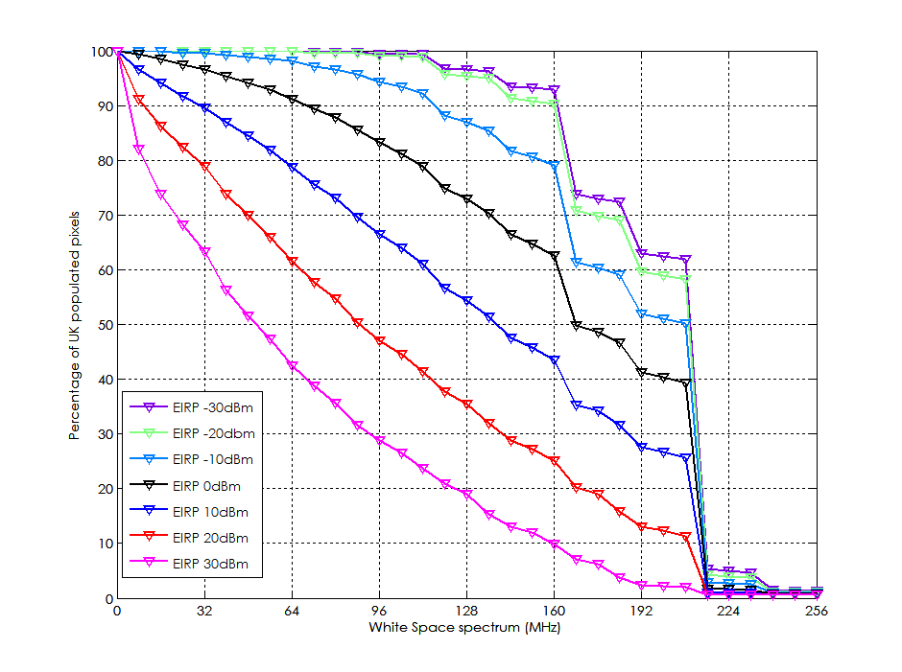
Figure 55: White space availability in the UK as a percentage of pixel area
The graph shows that, for a WSD power of 10dBm, 50% of the populated pixels have access to approximately 144MHz. of spectrum.
    - TVWS availability accounting for population density
Figure 56 presents the white space availability in the UK taking account of the population density considering the number of households per pixel. The analysis considers the populated pixels, but the data has now been weighted taking into account the number of households in each pixel. The graph thus shows the TVWS availability for a given percentage of households as a function of WSD EIRP.
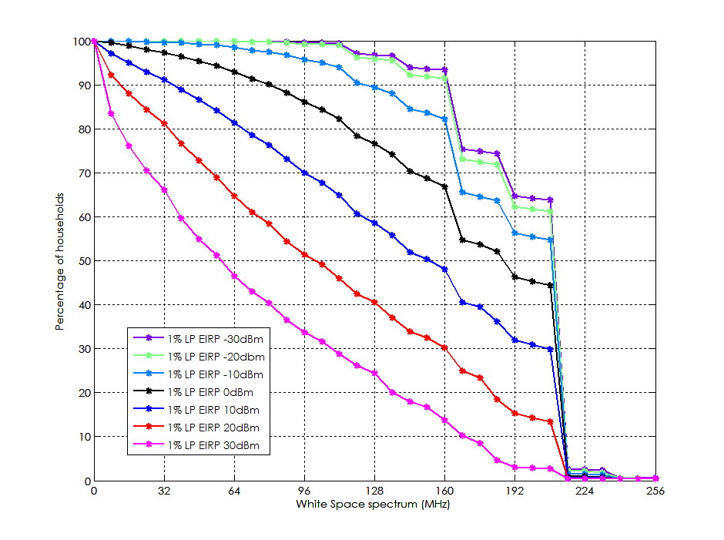
Figure 56: White space availability in the UK as a percentage of households
The graph shows that 50% of households have access to 152MHz of spectrum at a power of 10dBm. As the device EIRP is increased the amount of available spectrum decreases.
    - White Space availability maps for the UK
The maps presented in this section illustrate the white space availability for the whole of the UK. The maps are colour coded to show how the number of available white space channels varies across the UK in each region. Cooler colours (shades of blue) indicate low availability and the warmer colours denote increased availability of white space channels. The maps represent white space availability as a function of WSD EIRP level ranging from -30dBm to +30dBm in 10dB intervals.
      - White Space availability for all the pixels
The white space availability maps are generated considering the reference geometry for all the pixels in the UK. All pixels, whether populated or unpopulated, are protected for DTT coverage using the 20m-separation reference geometry for mobile WSD into fixed DTT. Figure 57: WSD EIRP of -30dBm (left side); WSD EIRP of -20dBm (right side).Figure 57 to Figure 60 (section A5.2.7.1) shows the availability maps for this scenario as a function of WSD power. As the WSD power is increased, the number of channels available decreases.

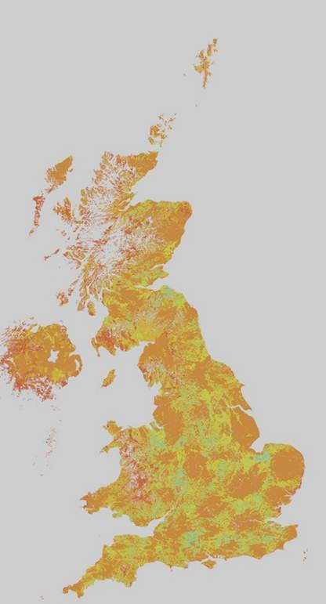 | WS channels  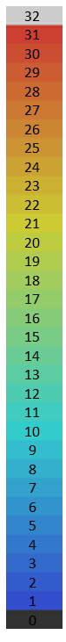 | 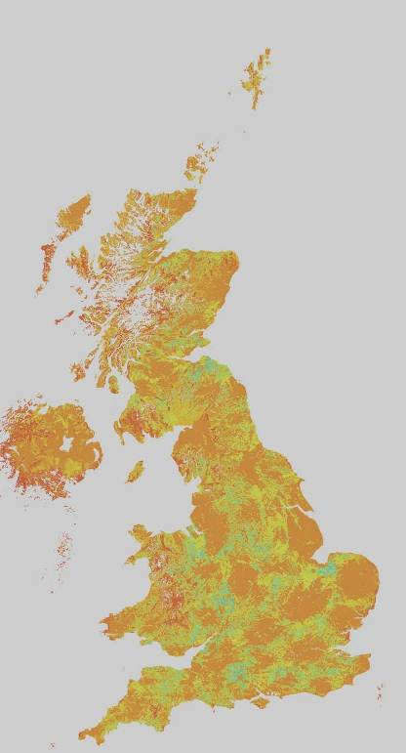
Figure 57: WSD EIRP of -30dBm (left side); WSD EIRP of -20dBm (right side).
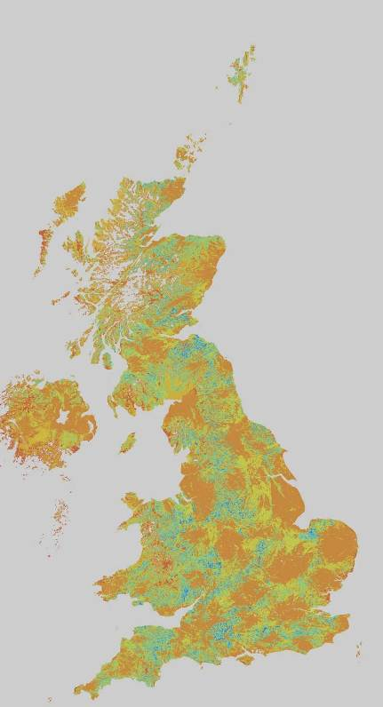 | WS channels | 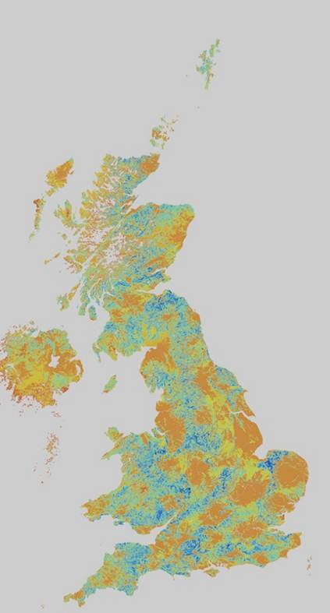

Figure 58: WSD EIRP -10dBm (left side); WSD EIRP 0dBm (right side)
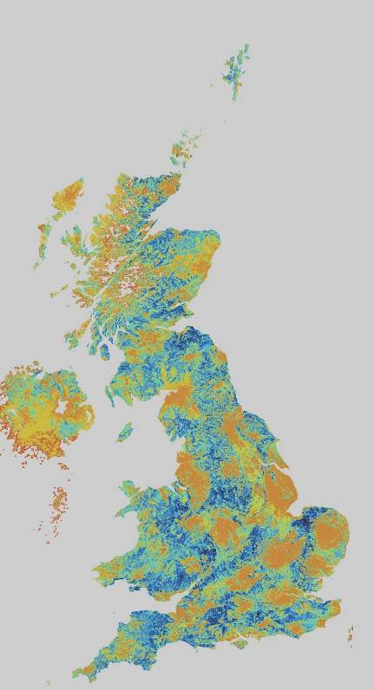 |  | WS channels | 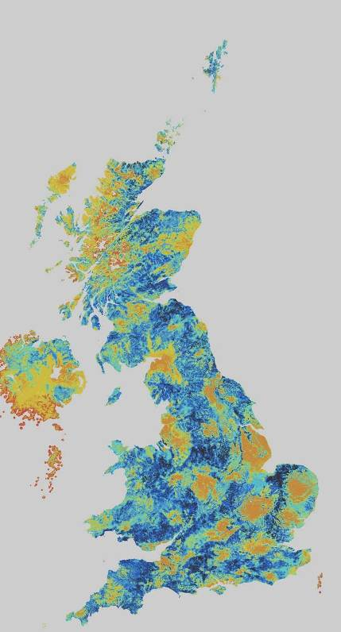
 | Figure 59: WSD EIRP 10dBm (left side); WSD EIRP 20dBm (right side)  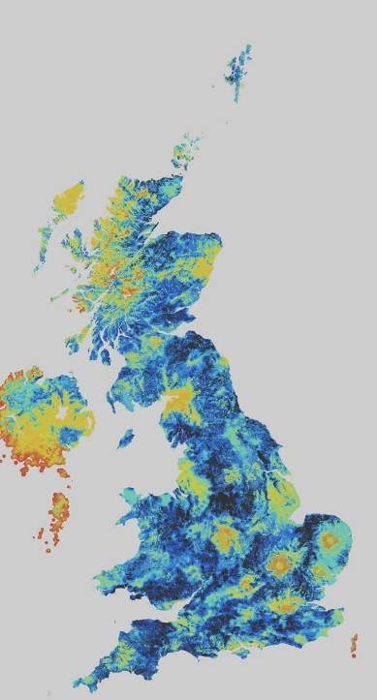 | WS channels
Figure 60: WSD EIRP 30dBm
      - White Space availability maps protecting populated pixels
The maps in this section show the TVWS availability for the case where the reference geometry is modified according to the distance to the nearest populated pixel. For populated pixels and their immediate neighbours, the 20m reference geometry is used to calculate the WSD EIRP. For unpopulated pixels, the reference geometry is relaxed from 20m to consider the distance to the nearest populated pixel. Figure 61 (section A5.2.7.2) presents the resulting availability maps for this scenario. It can be seen that this approach increases the white space availability, particularly for sparsely populated rural areas in the UK.
 |  | WS channels |  |  | 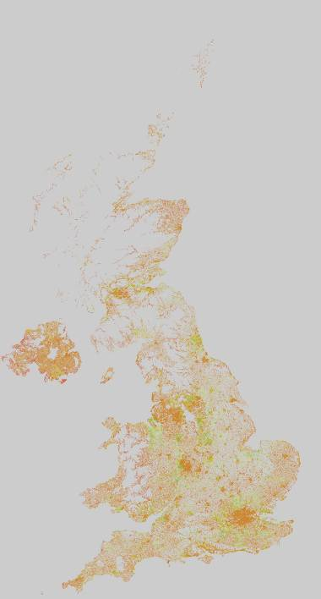
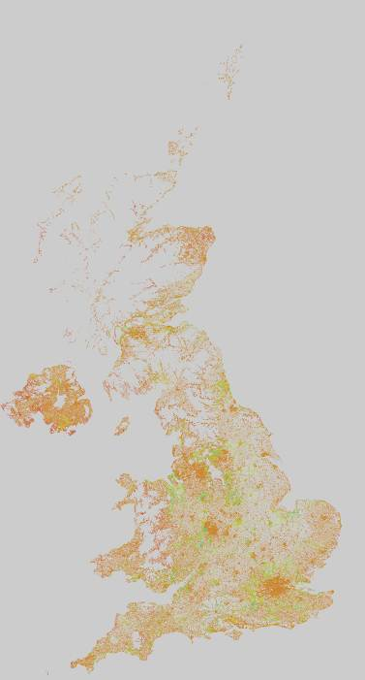 |  | WS channels |  | 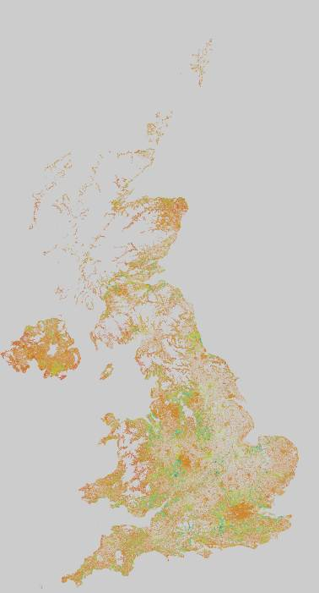
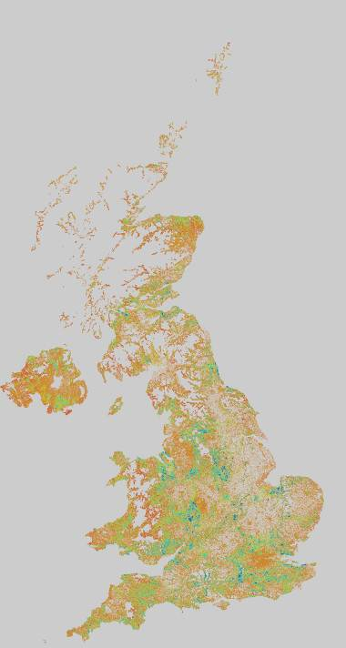 |  | WS channels | 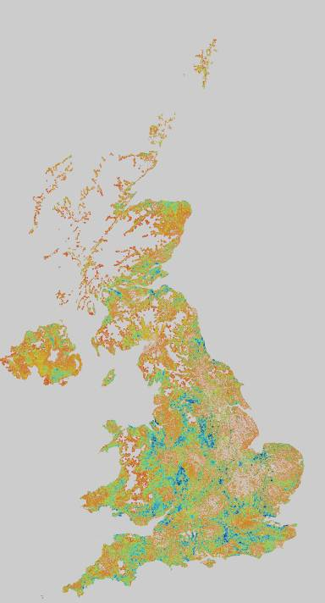
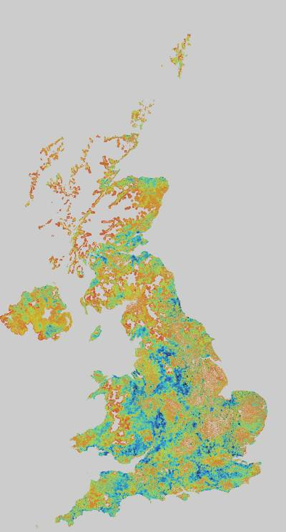 | WS channels
Figure 61: WSD EIRP of -30dBm (left side), WSD EIRP of -20dBm (right side) (fist row);
WSD EIRP of -10dBm (left side), WSD EIRP of 0dBm (right side) (second row);
WSD EIRP of 10dBm (left side), WSD EIRP of 20dBm (right side) (third row);
WSD EIRP of 30dBm (left side) (forth row).

    - Conclusions
An initial study of TV White Space in the UK based on the geolocation database approach has been presented. A geolocation database has been constructed by deriving the maximum permitted power levels for WSDs in a given specific location. The database has been analysed to illustrate the resulting availability. The EIRP calculations for the database follow the methodology described in Ofcom’s ‘Implementing Geolocation’ consultation document.

The TVWS availability varies with the WSD device power. Availability is significantly reduced at higher device powers, particularly in populated areas and in the vicinity of over-lapping coverage areas between the DTT transmitters. Relaxing the reference geometry in unpopulated pixels can increase the white space availability. An approach has been developed where the 20m separation used in the reference geometry is replaced by the distance between the candidate WSD pixel and the nearest populated pixel, This could enable higher power applications such as rural base stations in remote areas and on the edges of populated areas.
    - References
- Implementing Geolocation, Ofcom Consultation Document published 9th November 2010, http://stakeholders.ofcom.org.uk/binaries/consultations/geolocation/summary/geolocation.pdf
- ECC 159, http://www.erodocdb.dk/docs/doc98/official/Pdf/ECCRep159.pdf
  - Poland (from WD2)
Polish studies National Institute of Telecommunications Poland presented alternative methodology of White Space Spectrum assessment which can be considered for usage in some countries especially where high interferences levels coming from other broadcasting stations exists. Such methodology is not based on protection of minimum medial field strength for the planning but instead it is based on protection of interference-limited DTT coverage areas and respective higher values of required median field strength. Using such methodology it is possible to obtain a valuable number of available White Space Spectrum TV channels, while ensuring adequate protection of DTT coverage areas in the frequency range 470 – 790 MHz. Below it is shown background of the methodology and example result.
    - Current DTT situation example
In many European countries DTT stations coverage areas are limited mainly due to interferences coming from other DTT stations. Figure 62 shows an example of real DVB-T station coverage area which is limited due to interferences coming from other DTT stations.
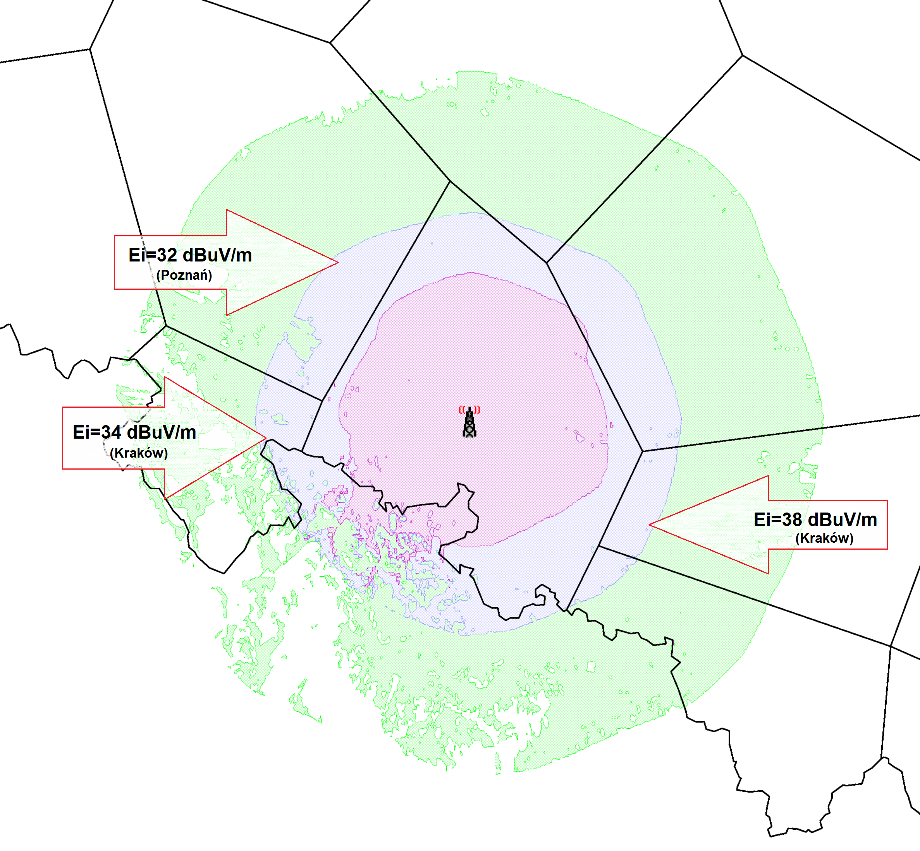
Figure 62: Example of coverage area of DTT station (Opole, ch. 23).
- interferences levels from other Poland DTT stations
Violet – interference limited coverage (~ 60 – 65 dBµV/m)
Blue – noise limited coverage (Emin ~ 56 dBµV/m)
Green – calculated from ECC Report 159 WSD protected area (for 30 m 36 dBm)
Ei – existing interferences from other DTT stations
In such cases it can be noticed that current existing interferences levels are much higher then these allowed for new WSD based on values presented in the ERC Report 159 and that coverage area of DTT station is limited due to interferences coming from other broadcasting stations as well as required field strength for proper reception is higher than minimum median field strength for the planning.
    - The methodology for White Space calculations in the TV bands
The methodology for the protection of DTT in such cases assumes calculation of coverage’s areas (interferences limited) to be protected taking into account characteristic of broadcasting receiving antennas.
The main assumptions of the methodology are as follows:
- values of the median field strength to be protected are calculated in every point in accordance with the current existing interference situation i.e. taking into account cumulative effect of interferences from other broadcasting stations,
- coverage areas to be protected are defined by calculation of interference limited areas,
- maximum permissible nuisance field strength from WSD is 10-20 dB lower (exact value to be decided by Administration) then existing power sum of nuisance field strengths coming from other broadcasting stations,
- WSD transmission on adjacent channels (N+1, N-1) is not allowed in the coverage area of channel N to be protected,
- in overlapping areas where the same TV multiplex can be received from two or more TV stations it can be decided to protect only one coverage area.
    - Example results of the analysis
Example result of the analysis is show in Figure 63 and includes calculating availability of WSD TV channels in the UHF band in Poland for CPE fixed type WSD: 10 m a.g.l. with ERP 30 dBm.
Calculations availability of all TV channels (21-60) on Polish territory were checked in around 600,000 points, which means approx. raster 1km x 1km with DEM/DTM.
CPE fixed type: 10 m a.g.l. with ERP 30 dBm - real DVB-T reception.
Methodology presented here, based on existing interference levels in TV bands, results in more TV channels availability assuring protection of realistic interference limited DTT coverage areas. Based on such methodology it can be expected an average around 10-15 channels available in a country depending on local conditions (from 0 to 30 channels) giving also protection for adjacent DTT channels (n+1, n-1).

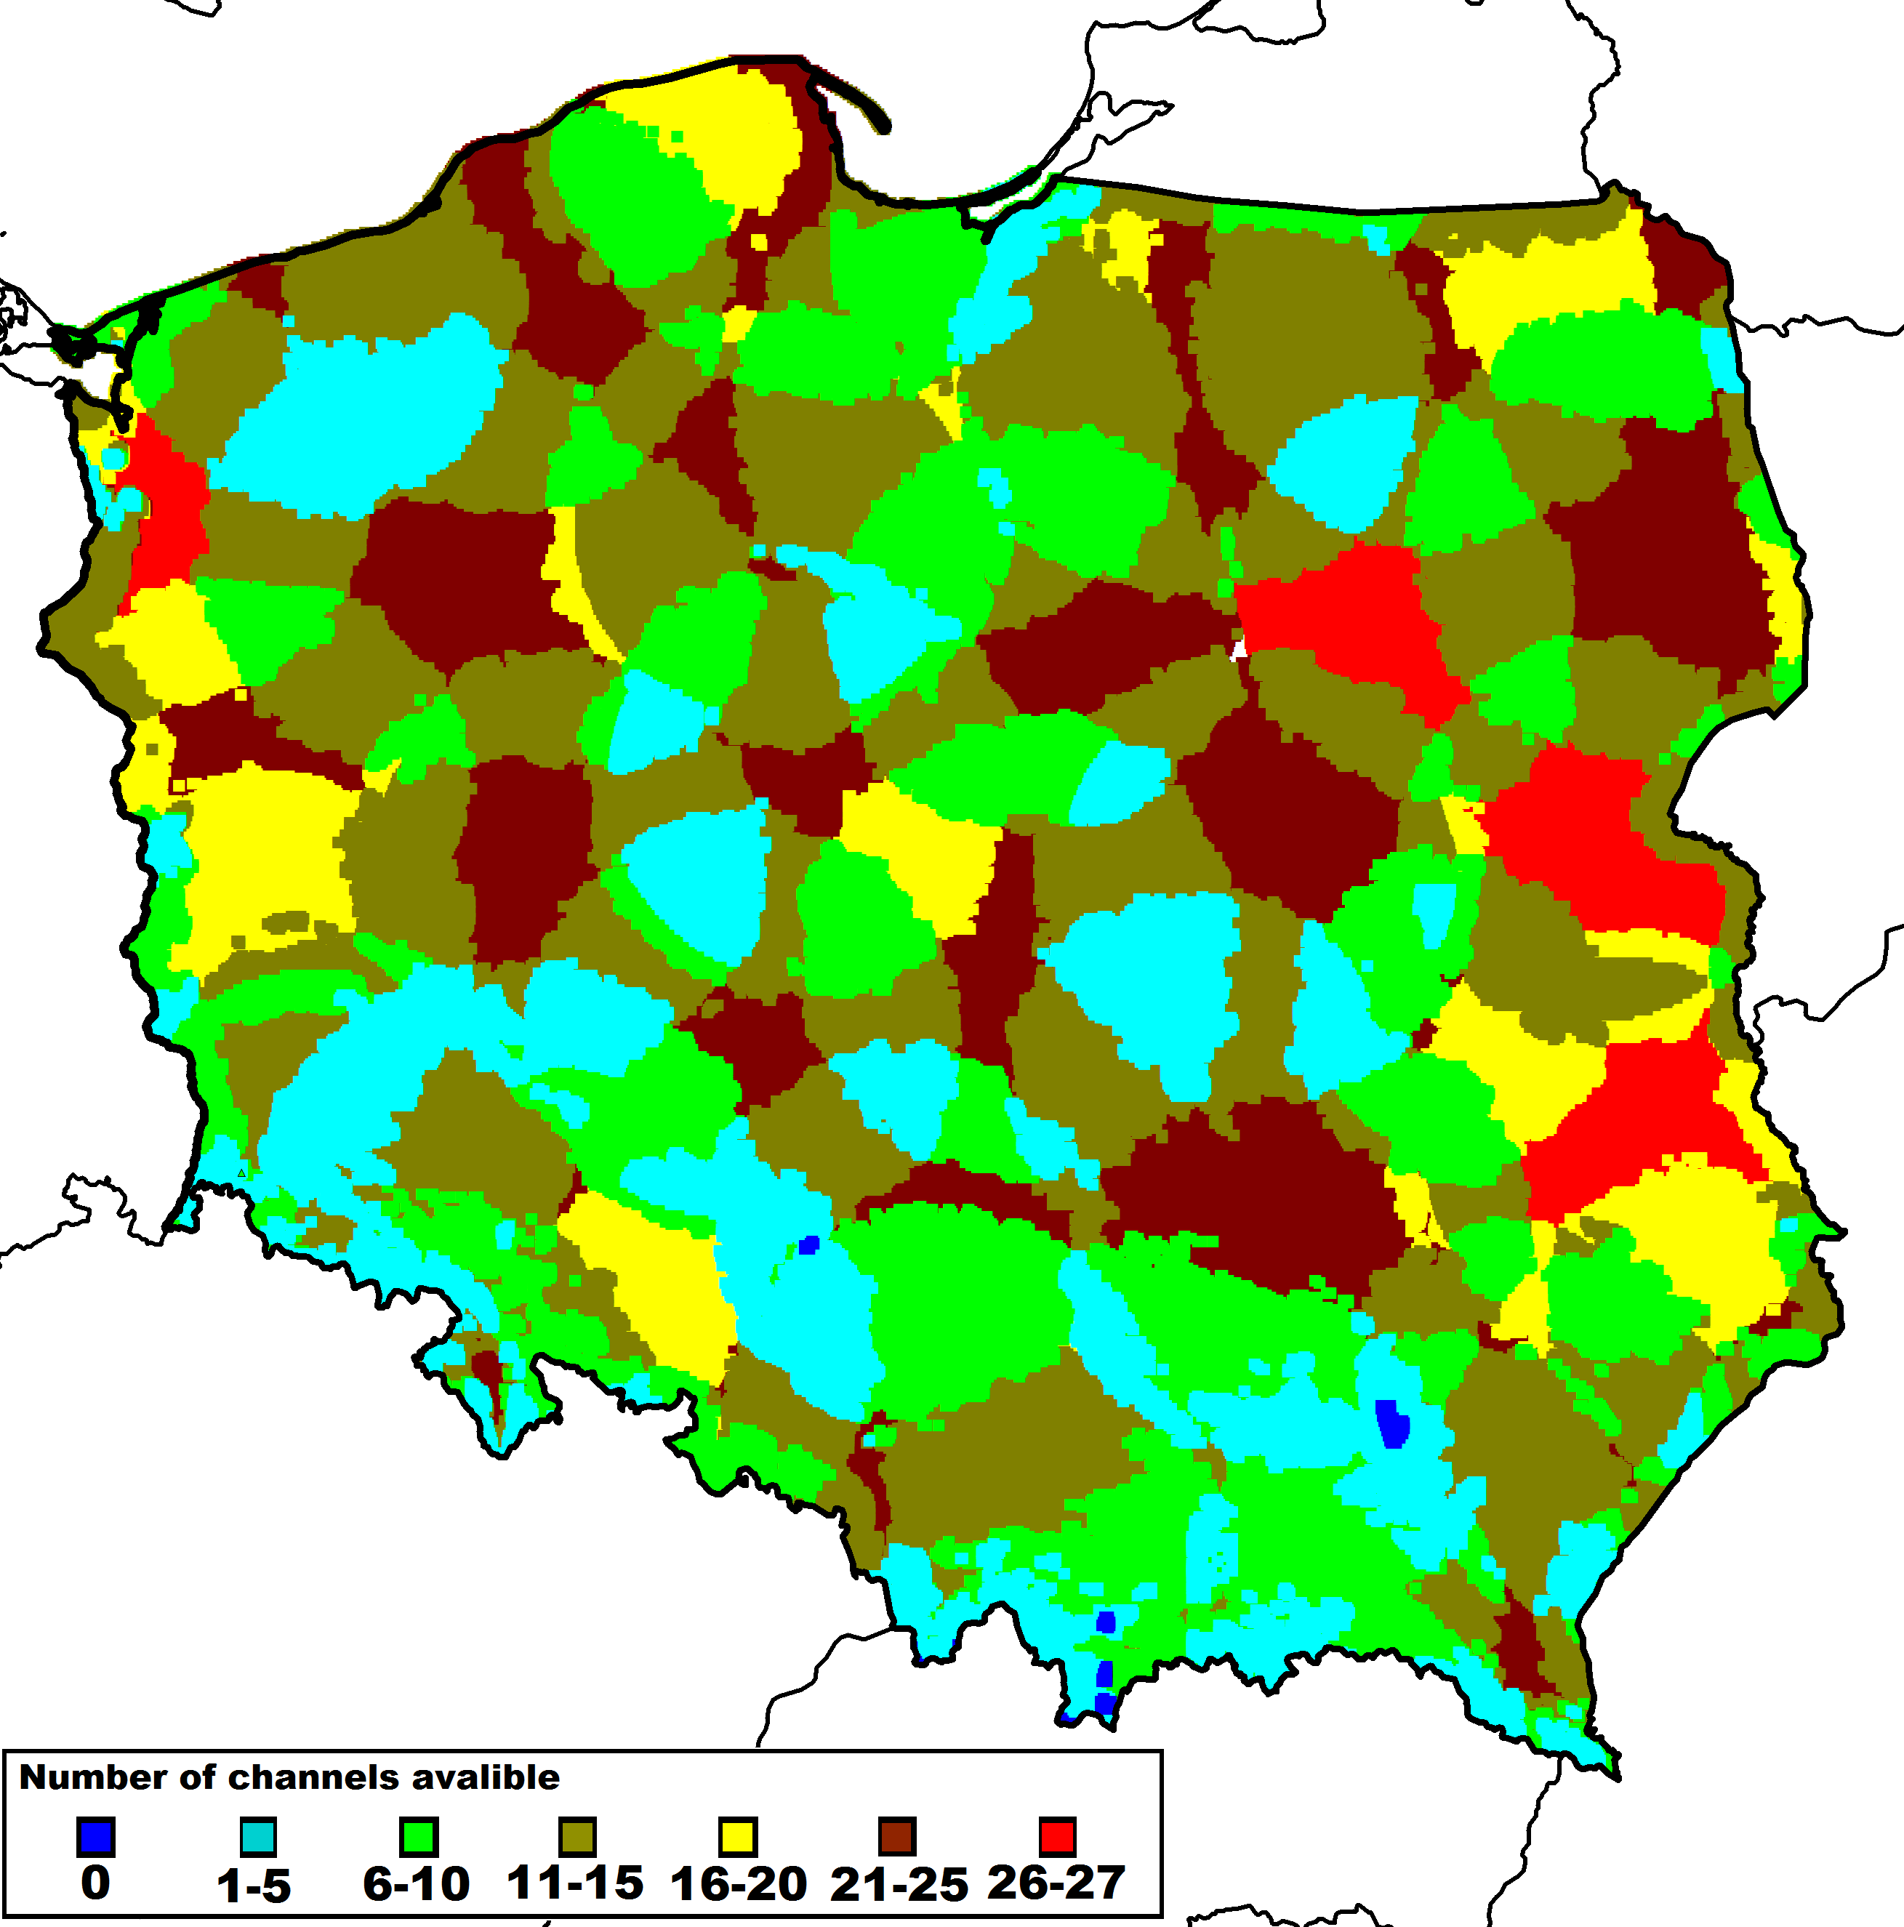
Figure 63: Result of the analysis – WSD availability in Poland:

- Calculations with SEAMCAT on interference assessment
[Ed. Note: This annex is not referenced in the main body of the report]
  - Introduction
The purposes of these analyses are:
- to define the concept of ‘degradation of location probability’, Δ_{LP};
- to coordinate the basis of work, involving Δ_{LP}, being carried out within SE43 and in particular to describe/define the calculation methodology for the relevant studies;
- to carry out relevant (independent) technical studies (for SE43) and to provide results which can be compared with similar studies using the same calculation methodology.
- to set the framework for future SE43 calculations and studies
For sake of verification, the EBU TECHNICAL was asked to make calculations with a given set of parameters and the results were compared with the output of SEAMCAT using the same parameters, as shown in the tables throughout the document.
  - Definitions
Pixel
A ‘pixel’ is a small area, about [50 m x 50 m] to [100m x 100m], within which DTT reception quality is to be evaluated. Reception quality, ‘acceptable’ or ‘unacceptable’, is calculated/measured at a large number of sites/points within the pixel,
Location Probability
The location Probability, LP, is the ratio of the number of sites/points/events within the pixel where an acceptable/agreed DTT reception quality is achieved to the total number of sites/points where calculations/measurements are carried out. It is emphasized that LP is a local parameter, pertaining to, and evaluated within, areas of the size of a pixel.
‘Degradation of Location Probability’
LP evaluated in a given interference situation will change when an additional interference (or set of interferences) is introduced. In particular, the LP will be reduced as additional interference is introduced. For example, if LP_{b} is the LP in the original, given situation and LP_{a} is the LP after the additional interference is introduced, the degradation in LP, Δ_{LP}, is defined as:
Δ_{LP} = LP_{b} – LP_{a}.
Example of Monte Carlo simulation (e.g. SEAMCAT).
Events are treated within a pixel. For each event, the wanted DTT power, P_{w}, is calculated at a (randomly chosen) point, as well as the equivalent noise power, N, the interfering WSD power, P_{i}. The noise nuisance field is defined as N´ = N + C/N and the nuisance power is defined as P_{i}´= P_{i} + PR. The total nuisance field is defined as the power sum of P_{i}´ and N´, N´ ⊕ P_{i}´. The point is covered if
Pw ≥ N´, in the presence of noise only
Pw ≥ N´ ⊕ Pi´(power sum), in the presence of noise and the interferer.
The location probability is the ratio of the number of trials where
Pw ≥ N´ (yielding the location probability ‘before’, LPb), and
Pw ≥ N´ ⊕ Pi´ (yielding the location probability ‘after’, LPa),
respectively, to the total number of trials.

Interference Probability
Interference Probability, IP, is the ratio of the number of sites/points/events within an area (of any size) where an acceptable/agreed DTT reception quality is not achieved (due to noise, interference, etc) to the total number of sites/points where calculations/measurements are carried out within that area.
It is to be emphasized that IP is not necessarily a local parameter, and in particular may not necessarily be evaluated within areas the size of a pixel. Furthermore LP and IP have a meaningful relationship only when both are calculated within the context of a pixel.
‘Degradation of Interference Probability’
IP evaluated in a given interference situation will change when an additional interference (or set of interferences) is introduced. In particular, the IP will be increased as additional interference is introduced. For example, if IP_{b} is the IP in the original, given situation and IP_{a} is the IP after the additional interference is introduced, then the degradation in IP, Δ_{IP}, is defined as:
Δ_{IP} = IP_{a} – IP_{b}.
Example of Monte Carlo simulation (e.g. SEAMCAT)
Events are treated within a pixel. For each event, the wanted DTT power, P_{w}, is calculated at a (randomly chosen) point, as well as the equivalent noise power, N, the interfering WSD power, P_{i}, and the power sum of the nuisance fields P_{i}´ and N´, N´ ⊕ P_{i}´. The point is interfered with if
Pw < N´, in the presence of noise only
Pw < N´ ⊕ Pi´(power sum), in the presence of noise and the interferer.
The interference probability, IP, is the ratio of the number of trials where
Pw < N´ (yielding the interference probability ‘before’, IPb), and
Pw < N´ ⊕ Pi´ (yielding the interference probability ‘after’, IPa),
respectively, to the total number of trials.

Relationship between Interference Probability and Location Probability (IP vs. LP)
In compatibility calculations, SEAMCAT calculates the IP in particular situations.
In compatibility calculations, broadcasters calculate the LP in particular situations.
It is seen in the 2 examples above, involving Monte Carlo simulation, that the calculation of LP and the calculation of IP are very similar, and in fact that LP = 100 – IP, expressed in percent.
In order for IP and LP calculations to be comparable, the areas where the respective calculations are carried out must be the same. This means that the area considered in SEAMCAT calculations must be restricted to areas the size of a pixel. LP calculations for areas significantly larger than a pixel have no meaning or relevance.
GOLDEN RULE: LP and IP calculations are to be carried out only for areas the size of a pixel (or smaller)
When IP and LP calculations are to be compared, the relationship between the two parameters must be kept in mind:
LP(%) = 100 – IP(%)

Just as the LP can be calculated before (LP_{b}) and after (LP_{a}) the introduction of additional interference, so can the IP, yielding IP_{b} and IP_{a}. Just as the LP decreases (‘degrades’) with additional interference, the IP increases (‘degrades’) with additional interference. Then the degradation in location probability Δ_{LP} = LP_{b} – LP_{a} corresponds to the degradation in interference probability Δ_{IP} = IP_{a} – IP_{b}. Expressed this way, both quantities are positive and equal.
Note that the calculation to determine LP_{b} (and IP_{b}) and LP_{a} (and IP_{a}) should be carried out in common Monte Carlo simulations.
  - Description of the set-up for the first task
    - Assumptions used in calculations
Broadcast pixel: 100 m x 100 m
Frequency: 600 MHz
Environment: rural
WSD antenna height: 10.1 m
DTT receive antenna height: 10 m
DTT receiver antenna gain: 0 dBi
Propagation model: JTG 5-6

Equivalence between loss L (dB) and field strength E (dBμV/m) for 1 kW erp:
L = 139.3 + 20 log f(MHz) – E = 194.863 – E

Relationship between field strength and received power:
Pr dBm = E dBμV/m - 20 log f MHz - 77.2 = E – 132.76
    - Protection requirements of DTT
(C/N) = 20 dB required C/N
PRco = 20 dB protection ratio
Pmed = -77.1 dBm ≡ 55.663 dBμV/m: median receive power/field strength (median received power was used only for the task 1 and task 2)
Initial Location Probability (LP): 95%
μ = 1.645, σ = 5.5 dB statistics
Pmin = Pmed - μσ = -86.148 dBm ≡ 46.615 dBμV/m minimum receive power/field strength
N = Pmin – (C/N) = -106.148 dBm ≡ 26.615 dBμV/m equivalent noise power/field strength

Interference distance to be considered and corresponding propagation loss:
1 km: loss = 102.044 dB (102.05 dB in SEAMCAT); 13 km: loss = 145.011 dB (145.01 dB in SEAMCAT);

    - Methodology
The LP within a pixel at the DTT coverage edge, in the presence of noise only, is LPb = 95%.
The interferer’s e.i.r.p is to be determined at each distance (1 km and 13 km) such that, in the presence of noise and the interference, the resulting LPa is either 94.9% or 94.5% or 94% (i.e., the degradation in LP is 0.1% or 0.5% or 1.0%).
In SEAMCAT, the corresponding IPs are calculated to be IP = 5.1%, 5.5% or 6 % (i.e., the degradation in IP is 0.1% or 0.5% or 1.0%).
For highest precision, 100’000 trials are used to determine the LP, or IP.
The degradation in LP, ΔLP is determined by ΔLP = LPb – LPa.
The degradation in IP, ΔIP is determined by ΔIP = IPa – IPb.
For SEAMCAT, 2 interfering transmitters (It) were used in the calculations:
The 1st It corresponds to the background noise i.e. degradation of location probability became 95% which corresponds to 5% interference probability in SEAMCAT. iRSS (interfering signal strength) in this case is -106.148 dBm.
The 2nd It is a WSD device under consideration.
Note that the standard deviation for the noise is 0 dB, whereas for the WSD it is 5.5 dB for the propagation distances under consideration.
    - First set of results
There are two options to define background noise in SEAMCAT, the first one will be to define 2 interferers (1) and the second one is to use Noise floor as a background noise (2).
In SEAMCAT, 2 interfering transmitters (It) were used in the calculations:
The 1st It corresponds to the background noise i.e. natural degradation of location probability became 95% which corresponds to 5% interference probability in SEAMCAT. iRSS (interfering signal strength) calculated by SEAMCAT in this case is -106.148 dBm. In order to simulate this noise interference at 1 km and at 13 km, a ‘noise transmit power’ N_{tx} was assumed for the 1st interferer: N_{tx} = -4.098 dBm for 1 km separation distance, and N_{tx} = 38.86 dBm for 13 km separation distance.
The 2nd interferer is merely a WSD device.
In this simulations Noise Floor (in tab Victim link) was set to -106.148 dBm (standard deviation = 0 dB). Such settings give user possibility to use Interference criterion C/(N+I) = 20 dB. See results of the calculations in the Table 19.
Table 19: Results for 1 WSD in the presence of noise power (-106.148 dBm)

Separation distance (km) (JTG 5/6, 600 MHz, rural) | Pwsd_max (dBm)
Separation distance (km) (JTG 5/6, 600 MHz, rural) | IP = 5.1% (LPa=94.9%) |  | IP = 5.5% (LP_{a}=94.5%) |  | IP = 6% (LP_{a}=94%)
Separation distance (km) (JTG 5/6, 600 MHz, rural) | SEAMCAT | EBU | SEAMCAT | EBU | SEAMCAT | EBU
1 km | -26.5 | -26.71 | -19.8 | -19.78 | -16.7 | -16.80
13 km | 16.3 | 16.26 | 23.0 | 23.18 | 26.2 | 26.16

For the SEAMCAT simulation, calibration has been done for an effective ‘noise transmit power’, N_{tx}, i.e. assuming that the noise is produced by a transmitting interferer (with standard deviation = 0 dB for the propagation statistics) with the derived power, N_{tx}, based on the loss for the distances 1 km and 13 km (see example in Table 20.
For the EBU simulations, the noise power was taken to be -106.148dBm at the DTT receiver input.
The Table 20 and Table 21 present results of the calculations of noise power impact, WSD median power and Noise power + WSD median power on DTT reception, and the corresponding degradations, Δ_{IP} and Δ_{LP}, respectively.
Table 20: SEAMCAT calibration results for Ntx noise power and WSD impact separately, ΔIP
Separation distance (km)  (JTG 5/6, 600 MHz, rural) | Ntx (Noise power only)  (std = 0.0 dB) |  | WSD median power  (std = 5.5 dB) |  | Noise power + WSD median power
Separation distance (km)  (JTG 5/6, 600 MHz, rural) | N_{tx}  dBm | Interference probability  IP_{b} % | Power max  dBm | Interference probability  IP % | Interference probability  IP_{a} % | Δ_{IP} =  IP_{a} – IP_{b}
1 km  (SEAMCAT propagation) | -4.098 | 5.00 | -7.843 | 5.01 | 12.08 | 7.08
13 km  (SEAMCAT propagation) | 38.862 | 5.00 | 35.087 | 5.00 | 12.10 | 7.10

Table 21: EBU calibration results for noise power and WSD impact separately, ΔLP
Separation distance (km)  (JTG 5/6, 600 MHz, rural) | Noise power  (std = 0.0 dB) |  | WSD median power  (std = 5.5 dB) |  | Noise power + WSD median power
Separation distance (km)  (JTG 5/6, 600 MHz, rural) | Noise power  dBm | Location probability  LPb % | Power max  dBm | Location probability  LP % | Location probability  LPa % | ΔLP =  LPb – LPa
1 km  (EBU propagation) | -106.148 | 94.99 | -7.850 | 95.00 | 87.98 | 7.01
13 km  (EBU propagation) | -106.148 | 94.99 | 35.117 | 95.00 | 87.98 | 7.01

Comparing the last column of Table 20 and Table 21, it is seen that the degradation of LP and LP, respectively, correspond to each other (to within 0.1 %) as they should if the calculations have been carried out on the same basis.
  - Description of the set-up for the second task.
    - Methodology
In this task the same assumptions as in the first one were considered.
The LP within the pixel, in the presence of noise only, is LP_{b} = 95%. From 1 to 40 equivalent interferers are considered (in addition to the noise).
Case 1:
N interferers with equal e.i.r.p. were set at 1 km distance . The P_{wsd_max} value is taken from Table 1 (for both EBU and ECO calculations). Δ_{LP} was calculated such that, in the presence of noise and any WSD interference acting alone, the resulting LP_{a} is either 94.9% or 94.5% or 94% (i.e., Δ_{LP} is 0.1% or 0.5% or 1.0%). In SEAMCAT the calculation leads to IP 5.1%, 5.5% or 6 % (i.e. Δ_{IP} is 0.1% or 0.5% or 1.0%). These results are as shown in the first row (‘1 WSD’) of Table 22. The succeeding rows show how the cumulative interference effects increase as the number of equivalent interferers increases.
Table 22: ΔLP results for N WSDs with equal e.i.r.p. in the presence of noise power (-106.148 dBm)

Separation distance (km) (JTG 5/6, 600 MHz, rural) | ΔLP (=ΔLP) for N WSDs (with equal Pwsd) at 1 km distance
Separation distance (km) (JTG 5/6, 600 MHz, rural) | SEAMCAT  -26.5 dBm | EBU  -26.7 dBm | SEAMCAT  -19.8 dBm | EBU  -19.8 dBm | SEAMCAT  -16.7 dBm | EBU  -16.8 dBm
1 WSD | 0.1% | 0.1% | 0.5% | 0.5% | 1.0% | 1.0%
2 WSDs | 0.2% | 0.2% | 1.04% | 1.0% | 1.95% | 2.0%
5WSDs | 0.47% | 0.5% | 2.5% | 2.5% | 5.2% | 5.0%
10 WSDs | 1.0% | 1.0% | 5.1% | 5.1% | 10.2% | 10.0%
20 WSDs | 2.2% | 2.1% | 5.1% | 10.2% | 19.5% | 19.4%
40 WSDs | 4.4% | 4.2% | 19.3% | 19.5% | 34.7% | 34.1%

Case 2:
2 equivalent interferers are considered (in addition to the noise). The common e.i.r.p. of 2 WSD interferers is to be determined such that the Δ_{LP}/Δ_{IP} is 0.1%, 0.5%, 1.0%.
The results are summarized in Table 4. It is seen that the EIRP of each of the WSDs must be reduced by about 3 dB compared to the single-entry case (see Table 23) in order for the degradation to LP (and IP) reach the same value that was achieved for a single WSD interferer.
Table 23: Results for 2 WSDs, equal EIRP, in the presence of noise power (-106.148 dBm)
Separation distance (km) (JTG 5/6, 600 MHz, rural | Pwsd_max (dBm) for each of 2 WSD’s
Separation distance (km) (JTG 5/6, 600 MHz, rural | IP = 5.1% (LPa=94.9%) |  | IP = 5.5% (LPa=94.5%) |  | IP = 6% (LPa=94%)
Separation distance (km) (JTG 5/6, 600 MHz, rural | SEAMCAT | EBU | SEAMCAT | EBU | SEAMCAT | EBU
1 km | -29.6 | -29.71 | -22.7 | -22.79 | -19.8 | -19.81
13 km | 13.2 | 13.24 | 20.2 | 20.18 | 23.2 | 23.16
  - Conclusions
This contribution describes a methodology and the associated parameters involved in evaluating location probabilities and interference probabilities when calculations are to be performed to determine the interference potential to DTT reception.
The basic parameters so far established are:
- the definition and interconnection of location probability and interference probability, and their usage
- the propagation model (the JTG 5-6 model)
- the Monte Carlo techniques to be used to arrive at statistically meaningful conclusions
- the power sum of noise and interferers to determine total interference levels

Preliminary calculations have been carried out which show that:
- the propagation model used by EBU Technical and by ECO yield essentially the same results with very small variation (less than 0.1 dB),
- the Monte Carlo approaches to calculate interference to DTT reception require a minimum set of assumptions (e.g. number of trials, interference criteria, calculation of noise levels, standard deviations, power summing of interference contributions, etc)
- the calculation of location probabilities and interference probabilities within a pixel yield essentially the same results with very small variation (less than 0.1 %)
Further work needs to be performed on tasks which seem to be of relevance to the current work of SE43. Some of the elements, parameters, etc. for such future tasks are given in the Annex.
APPENDIX 1 TO ANNEX 7
Assumptions that may be used in calculations:
Broadcast pixel: 100 m x 100 m
Frequency:600 MHz
Environment: rural
WSD antenna height: 10.1 m
Propagation model: JTG 5-6 (rural area, 50% time for the path between DTT transmitter (BS) and DTT receiver, clutter height = 0 m)
P_{med} = -77.1 dBm (at the edge of the coverage area)
σ = 5.5 dB
DTT:
DTT receive antenna height: 1.5 m, 10 m
DTT receiver antenna gain: 0 dBi, 9.15 dBi
(C/N) = 20 dB required C/N
PR_{co} = 20 dB co-channel protection ratio
PR_{adj} adjacent channel protection ratio

DTT BS powers (examples):
Case 1:
DTT ERP: 1kW
DTT transmit power: 62.15 dBm
DTT transmitter antenna height: 150 m
DTT transmitter antenna gain: 0 dB
Coverage radius: ≈24.965 km

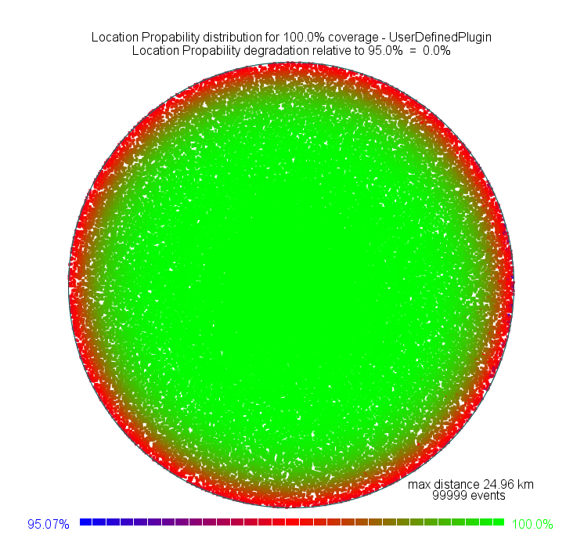
Figure 64: DTT coverage area, in the presence of noise only is 95%

Case 2:
DTT ERP: 10kW
DTT transmit power: 72.15 dBm
DTT transmitter antenna height: 300 m
DTT transmitter antenna gain: 0 dBr.
Coverage radius: ≈ 50.110 km
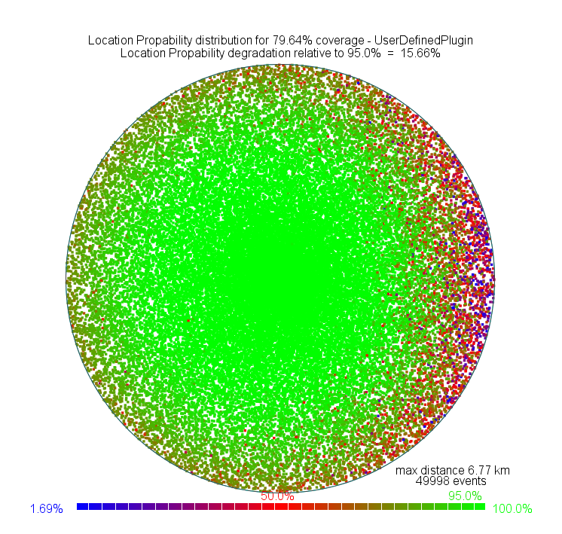

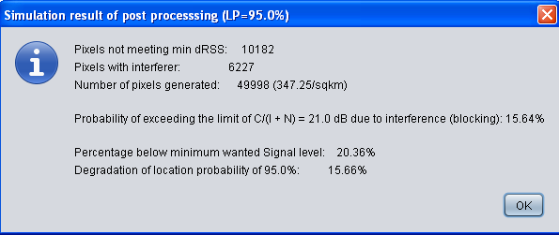
Figure 65: Results for 2 WSDs, equal EIRP, in the presence of noise power (-106.148 dBm)

Case 3:
DTT ERP: 100kW
DTT transmit power: 82.15 dBm
DTT transmitter antenna height: 600 m
DTT transmitter antenna gain: 0 dB.
Coverage radius:≈ 86.490 km
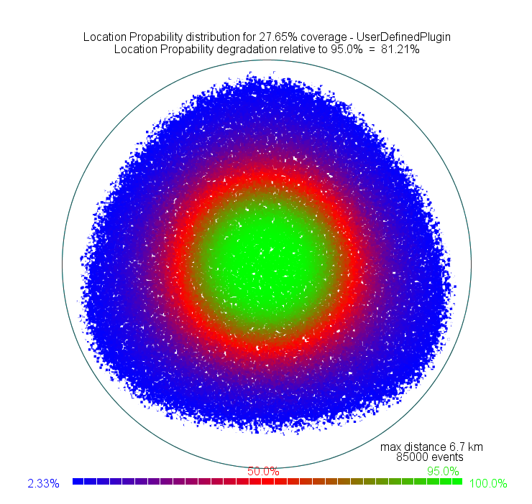

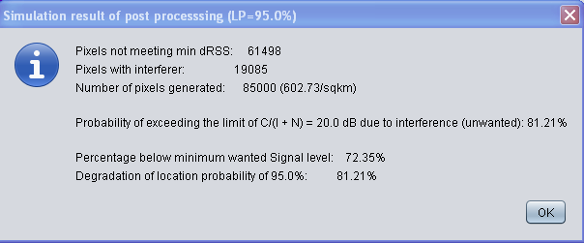
Figure 66: Coverage area + 3 Interferer

- List of reference
- Reference one (style: reference)
- Reference two
- Etc.

In the European Union the technical conditions and the licensing regimes for equipment using the radio spectrum in the frequency range up to 3000 GHz are described in the “Radio Interface Specifications” (RIS). Most CEPT administrations not being part of the EU have meanwhile also introduced RIS. The available RIS are published in the European EFIS-database (see www.efis.dk) where information field Nr. 7 defines the maximum allowed transmission power or power density.
If an interference source is removed, the LP will increase, and the IP will decrease, and both ‘degradations’ will be negative.
Because the results of a Monte Carlo simulation can vary slightly from simulation to simulation, the most accurate determination of the difference LPb – LPa (or IPa – IPb) would involve the calculation of LPb and LPa (IPa and IPb) using the same randomly generated values for the wanted field in the presence of noise and interference as those for the wanted field in the presence of noise only.

