  - Poland
Polish studies National Institute of Telecommunications Poland presented an alternative methodology of White Space Spectrum assessment which might be considered for usage in some countries especially where high interferences levels coming from other broadcasting stations exists. Such methodology is not based on protection of minimum medial field strength for planning as contained e.g. in the GE06 Agreement, but instead it is based on a protection of interference-limited DTT coverage areas.

    - Example of a DTT/Current Situation in Poland
In European countries, DTT stations coverage areas are often limited by co-channel interferences from other DTT stations in the same country or in a neighbouring country. Figure 66 shows an example of theoretical DVB-T coverage area for fixed reception potentially limited by interferences from other DTT stations. All calculations in this example were made using ITU-R P. 1546-2 propagation model and parameters of DTT stations which will be used in real implementation.

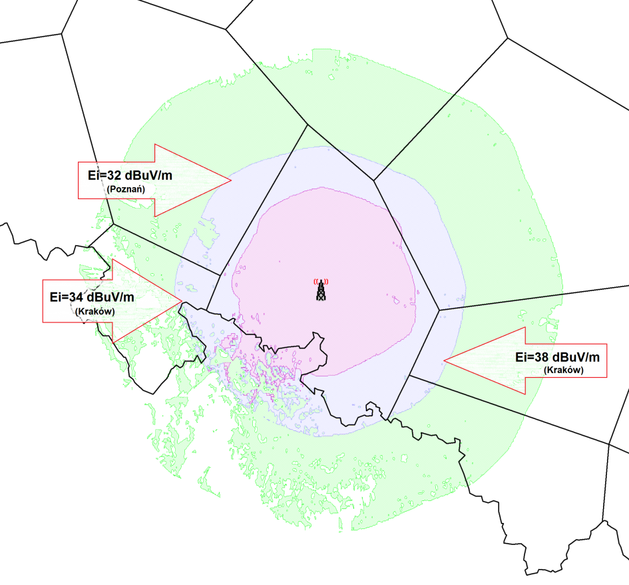
Figure 66: Example of coverage area of DTT station for fixed reception (Opole, ch. 23)
- interferences levels from other DTT stations in Poland
Violet – interference limited coverage (~ 60 – 65 dBµV/m)
Blue – noise limited coverage (Emin ~ 56 dBµV/m)
Green – calculated from ECC Report 159 WSD protected area (for 30 m 36 dBm)

Ei – existing interferences from other DTT stations in fixed reception mode
It is noted that interferences levels might be much higher then those allowed for new WSD based on values presented in the ERC Report 159 and that required field strength for proper reception could be higher than minimum median field strength used for DTT network planning.
    - Alternative Methodology

The main assumptions of a methodology following the idea explained above are as follows:
- values of the median field strength to be protected are calculated at every point in accordance with a certain interference situation i.e. taking into account cumulative effect of co-channel interferences from other broadcasting stations,
- coverage areas to be protected are defined by calculation of interference limited areas,

- maximum permissible nuisance field strength from WSD is 10-20 dB lower (exact value to be decided by Administration) then existing power sum of nuisance field strengths coming from other broadcasting stations,
- WSD transmission on adjacent channels (N+1, N-1) is not allowed in the coverage area of channel N to be protected,
- in overlapping areas where exactly the same TV content can be received from two or more TV stations it can be decided to protect only one coverage area.

If the calculation of interference limited areas is to based on real interference situation, detailed information on all broadcasting stations involved – wanted and interfering – would be needed, e.g. on parameters for real antenna implementation (i.e. height, tilt, horizontal and vertical diagrams) and real ERP.
If the intention is to base the calculation of interference limited areas on plan entries of the GE06 Digital Plan, the following is to be noted:
- All plan entries in the Digital Plan GE06 provide a certain “mask of rights”, with respect to potential interferences produced by these plan entries towards other plan entries as well as with respect to protection from emissions by these other plan entries.
- This always represents an upper limit. There is absolutely no obligation to implement a plan entry as provided in the GE06 Digital Plan, e.g. on full ERP, nor to implement a plan entry at all.
- For none of the plan entries information is provided on its real implementation, e.g. on real antenna diagrams, ERP implemented of antenna down tilt.
- Therefore, any approach based on interferences “potentially emitted” by GE06 Digital Plan entries i.e. with parameters as contained in the Plan is clearly an overestimation of the level of interferences real DVB-T reception has to cope with.
- Finally it is noted, that it would be very difficult to estimate the level of potential interferences at every single point with certain accuracy, even if based on real transmission parameters of existing DTT transmitters. In such a case, additional degrees of uncertainty would be added to the entire process, e.g. with respect to correct data as well as to prediction algorithms.

    - Results of example analysis
Figure 67 shows results of an example analysis on availability of WSD TV channels in the UHF band in Poland for CPE fixed type WSD, i.e. at 10 m a.g.l. with an ERP of 30 dBm using methodology described above This analysis has been carried out for interference limited DVB-T reception, based on DT1 plan entries of Poland and its neighbouring countries in the GE06 Digital Plan.
Availability of White Spaces in the TV band was estimated for all TV channels (21-60) on Polish territory at abound 600,000 points, i.e. using a raster of 1km x 1km with DEM/DTM.

Methodology presented here, based on certain interference levels into DVB-T channels/reception, results in a higher number of TV channels potentially available for WSD. Based on such a methodology it can be expected that an average of about 10-15 channels (in a range from 0 to 30 channels) might be available in Poland, providing also protection for adjacent DTT channels (N+1, N-1).

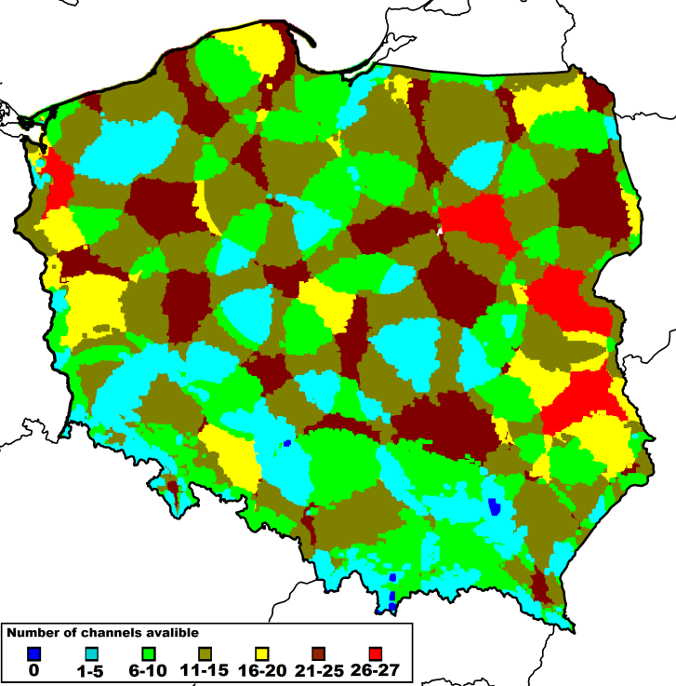
Figure 67: Result of an example analysis – WSD availability in Poland, based on data from GE06 Digital Plan entries in Poland and in neighboring countries

