 |  | SE43(11)32

10th meeting of SE43
Bologna, 5 – 7 July 2011

Date issued:
Source: | INdT
Subject: | Further analysis on EIRP limits for WSDs
Summary: | This contribution revisits the document SE43(11)12 to clarify some aspects of the modelling and the simulation methodology. Considerations on some assumptions are given, as with respect to protection criteria, multiple interferers, and interference modelling. New WSD power limits are provided.
Proposal: | It is proposed that the Attachment of this contribution is attached to the working document SE43(11)18A and the text in Section 5 is placed into Section 3 of the working document.
Background: | CEPT SE 43 group addressed the identification of a common set of the parameters to calculate location specific WSD Power as a topic that requires immediate further studies (issue B1 of section 11 of ECC Report 159).  SE43(11)12 contribution to ECC Report 159 proposes a set of parameters for the calculation of location specific WSD power levels, as well as maximum WSD power values for fixed and portable outdoor WSDs to protect broadcast services.

Password protection required? (Y/N) | N

ATTACHMENT
FURTHER ANALYSIS ON EIRP LIMITS FOR WSDs
(Considerations on the SE43(11)12 contribution)

- INTRODUCTION
SE43(11)12 contribution to ECC Report 159 proposes a set of parameters for the calculation of location specific WSD power levels, as well as maximum WSD power values for fixed and portable outdoor WSDs to protect broadcast services.
Assumptions and methodology in SE43(11)12 are revisited in this contribution. Considerations are made on the composition of scenarios and on the adopted criterion to protect the primary service. New WSD power limits are provided.

- BACKGROUND
Five interference scenarios combining mobile or fixed WSD transmission with mobile or fixed DTT reception are considered in SE43(11)12. The study is developed considering:
- A minimum separation distance between the WSD transmitter and the DTT receiver;
- The worst angular scenarios between WSD transmit antenna and DTT receive antenna;
- 3 equivalent WSDs contributing to the interference to the DTT receiver.
Mobile WSD transmit antenna and mobile DTT receive antenna are omnidirectional, and present 0 dBi and 2.15 dBi gain, respectively. Fixed DTT receive antenna gain is 9.15 dBi. Due to the short distances between WSD and DTT receiver, the free space propagation model is adopted, i.e.,
$PL_{FS}=32.45+20\log_{10}\left(f_{MHz}\right)+20\log_{10}\left(d_{km}\right) [dB]$,
where $PL_{FS}$ is the free space path loss as a function of the frequency $f_{MHz}$ in MHz and of the transmitter-receiver distance $d_{km}$ in kilometers. A fixed carrier frequency is considered in calculations, $f_{MHz}=650 MHz$.
The five scenarios are described below.
  - Scenarios considered in SE43(11)12 contribution

    - Scenario 1: Mobile WSD transmission (1.5 m agl) and fixed roof-top DTT reception (10 m agl)
Figure 1 illustrates the reference geometry of Scenario 1. In this scenario, 22 m separate a mobile WSD at 1.5 m above ground level (agl) from the base of a rooftop DTT receive antenna at 10 m agl. The distance between the two antennas is then 23.58 m, and the corresponding path loss is 56.15 dB. A vertical DTT receive antenna pattern is considered, where the discrimination from the WSD to the DTT antenna for this reference geometry is 0.45 dB, and the front-to-back ratio is 3 dB.

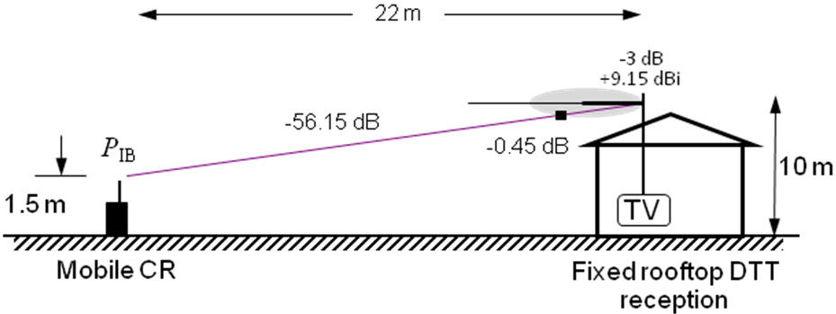
Figure 1 - Reference geometry of Scenario 1.

    - Scenario 2: Mobile WSD transmission (10 m agl) and fixed roof-top DTT reception (10 m agl)
Figure 2 illustrates the reference geometry of Scenario 2. In this scenario, 20 m separate a mobile WSD at 10 m agl, supposed in a story window, from a rooftop DTT receive antenna at 10 m agl. The corresponding path loss is 54.72 dB. There is no receive antenna or polarization discrimination. The front-to-back ratio is 16 dB.
P
IB
Fixed rooftop DTT
reception
TV
-
54.72 dB
Portable WSD
from n^{th} story window
10 m
-
16 dB
+9.15
dBi

20m
Figure 2 - Reference geometry of Scenario 2.

    - Scenario 3: Mobile WSD transmission (1.5 m agl) and mobile DTT reception (1.5 m agl)
Figure 3 illustrates the reference geometry of Scenario 3. In this scenario, 2 m separate a mobile WSD at 1.5 m agl from a mobile DTT receive antenna also at 1.5 m agl. The corresponding path loss is 34.72 dB. There is no receive antenna or polarization discrimination.
Figure 3 - Reference geometry of Scenario 3.
2 m
1.5 m
1.5 m
Mobile DTT reception at 1.5 m agl
WSD
DTT
-34.72 dB

    - Scenario 4: Fixed WSD transmission (10 m agl) and fixed roof-top DTT reception (10 m agl)
Figure 4 illustrates the reference geometry of Scenario 4. In this scenario, 20 m separate a fixed WSD at 10 m agl from a rooftop DTT receive antenna at 10 m agl. The corresponding path loss is 54.72 dB. There is no receive antenna discrimination, the polarization discrimination is 3 dB, and the front-to-back ratio is 16 dB.
Figure 4 - Reference geometry of Scenario 4.
P
IB
Fixed rooftop DTT
reception
TV
-
54.72 dB
Fixed WSD
10 m
-
16 dB
+9.15
dBi
H-polar
Slant-polar
20m

    - Scenario 5: Fixed WSD transmission (10 m agl) and mobile DTT reception (1.5 m agl)
Figure 5 illustrates the reference geometry of Scenario 5. In this scenario, 20 m separate the base of a fixed WSD at 10 m agl from a mobile DTT receiver with antenna at 1.5 m agl. The distance between the two antennas is then 21.73 m, and the corresponding path loss is 55.45 dB. A vertical WSD transmit antenna pattern is considered, where the discrimination from the WSD to the DTT antenna for this reference geometry is 10 dB. There is no receive antenna or polarization discrimination. Therefore, the total loss is 55.45 + 10 = 65.45 dB.
Mobile DTT reception
P
IB
-
- 55.45 dB
Fixed WSD
1.5 m
20m
10 m
Figure 5 - Reference geometry of Scenario 5.
  - Protection criteria considered in SE43(11)12 contribution
SE43(11)12 contribution proposes the use of two criteria to protect the primary service: the limitation of the location probability degradation ($ΔLP$) and the limitation of interference.
Location probability ($LP$) is a measure commonly used in DTT planning to represent the availability of the DTT signal in a given area. An area is considered covered if at least 95% of the locations within the area can receive the minimum field strength $E_{wmed_ref} [dBμV/m]$. Limiting the degradation on $LP$ is then a measure to protect the DTT service. SE43(11)12 proposes as protection criterion $ΔLP=0.1\%$.
Limitation of interference into the broadcast service is considered by defining $I/N$ thresholds. ITU-R BT 1786 recommends $I/N= -20 dB$ for all radiations and emissions without a corresponding frequency allocation in the Radio Regulations. SE43(11)12 proposes as protection criterion $I/N= -3 dB$.
The combination of the two protection criteria divides the DTT coverage area into two regions, as illustrated in Figure 6. Region I corresponds to the layer externally delimited by the coverage edge, where the median field strength $E_{wmed} [dBμV/m]$ is such that the location probability ($LP$) is 95%. The limit between Region I and Region II is determined by the edge where the field strength is $10 dB$ above the one at the coverage edge, and the area internal to this edge composes the Region II.

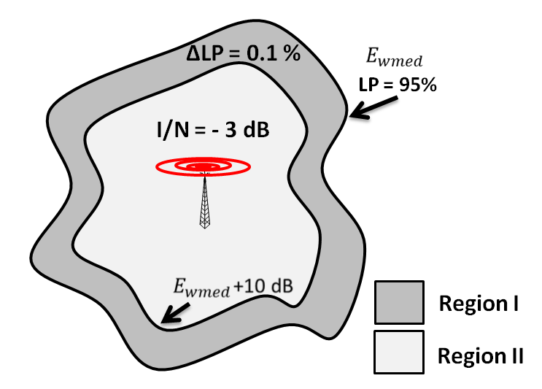
Figure 6 - Protection criteria inside the DTT coverage area - SE43(11)12.
In Region I, the maximum WSD EIRP is location specific and satisfies $ΔLP=0.1\%$. Differently, the maximum WSD EIRP in Region II assumes a fixed value, defined at the external edge of the region, where it satisfies $ΔLP=0.1\%$, and corresponds to $I/N= -3 dB$. Therefore, inside Region II the protection criterion adopted in SE43(11)12 is the limitation of interference.

  - Study methodology in SE43(11)12 contribution
Methodology adopted in SE43(11)12 was suggested in ECC Report 159 (Section 4.3.4. and Annex 6). It is based on Monte Carlo simulations, where the wanted DTT signal and the interfering signal (WSD) are modeled as statistical variables as follows:
- $E_{wmed} [dBμV/m] \sim N\left(E_{wmed}, σ_{w}=5.5\right)$ is the median field strength of the wanted signal at the DTT receiver input, with mean $E_{wmed}$ and standard deviation $σ_{w}$;
- $E_{imed} [dBμV/m] \sim N\left(E_{imed}, σ_{I}=3.5\right)$ is the median field strength of the interference at the DTT receiver input, with mean $E_{imed}$ and standard deviation $σ_{I}$.
After a large number of trials, one calculates:
- Location probability ($LP$)
$LP=\operatorname{Pr}\left\{E_{wmed}>E_{wmed_ref}\right\}$,
where $E_{wmed_ref}$ is the minimum median field strength for DTT reception.
- Location probability under WSD interference ($LP_{WSD}$)
$LP_{WSD}=\operatorname{Pr}\left\{E_{wmed}>E_{wmed_ref}+E_{imed}\right\}$.
- Location probability degradation ($ΔLP$)
$ΔLP=LP-LP_{WSD}$.
This methodology permits the calculation of the maximum interference median field strength $E_{imed}$ at the DTT receiver input for a given $ΔLP$. From $E_{imed}$, the maximum WSD EIRP can be calculated for different scenarios according to specific path loss values and antenna configurations.
    - Understanding the calculation of the maximum interference median field strength $E_{imed}$ at the DTT receiver input for a given $ΔLP$
By definition, the location probability at the DTT service coverage edge is $LP=95\%$. From ECC Report 159, the minimum median field strength for fixed outdoor DTT reception is $E_{wmed_ref}=56.21 dBμV/m$.
The median field strength of the wanted signal at the DTT receiver input $E_{wmed}$ for $LP=95\%$ is illustrated in Figure 7. It is thus determined as follows.

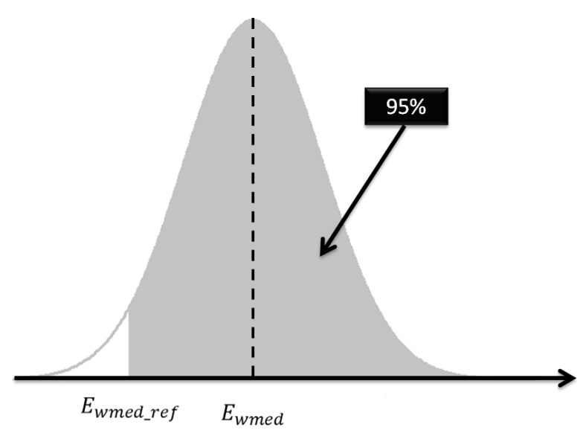
Figure 7 - Median field strength of the wanted signal for LP=95%.
$0.95=\operatorname{Pr}\left\{E_{wmed}>56.21\right\}=Q\left(\frac{56.21-E_{wmed}}{5.5}\right)→E_{wmed}=65.26 dBμV/m$.
The median field strength at the coverage edge for $LP=95\%$, $E_{wmed}=65.26 dBμV/m$, corresponds to $-68.20 dBm$, value coherent with the target mean received signal level for $LP=95\%$ in ECC Report 159 – Table 1.
Location probability ($LP$) can be directly calculated from the median field strength of the wanted signal at the DTT receiver, $E_{wmed}$, as expressed below:
$$LP=\operatorname{Pr}\left\{E_{wmed}>E_{wmed_ref}\right\}=Q\left(\frac{E_{wmed_ref}-E_{wmed}}{σ_{w}}\right).$$
The maximum interference median field strength $E_{imed}$ at the DTT receiver input for a given $ΔLP$ is obtained by Monte Carlo simulations. For instance, for $ΔLP=0.1\%$ at the coverage edge, where $LP=95\%$, $LP_{WSD}=94.9\%$. Then, the interference median field strength $E_{imed}$ to be found by simulations is such that:
$LP_{WSD}=\operatorname{Pr}\left\{E_{wmed}>E_{wmed_ref}+E_{imed}\right\}=0.949$,
where the field strengths are summed in linear scale, and $E_{wmed}$ and $E_{imed}$ are defined as the statistical variables below:
$$E_{wmed} [dBμV/m] \sim N\left(E_{wmed}=65.26 dBμV/m, σ_{w}=5.5\right)$$
$E_{imed} [dBμV/m] \sim N\left(E_{imed}, σ_{I}=3.5\right)$.
Simulations were carried out over 1,000 trials and 1,000 random variable samples per trial. Table 1 gives the theoretical and the simulated values of $LP$ for different wanted median field strengths $E_{wmed}$ from the coverage edge until the location where the median field strength is $10 dB$ higher than $E_{wmed}$ at the edge. The corresponding values of maximum interference field strength for $ΔLP=0.1\%$ are also presented in Table 1. ${E'}_{imed}$ is the maximum permitted interference field strength at the DTT receive antenna input, i.e.,
${E'}_{imed}=E_{imed}- PR\left(0\right)-G_{a}$,
where $PR\left(0\right)$ is the co-channel protection ratio and $G_{a}$ is the DTT receive antenna gain (including feeder losses). For fixed DTT reception, $PR\left(0\right)=21 dB$ and $G_{a}=9.15 dBi$ (ECC Report 159 and SE43(11)12 contribution).

Table 1– Relationship between $E_{wmed}$, $LP$, and ${E'}_{imed}$ for fixed outdoor DTT reception and $ΔLP=0.1\%$.
Location | $$E_{wmed} [dBμV/m]$$ | $$LP [\%]$$  (calculated) | $$LP [\%]$$  (simulated) | $${E'}_{imed}[dBμV/m]$$
Coverage edge ($E_{wmed}$) | 65.26 | 95.01 | 94.96 | 5.408
$$E_{wmed}+1 dB$$ | 66.26 | 96.62 | 96.61 | 7.008
$$E_{wmed}+2 dB$$ | 67.26 | 97.77 | 97.74 | 8.408
$$E_{wmed}+3 dB$$ | 68.26 | 98.58 | 98.56 | 10.01
$$E_{wmed}+4 dB$$ | 69.26 | 99.12 | 99.11 | 11.71
$$E_{wmed}+5 dB$$ | 70.26 | 99.47 | 99.46 | 13.61
$$E_{wmed}+6 dB$$ | 71.26 | 99.69 | 99.69 | 15.41
$$E_{wmed}+7 dB$$ | 72.26 | 99.82 | 99.83 | 17.11
$$E_{wmed}+8 dB$$ | 73.26 | 99.90 | 99.90 | 19.01
$$E_{wmed}+9 dB$$ | 74.26 | 99.95 | 99.95 | 20.91
$$E_{wmed}+10 dB$$ | 75.26 | 99.97 | 99.97 | 22.51

The same procedure described above can be used to obtain the maximum permitted interference field strength for portable outdoor DTT reception. According to ECC Report 159, the minimum median field strength of the wanted signal at the DTT receiver input in this case is $E_{wmed_ref}=61.21 dBμV/m$. Furthermore, the co-channel protection ratio and the DTT receive antenna gain assume the following values: $PR\left(0\right)=19 dB$ and $G_{a}=2.15 dBi$. Table 2 shows the obtained values of $LP$ and maximum interference field strength for $ΔLP=0.1\%$ for different wanted median field strengths $E_{wmed}$.

Table 2– Relationship between $E_{wmed}$, $LP$, and ${E'}_{imed}$ for portable outdoor DTT reception and $ΔLP=0.1\%$.
Location | $$E_{wmed} [dBμV/m]$$ | $$LP [\%]$$  (calculated) | $$LP [\%]$$  (simulated) | $${E'}_{imed}[dBμV/m]$$
Coverage edge ($E_{wmed}$) | 70.26 | 95.01 | 94.98 | 19.51
$$E_{wmed}+1 dB$$ | 71.26 | 96.62 | 96.60 | 21.01
$$E_{wmed}+2 dB$$ | 72.26 | 97.77 | 97.78 | 22.31
$$E_{wmed}+3 dB$$ | 73.26 | 98.58 | 98.58 | 24.01
$$E_{wmed}+4 dB$$ | 74.26 | 99.12 | 99.11 | 25.71
$$E_{wmed}+5 dB$$ | 75.26 | 99.47 | 99.46 | 27.41
$$E_{wmed}+6 dB$$ | 76.26 | 99.69 | 99.69 | 29.21
$$E_{wmed}+7 dB$$ | 77.26 | 99.82 | 99.83 | 31.21
$$E_{wmed}+8 dB$$ | 78.26 | 99.90 | 99.90 | 33.11
$$E_{wmed}+9 dB$$ | 79.26 | 99.95 | 99.95 | 34.91
$$E_{wmed}+10 dB$$ | 80.26 | 99.97 | 99.97 | 36.41

- SOME CONSIDERATIONS ON THE STUDY DEVELOPED IN SE43(11)12 CONTRIBUTION
Results shown in Table 1 agree with those presented in SE43(11)12 contribution for fixed outdoor DTT reception, $ΔLP=0.1\%$, and 1 WSD interferer (SE43(11)12 – Table 2).
Results shown in Table 2 do not agree with those presented in SE43(11)12 contribution for portable outdoor DTT reception, $ΔLP=0.1\%$, and 1 WSD interferer (SE43(11)12 – Table 4). There exists a discrepancy of about $7 dB$ between our numbers and the ones of SE43(11)12 for the maximum permitted interference median field strength at the DTT receive antenna input. This value corresponds to the difference between the antenna gains for a fixed DTT receiver, $9.15 dBi$, and a portable DTT receiver, $2.15 dBi$. Using the antenna gain for fixed DTT receiver in the place of the one for portable DTT receiver is the probable source of disagreement between both sets of results.
Considering the described procedure to obtain the maximum interference median field strength at the DTT receive antenna input and the values shown in Table 2, the values of maximum interference field strength (and consequently the maximum WSD EIRPs) presented in SE43(11)12 contribution for portable outdoor DTT reception are underestimated in $7 dB$.
Other aspects are addressed in the following.
  - Criteria for primary service protection
As mentioned in Section 2.2., SE43(11)12 contribution proposes the combination of two criteria to protect the primary DTT service. Near the DTT coverage edge, WSD emission limits are defined to satisfy a maximum location probability degradation level. Inside the coverage area, where WSD emission limits could be higher, a criterion based on a maximum interference-to-noise ratio ($I/N$) is adopted.
Limitation of interference to broadcasting systems is recommended in ITU-R BT.1786. It recommends:
that the total interference to systems operating in the broadcasting service, from all sources of interference, as prescribed in the Recommendation mentioned in considering d) above, should at no time exceed one per cent of the total receiving system noise power.
The mentioned considered d) states that:
there is an established protection criteria in Recommendation ITU-R SM.1757 and Report ITU-R SM.2050 for terrestrial broadcasting services restricting interference caused by emissions from ultra-wideband devices.
In SE43(11)12 contribution, a draft new Recommendation ITU-R BT that has been recently approved as Recommendation ITU-R BT 1895 is evoked. This Recommendation also defines $I/N$ based protection criteria to broadcasting services. Following this approval, Recommendation ITU-R BT.1786 has been suppressed.
Studies related to the impact of interference on systems operating in the broadcasting service have considered as interference sources non-broadcasting radiocommunication devices like ultra-wideband (UWB) devices and short-range FM modulators.
Planning criteria for DTT services consider reference values of minimum field strength and protection ratio for acceptable DTT service quality (Recommendation ITU-R BT.1368-3). Specific studies on the impact of interference from mobile service (especially from LTE) on DVB-T receivers (ECC Report 148) define reference values of overloading threshold.
Protection of the primary DTT service should be defined according to specific studies on the impact of interference on DTT receiver and on DTT reception quality. The protection criterion can jointly consider the following three elements: location probability, protection ratio and overloading threshold. Location specific emissions of WSDs can be limited by a determined level of location probability degradation, where a reference protection ratio is considered and the overloading threshold is respected.

  - Multiple WSD interferers
Simultaneous multi-interferers are considered in SE43(11)12 studies. In adjacent channels, 3 equivalent WSDs are assumed to contribute to the interference to the DTT receiver. This assumption decreases the permitted interference levels and the WSD EIRPs in about 4-5 dB.
Considering that:
- the interference limits are calculated for the worst case separation distance between the WSD transmitter and the DTT receiver and the worst case angle from the WSD transmitter to the direction of main response of the DTT receive antenna;
- there will be a media access control for WSD transmission and for this reason multiple WSDs in the same location (pixel) do not use simultaneously the same available channel to avoid mutual interference,
then, the assumption of 3 equivalent WSDs interferers is too severe.
Even the spatial composition of 3 WSDs interferers in the worst case interference configuration is improbable in the case of fixed outdoor WSDs and DTT reception (Scenario 4). Figure 8 illustrates the situation.

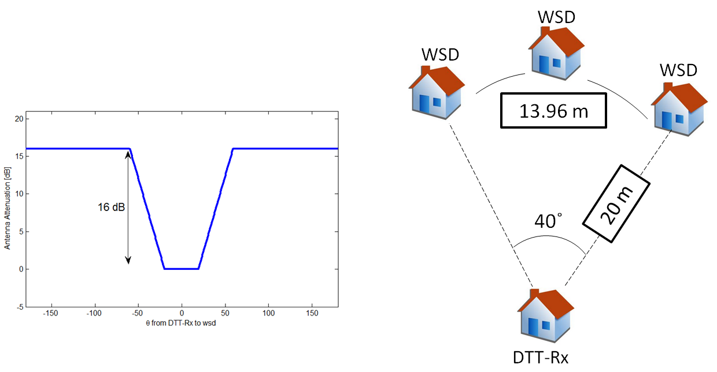
Figure 8 - Attenuation diagram of DTT receive antenna (ITU-R BT.419-3) and the spatial composition of the worst case interference configuration with 3 WSDs interferers.

The main response of DTT receive antenna comprises $-{20}^{o}≤θ≤+{20}^{o}$, where there is no signal attenuation. Then, for causing the worst case interference to a DTT receiver at 20 m, 3 WSDs should be placed in front of the DTT receive antenna over an arc of less than $14 m$ extension. This is an improbable scenario for fixed outdoor WSDs.
It follows an additional investigation on the probability of occurrence of the worst case interference situation for fixed DTT reception. Scenario 4 is taken as reference.
A $100 m×100 m$ pixel is considered. The pixel is divided in small 4 m² areas as shown in Figure 9. The study consists in calculating the total loss between each mini-pixel and a given mini-pixel where a fixed DTT receiver is assumed to be located. The fixed DTT receive antenna is pointed to a DTT transmitter and presents the directivity recommended in ITU-R BT. 419-3. All possible locations of DTT receive antenna inside the pixel are considered.

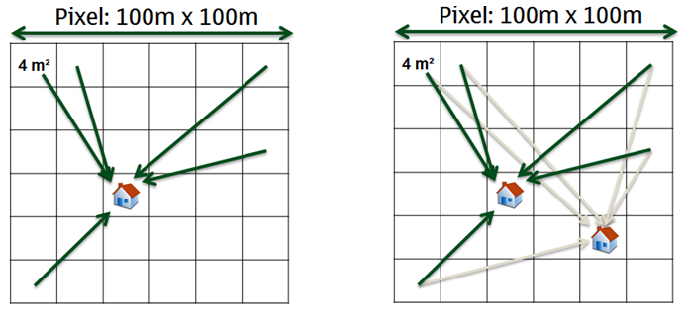
Figure 9 - Calculation of probability of occurrence of scenario 4.

Figure 10 shows the cumulative distribution of total loss for all possible locations of DTT receive antenna. As it can be noticed, the probability of occurrence of the worst case scenario (total loss 57.72 dB) inside a pixel of 100 m x 100 m is in the order of 0.5% when the minimum distance of 20 m between the WSD (located at a mini-pixel) and the DTT receiver is observed (curve in red). When there is no minimum distance limitation, this probability increases to 2% (curve in blue).

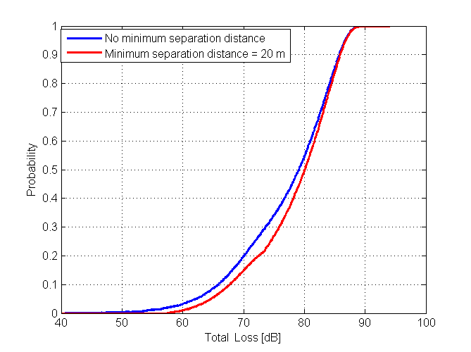
Figure 10 - Cumulative distribution of total loss inside a pixel for Scenario 4.

  - Composition of scenarios for primary service protection
Scenarios considered in SE43(11)12 correspond to worst case interference situations for the primary DTT service.
Fixed outdoor WSD transmit antenna is considered in Scenarios 4 and 5 at 10 m agl. Fixed outdoor WSD transmit antenna at 30 m agl. is foreseen in ECC Report 159 (Section 3.2.4) in a scenario that resembles the traditional fixed service point-to-point usage, where the WSD receive antenna is also fixed outdoor above roof-top. This WSD transmit antenna type must also be considered. Then, two new scenarios are described below.
    - Scenario 6: Fixed WSD transmission (30 m agl) and fixed roof-top DTT reception (10 m agl)
Figure 11 illustrates the reference geometry of Scenario 6. In this scenario, 20 m separate the base of a fixed WSD at 30 m agl from the base of a rooftop DTT receive antenna at 10 m agl. The corresponding path loss is 57.74 dB. Taking as reference an LTE BS antenna, the vertical WSD transmit antenna attenuation at ${45}^{o}$ is 25.12 dB. Attenuation at ${45}^{o}$ for the DTT reception is 15.61 dB for a typical Yagi antenna. Therefore, the total loss gives $57.74+25.12+15.61=98.47 dB$.

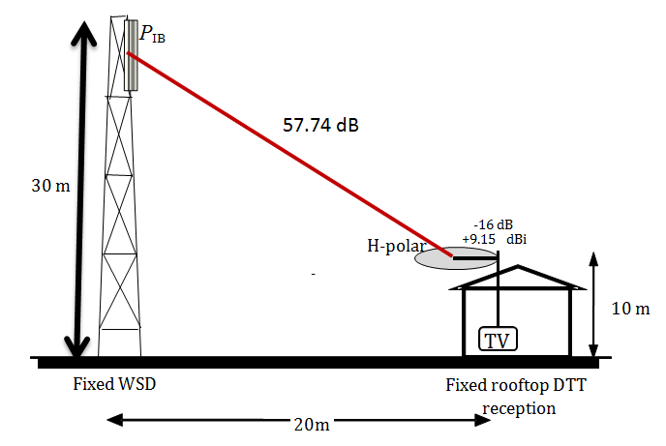
Figure 11 - Reference geometry of Scenario 6.

    - Scenario 7: Fixed WSD transmission (30 m agl) and mobile DTT reception (1.5 m agl)
Figure 12 illustrates the reference geometry of Scenario 7. In this scenario, 20 m separate the base of a fixed WSD at 30 m agl from a mobile DTT receiver with antenna at 1.5 m agl. The corresponding path loss is 59.54 dB. Considering an LTE BS antenna, the vertical WSD transmit antenna attenuation at ${55}^{o}$ is 39.06 dB. There is no receive antenna or polarization discrimination. Therefore, the total loss is $59.54+39.06=98.60 dB$.

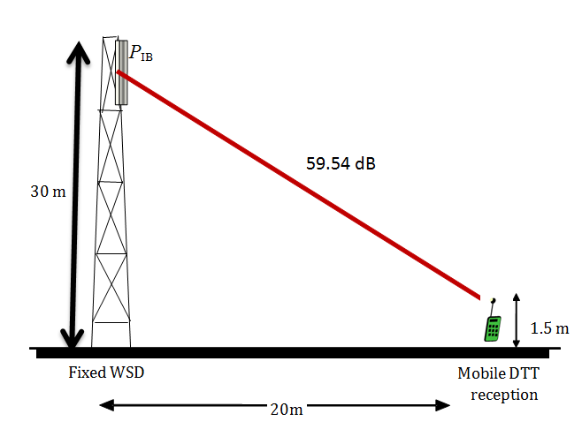
Figure 12 - Reference geometry of Scenario 7.

Because of the vertical antenna radiation pattern of both WSD transmitter and DTT receiver, the total loss between them in Scenario 6 is $98.47-57.72= 40.75 dB$ higher than in Scenario 4. In Scenario 7, the total loss is $98.60-65.45=33.15 dB$ higher than in Scenario 5. Therefore, the WSD EIRP limits in Scenarios 6 and 7 for fixed outdoor WSD transmission at 30 m agl. exceed the ones determined for fixed outdoor WSD transmission at 10 m agl. in Scenarios 4 and 5 respectively by $40.75 dB$ and $39.06 dB$.

  - Modeling of interference
In the simulation model in SE43(11)12, the loss between WSD transmitter and DTT receiver is the most conservative one (free space loss). Besides this assumption, the interference signal is modeled as a Gaussian random variable with standard deviation $σ_{I}=3.5 dB$. Path loss model at short distances between WSD and DTT receiver, as well as the modeling of interference are aspects that deserve further discussion. A lower standard deviation $σ_{I}=1 dB$ is considered in the following simulations.

- WSD EIRP LIMITS
We present now the maximum interference field strengths and the corresponding WSD EIRP limits for each scenario (including the proposed Scenarios 6 and 7), according to the considerations made in Section 3:
- Protection criterion is based on the limitation of the location probability degradation, i.e., $ΔLP=0.1\%$;
- Protection ratio is the same adopted in SE43(11)12: (co-channel) $PR(0)=21 dB$ for fixed DTT reception and $19 dB$ for mobile DTT reception; (1st adjacent channel) $P{R(Δf)}_{1st}=-30 dB$; and (2nd adjacent channel) $P{R(Δf)}_{2nd}=-40 dB$;
- Overloading threshold values are given in Tables 3 and 4 (10th percentile values are adopted);
Table 3 - DVB-T overloading thresholds in the presence of a time constant LTE BS interfering signal in a Gaussian channel environment (adapted from Table 5b - ECC Report 148).
DVB-T Oth for 64-QAM 2/3 DVB-T signal (LTE UE TPC off)
Channel edge separation (MHz) | O_{th} (dBm)
Channel edge separation (MHz) | 90th |  | 50th |  | 10th
Channel edge separation (MHz) | Fixed DTT | Portable DTT | Fixed DTT | Portable DTT | Fixed DTT | Portable DTT
1 | -2 | -3 | -8 | -17 | -13 | -26
9 | 4 | 0 | -1 | -13 | -7 | -22

Table 4 - DVB-T overloading thresholds in the presence of a time constant LTE UE interfering signal in a Gaussian channel environment (adapted from Table 7b - ECC Report 148).
DVB-T Oth for 64-QAM 2/3 DVB-T signal (LTE UE TPC off)
Channel edge separation (MHz) | O_{th} (dBm)
Channel edge separation (MHz) | 90th |  | 50th |  | 10th
Channel edge separation (MHz) | Fixed DTT | Portable DTT | Fixed DTT | Portable DTT | Fixed DTT | Portable DTT
1.5 | -14… -9 | -3 | -16… -16 | -15 | -23 … -17 | -27
9.5 | -10 … 9 | -13 | -28 … 2 | -30 | -46 … -5 | -47

- DTT fixed receivers are considered to use silicon-type tuners implemented in set-top boxes and/or integrated TV (iDTV);
- DTT portable receivers are considered to use silicon-type tuners implemented in small USB-type devices;
- Only 1 WSD interferer is considered;
- Interference is modeled as a Gaussian random variable with $σ_{I}=1 dB$;
- Other configuration parameters are identical to the ones in SE43(11)12 simulation.
Tables 5 and 6 show the obtained values of $LP$ and maximum interference field strength for $ΔLP=0.1\%$ for different wanted median field strengths $E_{wmed}$. Results for fixed outdoor DTT reception are in Table 5 and for mobile outdoor DTT reception in Table 6. Results for the location where the wanted field strength is $E_{wmed}+20 dB$ are also shown.

Table 5– Relationship between $E_{wmed}$, $LP$, and ${E'}_{imed}$ for fixed outdoor DTT reception and $ΔLP=0.1\%$.
Location | $$E_{wmed} [dBμV/m]$$ | $$LP [\%]$$  (calculated) | $$LP [\%]$$  (simulated) | $${E'}_{imed}[dBμV/m]$$
Coverage edge ($E_{wmed}$) | 65.26 | 95.01 | 95.00 | 6.908
$$E_{wmed}+1 dB$$ | 66.26 | 96.62 | 96.61 | 8.308
$$E_{wmed}+2 dB$$ | 67.26 | 97.77 | 97.78 | 9.608
$$E_{wmed}+3 dB$$ | 68.26 | 98.58 | 98.57 | 11.11
$$E_{wmed}+4 dB$$ | 69.26 | 99.12 | 99.10 | 13.21
$$E_{wmed}+5 dB$$ | 70.26 | 99.47 | 99.47 | 15.01
$$E_{wmed}+6 dB$$ | 71.26 | 99.69 | 99.68 | 16.91
$$E_{wmed}+7 dB$$ | 72.26 | 99.82 | 99.83 | 18.81
$$E_{wmed}+8 dB$$ | 73.26 | 99.90 | 99.90 | 20.91
$$E_{wmed}+9 dB$$ | 74.26 | 99.95 | 99.95 | 22.81
$$E_{wmed}+10 dB$$ | 75.26 | 99.97 | 99.97 | 24.61
$$E_{wmed}+20 dB$$ | 85.26 | 100.0 | 100.0 | 37.51

Maximum interference field strengths in Table 5 are about $1.5$-$2 dB$ above the ones in Table 1. The difference is a consequence of the lower standard deviation $σ_{I}$ in the last simulation.

Table 6– Relationship between $E_{wmed}$, $LP$, and ${E'}_{imed}$ for portable outdoor DTT reception and $ΔLP=0.1\%$.
Location | $$E_{wmed} [dBμV/m]$$ | $$LP [\%]$$  (calculated) | $$LP [\%]$$  (simulated) | $${E'}_{imed}[dBμV/m]$$
Coverage edge ($E_{wmed}$) | 70.26 | 95.01 | 95.03 | 20.91
$$E_{wmed}+1 dB$$ | 71.26 | 96.62 | 96.64 | 22.11
$$E_{wmed}+2 dB$$ | 72.26 | 97.77 | 97.77 | 23.61
$$E_{wmed}+3 dB$$ | 73.26 | 98.58 | 98.57 | 25.21
$$E_{wmed}+4 dB$$ | 74.26 | 99.12 | 99.12 | 27.01
$$E_{wmed}+5 dB$$ | 75.26 | 99.47 | 99.47 | 29.21
$$E_{wmed}+6 dB$$ | 76.26 | 99.69 | 99.69 | 31.21
$$E_{wmed}+7 dB$$ | 77.26 | 99.82 | 99.83 | 32.91
$$E_{wmed}+8 dB$$ | 78.26 | 99.90 | 99.90 | 35.01
$$E_{wmed}+9 dB$$ | 79.26 | 99.95 | 99.95 | 36.91
$$E_{wmed}+10 dB$$ | 80.26 | 99.97 | 99.97 | 38.81
$$E_{wmed}+20 dB$$ | 90.26 | 100.0 | 100.0 | 51.61

Maximum interference field strengths in Table 6 are about $1$-$2.5 dB$ above the ones in Table 2. The difference is a consequence of the lower standard deviation $σ_{I}$ in the last simulation.
Next, the maximum permitted interference field strengths at the DTT receive antenna input ${E'}_{imed}$ shown in Tables 5 and 6 for fixed and portable outdoor DTT reception are translated to interference power levels through:
$P_{dBm}=E_{dBμV/m }-20\log_{10}\left(f_{MHz}\right)-77.2$.
Using the referenced values of protection ratio, the maximum permitted interference powers for 1st and 2nd adjacent channels are organized in Table 7. Overloading thresholds for each combination of WSD transmitter and DTT receiver types are also given. Observe that except in the case of portable WSD transmission and portable DTT reception, when the overloading threshold is met at $E_{wmed}+5 dB$ location, the overloading threshold is far from be achieved even in $E_{wmed}+20 dB$ location.

Table 7 – Maximum permitted interference $I[dBm]$ at the receiver input and overloading thresholds [dBm].
Location | Fixed outdoor DTT receiver |  | Portable outdoor DTT receiver
Location | 1st adjacent channel | 2nd adjacent channel | 1st adjacent channel | 2nd adjacent channel
Coverage edge ($E_{wmed}$) | -75.55 | -65.55 | -63.55 | -53.55
$$E_{wmed}+1 dB$$ | -74.15 | -64.15 | -62.35 | -52.35
$$E_{wmed}+2 dB$$ | -72.85 | -62.85 | -60.85 | -50.85
$$E_{wmed}+3 dB$$ | -71.35 | -61.35 | -59.25 | -49.25
$$E_{wmed}+4 dB$$ | -69.25 | -59.25 | -57.45 | -47.45
$$E_{wmed}+5 dB$$ | -67.45 | -57.45 | -55.25 | -45.25
$$E_{wmed}+6 dB$$ | -65.55 | -55.55 | -53.25 | -43.25
$$E_{wmed}+7 dB$$ | -63.65 | -53.65 | -51.55 | -41.55
$$E_{wmed}+8 dB$$ | -61.55 | -51.55 | -49.45 | -39.45
$$E_{wmed}+9 dB$$ | -59.65 | -49.65 | -47.55 | -37.55
$$E_{wmed}+10 dB$$ | -57.85 | -47.85 | -45.65 | -35.65
$$E_{wmed}+20 dB$$ | -44.95 | -34.95 | -32.85 | -22.85
Oth [dBm] – LTE BS transmitter | -13 | -7 | -26 | -22
Oth [dBm] – LTE UE transmitter | -20 | -25.5 | -27 | -47

Now, from the maximum permitted interference at the DTT receiver input given in Table 7, one calculates the maximum permitted WSD EIRP for each scenario. Table 8 shows these values for Scenarios 1, 2, 3, 4 and 5, while the results for Scenarios 6 and 7 are given in Table 9. WSD EIRP limits already consider the overloading thresholds.
Scenarios in yellow present the most restrictive WSD power limits according to the type of WSD transmitter (fixed or portable). WSD EIRPs that were limited by the overloading threshold are also indicated.
Because of the low value of overloading threshold for portable DTT reception (see Table 7), WSD emissions for portable WSD transmission / portable DTT reception are limited by the overloading threshold in locations where the wanted field strength is equal to or higher than $E_{wmed}+5 dB$. For fixed WSD transmission, the EIRP at $E_{wmed}+20 dB$ location is near the overloading threshold, which limits the EIRP at $43.45 dBm$.

Table 8 - Maximum permitted WSD EIRP [dBm] (Scenarios 1-5).
Location | Portable WSD transmitter |  | Portable WSD transmitter |  | Portable WSD transmitter |  | Fixed WSD transmitter |  | Fixed WSD transmitter
Location | Fixed DTT receiver |  | Fixed DTT receiver |  | Portable DTT receiver |  | Fixed DTT receiver |  | Portable DTT receiver
Location | Scenario 1 |  | Scenario 2 |  | Scenario 3 |  | Scenario 4 |  | Scenario 5
Location | 1st adj | 2nd adj | 1st adj | 2nd adj | 1st adj | 2nd adj | 1st adj | 2nd adj | 1st adj | 2nd adj
Coverage edge ($E_{wmed}$) | -19.0 | -9.0 | -20.8 | -10.8 | -28.8 | -18.8 | -17.8 | -7.8 | 1.9 | 11.9
$$E_{wmed}+1 dB$$ | -17.6 | -7.6 | -19.4 | -9.4 | -27.6 | -17.6 | -16.4 | -6.4 | 3.1 | 13.1
$$E_{wmed}+2 dB$$ | -16.3 | -6.3 | -18.1 | -8.1 | -26.1 | -16.1 | -15.1 | -5.1 | 4.6 | 14.6
$$E_{wmed}+3 dB$$ | -14.7 | -4.7 | -16.6 | -6.6 | -24.5 | -14.5 | -13.6 | -3.6 | 6.2 | 16.2
$$E_{wmed}+4 dB$$ | -12.6 | -2.6 | -14.5 | -4.5 | -22.7 | -12.7 | -11.5 | -1.5 | 8.0 | 18.0
$$E_{wmed}+5 dB$$ | -10.8 | -0.8 | -12.7 | -2.7 | -20.5 | -12.3 | -9.7 | 0.3 | 10.2 | 20.2
$$E_{wmed}+6 dB$$ | -8.9 | 1.1 | -10.8 | -0.8 | -18.5 | -12.3 | -7.8 | 2.2 | 12.2 | 22.2
$$E_{wmed}+7 dB$$ | -7.0 | 3.0 | -8.9 | 1.1 | -16.8 | -12.3 | -5.9 | 4.1 | 13.9 | 23.9
$$E_{wmed}+8 dB$$ | -4.9 | 5.1 | -6.8 | 3.2 | -14.7 | -12.3 | -3.8 | 6.2 | 16.0 | 26.0
$$E_{wmed}+9 dB$$ | -3.0 | 7.0 | -4.9 | 5.1 | -12.8 | -12.3 | -1.9 | 8.1 | 17.9 | 27.9
$$E_{wmed}+10 dB$$ | -1.2 | 8.8 | -3.1 | 6.9 | -10.9 | -12.3 | -0.1 | 9.9 | 19.8 | 29.8
$$E_{wmed}+20 dB$$ | 11.7 | 21.7 | 9.8 | 19.8 | 1.9 | -12.3 | 12.8 | 22.8 | 32.6 | 42.6

Table 9 - Maximum permitted WSD EIRP [dBm] (Scenarios 6 and 7).
Layer | Fixed WSD transmitter |  | Fixed WSD transmitter
Layer | Fixed DTT receiver |  | Portable DTT receiver
Layer | Scenario 6 |  | Scenario 7
Layer | 1st adj | 2nd adj | 1st adj | 2nd adj
$$E_{wmed_ref}$$ | 22.9 | 32.9 | 35.1 | 45.1
$E_{wmed_ref}$ + 1 dB | 24.3 | 34.3 | 36.3 | 46.3
$E_{wmed_ref}$ + 2 dB | 25.6 | 35.6 | 37.8 | 47.8
$E_{wmed_ref}$ + 3 dB | 27.1 | 37.1 | 39.4 | 49.4
$E_{wmed_ref}$ + 4 dB | 29.2 | 39.2 | 41.2 | 51.2
$E_{wmed_ref}$ + 5 dB | 31.0 | 41.0 | 43.4 | 53.4
$E_{wmed_ref}$ + 6 dB | 32.9 | 42.9 | 45.4 | 55.4
$E_{wmed_ref}$ + 7 dB | 34.8 | 44.8 | 47.1 | 57.1
$E_{wmed_ref}$ + 8 dB | 36.9 | 46.9 | 49.2 | 59.2
$E_{wmed_ref}$ + 9 dB | 38.8 | 48.8 | 51.1 | 61.1
$E_{wmed_ref}$ + 10 dB | 40.6 | 50.6 | 53.0 | 63.0
$E_{wmed_ref}$ + 20 dB | 53.5 | 63.5 | 65.8 | 75.8

- SUMMARY AND CONCLUSIONS
The appropriate methodology of calculation of maximum WSD power levels with the protection of the primary DTT service must consider the effective impacts of WSD interference on the DTT receiver and on the DTT reception quality.
Based on the studies presented above, location specific emissions of WSDs can be limited by a determined level of location probability degradation, where a reference protection ratio is considered and an overloading threshold is respected. It is needed further investigation on:
- The path loss model for short distances between WSD transmitter and DTT receiver;
- The modeling of interference signal at DTT receiver;
- Suitable levels of location probability degradation, possibly variable according to the location;
- Reference values of protection ratio;
- Reference values of overloading threshold for DTT receivers.
Absolute values of WSD maximum power are provided for different scenarios (Table 8 and Table 9), including two scenarios that resemble the traditional fixed service point-to-point usage, where both the WSD transmit and the WSD receive antenna are fixed outdoor above roof-top.
The reference scenarios are worst case interference situations with low probability of occurrence. Considering simultaneous multiple WSD interferers over the reference scenarios is a worst case over worst case assumption. For this reason, it is suggested that the calculation of WSD power limits takes into account statistics of reference scenarios.

INdT (Nokia Institute of Technology) is a non-profit research and development institute founded by Nokia in Brazil.
In Tables 2, 3, 4 and 5 of SE43(11)12 contribution, the value informed as the wanted median field strength $E_{wmed}$ at the coverage edge ($LP=95\%$) is, in fact, the value of the minimum median field strength $E_{wmed_ref}$. Remaining $E_{wmed}$ values in those tables represent locations where the median field strength sequentially increases $1 dB$ from $E_{wmed}$ up to $E_{wmed}+10 dB$.
Minimum value of the signal-to-interference ratio required to obtain a specified reception quality under specified conditions at the receiver input
Interfering signal level above which the receiver begins to lose its ability to discriminate against interfering signals at frequencies differing from that of the wanted signal.
In geo-location database operation mode, WSD EIRP limits are defined for different $100 m×100 m$ area units called pixels (ECC Report 159).

