 |  | SE43(11)33

10th meeting of SE43
Bologna, 5 – 7 July 2011

Date issued:
Source: | INdT
Subject: | Maximum EIRP calculation method
Summary: | This contribution addresses issue B1 of section 11 of ECC Report 159: Identification of a common set of the parameters defined in the methodology to calculate location specific WSD power level. This proposal consists of a methodology to calculate the maximum WSD EIRP based on median field strength received from the DTT Transmitter, degradation in location probability, overloading thresholds and worst case geometries presented in Annex 7 of the aforementioned document and in document SE43(11)12 submitted in the 9th meeting of SE43.
Proposal: | To include the approach proposed in the attachment in the working document.
Background: | CEPT SE 43 group addressed the identification of a common set of the parameters to calculate location specific WSD Power as a topic that requires immediate further studies (issue B1 of section 11 of ECC Report 159).  In the 9th meeting of SE43, document SE43(11)12 addressed this topic, considering the protection criterion of $I/N ≈ -3 dB$ to set the maximum EIRP of white spaces devices.  INdT considers the DTT planning criteria, exposed in ITU-R BT. 1368-3, which recommends protection ratios as protection criteria in the DTT planning, as well as the measurements described in ECC Report 148, that gives protection ratio values for DVB systems interfered by LTE.

Password protection required? (Y/N) | N

ATTACHMENT
Maximum EIRP calculation Method
- Introduction
CEPT SE 43 group addressed the identification of a common set of the parameters to calculate location specific WSD Power as an subject that requires immediate further studies (issue B1 of section 11 of ECC Report 159).
In the 9th SE 43 meeting, document SE43(11)12 proposed a common set of parameters for the calculation of WSD power levels. It consisted of applying the criteria of 0.1% degradation for the location probability from the edge of the coverage area until a distance inside the coverage area which corresponded to wanted field strength 10 dB higher than in the coverage edge. In the remaining part the interference level was limited to an$I/N ≈ -3 dB$.
In this contribution, it is proposed to divide the coverage area in layers, defined by the received wanted field strength at the border of each area. Inside each layer, the criteria of 0.1% degradation in location probability is applied and the maximum allowed interference is set respecting the overloading thresholds for each type of DTT receiver. The maximum permitted EIRP is obtained by simulations considering those limits and reference geometries between WSDs and DTT receivers.
- Background
Recommendation ITU-R BT. 1368-3 – Planning criteria for digital terrestrial television services in the VHF/UHF bands – recommends that relevant protection ratios and the relevant minimum field strength values be used as the basis for frequency planning for digital terrestrial television services. In Annex 2, the planning criteria for DVB-T digital television, relevant protection ratios for the DVB-T wanted digital terrestrial television signals considering interference from DVB-T signals, from analogue terrestrial television, single continuous wave of FM carrier, and T-DAB signals are presented.
ECC Report 148 – Measurements on the performance of DVB-T receivers in the presence of interference form the mobile service (especially from LTE) – presented a study to assess the impact of LTE on the broadcast service, in terms of protection ratios and overloading thresholds.
ECC Report 159 – Technical and operational requirements for the possible operation of cognitive radio systems in the ‘white spaces’ of the frequency band 470 – 790 MHz – comments that location probability is widely used in the planning of DTT networks in order to quantify the quality of coverage and considers that the reduction of DTT location probability due to the presence of any interferer is a highly suitable metric for specifying regulatory emission limits for WSDs operating in DTT frequencies (Sec. 4.3.4.2) .

  - Definitions

    - White space devices
The analysis presented in this contribution considers two types of WSDs – fixed and portable. It is assumed that LTE will be the employed technology.
    - DTT receivers
This analysis considers two types of DTT receivers – fixed and portable. It is also assumed silicon-type tuners implemented in set-top boxes for fixed receivers, and silicon-type tuners implemented in USB-type devices for portable receivers (ECC Report 148). Portable DTT receivers are considered to use an antenna with 2.15 dBi gain, and fixed DTT receivers are considered to use an antenna with 9.15 dBi gain (Table 1, from ECC Report 149).
    - Radio frequency protection ratio (PR)
It is the minimum value of the signal-to-interference ratio required to obtain a specified reception quality under specified conditions at the receiver input. It depends on both transmitter and receiver characteristics. Following the assumptions made for WSD and DTT receivers, the values of protection ratio for DVB-T interfered considered in this contribution are those presented in ECC Report 148, where the specified reception quality was determined by the absence of a picture failure during a minimum observation time of 30 seconds. We will also assume values that protect the majority of DTT receivers, represented by the 90% percentile highlighted in Table 1 and Table 2.
The protection ratio values in Table 2 present some variation due to different LTE UE sequences used in the measurements. As this spread in protection ratios is still under investigation by industry, in this contribution, mean values will be used. It is assumed that the co-channel protection ratio is 19 dB for portable DTT-Rx and 21 dB for fixed DTT-Rx. It is important to stress that all values presented here are relative to 64-QAM 2/3 DVB-T in a Gaussian Channel. The values should be adjusted for other systems variants and channels.
Table 1 - DVB-T PR values in the presence of a LTE BS interfering signal in a Gaussian channel environment at the 10th, 50th and 90th percentile (adapted from Table 5a - ECC Report 148).
DVB-T PR for 64-QAM 2/3 DVB-T signal
(LTE BS, Constant Average Power)
Channel edge separation (MHz) | PR (dB)
Channel edge separation (MHz) | 10th |  | 50th |  | 90th
Channel edge separation (MHz) | Fixed DTT | Portable DTT | Fixed DTT | Portable DTT | Fixed DTT | Portable DTT
1 | -43 | -42 | -37 | -37 | -33 | -33
9 | -46 | -49 | -44 | -45 | -40 | -36

Table 2 - DVB-T PR values in the presence of a LTE-UE interfering signal without TPC in a Gaussian channel environment at the 10th, 50th and 90th percentile (adapted from 7a - ECC Report 148).
DVB-T PR for 64-QAM 2/3 DVB-T signal
(LTE UE TPC off)
Channel edge  separation (MHz) | PR (dB)
Channel edge  separation (MHz) | 10th |  | 50th |  | 90th
Channel edge  separation (MHz) | Fixed DTT | Portable DTT | Fixed DTT | Portable DTT | Fixed DTT | Portable DTT
1.5 | -15 … -14 | -28 | -14 | -23 | -13 | -18
9.5 | -51 | -43 | -49 … -42 | -37 | -46 … -32 | -31
    - Receiver front-end overloading threshold
The overloading threshold is defined as the interfering signal level expressed in dBm, above which the receiver begins to lose its ability to discriminate against interfering signals at frequencies differing from that of the wanted signal, i.e. the receiver has a non-linear behavior. The values used in this contribution also came from ECC Report 148, and are summarized in Table 3 and Table 4.
The overloading thresholds presented here will be used as a protection criterion, i.e. they will determine the maximum allowed interference that a WSD can cause in a DTT receiver.
Table 3 - DVB-T overloading thresholds in the presence of a time constant LTE BS interfering signal in a Gaussian channel environment (adapted from Table 5b - ECC Report 148).
DVB-T Oth for 64-QAM 2/3 DVB-T signal (LTE UE TPC off)
Channel edge separation (MHz) | O_{th} (dBm)
Channel edge separation (MHz) | 90th |  | 50th |  | 10th
Channel edge separation (MHz) | Fixed DTT | Portable DTT | Fixed DTT | Portable DTT | Fixed DTT | Portable DTT
1 | -2 | -3 | -8 | -17 | -13 | -26
9 | 4 | 0 | -1 | -13 | -7 | -22

Table 4 - DVB-T overloading thresholds in the presence of a time constant LTE UE interfering signal in a Gaussian channel environment (adapted from Table 7b - ECC Report 148).
DVB-T Oth for 64-QAM 2/3 DVB-T signal (LTE UE TPC off)
Channel edge separation (MHz) | O_{th} (dBm)
Channel edge separation (MHz) | 90th |  | 50th |  | 10th
Channel edge separation (MHz) | Fixed DTT | Portable DTT | Fixed DTT | Portable DTT | Fixed DTT | Portable DTT
1.5 | -14… -9 | -3 | -16… -16 | -15 | -23 … -17 | -27
9.5 | -10 … 9 | -13 | -28 … 2 | -30 | -46 … -5 | -47

In Table 3 and in Table 4, following the analysis done in ECC Report 148, the values in the 10th percentile are those that overload 10% of receivers measured, i.e. they protect 90% of the measured receivers.
  - Interference scenarios
ECC Report 159 and document SE43(11)12 suggested some combinations of scenarios to be evaluated when assessing the interference, illustrated in Figure 1, Figure 2, Figure 3, Figure 4 and Figure 5. Due to the short interference distances, free space propagation is assumed:
$PL_{FS}=32.45+20\log_{10}\left(f_{MHz}\right)+20\log_{10}\left(d_{km}\right) [dB]$,
where $PL_{FS}$ is the free space path loss in dB, $f_{MHz}$ is the frequency in MHz, and $d_{km}$is the transmitter-receiver distance in km. A fixed carrier frequency of $650 MHz$is considered in calculations.
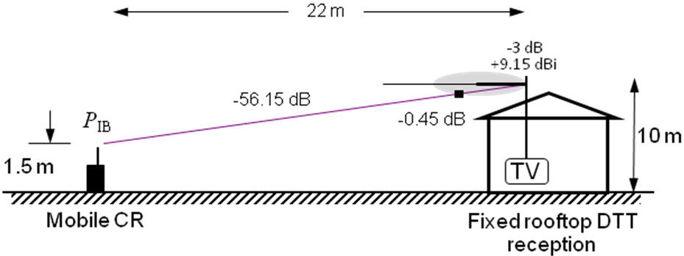
Figure 1 – Scenario 1: mobile WSD transmission and fixed roof-top DTT reception.

P
IB
Fixed rooftop DTT
reception
TV
-
54.72 dB
Portable WSD
from n^{th} story window
10 m
-
16 dB
+9.15
dBi

20m
Figure 2 – Scenario 2: mobile WSD transmission at 10 m agl
and fixed roof-top DTT reception.

2 m
1.5 m
1.5 m
Mobile DTT reception at 1.5 m agl
WSD
DTT
-34.72 dB
Figure 3 – Scenario 3: mobile WSD transmission at 1.5 m agl and mobile DTT reception at 1.5 m agl.
P
IB
Fixed rooftop DTT reception
TV
-
54.72 dB
Fixed WSD
10 m
-
16 dB
+9.15
dBi
H-polar
Slant-polar
20m
Figure 4 – Scenario 4: fixed WSD transmission and fixed DTT
reception at 10 m agl.

Mobile DTT reception
P
IB
-
- 55.45 dB
Fixed WSD
1.5 m
20m
10 m
Figure 5 – Scenario 5: fixed WSD transmission at 10 m agl and mobile DTT reception at 1.5 m agl.
The relevant parameters of each scenario are summarized in Table 5. The total loss in each scenario will be used to define the maximum EIRP for each type of WSD. The attenuation diagram of DTT receiver antenna came from recommendation ITU-R BT. 419-3.

Table 5 – Link parameters for each of the five described scenarios
 | Distance [m] | DTT height [m] | WSD height [m] | Polarization discrimination [dB] | Rx Antenna discrimination [dB] | Tx antenna attenuation [dB] | Total Loss [dB]
Scenario 1 | 22 | 10 | 1.5 | - | 0.45 | - | 56.6
Scenario 2 | 20 | 10 | 10 | - | - | - | 54.72
Scenario 3 | 2 | 1.5 | 1.5 | - | - | - | 34.72
Scenario 4 | 22 | 10 | 10 | 3 | - | - | 57.72
Scenario 5 | 20 | 1.5 | 10 | - | - | 10 | 65.45

  - Assumptions:
- Applying the criterion of 0.1% degradation in location probability inside the DTT coverage area, which is divided in layers according to the DTT received field strength.
- Using degradation in location probability and overloading thresholds as protection criteria.
- Single interferers are considered. We assume that there will be a media access control for WSD transmission, i.e. for technical reasons it is unlikely to have more than one interferer using the same channel, in the same location at the same time. Furthermore, some of the reference worst-case geometries used to calculate WSD maximum EIRP do not allow the presence of more than one interferer. This topic is discussed in document - Further analysis on EIRP limits for WSDs.
- Use of reference worst-case geometries to calculate the maximum WSD EIRP.
- DTT fixed receivers are considered to use silicon-type tuners implemented in set-top boxes and/ or integrated TV (iDTV).
- DTT portable receivers are considered to use silicon-type tuners implemented in small USB-type devices.
- Simulation Methodology and Results
The simulation methodology is based on Monte Carlo simulations where the DTT wanted signal and the interference from the WSD are modeled as statistical variables with normal distribution as follows:
- $E_{wmed} [dBμV/m] \sim N\left(E_{wmed}, σ_{S}=5.5\right)$ is the median field strength of the wanted signal at the DTT receiver input, with mean $E_{wmed}$ and standard deviation $σ_{w}$;
- $E_{imed} [dBμV/m] \sim N\left(E_{imed}, σ_{I}=3.5\right)$ is the median field strength of the interference at the DTT receiver input, with mean $E_{imed}$ and standard deviation $σ_{I}$.

3.1 Calculation of location probability in the absence of interference
At the coverage edge, where 95% of the locations are covered, the minimum median field strength at 650 MHz for a fixed DTT reception is $E_{wmed_ref}=56.21 dBμV/m.$ For a portable DTT reception, the minimum median field strength at the same frequency is $E_{wmed_ref}= 61.21 dBμV/m$(from ECC Report 159, Table 1). The standard deviation of the wanted DTT signal, from ITU-R 1546, is $σ_{s}= 5.5 dB$and the standard deviation of the interference from the WSD is $σ_{i}=3.5 dB$, from Hata model when dealing with short distances.
The DTT location probability is defined as the probability with which a DTT receiver would operate correctly at a specific location. At the coverage edge, in the absence of noise and interference from other DTT transmitters, the location probability can be calculated as:
$$LP_{}=\operatorname{Pr}\left( E_{wmed}≥ E_{wmed_ref}\right)$$
The variation of the location probability with the minimum median field strength, $E_{wmed}$ at 650 MHz, is shown in Figure 6 for both fixed and portable DTT reception. The values of $E_{wmed}$ marked in the curve are summarized in Table 6. The values of $E_{wmed }$in yellow in this table represent the minimum median field strength at the coverage edge. The following values represent layers inside the DTT coverage area where the received median field strength is${ E}_{wmed_ref}+Δ_{dB}$. The value of $Δ_{dB}$ depends on the detail of the information present at the database. In this contribution, the results are shown in layers with $Δ=5 dB$, from the edge of the coverage area until the ${ E}_{wmed_ref}+30 dB$. The optimum value of $Δ_{dB}$this interval is a topic left for further studies.
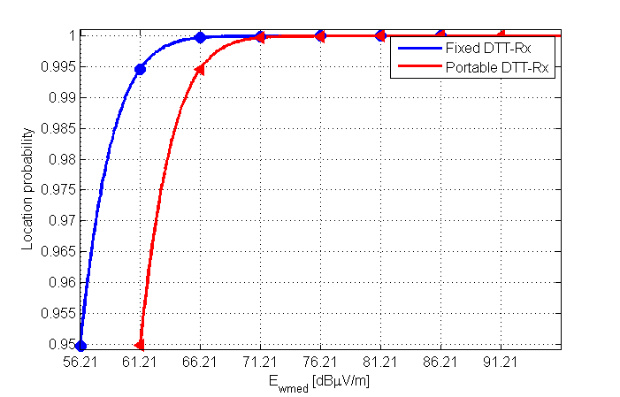
Figure 6 - Location probability as a function of the minimum median field strength for fixed and portable DTT-Rx.

Table 6 – Location probability for fixed DTT-Rx as a function of${ E}_{med}$, for fixed and portable DTT-Rx.
Location Probability - $LP_{1}$ | $$E_{wmed}[dBμV/m ]$$  Fixed DTT-Rx | $$E_{wmed}[dBμV/m ]$$  Portable DTT-Rx
95% | 56.21 | 61.21
99.46% | 61.21 | 66.21
99.97% | 66.21 | 71.21
100% | 71.21 | 76.21
100% | 76.21 | 81.21
100% | 81.21 | 86.21
100% | 86.21 | 91.21

3.2 Calculation of location probability in the presence of interference
After calculating the location probability in the absence of interference, it is possible to calculate the mean interference field strength,$E_{imed} [dBμV/m]$, that degrades $LP_{1}$. The new expression of location probability considering one interfering source can be written as
$LP_{WSD}=Pr⁡( E_{wmed }≥E_{wmed_ref}+E_{imed})$.
The received signal from DTT-Tx and the interference are modeled as statistical variables with normal distribution. Through Monte Carlo simulation it was possible to trace the relationship between the location probability and $E_{imed}$ for different values of$E_{med}$, i.e. in different regions inside the coverage area. As $E_{imed}$ is calculated at the receiver input it is necessary to consider relevant protection ratios for each combination of WSD – DTT-Rx.
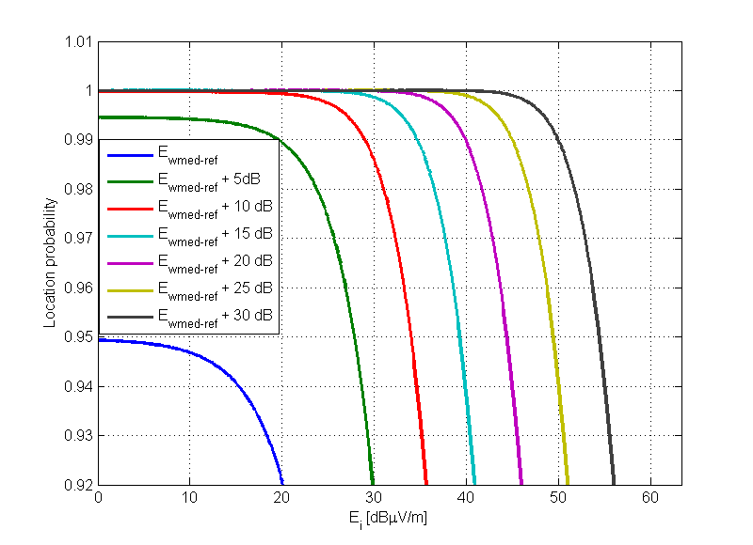
Figure 7 - Location probability as a function of $E_{i}$for different values of $E_{med}$ for fixed DTT-Rx.
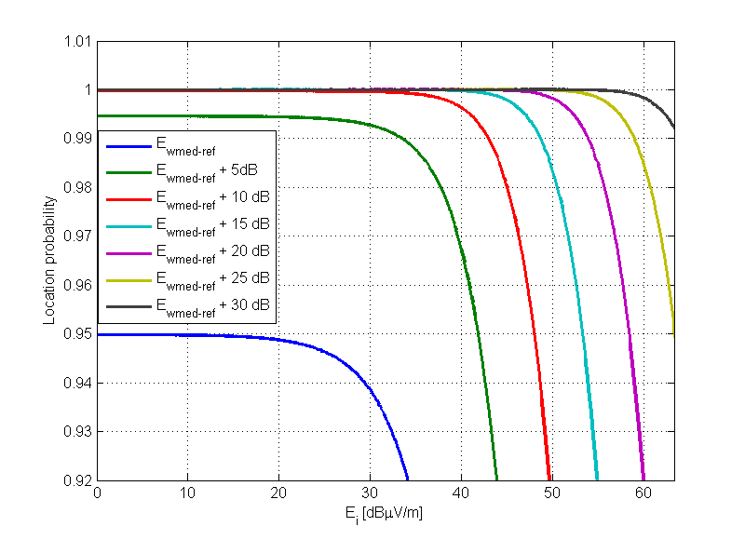
Figure 8 - Location probability as a function of $E_{i}$for different values of $E_{wmed}$ for portable DTT-Rx.
Table 7 summarizes the results of $E_{imed}$ for $ΔLP=0.1\%$ and for different values of $E_{wmed}$. As expected, as the value of $E_{wmed}$ increases, the value of $E_{imed}$necessary to degrade the location probability also increases.
Table 7 - Values of $E_{imed}$for $ΔLP=0.1\%$, considering Fixed and Portable DTT reception in co-channel operation - $f=650 MHz$
$$E_{wmed}$$ | $$E_{imed}[dBμV/m ]$$  Fixed DTT-Rx – co-channel | $$E_{imed}[dBμV/m ]$$  Portable DTT-Rx – co-channel
$$E_{wmed_ref}$$ | 5.4083 | 19.5083
$E_{wmed_ref}$ + 5 dB | 13.6083 | 27.4083
$E_{wmed_ref}$ + 10 dB | 22.5083 | 36.4083
$E_{wmed_ref}$ + 15 dB | 29.2083 | 43.3083
$E_{wmed_ref}$ + 20 dB | 34.7083 | 48.8083
$E_{wmed_ref}$ + 25 dB | 39.8083 | 54.0083
$E_{wmed_ref}$ + 30 dB | 44.9083 | 58.8083
It is also important to notice that the values of $E_{imed}$ presented in Figure 7, in Figure 8 and in Table 7 are related to co-channel operation: they already consider the receiver antenna gain (for fixed reception) and the co-channel protection ratio$PR(0)$, following the analyses described in ECC Report 159, Annex 6. The analysis in different channels relies on the values of protection ratio for different combinations of WSD types and DTT Rx receivers.
In adjacent channels, where the protection ratio is lower than the co-channel protection ratio, it is expected to observe an increase in the maximum $E_{imed}$ to cause the same degradation in location probability. In fact, the value of $E_{imed}$ is increased by a value of $PR\left(0\right)-PR(Δf)$, which is the difference between the protection ratio in the selected channel and in co-channel:
$$E_{imed_{adj}}=E_{imed_{cochannel}}+\left(PR\left(0\right)-PR\left(Δf\right)\right).$$
Table 8 shows values of $PR\left(0\right)-PR\left(Δf\right)$ for different combinations of WSD types and DTT receiver types.
Table 8 – Difference between co-channel protection ratios and adjacent channels protection ratios.
Type of WSD | $PR\left(0\right)-PR\left(Δf\right)$ [dB]
Type of WSD | DTT-Rx fixed |  | DTT-Rx portable
Type of WSD | 1st adjacent channel | 2nd adjacent channel | 1st adjacent channel | 2nd adjacent channel
Fixed WSD | 54.00 | 61.00 | 52.00 | 55.00
Portable WSD | 34.00 | 60.00 | 37.00 | 50.00

Figure 9 and Figure 10 show the maximum $E_{imed}$ to cause a degradation of 0.1% in location probability, in different channels, following Equation (3) and the values presented in Table 8. It was considered that the co-channel protection ratio for each type of DTT receiver had the same value, independent of the type of WSD (21 dB for fixed DTT and 19 dB for portable DTT), so the values of $E_{imed}$ in the co-channel were the same.
In the first and in the second adjacent channels, the differences of protection ratio are those presented in Table 8 – difference of the co-channel protection ratio and adjacent channel protection ratios from Table 1 and Table 2. As portable WSDs have a greater difference in the values of protection ratio between the 1st and the 2nd adjacent channels, the values of $E_{imed}$ also present this difference.
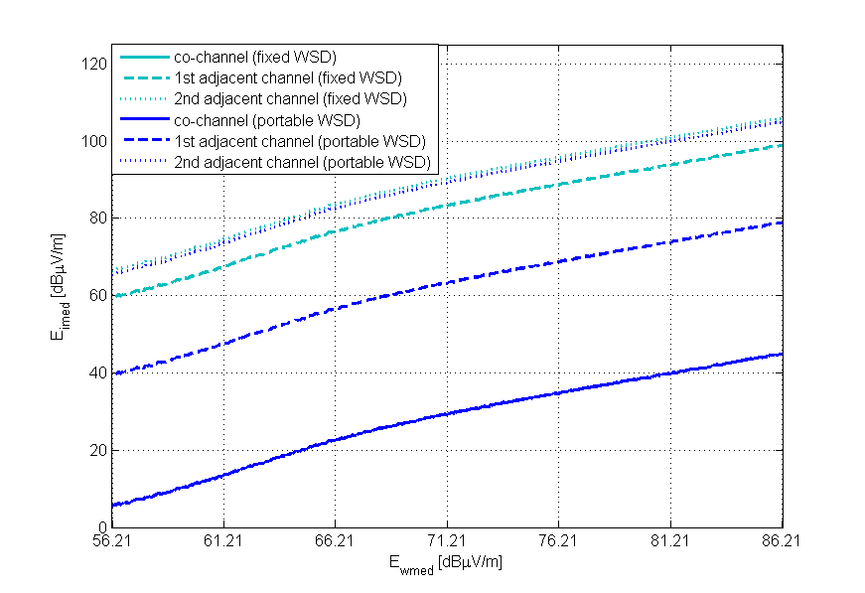
Figure 9 - $E_{imed}$ as a function of $E_{wmed}$ in different channels for fixed DTT reception and ΔLP=0.1%.
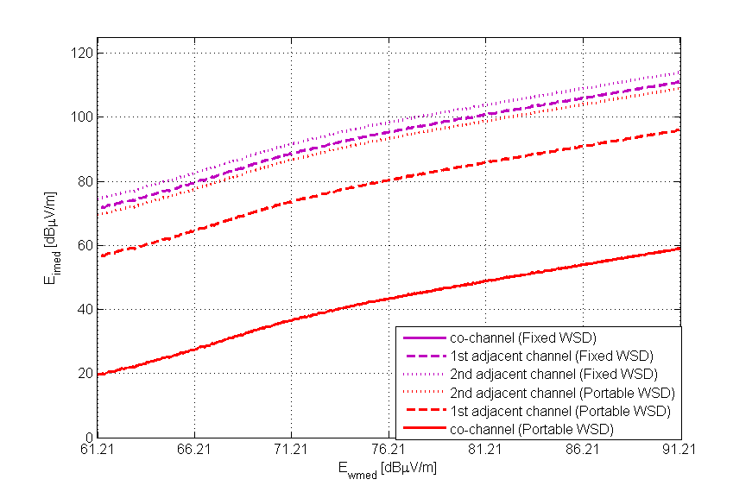
Figure 10 - $E_{imed}$ as a function of $E_{wmed}$ in different channels for portable DTT reception and ΔLP=0.1%.

Now that the protection criterion of a degradation of 0.1% in location probability is satisfied, it is necessary to verify if the interference caused by WSDs is sufficient to overload the DTT receivers, according to the overloading thresholds presented in Table 3 and in Table 4. In each layer, the value of $I_{\left[dBm\right]}$, the maximum interference allowed at the DTT receiver input, can be written as:
$$I_{\left[dBm\right]}={E_{imed}}_{\left[dBμV/m\right]}-20\log_{10}\left(f_{\left[MHz\right]}\right)-77.2 .$$

Table 9 and Table 10 summarize the results for the 1st and 2nd adjacent channels, as the use of co-channel inside the DTT coverage area is improbable.
Table 9 – Interference and overloading values for fixed DTT-reception in the 1st and in the 2nd adjacent channels.
 | $I_{\left[dBm\right]}$Fixed WSD |  | $I_{\left[dBm\right]}$Portable WSD
$$E_{wmed}$$ | 1st adjacent channel | 2nd adjacent  channel | 1st adjacent channel | 2nd adjacent  channel
$$E_{wmed_ref}$$ | -74.05 | -67.05 | -94.05 | -68.05
$E_{wmed_ref}$ + 5 dB | -65.85 | -58.85 | -85.85 | -59.85
$E_{wmed_ref}$ + 10 dB | -56.95 | -49.95 | -76.95 | -50.95
$E_{wmed_ref}$ + 15 dB | -50.25 | -43.25 | -70.25 | -44.25
$E_{wmed_ref}$ + 20 dB | -44.75 | -37.75 | -64.75 | -38.75
$E_{wmed_ref}$ + 25 dB | -39.65 | -32.65 | -59.65 | -33.65
$E_{wmed_ref}$ + 30 dB | -34.55 | -27.55 | -54.55 | -28.55
O^{th} [dBm] | -13 | -7 | -20 | -25.50

Table 10- Interference and overloading values for portable DTT-reception in the 1st and in the 2nd adjacent channels.
 | $I_{\left[dBm\right]}$Fixed WSD |  | $I_{\left[dBm\right]}$Portable WSD
$$E_{wmed}$$ | 1st adjacent channel | 2nd adjacent  channel | 1st adjacent channel | 2nd adjacent  channel
$$E_{wmed_ref}$$ | -61.95 | -58.95 | -76.95 | -63.95
$E_{wmed_ref}$ + 5 dB | -54.05 | -51.05 | -69.05 | -56.05
$E_{wmed_ref}$ + 10 dB | -45.05 | -42.05 | -60.05 | -47.05
$E_{wmed_ref}$ + 15 dB | -38.15 | -35.15 | -53.15 | -40.15
$E_{wmed_ref}$ + 20 dB | -32.65 | -29.65 | -47.65 | -34.65
$E_{wmed_ref}$ + 25 dB | -27.45 | -24.45 | -42.45 | -29.45
$E_{wmed_ref}$ + 30 dB | -22.65 | -19.65 | -37.65 | -24.65
O^{th} [dBm] | -26 | -22 | -27 | -47

Neither of the interference values presented in Table 9 was sufficient to overload a fixed DTT receiver (assuming a silicon-type tuner). However, when portable DTT-reception was considered, the maximum $E_{imed}$ reached the overloading threshold in the second adjacent channel for both fixed and portable WSDs (highlighted values in Table 10) and in the first adjacent channel for a fixed WSD, i. e. the receivers lost their ability to discriminate against interfering signals and may behave in a non-linear way.
  - Using the overloading threshold as a protection criteria
The analysis done in the last section showed that the overloading threshold even when the protection criterion of degradation in location probability was observed.
In order to protect those DTT receivers, document SE43(11)12 proposed to set a fixed limit for the maximum interference caused by a WSD, which respects the reference values of overloading thresholds. Using the overloading thresholds as a second protection criterion, we obtained the values in Table 11 as the maximum interference that a WSD can cause into a DTT receiver input. For fixed DTT-reception, as the overloading threshold was not reached, the maximum interference limits are those from Table 9.
Table 11 – Maximum interference values for portable DTT-reception in the 1st and in the 2nd adjacent channels
 | $I_{\left[dBm\right]}$Fixed WSD |  | $I_{\left[dBm\right]}$Portable WSD
$$E_{wmed}$$ | 1st adjacent channel | 2nd adjacent  channel | 1st adjacent channel | 2nd adjacent  channel
$$E_{wmed_ref}$$ | -61.95 | -58.95 | -76.95 | -63.95
$E_{wmed_ref}$ + 5 dB | -54.05 | -51.05 | -69.05 | -56.05
$E_{wmed_ref}$ + 10 dB | -45.05 | -42.05 | -60.05 | -47.05
$E_{wmed_ref}$ + 15 dB | -38.15 | -35.15 | -53.15 | -47.00
$E_{wmed_ref}$ + 20 dB | -32.65 | -29.65 | -47.65 | -47.00
$E_{wmed_ref}$ + 25 dB | -27.45 | -24.45 | -42.45 | -47.00
$E_{wmed_ref}$ + 30 dB | -26.00 | -22.00 | -37.65 | -47.00

  - Maximum WSD EIRP limits
After determining the maximum interference that degrades the location probability in 0.1% and respects the overloading thresholds, the maximum WSD EIRP can be calculated. In order to determine the WSD transmit power limits, it is necessary to consider the reference geometries presented in section 2.2. For each one of the five scenarios, the EIRP can be written as:
$$EIRP_{\left[dBm\right]}=I_{\left[dBm\right]}+LOSS,$$
where $LOSS$ is the total loss from Table 5, and $I_{\left[dBm\right]}$ is the maximum interference considering the overloading threshold - Table 9 and Table 11. The results in each layer and in each scenario are presented in Table 12.
Table 12 - Maximum WSD EIRP [dBm] considering the 10th percentile of overloading thresholds [dBm]
Layer | Fixed DTT |  | Fixed DTT |  | Portable DTT |  | Fixed DTT |  | Portable DTT
Layer | Portable WSD |  | Portable WSD |  | Portable WSD |  | Fixed WSD |  | Fixed WSD
Layer | Scenario 1 |  | Scenario 2 |  | Scenario 3 |  | Scenario 4 |  | Scenario 5
Layer | 1st adj | 2nd adj | 1st adj | 2nd adj | 1st adj | 2nd adj | 1st adj | 2nd adj | 1st adj | 2nd adj
$$E_{wmed_ref}$$ | -37.4 | -11.4 | -39.3 | -13.3 | -42.2 | -29.2 | -16.3 | -9.3 | 3.5 | 6.5
$E_{wmed_ref}$ + 5 dB | -29.2 | -3.2 | -31.1 | -5.1 | -34.3 | -21.3 | -8.1 | -1.1 | 11.4 | 14.4
$E_{wmed_ref}$ + 10 dB | -20.3 | 5.7 | -22.2 | 3.8 | -25.3 | -12.3 | 0.8 | 7.8 | 20.4 | 23.4
$E_{wmed_ref}$ + 15 dB | -13.6 | 12.4 | -15.5 | 10.5 | -18.4 | -12.3 | 7.5 | 14.5 | 27.3 | 30.3
$E_{wmed_ref}$ + 20 dB | -8.1 | 17.9 | -10.0 | 16.0 | -12.9 | -12.3 | 13.0 | 20.0 | 32.8 | 35.8
$E_{wmed_ref}$ + 25 dB | -3.0 | 23.0 | -4.9 | 21.1 | -7.7 | -12.3 | 18.1 | 25.1 | 38.0 | 41.0
$E_{wmed_ref}$ + 30 dB | 2.1 | 28.1 | 0.2 | 26.2 | -2.9 | -12.3 | 23.2 | 30.2 | 39.5 | 43.5

The highlighted columns in Table 12 show the most restrictive cases of interference for each WSD device type. Scenario 3 is the worst case scenario for portable WSD while Scenario 4 is the worst case scenario for fixed WSDs. In scenario 3, where the overloading limits were achieved, in the last two layers the maximum EIRP in the 1st adjacent channel was higher than in the 2nd adjacent channel, due to the worse receiver performance in the presence of interference at the 2nd adjacent channel.
It is important to stress that those limits were obtained considering the performance of the 10% worst DTT receivers together with worst case reference geometries. If we considered the overloading threshold for 50% of the receivers, for example, the maximum power values would be:

Table 13 - Maximum WSD EIRP [dBm] considering the 50th percentile of overloading thresholds [dBm]
Layer | Fixed DTT |  | Fixed DTT |  | Portable DTT |  | Fixed DTT |  | Portable DTT
Layer | Portable WSD |  | Portable WSD |  | Portable WSD |  | Fixed WSD |  | Fixed WSD
Layer | Scenario 1 |  | Scenario 2 |  | Scenario 3 |  | Scenario 4 |  | Scenario 5
Layer | 1st adj | 2nd adj | 1st adj | 2nd adj | 1st adj | 2nd adj | 1st adj | 2nd adj | 1st adj | 2nd adj
$$E_{wmed_ref}$$ | -37.4 | -11.4 | -39.3 | -13.3 | -42.2 | -29.2 | -16.3 | -9.3 | 3.5 | 6.5
$E_{wmed_ref}$ + 5 dB | -29.2 | -3.2 | -31.1 | -5.1 | -34.3 | -21.3 | -8.1 | -1.1 | 11.4 | 14.4
$E_{wmed_ref}$ + 10 dB | -20.3 | 5.7 | -22.2 | 3.8 | -25.3 | -12.3 | 0.8 | 7.8 | 20.4 | 23.4
$E_{wmed_ref}$ + 15 dB | -13.6 | 12.4 | -15.5 | 10.5 | -18.4 | -5.4 | 7.5 | 14.5 | 27.3 | 30.3
$E_{wmed_ref}$ + 20 dB | -8.1 | 17.9 | -10.0 | 16.0 | -12.9 | 0.1 | 13.0 | 20.0 | 32.8 | 35.8
$E_{wmed_ref}$ + 25 dB | -3.0 | 23.0 | -4.9 | 21.1 | -7.7 | 4.7 | 18.1 | 25.1 | 38.0 | 41.0
$E_{wmed_ref}$ + 30 dB | 2.1 | 28.1 | 0.2 | 26.2 | -2.9 | 4.7 | 23.2 | 30.2 | 42.8 | 45.8

The difference between the EIRP values obtained in Table 12 and Table 13, especially in Scenario 3, shows the importance of selecting appropriate overloading thresholds for each device type. This information is mandatory for adjusting the EIRP values according to the WSD characteristics.
    - Probability of occurrence of worst-case geometries
The previous subsection addressed the calculation of maximum EIRP based on the worst case scenarios described in section 2.2. However, considering the position of the interferers as well as the antenna directivity pattern described in ITU-R 419-3, the contribution further analysis on EIRP limits for WSDs investigated the probability of occurrence of scenario 4 in a 100m x 100m pixel. The results are presented in Figure 11.
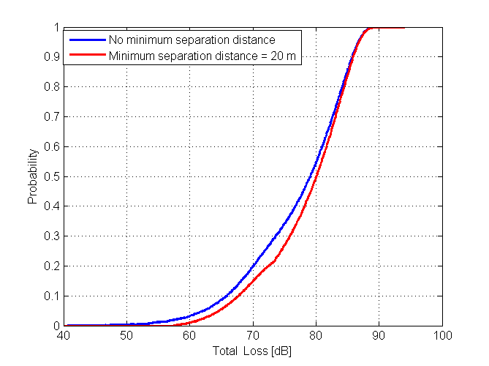
Figure 11- Cumulative distribution of total loss inside a pixel for Scenario 4.
The probability of scenario 4, when considering the minimum separation distance between DTT receiver and WSD interferer, is in the order of 0.5%. When considering no minimum separation distance, the probability of a path loss lower than 57.72 dB increases to 2%.
If we apply the same methodology described previously to calculate the maximum WSD EIRP, considering the probability of occurrence of total loss inside a pixel, instead of worst case reference geometries, it is possible to trace a relationship between the maximum EIRP and the total loss. Figure 12 and Figure 13 illustrate the results considering a fixed WSD at 10 m, and a fixed DTT receiver at 10 m.
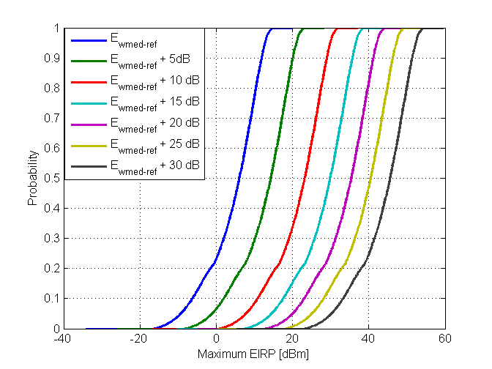
Figure 12 - Maximum WSD EIRP values in the 1st adjacent channel,
considering fixed DTT reception and fixed WSD.
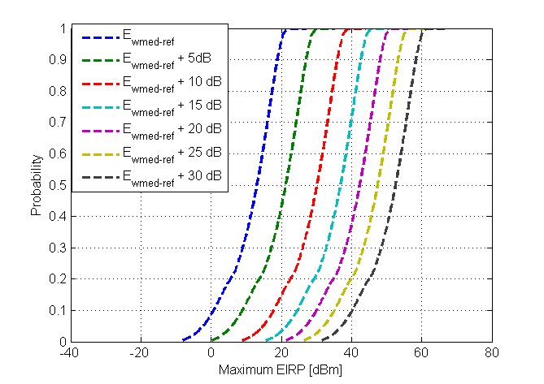
Figure 13 - Maximum WSD EIRP values in the 2nd adjacent channel,
considering fixed DTT reception and fixed WSD.
In the cumulative curves, the worst case geometries are represented by the 2% of EIRP values, i.e. the calculated maximum EIRP is limited by a scenario with a low probability inside a pixel.
- Conclusions
This contribution has shown results of maximum WSD EIRP calculation in different layers inside the DTT coverage area, determined by the received median field strength. In each layer, the criterion of 0.1% of degradation in location probability was applied in order to set the EIRP limits for white space devices.
The criterion of degradation in location probability was considered highly suitable for metric to quantify the impact of WSD interference in DTT receivers, in ECC Report 159. Following the methodology suggested in the same report, it was possible to calculate maximum interference field strengths that cause the limit of 0.1% degradation in location probability.
It was shown that the use of this criterion to determine maximum interference limits was not sufficient to overload fixed DTT receivers. The same was not observed for portable receivers. It has been shown that the maximum interference limits calculated observing the limit of degradation in location probability, caused overloading in portable DTT receivers. Considering interference from portable white space devices, the overloading occurred in the 2nd adjacent channel from the fourth layer, where the mean received field strength was 15 dB higher than in the edge of the coverage area. Considering interference from fixed white space devices, the overloading occurred in the 1st and 2nd adjacent channels in the last layer, where the mean received field strength was 30 dB higher than in the edge of the coverage area.
To avoid overloading DTT receivers, overloading thresholds were used as protection criterion to set maximum WSD-DTT interference limits. Those interference limits were used together with reference worst case geometries to set maximum WSD EIRP for each type of device. As the WSD EIRP was limited by overloading threshold values, it is suggested to establish definitive reference values for each device type.

INdT (Nokia Institute of Technology) is a non-profit research and development institute founded by Nokia in Brazil.

