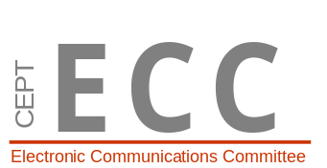 |  | SE43(11)Info 08

10th meeting of SE43
Bologna, 5 – 7 July 2011
Date issued: | 4th of July 2011
Source: | Wise Project
Subject: | WSD Maximum Power Measurement Report

Summary: | A measurement campaign to study the WSD maximum power was organized as part of the Finnish WISE-project. WISE (White space test environment for broadcast frequencies) is a project with the aim to construct an open, cognitive radio geolocation database test bed for studying the use of cognitive radios in the UHF television broadcast bands. This includes simulations, test database, test network and measurement platform. The project partners are Aalto University, Digita, Fairspectrum, Ficora, Nokia, University of Turku, Turku University of Applied Sciences and it is funded by Tekes, the national technology funding organization, as part of a larger cognitive radio Trial-program.
Proposal: | For information to the SE43
 | 

Password protection required? (Y/N) | N

