ECC Report <No>

Compatibility and sharing studies of PMSE video links, DECT and PPDR with incumbent services and with DA2GC in the 2 GHz unpaired bands
Approved DD Month YYYY (Arial 9pt bold)
[last updated: DD Month YYYY) (Arial 9pt) [date of the latest update]]

Executive summary
This ECC Reports considers compatibility issues concerning a possible implementation of DA2GC and PMSE within the 2 GHz unpaired bands based on a Commission Mandate to CEPT to undertake studies on the harmonised technical conditions for the 1900-1920 MHz and 2010-2025 MHz frequency bands in the EU with the purpose to assess and identify alternative uses of the unpaired terrestrial 2 GHz band other than for the provision of mobile electronic communications services (as introduced by the UMTS Decision).
Both applications,
- Broadband Direct Air-to-Ground Communications, preferably in a paired spectrum arrangement
- PMSE, preferably for use by wireless cameras
are part of a shortlist of potential harmonised uses of the 1900-1920 MHz and 2010-2025 MHz frequency bands to be given priority in this Mandate.
Two different approaches are considered dependent on the implementation of forward and reverse link of the DA2GC system in each of the 2 GHz unpaired band, taking into account a spectrum demand of 2 x 10 MHz for FDD or 20 MHz for TDD DA2GC. Both radio applications PMSE links and Broadband DA2GC are considered as a potential interferer and as a potential victim. As spectrum preferably for use by wireless cameras is looked for, the corresponding three PMSE scenarios, cordless camera links (CCL), mobile video links (MVL) and portable video links (PVL) are considered. The evaluation results are based on worst case single link scenarios between the interferer and the victim system.
It is concluded that adjacent-channel operation of DA2GC and PMSE video links (CCL, MVL and PVL) is feasible with separation distances and some mitigation techniques depending on the PMSE scenario.
Co-channel operation of DA2GC FL and PMSE CCL would be feasible with less CCL Tx/Rx antenna gain and/or less CCL Tx power than used in the calculations. Co-channel operation of DA2GC RL and PMSE CCL is not feasible due to the high exceeding of the protection criterion of the CCL Rx.
Co-channel operation of PMSE MVL/PVL transmissions and the DA2GC RL would also be feasible with sufficient separation distances. However, co-channel operation of DA2GC RL and PMSE MVL/PVL is not feasible due to the high exceeding of the protection criterion of the MVL/PVL Rx.
The results presented in this ECC Report are expected to be taken into account in the development of harmonised technical conditions for the 1900-1920 MHz and 2010-2025 MHz frequency bands.

TABLE OF CONTENTS

0 Executive summary 2
1 Introduction 7
2 Definitions 8
3 DA2GC implementation alternatives 9
3.1 DA2GC FL in the lower band, RL in the upper band 9
3.2 DA2GC RL in the lower band, FL in the upper band 10
3.3 Interference scenarios 11
1) DA2GC FL in lower and RL in upper band 11
2) DA2GC RL in lower and FL in upper band 11
4 Technical characteristics 12
4.1 Broadband DA2GC system 12
4.2 PMSE wireless video links 15
4.2.1 PMSE wireless video link scenarios selected for the studies 15
4.2.2 Cordless camera link 16
4.2.3 Portable video link 17
4.2.4 Mobile video link from a ground vehicle 19
4.2.5 PMSE wireless video link characteristics used in the studies 19
4.3 UMTS BS technical characteristics 22
5 Results of the compatibility evaluations 24
5.1 General remarks 24
5.2 DA2GC FL in the band 1900-1920 MHz 24
5.2.1 Scenario (1a) 24
5.2.1.1 PMSE CCL Rx interfered by a DA2GC GS 24
5.2.1.2 PMSE MVL Rx at helicopter interfered by a DA2GC GS 26
5.2.1.3 PMSE PVL Rx interfered by a DA2GC GS 27
5.2.2 Scenario (1b) 28
5.2.2.1 DA2GC AS interfered by a PMSE CCL Tx 28
5.2.2.2 DA2GC AS interfered by a PMSE MVL Tx at motorcycle 29
5.2.2.3 DA2GC AS interfered by a PMSE PVL Tx 31
5.3 DA2GC RL in the band 2010 – 2025 MHz 32
5.3.1 Scenario (1c) 32
5.3.1.1 PMSE CCL Rx interfered by a DA2GC AS 32
5.3.1.2 PMSE MVL Rx at helicopter interfered by a DA2GC AS 33
5.3.1.3 PMSE PVL Rx interfered by a DA2GC AS 35
5.3.2 Scenario (1d) 36
5.3.2.1 DA2GC GS interfered by a PMSE CCL Tx 36
5.3.2.2 DA2GC GS interfered by a PMSE MVL Tx at motorcycle 36
5.3.2.3 DA2GC GS interfered by a PMSE PVL Tx 37
5.4 DA2GC RL in the band 1900 – 1920 MHz 38
5.4.1 Scenario (2a) 38
5.4.1.1 PMSE CCL Rx interfered by a DA2GC AS 38
5.4.1.2 PMSE MVL Rx at helicopter interfered by a DA2GC AS 39
5.4.1.3 PMSE PVL Rx interfered by a DA2GC AS 39
5.4.2 Scenario (2b) 39
5.4.2.1 DA2GC GS interfered by a PMSE CCL Tx 39
5.4.2.2 DA2GC GS interfered by a PMSE MVL Tx at motorcycle 40
5.4.2.3 DA2GC GS interfered by a PMSE PVL Tx 40
5.5 DA2GC FL in the band 1900 – 1920 MHz 41
5.5.1 Scenario (2c) 41
5.5.1.1 PMSE CCL Rx interfered by a DA2GC GS 41
5.5.1.2 PMSE MVL Rx at helicopter interfered by a DA2GC GS 41
5.5.1.3 PMSE PVL Rx interfered by a DA2GC GS 41
5.5.2 Scenario (2d) 41
5.5.2.1 DA2GC AS interfered by a PMSE CCL Tx 41
5.5.2.2 DA2GC AS interfered by a PMSE MVL Tx at motorcycle 42
5.5.2.3 DA2GC AS interfered by a PMSE PVL Tx 42
5.6 PMSE in the band 1900-1920 MHz vs. MFCN 42
5.6.1 Result and analysis for a cordless camera link 43
5.6.2 Result and analysis for a portable video link 43
5.6.3 Result and analysis for a mobile video link 44
6 Conclusions 45
ANNEX 1: potential for the beamforming DA2GC system described in ETSI TR 101 599 to operate in spectrum adjacent to PMSE systems within the 2GHz unpaired bands 48
ANNEX 2: List of reference 50

LIST OF ABBREVIATIONS

Abbreviation | Explanation
ACIR  ACLR  ACS  AS  BS  CEPT  CGC  DA2GC  DEC  DECT | Adjacent Channel Interference Ratio  Adjacent Channel Leakage Ratio  Adjacent Channel Selectivity  Aeronautical Station  Base Station  European Conference of Postal and Telecommunications Administrations  Complementary Ground Component  Direct Air to Ground Communications  Decision  Digital Enhanced Cordless Telecommunications
ECC  ECO  EESS  EIRP  ENG  ERM  ETSI  FDD  FL  GS  GSM  GUI  I  I/N  ITU-R  LTE  MSS  MVL  OB  OBU  PMSE  PPDR  RB  RL  Rx  SAB  SAP  SEAMCAT  SEM  SRD  TDD  TR  TRR  Tx  UE  UMTS  w  w/o  WiFi | Electronic Communications Committee  European Communications Office  Earth Exploration Satellite Service  Equivalent Isotropically Radiated Power  Electronic News Gathering  Electromagnetic compatibility and Radio spectrum Matters  European Telecommunications Standards Institute  Frequency Division Duplex  Forward Link  Ground Station  Global System for Mobile Communications  Graphical User Interface  Interference  Interference to Noise  International Telecommunication Union - Radiocommunication Sector  Long Term Evolution  Mobile Satellite Service  Mobile Video Link  Outside Broadcasting  Onboard Unit  Programme Making and Special Events  Public Protection and Disaster Relief  Resource Block  Return Link  Receiver  Services Ancillary to Broadcasting  Services Ancillary to Programme making  Spectrum Engineering Advanced Monte Carlo Analysis Tool  Spectrum Emission Mask  Short Range Device  Time Domain Duplex  Technical Report  Tactical Radio Relay  Transmitter  User Equipment  Universal Mobile Telecommunications System  With  Without  Wireless Fidelity

Introduction
The ECC/DEC/(06)01 which initially entered into force on 24 March 2006 and addressed both paired (1920-1980 MHz and 2110-2170 MHz) and unpaired (1900-1920 MHz and 2010-2025 MHz) frequency bands aimed at providing a common approach for planning and use of spectrum including channel arrangements. The revision of ECC/DEC/(06)01 was preceded by a questionnaire on the use of the unpaired 2 GHz bands in 2010. Further updated information on the current status of individual authorisations in force on the unpaired 2 GHz bands can be found in ECO Report 03.

The frequency bands 1900-1920 MHz and 2010-2025 MHz were individually licensed years ago in many countries for UMTS TDD. However, in most of the countries these bands are currently not in use. Frequency arrangements for these frequency bands have been removed from the revision of the ECC Decision (06)01, which entered into force 2nd November 2012.

The following alternative uses for the unpaired 2 GHz bands have been proposed:

- Use (parts of) the bands 1900-1920 MHz and/or 2010-2025 MHz to satisfy the spectrum demand of 20 MHz TDD or 2x10 MHz FDD for Broadband Direct Air to Ground Communications (DA2CG).
The following options / combinations of bands for Broadband DA2GC would be possible:
    - Use of the band 1900-1920 MHz for TDD Broadband DA2GC (guard bands may be required);
    - Pair 10 MHz of the spectrum in the band 1900-1920 MHz with 10 MHz of the spectrum in the band 2010-2025 MHz for FDD Broadband DA2GC (“internal pairing”, guard bands may be required);
    - Use the remaining 15 MHz within 1900-1920 MHz and 2020-2025 MHz, e.g. for video links and/or other SRDs (guard bands may be required);
    - Sharing options in the spectrum used by BDA2G need to be studied.

- Use of the entire 1900-1920 MHz or 2010-2025 MHz band for PMSE (in particular, video links);

- Use of both bands for SRDs (e.g.: among those applications requiring spectrum in the 2.4 GHz band);

- Combine 1880-1900 MHz (DECT band) with 1900-1920 MHz, making available a 40 MHz block in the long term;

- Ad-hoc PPDR network (potential compatibility to be confirmed).

This Report provides results of compatibility studies between a Broadband DA2GC system located in the unpaired 2 GHz bands (mainly FDD approach assumed [1], but also TDD systems are considered [18]) and PMSE which is also a candidate application for the 2 GHz unpaired bands and already in operation above 2025 MHz on a tuning range basis. The results apply to the operation of PMSE links within the bands 1900-1920 MHz and 2010-2025 MHz as well as above 2025 MHz.

Definitions
Term | Definition
Forward link (FL) | Downlink direction; communication from base station to aircraft.
Return link (RL) | Uplink direction; communication from aircraft to base station.

DA2GC implementation alternatives

This Report considers a Broadband DA2GC system located in the unpaired 2 GHz bands (mainly FDD approach assumed, based on the system described in ETSI TR 103 054 [1] and PMSE which is also a candidate application for the 2 GHz unpaired bands and already in operation above 2025 MHz on a tuning range basis.

Both the transmission and the receiving paths of PMSE links with Broadband DA2GC (both FL (Forward Link) and RL (Reverse Link)) are considered. Both radio applications (PMSE links and Broadband DA2GCare considered as a potential interferer and as a potential victim. A paired arrangement for Broadband DA2GC is taken into account (FL in one band, RL in the other band at 2 GHz). In case the co-channel usage (PMSE links / Broadband DA2GC) and adjacent channel arrangement for these two applications is investigated.

Two different approaches [2] are considered dependent on the implementation of forward and reverse link of the DA2GC FDD system in each of the 2 GHz unpaired band. A possible sharing between DA2GC FL and PMSE – subject to be proven by the studies – is assumed in the implementation overviews. A spectrum demand of 2 x 10 MHz for FDD DA2GC is assumed.

DA2GC FL in the lower band, RL in the upper band
Figure 1 gives an overview of the realization alternative 1: the FL is located in the lower frequency band (1900-1920 MHz) and shared with PMSE video links, whereas the RL is located in the upper frequency band (2110-2025 MHz) having guard bands to adjacent services.

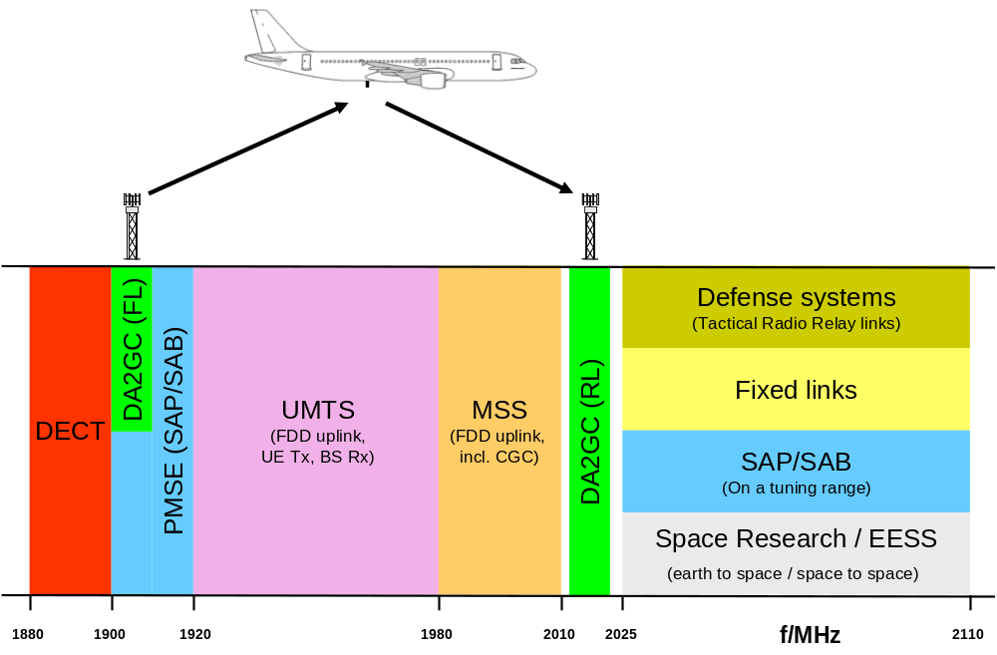
Figure 1: DA2GC compatibility/sharing with PMSE with FL in the lower band

DA2GC RL in the lower band, FL in the upper band
Figure 2 gives an overview of the realization alternative 2: the RL is located in the lower frequency band (1900-1920 MHz), whereas the FL is located in the upper frequency band (2110-2025 MHz) and shared with PMSE video links.

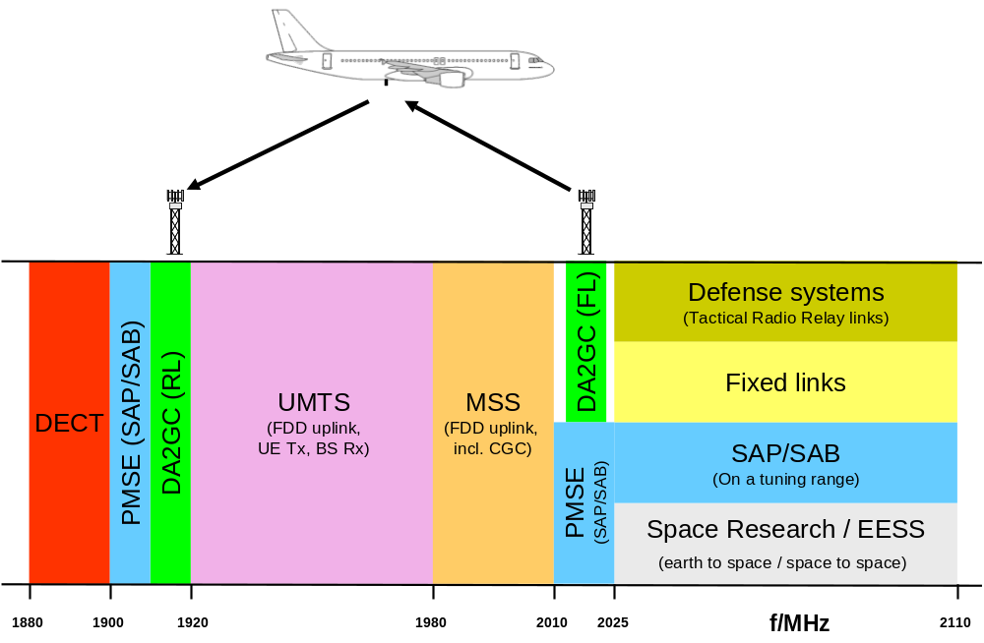
Figure 2: DA2GC compatibility/sharing with PMSE with RL in the lower band

Interference scenarios
Following interference scenarios are evaluated:

1) DA2GC FL in lower and RL in upper band
  - The reception at a PMSE receiver is interfered with by a DA2GC ground station (GS) transmission (DA2GC FL) in co-channel and adjacent (in-band) channel operation.
  - The reception at a DA2GC aircraft station (AS), i.e. the DA2GC FL, is interfered with by a PMSE transmission in co-channel and adjacent (in-band) channel operation.
  - The reception at a PMSE receiver is interfered with by the DA2GC AS transmission (DA2GC RL) in adjacent channel operation.
  - The reception at a DA2GC GS, i.e. the DA2GC RL, is interfered with by a PMSE transmission in adjacent channel operation.

2) DA2GC RL in lower and FL in upper band
  - The reception at a PMSE receiver is interfered with by a DA2GC AS transmission (DA2GC RL) in adjacent (in-band) channel operation.
  - The reception at a DA2GC GS, i.e. the DA2GC RL, is interfered with by a PMSE transmission in adjacent (in-band) channel operation.
  - The reception at a PMSE receiver is interfered with by the DA2GC GS transmission (DA2GC FL) in co-channel and adjacent channel (incl. in-band) operation.
  - The reception at a DA2GC AS, i.e. the DA2GC FL, is interfered with by a PMSE transmission in co-channel and adjacent channel (incl. in-band) operation.

The evaluation results are based on worst case single link scenarios between the interferer and the victim system.

Technical characteristics
Technical characteristics of the broadband DA2GC system, PMSE video links and MFCN base stations used for the sharing and compatibility studies are given in the following subsections.

Broadband DA2GC system
The DA2GC system parameters are primarily based on 3GPP specifications for LTE transmitter and receiver characteristics [3], but some are modified according to the need of the aeronautical use case, mainly related to antenna characteristics of GS and AS as well as Tx power of the AS [1]. Parameters applied in present study are those already listed in [4] - [6].
The following tables provide an overview of the main parameters for the DA2GC GS and AS.
Table 1: Main parameters for DA2GC ground stations (TR 103 054)
Parameter | DA2GC ground station
 | FDD
Base station type | Macro
Environment | Rural
Cell radius (max.) | Up to 100 km
Tx power | 46 dBm
Antenna type | 3 x 120° sector antennas
Antenna gain | Up to 17 dBi
Antenna height | 50 m
Antenna tilt | 10°(up-tilt)  (Note 1)
Channel bandwidth | 2 x 10 MHz (FDD)
Frequency re-use factor | 1
Signal bandwidth (related to number of occupied resource blocks with bandwidth of 180 kHz) | 9 MHz (FDD)
Rx thermal noise | -104.5 dBm (FDD)
Rx noise figure | 5 dB
Rx noise floor | -99.5 dBm (FDD)
Rx reference sensitivity level | -101.5 dBm (FDD)  (Note 2)
Interference protection ratio I/N | -6 dB
Interference protection level | -105.5 dBm (FDD)  (Note 2)
Tx spectrum emission mask (SEM) / Spurious emissions | According to [15]
Adjacent channel leakage ratio (ACLR) limit | 45 dB  (Note 3)
Rx in-band / out-of-band blocking | According to [15]
Rx adjacent channel selectivity (ACS) | 43.5 dB  (according to [15])

Note 1: The antenna up-tilt is dependent on the final characteristic of the antenna and the cell radius to be covered. The value used here is suitable for large cells; for cells with smaller radius the main lobe should have higher up-tilt.
Note 2: In [16] the sensitivity level of -101.5 dBm is also applied for signal bandwidths above 10 MHz, as only up to 25 resource blocks (RB) are assigned to a single UE link, even if more RBs are feasible.
Note 3: In general the ACLR limit given in the table or the absolute limit of -15 dBm/MHz is valid, whichever is less stringent (macro BS according category B) [15].

Table 2: Main parameters for DA2GC aircraft stations (TR 103 054)
Parameter | DA2GC aircraft station
 | FDD
Tx power (max./min.)  (Note 1) | 40 dBm / -23 dBm
Antenna type | Azimuth: Omni-directional  Elevation: See Figure 4
Antenna gain | 6.54 dBi  (Note 2)
Antenna height | 3000 - 13000 m  (Note 3)
Channel bandwidth | 2 x 10 MHz
Signal bandwidth  (related to number of occupied resource blocks with bandwidth of 180 kHz) | 9 MHz
Rx thermal noise | -104.5 dBm
Rx noise figure | 9 dB
Rx noise floor | -95.5 dBm
Rx reference sensitivity level | -97.5 dBm
Interference protection ratio I/N | -6 dB
Interference protection level | -101.5 dBm
Tx spectrum emission mask (SEM) / Spurious emissions | According to [14]
Adjacent channel leakage ratio (ACLR) limit | 37 dB  (Note 4)
Rx in-band / out-of-band blocking | According to [14]
Rx adjacent channel selectivity (ACS) | 33 / 30 / 27 dB for channel bandwidths of 10 / 15 / 20 MHz (according to [14])

Note 1: The Tx power of the mobile station is dependent on the power control implementation applied by the equipment provider.
Note 2: For former evaluation a simple omni-directional characteristic with 0 dBi gain was assumed. The final diagram incl. the gain will be dependent on further antenna optimization steps as well as on limits set by the regulation. In the range just below the horizontal aircraft plane the antenna gain will normally be higher (up to about 6 dBi) to allow access of the OBU to the BS at the cell edge.
Note 3: The current assumption for a DA2GC OBU is that it will not transmit for altitudes below 3000 m as the GSM/WiFi onboard wireless access networks for the passengers have to be switched off below that threshold. In case the airlines are interested to use the DA2GC also for their operational services (non-safety relevant), it has to be clarified with the regulatory authorities under which conditions DA2GC radio links can kept until the aircraft reaches the airport ground (only wired access in the aircraft below the altitude threshold allowed).
Note 4: A higher ACLR value is required to keep the maximum allowed out-of-band emission level given in [14] in case of higher maximum Tx power of up to 40 dBm for the DA2GC OBU.

In Table 2 the ACLR limit is given according to the LTE UE specifications, but as explained in Note 4 below the table the same absolute out-of-band spectrum emissions are assumed as for LTE UEs, but the higher AS Tx power requires a more stringent ACLR.

The following figures provide antenna patterns for the DA2GC GS and AS used for the evaluations.

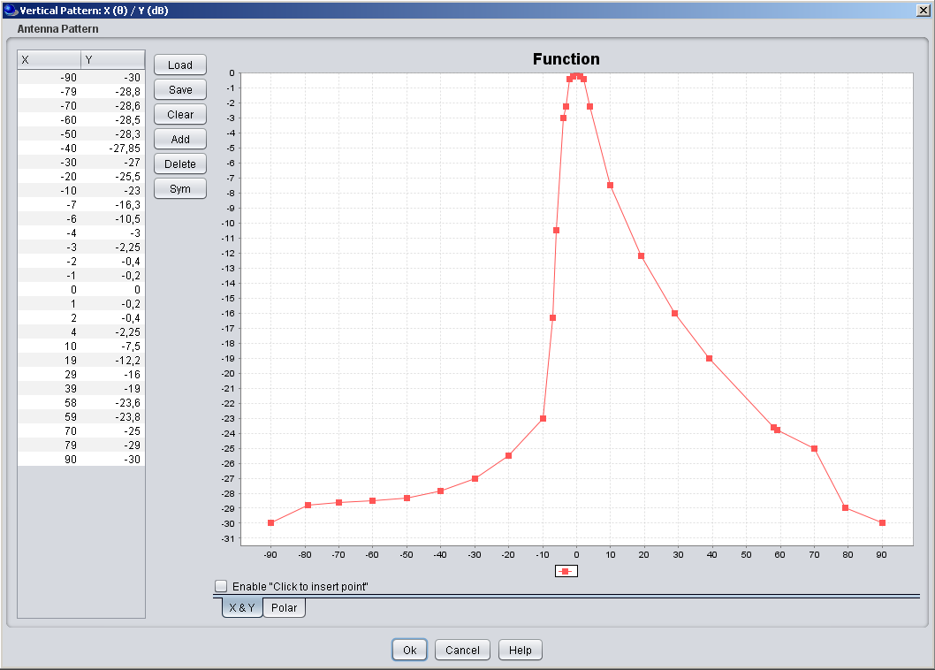
Figure 3: Vertical sector antenna pattern (approximated cosecant-squared) characteristic of the DA2GC GS (screen shot of SEAMCAT GUI; up-tilt not considered in the diagram).

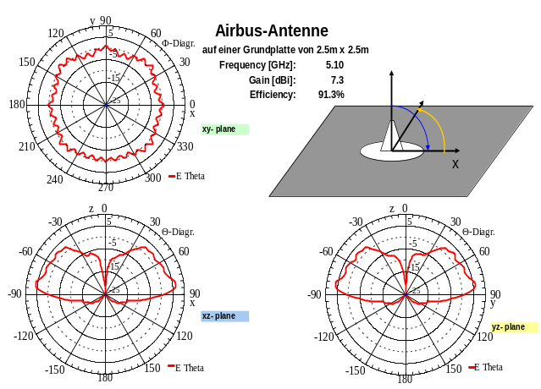
Figure 4: Vertical antenna pattern (monopole) for the DA2GC AS (gain of 6.54 dBi; direction to earth at 0°, to the horizon at ±90°).
The compatibility evaluations have been performed with the maximum AS Tx power of 40 dBm as a worst case assumption, i.e. the Tx power always corresponds to a value according to a placement of the aircraft at the cell edge. Taking into account, in addition to TX power control in the DA2GC AS, the level of interference from the DA2GC AS will be less in reality, when the aircraft is close to the DA2GC GS.

PMSE wireless video links

Based on the outcome of a joint meeting of PTs FM48 and FM51 [7] the priority of first compatibility studies should be on the PMSE use case for SAP/SAB (Services Ancillary to Programme making/Services Ancillary to Broadcasting) and ENG/OB (Electronic News Gathering and Outside Broadcasting) links, respectively. Those links are typically used only temporarily at different locations and therefore have a long history of spectrum sharing in different frequency bands. Typical application scenarios and technical characteristics of SAP/SAB equipment are described in detail in ERC Report 38 (video links) [8]. In the following subsections, Error: Reference source not found characteristics for three different types of links are given, e.g. maximum output powers (EIRP) as well as the minimum transmit and receive antenna gains. These parameters according to Table 19 and Table 22 in ECC Report 172 [9] have already been used in other compatibility studies.
Video link SAP/SAB equipment is typically used in a variety of scenarios which are quite different from each other. E.g., a cordless camera link might consist of a small hand-held camera transmitter and a small portable receiver. On the other hand, large TV trucks or even helicopters can be used to carry video link equipment which gives significant difference in antenna height, gain, and propagation environment. ERC Report 38 [8] includes a collection of examples.

PMSE wireless video link scenarios selected for the studies
For the present study, three usage scenarios of video links have been selected: cordless camera link, portable video link and mobile video link from a ground vehicle. They are described in the following tableError: Reference source not found and illustrated in Figure 5, Figure 6 aFigure 7 and Figure 8.

Table 3: Usage scenarios, antenna types and propagation models for wireless video link coexistence study (according Table 19 in [9])
# | Name | Transmitter | Tx Ant. Type | Receiver | Rx Ant. Type | Propagation Model [8]
1 | Cordless Camera Link | Handheld camera with integrated transmitter | Semi-sphere omnidirectional | Portable receiver | Directional  (e.g. Disk Yagi) | Urban, below rooftop
2 | Portable Video Link | Handheld camera with separate transmitter  (two-man radio camera) | Directional  (e.g. Disk Yagi) | TV van | 1.2 m parabolic dish | Suburban, below rooftop
3 | Mobile Video Link | Portable camera mounted on a ground vehicle (e.g. motorcycle) | Semi-sphere omnidirectional | Receiver on helicopter | Semi-sphere omnidirectional | Open area, free space (helicopter links);  (ground links)
4 | Temporary Point to Point link | Temporary antenna location ( often on truck) | Directional | Pylon | Directional | [TBC]

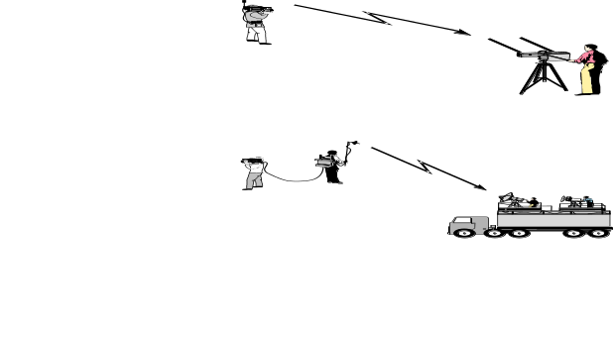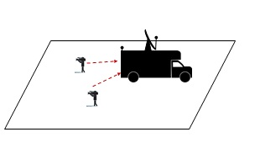
Figure 5: Scenario 1 – Cordless camera link

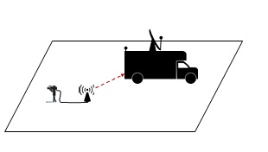
Figure 6: Scenario 2 – Portable video link

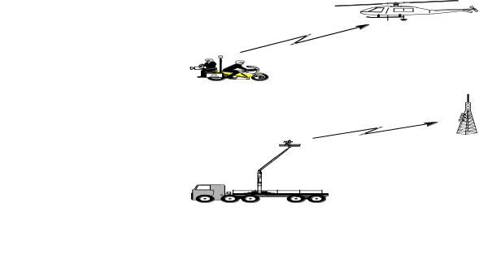
Figure 7: Scenario 3 – Mobile video link

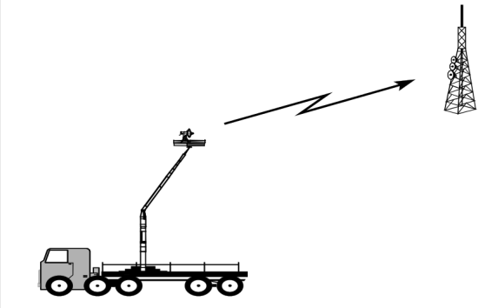
Figure 8: Scenario 4 – Temporary Point to Point link

Scenarios 1 and 2 are located in a urban environment, whereas scenario 3 is placed in a rural environment.

Cordless camera link

Those are handheld camera with integrated transmitter, power pack and antenna. Normally they are used by a cameraman to send a video link to an equipped van at short distance. The emitted power is therefore lower than in other cases.

Table 4: Cordless camera characteristics
Cordless camera characteristics | Parameter values | Unit | Justification
Channel bandwidth | 5-10-20 | MHz | ECC report 172
Frequency band | 1900-1920  2010-2025 | MHz  MHz
Receiver
Rx Antenna Height | 1,5 | m | ECC report 172
Rx Typical Antenna Gain  Rx Max Antenna Gain | 6  16 | dBi  dBi | ECC report 172
Rx Antenna Gain Pattern | ITU-R Rec F.1336  Sector antenna with average side lobes (k=0.X) |  | Different pattern for vertical and horizontal
Rx Noise Figure | 4 | dB | ECC report 172
I/N protection criterion | -6 | dB | ECC report 172
Adjacent Channel Selectivity | TBD | dB | TBD
Transmitter
Tx Max e.i.r.p.  Tx Typical e.i.r.p. range | 6  -7 to 0 | dBW  dBW | ECC report 172
Tx Spurious emissions | -30 | dBm/MHz | ERC REC 74-01
Tx Adjacent Channel Leakage Ratio (relative to maximum Tx power) | See §4.2.5
Tx Antenna Height | 1,5 | m | ECC report 172
Tx Typical Antenna Gain  Tx Max Antenna Gain | 0  5 | dBi  dBi | ECC report 172
Tx Antenna Gain Pattern | [Semi-sphere] omnidirectional | / | ECC report 172

The propagation model used for interference simulation is Extended Hata.

Portable video link

Portable links are mostly handheld camera but with separate body worn transmitter, power pack and antenna. The emitted power is normally greater than in the case of cordless camera, but lower than in the case of mobile links.

Table 5: Portable video characteristics
Portable video characteristics | Parameter values | Unit | Justification
Channel bandwidth | 5-10-20 | MHz | ECC report 172
Frequency band | 1900-1920  2010-2025 | MHz  MHz
Receiver
Rx Antenna Height | 5 | m | ECC report 172
Rx Typical Antenna Gain  Rx Max Antenna Gain | 17  27 | dBi  dBi | ECC report 172
Rx Antenna Gain Pattern | ITU-R Rec F.1336  Sector antenna with average side lobes (k = 0.X) |  | Different pattern for vertical and horizontal
Rx Noise Figure | 4 | dB | ECC report 172
I/N protection criterion | -6 | dB | ECC report 172
Adjacent Channel Selectivity | TBD | dB | TBD
Transmitter
Tx Max e.i.r.p.  Tx Typical e.i.r.p. range | 16  -7 to 0 | dBW  dBW | ECC Report 172
Tx Spurious emissions | -30 | dBm/MHz | ERC REC 74-01
Tx Adjacent Channel Leakage Ratio (relative to maximum Tx power) | See §4.2.5
Tx Antenna Height | 3 | m | ECC report 172
Tx Typical Antenna Gain  Tx Max Antenna Gain | 6  16 | dBi  dBi | ECC report 172
Tx Antenna Gain Pattern | ITU-R Rec F.1336  Sector antenna with average side lobes (k = 0.X) |  | Different pattern for vertical and horizontal

The propagation model used for interference simulation is Extended Hata.

Mobile video link from a ground vehicle

Table 6: Portable video characteristics
Mobile video characteristics | Parameter values | Unit | Justification
Channel bandwidth | 5-10-20 | MHz | ECC report 172
Frequency band | 1900-1920  2010-2025 | MHz  MHz
Receiver (airborne)
Rx Antenna Height | 30-600 | m | ECC report 172
Rx Typical Antenna Gain  Rx Max Antenna Gain | 5  13 | dBi  dBi | ECC Report 172
Rx Antenna Gain Pattern | [Semi-sphere] omnidirectional | / | ECC report 172
Rx Noise Figure | 4 | dB | ECC report 172
I/N protection criterion | -6 | dB | ECC report 172
Adjacent Channel Selectivity | TBD | dB | TBD
Transmitter (ground vehicle)
Tx Max e.i.r.p.  Tx Typical e.i.r.p. range | 26  3 to 6 | dBW  dBW
Tx Spurious emissions | -30 | dBm/MHz | ERC REC 74-01
Tx Adjacent Channel Leakage Ratio (relative to maximum Tx power) | See §4.2.5
Tx Antenna Height | 1,5 | m | ECC report 172
Tx Typical Antenna Gain  Tx Max Antenna Gain | 3  5 | dBi  dBi | ECC report 172
Tx Antenna Gain Pattern | [Semi-sphere] omnidirectional | / | ECC report 172

The propagation model used for interference simulation is Free space for helicopter link, Rural with ground link..

Temporary Point to Point links

Temporary Point to Point links characteristics | Parameter values | Unit | Justification
Channel bandwidth | 5-10-20 | MHz | ECC report 172
Frequency band | 1900-1920  2010-2025 | MHz  MHz
Receiver
Receiver Antenna Height | 4 to 10 | m
Receiver Typical Antenna Gain  Receiver Maximum Antenna Gain | 17  27 | dBi | ECC report 172
Receiver Antenna Gain Pattern | ITU-R Rec F.1336  Sector antenna with average side lobes (k = 0.X) |  | Different pattern for vertical and horizontal
Receiver Noise Figure | 4 | dB | ECC report 172
I/N protection criterion | -6 | dB | ECC report 172
Adjacent Channel Selectivity | TBD | dB | TBD
Transmitter
Transmitter Max e.i.r.p.  Typical Transmitter e.i.r.p. range | 40  20 | dBW  dBW
Transmitter Spurious emissions | -30 | dBm/MHz | ERC REC 74-01
Transmitter Adjacent Channel Leakage Ratio (relative to maximum Tx power) | See § 4.2.4
Transmitter Antenna Height | 4 to 10 | m | ECC report 172
Transmitter Typical Antenna Gain  Transmitter Maximum Antenna Gain | 13  23 | dBi  dBi | ECC report 172
Transmitter Antenna Gain Pattern | ITU-R Rec F.1336  Sector antenna with average side lobes (k = 0.X) |  | Different pattern for vertical and horizontal

The propagation model used for interference simulation is ITU-R Rec P.452.

PMSE wireless video link characteristics used in the studies
For the worst case single link scenarios considered in this report, only the vertical antenna patterns are relevant. These patterns for the antennas used in the three selected PMSE video link scenarios (see Table 3) are given below.

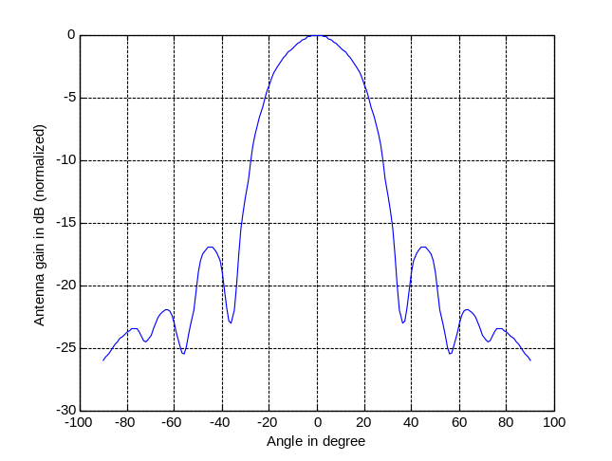 | 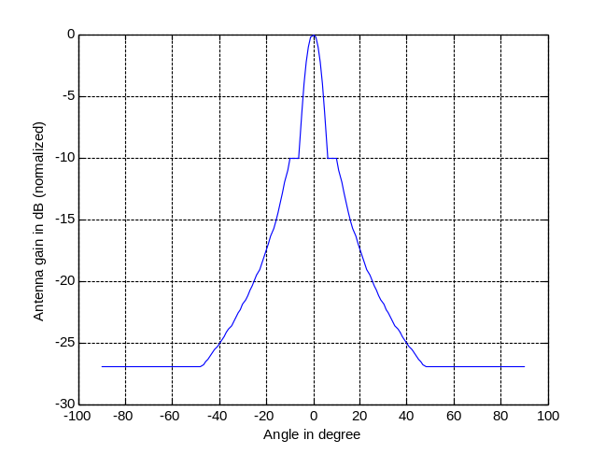
Figure 10: Disc Yagi antenna diagram (normalized) [8] | Figure 11: Diagram of parabolic dish antenna (normalized) [8] [17]

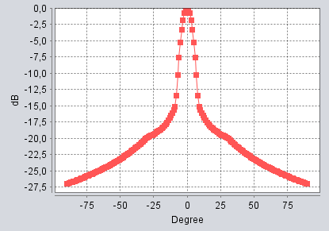
Figure 12: Diagram of semi-sphere omnidirectional antenna
According to [10] the transmitter output spectrum shall be considered with respect to the measurement mask in Figure 13 where B is the declared channel bandwidth which is equal to 10 MHz for present study [7]. The power is required to be determined outside the channel bandwidth B within block 2 and block 3 as shown in the figure.
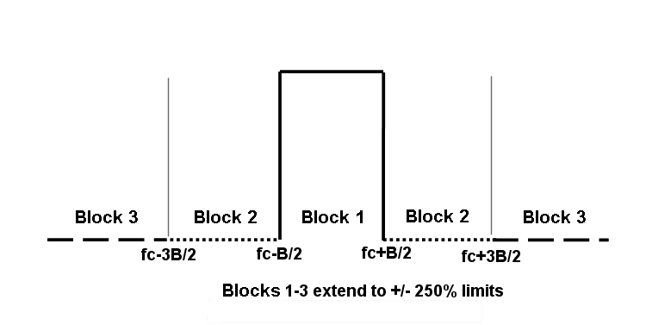
Figure 13: Measurement mask normalized to the channel bandwidth B [10].
The required bandwidth (ACLR) power limits are given in Table 7 and Table 8 taken from [10] with P_{MAX} the mean transmitter output power and P₀ the output power incl. the antenna gain. The impact of any discrete components occurring in the adjacent bands was not considered in the present study.
Table 7: Integrated power limits relative to P_{MAX} for P₀ < 0.3 W EIRP
Out-of-band block | Each half of the region | Both halves of the region
Block 2 | -36 dB | -33 dB
Block 3 | -42 dB | -39 dB
Table 8: Integrated power limits relative to P_{MAX} for P₀ > 0.3 W EIRP
Out-of-band block | Each half of the region | Both halves of the region
Block 2 | -36 dB - 10 log (P₀/0.3) | -33 dB - 10 log (P₀/0.3)
Block 3 | -42 dB - 10 log (P₀/0.3) | -39 dB - 10 log (P₀/0.3)

For the scenarios the same value for P_{MAX} is used as given in ECC Report 172 [9].
For the CCL Tx scenario two values for P_{MAX} are used as given in ECC Report 172 [9]. With P_{MAX} equal to 30 dBm and a Tx antenna gain of 6 dBi, i.e. the ACLR value corresponds to about 56 dB in Block 2 and 62 dB in Block 3 for each half of the region. With P_{MAX} equal to 17 dBm and a Tx antenna gain of 5 dBi, the ACLR value corresponds to about 53 dB in Block 2 and 59 dB in Block 3 for each half of the region.
With P_{MAX} equal to 30 dBm and a Tx antenna gain of 5 dBi, the ACLR value corresponds to about 46 dB in Block 2 and 52 dB in Block 3 for each half of the region for the MVL.
With P_{MAX} equal to 30 dBm and a Tx antenna gain of 16 dBi, i.e. the ACLR value corresponds to about 57 dB in Block 2 and 63 dB in Block 3 for each half of the region for the PVL.
The level of spurious transmitter emissions, measured as described in the ETSI specification [10], shall not exceed the limits given in Table 9. The measurement bandwidth for carrier frequencies > 1000 MHz is 1 MHz, i.e. for the frequency band considered in present study the spurious emissions should be below -30 dBm/MHz during operation of the video link.
Table 9: Radiated spurious emissions
State | Frequencies <= 1 GHz | Frequencies > 1 GHz
Operating | 250 nW | 1 µW
Standby | 2 nW | 20 nW

Further parameters for the video link scenarios applied in the present studies:
- The adjacent channel selectivity (ACS) of a receiver for wireless video equipment operating above 1.3 GHz is specified to be 30 dB [11].
- The same values are used as given in ECC Report 172 [9] for the Rx noise figure (4 dB) and the I/N threshold (-6 dB) for the video link.
- No cable/feeder losses are considered on the transmission and reception side for the wireless video link.
- For the CCL Tx scenario two values for P_{MAX} (see Table 4Table 2) are used as given in ECC Report 172 [9]:
    - Tx Max of 30 dBm with 6 dBi antenna gain
    - Tx Max of 17 dBm with 5 dBi antenna gain

Table 10: Summary of parameters for PMSE wireless video link scenarios
Parameter | CCL | MVL | PVL
Tx/Rx Bandwidth | 10 MHz | 10 MHz | 10 MHz
Frequency bands | 1900-1920 MHz  2010-2025 MHz | 1900-1920 MHz  2010-2025 MHz | 1900-1920 MHz  2010-2025 MHz
Tx Max output power | 1) 30 dBm (according to Table 13 in [9])  2) 17 dBm (according to Table 22 in [9]) | 30 dBm (according to Table 22 in [9]) | 30 dBm (according to Table 22 in [9])
Antenna tilt | 0° | Tx: 0°, Rx pointing towards earth surface | 0°
Antenna horizontal direction | Pointed at interferer | Pointed at interferer | Pointed at interferer
Antenna Directivity Loss horizontal | 0 dB | 0 dB | 0 dB
Antenna Directivity Loss vertical | 0 dB | 0 dB | 0 dB
ACLR (dB) | 1) 56 (Block 2), 62 (Block 3)  2) 53 (Block 2), 56 (Block 3) | 46 (Block 2), 52 (Block 3) | 57 (Block 2), 63 (Block 3)
Spurious emissions | -30 dBm/MHz | -30 dBm/MHz | -30 dBm/MHz
ACS | 30 dB | 30 dB | 30 dB
Rx Noise figure | 4 dB | 4 dB | 4 dB
I/N | -6 dB | -6 dB | -6 dB
Rx Antenna height | 1.5 m | 150 m | 5 m
Tx Antenna height | 1.5 m | 1.5 m | 3 m
Rx Antenna gain | 16 dBi (according to Table 19 in [9]) | 5 dBi (according to Table 19 in [9]) | 27 dBi (according to Table 19 in [9])
Tx Antenna gain | 1) 6 dBi (according to Table 13 in [9])  2) 5 dBi (according to Table 19 in [9]) | 5 dBi (according to Table 19 in [9]) | 16 dBi (according to Table 19 in [9])

UMTS BS technical characteristics

Table 11: UMTS Wide Area BS from ETSI TS 125 104

Parameter | Value | Comment
Channel bandwidth | 5 MHz
Transmission bandwidth | 3.84 MHz
Reference service | Speech 12.2 kb/s
Processing gain (PG) | 25 dB | 10.log(3840/12.2)
Sensitivity (Sens) | -121 dBm | Table 7.1
E_{b}/N₀ | 5.1 dB | Table 8.2
Noise figure (NF) | 7 dB | Sens + PG - N = E_{b}/N₀  N = 10.log(k.T.BW.1000) + NF
Standard wanted signal (C_{W-STANDARD}) | -115 dBm | Tables 7.3 and 7.4
Standard desensitization (D_{STANDARD}) | 6 dB | = C_{W-STANDARD} - Sens
Standard wideband blocking level (I_{OOB-STANDARD}) | -52 dBm (1st adjacent block)  -40 dBm (2nd adjacent block  and following ones) | Table 7.3  Table 7.4
Target desensitization (D_{TARGET}) | 1 dB
Target wideband blocking level (I_{OOB-TARGET}) | -62.7 dBm (1st adjacent block)  -50.7 dBm (2nd adjacent block  and following ones)
Antenna height | 30m
Antenna gain | 17 dBi
Cable loss | 0 dB (with RRU)
Antenna vertical discrimination | 17 dB | when the angle from the main lobe centre is higher than 20°
Horizontal antenna pattern | Omni-directional | Envelope of a 3-sector-antenna
Vertical antenna pattern | 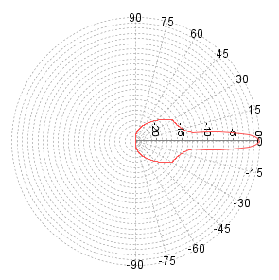  A down-tilt of 3° is assumed | SEAMCAT 4.0.0, Library Antenna, 3GPP Tri-Sector Antenna

Results of the compatibility evaluations

General remarks
The diagrams with evaluation results shown in following subsections show
- the path loss with and without consideration of the vertical antenna characteristics of the involved system components, i.e. the DA2GC GS and AS as well as the PMSE video link Tx and Rx, but without inclusion of antenna gains,
- the received interference power at the victim station (always related to the signal bandwidth of the victim system; in present study the bandwidth of both systems is equal to 10 MHz [20]),
- the resulting interference-to-noise ratio (I/N) compared to the threshold of victim system along the ground-based distance (great circle distance) between the involved stations. In case of involvement of a DA2GC AS results are given for aircraft altitudes of 3 km and 10 km, respectively. With respect to interference the worst case assumption is to have line-of-sight propagation between interferer and victim. Therefore, in all cases with involvement of the DA2GC AS and/or MVL Rx (helicopter) free space loss was applied [12]. In the cases where both victim and interferer are placed on the ground the Extended Hata Model for open rural area was applied for the computation of the path loss (see e.g. [13] for information about the model). Where applicable, also suburban and urban area environment were considered.
For the I/N computation the resulting adjacent channel interference ratio (ACIR) was considered which is based on following relationship of the Tx and Rx characteristics of interferer and victim equipment:
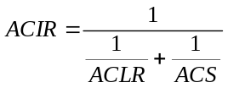
The ACLR and ACS values of the involved systems may vary dependent on the frequency separation which is related to the positioning of the DA2GC signal and the PMSE video link signal as mentioned before.

DA2GC FL in the band 1900-1920 MHz

Scenario (1a)
This scenario is related to a positioning of the DA2GC FL in the lower unpaired 2 GHz band, i.e. the carrier frequency is selected to 1905 MHz. For the PMSE transmission two cases have to be differentiated. In the first case the PMSE signal is transmitted in co-channel operation to the DA2GC signal (reminder: both signals have the same bandwidth), in the second case the PMSE signal is transmitted in the adjacent channel with a carrier frequency of 1915 MHz, i.e. the transmission is still inside the lower unpaired 2 GHz band (see Figure 1).

PMSE CCL Rx interfered by a DA2GC GS
Based on the given ACLR and ACS values of the interfering and the victim system, respectively, a final ACIR value of 28.7 dB can be computed, which is dominated by the ACS value of the PMSE Rx.
In Figure 14 to Figure 16 the resulting interference power and I/N at the CCL Rx is shown, taken into account 3 different environments of the Extended Hata propagation model (rural area, suburban (middle), urban (bottom). For the co-channel operation (blue curve) it can be seen that the I/N is above the threshold up to about 36 km, in rural environment, 12 km in suburban areas and 6 km in urban areas, i.e. sharing between DA2GC FL and CCL is practically not feasible in rural environment, but likely in suburban and urban areas. In case of adjacent channel operation the CCL transmission will be disturbed in a radius of about 7.5 km around the DA2GC GS in rural area. The required separation distance is reduced in suburban and urban environment to about 2 km and 1 km, respectively.
It has to be noted that this is really a worst case situation. If the adjustment of high gain dish antenna at the PMSE Rx is only slightly changed, the interference will be drastically reduced due to the small beam characteristic. As the number of DA2GC GS required covering the pan-European area is rather low (about 400 sites), the final interference probability for CCL is also very low.
Extended-Hata Rural: ACLR = 34.59/ ACS =30 / ACIR =28.70 dB
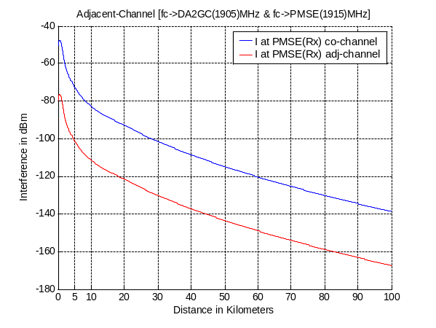 | 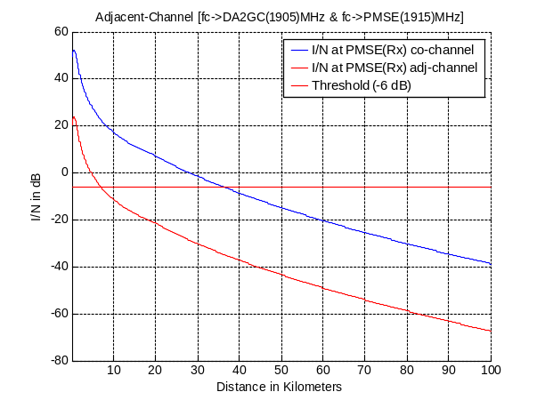
Figure 14: Co- and adjacent channel interference signal power and resulting I/N at CCL Rx (Ext. Hata Model for open rural area)
Extended-Hata Sub Urban: ACLR = 34.59/ ACS =30 / ACIR =28.70 dB
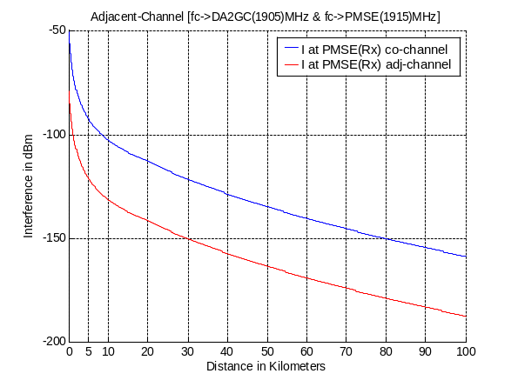 | 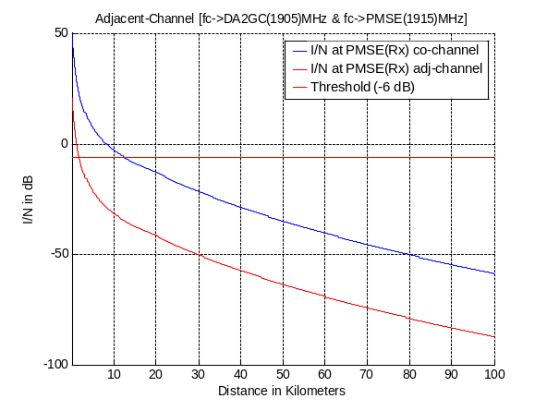
Figure 15: Co- and adjacent channel interference signal power and resulting I/N at CCL Rx (Ext. Hata Model for suburban area)

Extended-Hata Urban: ACLR = 34.59/ ACS =30 / ACIR =28.70 dB
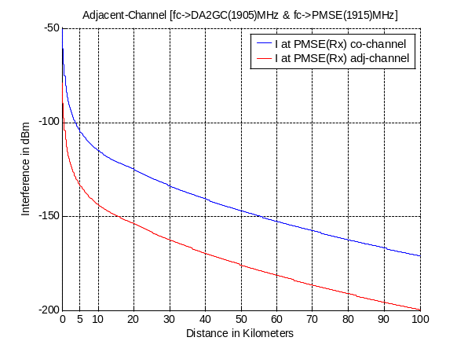 | 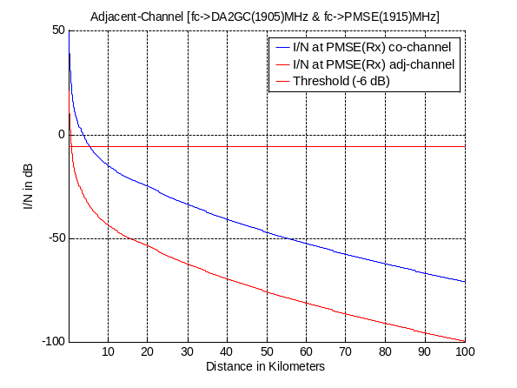
Figure 16: Co- and adjacent channel interference signal power and resulting I/N at CCL Rx (Ext. Hata Model urban area)

PMSE MVL Rx at helicopter interfered by a DA2GC GS
Based on the given ACLR and ACS values of the interfering and the victim system, respectively, a final ACIR value of 29.9 dB can be computed.
In Figure 17 the path loss between the DA2GC GS and the MVL Rx at the helicopter for free space propagation is shown based on the technical parameters given in section 4.2. Only the vertical antenna diagram characteristics are considered, i.e. it is always assumed that the main lobes of the horizontal antenna diagrams (typically sector antennas for DA2GC GS as well as an omnidirectional antenna at the helicopter) are pointed directly to each other (worst case).
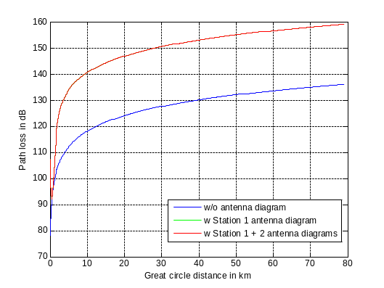
Figure 17: Path loss w & w/o consideration of vertical antenna characteristics (antenna gain not included) at DA2GC GS (Station 1) and MVL Rx (Station 2) at helicopter (free space).
Figure 18 and Figure 19 show the resulting interference power and I/N at the MVL Rx. For the co-channel operation (blue curve) it can be seen that the I/N is distinctly above the threshold, i.e. band sharing between DA2GC FL and MVL to a helicopter is not feasible. In case of adjacent channel operation the MVL transmission will be disturbed in a radius of about 10.5 km around the DA2GC GS.
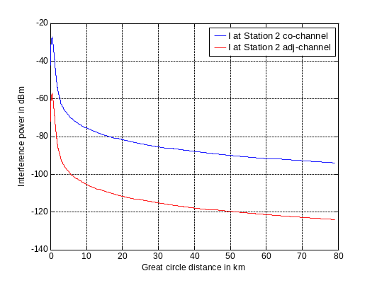
Figure 18: Co- and adjacent channel interference signal power at MVL Rx (Station 2) at helicopter (free space).
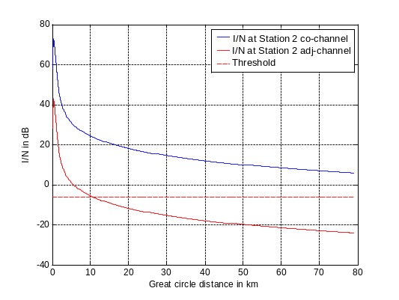
Figure 19: Resulting co- and adjacent channel I/N at MVL Rx (Station 2) at helicopter (free space).

PMSE PVL Rx interfered by a DA2GC GS
Based on the given ACLR and ACS values of the interfering and the victim system, respectively, a final ACIR value of 29.9 dB can be computed, which is dominated by the ACS value of the PMSE Rx.
In Figure 20 the resulting interference power and I/N at the PVL Rx is shown, taken into account 3 different types of the Extended Hata propagation model (open rural area (top), suburban (middle), urban (bottom). For the co-channel operation (blue curve) it can be seen that the I/N is distinctly above the threshold, i.e. band sharing between DA2GC FL and PVL to a TV van is practically not feasible. In case of adjacent channel operation the PVL transmission will be disturbed in a radius of about 26 km around the DA2GC GS in open area. The required separation distance is reduced in suburban and urban environment to about 7 and 3 km, respectively.
It has to be noted that this is really a worst case situation. If the adjustment of high gain dish antenna at the PMSE RX is only slightly changed, the interference will be drastically reduced due to the small beam characteristic. As the number of DA2GC GS required covering the pan-European area is rather low (about 400 sites), the final interference probability for PVL is also very low.

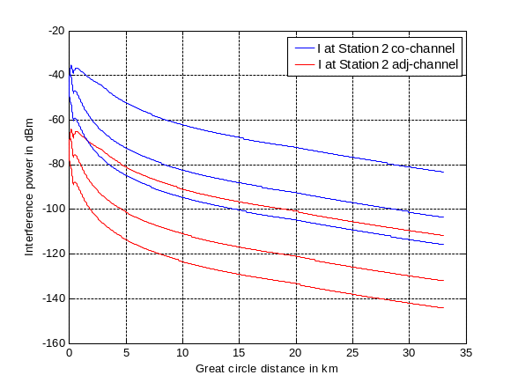 | 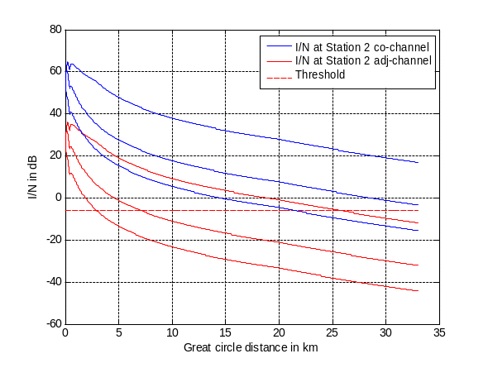
Figure 20: Co- and adjacent channel interference signal power and resulting I/N at PVL Rx (Ext. Hata Models for open rural area (top), suburban and urban)

Scenario (1b)

DA2GC AS interfered by a PMSE CCL Tx
In this scenario the interference of a CCL Tx signal on the reception at a DA2GC AS is evaluated. For the CCL Tx two cases with different Tx EIRP and antenna gain were considered. In Figure 21 and Figure 22 the results are given for aircraft altitudes of 3 km and 10 km for case 1), in Figure 23 for an aircraft altitude of 3 km for case 2. The protection threshold is met for aircraft altitudes higher than 7 km for case 1), and already for an aircraft altitude of 3 km for case 2.

- Tx Max of 30 dBm with 6 dBi antenna gain

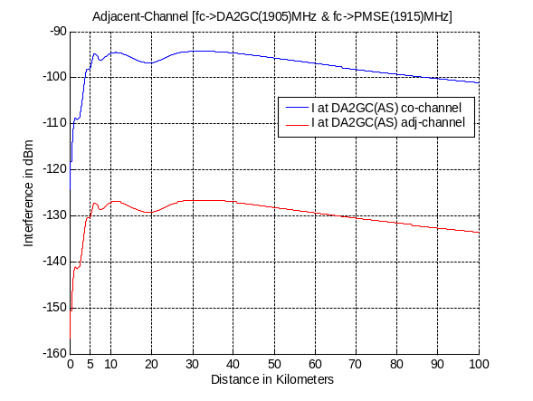 | 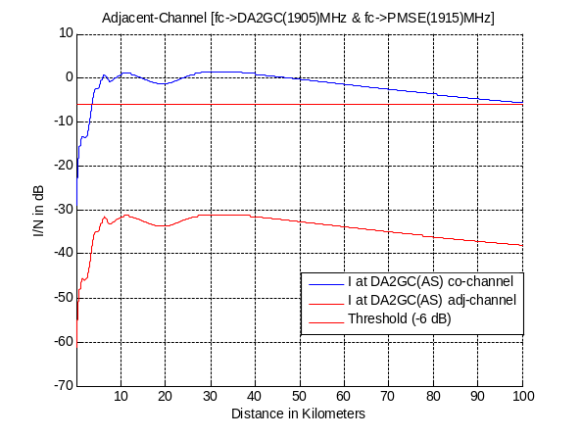
Figure 21: Co- and adjacent channel interference signal power and resulting I/N at DA2GC AS with
aircraft altitude of 3 km (free space)
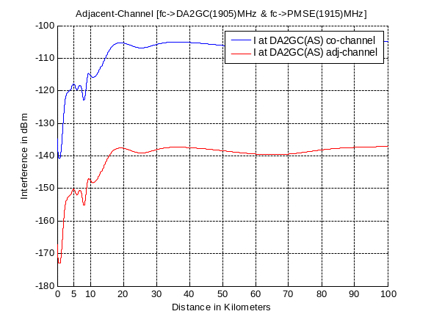 | 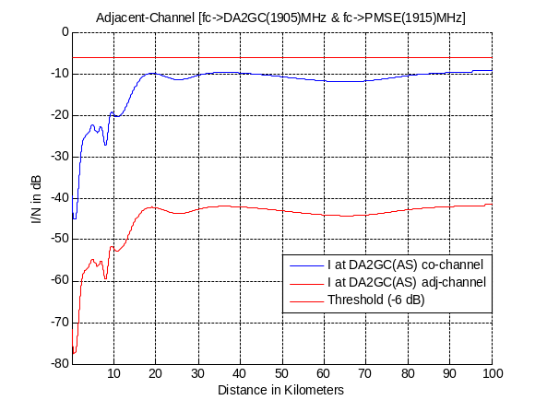
Figure 22: Co- and adjacent channel interference signal power and resulting I/N at DA2GC AS with
aircraft altitude of 10 km (free space)

- Tx Max of 30 dBm with 6 dBi antenna gain

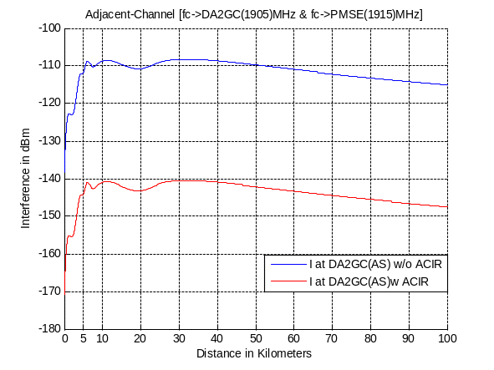 | 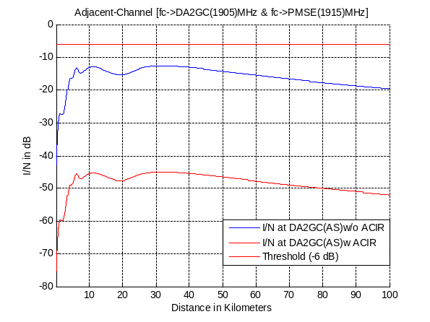
Figure 23: Interference signal power and resulting I/N at DA2GC AS with
aircraft altitude of 3 km w/ & w/o consideration of ACIR (free space)

DA2GC AS interfered by a PMSE MVL Tx at motorcycle
This scenario has same basic parameter as used in scenario (1a), but now the interference of a MVL Tx signal transmitted from a motorcycle on the reception at a DA2GC AS is evaluated. The resulting ACIR corresponds to 32.8 dB. In Figure 24 to Figure 26 the results are given for an aircraft altitude of 3 km, in Figure 27 to Figure 29 for 10 km. Like in scenario (1a) co-channel operation is not possible, but adjacent channel operation can be applied under the assumptions made before for both systems.
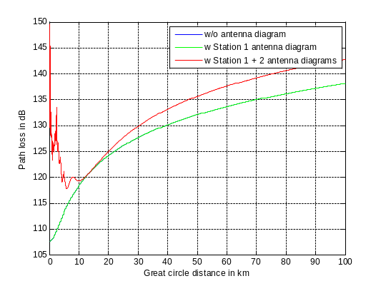
Figure 24: Path loss w & w/o consideration of vertical antenna characteristics (antenna gain not included) at MVL Tx (Station 1) at motorcycle and DA2GC AS (Station 2) with aircraft altitude of 3 km (free space).

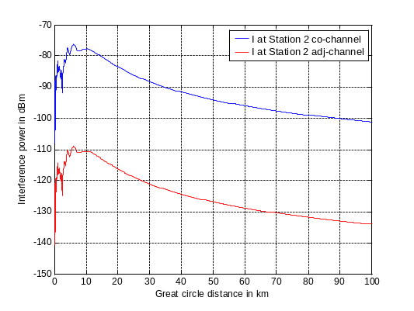
Figure 25: Co- and adjacent channel interference signal power at DA2GC AS (Station 2) with aircraft altitude of 3 km (free space).

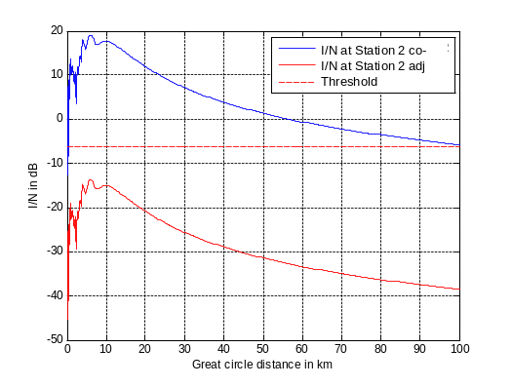
Figure 26: Resulting co- and adjacent channel I/N at DA2GC AS (Station 2) with aircraft altitude of 3 km (free space).
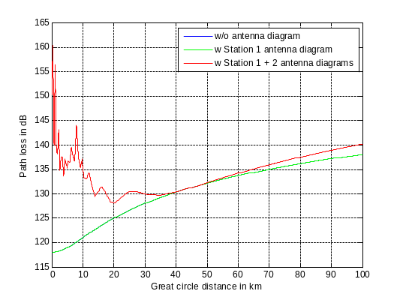
Figure 27: Path loss w & w/o consideration of vertical antenna characteristics (antenna gain not included) at MVL Tx (Station 1) at motorcycle and DA2GC AS (Station 2) with aircraft altitude of 10 km (free space).

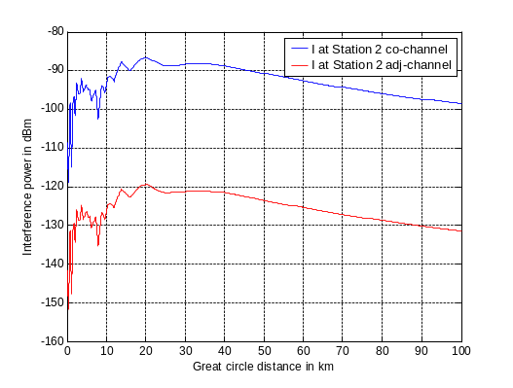
Figure 28: Co- and adjacent channel interference signal power at DA2GC AS (Station 2) with aircraft altitude of 10 km (free space).

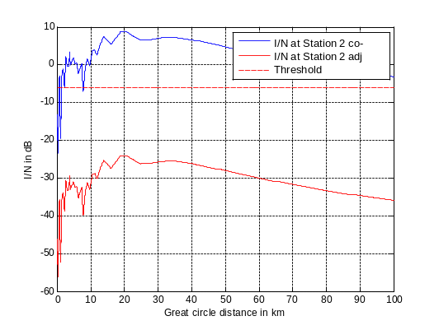
Figure 29: Resulting co- and adjacent channel I/N at DA2GC AS (Station 2) with aircraft altitude of 10 km (free space).

DA2GC AS interfered by a PMSE PVL Tx
In this scenario the interference of a PVL Tx signal on the reception at a DA2GC AS is evaluated. The resulting ACIR corresponds to 32.9 dB (dominated by the ACS of the AS). In Figure 30 and Figure 31 the results are given for aircraft altitudes of 3 and 10 km, respectively. Like in scenario (1a) co-channel operation is not possible, but adjacent channel operation can be applied under the assumptions made before for both systems.

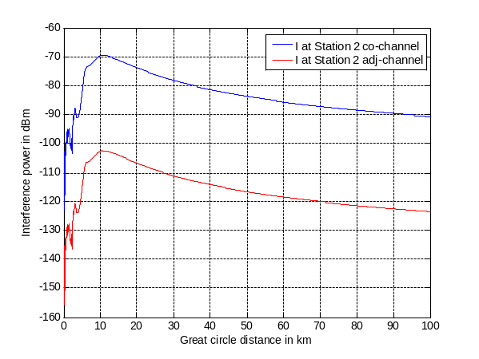 | 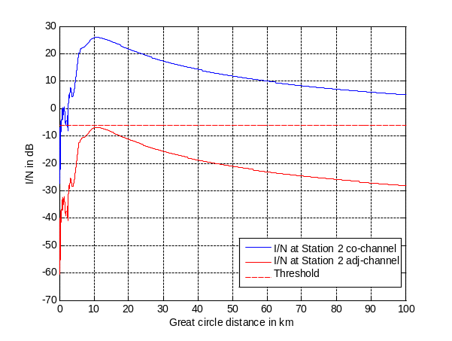
Figure 30: Co- and adjacent channel interference signal power and resulting I/N at DA2GC AS with
aircraft altitude of 3 km (free space)

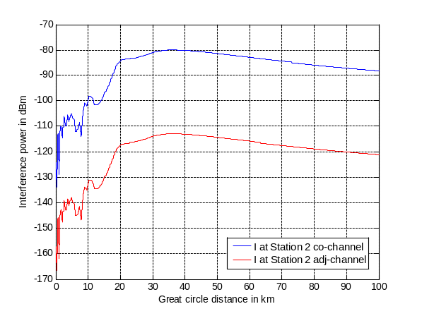 | 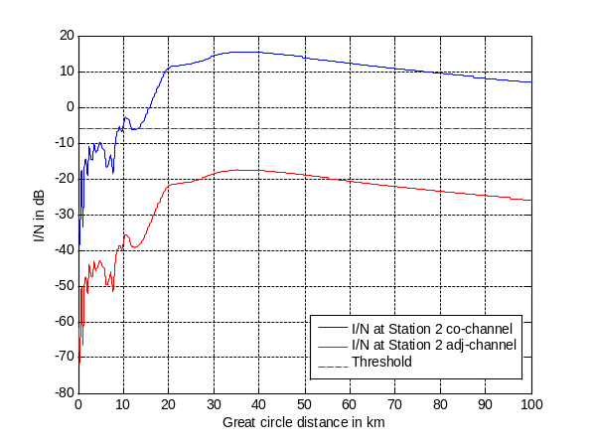
Figure 31: Co- and adjacent channel interference signal power and resulting I/N at DA2GC AS with
aircraft altitude of 10 km (free space)

DA2GC RL in the band 2010 – 2025 MHz

Scenario (1c)
For this scenario a transmission of the DA2GC RL in the upper unpaired 2 GHz band is considered.

PMSE CCL Rx interfered by a DA2GC AS
This scenario is similar to scenario (2a). The only difference is in the carrier frequency as now the upper unpaired 2 GHz band is considered. As the change in path loss is less than 0.5 dB no new figures are shown, i.e. the results are comparable to those in Figure 44 and Figure 45.

PMSE MVL Rx at helicopter interfered by a DA2GC AS
Now the reception of the MVL signal at the helicopter is interfered by a signal transmitted from a DA2GC AS. Again results for 2 aircraft altitudes of 3 and 10 km are given. As already noted in Figure 1 co-channel operation is not feasible, in case of adjacent channel operation (now above 2015 MHz outside the upper unpaired 2 GHz band) the resulting ACIR of 29.5 dB reduces the interference impact, but for an aircraft altitude of 3 km the I/N threshold is still exceeded for ground distances up to about 25 km between both stations.
It has to be mentioned, that the antenna gain of 5 dBi of the MVL Rx is also assumed to be available above the helicopter in the computation (omnidirectional vertical diagram). In a real environment the antenna diagram will have a strong attenuation up to 10 – 20 dB in the direction to the aircraft. In addition the power control feature of the DA2GC AS was not applied, i.e. the signal is always transmitted with full power of 40 dBm. In a realistic scenario the transmission with maximum power will only happen at cell edge, therefore the interference probability is strongly reduced.
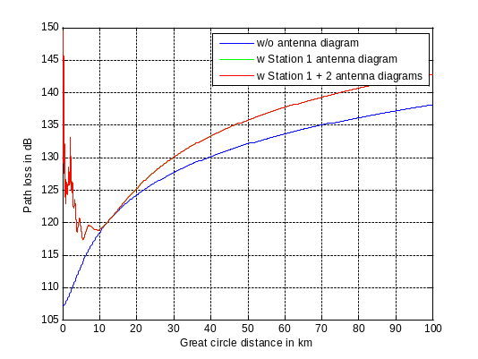
Figure 32: Path loss w & w/o consideration of vertical antenna characteristics (antenna gain not included) at DA2GC AS (Station 1) with aircraft altitude of 3 km and MVL Rx (Station 2) at helicopter (free space).

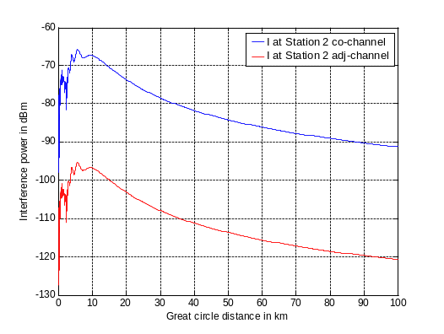
Figure 33: Co- and adjacent channel interference signal power at MVL Rx (Station 2) at helicopter for aircraft altitude of 3 km (free space).

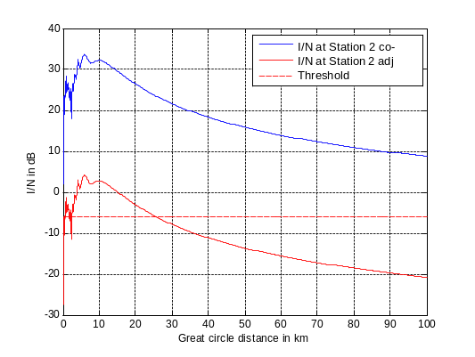
Figure 34: Resulting co- and adjacent channel I/N at MVL Rx (Station 2) at helicopter for aircraft altitude of 3 km (free space).

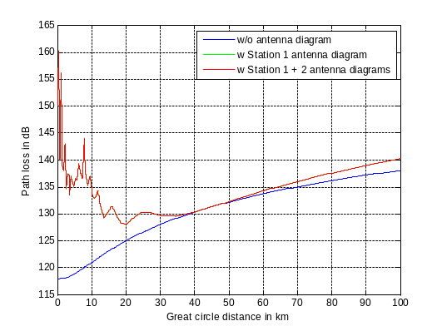

Figure 35: Path loss w & w/o consideration of vertical antenna characteristics (antenna gain not included) at DA2GC AS (Station 1) with aircraft altitude of 10 km and MVL Rx (Station 2) at helicopter (free space).
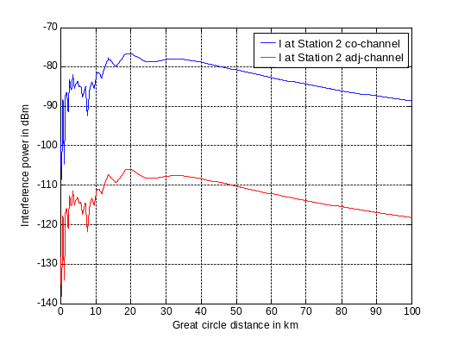
Figure 36: Co- and adjacent channel interference signal power at MVL Rx (Station 2) at helicopter for aircraft altitude of 10 km (free space).

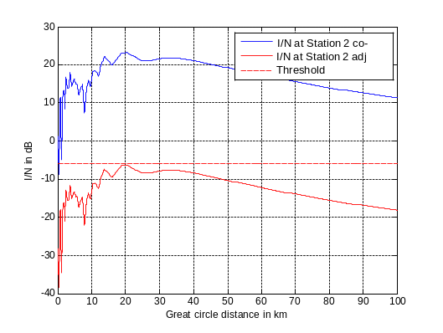
Figure 37: Resulting co- and adjacent channel I/N at MVL Rx (Station 2) at helicopter for aircraft altitude of 10 km (free space).

PMSE PVL Rx interfered by a DA2GC AS
Now the reception of the PVL signal is interfered by a signal transmitted from a DA2GC AS. Again results for aircraft altitudes of 3 km and 10 km are given in Figure 38 and Figure 39.
Co-channel operation is not feasible, but also in case of adjacent channel operation (now above 2015 MHz outside the upper unpaired 2 GHz band) the resulting ACIR is not sufficient to reduce the interference impact below the I/N threshold. Similar to scenario (1a) the interference power will be strongly reduced, if the adjustment of the dish antenna is only slightly changed or if the line-of-sight condition (free space propagation assumed) between the dish antenna and the aircraft is affected. In addition the final interference probability will be further reduced by the Tx power control feature of the DA2GC AS.

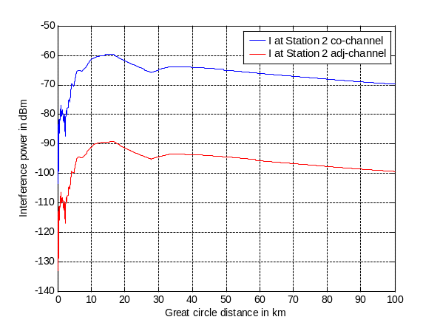 | 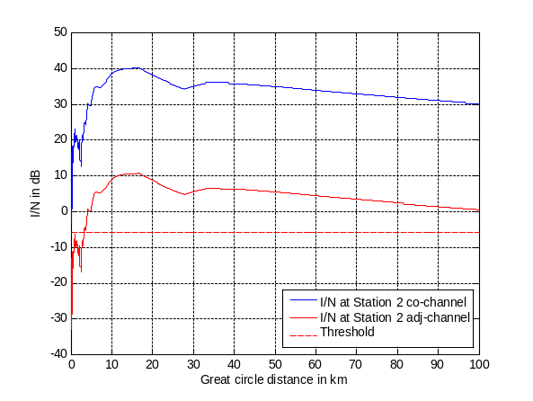
Figure 38: Co- and adjacent channel interference signal power and resulting I/N at PVL Rx for
aircraft altitude of 3 km (free space)

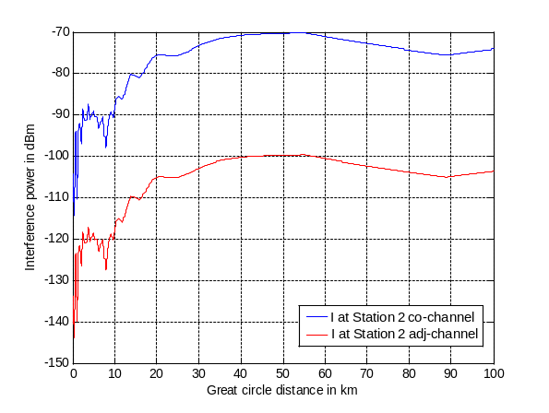 | 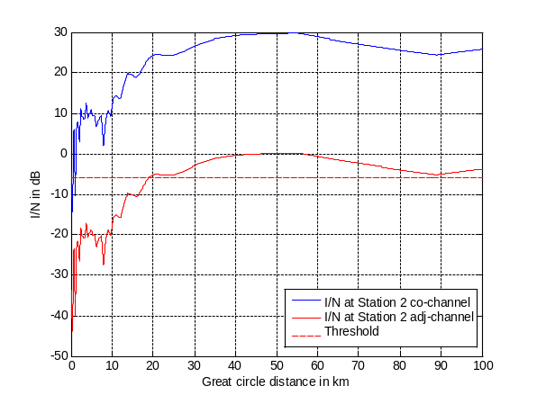
Figure 39: Co- and adjacent channel interference signal power and resulting I/N at PVL Rx for
aircraft altitude of 10 km (free space)

Scenario (1d)

DA2GC GS interfered by a PMSE CCL Tx
This scenario is comparable with scenario (2b) under consideration of changed carrier frequency with respect to upper and lower unpaired 2 GHz band. As the change in path loss is less than 0.5 dB no new figures are shown, i.e. the results are comparable to those in Figures XX and XX.

DA2GC GS interfered by a PMSE MVL Tx at motorcycle
Similar to scenario (1c) the impact of a MVL Tx from a motorcycle on the reception of the DA2GC RL at a GS has been evaluated in the upper unpaired 2 GHz band. In the case of co-channel operation the MVL transmission would disturb the DA2GC link, if the motorcycle is in a range of about 9 km around the GS.
For adjacent channel operation (resulting ACIR equal to 41.6 dB) the range in which the MVL disturbs the DA2GC RL reception goes down to about 0.4 km. In contrast to the other scenarios the Extended Hata Model for open rural area has been applied for path loss computation instead of the free space model, but due to the high antenna height used for the DA2GC GS the difference is only very small. In a real environment the line-of-sight connection between the motorcycle antenna and the GS antenna may be at least partly disturbed by clutter and vegetation, therefore the interference impact is not seen as very critical. Some dBs can be further gained if an additional frequency guard band is introduced for PMSE MVL in areas near DA2GC GSs, which will have typically large inter-site distances of about 60 – 100 km.
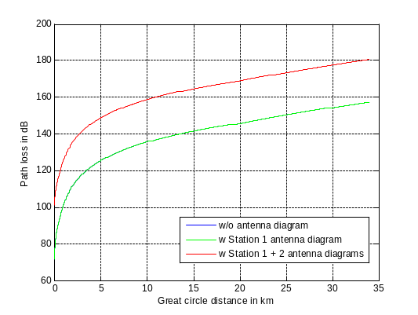
Figure 40: Path loss w & w/o consideration of vertical antenna characteristics (antenna gain not included) at MVL Tx (Station 1) at motorcycle and DA2GC GS (Station 2) (Ext. Hata Model for open rural area).

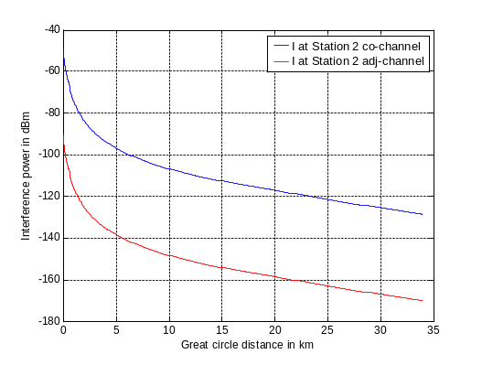
Figure 41: Co- and adjacent channel interference signal power at DA2GC GS (Station 2) (Ext. Hata Model for open rural area).

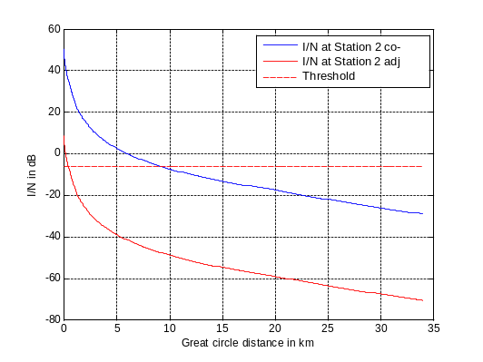
Figure 42: Resulting co- and adjacent channel I/N at DA2GC GS (Station 2)
(Ext. Hata Model for open rural area).

DA2GC GS interfered by a PMSE PVL Tx
Similar to scenario (1c) the impact of a PVL Tx on the reception of the DA2GC RL at a GS has been evaluated in the upper unpaired 2 GHz band. Interference signal power and resulting I/N are given in Figure 43 for different propagation models (Ext. Hata Model for open rural area (top), suburban and urban). As noted before co-channel operation is not seen as feasible, as the PVL transmission would disturb the DA2GC link, if the wireless camera is in a range of about 24 km around the GS (open rural area assumed).
For adjacent channel operation the range in which the PVL disturbs the DA2GC RL reception goes down to about 1.3 km in open rural area. In suburban area it is further reduced to about 0.3 km and tends to zero in urban area. As in real environment the line-of-sight connection between the PVL Tx antenna and the GS antenna may be at least partly disturbed by clutter and vegetation the interference impact is not seen as very critical. In addition also the Yagi antenna used at the PMSE Tx has a strong directivity, so changes in the horizontal adjustment have drastic impact on the final I/N. Some dBs can be further gained if an additional frequency guard band is introduced for PMSE PVL in areas near DA2GC GSs, which will have typically large inter-site distances of about 60 – 100 km compared to usual macro cell grid of mobile radio networks.
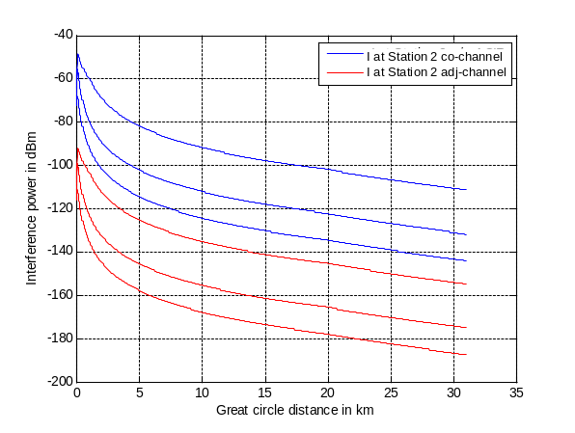 | 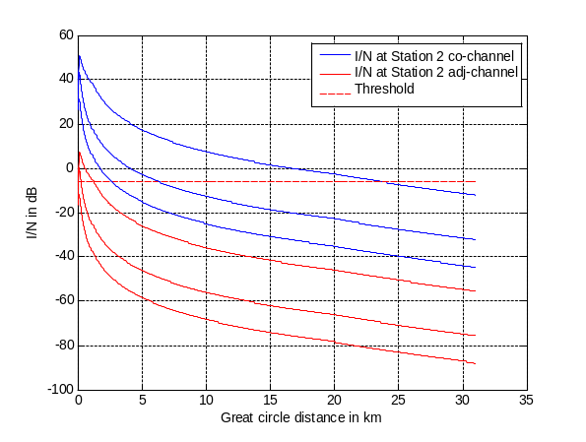
Figure 43: Co- and adjacent channel interference signal power and resulting I/N at DA2GC GS (Ext. Hata Model for open rural area (top), suburban and urban)

DA2GC RL in the band 1900 – 1920 MHz

Scenario (2a)
For this scenario a transmission of the DA2GC RL in the lower unpaired 2 GHz band with a carrier frequency of 1915 MHz is considered.

PMSE CCL Rx interfered by a DA2GC AS
Now the reception of the CCL signal is interfered by a signal transmitted from a DA2GC AS. Again results for aircraft altitudes of 3 km and 10 km are given in Figure 44 and Figure 45.
Co-channel operation is not feasible, but also in case of adjacent channel operation the resulting ACIR is not sufficient to reduce the interference impact below the I/N threshold. Similar to scenario (1a) the interference power will be strongly reduced if the adjustment of the dish antenna is only slightly changed or if the line-of-sight condition (free space propagation assumed) between the dish antenna and the aircraft is affected. In addition the final interference probability will be further reduced by the Tx power control feature of the DA2GC AS.
In order to demonstrate whether suggested mitigations techniques were sufficient, further studies are needed. Otherwise coexistence has to be considered as not feasible in adjacent channel.
ACLR = 39.29 / ACS =30 / ACIR= 29.516
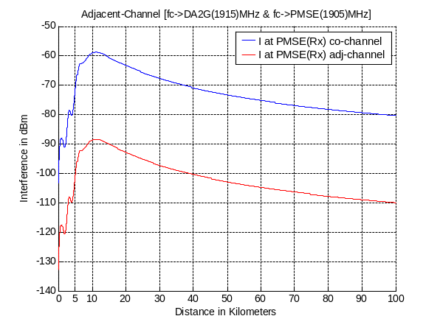 | 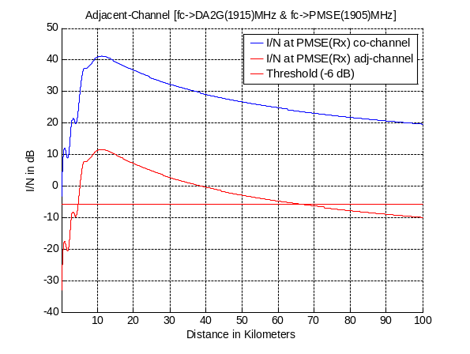
Figure 44: Co- and adjacent channel interference signal power and resulting I/N at CCL Rx for
aircraft altitude of 3 km (free space)

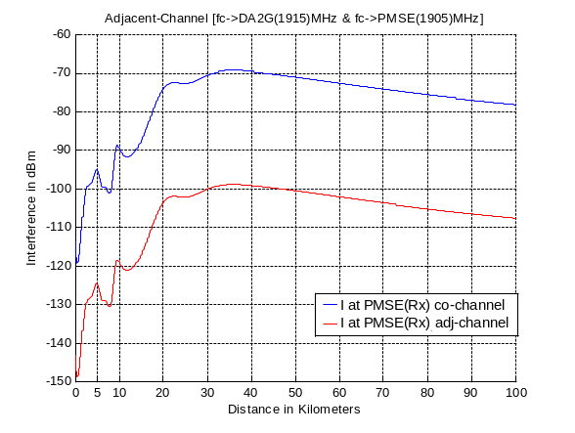 | 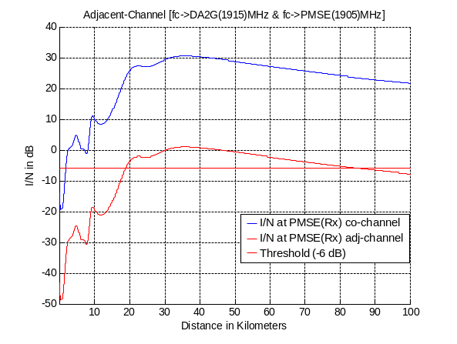
Figure 45: Co- and adjacent channel interference signal power and resulting I/N at CCL Rx for
aircraft altitude of 10 km (free space)

PMSE MVL Rx at helicopter interfered by a DA2GC AS
This scenario is similar to scenario (1c). The only difference is in the carrier frequency as now the lower unpaired 2 GHz band is considered. As the change in path loss is less than 0.5 dB no new figure is shown, i.e. the results are comparable to those in Figure 33 to Figure 37. In-band adjacent channel operation (see Figure 2) might be feasible under consideration of the remarks made in Section 5.3.1.2 with respect to helicopter antenna diagram and Tx power control at the DA2GC AS.

PMSE PVL Rx interfered by a DA2GC AS
This scenario is similar to scenario (1c). The only difference is in the carrier frequency as now the lower unpaired 2 GHz band is considered. As the change in path loss is less than 0.5 dB no new figures are shown, i.e. the results are comparable to those in Figure 38 and Figure 39. Even in-band adjacent channel operation (see Figure 2) might be affected in worst case situations considered in present study, but the probability of occurrence is rather low.

Scenario (2b)

DA2GC GS interfered by a PMSE CCL Tx
In this scenario the impact of a CCL Tx on the reception of the DA2GC RL at a GS has been evaluated in the lower unpaired 2 GHz band.
For the CCL Tx two cases with different Tx EIRP and antenna gain were considered. The interference signal power and resulting I/N are given in Figure 46 for case 1) and in Figure 47 for case 2) for the Ext. Hata Model for open rural area.

- Tx Max of 30 dBm with 6 dBi antenna gain

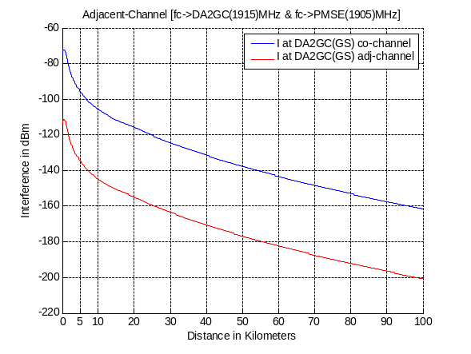 | 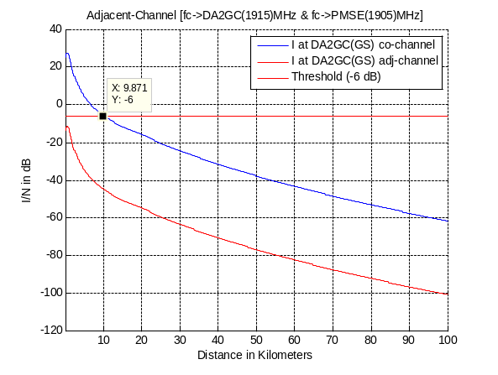
Figure 46: Co- and adjacent channel interference signal power and resulting I/N at DA2GC GS (Ext. Hata Model for open rural area)

- Tx Max of 17 dBm with 5 dBi antenna gain
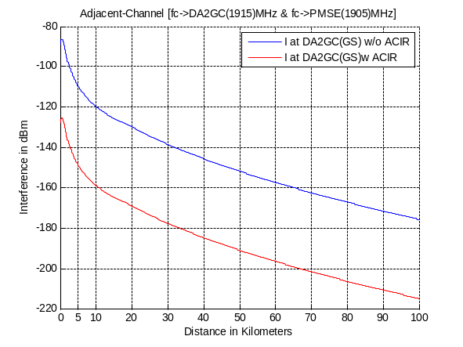 | 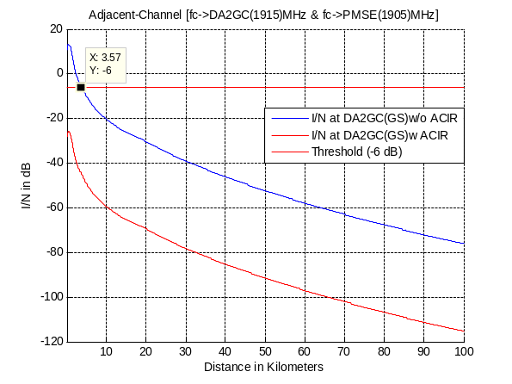
Figure 47: Interference signal power and resulting I/N at DA2GC GS w/ & w/o consideration
of ACIR (Ext. Hata Model for open rural area)

DA2GC GS interfered by a PMSE MVL Tx at motorcycle
This scenario is comparable with scenario (1d) under consideration of changed carrier frequency with respect to upper and lower unpaired 2 GHz band, i.e. for adjacent channel in-band operation of both systems there will be some disturbance of the DA2GC RL, if a MVL transmitter is near a DA2GC GS (within a range of about 400 m, see Figure 42). Due to expected low number of DA2GC GS across Europe and only temporary use of MVL links near the sites, the impact is rated as rather uncritical.

DA2GC GS interfered by a PMSE PVL Tx
This scenario is comparable with scenario (1d) under consideration of changed carrier frequency with respect to upper and lower unpaired 2 GHz band, i.e. for adjacent channel in-band operation of both systems there will be some disturbance of the DA2GC RL, if a PVL transmitter is near a DA2GC GS (within a range of about 1.3 km in open rural areas, see Figure 43). Due to expected low number of DA2GC GS across Europe and only temporary use of PVL links near the sites, the impact is rated as rather uncritical.

DA2GC FL in the band 1900 – 1920 MHz

Scenario (2c)
This scenario is similar to scenario (1a), only the change in the carrier frequency has to be considered. As the change in path loss is less than 0.5 dB no new figures are shown, i.e. the results are comparable to those in Figures XX and XX.

PMSE CCL Rx interfered by a DA2GC GS
Using Figure 14 as reference for the results it be concluded that even in case of adjacent channel operation using the band above 2025 MHz the CCL link will be disturbed in a range around the DA2GC GS with radius of about 7.5 km in open rural areas. As mentioned already before the interference is strongly reduced in case that the adjustment of the disc yagi antenna is slightly moved away from the direction to the DA2GC GS.

PMSE MVL Rx at helicopter interfered by a DA2GC GS
Using Figure 17 to Figure 19 as reference for the results it be concluded that even in case of adjacent channel operation using the band above 2025 MHz the MVL link will be disturbed in a range around the DA2GC GS with radius of about 10 km. Introducing further frequency guard bands, i.e. shifting the carrier frequency to values above 2030 MHz will hopefully help as the limiting factor is mainly the ACS performance of the MVL Rx at the helicopter (unfortunately no further information is available for higher frequency separations).

PMSE PVL Rx interfered by a DA2GC GS
This scenario is similar to scenario (1a), only the change in the carrier frequency has to be considered. Using Figure 20 as reference for the results it be concluded that even in case of adjacent channel operation using the band above 2025 MHz the PVL link will be disturbed in a range around the DA2GC GS with radius of about 25 km in open rural areas. Introducing further frequency guard bands, i.e. shifting the carrier frequency to values above 2030 MHz will hopefully help as the limiting factor is mainly the ACS performance of the PVL Rx on the TV van (unfortunately no further information is available for higher frequency separations). As mentioned already before the interference is strongly reduced in case that the adjustment of the dish antenna is slightly moved away from the direction to the DA2GC GS.

Scenario (2d)
The only difference to scenario (1b) is in the carrier frequency (now in the upper unpaired 2 GHz band).

DA2GC AS interfered by a PMSE CCL Tx
Figure 21 and Figure 22 can act as reference. Adjacent channel operation of both systems is feasible (CCL transmission in the upper adjacent band to the upper part of the unpaired 2 GHz band), and also co-channel operation with limited CCL Tx power as shown in case 2.

DA2GC AS interfered by a PMSE MVL Tx at motorcycle
Figure 24 to Figure 29 can be used as reference. Adjacent channel operation of both systems is feasible (MVL transmission in the upper adjacent band to the upper part of the unpaired 2 GHz band), but no co-channel operation.

DA2GC AS interfered by a PMSE PVL Tx
Figure 30 to Figure 31 can act as reference. Adjacent channel operation of both systems is feasible (PVL transmission in the upper adjacent band to the upper part of the unpaired 2 GHz band), but no co-channel operation.

PMSE in the band 1900-1920 MHz vs. MFCN

An MCL method is used: it consists in evaluating for each scenario listed in the table below the maximum EIRP that can be transmitted by the video transmitter when adjacent to the MFCN uplink frequency range 1920-1980 MHz.
Table 12: MCL scenarii
Scenario | Type of  link | Type of  equipment | Antenna  height | Ground  distance  with BS | Propagation  model
#1 | Cordless camera link | Handheld camera with integrated transmitter | 1.50m | 30m  [TBC] | Extended Hata, Urban
#2 | Portable video link | Handheld camera with separate transmitter | 3m | 30m  [TBC] | Extended Hata, Urban
#3 | Mobile video link | Camera mounted on a ground vehicle | 1.50m | 50m  [TBC] | Extended Hata, Urban
#4 | Temporary Point to Point link | Temporary antenna location ( often on truck) | TBD | TBD | [TBC]

Editor’s note: Used propagation models have to be verified and consistency with table of the paragraph 4.2.1 has to be checked.

For the in-band emission case, the maximum EIRP acceptable from a video transmitter is given by the following formula:
VideoTX_EIRP_{max} = Blocking_Level + Path_Loss - BS_Antenna_Gain + BS_Antenna_Discrimination

Preliminary result and analysis for a cordless camera link
Table 13: Result for cordless camera link
Frequency range | MHz | 1920-1915 | 1915-1900
Victim BS characteristics
Blocking level | dBm | -62,7 | -50,7
Attenuation calculation
Path loss | dB | 71,3 | 71,3
Antenna gain (w/ cable loss) | dBi | 17 | 17
Antenna discrimination | dB | 17 | 17
Interferer VL
Max eirp acceptable | dBm | 8,5 | 20,5

With the assumptions of the scenario of the table 12, according to the table above, cordless camera links can operate in the 1900-1915 MHz frequency range as long as their EIRP is limited to 20,5 dBm/5MHz (which is 2,5 dB below the typical EIRP range of 23 to 30 dBm for this kind of product) and in the band 1915-1920 MHz frequency range as long as their EIRP is limited to 8,5 dBm/5MHz .
With different separation distances, the evolution of maximal EIRP acceptable [TBC] is described in the following figure with HATA propagation model:

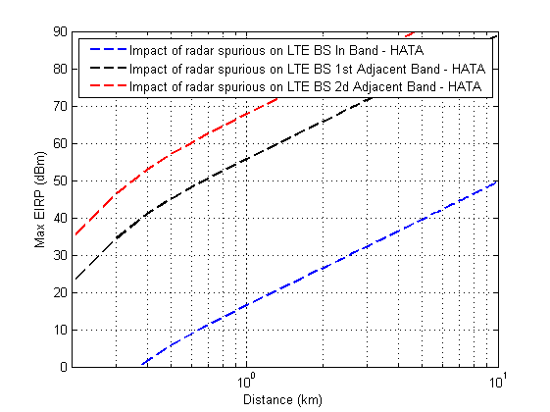

To update for the next SE7 meeting.

Preliminary result and analysis for a portable video link
Table 14: Result for portable video link
Frequency range | MHz | 1920-1915 | 1915-1900
Victim BS characteristics
Blocking level | dBm | -62,7 | -50,7
Attenuation calculation
Path loss | dB | 70,4 | 70,4
Antenna gain (w/ cable loss) | dBi | 17 | 17
Antenna discrimination | dB | 17 | 17
Interferer VL
Max eirp acceptable | dBm | 7,6 | 19,6

With the assumptions of the scenario of the table 12, according to the table above, portable camera links can operate in the 1900-1915 MHz frequency range as long as their EIRP is limited to 19,6 dBm/5MHz (which is 3,4 dB below the typical EIRP range of 23 to 30 dBm for this kind of product) and in the band 1915-1920 MHz frequency range as long as their EIRP is limited to 7.6 dBm/5MHz.
The same evaluation for different separation distances has to be conducted as in the paragraph 5.6.1.

Preliminary result and analysis for a mobile video link
Table 15: Result for mobile video link
Frequency range | MHz | 1920-1915 | 1915-1900
Victim BS characteristics
Blocking level | dBm | -62,7 | -50,7
Attenuation calculation
Path loss | dB | 82,7 | 82,7
Antenna gain (w/ cable loss) | dBi | 17 | 17
Antenna discrimination | dB | 17 | 17
Interferer VL
Max eirp acceptable | dBm | 20,0 | 32,0

According to the table above, portable camera links can operate in the 1900-1915 MHz frequency range as long as their EIRP is limited to 32 dBm/5MHz (which is 1 dB below the typical EIRP range of 33 to 36 dBm for this kind of product) and in the band 1915-1920 MHz frequency range as long as their EIRP is limited to 20 dBm/5MHz.
The same evaluation for different separation distances has to be conducted as in the paragraph 5.6.1.

Preliminary Result and analysis for a Point to Point link
[TBD]

Conclusions
Worst case link evaluations concerning the compatibility between DA2GC and outdoor PMSE video links have been conducted for the implementation of the DA2GC FDD system [1] in the unpaired 2 GHz bands. For that DA2GC system the two different alternatives for the realization of FL and RL in the lower and upper band were taken into account.
Both the transmission and the receiving paths of PMSE video links and Broadband DA2GC (both FL (Forward Link) and RL (Reverse Link)) have been studied, and both radio applications (PMSE video links and Broadband DA2GC) have been considered as a potential interferer and as a potential victim. Furthermore a paired arrangement for Broadband DA2GC has been taken into account (FL in one, RL in the other unpaired 2 GHz band). Both, co-channel usage of PMSE video links and Broadband DA2GC and adjacent channel arrangement for these two applications have been investigated.
The results of the evaluations from section 5 according to the scenarios identified in section 3.3 are summarized in Table 16 to for the system described in ETSI TR 103 054 [1]. The scenarios not calculated are considering the same victim-interferer situations, but in the other unpaired 2 GHz band, thus the results are comparable.

Table 16: Summary of compatibility study results between DA2GC FDD system (ETSI TR 103 054)
and PMSE Cordless Camera Link
Scenario | Victim | Interferer | Adjacent channel operation | Co-channel operation
(1a) | CCL Rx (portable hand-held receiver) | DA2GC GS Tx | Feasible with separation distance | Feasible with mitigation techniques and separation distance.
(1b) | DA2GC AS Rx | CCL Tx (hand-held camera) | Feasible without mitigation techniques | Feasible with mitigation techniques
(2a) | CCL Rx  (portable hand-held receiver) | DA2GC AS Tx | Feasible with mitigation techniques | Not feasible.
(2b) | DA2GC GS Rx | CCL Tx (hand-held camera) | Feasible without mitigation techniques | Feasible with separation distance

Co-channel operation of DA2GC FL and PMSE CCL would be feasible with less CCL Tx/Rx antenna gain and/or less CCL Tx power than used in the calculations. Co-channel operation of DA2GC RL and PMSE CCL is not feasible due to the high exceeding of the protection criterion of the CCL Rx.
Adjacent channel operation between DA2GC FL/RL and PMSE CCL is feasible with limited mitigation for the worst case scenarios.

Table 17: Summary of compatibility study results between DA2GC FDD system (ETSI TR 103 054)
and PMSE Mobile Video Link
Scenario | Victim | Interferer | Adjacent channel operation | Co-channel operation
(1a) | MVL Rx (helicopter) | DA2GC GS Tx | Feasible with separation distance | Not feasible
(1b) | DA2GC AS Rx | MVL Tx (motorcycle) | Feasible without mitigation techniques | Not feasible
(1c) | MVL Rx (helicopter) | DA2GC AS Tx | Feasible with mitigation technics | Not feasible
(1d) | DA2GC GS Rx | MVL Tx (motorcycle) | Feasible with separation distance | Feasible with separation distance

As already foreseen in the conclusions of [2] co-channel operation of DA2GC FL and PMSE MVL is not feasible. Co-channel operation of DA2GC RL and PMSE MVL is not feasible due to the high exceeding of the protection criterion of the MVL Rx.

Adjacent channel operation of the DA2GC RL and PMSE MVL is feasible. For adjacent channel operation of the DA2GC FL and PMSE MVL separation distances have to be applied, in particular for the scenario where the DA2GC GS is transmitting adjacent to the reception at the helicopter. However, the necessary separation distance of about 10.5 km compared to inter-site distances of the DA2GC GS of 100-170 km would allow for PMSE MVL operations in wide areas adjacent to the DA2GC GS.

Table 18: Summary of compatibility study results between DA2GC FDD system (ETSI TR 103 054)
and PMSE Portable Video Link
Scenario | Victim | Interferer | Adjacent channel operation | Co-channel operation
(1a) | PVL Rx  (TV van) | DA2GC GS Tx | Feasible with separation distance | Not feasible
(1b) | DA2GC AS Rx | PVL Tx (hand-held camera) | Feasible without mitigation techniques | Not feasible
(1c) | PVL Rx  (TV van) | DA2GC AS Tx | Feasible with mitigation technics | Not feasible
(1d) | DA2GC GS Rx | PVL Tx (hand-held camera) | Feasible with separation distance | Feasible with separation distance

Adjacent-channel operation of DA2GC FL/RL and PMSE PVL is considered feasible with separation distances from DA2GC GS.
Co-channel operation of DA2GC FL and PMSE PVL is not feasible. Co-channel operation of DA2GC RL and PMSE PVL is not feasible due to the high exceeding of the protection criterion of the PVL Rx.
The results of a compatibility study between the Broadband DA2GC system described in ETSI TR 101 599 [18] and PMSE equipment mounted on a helicopter are included in Annex 1. It can be seen from this study that adjacent band operation for this TDD DA2GC system is feasible with a maximum required separation distance of 3.7 km.

No detailed studies have yet been carried out for this TDD Broadband DA2GC system in respect of the other PMSE sharing scenarios listed in Tables 8 to 10 above. However, a simple comparison of the transmit powers and antenna gain patterns of the system, compared to those of the FDD system on which the results in Tables 8 to 10 are based allows for some broad conclusions to be drawn. In the case of ground-based PMSE systems, the likely required separation distances would be no greater than those calculated for the system described in TR 103 054

- potential for the beamforming DA2GC system described in ETSI TR 101 599 to operate in spectrum adjacent to PMSE systems within the 2GHz unpaired bands
  - Ground Station EIRP
The worst-case transmitted power (EIRP) as a function of elevation (selected points) is shown in Table 1 below:

Elevation | TR 101 599
0° elevation | P = 22 dBm
0° elevation | G = -10 dBi
0° elevation | EIRP = 12 dBm
10° elevation | P = 22 dBm
10° elevation | G = 23 dBi
10° elevation | EIRP = 45 dBm
90° elevation | P = 22 dBm
90° elevation | G = 15 dBi
90° elevation | EIRP = 37 dBm

Table 1 – EIRP for sample elevation angles

  - PMSE helicopter profile
The DA2GC ACLR for a 10 MHz receive bandwidth is 43 dB and the PMSE ACS with respect to a 10 MHz transmit bandwidth is 30 dB. The PMSE ACS therefore dominates, giving an overall ACLR of 29.9 dB. Using this value, together with the DA2GC Ground Station power profile reflected in the previous section, the level of interference received by a PMSE helicopter at 150 m altitude (free space path loss) is shown in Figure 1 below. It can be seen from this plot that the necessary ground path separation for the system described in TR 101 599 is 3.7 km.
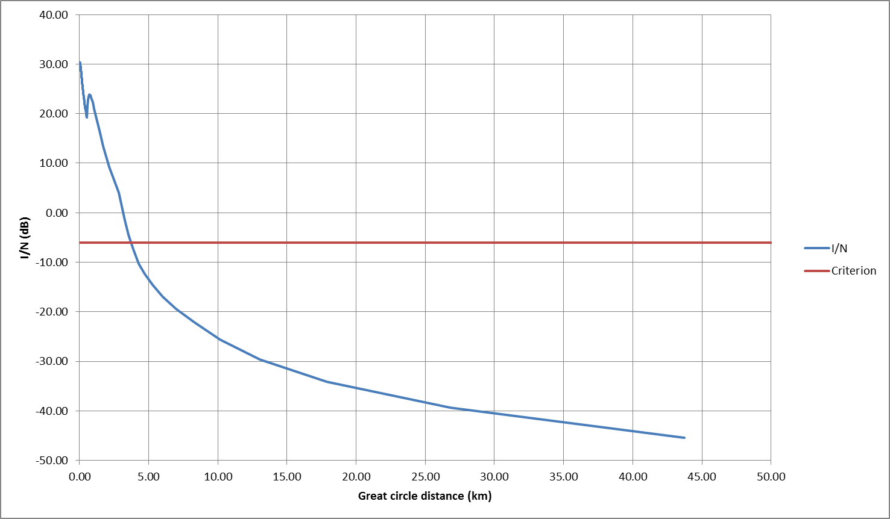

Figure 1 – Interference at helicopter (150m altitude) versus separation distance

  - Reverse direction
The preceding section has addressed the potential for interference when the DA2GC Ground Station is the potential interferer and the PMSE receiver at a helicopter is the potential victim. The TR 101 599 system however uses TDD so it is also necessary to consider the situation where a PMSE transmitter is the potential interferer and the DA2GC Ground Station is the potential victim.

Taking the helicopter link as an example, it is possible to compare the sum of the EIRP and receive gain in both directions to see which direction dominates or whether the potential impact is balanced. This is shown in Table 2 below:

Elevation (degrees) | EIRP (dBm) | G_{Rx} (dBi) | EIRP + G_{Rx}
0 | 12 (DA2GC GS) | 5 (PMSE) | 17
10 | 45 | 5 | 50
90 | 37 | 5 | 42
0 | 26 (PMSE) | -10 (DA2GC GS) | 16
10 | 26 | 23 | 49
90 | 26 | 15 | 41

Table 2 – Comparison of link gains between cases where
PMSE (helicopter) & DA2GC Ground Station is the victim

It can be seen from Table 2 that, for the helicopter case, the potential impact of interference is balanced between the two systems.
In the case of other ground based PMSE transmitters it is mainly the 0 degrees elevation case that is of interest. The balance on these links is such that interference into the PMSE system dominates because the PMSE receive gain is generally greater than 5 dBi and the PMSE EIRP is generally less than the value of 26 dBm used in the helicopter scenario.
  - Conclusions
It is shown, on the basis a worst case example, that that the necessary ground path separation for the system described in TR 101 599 and a PMSE receiver at a helicopter is 3.7 km.
Furthermore, DA2GC operations in the reverse direction (TDD) will not give rise to a separation distance greater than those estimated for the forward direction.

- List of reference
- ETSI TR 103 054: Electromagnetic compatibility and Radio spectrum Matters (ERM); System Reference Document; Broadband Direct-Air-to-Ground Communications operating in part of the frequency range from 790 MHz to 5 150 MHz; V1.1.1, July 2010.
- CEPT FM48(13)006: Annex 3: Implementing options for Broadband DA2GC and PMSE (wireless cameras); January 2013.
- Holma, H.; Toskala, A.: LTE for UMTS – OFDMA and SC-FDMA Based Radio Access; John Wiley & Sons, 2009.
- CEPT SE44(12)033rev1: Deutsche Telekom AG / Compatibility between DA2GC and other services at unpaired 2 GHz bands; August 2012.
- CEPT SE44(12)048: Deutsche Telekom AG / Compatibility between DA2GC and other services at unpaired 2 GHz bands; January 2013.
- CEPT SE44(13)004: Deutsche Telekom AG / Compatibility between DA2GC in the 2 GHz unpaired bands and other services in the adjacent bands; January 2013.
- CEPT FM48/51(13)007 Annex 2: Liaison Statement to SE44 and WG SE / Subject: Broadband DA2GC and PMSE; Frequency bands 1900-1920 MHz and 2010-2025 MHz; January 2013.
- ERC Report 38: Handbook on Radio Equipment and Systems Video Links for ENG/OB Use; May 1995.
- ECC Report 172: Broadband Wireless Systems Usage in 2300-2400 MHz; March 2012.
- ETSI EN 302 064-1: Electromagnetic compatibility and Radio spectrum Matters (ERM); Wireless Video Links (WVL) operating in the 1,3 GHz to 50 GHz frequency band; Part 1: Technical characteristics and methods of measurement; V1.1.2, July 2004.
- ETSI ES 202 239: Electromagnetic compatibility and Radio spectrum Matters (ERM); Wireless digital video links operating above 1,3 GHz; Specification of typical receiver performance parameters for spectrum planning; V1.1.1, October 2003.
- ITU-R Rec. P.525-2: Calculation of free-space attenuation; August 1994.
- SEAMCAT (Spectrum Engineering Advanced Monte Carlo Analysis Tool) Handbook, January 2010.
- 3GPP TS 36.101: User equipment (UE) radio transmission and reception; V10.3.0, June 2011.
- 3GPP TS 36.104: Base station (BS) radio transmission and reception.
- ITU-R Report M.2039: Characteristics of terrestrial IMT-2000 systems for frequency sharing/ interference analyses; November 2010.
- ITU-R Rec. F.699-7: Reference radiation patterns for fixed wireless system antennas for use in coordination studies and interference assessment in the frequency range from 100 MHz to about 70 GHz; April 2006.
- ETSI TR 101 599, System Reference Document on Broadband Direct-Air-to-Ground Communications System employing beamforming antennas, operating in the 2.4 GHz and 5.8 GHz bands; V1.1.3 September 2012.
- CEPT SE(13)046: LS on Broadband DA2GC and PMSE; Frequency bands 1900-1920 MHz and 2010-2025 MHz
- CEPT SE(13)046A1: PMSE use cases
- CEPT SE(13)023: LS from WG FM on compatibility studies for the unpaired 2 GHz bands 1900-1920 MHz and 2010-2025 MHz
- Etc.

Studies in ECC Report 172 [9] also consider only these three PMSE scenarios.
Two alternative Broadband DA2GC systems are also under consideration for operation within these frequency bands, both of which are based on a TDD implementation. Some studies have also been carried out in respect of one of these alternative systems (the system described in ETSI TR 101 599 [18]). These are referred to in Section 6 and detailed results of one study specific to that system are included in Annex 1.
of about 7.5 km (rural), 2 km (sub-urban) and 1 km (urban) for the worst case assumption.
The separation distance of about 36 km in rural area is reduced to about 12 km in suburban area and to about 6 km in urban area, i.e. co-channel operation would be feasible in specific areas or with PMSE CCL Rx with less antenna gain.
Protection is achieved at aircraft altitudes above 7000 m in case 1), i.e. co-channel operation would be feasible with PMSE CCL Tx with less transmission power and /or less antenna gain as shown in case 2).
With the assumption that the probability of occurrence of the worst case scenario considered is rather low due to power control at the DA2GC AS and antenna pointing for the PMSE CCL.
of about 9.9 km (rural for case 1) and about 3.6 km (rural for case 2) for the worst case assumption. These distances will be much less for suburban and urban environment.
of about 10.5 km (rural) for the worst case assumption.
With the assumption of >10 dB attenuation (MVL Rx antenna pattern / helicopter material) into the direction of the aircraft.
of about 0.4 km (rural) for the worst case assumption.
of about 26 km (rural), 7 km (sub-urban) and 3 km (urban) for the worst case assumption.
With the assumption that the probability of occurrence of the worst case scenario (PVL Rx antenna pointing in the direction of an DA2GC AS Tx) is considered rather low.
of about 1.3 km (rural), 0.3 km (sub-urban) and none (urban) for the worst case assumption.

