SRD/MG
53rd Meeting of SRD/MG  Biel, 7-9 September 2011 | SRDMG(11)071

Date issued: 28 July 2011

Source: Portugal

Subject: Vehicle radars in Annexes 5 and 6 of ERC Recommendation 70-03

N
Password protection required? (N)

Summary

Annexes 5 and 6 of ERC Recommendation 70-03 (Version of 9 February 2011) allow different emission limits for radar systems in the band 24.05 – 24.25 GHz.

Portugal is of the view that both entries for radar systems, as contained in Annexes 5 and 6 of ERC/REC 70-03, should have some text explaining the corresponding regulatory solutions. These clarifications should give the rationale for the two distinct entries in ERC/REC 70-03 for the band 24.05 – 24.25 GHz, in order to avoid the implementation of both by national administrations.

In addition, it is proposed that SRD/MG investigates if it is possible to concentrate in a single Annex of ERC/REC 70-03 the use of Vehicle Radars in the band 24.05 – 24.25 GHz.

Proposal

SRD/MG is invited to clarify the regulatory solutions proposed for radars systems in Annexes 5 and 6 of Recommendation 70-03 in the band 24.05 – 24.25 GHz.

Annex 5 of Recommendation 70-03, Road Transport and Traffic Telematics (RTTT), covers frequency bands and regulatory as well as informative parameters recommended for RTTT including radar system installations to be used in vehicles. The following emission limits are proposed for the band 24.05 – 24.25 GHz:

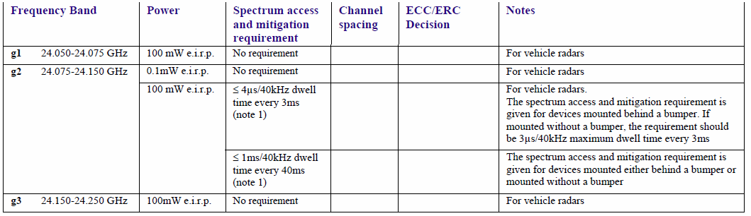

EN 300 440 is the relevant harmonised ETSI standard for this band and is pending replacement by EN 302 858 which is under development.

Annex 6 of Recommendation 70-03, “Radiodetermination applications”, covers frequency bands and regulatory as well as informative parameters recommended for SRD radiodetermination applications including SRD radar systems, Equipment for Detecting Movement and Alert. Radiodetermination is defined as the determination of the position, velocity and/or other characteristics of an object, or the obtaining of information relating to these parameters, by means of the propagation properties of radio waves. The following emission limits are proposed for the band 24.05 – 24.25 GHz:

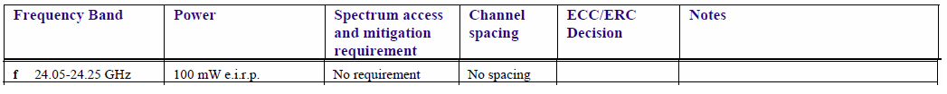
EN 300 440 is the relevant harmonised ETSI standard for this band, the same as for Annex 5.

With this, it can be concluded that there are two different regulatory solutions for the same application, i.e. radar systems in the band 24.05 – 24.25 GHz.

Concerning the implementation status as presented in Appendix 1 of ERC/Rec 70-03, it can be seen that some countries implement both Annex 5 and 6 for the frequency band 24.05 – 24.25 GHz, which, in our understanding, is a contradiction, as different limits are being authorized for the same application.

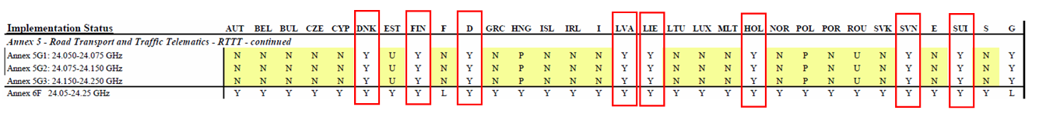

Portugal requests SRD/MG to clarify the regulatory solutions proposed for radars systems in Annexes 5 and 6 of Recommendation 70-03 in the band 24.05 – 24.25 GHz, aiming at solving the existing ambiguity.

In addition, it is proposed that SRD/MG investigates if it is possible to concentrate in a single Annex of ERC/REC 70-03 the use of Vehicle Radars in the band 24.05 – 24.25 GHz.

