**TG6(13)Temp 02**

**4.12.2013**

ECC Report <No>

Long Term Vision for the UHF broadcasting band

**Approved DD Month YYYY (Arial 9pt bold)**

**[last updated: DD Month YYYY) (Arial 9pt) [date of the latest update]]**

# Executive summary

Body text (style: ECC Paragraph)

(advice: the Executive Summary should provide a short and concise explanation on the purpose of the respective ECC Report and should clearly indicate the covered subjects to which it applies. In addition, it should clearly explain the application of the document.)

**TABLE OF CONTENTS**

[0 Executive summary 2](#_Toc369079788)

[1 Introduction 5](#_Toc369079789)

[2 Definitions 6](#_Toc369079790)

[3 SCOPE 7](#_Toc369079791)

[4 BaCKGround 8](#_Toc369079792)

[4.1 THE KEY ISSUES 8](#_Toc369079793)

[4.2 THE SPECTRUM CONTEXT 8](#_Toc369079794)

[4.3 CURRENT SITUATION 8](#_Toc369079795)

[5 TECHNOLOGY, SERVICE AND NETWORK EVOLUTION 9](#_Toc369079796)

[6 Long term vision issues 10](#_Toc369079797)

[6.1 GENERAL DESCRIPTION OF SCENARIOS 10](#_Toc369079798)

[6.2 SCENARIO 1 10](#_Toc369079799)

[6.2.1 DESCRIPTION 10](#_Toc369079800)

[6.2.2 ASSESSMENT 10](#_Toc369079801)

[6.2.2.1 TECHNICAL/FEASIBILITY STUDIES 10](#_Toc369079802)

[6.2.2.2 CROSS-BORDER COORDINATION AND COEXISTENCE 10](#_Toc369079803)

[6.2.2.3 ECONOMIC, SOCIAL AND CULTURAL ISSUES 10](#_Toc369079804)

[6.2.2.4 REGULATORY IMPACT 10](#_Toc369079805)

[6.2.2.5 MIGRATION ISSUES 10](#_Toc369079806)

[6.3 SCENARIO X 10](#_Toc369079807)

[6.3.1 DESCRIPTION 10](#_Toc369079808)

[6.3.2 ASSESSMENT 11](#_Toc369079809)

[6.3.2.1 TECHNICAL/FEASIBILITY STUDIES 11](#_Toc369079810)

[6.3.2.2 CROSS-BORDER COORDINATION AND COEXISTENCE 11](#_Toc369079811)

[6.3.2.3 ECONOMIC, SOCIAL AND CULTURAL ISSUES 11](#_Toc369079812)

[6.3.2.4 REGULATORY IMPACT 11](#_Toc369079813)

[6.3.2.5 MIGRATION ISSUES 11](#_Toc369079814)

[6.4 6.X ANALYSIS OF THE SCENARIOS AND COMBINATIONS 11](#_Toc369079815)

[6.4.1 6.x.x CROSS-BORDER COORDINATION AND COEXISTENCE 11](#_Toc369079816)

[6.5 6.x SUMMARY OF ANALYSIS 11](#_Toc369079817)

[7 RECOMMENDATIONS 12](#_Toc369079818)

[8 Conclusions 13](#_Toc369079819)

[ANNEX 1: heading (style: ECC annex - heading1) 14](#_Toc369079820)

[ANNEX 2: Heading (style: ECC Annex heading1) 15](#_Toc369079821)

[ANNEX 3: List of reference 16](#_Toc369079822)

**Note on the Table of Contents (delete after reading)**

This is automatically styled and compiled from the headings, subheadings and page numbers from the document that follows. To update the Table of Contents move cursor within the table and press F9.

**LIST OF ABBREVIATIONS**

|  |  |
| --- | --- |
| **Abbreviation** | **Explanation (style: Arial 10pt bold red (colour values RGB: 210, 35, 42)** |
| **CEPT** | European Conference of Postal and Telecommunications Administrations |
| **ECC** | Electronic Communications Committee |
| **<abbr>** | <explanation – edit the table as necessary> |
| **AV** | Audio-video |
| **HPHT** | High-power high-tower |
| **LPLT** | Low-power low-tower |
| **UE** | User equipment |
| **MBB** | Mobile broadband |
| **RAS** | Radio astronomy service |

# Introduction

Body text (style: ECC Paragraph)

(advice: this document gives a template for preparing an ECC Report. All existing contents including the annexes are given for information purposes, only, and they shall be replaced by the relevant contents of the new ECC Report.)

* The motivation for the studies
* Creation of TG6/
* What is long term?

# Definitions

|  |  |
| --- | --- |
| **Term** | **Definition (style: Arial 10pt bold red (colour values RGB: 210, 35, 42)** |
| **<Term 1>** | <Definition 1> |
| **<Term 2>** | <Definition 2> |
| Data | [Definition is required] |
|  |  |

## scenario

A scenario considered in the studies presented in this report should be understood as a combination of the following elements:

* **Service[[1]](#footnote-1)**, which is defined (in the context of this report) as content/information and/or functions provided to/from a user (e.g. audio/video linear, audio/video non linear, interactive/on-demand services, data, PMSE, etc) in the band 470-694 MHz;
* **Terminal/user device**, which is defined (in the context of this report) as receiving/transmitting equipment for the above service (e.g. large flat screen, portable TV sets, PC, laptop, smartphone, game console, tablets, etc);
* **Usage environment,** describing the radio propagation environment (e.g. rural, dense urban) as well as the receiving mode (fixed, portable/mobile) and location (e.g. at home, in public places, and vehicles )
* **Delivery,** which is defined (in the context of this report) as the means to providethe service (e.g. technology used, network architecture, etc).

# SCOPE

* Explain the activities covered in TG6

# BaCKGround

## THE KEY ISSUES

* The tasks
* Principles
* Objectives/Challenges

## THE SPECTRUM CONTEXT

* GE06
* RSPP
* WRC-15 (AI 1.1 and 1.2)
* EC Mandate 700 MHz

## CURRENT SITUATION

# TECHNOLOGY, SERVICE AND NETWORK EVOLUTION

* Broadcasting (video resolution, coding, modulation/systems, receiving modes, coverage requirements)
* Mobile Broadband (current forecasts, growth in data demand)
* Other services/applications (e.g. PMSE, PPDR, etc.)
* Network convergence/cooperation concepts
* Future usage patterns (formats, contents, etc..)
* Dynamic broadcast, underlay/overlay, etc..
* The services/applications involved
* Current developments/prospects
* Market models
* Standardization

# Long term vision issues

## GENERAL DESCRIPTION OF SCENARIOS

CEPT considers the scenarios listed in Table 1 as feasible for the development in the band 470-694 MHz in a long term. These scenarios may occur either as standalone or in combination with each other.

**Table 1**. Long term scenarios in the band 470-694 MHz

|  |  |  |  |  |  |  |  |
| --- | --- | --- | --- | --- | --- | --- | --- |
| **No** | **Service** | **Terminal/ user device** | **Usage environment** | **Delivery** | | **Source** | **§** |
| **Technology** | **Network** |
|  | AV linear,  AV non-linear | Large screen | Stationary, portable outdoor/indoor | DTT | HPHT | Doc. 25 (EBU) | [6.2](#_SCENARIO_1_[from) |
|  | AV linear, AV non-linear | Large screen, small screen/tablet | Stationary, portable outdoor/indoor | DTT | LPLT | Doc. 25 (EBU) | [6.3](#_SCENARIO_X2_[from) |
|  | AV linear, AV non-linear | Large screen, small screen/tablet | Stationary, portable outdoor/indoor | DTT (outdoor), WiFi (indoor) | HPHT/ LPLT | Doc. 25 (EBU) | [6.4](#_SCENARIO_3_[from) |
|  | AV linear, AV non-linear | Large screen, small screen/tablet | Stationary, portable outdoor/indoor | DTT (outdoor), WiFi (indoor), DTT chips inside UE | HPHT/ LPLT | Doc. 25 (EBU) | [6.5](#_SCENARIO_4_[from) |
|  | AV linear, AV non-linear | Large screen, small screen/tablet | Stationary, portable outdoor/indoor | LTE Broadcast | HPHT | Doc. 25 (EBU) | [6.6](#_SCENARIO_5_[from) |
|  | AV linear, AV non-linear | Large screen, small screen/tablet | Stationary, portable outdoor/indoor | LTE Broadcast | LPLT | Doc. 25 (EBU), Doc. 38 (Qualcomm) | [6.7](#_SCENARIO_6_[from) |
|  | AV linear, AV non-linear, Data | Large screen, small screen/tablet | Stationary, portable outdoor/indoor, mobile | LTE Broadcast | LPLT | Doc. 38 (Qualcomm) | [6.8](#_SCENARIO_7_[from) |
|  | AV linear, AV non-linear, Data | Large screen, small screen/tablet | Stationary, portable outdoor/indoor, mobile | LTE | LPLT | Doc. 35 (NSN, Nokia) | [6.9](#_SCENARIO_8_[from) |
|  | AV linear, AV non-linear, Data | Large screen, small screen/tablet | Stationary, portable outdoor/indoor, mobile | LTE,  LTE Broadcast | HPHT/ LPLT | Docs. 7, 40 (Ericsson) | [6.10](#_SCENARIO_9_[from) |
|  | PMSE content | PMSE equipment | Portable, mobile | Digital | Low power links | Doc. 47 (SUI) | [6.11](#_SCENARIO_10_[from) |
|  | Smart data quantities | Smart communication unit | Stationary, portable outdoor/indoor, mobile | Dynamic cognitive communication | HPHT/ LPLT | Doc. 34 (S) | 6.[12](#_SCENARIO_11_[from) |
|  | As of today | As of today | As of today | As of today | As of today | Ireland |  |

It needs to be noted that RAS, currently used in some European countries in the band 608-614 MHz, may be still operational in the future and will need to be taken into account by all scenarios foreseen in the band 470-694 MHz (see RR 5.149).

## SCENARIO 1 [from Doc. 25, EBU]

In this scenario DTT remains the primary technology for the delivery of broadcast services  
in the band 470-694 MHz using DVB standards.

This scenario assumes a natural evolution of the DTT platform taking into account the ongoing technological and service developments, and assuming a stable regulatory environment and access to the spectrum.

### DESCRIPTION

**Services**

* Linear and non-linear TV services, as they evolve over time
* Migration of TV services, both linear and non-linear, from SDTV to HDTV and, eventually, UHDTV
* Progressive introduction of hybrid TV services, integration of the mainstream linear TV services delivered over DTT with catch-up and on-demand services delivered via broadband networks
* The interleaved spectrum (white spaces) would continue to be used for secondary services such as PMSE and, potentially, white space devices, possibly under LSA regime.

**Terminal / user devices**

* TV receivers as they evolve over time
* Other devices, including portable and mobile terminals capable of receiving via terrestrial broadcast networks

**Usage environment**

* Primarily the home environment including in urban, sub-urban and rural areas
* Public places and vehicles, provided that the networks are designed to ensure the required coverage

**Delivery**

The DTT networks would remain a mix of high-power-high-tower (HPHT) and low-power-low-tower (LPLT) transmitters, as well as a mix of MFN and SFN configuration.

Transmission technology would be upgraded, including:

* migration from DVB-T towards DVB-T2 and beyond

### migration from MPEG-2 to MPEG-4 and, eventually, HEVCASSESSMENT

#### TECHNICAL/FEASIBILITY STUDIES

#### CROSS-BORDER COORDINATION AND COEXISTENCE

#### ECONOMIC, SOCIAL AND CULTURAL ISSUES

#### REGULATORY IMPACT

#### MIGRATION ISSUES

(...)

## SCENARIO 2 [from Doc. 25, EBU]

In this scenario DTT remains the primary technology for the delivery of broadcast services  
in the band 470-694 MHz (Scenario 1) + DTT network topology evolves towards   
low-power-low-tower configuration.

This scenario assumes a natural evolution of the DTT platform taking into account the ongoing technological and service developments, and assuming a stable regulatory environment and access to the spectrum.

### DESCRIPTION

**Services**

* Linear and non-linear TV services, as they evolve over time
* Migration of TV services, both linear and non-linear, from SDTV to HDTV and, eventually, UHDTV
* Progressive introduction of hybrid TV services, integration of the mainstream linear TV services delivered over DTT with catch-up and on-demand services delivered via broadband networks
* The interleaved spectrum (white spaces) would continue to be used for secondary services such as PMSE and, potentially, white space devices, possibly under LSA regime.

**Terminal / user devices**

* TV receivers as they evolve over time, with a focus on the on large flat screens
* Other devices, including portable and mobile terminals capable of receiving via terrestrial broadcast networks

**Usage environment**

* Primarily the home environment including in urban, sub-urban and rural areas
* Public places and vehicles, provided that the networks are designed to ensure the required coverage

**Delivery**

The DTT network configuration would evolve from the current mix of high-power-high-tower (HPHT) and low-power-low-tower (LPLT) transmitters towards LPLT topology. Synergies with the cellular network infrastructure should be sought.

Transmission technology would be upgraded, including:

* migration from DVB-T towards DVB-T2 and beyond
* migration from MPEG-2 to MPEG-4 and, eventually, HEVC

### ASSESSMENT

#### TECHNICAL/FEASIBILITY STUDIES

#### CROSS-BORDER COORDINATION AND COEXISTENCE

#### ECONOMIC, SOCIAL AND CULTURAL ISSUES

#### REGULATORY IMPACT

#### MIGRATION ISSUES

## SCENARIO 3 [from Doc. 25, EBU]

In this scenario DTT remains the primary technology for the delivery of broadcast services  
in the band 470-694 MHz (Scenario1) + DTT networks are designed for outdoor coverage and coupled with other means for indoor coverage (e.g. WiFi).

This scenario assumes a natural evolution of the DTT platform taking into account the ongoing technological and service developments, and assuming a stable regulatory environment and access to the spectrum.

### DESCRIPTION

**Services**

* Linear and non-linear TV services, as they evolve over time
* Migration of TV services, both linear and non-linear, from SDTV to HDTV and, eventually, UHDTV
* Progressive introduction of hybrid TV services, integration of the mainstream linear TV services delivered over DTT with catch-up and on-demand services delivered via broadband networks
* The interleaved spectrum (white spaces) would continue to be used for secondary services such as PMSE and, potentially, white space devices, possibly under LSA regime.

**Terminal / user devices**

* TV receivers as they evolve over time, with a focus on the on large flat screens
* Other devices, including portable and mobile terminals capable of receiving via terrestrial broadcast networks
* Any indoor device that can be connected to the complementary technology to DTT (e.g. WiFi)

**Usage environment**

* Primarily the home environment including in urban, sub-urban and rural areas
* Enhanced indoor coverage would be provided through a complementary technology (e.g. WiFi)
* Public places and vehicles, provided that the networks are designed to ensure the required coverage

**Delivery**

The DTT networks are designed for outdoor coverage (both fixed and mobile) and combined with other means to ensure indoor coverage (e.g. transcoding to WiFi).

The network configuration could remain a mix of high-power-high-tower (HPHT) and low-power-low-tower (LPLT) transmitters (as in Scenario 1) or could evolve towards LPLT (as in Scenario 2).

Transmission technology would be upgraded, including:

* migration from DVB-T towards DVB-T2 and beyond
* migration from MPEG-2 to MPEG-4 and, eventually, HEVC

## SCENARIO 4 [from Doc. 25, EBU]

In this scenario DTT remains the primary technology for the delivery of broadcast services  
in the band 470-694 MHz (Scenario 1) + DTT receivers are included in mobile devices.

This scenario assumes a natural evolution of the DTT platform taking into account the ongoing technological and service developments, and assuming a stable regulatory environment and access to the spectrum.

### DESCRIPTION

**Services**

* Linear and non-linear TV services, as they evolve over time
* Migration of TV services, both linear and non-linear, from SDTV to HDTV and, eventually, UHDTV
* Progressive introduction of hybrid TV services, integration of the mainstream linear TV services delivered over DTT with catch-up and on-demand services delivered via broadband networks
* The interleaved spectrum (white spaces) would continue to be used for secondary services such as PMSE and, potentially, white space devices, possibly under LSA regime.

As all user devices would eventually be capable of connecting to both, broadcast as well as broadband networks, including wireless broadband in another frequency band (e.g. via LTE, or WiFi) this would offer additional possibilities, such as:

* a readily available return channel for interactive and on-demand broadcast services
* traffic off-loading from mobile broadband networks onto DTT (e.g. for linear services, large file downloads, software and application upgrades)

**Terminal / user devices**

* TV receivers as they evolve over time, with a focus on the on large flat screens
* DTT receiving capabilities would be included in other devices, including portable and mobile terminals in order to make them capable of receiving via terrestrial broadcast networks in the UHF band.

**Usage environment**

* Primarily the home environment including in urban, sub-urban and rural areas
* Enhanced indoor coverage would be provided through a complementary technology (e.g. WiFi)
* Public places and vehicles, provided that the networks are designed to ensure the required coverage

**Delivery**

The DTT network configuration could remain a mix of high-power-high-tower (HPHT) and low-power-low-tower (LPLT) transmitters (as in Scenario 1) or could evolve towards LPLT (as in Scenario 2). The broadcast networks could be designed for any reception mode, including fixed roof-top, portable and mobile) or could be combined with complementary means for indoor coverage (as in Scenario 3).

Transmission technology would be upgraded, including:

* migration from DVB-T towards DVB-T2 and beyond
* migration from MPEG-2 to MPEG-4 and, eventually, HEVC

## SCENARIO 5 [from Doc. 25, EBU]

In this scenario linear and non-linear broadcast services are delivered using the LTE eMBMS specification with high-power-high-tower (HPHT) topology.

This scenario assumes that the broadcast services in the UHF band would in the future be delivered via LTE eMBMS HPHT networks. Service requirements, the types of user devices and usage environments are assumed to be similar as in the scenarios described above.

### DESCRIPTION

**Services**

* Linear and non-linear TV services, as they evolve over time
* Migration of TV services, both linear and non-linear, from SDTV to HDTV and, eventually, UHDTV
* Progressive introduction of hybrid TV services, integration of the mainstream linear TV services with catch-up and on-demand services
* The interleaved spectrum (white spaces) would continue to be used for secondary services such as PMSE and, potentially, white space devices, possibly under LSA regime.

**Terminal / user devices**

* TV receivers as they evolve over time, with a focus on the on large flat screens
* Other devices, including portable and mobile terminals capable of receiving LTE eMBMS

**Usage environment**

* Primarily the home environment including in urban, sub-urban and rural areas
* Public places and vehicles, provided that the networks are designed to ensure the required coverage

**Delivery**

The LTE eMBMS networks would be deployed on the basis of a high-power-high-tower (HPHT) architecture utilising the current DTT network infrastructure to minimise changes required to the consumers fixed aerial installations. The networks would be built for fixed roof-top reception, or could be extended to provide a stable robust signal indoors for stationary devices and outdoor coverage for mobile devices.

The UHF band would be used only for eMBMS (downlink-only) while bi-directional (unicast) mobile broadband traffic would be carried in another spectrum (i.e. IMT frequency bands).

## SCENARIO 6 [from Docs. 25 (EBU), 38 (Qualcomm)]

[Ed. note: Qualcomm to check what elements from Doc. 38 needs to be used to amend the text in this section]

In this scenario linear and non-linear broadcast services are delivered using the LTE eMBMS specification with a cellular low-power network topology.

This scenario assumes that the broadcast services in the UHF band would in the future be delivered via LTE eMBMS LPLT networks. Service requirements, the types of user devices and usage environments are assumed to be similar as in the scenarios described above.

### DESCRIPTION

**Services**

* Linear and non-linear TV services, as they evolve over time
* Migration of TV services, both linear and non-linear, from SDTV to HDTV and, eventually, UHDTV
* Progressive introduction of hybrid TV services, integration of the mainstream linear TV services with catch-up and on-demand services
* The interleaved spectrum (white spaces) would no longer be available. Therefore, neither the current secondary services such as PMSE would be able to operate in the 470-694 MHz band nor it would be possible to introduce white space devices.

**Terminal / user devices**

* TV receivers as they evolve over time, with a focus on the on large flat screens
* Other devices, including portable and mobile terminals capable of receiving LTE eMBMS

**Usage environment**

* Primarily the home environment including in urban, sub-urban and rural areas
* Public places and vehicles, provided that the networks are designed to ensure the required coverage

**Delivery**

In this scenario, the LTE eMBMS networks would be deployed in a low-power-low-tower (LPLT) configuration. The existing cellular network architecture could be used.

The networks would be built for fixed roof-top reception, or could be extended to provide a stable robust signal indoors for stationary devices and outdoor coverage for mobile devices.

The UHF band would be used only for eMBMS (downlink-only) while bi-directional (unicast) mobile broadband traffic would be carried in another spectrum (i.e. IMT frequency bands).

## SCENARIO 7 [from Doc. 38, Qualcomm]

In this scenario LTE Broadcast is a service to deliver broadcast and multicast content over LTE cellular networks. The service is delivered over a technology standardised by 3GPP as eMBMS.

The scenario can be summarised as follows:

* The platform delivers terrestrial broadcasting services. The platform being an IP platform can deliver multicast, unicast, non-linear, interactive/on-demand services. In general, the platform provides a large IP downlink channel that can deliver any data to users.
* The receiving equipment includes the current terrestrial broadcasting receivers (e.g. large flat screen, portable TV sets) but also extends to any LTE capable device (including tablets and smartphones).
* The platform ensures fixed rooftop reception nationally and mobile reception in high density areas and areas of specific interest.
* The platform leverages the existing cellular infrastructure through the addition of LTE-Broadcast capability in 470-694 MHz on existing cellular transmission sites. For national linear broadcast content, the network operates as nationwide SFN delivering a minimum 2 bps/Hz. The overall platform is IP based, ensuring flexibility for the introduction of new technology (e.g. new codecs) and providing opportunities for convergence of linear and non-linear services.

### DESCRIPTION

#### DL delivery platform supporting interactivity

The adaptive LTE-Broadcast platform delivers most services over a large Supplemental Downlink (SDL) channel operated as a Secondary Component Carrier (SCC). A small FDD band provides the Primary Component Carrier (PCC). A single network delivers content to all users.

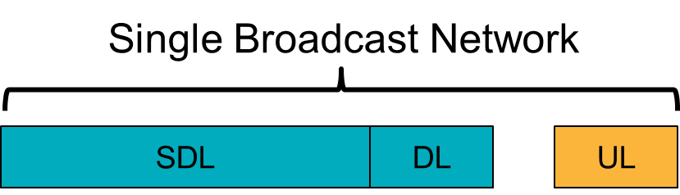

Figure 1: Adaptive LTE-Broadcast platform (including UL) scenario.

The network can broadcast content free-to-air, but can also multicast and unicast content. When/if required, the Primary Component Carrier can support all typical LTE functionalities such as access control, billing, emergency calls.

The exact band plan would need to take a number of elements into account, including the spectrum requirement of other services (e.g. radio astronomy, PMSE). An example band plan, assuming that the entire 470-694 MHz band is dedicated to broadcast, is illustrated in the Figure 2 below. This band plan is not proposed as a recommended band plan as, amongst other questions, does not take into account the spectrum requirement of other services, assumes that the band 694-703 MHz is available. Further studies are required to determine an appropriate band plan, should this option be selected. The band plan is only provided to illustrate that the FDD sub-band is significantly smaller than the SDL sub-band, i.e. the platform remains a DL dominated platform.

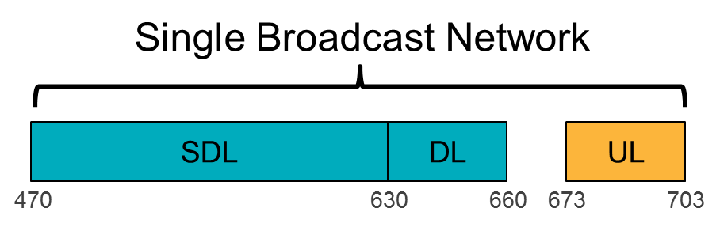

Figure 2: Indicative example band plan (Not part of proposal).

#### Dynamic broadcast/unicast

The adaptive LTE-Broadcast platform is, as illustrated in Figure 1 is a large mobile downlink pipe that can deliver broadcast or unicast content. The platform can allocate the required bandwidth to the broadcast of linear content and leverage any additional capacity for the delivery of unicast data. As such, the platform can adapt to the national broadcast requirements while maintaining harmonization at CEPT level.

For services requiring user registration, the network can monitor the number of terminals accessing the service in a cell and dynamically operate either in broadcast, multicast or unicast mode.

#### Mixed Service SFN

The network operates as a nationwide SFN (Frequency reuse 1) for linear broadcast content. The network is designed for ‘Mixed Service’, i.e. delivering mobile coverage in areas of interest, while guaranteeing fixed rooftop reception throughout the network, as illustrated in Figure 3. The network requires a transmission site density lower or equal to that of existing cellular network (10 km cell range), in order to ensure that an initial deployment could be achieved by simply reusing existing cellular sites (no network densification). The adoption of a coverage mode (ranging from true mobile to fixed rooftop) for a given area would be the result of discussions at national level, but does not impact the band plan or the harmonisation. Existing cellular networks are ‘naturally’ denser in high density population areas and therefore offer the possibility to adopt mobile coverage in these areas without requiring network densification.

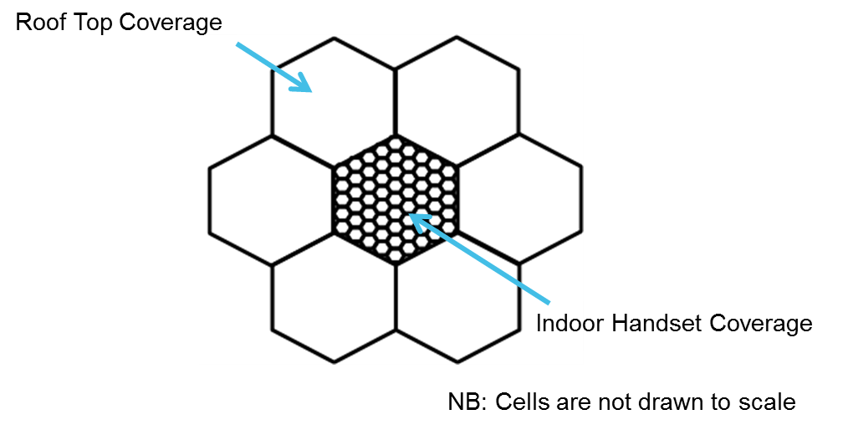

Figure 3: Mixed Service SFN

Such a Mixed Service SFN is interference limited. Directional antennas, even pointed in the wrong direction, would be able to receive the signal. In the long term, the adoption of a ‘low power low tower’ type of network implies that omnidirectional antennas would be sufficient for fixed rooftop reception, reducing significantly the cost of rooftop reception and increasing the flexibility of the platform and it ability to evolve in time.

#### IP-based platform

LTE and LTE Broadcast are All IP Networks (AIPN) by definition, providing the two following benefits:

* LTE and LTE Broadcast benefit from economies of scale and large support, both on device and network sides.
* LTE and LTE Broadcast can integrate seamlessly future evolutions of delivery mechanisms.

In particular, while the LTE FEC is integrated in LTE Broadcast itself, a number of functionalities, such as outter block coding (i.e. Raptor code), encapsulation (DASH) and source encoding/decoding (e.g. HEVC) are performed at application layer as illustrated in Figure 4. This provides a number of benefits, the most important being the ability of the delivery network to integrate seamlessly the latest standards of video-delivery.

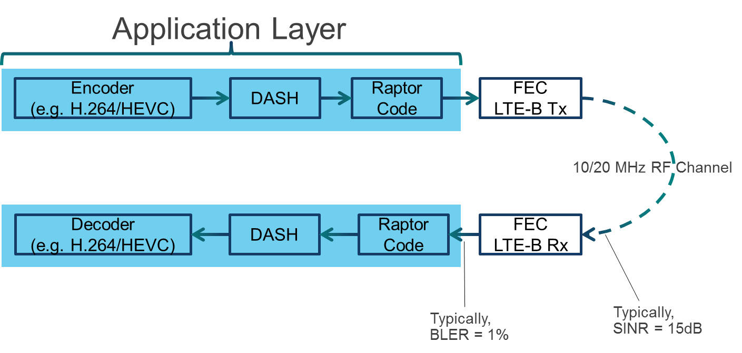

Figure 4: Typical LTE-Broadcast encoding/decoding chain

LTE supports both unicast delivery and multicast/broadcast delivery (through LTE Broadcast). There are multiple benefits to supporting both delivery methods in parallel, in the context of so-called hybrid delivery scenario, i.e. scenarios where part of the content is delivered over unicast and part of the content is delivered over broadcast. In practice, hybrid delivery scenario can be deployed by leveraging the functionality of Dynamic Adaptive Streaming over HTTP (DASH) on top of LTE Broadcast.

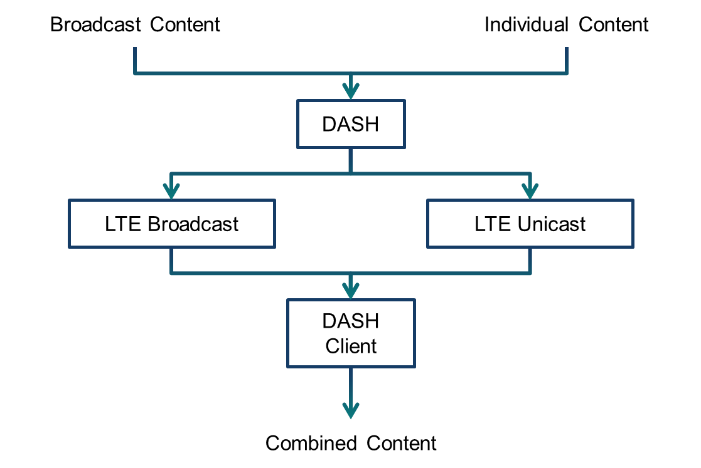

Figure 5: Hybrid delivery scenario.

Hybrid delivery scenarios support the following features:

* Delivery of certain components/media streams/representations/segments over broadcast and other components over unicast with synchronization at the client.
* Use of unicast for optimized user experience, for example for reducing channel-change times unicast may be used to enable an immediate switch until sufficient broadcast data is available to seamlessly switch back to the broadcast delivered representation.
* Seamless transition of a broadcast-delivery into a time-shift mode, such that the same content is available for later consumption in the cloud.
* Coverage extensions for broadcast distribution.
* Dynamic unicast/broadcast.

#### LTE Broadcast Service Area/MBSFN

While the network supports nationwide SFN areas (desirable for national linear TV channels), there is often a need to support delivery of local content. LTE-Broadcast supports overlap between MBSFN areas in order to enable local, regional, and national services. One cell can belong to up to 8 MBSFN areas, as illustrated in Figure 6. Interference between neighboring MBSFN areas is tolerable when the areas are separated by a few kilometers in a low tower low power deployment. Directional receiving antennas can be beneficial to discriminate signals at the edge between 2 co-channel MBSFN areas.

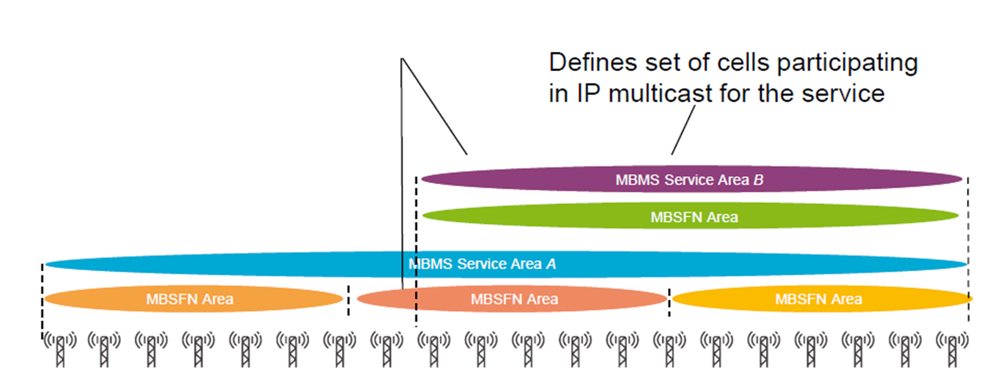

**Figure 6: LTE-Broadcast supports multiple MBMS Service area and MBSFN areas.**

## SCENARIO 8 [from Doc. 35, NSN, Nokia]

### DESCRIPTION

This MBB-scenario is based on the visible trend that the importance of terrestrial broadcasting transmissions in the UHF channels as a delivery mechanism will decrease, when TV programs are more and more received via other ways than traditional DTT (Digital Terrestrial Television). This development includes the trend that linear TV reception is increasingly done via broadband (fixed and mobile/wireless), cable and satellite distribution and that non-linear usage of TV content is greatly increasing. There are also other trends like higher spectrum fees of UHF band that will impact to the DTT business case, especially; some commercial pay-TV operators with limited amount of users may find other delivery mechanisms more cost-efficient. Already today there are some applications (like Netflix) that provide TV content via broadband (both mobile and fixed) networks.

With these trends, regulators can gradually withdraw some DTT licenses, one by one, and repurpose these frequencies for Mobile Broadband use. On the other hand, the most used DTT licenses can continue as long as required, e.g. free national TV licenses with public service obligations that may be financed by other means than commercial funding. It is assumed that most of DTT will be evolved to DVB-T2 technology, which is more spectrum efficient than DVB-T and also supports single frequency networks (SFNs).

Mobile Broadband (MBB) networks can be licensed to those freed channels. The freed channels could be best used by Supplementary Downlink (SDL) (combined with other MBB bands via LTE Advanced carrier aggregation (CA)), as SDL is better compatible with the remaining DTT use than FDD or TDD networks. FDD operation also requires more harmonized conditions and a wider freed spectrum block at the same time. TDD includes uplink that is less compatible with the DTT use. SDL would then facilitate both ‘traditional’ MBB DL and also LTE Broadcast (eMBMS), based on market demand. Additionally, SDL use would also support the trend that the future MBB traffic is asymmetric towards downlink direction. Already today, in some networks the average asymmetry is about 8:1 towards downlink and the traffic is expected to be more downlink oriented in spite of increasing video etc uploading with smart phones (as usually the uploaded content will be downloaded many times, still supporting downlink oriented traffic).

## SCENARIO 9 [from Docs. 7, 40, Ericsson]

The purpose of this scenario is to explore some of developments and results with regards to relevant items related to convergence of applications, such as:

* types of services and applications, and
* available technology choices including support for possible convergent offerings between digital television; broadcast providers and mobile broadband service providers.

This scenario is presenting a view on current trends in multimedia distribution in general and television in particular. Access to radio and television based content over broadband networks is becoming an essential element of future IP based media services. The opportunity that LTE networks offer as a complement to the current terrestrial broadcasting technologies with the aim of improving the consumer experience has been investigated.

In addition to the demands of media consumers, mobile broadband networks also provide interesting opportunities for program development in the domain of ENG/OB. LTE networks enable transmission of high definition (HD) video streams from live cameras with the low latency and high quality required for studio feeds.

Specifically, an overview of the LTE Multimedia Broadcast/Multicast Service (MBMS) has been presented as a solution for mass multimedia distribution over LTE. The spectrum requirements to provide roof-top reception television service using a cellular network deployment and MBMS has also been investigated. The spectral efficiency of MBMS for this application has been determined by simulations.

The simulations show that MBMS has a spectral efficiency of 3.1 bit/s/Hz up to a cellular inter site distance (ISD) of 2 km. With this, 84 MHz of spectrum are sufficient to provide the desired aggregate service rate. Comparing this to the 300 MHz used by television services today, the potential savings in spectrum are significant. It is noted that spectrum requirements could be further reduced by replacing MPEG2 with H.264, for which bit-rate efficiency gains of 30 – 50 % have been reported. H.264 has been defined as one codec to be used with MBMS; however, for television services targeting large screens, additional H.264 profiles will have to be mandated for MBMS.

Therefore, current linear television distribution networks and LTE networks are complementary and can be used in cooperation very effectively in order to support the evolving consumer demands, thus paving the way towards more complete convergence and synergism in the future (win-win strategies). The combination of the two modes of delivery enables the easy introduction of new advanced services and applications and supports successful convergent offerings between digital television, broadcast providers, and mobile broadband service providers.

### DESCRIPTION

Broadcasting offers an effective way of distributing traditional linear programming to large populations in real time and with the use of recording devices the delayed consumption and archival of programming by users may also be possible. However, there are also the consumers’ increasing demands to access programming “a la carte” anywhere, anytime. In recent years linear television has been complemented by some form of video on-demand, be it IPTV based movie stores or web-based video clips services[[2]](#footnote-2). Indeed, the web sites of broadcasters, which are among the largest and with most traffic at national levels, offer proof of the growing popularity of innovative, streamed media services. Users employ a variety of devices to access such programming “a la carte”, ranging among Internet-enabled television sets, desktops, laptops, tablets, c-boards, and smartphones, among others that continue to proliferate.

Mobile broadband user terminal devices, such as smartphones and tablets, are increasingly important for access to media content and services. Innovative media services are among the main drivers of broadband take-up. Mobile broadband is becoming a significant delivery platform for broadcasters and it also enables more dynamic and interactive access of content.

However, the full potential of mobile broadband for the delivery of broadcasting content and services to large audiences is still not fully exploited.

#### Examples of IP-based media services

New IP-based media services are currently being developed, refined and made accessible over mobile broadband networks. Traditional as well as a new variety of content is developing, including social media, texting and chatting that is engaging and entertaining a growing audience. In particular the younger and middle-aged audience groups are establishing these new behaviors where media content, in addition to the living room based television set, is also consumed on desktops, laptops, tablets and smartphones {1} {16}. Whatever the case may be in terms of future consumption, access to radio and television based content over broadband networks is becoming an essential element of future IP-based media services.

While still covering a significant consumer base, as well as large geographical areas, the current analogue or digital terrestrial broadcasting technologies are the primary, or the only, means of delivering television services to a living-room based television set using a fixed antenna, in numerous countries. It would be exceptionally demanding to substitute these technologies for the purpose of modernization and adaption to the new behavior of consumers and the new variety of content provisions. The reality is that both forms of access will coexist and evolve in their own ways for a long time and win-win solutions need to be developed for the cooperation and convergence between Broadcasting and Mobile Services; hence it is expected that the current terrestrial broadcasting technologies will remain in use for years to come. In some countries, the availability of terrestrial television program channels and television viewing time is still on the increase. However, in other countries the increase of viewing time is now becoming more flat, or even having a somewhat negative trend with regard to linear television viewing {1}, particularly with regard to the younger television audience.

television viewing now is becoming a social event as people are using social media to discuss what they are watching. Indeed, the referred study {1} shows “Social television: sixty-two percent of people use social networking sites and forums while watching television on a weekly basis and this number is growing. Of these people, forty percent will be discussing what they are currently watching on television over social networks.”

Notably, studies have shown that consumer behavior is changing in terms of freedom of location, time and choice when accessing content, as well as improved quality, quantity and interaction. One other significant change in behavior is the growth of non-linear content. Accordingly, a trend is emerging with broadcasting focusing on live events whereas stored content will increasingly be made available by streaming.

An essential question to consider when satisfying the new demands of media consumers is how to provide access to linear and non-linear content while using different devices and different sized screens. Broadcasting networks are suitable for linear content, and television receivers are now being equipped with broadband access. Mobile broadband networks are well suited for non-linear content with interactive use, and the devices primarily used on those networks are highly flexible with regard to usage and mobility.

In February 2010, the Canadian Radio-television Telecommunications Commission (CRTC) released a report entitled “Navigating Convergence: Charting Canadian Communications Change and Regulatory Implications”, an analysis of many of the trends, opportunities and challenges that faced the industry at that time. Since the document was published, many of the trends it identified have not only continued, but also accelerated. The 2011 follow-up report {2} entitled “Navigating Convergence II: Charting Canadian Communications Change and Regulatory Implications“ describes an environment characterized by greater-than-anticipated consumption of content from Internet sources, further consolidation within the communications industry, substitutability of services, a proliferation of communications devices, and network traffic growth for both fixed and wireless networks. The report focuses on the evolution of wired and wireless networks, media-consumption trends and consumer-related issues.

Furthermore, in the 2012 annual “Communications Monitoring Report”, which provides an overview of the Canadian communications sector, it is shown that Canadians are consuming more content, both traditional television and radio broadcasts and digital media content {3}. On a weekly basis, they watched an average of 28.5 hours of television, up from 28 hours in 2010, and listened to an average of 17.7 hours of radio, up from 17.6 hours the previous year. Canadians also actively consumed digital media content. Typical users watched 2.8 hours of Internet television per week, an increase from 2.4 hours in 2010. Four per cent of Canadians report only watching television programming online, while 4 % watched programming on a smartphone and 3 % on a tablet. Additionally, Canadians also stream the signal of an AM or FM station over the Internet.

In addition to the demands of media consumers, mobile broadband networks also provide interesting opportunities for supporting wireless feeds for news gathering applications for program development in the domain of Electronic News Gathering/Outside Broadcasting services (ENG/OB). This mobile broadband application provides real time feeds for broadcasting; the users could be professionals (e.g., camera people on a motorcycle following an event and transmitting the feed using LTE) or consumers (e.g., people with smartphone terminal devices sending videos to newspapers and broadcasters). Indeed, the more advanced LTE networks enable the transmission of high-definition (HD) video streams from live cameras with the low latency and high quality required for studio feeds. This has been demonstrated in several events, including:

* Swedish Crown Princess' Royal Wedding in 2010, where Swedish television companies broadcasted live from the celebrations in Stockholm, as well as being available live from the official website of the wedding {2};
* Japanese Nippon television reporting from the Nobel press conference in Stockholm 2010 {3};
* YouTube streamed the entire wedding of Prince William and Kate Middleton's event live from [The Royal Channel](http://www.youtube.com/user/TheRoyalChannel" \t "_blank), which was built specifically for wedding. BBC provided full streaming of the event at BBC News' [dedicated wedding site](http://www.bbc.co.uk/news/uk-11767495" \t "_blank). It was possible to watch the entire event live on a smartphone or other Internet devices such as tablets {4}.
* For the Summer Olympics 2012, Bell Mobility and Rogers set up Canada’s Olympic Broadcast Media Consortium (in both English and French) to broadcast live events from London over the Internet, television, and mobile. One week into the Games, 61% of the traffic on the Consortium’s digital platforms was powered by mobile devices, receiving nearly 90 million page views and indicating an enthusiastic shift in consumer behaviour as viewers took the Games with them wherever they went {4}; and
* Viewer statics for BBC on Olympics 2012 are available at <http://www.bbc.co.uk/blogs/bbcinternet/2012/08/digital_olympics_reach_stream_stats.html>.

Compared to using alternative dedicated / transportable links for ENG/OB, LTE networks can be more readily setup with less overhead. The LTE quality of service framework ensures priority for the ENG/OB services above other types of traffic in the LTE network, thereby providing carrier-grade performance. The LTE quality of service framework ensures priority for the ENG/OB services above other types of traffic in the LTE network, thereby providing carrier-grade performance.

For these reasons, it is necessary to address further the opportunity of new advanced IP-based mobile broadband radiocommunication technologies to offer a complement to the current terrestrial broadcasting technologies with the aim of improving the consumer experience.

Traditional linear television distribution networks and LTE networks are regarded as being complementary and can be used in cooperation very effectively in order to support the evolving consumer demands. The combination of the two modes of delivery enables the easy introduction of new advanced services and applications and supports successful convergent offerings between digital television, broadcast providers, and mobile broadband service providers.

Currently mobile operators almost certainly have sufficient capacity for the additional traffic generated by the discussed new service offerings; however, further studies are needed. The future rapid increase in the traffic volume, certainly calls for additional capacity and new solutions.

An overview of the Multimedia Broadcast / Multicast Service (MBMS) that has been introduced in 3GPP specifications in recent years, including for LTE, is presented, as one solution to cope with live television as well as podcasting. One advantage of MBMS is that it enables the use of single frequency networks (SFN) for television broadcasting. LTE evolved MBMS (eMBMS) is based for SFN use and therefore an overview of a study of the spectrum requirements for television broadcasting over LTE is presented.

#### Input power consumption

Using a dense cellular structured network for television distribution instead of a sparse television network raises the question of the impact on total input power consumption. The total radiated transmitter output power required for a desired coverage area as well as the input power consumption has been investigated in {8}, for a classical television roof-top reception scenario for both cases, based on common assumptions listed in Table 1.

|  |  |
| --- | --- |
| **Parameter / model** | **Value / description** |
| carrier frequency | 600 MHz |
| Bandwidth | 8 MHz |
| propagation model | Recommendation, ITU-R P.1546 |
| SNR target | 18 dB |
| noise figure | 9 dB |
| receive antenna gain | 10 dBi |
| transmit antenna gain | 10 dBi |
| shadowing margin | 9.9 dB |

Table 1 Assumptions for input for a power consumption comparison

For, in this case DVB-T, a television transmitter it is assumed a power efficiency of 23 % {14}. For the assumed LTE MBMS transmitters the input power consumption information provided in {15}, representing a state-of-the-art transmitter of the year 2010. For the radio frequency (RF) power amplifier (PA), an efficiency of 26 % can be calculated for a macro base station, which is close to the performance of the DVB-T transmitter efficiency. The MBMS transmitter PA has an output power dependent input power consumption. The need for input power for cooling is not considered neither for MBMS nor DVB-T. For the LTE MBMS input power consumption, also a basic input power consumption has to be added for the baseband as well as for the RF signal generation and receiver parts. In {8} this is calculated as being 17.7 W. Since a dense MBMS network uses many sites to achieve the same coverage area as a single television transmitter, the question asked is how the basic power consumtion will impact the total input power consumption in comparison.

Considering that a dedicated carrier for MBMS will likely be added to an existing LTE base station (eNB) rather than deploying an eNB dedicated to MBMS, there could be some input power consumption related synergies. This is not considered in this model, to avoid any doubt of an overly optimistic input power consumption assessment.

Figure 3 shows the total radiated output power of a single television transmitter site of 500 m height above average terrain and for a cellular network with omnidirectional transmitters of 37.5 m height and varying ISD. For the television transmitter graph (black) the shape is given by the propagation model (see Table 1). For the cellular network the graphs (colored) are straight lines representing the square growth of the number of sites within the intended coverage area. The total radiated transmitter output power decreases with decreasing ISD, because the number of sites increases, calculated to the power of 2 whereas the path-loss decreases to the power larger than 2.



Figure 3 Total radiated transmitter power of a single high tower transmitter and a network of low tower transmitters for the same total coverage area

For the MBMS network, the total input power consumption, however, decreases with increasing ISD up to a value of 7000 m, beyond that ISD, the input power consumption increases again as shown in Figure 4. The reason is that each cellular site has a basic input power consumption of 17.7 W and this becomes dominant when decreasing the ISD towards 500 m.

For the television transmitter, the graph is simply “shifted” by the antenna gain of 10 dB and the transmitter power efficiency of about -6 dB, based on 23 % efficiency; thus adding the resulting 4 dB gain to the propagation model Recommendation ITU-R P.1546.



60 km

Figure 4 Total power consumption of a single high tower transmitter and a network of low tower transmitters for the same total coverage

In summary, for the case of an optimal ISD, the cellular network consumes less input power than the single high antenna site for a coverage radius exceeding 60 km as shown in Figure 4.

When the target is not roof-top coverage but portable outdoor (on street level) then 20dB lower EIRP is required for the same SNR for the single high-tower site. For the cellular network either 20dB lower power or a lower density is sufficient. The total power consumption changes accordingly as shown in Figure 5. The left-hand plot shows the results when the eNB basic power consumption is included. It is visible that the ISD of 4000m minimises the power consumption. The right-hand plot shows the case when the eNB basic power consumption is excluded. For the ISD of 4000m the total power consumption is only 1dB lower. Therefore, it can be concluded that for mobile coverage target, the basic eNB power consumption is negligible within the achievable simulation accuracy.

As a future outlook, the next generation of power amplifiers will have increased efficiency above 40%.



Figure 5 Total power consumption of a single high tower transmitter and a network of low tower transmitters for the same total coverage   
left plot: with basic power consumption - right plot: without basic power consumption of eNBs considered

#### LTE eMBMS service probability assessment

The performance of eMBMS is considered here for a hypothetical LTE deployment, exemplified in the area of Cologne, Germany, a city of about 1 million inhabitants in a radius of 11.3 km.

The service quality requirements are applied as specified for DVB-T in Germany using the so called Quasi Error Free (QEF) reception, meaning less than one uncorrected error event per transmission hour. For eMBMS it is assumed Dynamic Adaptive Streaming over HTTP (DASH) based video transmission with DASH segments of 1 s and each segment forms a source block for the Application Layer Forward Error Correction (AL-FEC). The tolerable AL-FEC block error rate is therefore

*1s / 3600s = 2.78e-4*

For DVB-T in Germany, good portable indoor coverage is a planning goal. The coverage verification test specifies that the television receiver antenna is placed at optimum position in a disk of 0.5 m radius[[3]](#footnote-3). This is mirrored in the eMBMS simulations by choosing the optimal position within a 1 m straight line of the random initial user position. Once optimal position has been selected, the channel is assumed to be static.

For this assessment one of the existing mobile broadband 3G networks is used. In the area of Cologne, there are 240 sites in a 10 km radius and 431 in a 20 km radius. These are too large numbers to model all sites in detail in an eMBMS radio network and protocol simulation. Therefore, from the site data only the ISD is taken into account as the major factor that impacts the service probability. eMBMS simulations are performed for a uniform ISDs and the uniform ISD is varied between simulations. Table 2 shows the eMBMS simulation parameters. The antenna heights and propagation model are according to 3GPP case 1[[4]](#footnote-4), but scaled to 700 MHz and using 8 dB outdoor-to-indoor loss, taken from DVB-T assumptions.

|  |  |
| --- | --- |
| **Parameter / Model** | **Value / Description** |
| carrier frequency | 700 MHz |
| bandwidth | 5 MHz |
| propagation model | 3GPP Spatial Channel Model urban macro |
| indoor loss | 8 dB |
| transmit power | 20 W |
| site sectorisation | 3-fold |
| eNB antenna height | 32 m |

Table 2 eMBMS simulation parameters

The DVB-T transmitter covering the city of Cologne area in Germany is configured for a transmission rate of 13.27 Mbit/s, which corresponds to a spectral efficiency of 1.66 bit/s/Hz. For eMBMS, an all the considered sites are assumed to belong to one Multicast-Broadcast Single Frequency Network (MBSFN). Therefore the same physical layer Modulation and Coding Scheme (MCS) and AL-FEC code rate has to be chosen for all sites. The AL-FEC code rate is set to 0.98, i.e. applying only a minimal amount of redundancy on the application layer, because it has turned out it is more efficient to apply most redundancy on the physical layer in this static reception scenario. A small amount of AL-FEC here ensures an error floor of the physical layer is compensated for. Finally the MCS is chosen for eMBMS so as to most closely match the spectral efficiency of DVB-T. MCS index 18, using 64QAM, gives a payload spectral efficiency of 1.6 bit/s/Hz.

From the simulation the eMBMS service probability is obtained, i.e. the percentage of randomly distributed users for which the QEF criterion is met. The results clearly indicate potential for MBSFN as a technology to fulfill the service probability criterion. Figure 4 shows the service probability versus the ISD; for small ISD up to 5 km, the service probability is about 95 % and then decreases with increasing ISD.



Figure 4 Service probability versus the ISD

Figure 5 shows the map of greater Cologne with a 20 km radius circle and Figure 6 shows the ISD Cumulative Distribution Function of the 3G sites in the 20 km radius as well as in a 10 km radius. In the center 10 km radius the ISD is obviously smaller as the network is more dense due to increased 3G mobile broadband capacity requirements.

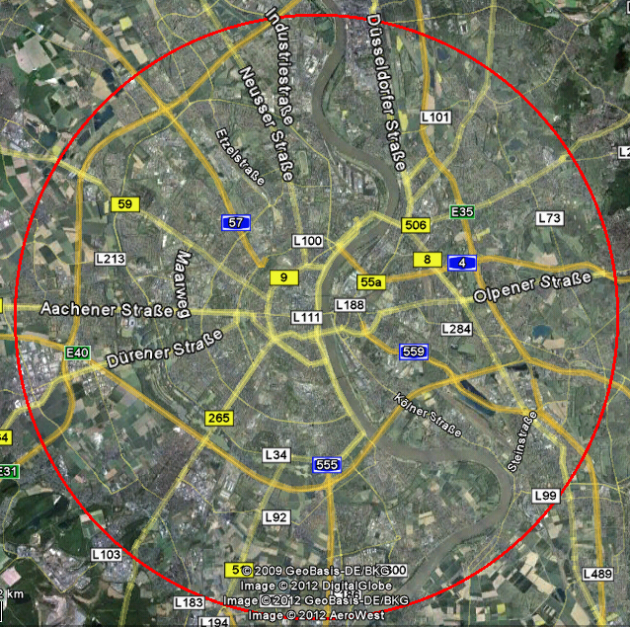

Figure 5 Map of greater Cologne, Germany, with a 10 km radius circle



Figure 6 ISD Cumulative Distribution Function (CDF) of the 3G sites in the 20 km radius as well as in a 10 km radius

For each site the mean ISD is determined to its neighbor sites by Voronoi tessellation. Then the corresponding service probability of each site is determined using the graph in Figure 4. Figure 7 shows a map of the area with the polygons served by each site colored according to the service probability. In the center 10 km radius where most of the population lives, the service probability from all sites is above 95 %. In the area between 10 km and 20 km the probability decreases as the ISD is larger, but still 93 % of the sites provide service probability better than 95 %.

The service probability of the existing DVB-T transmitter in the area is shown in Figure 8, where the green color represents better than 95 % portable indoor, and the inner 10 km radius is largely colored in green. In the outer ring, the beige patches dominate, representing a lower service probability, of only 70 % and only for portable outdoor reception. Visually, the DVB-T percentage of area with > 95 % indoor service is not better than what can be achieved with eMBMS based on the existing 3G sites. For mobile broadband capacity requirement reasons, the networks will also be further densified in the future, and the eMBMS service probability will then also benefit.

Using DVB-T2 instead of DVB-T, the service probability of Figure 8 can be achieved at a higher data rate of 22.0 Mbit/s, corresponding to a spectral efficiency of 2.74bit/s/Hz. When selecting at MCS index 26 for LTE, a similar spectral efficiency of 2.78 bit/s/Hz can be achieved. As the transmission is less robust than in the previously discussed case, the service probabilities provided by each LTE site decreases where the ISD is large. Figure 9 shows the resulting service probability map. Still all sites in the 10 km radius provide service indoor probability above 95 % and all sites within the 20 km ring provide indoor service probability above 70 %, so the overall coverage appears no worse than that of the DVB plot.

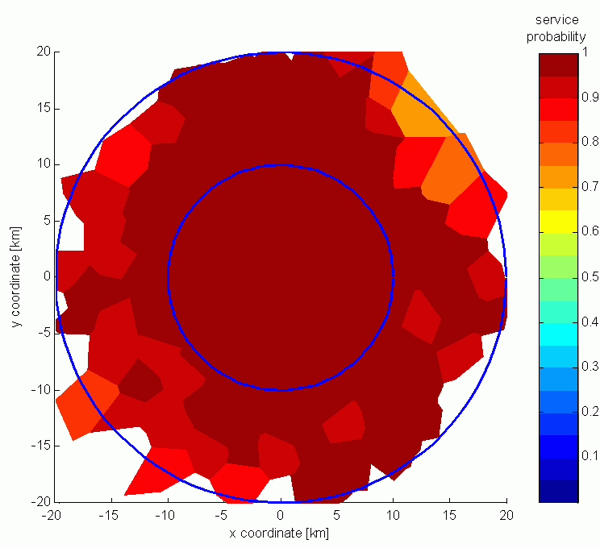

Figure 7 LTE broadcast coverage map each site colored according to the service probability

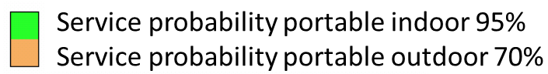

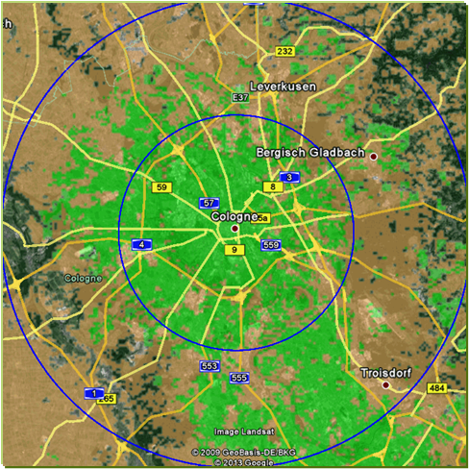

Figure 8 Service probability of the existing DVB-T transmitter in the area   
Service map overlay source: Media Authority of North Rhine-Westphalia; Germany, map (c) Google



Figure 9 LTE broadcast coverage map with the polygons for MCS selected to match DVB-T2 spectral efficiency

#### eMBMS large-scale SFN benefit

LTE networks are designed so that the same carrier frequency can be used in all cells. eMBMS further exploits this fact by using MBSFNs. An MBSFN can be as large as the geographical area in which the same information shall be broadcast. In contrast, DVB-T networks usually use different frequencies for adjacent transmitters although the same content is broadcast. The main reasons are to prevent inter-symbol-interference due to very large transmitters distances and because of cross-border constraints. The drawback is obviously the less efficient use of spectrum, contributing to the so called television white space (TVWS). DVB-T2 provides transmission modes for large SFNs but on the expense of mobile reception performance. Furthermore, for cross-border coordination constraints, essentially the RRC06 frequency plan, prevents deploying nation-wide DVB-T2 SFN.

For example, in the main cities of Germany 6 DVB-T multiplexes are used. Five of them carry content for nation-wide distribution, but different frequencies are used geographically, in total 320 MHz. The remaining DVB-T multiplex carries regional programs. With eMBMS, a channel can be used nation-wide. For ease of illustration assume that eMBMS could be operated with 8 MHz channel bandwidth like DVB-T, and that both have the same spectral efficiency as shown in the example of the previous chapter. Then, for each of the 5 DVB-T nation-wide multiplexes, one eMBMS channel is required, i.e. in total only 40 MHz.

At the border of a considered MBSFN area, the neighbor cells belonging to another MBSFN area must not use the same timeslots on the same channel to prevent interference to the considered MBSFN area. Therefore, in the border, e.g., between the areas where different regional programs are broadcast, different time-frequency resources need to be used in each of the regions, leading to increased time-frequency resource requirements. This implies reduced capacity for unicast is available in these areas, which in turn may imply a need for an increased network density to provide the unicast capacity or increased spectrum requirements in these border area. However, the border area where this kind of coordination is necessary typically extends only over a few (macro) cells, in contrast to high tower television networks, where the coordination distances can be several hundred kilometers. This benefit of small cell networks also greatly alleviates cross border coordination issues.

#### LTE broadcast a complement to terrestrial television

Building on the above findings, while considering different needs for media and audio-visual content, a future media landscape based on complementary LTE-Broadcasting networks and terrestrial television broadcasting networks in a collaborative setting, could improve the total audio-visual consumer experience while improving the use of spectrum in the radio frequency range 470 – 694 MHz.

In addition to the traditional audio-visual content, delivered over the current analogue and digital terrestrial television broadcasting networks, new consumer demands and behaviors {1} are suggesting a need for more program channels with different and dedicated content, also offering regional and local content, as well as on-demand content available and accessible anytime-anywhere. LTE-Broadcasting, with its expected flexible unicasting and broadcasting capabilities, could easily be responding to several of these requirements by offering a viable technical distribution platform to provide the complementary audio-visual services and applications in the future media landscape. In delivering large scale audio-visual content to the general public of consumers, the efficient use of the radio frequency spectrum is an essential aspect and is of great concern to national regulators. The observations are that audio-visual content delivered over the current LTE networks is increasingly significant to the consumers; the largest and fastest growing mobile data traffic segment is video. It is expected to increase by around 55 % annually up until the end of 2019, by which point it is forecasted to account for more than 50 % of global mobile traffic {16}.

This approach, of using complementing LTE-Broadcasting networks in the range 470 – 694 MHz, does not necessarily suggest any reduction of spectrum use for the current analogue and digital terrestrial television broadcasting networks in a foreseeable time, when these networks are still sustainable to operate. Until then, the use of complementing LTE-Broadcasting in the band would represent a more efficient use of the current broadcasting allocation in the range 470 – 694 MHz. This range of spectrum is currently subject to particular attention by Administrations and stakeholders as this band is commonly understood to be under-utilized in many countries considering the very large distances between the transmitting broadcasting stations. Furthermore it provides the most attractive radio wave propagation characteristic available, which is of particularly interest for large scale service offerings over large geographical areas to the general public of consumers.

In addition to LTE-Broadcasting, unicasting over LTE could be providing access to internet and audio-visual content to the individual consumer in this band. A unicasting distribution already provides a convincing capability of LTE networks to deliver audio-visual content. This capability is in commercial play and is heavily used by consumers on a global basis. The feasibility of delivering audio-visual content on a LTE network using unicasting to a large extent depends on the number of simultaneous consumers within the service area of a LTE cell. Expanding the use of LTE-Broadcasting and unicasting to this band would be valuable to consumers using mobile or fixed devices in sparsely populated areas. Introducing unicasting in this band could release some of the less consumed audio-visual content, currently being distributed over the terrestrial television broadcasting networks, by distribution of such content using on-demand over LTE networks. It is also suggested to use unicasting in densely populated areas where feasible. The on-demand capability enabled by unicasting over a LTE network is regarded to be presenting a convincing case and strength in this range of spectrum.

The use of LTE-Broadcasting in the range 470 – 694 MHz is suggested to be rolled out in a “underlay” cellular structure using elements from specification of the evolved Multimedia Broadcast Multicast Service (eMBMS) while also considering the need for further enhancements. Such network design is suggesting a use of LTE-Broadcasting in a macro cellular structure on adjacent channels to the terrestrial broadcasting television channels “under” the current terrestrial broadcasting television channels “overlay” network. The LTE-Broadcasting operations should be ensured under licensed conditions and be planned in relation to an existing terrestrial broadcasting television channel plan while using downlink-only as to avoid transmitting devices in e.g. home environments close to television receivers; notably, the downlink-only scheme might still need to be accompanied by complementary means of mitigations techniques. The LTE-Broadcasting network could be providing a “true” broadcasting service and/or unicasting as well as be providing traditional mobile broadband services, any need for uplink interaction, would be handled via any other band, typically used by current and future integrated and complementary mobile broadband networks

* enabling both terrestrial television and LTE to complement each other and to coexist
* offering a cooperative multi-screen media television landscape for a win-win for all

while

* recognizing that video content in MBB applications is essential to consumers
* affording seamless video content between devices
* furnishing solutions also for other media content than television
* supporting broadcasting for unlimited number of viewers

further

* savings of spectrum for broadcasting services; based on the principle of SFN
* reusing the dense LTE infrastructure for broadcasting to provide capacity
* delivering IP based broadcasting of video, audio and text streams
* providing hybrid, interactive television and video on demand
* using LTE broadband terminals, or possibly LTE modem integrated into set-top boxes

## SCENARIO 10 [from Doc. 47, SUI]

In this scenario, PMSE systems, in particular, wireless microphones operate in a dedicated spectrum (so called “safe harbour”).

### DESCRIPTION

This scenario assumes that some spectrum in the band 470-790 MHz is reserved for exclusive PMSE usage (Figure 1). The possible ways to operate such a reserved spectrum (“safe harbour”) are described in ECC Report 159.

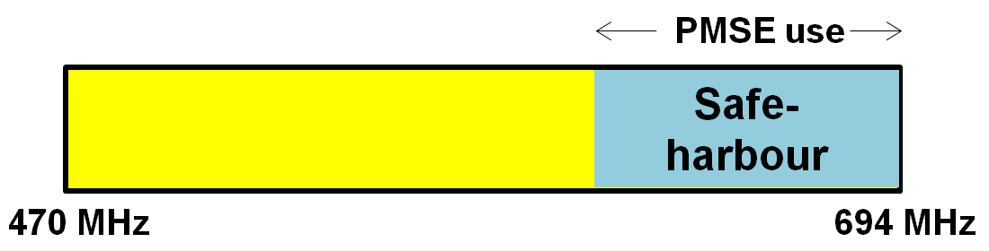

1. Example of “safe harbour” spectrum for PMSE use

The exact amount of “safe harbour” spectrum needs to be defined on the basis of spectrum requirements for PMSE systems.

## SCENARIO 11 [from Doc.34, S]

### DESCRIPTION

**Service**

In this scenario the content/information/function are *smart data quantities*. These smart data quantities are being stored in a data storage or produced in a data production or generated in a data function generator which are all placed in one *generic smart communication unit*. They can easily be transmitted in the most efficient manner from the source unit to the destination unit. The source and the destination unit have the same functionalities – their role is defined by the user and it changes depeding on the type of communication which is agreed and established.

**Terminal/user device**

The generic smart communication unit can store, produce, generate, transmit and receive smart data quantities.

The generic smart communication unit “knows” everything about the smart data quantities: when, where and how data is to be transmitted/received. The generic smart communication unit “knows” all about its geographical position and it can continuously update the information on the terrain and clutter on the way to the transmitting/receiving unit. Furthermore it “knows” what kind of radio networks that are accessible and also what radio frequencies are available for the specific transmission that is to be established. It is designed in a way so that it can easily switch between transmitting and receiving mode.

For personal use the generic smart communication unit is a smart electronic personal companion that allows one to interface with all communication needs and media units such as large flat screens, portable TV sets, PCs, laptops, smartphones, game consoles, tablets.

**Usage Environment**

The usage environment may be urban or rural: the smart communication units are designed to sense its environment both when they are in the transmitter and in the receiver mode. They can be used as fixed, portable or mobile units, at home or in public places or vehicles.

**Delivery**

As described above the generic smart communication unit “knows” everything about the smart data quantities to be delivered as well as about its geographical position. It can constantly update the information on the terrain and clutter on the way to the receiving unit. Most importantly, the generic smart communication unit “knows” what kind of radio networks and what frequencies that may be available for the specific transmission that is to be established. The radio networks of different kinds enable communication between communication units in simple and efficient manner by co-operating with each other.

The technology used for delivery of the smart data quantities is based on the dynamic cognitive communication where the generic smart communication unit analyses its task. By sensing the radio and infrastructural environment the generic smart communication unit chooses in co-operation with the radio network the best suited transmission path, frequency and infrastructure.

## 6.X ANALYSIS OF THE SCENARIOS AND COMBINATIONS

### 6.x.x CROSS-BORDER COORDINATION AND COEXISTENCE

## 6.x SUMMARY OF ANALYSIS

# RECOMMENDATIONS

# Conclusions

Body text (style: ECC Paragraph)

(advice: a conclusion may review the main points of the ECC Report. A conclusion might elaborate on the results of the ECC Report and suggest extensions.)

1. heading (style: ECC annex - heading1)

Body text (style: ECC Paragraph)

* 1. heading 2 (style: ECC annex heading2)

1. Heading (style: ECC Annex heading1)
   * + 1. Heading 4 (style: ECC Annex heading4)
2. List of reference
3. Reference one (style: reference)
4. Reference two
5. Etc.

1. Not defined in terms of frequency allocation (Article 5 of ITU Radio Regulations). [↑](#footnote-ref-1)
2. For a description of linear and non-linear television see, for example:  
   <http://www.hans-bredow-institut.de/de/forschung/linear-and-non-linear-television-viewers%E2%80%99-perspective> [↑](#footnote-ref-2)
3. BNetzA: Messvorschrift (MV) für die Messung von terrestrisch abgestrahlten digitalen Fernseh-Rundfunk-Signalen (DVB-T-Signalen), Dokument 511 MV 06, 2009. [↑](#footnote-ref-3)
4. 3GPP: TR 25.814. Physical layer aspects for evolved Universal Terrestrial Radio Access (UTRA), Release 7, V7.1.0, Sept. 2006. [↑](#footnote-ref-4)