ECC Report XXX

The impact of non- specific SRDs on radio services in the band 57 – 66 GHz
Month Year (Arial 9pt bold)
(last updated: date) (Arial 9pt)

Executive summary
This ECC Report deals with a possible revision of Annex 1 to ERC/REC 70-03 in order to increase the existing frequency range for non-specific Short Range Devices from 61.0 – 61.5 GHz to 57 – 66 GHz.
The Report considered the conclusions of ECC Reports 113 and 114, in order to identify the results given in those ECC Reports which may be relevant for the compatibility in the 57 – 66 GHz frequency range. Additional compatibility studies where developed in order to consider the compatibility between non-specific SRDs and the Fixed Service.
Considering, the potential of interference to the Fixed Service in the frequency range 64-66 GHz and the lack of information relating to the deployment of Fixed Service links in this frequency range, it is not proposed to include 64-66 GHz in the proposed extension of Annex 1 to Rec. 70-03 for non-specific SRDs.
Based on the results of the studies, an introduction of non-specific SRDs with 20dBm e.i.r.p. may be possible without producing harmful interference, but only for the most sophisticated antenna pattern specified in EN 302 217.
In addition, the following restrictions could help to mitigate:
- Tx power 10dBm, Max e.i.r.p. 20dBm
- Or exclusion of fixed outdoor
In order to limit the impact on narrow band services, the maximum mean e.i.r.p density may be limited to 13 dBm/MHz as in the current regulations (see Annex 3 to Rec. 70-03).

TABLE OF CONTENTS

0 Executive summary 2
1 Introduction 5
2 BACKGROUND 6
3 Compatibility between SRD and other services/systems 7
3.1 Fixed Services in 57-59 GHz, 59-62 GHz and 64-66 GHz 8
3.2 Radiolocation 8
3.3 EESS 8
3.4 Other services 9
The following other services were considered in ECC Report 114 [3], where no compatibility issues for SRDs with 20dBm e.i.r.p. and a PSD of 13 dBm/MHz are expected.: 9
4 Complementary studies 10
4.1 FS Antenna pattern 11
4.2 Single entry scenario based on I/N 12
4.3 Impact on a real link 16
4.4 Power Spectral Density considerations 18
4.5 Summary 19
5 Conclusions 20
ANNEX 1: Overview of the US/Canada/Australia regulations at 60 GHz 21
ANNEX 2: List of reference 23

LIST OF ABBREVIATIONS

Abbreviation | Explanation
BW | Bandwidth
BWCF | Bandwidth Correction Factor
CEPT | European Conference of Postal and Telecommunications Administrations
e.i.r.p | Equivalent isotropically radiated power
ECC | Electronic Communications Committee
EESS | Earth Exploration Satellite Service
FS | Fixed Service
MGWS | Multi Gigabit Wireless System
PSD | Power Spectral Density
SRD | Short Range Devices

Introduction
This ECC Report deals with a possible revision of Annex 1 to ERC/REC 70-03 [1] in order to increase the existing frequency range for non-specific Short Range Devices from 61.0 – 61.5 GHz to 57 – 66 GHz.
The Report considered the existing ECC Reports 113 [2] and 114 [3], in order to identify the results given in those ECC Reports which may be relevant for the compatibility in the 57 – 66 GHz frequency range with a special focus to the frequency range 59 – 63 GHz which was identified as the core band. Additional compatibility where developed as appropriate.

BACKGROUND
SE24 considered a request from SRD-MG, dealing with a possible revision of Annex 1 to ERC/REC 70-03 in order to increase the existing frequency range 61.0 – 61.5 GHz to 57 – 66 GHz with the same e.i.r.p. limit of 20 dBm.
The identification of a larger frequency range may need to account for possible worldwide identification of spectrum for SRD applications. Annex 1 provides information on the current allocations in the United States, Canada and Australia. Based on this material, a minimum extension may be based on the minimum common part 59 – 63 GHz.
It should be noted that the frequency range 64– 66 GHz should be cautiously investigated due to the lower oxygen absorption.

Compatibility between SRD and other services/systems
A list of other services to be considered for compatibility study was derived from information on allocation of frequencies in European Common Frequency Allocations table as given in ECC Report 114 [3].
Table 1 provides a list of frequency allocations that might be relevant for in-band or adjacent band compatibility analysis in the frequency range 57-66 GHz.
In “red”, the services to be considered in the minimum common part (59 – 63 GHz).
- European Frequency Allocations in 60 GHz range
FREQUENCY BAND | ALLOCATIONS | APPLICATIONS
56.9 - 57.0 GHz | EARTH EXPLORATION-SATELLITE (passive)  FIXED  MOBILE  SPACE RESEARCH (passive) | Passive sensors (satellite) (52.6 - 59.3 GHz)  Fixed links (55.78 - 59.0 GHz)
57.0 - 58.2 GHz | EARTH EXPLORATION-SATELLITE (passive)  FIXED  INTER-SATELLITE  MOBILE  SPACE RESEARCH (passive) | Passive sensors (satellite) (52.6 - 59.3 GHz)  Fixed links (55.78 - 59.0 GHz)
58.2 - 59.0 GHz | EARTH EXPLORATION-SATELLITE (passive)  FIXED  RADIO ASTRONOMY  SPACE RESEARCH (passive) | Passive sensors (satellite) (52.6 - 59.3 GHz)  Fixed links (55.78 - 59.0 GHz)
59.0 - 59.3 GHz | EARTH EXPLORATION-SATELLITE (passive)  FIXED  INTER-SATELLITE  MOBILE  RADIOLOCATION  SPACE RESEARCH (passive) | Passive sensors (satellite) (52.6 - 59.3 GHz)  Defence systems (59.0 - 61.0 GHz)
59.3 - 62.0 GHz | FIXED  INTER-SATELLITE  MOBILE  RADIOLOCATION | Defence systems (59.0 - 61.0 GHz)  Fixed links  ISM  Non-specific SRDs  Radio LANs
62.0 - 63.0 GHz | INTER-SATELLITE  MOBILE  RADIOLOCATION | Land mobile  Radiolocation (military) (62.0 - 64.0 GHz)
63.0 - 64.0 GHz | INTER-SATELLITE  MOBILE  RADIOLOCATION | Radiolocation (military) (62.0 - 64.0 GHz)  RTTT
64.0 - 65.0 GHz | FIXED  INTER-SATELLITE  MOBILE except aeronautical mobile | Fixed links (64.0 - 66.0 GHz)
65.0 - 66.0 GHz | EARTH EXPLORATION-SATELLITE  FIXED  INTER-SATELLITE  MOBILE except aeronautical mobile  SPACE RESEARCH | Fixed links (64.0 - 66.0 GHz)  Land mobile

In addition, ECC Recommendation (09)01 [4] provides a channel arrangement for the Fixed Service operating in the frequency range 57 – 64 GHz (i.e. also including 62 – 64 GHz).

The following sections are providing the summary of relevant results of ECC Report 113 [2] and ECC Report 114 [3].

Fixed Services in 57-59 GHz, 59-62 GHz and 64-66 GHz
ECC Report 114 [3] investigated the compatibility between MGWS and Fixed Service in the bands 57-59 GHz and 64-66 GHz.
For the frequency range 59-62 GHz, there was no information on FS used in this sub-band until now, therefore no studies were deemed necessary. ECC Recommendation (09)01 provides a channel arrangement for the Fixed Service operating in the frequency range 57 – 64 GHz (i.e. also including 62 – 64 GHz).
The compatibility was conducted considering a single interferer in ECC Report 114.
It is considered that the scenarios for non-specific Short Range Devices may differ from those considered in ECC Report 114 developed for MGWS. It was therefore decided to conduct additional studies for the Fixed Service (see section 4) in order to identify the appropriate technical characteristics for the deployment of non-specific SRDs. The frequency range 64– 66 GHz should be cautiously investigated due to the lower oxygen absorption.

Radiolocation
ECC Report 113 [2] and ECC Report 114 [3] investigated the compatibility between a 40dBm e.i.r.p. transmitter in the main beam of a radiolocation system antenna in frequency range 63-64 GHz and 59-64 GHz.
ECC Report 114 concluded that the required maximum separation distances to ensure mutual co-existence of radiolocation systems with MGWS should be in the order of 2800 m (with an e.i.r.p. of 40 dBm).
The proposed limit for SRD is 20dBm; therefore, no additional study was conducted.

EESS
Passive sensors (satellite) are operated from 52.6 to 59.3 GHz (see the RR [5]). Thus the co-existence of SRDs and EESS in the frequency band 57-59.3GHz has to be studied.
The following bands are considered in ECC Report 114:
- 55.78 – 59.3 GHz: ECC Report 114 concluded that “No compatibility problems between MGWS and EESS are expected in the frequency range 57-59.3 GHz since the density of MGWS transmitters that would exceed the EESS interference limits is comfortably above expected MGWS deployment densities”.
- 65 - 66 GHz: ECC Report 114 anticipated that there will be no use of EESS (passive) in this band.

Indeed MCL calculations in ECC Report 114 show that up to 3271 devices/km2 can be deployed outdoor without interfering into passive sensors, on the basis of the following assumptions:
- In the frequency band 57-59.3 GHz, the atmospheric attenuation is always above 90 dB in the zenith direction
- The emission in the zenith direction for a single MGWS WPAN (worst case) transmitter is about 12 dBm/MHz e.i.r.p.
- EESS receivers are located around 830 km of altitude.
As for the unwanted emissions of MGWS falling in the adjacent band below 57 GHz, ECC Report 114 noted that the assumptions considered in the calculations for the absorption in the zenith direction covers also the frequency range down till ca. 56.4 GHz, therefore the conclusions reached for the co-sharing case were also directly applicable for the unwanted emissions case.
The power from a single MGWS system in the direction of the EESS sensor was 37dBm (12 dBm/MHz, with 325 MHz bandwidth). Therefore, with a proposed e.i.r.p of 20dBm, it can be concluded without additional compatibility studies that SRDs would not cause harmful interferences to EESS and no additional compatibility study were conducted.

Other services

The following other services were considered in ECC Report 114 [3], where no compatibility issues for SRDs with 20dBm e.i.r.p. and a PSD of 13 dBm/MHz are expected.:
- Inter-Satellite Service: although the study had no information on actual ISS use in this band, it was assumed that due to high oxygen absorption, see Annex 2 to ECC Report 114, resulting in approximately 50 dB attenuation in this case, plus free space loss for over 700 km distance, no compatibility issue is expected.
- Radio Astronomy Service in 58.2-59 GHz: it appeared that any potential use of this band by radio astronomy would be a matter for national consideration.
- Mobile Service in 57-58.2 / 59-64 GHz: it was noted that the Mobile Service allocation might be used by defence systems in the harmonised military band 59-61 GHz, however the information received from NATO at the time of this study was inconclusive and not sufficient for detailed co-existence studies.
- Mobile Service in 64-66 GHz: no Mobile Services are envisaged in this band, which is designated for Fixed Services in CEPT.
- Mobile Service in adjacent band 66-71 GHz: No actual use or systems in Mobile Services in this band were reported.
- Radio Navigation in adjacent band 66-71 GHz: No information on Radio Navigation Service in this band was available to the study.
- Radio Navigation Satellite in adjacent band 66-71 GHz: No information on Radio Navigation Satellite Service in this band was available to the study.
- Space Research in 55.78-59.3 / 65-66 GHz: No information on Space Research Service use or protection requirements in this band was available to the study.

Complementary studies
In this section the impact of non specific SRDs on the Fixed Service (FS) in the 60 GHz range is investigated.
Table 2 gives a brief summary on the existing regulations, applications and the atmospheric absorption loss in this frequency band.
- Fixed Service situation
F (GHz) | FS in CEPT | Gaseous absorption (P.676-8) | FS in Germany | FS systems
57-58 | ECC/REC (09)01 [4]  (implemented by 4 administrations) | 10dB/km | Vfg. 86 / 2003: General Allocation to FS (57,1 – 57,8 GHz and 58,6 – 58,9 GHz, (<45dBm e.i.r.p., >35dBi, BW 50-100MHz) | - Nokia Metro hopper (50/100MHz)  - Lightpointe Airebeam G60
58-59 | ECC/REC (09)01 [4]  (implemented by 4 administrations) | 12dB/km |  | - Nokia Metro hopper (50/100MHz)  - Lightpointe Airebeam G60
59-60 | ECC/REC (09)01 [4]  (implemented by 4 administrations) | 15dB/km | Mitteilung 217 /2008: General Allocation to FS (<40dBm e.i.r.p., >35dBi, BW 150MHz-2GHz | - Huber/Suhner SL60 series (59-62 GHz)  - Lightpointe Airebeam Z60+G60
60-61 | ECC/REC (09)01 [4]  (implemented by 4 administrations) | 15dB/km
61-62 | ECC/REC (09)01 [4]  (implemented by 4 administrations) | 15dB/km
62-63 | ECC/REC (09)01 [4]  (implemented by 4 administrations) | 12dB/km
63-64 | ECC/REC (09)01 [4]  (implemented by 4 administrations) | 9dB/km |  | - Lightpointe Airebeam G60
64-65 | ECC/REC (05)02 [6]  (implemented by 12 | 5dB/km | Currently not available, but planned
65-66 | ECC/REC (05)02 [6]  (implemented by 12 | 3dB/km | Currently not available, but planned

FS Antenna pattern
- antenna pattern F.699 (=antenna 1) [7]

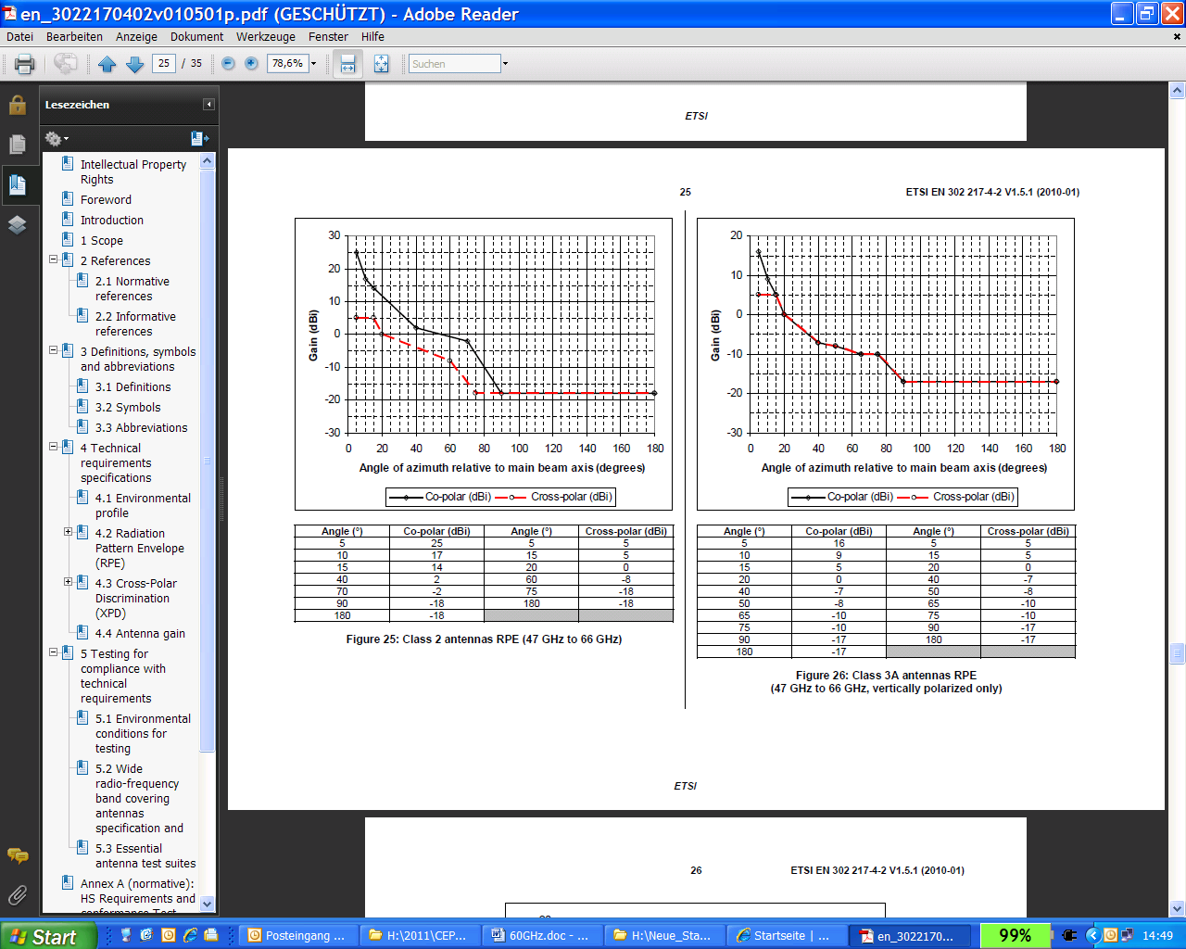
- Reference antenna pattern from ETSI EN 302 217-4-2 (left =antenna 2, right= antenna 3) [8]

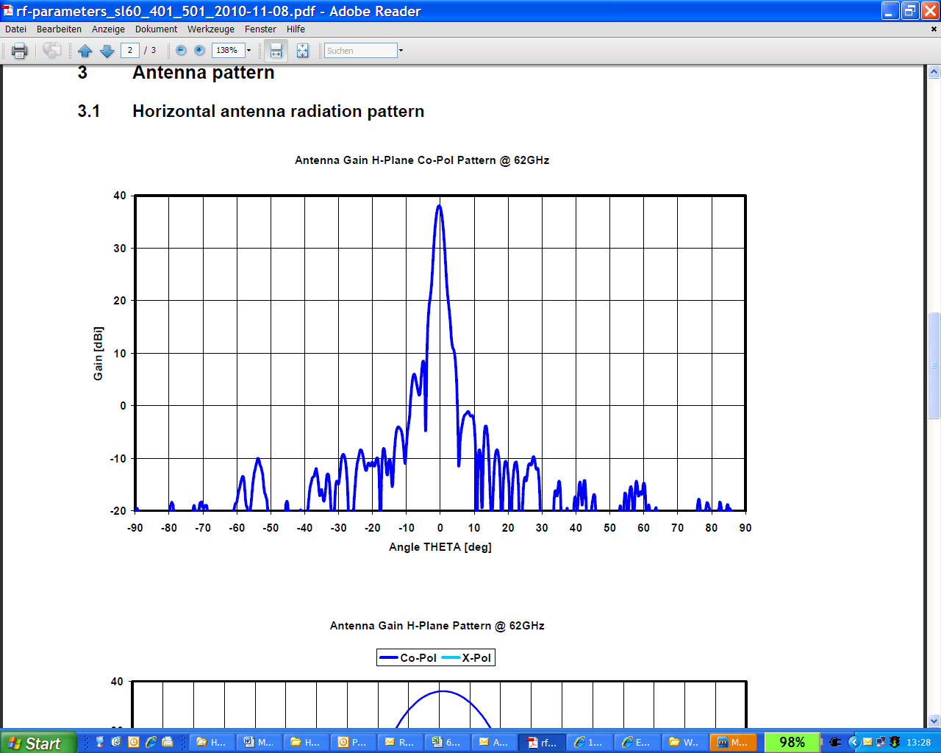
- Antenna pattern for the H&S System SL60-401 and 501 (=antenna 4)
Figure 4 shows the antenna pattern of the four used antennas.

- antenna pattern used (red antenna 1, blue antenna 2, green antenna 3, purple antenna 4)

Single entry scenario based on I/N
Figure 5 describes the scenario.

- Scenario under consideration
The ratio of the interfering power to the receiver noise floor (I/N or INR) at the FS victim receiver is calculated in this document. The following function is used in Figure 6 and 7 and shows the technical parameters assumed:
- INR=f(BW, δg, h, i, j, D)

The assumptions in these calculations are:
- BW: bandwidth of the FS link (50 and 1000MHz used)
- δg: the angular decoupling in azimuth between FS main beam and the line of interferers
- e.i.r.p. max: 20dBm mean e.i.r.p. in dBm assumed in 5MHz
- y0 and x0: Distance of the first interferer to the victim in x and y direction (both 0 m)
- hz: Antenna height offset (difference between Victim antenna and interfering height, 10m assumed in this document)
- i: running variable in x direction
- j: running variable in y direction (not relevant here)
- INR = I/N dB (N=-104dBm/MHz, NF=10dB)
- D: Antenna diameter of the FS receiver (pattern calculated based on Recommendation ITU-R F.699 [7]; see Figure 1 and 4)
- INR2, INR3, INR4 show the I/N values for the 3 other antennas (antenna 2,3,4), without D as parameter
- Propagation model: free space loss plus atmospherical loss (see Table 3)

- Atmospherical loss (Recommendation ITU-R P.676-8 [9])
 | 57-58 GHz | 58-59 GHz | 59-62 GHz | 62-63 GHz | 63-64 GHz
atmospherical loss | 10 dB/km | 12 dB/km | 15 dB/km | 12 dB/km | 9 dB/km

The following Figures are showing the I/N results at the victim receiver over the distance to the interferer with 20dBm/5MHz interfering power, 10m height offset and the 4 antenna pattern defined above. Figures 6-10 give the results for the interferer in mainbeam direction (but 10m height offset) and figure 11 for 10° azimuth decoupling between the mainbeam and the line of interferers. The results are shown for a FS system with 50MHz bandwidth (left figure) and 1000MHz bandwidth (right figure).

- 57 GHz I/N results for 10m height offset and mainbeam direction (FS bandwidth 50MHz left, 1GHz right)

- 58 GHz I/N results for 10m height offset and mainbeam direction (FS bandwidth 50MHz left, 1GHz right)

- 61 GHz I/N results for 10m height offset and mainbeam direction (FS bandwidth 50MHz left, 1GHz right)

- 62 GHz I/N results for 10m height offset and mainbeam direction (FS bandwidth 50MHz left, 1GHz right)

- 63 GHz I/N results for 10m height offset and mainbeam direction (FS bandwidth 50MHz left, 1GHz right)

- 61 GHz I/N results for 10m height offset and 10° azimuth decoupling from the FS mainbeam (FS bandwidth 50MHz left, 1GHz right)
Table 4 summarises the results for the 61 GHz band; the results depends a lot from the antenna pattern of the victim FS system and also from the bandwidth of the FS system.
- Separation distances at 61 GHz to fulfil an I/N of 0dB (distance for I/N -10dB in brackets)
FS bandwith | 50MHz | 50MHz | 1000MHz | 1000MHz
FS antenna pattern form EN 302 217-4-2 | Class 2,  antenna 2 | Real antenna, antenna 4 | Class 2,  antenna 2 | Real antenna, antenna 4
10m height offset, mainbeam direction | 700 m (2 km) | 700 m (2 km) | 400m (700 m) | 0 m (700 m)
10m height offset, 10° azimuth decoupling | 300 m (700 m) | 0 m (100 m) | 100 m (300 m) | 0 m (0 m)

Impact on a real link
In addition the impact on a real FS link is provided hereafter. The system parameters of a Huber und Suhner SL60 is given in Table 5.
- H&S system parameters
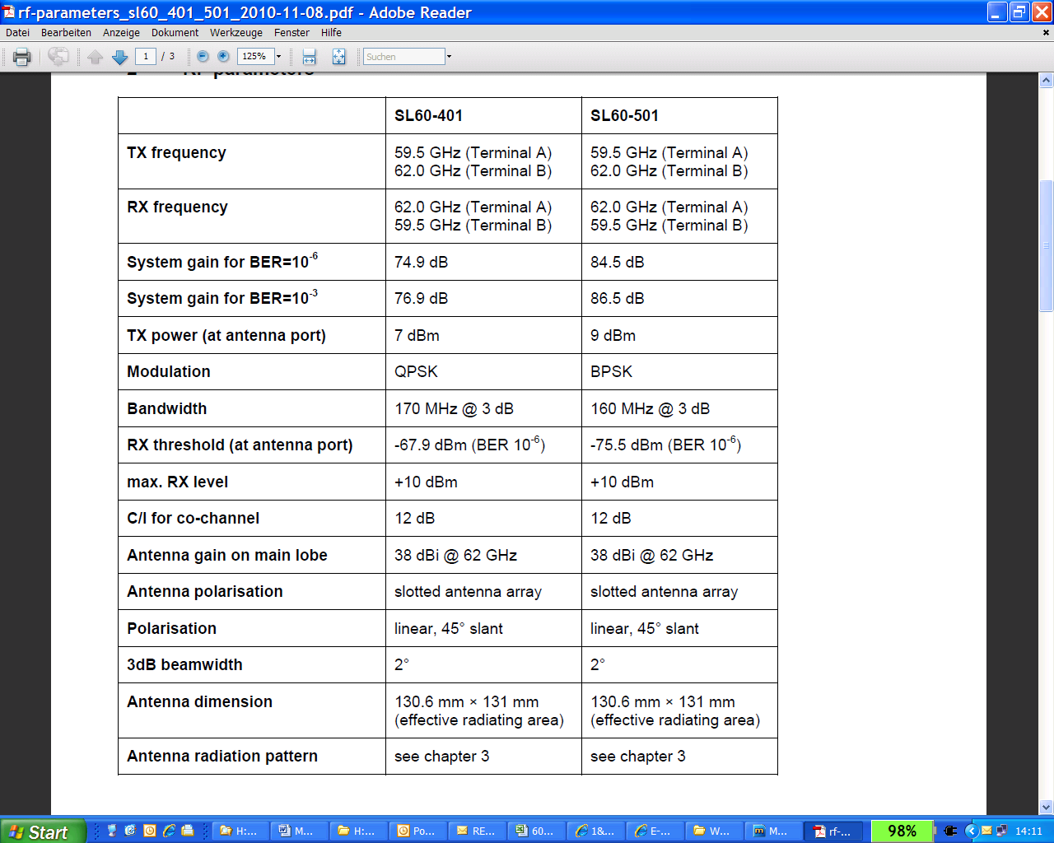
With the same procedure as in section 3 the signal to interference ratio (S/I, or SIR) is determined in this section for a fixed signal level of -67.9 dBm/170MHz and compared to the S/I limit of 12dB. The function in figure 8 contains the following parameters which are explained in section 3:
- SIR=f(δg, hz, i, j, D)
Figures 12-14 gives the SIR results for the 4 antenna types specified in section 2 above. The interfering power is assumed to be 20dBm and the angular decoupling in azimuth of 0°.

- 57 GHz S/I results with a Signal threshold value of -67.9 dBm/170MHz for a real H&S system (the minimum S/I value is 12dB, the height offset is 10m)

- 61 GHz S/I results with a Signal threshold value of -67.9 dBm/170MHz for a real H&S system (the minimum S/I value is 12dB, the height offset is 10m)

- 63 GHz S/I results with a Signal threshold value of -67.9 dBm/170MHz for a real H&S system (the minimum S/I value is 12dB, the height offset is 10m)
It can be seen that for the first 3 antenna types the SIR is slightly below the SIR objective of 12dB, while the real antenna pattern (purple curve) is able to fulfil this objective in almost all distances.

Power Spectral Density considerations
In the above calculation it is assumed that the interfering signal has smaller bandwidth as the FS link and therefore the bandwidth correction factor (BWCF) is 0dB. This assumption seems to reflect the reality (SRD bandwidth is suggested to be less or equal to 5MHz and the FS bandwidth is currently 50-200MHz and is planned to be up to 2 GHz) and therefore the introduction of a PSD limit per MHz would have no positive impact; Table 4 shows the effect of different PSD values to the BWCF. It can be seen that just PSD values of -10dBm/MHz and less would give mitigation to the FS with 50MHz and 1GHz bandwidth, while PSD values of more than 0dBm/MHz are not providing any benefit to the compatibility with the Fixed Service.
- Impact of PSD and bandwidth
PSD dBm/MHz e.i.r.p. | Pmax dBm/BW e.i.r.p. | BW SRD (MHz) | BW FS (MHz) | BWCF dB
-20,00 | 20,00 | 10000,00 | 50,00 | -23,01
-20,00 | 20,00 | 10000,00 | 1000,00 | -10,00
0,00 | 20,00 | 100,00 | 50,00 | -3,01
0,00 | 20,00 | 100,00 | 1000,00 | 0,00
13,00 | 20,00 | 5,01 | 50,00 | 0,00
13,00 | 20,00 | 5,01 | 1000,00 | 0,00
20,00 | 20,00 | 1,00 | 50,00 | 0,00
20,00 | 20,00 | 1,00 | 1000,00 | 0,00

Summary
The impact of SRDs with 20 dBm on the FS can be essential and depends very much on the FS system (Bandwidth and antenna pattern).
A height offset of 10 m is assumed to be representative.
For the most critical antenna pattern (those with the highest sidelobe levels) the interference can reach I/N values of up to 20dB for 50MHz FS systems and 10dB for 1 GHz FS systems. For a real antenna pattern which fulfills the most stringent antenna specifications of EN 302 217-4-2 [8], the interference can reach I/N values of up to 10dB for 50MHz FS systems and -3 dB for 1 GHz FS systems.
If we consider a real FS link including the most sophisticated antenna from section 2, then the required protection objective S/I of 12dB is nearly fulfilled with a height offset of 10m.
Based on this an introduction of non-specific SRDs with 20dBm e.i.r.p. may be possible without producing harmful interference, but only for the most sophisticated antenna pattern specified in EN 302 217 [8].
In addition, the following restrictions could help to mitigate:
- Tx power 10dBm, Max e.i.r.p. 20dBm
- Or exclusion of fixed outdoor
Any PSD limit on top of the max e.i.r.p. limit seems to be not required for the protection of wideband FS links, but maybe helpful for the protection of narrowband radio receivers.

Conclusions
Considering, the potential of interference to the Fixed Service in the frequency range 64-66 GHz and the lack of information relating to the deployment of Fixed Service links in this frequency range, it is not proposed to include 64-66 GHz in the proposed extension of Annex 1 to Rec. 70-03 for non-specific SRDs.
For the most sophisticated antenna pattern specified in EN 302 217, the introduction of non-specific SRDs with 20dBm e.i.r.p. may be possible without producing harmful interference. For other systems, there is a potential of interference.
The following restrictions are proposed for the frequency range 57-64 GHz:
- Tx power 10dBm, Max e.i.r.p. 20dBm
- Or exclusion of fixed outdoor
In order to limit the impact on narrow band services, the maximum mean e.i.r.p. density may be limited to 13
dBm/MHz as in the current regulations (see Annex 3 to Rec. 70-03).
- Overview of the US/Canada/Australia regulations at 60 GHz
A1.1 US FCC regulation
“
Abstract of US FCC 47 Part 15 regulation
………………….
§ 15.255 Operation within the band 57–64 GHz.
(a) Operation under the provisions of this section is not permitted for the following products:
(1) Equipment used on aircraft or satellites.
(2) Field disturbance sensors, including vehicle radar systems, unless the field disturbance sensors are employed for fixed operation. For the purposes of this section, the reference to fixed operation includes field disturbance sensors installed in fixed equipment, even if the sensor itself moves within the equipment.
(b) Within the 57–64 GHz band, emission levels shall not exceed the following:
(1) For products other than fixed field disturbance sensors, the average power density of any emission, measured during the transmit interval, shall not exceed 9 W/cm2, as measured 3 meters from the radiating structure, and the peak power density of any emission shall not exceed 18 W/cm2, as measured 3 meters from the radiating structure.
[Editor note: 9μW/cm2 = 9.5 dBμW/cm2 (pfd 3m); EIRP [dBm] = pfd [dBμW/cm2] +21 + 20 log D(m) = +40 dBm]
(2) For fixed field disturbance sensors that occupy 500 MHz or less of bandwidth and that are contained wholly within the frequency band 61.0–61.5 GHz, the average power density of any emission, measured during the transmit interval, shall not exceed 9 μW/cm2, as measured 3 meters from the radiating structure, and the peak power density of any emission shall not exceed 18 μW/cm2, as measured 3 meters from the radiating structure. In addition, the average power density of any emission outside of the 61–61.5 GHz band, measured during the transmit interval, but still within the 57–64 GHz band, shall not exceed 9 nW/cm2, as measured 3 meters from the radiating structure, and the peak power density of any emission shall not exceed 18 nW/cm2, as measured three meters from the radiating structure.
(3) For fixed field disturbance sensors other than those operating under the provisions of paragraph (b)(2) of this section, the peak transmitter output power shall not exceed 0.1 mW and the peak power density shall not exceed 9 nW/cm2 at a distance of 3 meters.
[Editor note: 9nW/cm2; EIRP [dBm] = +10 dBm]
(4) Peak power density shall be measured with an RF detector that has a detection bandwidth that encompasses the 57–64 GHz band and has a video bandwidth of at least 10 MHz, or using an equivalent measurement method.
(5) The average emission levels shall be calculated, based on the measured peak levels, over the actual time period during which transmission occurs.
(c) Limits on spurious emissions:
………………………..
“
From the present regulation (§ 15.255 “Operation within the band 57–64 GHz”), which abstract is reprinted in Annex 1, we can note:
- The band is limited to the upper value of 64 GHz (i.e. where the O2 absorption is still relatively high).
- The band 64-66 GHz is not allocated to any specific service/application (i.e. it is not covered by any title 47 part); in particular not, as in ERC Report 25, to FS applications (which are mostly licensed/light licensed).
- The FCC distinguishes “field disturbance sensors” from other permitted radio (the latter permitted up to +40 dBm while the first has 30 dB less power permitted).
A1.2 Canada
Canada as well designated for SRD only the band 57-64 GHz (see Annex 13 of the “rss210” document http://www.ic.gc.ca/eic/site/smt-gst.nsf/vwapj/rss210-issue7.pdf/$FILE/rss210-issue7.pdf).

In practice, the regulation is similar to the US one.
A1.3 Australia
Abstract of Australia ACMA LIPD (Low Interference Potential Devices) Class-License regulation
“

Item Class of transmitter Permitted operating frequency band (MHz) (lower limit exclusive, upper limit inclusive) Maximum EIRP Limitations
51 Data communications transmitters used outdoors 59000–63000 150 W 1. Transmitters are limited to land and maritime deployments.
2. Maximum transmitter power must be 20 mW or less.
3. Spurious emissions outside the band must be less than -30dBm/MHz.
4. For outdoor use only.
51 A Data communications transmitters used indoors 57000–66000 20 W 1. Maximum transmitter power must be 20 mW or less.
2. Spurious emissions outside the band must be less than -30dBm/MHz.
“
In Australia the use of “low interference potential devices” is regulated in:
http://www.comlaw.gov.au/ComLaw/Legislation/LegislativeInstrumentCompilation1.nsf/0/58DA61C0685CFB85CA2575ED0032C733/$file/RadcomLIPDClassLic2000.pdf
A1.4 Conclusions
- Outdoor use is limited from 59 to 63 GHz (i.e. unregulated deployment is also avoided in the lower portion of the band, where O2 absorption is still moderate). The 13 dBm (20 mW) permitted power is far less than the Annex 3, where no antenna directivity is provided; the higher permitted e.i.r.p. with high directivity antennas becomes very similar to the FS/FLANE regulations in ECC/REC(09)01 and ETSI EN 302 217-3.
- Indoor use from 57 to 66 GHz also impose antenna directivity for e.i.r.p. higher than 13 dBm; this again is similar to MGWS/RLAN use described in ECC/REP 114, where antenna is not likely pointed to a window, then implying an average higher indoor/outdoor attenuation and additional antenna decoupling.

- List of reference
- ERC/REC 70-03: Short Range Devices (SRD) (www.ecodocdb.dk)
- ECC Report 113: Compatibility studies around 63 GHz between ITS and other systems (www.ecodocdb.dk)
- ECC Report 114: Compatibility studies between MGWS in frequency range 57-66 GHz and other services/systems (except ITS in 63-64 GHz) (www.ecodocdb.dk)
- ECC Recommendation (09)01: Use of the 57-64 GHz band for point-to-point FWS (www.ecodocdb.dk)
- Radio Regulations (www.itu.int)
- ECC/REC (05)02: 64-66 GHz - Fixed Service (www.ecodocdb.dk)
- Recommendation ITU-R F.699: Reference radiation patterns for fixed wireless system antennas for use in coordination studies and interference assessment in the frequency range from 100 MHz to about 70 GHz (www.itu.int)
- ETSI EN 302 217-4-2: Fixed Radio Systems;Characteristics and requirements for point-to-point equipment and antennas; Part 4-2: Antennas;Harmonized EN covering the essential requirements of article 3.2 of the R&TTE Directive (www.etsi.org)
- Recommendation ITU-R P.676-8: Attenuation by atmospheric gases (www.itu.int)

Available on-line via EFIS (http://www.efis.dk)

