ECC Report XXX

Co-existence study considering UWB applications inside aircraft and existing radio services in the frequency bands from 3.1 GHz to 4.8 GHz and from 6.0 GHz to 8.5 GHz
(last updated: date) (Arial 9pt)

Executive summary
Ultra-wideband radio technology (UWB-RT) is an attractive technology candidate system enabling innovative, robust, economic and sustainable "control and monitoring" as well as media services on board aircrafts. The priority for ground based UWB applications was very high since the regulatory work on UWB started in Europe [reference to EC mandates 1-4]. CEPT has developed regulations for UWB devices (see for example ECC/DEC/(06)04) but due to missing co-existence studies within ECC, there were no regulations developed for UWB on board aircraft. This report provides compatibility studies for UWB applications inside aircraft and existing radio services in the frequency bands from 3.1 GHz to 4,8 GHz and from 6.0 GHz to 8.5 GHz.

The Table below provides an overview of the results of the compatibility studies which were achieved assuming 2 active devices per aircraft and that UWB devices are operating using 500 MHz channel bandwidth.

Frequency range | Service | Compatibility situation
3.1-3.4 GHz | Radiolocation Service (military) | UWB should not be activated before the aircraft reaches an altitude of 1 km above the radar
3.4-4.2 GHz | FS | If any risk than at low altitudes (<300m) but here the situation is very similar to indoor usage.
3.4-4.2 GHz | FSS | Long term limits exceeded up to11dB (10.000m, 49dBi) and up to 17dB (5.000m, 49dBi). Additional mitigation techniques such as LDC should be further studied.
4.2-4.4 GHz | Altimeter | 60m separation distance (intra compatibility issue – seen as outside the responsibility of CEPT)
4.4-4.8 GHz | MS (military) | No studies are provided but due to the status as harmonised NATO band and the planned usage of UAV, this band should be avoided.
4.4-4.8 GHz | FS | If any risk than at low altitudes (<300m) but here the situation is very similar to indoor usage.
4.4-4.8 GHz | FSS (4.5 – 4.8 GHz) | Long term limits exceeded up to 11dB (10.000m, 49dBi) and up to 17dB (5.000m, 49dBi). Additional mitigation techniques such as LDC should be further studied.
6.0-6.650 GHz | FS | If any risk than at low altitudes (<300m) but here the situation is very similar to indoor usage
6.650 -6.6752 GHz | RAS | In order to meet the protection criterion given in Recommendation ITU-R RA.769, a notch of 21 dB should be implemented in this band to meet a level -62dBm/MHz. . The use of shielded portholes could also be a solution.
6.6742-8.5 GHz | FS | If any risk than at low altitudes (<300m) but here the situation is very similar to indoor usage

In case UWB devices are used using different characteristics, further studies would be needed.

TABLE OF CONTENTS (Arial 10pt bold white)

0 Executive summary 2
1 Introduction 6
2 Description of Uwb airborne systems 6
2.1 Service description 6
2.2 UWB airborne characteristics 6
2.3 List of Radio based Services to be considered 7
3 Fuselage attenuation 7
3.1 Background information 7
3.2 Suggested table of values 8
4 Compatibility studies 9
4.1 Compatibility between UWB airborne and Radars in 3.1-3.4 GHz 9
4.1.1 Radar characteristics 9
4.1.2 UWB characteristics 10
4.1.3 Methodology 11
4.1.4 Results 11
4.1.4.1 Surface search radars 11
4.1.4.2 Air search radars 11
4.1.5 Conclusion 12
4.2 Compatibility between UWB airborne and FSS Earth Stations in 3.4-4.2 GHz and 4.5 - 4.8 GHz 12
4.2.1 Assumptions for interference simulations 12
4.2.1.1 Feeder Link Earth Station 12
4.2.1.2 Earth station system characteristics 12
4.2.1.3 Protection criteria and permissible interference levels 12
4.2.1.4 Aircraft Altitude and velocity 13
4.2.1.5 Aggregate emission level of UWB devices on-board aircraft 13
4.2.2 Use of the C band by Fixed Satellite Service 13
4.2.3 Interference analysis results for a single flight scenario 13
4.2.4 Interference analysis results for multiple flights scenarios 16
4.2.5 Conclusion 16
4.3 FS 3.4-4.8 GHz, 6-8.5 GHz 17
4.4 Altimeter 4.2-4.4 GHz 18
4.5 Compatibility between UWB Airborne and RAS in 6650-6675.2 MHz 19
4.5.1 Scientific importance of the band 6650 – 6675.20 MHz 19
4.5.2 Regulatory aspects and references 19
4.5.3 Compatibility investigations 20
4.5.3.1 Single interferer scenario 20
4.5.3.2 Multiple interferers (aggregate) scenario 22
4.5.4 Proposal 23
5 Conclusions 24
ANNEX 1: CMS characteristics 25
ANNEX 2: airplane fuselage attenuation 27
ANNEX 3: Radar antenna patterns 35
ANNEX 4: Satellites in GSO orbit active C-band payloads in June 2011 (Excepting military satellites) 36
ANNEX 5: information relating to the traffic information 38
ANNEX 6: LIST OF REFERENCES 42

LIST OF ABBREVIATIONS

Abbreviation | Explanation
ACI | Airport Council International
AVOD | Audio/Video On Demand
CEPT | European Conference of Postal and Telecommunications Administrations
CMS | Cabin Management System
COCR | Communication Operating Concept Requirements
CRAF | Committee on Radio Astronomy Frequencies
EESS | Earth Exploration Satellite Service
ENR | En-route
FSS | Fixed Satellite Service
IFE | In-Flight Entertainment
LDC | Low Duty Cycle
LT | Location Tracking
MSS | Mobile Satellite Service
NSF | National Science Foundation
PC | Passenger Communications
PSU | Passenger Supply Units
RAS | Radioastronomy
spfd | spectral power flux density
TMA | Terminal Manoeuvring Area
TV | Test Volume
UWB-RT | Ultra-wideband radio technology

Introduction
Ultra-wideband radio technology (UWB-RT) is an attractive technology candidate system enabling innovative, robust, economic and sustainable "control and monitoring" as well as media services on board aircrafts. The priority for ground based UWB applications was very high since the regulatory work on UWB started in Europe [reference to EC mandates 1-4]. CEPT has developed regulations for UWB devices (see for example [1]) but due to missing co-existence studies within ECC, there were no regulations developed for UWB on board aircraft. This report provides compatibility studies for UWB applications inside aircraft and existing radio services in the frequency bands from 3.1 GHz to 4.8 GHz and from 6.0 GHz to 8.5 GHz.

Description of Uwb airborne systems

Service description
The SRdoc [2] provides a description of the proposed services. There are several innovative services foreseen in the airplane which could be enabled by a unified UWB Radio Technology (UWB-RT) -based radio platform. These applications include some of the functions of the Cabin Management System (CMS), Passenger Communication (PC) and In-Flight Entertainment (IFE) as well as Portable communications devices such as wireless headsets and handsets used by cabin and flight crew to improve flexibility in crew communication and consequently efficiency in aircraft operation. All applications envisaged for UWB airborne systems are expected to be non-critical for safety and regularity of flight.

This ECC Report focuses on the CMS application (see SRdoc [2]).

UWB airborne characteristics
Many parameters have to be taken into consideration in compatibility studies with incumbent services:
- type of aircraft (e.g. small business jet, short/long-haul commercial passenger aircraft, ...)
- attenuation due to the aircraft (see section 3),
- number of UWB devices onboard the aircraft,

The main characteristics are provided in ETSI TR 102 834 V1.1.1 (2009-05) [2]. The proposed limits are given in Error: Reference source not found.

- Proposed limits for equipment
Frequency | Area of operation / Category | Maximum Average power density (e.i.r.p.) (dBm/MHz
3.1 GHz to 4.8 GHz | LT and communications inside an aircraft | -41.3 dBm/MHz and using LDC
6.0 GHz to 8.5 GHz | LT and communications inside an aircraft | -41.3 dBm/MHz

Low Duty Cycle (LDC) use is defined as in the amended ECC Decision (06)12 [3] (or in the new ECC/DEC(06)04 Annex 2 [1]).

An available bandwidth of about 4 GHz is required in the SRdoc [2] and will be provided by the use of two frequency bands: 3.1 GHz to 4.8 GHz as well as 6 GHz to 8.5 GHz.

Regarding airborne UWB applications, several characteristics are described in the SRdoc [2], in particular the number of devices implemented in an aircraft.

Annex 1 provides overviews of the technical characteristics and for the deployment of CMS applications. Due to intra-compatibility issue, the number of access points operating at the same time on the same channel (assumed to be 500 MHz), is expected to be limited to 2 per aircraft. Only one UWB device will be operating on a given frequency (500 MHz) on each of the access point.

Up to 2 access points per airplane are assumed in the compatibility studies for affected radio services, hence an aggregation of up to 2 devices per airplane was considered as the worst case in the studies.

List of Radio based Services to be considered
Initial list of Services to be considered for compatibility analyses based on ECC Report 64 [4]:

• Fixed Service (FS)
• Mobile Satellite Service (MSS)
• Earth Exploration Satellite Service (EESS)
Radio Astronomy Service (RAS)
• Radio Navigation Satellite Service (RNSS)
• Fixed Satellite Service (FSS)
• Amateur/Amateur satellite systems (Amateur)
• Maritime mobile service including global maritime distress and safety system (Maritime)
• Aeronautical mobile service and radio determination service (Aeronautical)
• Meteorological radar

According to the Radio communication rules (RR, edition 2008), 3100-3400MHz is allocated to the Radiolocation service. The band 6650 – 6675.20 MHz is used in Europe by Radio Astronomy Service under the ITU-RR footnote 5.149 [5].

Note: this list should be reviewed in order to include only the service possibly impacted by Airborne UWB applications in the frequency bands 3.1 - 4.8 GHz and 6 - 8.5 GHz

According to the European Common Allocation Table [5] following bands are allocated to one or more of the services listed above (Table 2):

- Bands relevant for compatibility analysis
Services | Frequency range | Comments
Fixed Service (FS) | 3.4 GHz - 4.8 GHz and  5.925 GHz – 8.5 GHz | (see section 4.3)
FSS including MSS Feeder Link | 3.4 GHz – 4.2 GHz and 4.5 - 4.8 GHz | (see section 4.2)
Altimeter | 4.2-4.4 GHz | (see section 4.4)
Earth Exploration Satellite Service (EESS) / RAS | 3.1 GHz – 3.3 GHz and 6.452 GHz - 7.25 GHz and 8.025 GHz - 8.4 GHz  6650 – 6675.20 MHz | 3.1 GHz - 3.3 GHz: active Earth Exploration  6.452 GHz - 7.145 GHz: passive  7.145 GHz - 7.25 GHz: Earth-to-Space  8.025 GHz - 8.4 GHz: Space to Earth  6650 – 6675.20 MHz RAS RR footnote 5.149  (see section 4.5)
Radiolocation service | 3100 – 3400 MHz | (see section 4.1)

Fuselage attenuation
Conditions of coexistence between UWB systems (on-board aircraft) and victim systems need accurate information related to the “attenuation due to the aircraft”. In this section, the information from the Boeing report [7], and the ECC Report 93 [8] are discussed and compared with results obtained from simulations. Annex 2 provides a detailed analysis of the fuselage attenuation.

Background information
In ECC Report 93 [8], attenuation values are given in a table, with respective min and max values of +1 and +15dB. It should be noted that these values refer to attenuations at 1.8 and 2.4 GHz. In annex F of ECC Report 93, min attenuation values derived from the measurements were between -5dB (i.e. gain) and +3dB depending on the position of the measurement antenna within the cabin (i.e. window seat or aisle seat). The average observed attenuation value was +12dB for the window seat and +16dB for the aisle seat.

A report developed by Boeing [7] provides a mean value of +17.3dB but this value can’t be used since it was calculated for 5 GHz and as this was the single value applied for all configurations.

In Advisor Circular 20-158 [9], +12dB attenuation is the generic value used for areas entirely inside aircraft, for a large frequency band.

Numerical Simulation gives results between -4dB to +30dB at the frequency of 3.3 GHz, with average value of +5dB in the longitudinal and +15dB in the transversal plane.

Additional measurements also provided attenuation ranging from +10 to +15 dB in the frequency range 2 to 8 GHz [10]. The table below summarizes the different information about attenuation due to aircraft. The gap between some attenuation values can be explained by a different approach of measurement (near field, far field), the frequency band…

It can be noted that investigations have to be done on variation of attenuation according to the position of UWB antenna in the aircraft (antenna in flight deck, wing fuel tank, cabin compartment…etc).

Suggested table of values
A single number cannot be used to represent the attenuation of the aircraft fuselage. Several parameters should be taken into account when considering the attenuation from the fuselage (fuselage attenuation measurements were performed only on 1.8 GHz in Boeing report [7] where transmitters were placed at specific locations in the centre of the aircraft), in addition, it should be noted that a wideband signal like UWB will cause resonance effects that have not been taken into account yet.

For this reason the extremes in the radiation pattern from the Boeing report [7] cannot be used for any compatibility calculation, only a circular pattern based on the highest measured value averaged over an angular range representing at least one wavelength at the measurement position in the far field can be used.

Furthermore, measurements and simulations realised in the 3100-3500 MHz frequency band and in a far field approach have to be prioritized and a value of fuselage attenuation valid for the flight phase ought to be considered in the compatibility studies.

Thus, it is suggested to take into account table below as an initial reference for attenuation due to the aircraft and use it in compatibility studies (in particular in the S band).

- Attenuation due to the aircraft -
Values are relevant for the “far field” case and the 3100-3400 MHz frequency band
Case | Frequency range | min | Max | Average
1 | Aircraft « seen under angle A1 »  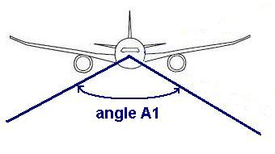 | 6dB | 30dB | 15dB
2 | Aircraft “seen under angle A2”  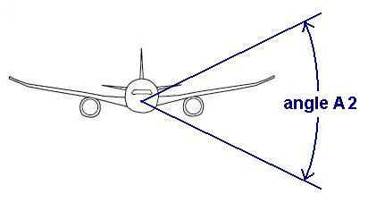 | -4dB | 25dB | 5dB
3 | Aircraft fitted with shielded windows | 30dB | 40dB | 35dB
Note: When flight deck is fitted with UWB antenna, case 2 has to be used for “nose-on” configuration

The above table shows that the “indoor” classification is not obvious unlike what is written in the ETSI SRdoc [2]. This point needs to be clarified, especially in the S band.

For the compatibility studies an average attenuation of 15dB for emissions in the downward direction and 5dB in the horizontal direction are considered.

Compatibility studies

Compatibility between UWB airborne and Radars in 3.1-3.4 GHz

Radar characteristics

According to the Radio Regulations (edition 2008), 3100-3400 MHz is allocated to Radiolocation service on a primary basis. Radar characteristics can be found in Recommendation ITU-R M.1465 [11].
In the 3100-3400 MHz frequency band, different radars can be found like,
- Aeronautical radio-navigation,
- Surface and air search,
- Instrumentation radar,
- Radiolocation radar,

The platform type can be airborne, surface ship or ground installation. The radar can be positioned near an airport or near specific installations which need protection (rural, urban or sub urban area). According to the type of radar and its application, radar ranges vary from about 30km up to 400km.
Characteristics and protection criteria for radars in the frequency band 3100-3700 MHz are provided in ITU-R Recommendation M.1465 [11]. In addition, Recommendation ITU-R M.1851 [12] provides mathematical models for radiodetermination radar antenna patterns.

Table 4 below details typical S-band radar characteristics considered in this study for surface search and air search radars:

- Attenuation due to the aircraft -
Values are relevant for the “far field” case and the 3100-3400 MHz frequency band
Radar characteristics | Value
Radar characteristics | Surface search radar | Air search radar
Bandwidth (L_radar) | 10 MHz
Thermal noise (kTBF with F=2dB) | -112 dBm/MHz
Protection criterion (Note 1) | I/N= -10 dB
Antenna horizontal beamwidth | 2° | 1°
Antenna vertical beamwidth | 2° | 30°
Maximum vertical scan | 1° | 90°
Main beam elevation | 1° | 20°
Antenna high | 20 m
Antenna gain in the main lobe | 38 dBi
Antenna pattern | Recommendation ITU-R M.1851 [12]
Note 1: Recommendation ITU-R M.1465 recommends 3 states that “the criterion of interfering signal power to radar receiver noise power level, I/N, of should be used as the required protection level for the radiolocation systems, and that this represents the net protection level if multiple interferers are present.”: since UWB airborne represent only a small part of the possible interferers, a I/N of -10 dB is used to account for some apportionment for this particular category of interferers. Besides an I/N ratio of -10 is sometimes considered in compatibility studies to avoid any disturbance or performance loss. It must be pointed out that in some cases (like safety of life) the I/N ratio can be equal to -12dB.

The vertical and horizontal antenna patterns for both types of radars are represented in Annex 3.

UWB characteristics

The characteristics of UWB devices and their deployment scenario considered in this study are summed up in Table 5 below:

- Characteristics of UWB-Airborne system deployment
Aircraft parameters | Value
Aircraft altitude | 100 m to 10 000 m
Fuselage attenuation (Note 1) | 15 dB/ 5 dB mean value
UWB characteristics
Central frequency | 3250 MHz
Bandwidth (L_uwb) | >300MHz
Maximum antenna Gain | 0 dBi
Maximum mean eirp | -41.3 dBm/MHz
Maximum peak eirp | 0 dBm/50MHz
Number of active UWB | 2

Note 1: a fuselage attenuation of 5 dB is considered for elevations below 30° between the aircraft and the radar, and 15 dB for elevations above 30° (see section 3.1).

Considering 2 active airborne UWB access Points with -41.3 dBm/MHz mean e.i.r.p. and an aircraft fuselage attenuation of 15 dB (resp. 5 dB), the overall emission of the airborne UWB from the aircraft is -53.3 dBm/MHz (resp. -43.3dBm/MHz).

All the calculations are carried out at a frequency of 3250 MHz.

Methodology
A radar is located at (48°N, 5°E) with a fixed main beam direction, horizontally pointing towards the South and with main beam elevation tuned either at 1° for surface search radars, or 20° for air search radars.

The interference level arriving at the radar antenna from an aircraft at a given altitude (500 m, 1000 m, 5 km, or 10 km) is calculated and mapped. Negative aircraft elevations relative to the radar are suppressed. For positive aircraft elevations, the free space loss is used.

Results

Surface search radars
Considering the 2 active airborne UWB access points, the maximum interfering level is not exceeded for aircraft altitudes of 500 m, 1 km, 5 km, and 10 km, whatever the radar elevation and the aircraft relative location to the radar be.

Air search radars
Figure 1 provides the overview of the calculated interference for Surface search radars.

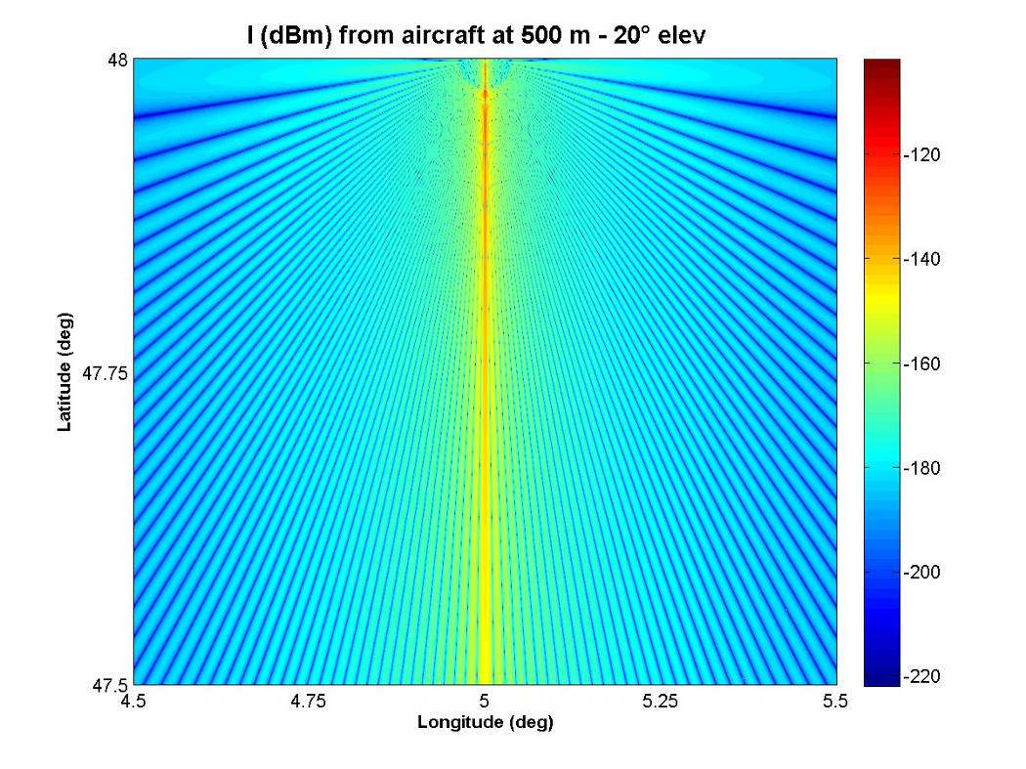
- Compatibility with Air search radars
The maximum level -122 is exceeded in the main lobe direction in azimut from 748m (48°N, elevation 41.9°) up to 4km (47.96°N, elevation 7.09°)

Considering 2 active airborne UWB access points, the radar suffers from interference when the aircraft flies at altitudes lower than 750 m and crosses its main beam. At altitudes higher than 750 m, the maximum interfering level is not exceeded.

Conclusion
Considering only one aircraft with 2 active UWB access points with -41.3 dBm/MHz individual e.i.r.p. and a fuselage attenuation of 15 dB for relative aircraft elevations above 30° and 5 dB otherwise, the calculations show the following:
Surface search radars:

The maximum interfering level is not exceeded even if the aircraft is located in the radar main beam.
Air search radars:

The maximum interfering level is exceeded for altitudes lower than 750 m, when the airraft is located in the radar main beam (more or less a few degrees depending on the altitude) and with low relative elevations or distances.

Besides, only the mean power UWB emissions were investigated, supposing that peak power emissions are sporadic. If not (that is, if peak power values are emitted on a regular basis), further study on the impact on peak power may be needed.

Compatibility between UWB airborne and FSS Earth Stations in 3.4-4.2 GHz and 4.5 - 4.8 GHz
In this section, the results of further compatibility studies are presented based on revised assumptions with regard to number of UWB transmitters on board the aircraft. The interference assessment has been made for both MSS feeder link earth stations and typical FSS earth stations with different antenna diameters.

Assumptions for interference simulations

Feeder Link Earth Station
- Antenna gain: 49.2 dBi; System Noise Temp: 71°K; Radiation Pattern: RR Appendix-7(WRC-07) [5]
- Elevation angles: 10 deg to 60 deg

Earth station system characteristics
The characteristics of C band receive earth stations considered in the simulation are summarised below. It is recognised here that the real system noise temperatures for 4.5 m, 3 m and 1.8 m antenna diameter earth stations can be different from the values assumed in this section.

- FSS Earth Station Characteristics in C band
Antenna Diameter (m) | System Noise Temp(°K) | Antenna Rx Gain (dBi) | G/T  (dB/K) | Radiation Pattern
9 | 71 | 49.2 | 30.7 | RR Appendix-7 (WRC-07)
6 | 71 | 45.54 | 27.0 | RR Appendix-7 (WRC-07)
4.5 | 150 | 43.04 | 21.2 | RR Appendix-7 (WRC-07)
3 | 150 | 39.52 | 17.7 | RR Appendix-7 (WRC-07)
1.8 | 150 | 35.08 | 13.3 | RR Appendix-8 (WRC-07)

Protection criteria and permissible interference levels
The interference criteria based on ITU Recommendations SF.1006 [13], F.1094 [14] and S.1432 [15] are given below for the long term propagation conditions.

- Single Entry Interference Criteria for FSS Earth Stations in C band
Antenna size | 9 | 6 | 4.5 | 3 | 1.8 | 1.2 | meters
System Noise temp | 71 | 71 | 150 | 150 | 150 | 120 | K
ref BW | 1000 | 1000 | 1000 | 1000 | 1000 | 1000 | kHz
p1 (long term) | 20 | 20 | 20 | 20 | 20 | 20 | %
J ( F1094/S1432) | -20 | -20 | -20 | -20 | -20 | -20 | dB
Pr(p) - long term | -140.1 | -140.1 | -136.8 | -136.8 | -136.8 | -137.1 | dBm

Aircraft Altitude and velocity
Two altitudes of 10 000 meters and 5 000 meters have been considered. A typical velocity of 900 km/hour (0.25 km/second) has been assumed to evaluate the dwell time of aircraft within the 3 dB main beam of the FSS antenna as well as the interference duration exceeding the I/N criterion of -20 dB.

Aggregate emission level of UWB devices on-board aircraft
The following assumptions are considered:
- e.i.r.p. level of a single UWB device: -41.3 dBm/MHz.
- Number of UWB devices onboard an aircraft: 2
- Aircraft penetration loss: 15dB
Therefore, the aggregate UWB interference from one aircraft: -53.29 dBm/MHz – assuming 15dB attenuation in the downward direction.

Use of the C band by Fixed Satellite Service
There are around 160 satellites carrying active C band payload in the Geo-stationary satellite orbit. The list of satellites are given in Annex 4.

Interference analysis results for a single flight scenario
The interference analysis results for two different altitudes are presented in Tables 8 and 9 for a single flight scenario. These tables also give the duration of aircraft within the main beam of the antenna (half power beam width) and the duration of interference events exceeding the I/N criterion of - 20 dB.

- Received interference levels, I/N margin, dwell time of aircraft within the 3 dB main lobe of FSS antenna and duration of interference exceeding the I/N criteria of - 20 dB at an altitude of 10000 meters for a single flight scenario and fuselage attenuation value of 15 dB
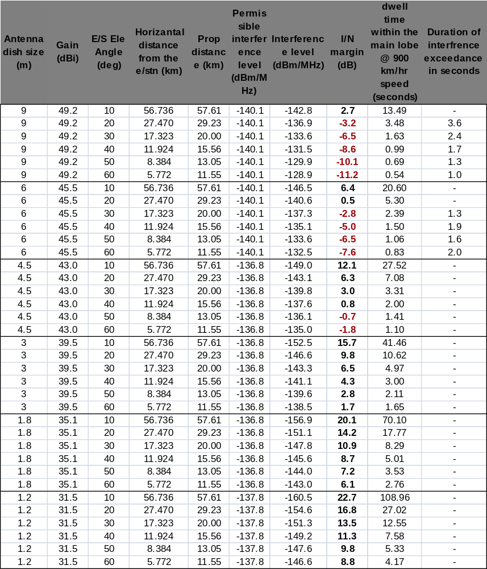

- Received interference levels, I/N margin and dwell time of aircraft within the 3 dB main lobe of FSS antenna and duration of interference exceeding the I/N criteria of - 20 dB at an altitude of 5 000 meters for a single flight scenario and fuselage attenuation value of 15 dB
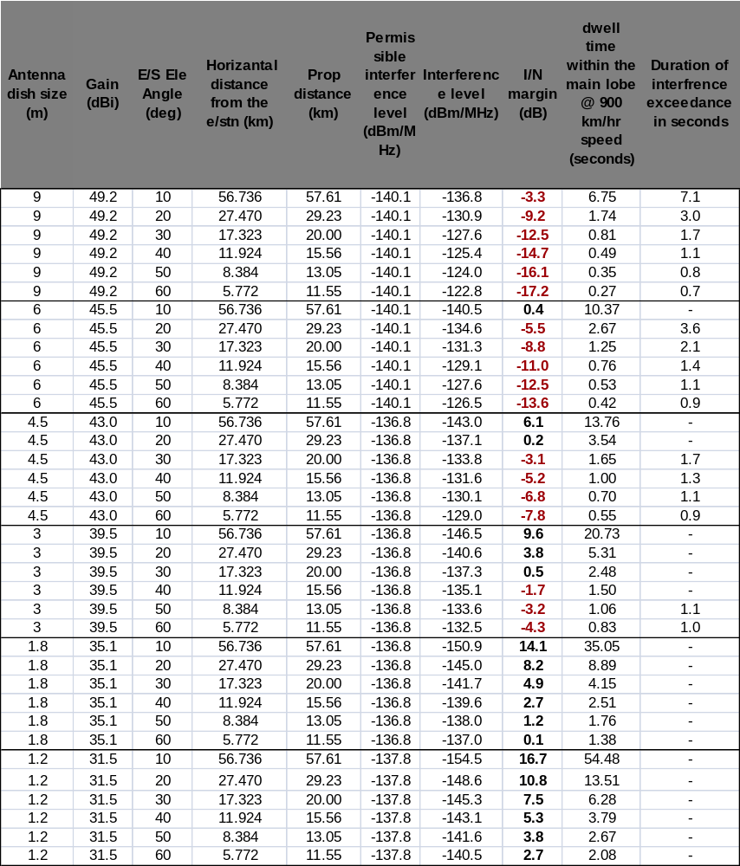

The results in Tables 8 and 9 show that a single aircraft with multiple UWB devices can cause interference into FSS earth stations while passing through or close to the main beam of an FSS earth station. The interference deficits vary from 11.2 dB to 3.2 dB and from 17.2 dB to 3.3 dB for 9 m FSS earth station antenna at 10000 m and 5000 altitudes respectively. The duration of interference exceeding the I/N criterion of -20 dB vary from 1.0 seconds to 3.6 seconds at 10000 m altitude and from 0.7 seconds to 7.1 seconds at 5000 m altitude. It can also be seen from Tables 8 and 9 that I/N deficits are larger for higher elevation angles compared to those for lower elevation angles. However, the duration of interference is more for lower elevation angles compared to that for higher elevation angles.

Interference analysis results for multiple flights scenarios
Based on the information provided by Airbus regarding the number of aircraft for some busy airports within Europe (see Annex 5), estimates on the aggregate interference duration for 10000 m and 5000 m altitudes are given in Tables 10 and 11 respectively.
- Aggregate interference duration in 24 hours for some busy airports in Europe at 10000 meters altitude
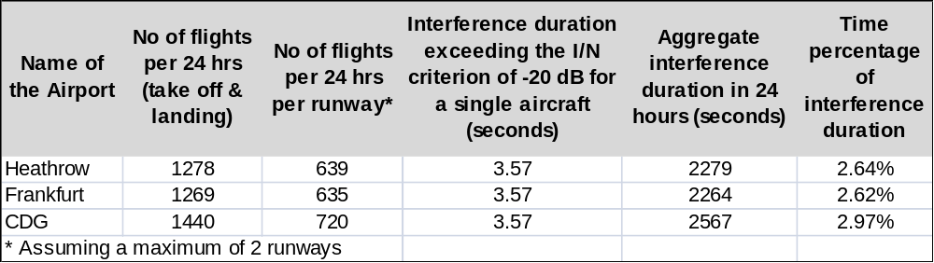
- Aggregate interference duration in 24 hours for some busy airports in Europe at 5000 meters altitude
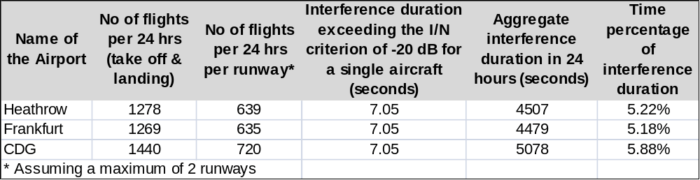

Conclusion
From the above, we can conclude that there is a potential interference from the proposed UWB airborne application in the frequency band 3400-4200 MHz and 4500-4800 MHz.
- The interference deficits vary from 11.2 dB to 3.2 dB and from 17.2 dB to 3.3 dB for 9 m FSS earth station antenna at 10000 m and 5000 altitudes respectively. The duration of interference exceeding the I/N criterion of - 20 dB vary from 1 second to 3.6 seconds at 10000 m altitude and from 0.7 seconds to 7.1 seconds at 5000 m altitude.
- The overall duration of interference to large earth stations near busy airports under multiple flights scenario can vary from 2264 seconds to 2567 seconds and from 4479 seconds to 5078 seconds in a period of 24 hours for 10000 meters and 5000 meters altitudes respectively. This translates to a maximum of 2.97% and 5.88%. Considering the safety of life service and critical telemetry applications provided by large MSS feeder link earth stations and FSS earth stations in C band, this interference duration is not insignificant if these types of stations are situated near a busy airport.
- Based on the studies, it is demonstrated that there is a real potential interference situation to different Fixed Satellite Services including MSS feeder links in 3.4-4.8 GHz frequency band from the proposed UWB airborne application.
- It has to be noted that mitigation techniques such as LDC could conceivably allow decreasing the impact of UWB airborne on FSS/MSS feeder links. However, this was not assessed in this report and further work would be needed to quantify the improvement resulting from LDC in the bands 3400-4200 MHz and 4500-4800 MHz.

FS 3.4-4.8 GHz, 6-8.5 GHz

In this section the impact of UWB on board aircraft on the Fixed Service is studied. Table 12 shows the worst case separation distance for 3 different FS antenna gain values in order to account for main beam and side lobe coupling.
- compatibility with FS
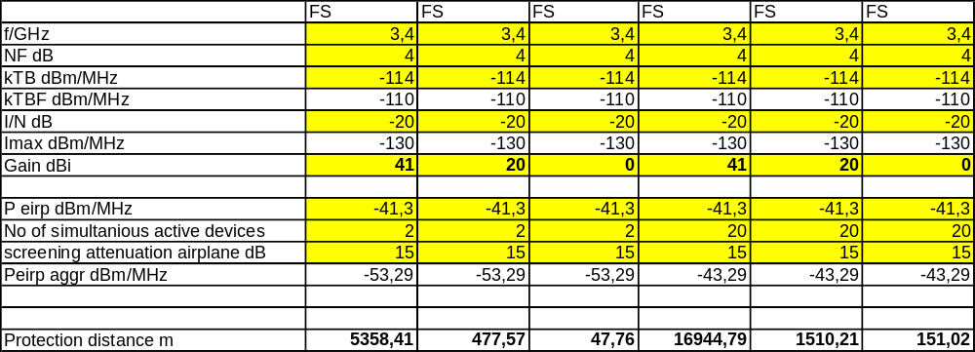

In addition the impact with an antenna pattern from Recommendation ITU-R F.699 [16] is provided in Figure 2. Figure 3 shows the assumed antenna pattern of a FS antenna with a diameter of 2m.

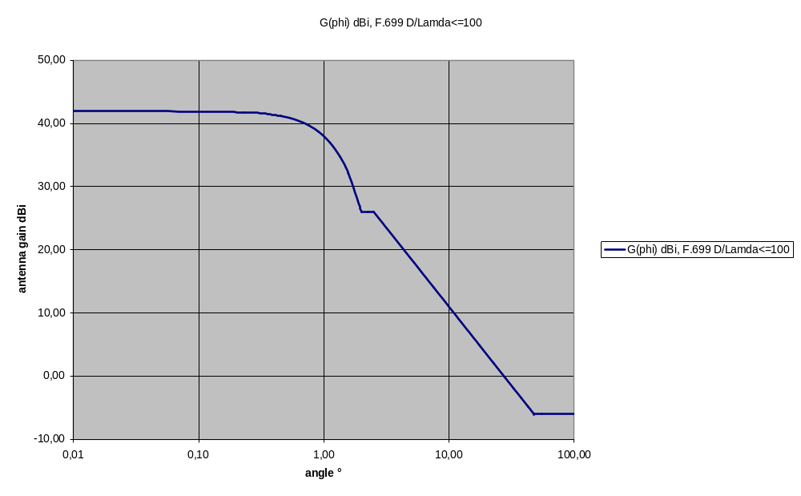
- Impact on the FS - antenna pattern from Recommendation ITU-R F.699

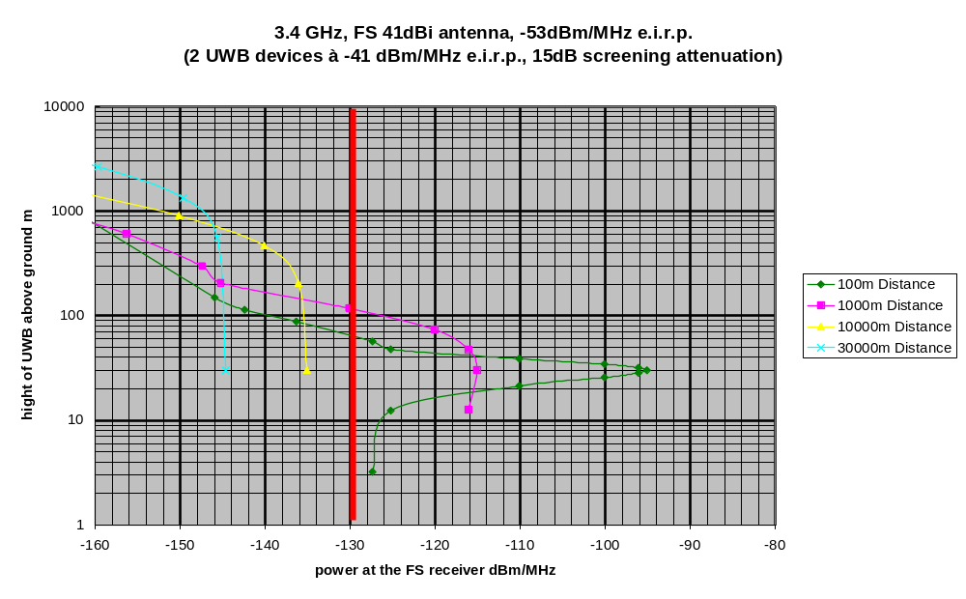
- Impact on the FS - antenna pattern with a diameter of 2m
It can be concluded that the impact depends on the altitude of the airplane:
- For altitudes above 100m the long term protection objectives of the FS are fulfilled
- For altitudes <100m in theory a protection zone of several km would be needed to fulfil the long term protection objective of the FS; however, in this case the airplane itself could already cause an interruption due to the shadowing of the affected FS link
- In addition, UWB on board aircraft can be considered as generic indoor UWB usage for this low flying altitude.

Since the probability to have fixed services crossing airport areas should be in practice very low, altitude limitations in airport areas may not be relevant.

Altimeter 4.2-4.4 GHz
In this section a rough estimation about the impact of UWB used on board aircraft on radio altimeters is provided.
- Impact of UWB used on board aircraft on radio altimeters
Altimeter
Altimeter
Altimeter
Altimeter
f/GHz
4,2
4,2
4,2
4,2
NF dB
4
4
4
4
kTB dBm/MHz
-114
-114
-114
-114
kTBF dBm/MHz
-110
-110
-110
-110
I/N dB
-6
-6
-6
-6
Imax dBm/MHz
-116
-116
-116
-116
Gain dBi
10
0
10
0
P eirp dBm/MHz
-41,3
-41,3
-41,3
-41,3
No of simultanious active devices
2
2
20
20
screening attenuation airplane dB
15
15
15
15
Peirp aggr dBm/MHz
-53,29
-53,29
-43,29
-43,29
Protection distance m
24,39
7,71
77,14
24,39

The tables above indicated that there may be a potential of interference to altimeter, however, this is seen to be more an intra-conformity issue for the aeronautical community and outside the responsibility of CEPT.

Compatibility between UWB Airborne and RAS in 6650-6675.2 MHz
The airborne UWB applications for in-flight entertainment are proposed to be used in the frequency range from 3.1 GHz to 4.8 GHz and from 6.0 GHz to 8.5 GHz. The frequency segment 6.0 - 8.5 GHz is overlapping the band 6650 – 6675.20 MHz which is used in Europe by Radio Astronomy Service under the ITU-RR footnote 5.149 [5]. Thus some regulatory provisions may be applicable to this band.

Scientific importance of the band 6650 – 6675.20 MHz
Presently, the methanol (CH₃OH) line (6.65 – 6.675.2 GHz) is covered in Footnotes 5.149 and 5.458A [5]. This line was only discovered in 1991 and has become an important diagnostic for the conditions in high-mass star formation regions. The study of such regions is also important for the understanding of the formation of our solar system and the composition of elements in our sun and the planets of the solar system. That is one of the reasons why extensive new research and equipment programmes have been started in several countries. The MPIfR (Germany) and the NSF (The United States) are planning an astrometric survey of such star forming regions. By measuring trigonometric parallaxes for a large number of such regions in all spiral arms will enable model-independent distances and transverse velocities to be determined. Precision 3-dimensional mapping of the Milky Way Galaxy to determine its size, rotation profile, dark matter halo mass, and classification has been the goal of astronomers for decades. Billions of dollars have been spent on space missions resulting in detailed maps of the local Galaxy but with insufficient precision at large enough distances to address some of the fundamental Galactic structure questions. Significant investments in new receivers for that frequency band are made all over the world. A newly developed receiver system, the ‘Vivaldi’ focal plane array will cover the frequency range of 4 to 8 GHz. It will be installed at the radio telescopes in Westerbork (The Netherlands), Sardinia (Italy) and Jodrell Bank (United Kingdom). Germany and the United States are cooperating on a new receiver system for joint high resolution VLBA observations and in Australia a new 7-beam receiver system found several hundred new star forming regions. It is planned to install a copy of that receiver at the Effelsberg telescope. CRAF indicated that the 6.7 GHz band is of considerable future importance for radio astronomy.

Regulatory aspects and references
The band 6650 – 6675.20 MHz is listed in Recommendation ITU-R RA.314 [17] and ITU-R Footnote 5.149 [5] which states that “administrations are urged to take all practicable steps to protect the radio astronomy service from harmful interference. Emissions from space borne or airborne stations which can be particularly serious sources of interference to the radio astronomy service (see Nos. 4.5 and 4.6 and Article 29). (WRC-07)". Article 29 (pages 301-302) [5] contains the general provisions and measures to be taken by administrations and other users of the spectrum for the protection of Radio Astronomy Service. References about the RAS band 6650-6675,20 MHz can be found in the ECC Report 64 (pages 54, 57, 86) and in the Annex 4 of the same Report (pages 100, 1004, 105) [4]. Similarly, Recommendation ITU-R SM.1757 [18] in its section "1.1.1.6.3 Radio astronomy service (RAS)" lists the band 6650-6675.20 MHz. Also ITU-R Report SM.2057 [19] mentions the band 6650-6675.20 MHz.

Compatibility investigations
Protection criteria used for radio astronomical measurements are contained in Recommendation ITU-R RA.769-2 [20]. A Methodology of protection of the Radio Astronomy Service in frequency bands shared with other services can be found in Recommendation ITU-R RA.1031-2 [21]. Accordingly, the threshold level of interference detrimental to radio astronomy spectral-line observations in the band 6650 - 6675.2 MHz is -230 dB(Wm⁻²Hz⁻¹). This value is derived with the methodology described by Recommendation ITU-R RA.769 [20], for an antenna side lobe gain of 0 dBi, assuming that interference reaches the radio telescope only through the side lobes. The case when interference reach the radiotelescope through the main beam, having a gain value as given by the model described in the Recommendation ITU-R RA.1631 [22], was not fully considered at this stage.

- Characteristics of UWB-Airborne system deployment used in RAS analysis
Aircraft parameters | Value
Aircraft altitude | 500 m to 13 800 m
Fuselage attenuation (Note 1) | 15 / 5 dB mean value
p1 (long term) | 20
J ( F1094/S1432) | -20
Pr(p) - long term | -140.1
UWB characteristics
Central frequency | 6.6625 GHz
Bandwidth (L_uwb) | 25 MHz
Maximum antenna Gain | 0 dBi
Maximum mean eirp | -41.3 dBm/MHz
Number of active UWB access points | 2

Note 1: a fuselage attenuation of 5 dB is considered for elevations below 30° between the aircraft and the RAS antenna which are predominant in the aggregation scenario, and 15 dB for elevations above 30° which describe the passage of a single aircraft close to the station.

Single interferer scenario
In the 25 MHz bandwidth of the band 6650-6675.20 MHz, one expects a transmitted power of -27 dBm, for an e.i.r.p. of -41 dBm/MHz. With a nominal 15 dB fuselage attenuation and two deployed devices that corresponds to downward pointing aircraft emissions of -53 dBm/MHz corresponding to a spfd of -105 dB(Wm⁻²Hz⁻¹) . According to Recommendation ITU-R RA 769 [20], the detrimental threshold level for spectral line observations is -230 dB(Wm⁻²Hz⁻¹). Hence, an extra attenuation of 125 dB provided by propagation is required for a random orientations of radio astronomy antennas with respect to the aircraft. It has been assumed that the highest flight level is at 45000 ft or 13.8 km. The propagation losses are calculated using Recommendation ITU-R P.452 [23] including line of sight, diffraction over spherical earth and troposcatter effects. For random orientation of antennas, the line of sight propagation model is considered to be sufficient.
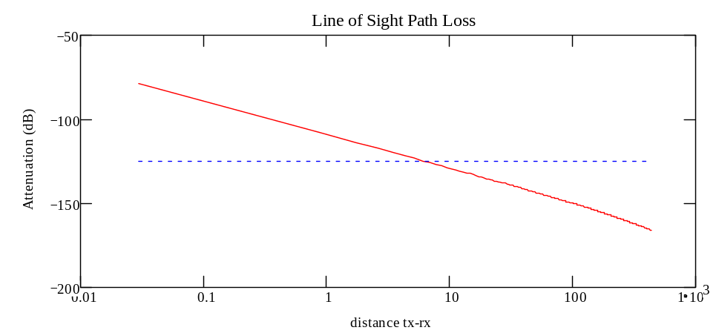
- The attenuation vs tx-rx separation distance
The calculations show that a single interferer (aircraft) must be more than 6.5 km away from a radio astronomy antenna, regardless of its pointing direction. The 6.5 km radius was calculated assuming a value of 0dBi for radio astronomy sidelobe antenna gain. According to the Recommendation ITU-R S.1428 [24] model for large antennas, there is a cone of 0.5° in diameter where the gain of e.g. a 50 m antenna exceeds 55 dBi. It is not unlikely for an aircraft to pass through the volume of airspace occupied by the side lobe cone. The required path loss is now 190 dB. and an aircraft passing through this cone will require a separation distance of more than 562 km from a radio astronomy antenna, in order not to cause interference exceeding the required protection level given by Recommendation ITU-R RA 769 [20].

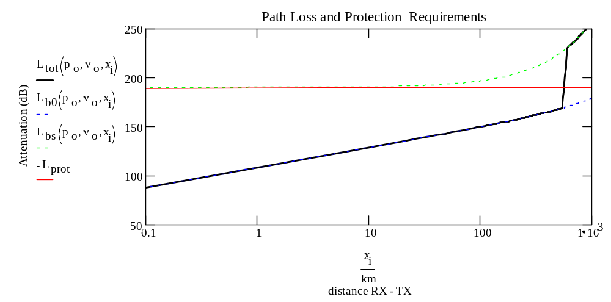
- Path Loss and Protection Requirement
The proposed implementation of airborne UWB applications for in-flight entertainment with the parameters given in table 14 is not compatible with the radio astronomy operations. Low flying aircraft during approach or take-off have been observed to come even closer than the separation distance, when their route passes over or grazes the radio telescope site, as it is the case for the airports in the vicinity of radio observatories for i.e. Jodrell-Bank (Manchester) or Effelsberg (Cologne, Frankfurt & Hahn). Hence this scenario is not uncommon in areas with high aircraft densities, as is the case in several western European countries. Assuming an aircraft density of 4.4·10⁻³/km² (see below) we obtain a probability of about 16% for an aircraft to be within a hemispherical range of 6.24 km around one of the above mentioned radio observatories. A reduction of the device emissions by an 8 dB notch filter for the radio astronomical band 6650 - 6675.2 MHz would reduce the separation distance to 2.5 km and make single entry interference cases sufficiently improbable. This corresponds to a spectral power density of -61 dBm/MHz measured in the downward direction (angle range A1 of Table 5) outside the aircraft which should be seen as the effective total RAS band emission limit for single aircraft close to RAS sites.

Multiple interferers (aggregate) scenario
In this scenario, it is necessary to consider the airspace volume that can contribute to the general background of interference.

As an example, the situation from Germany is used. The following assumptions are considered:
- Observations over Germany result in an average surface density of aircraft per hour of about 1.2·10⁻³/km² (for altitudes up to 13.8 km).
- Estimates from Eurocontrol (see Annex 5) result in a peak instantaneous surface density of about 4.4·10⁻³/km² (between 5000 feet (1.5 km) and 45 000 feet (13.8 km)).
This latter value is four times higher than the average value observed over Germany, but this is no inconsistency since the first value is a spatial average and the second one the peak value.

For distant aircraft, which contribute most to the aggregate interference, we may have to consider horizontal emissions (case 2 of table 5) with a fuselage attenuation of 5dB, hence we get the following dependence of required separation distances on deployment density and single device emission levels:

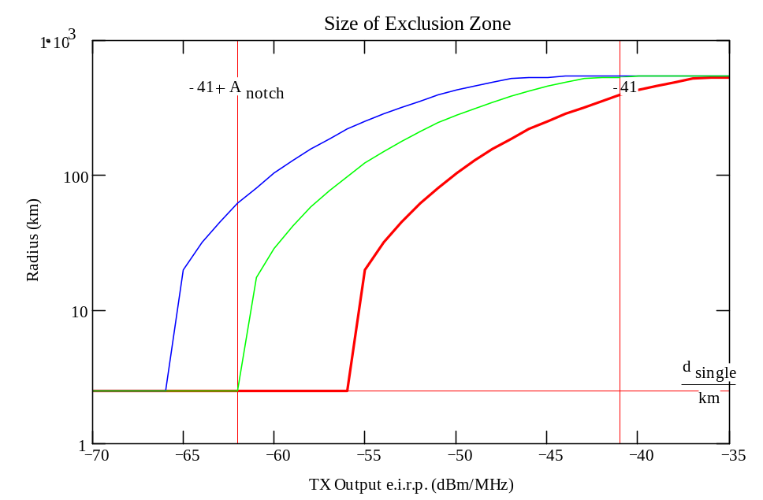
- Size of the Exclusion Zone
blue: 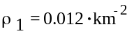 red: 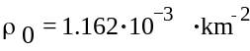 green: 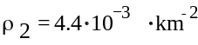

For a peak aircraft density of and for a nominal -41.3 dBm/MHz single device emission level we find that a separation distance of 538 km is required for protection of radio astronomy stations from aggregate emissions. For compatibility at the peak density ρ₂ a minimum reduction of single device emissions in the band 6650-6675.20 MHz by 21dB to -62 dBm/MHz is required to reduce the aggregate interference separation distance to the 2.5 km of the compatible single entry case described above. Two UWB access points and a 5 dB fuselage attenuation correspond to a spectral power density of -64 dBm/MHz measured in the horizontal direction (angle range case 2 in table 3) outside the aircraft. This should be seen as the effective total RAS band emission limit for single aircraft in the horizontal direction.

Proposal
It is found that an average emission of -64 dBm/MHz from all devices seen in a horizontal direction outside the aircraft may be sufficient to protect radio astronomy from aggregate interference in the frequency range 6650 – 6675.20 MHz. In order to achieve that, the single device emissions should be reduced to -62 dBm/MHz. This limit is based on the assumption of 2 continuously active devices and should be modified by 3 - 10·log(N) dB when N devices are expected to be active in the band (i.e. -59 dBm/MHz for only one active device).

A more preferable alternative would be the mandatory use of shielded windows (case 3 of table 3) yielding 35 dB fuselage attenuation. This would provide sufficient attenuation for the free deployment of up to eight UWB access points per aircraft.

Conclusions
The Table below provides an overview of the results of the compatibility studies which were achieved assuming 2 active devices per aircraft and that UWB devices are operating using 500 MHz channel bandwidth.
- Results of the compatibility studies
Frequency range | Service | Compatibility situation
3.1-3.4 GHz | Radiolocation Service (military) | UWB should not be activated before the aircraft reaches an altitude of 1 km above the radar
3.4-4.2 GHz | FS | If any risk than at low altitudes (<300m) but here the situation is very similar to indoor usage.
4.2-4.4 GHz
4.4-4.8 GHz
6.0-6.650 GHz
6.650 -6.6752 GHz
6.6742-8.5 GHz

Frequency range | Service | Compatibility situation
3.1-3.4 GHz | Radiolocation Service (military) | UWB should not be activated before the aircraft reaches an altitude of 1 km above the radar
3.4-4.2 GHz | FS | If any risk than at low altitudes (<300m) but here the situation is very similar to indoor usage.
3.4-4.2 GHz | FSS | Long term limits exceeded up to11dB (10.000m, 49dBi) and up to 17dB (5.000m, 49dBi). Additional mitigation techniques such as LDC should be further studied.
4.2-4.4 GHz | Altimeter | 60m separation distance (intra compatibility issue – seen as outside the responsibility of CEPT)
4.4-4.8 GHz | MS (military) | No studies are provided but due to the status as harmonised NATO band and the planned usage of UAV, this band should be avoided.
4.4-4.8 GHz | FS | If any risk than at low altitudes (<300m) but here the situation is very similar to indoor usage.
4.4-4.8 GHz | FSS (4.5 – 4.8 GHz) | Long term limits exceeded up to 11dB (10.000m, 49dBi) and up to 17dB (5.000m, 49dBi). Additional mitigation techniques such as LDC should be further studied.
6.0-6.650 GHz | FS | If any risk than at low altitudes (<300m) but here the situation is very similar to indoor usage
6.650 -6.6752 GHz | RAS | In order to meet the protection criterion given in Recommendation ITU-R RA.769, a notch of 21 dB should be implemented in this band to meet a level -62dBm/MHz. . The use of shielded portholes could also be a solution.
6.6742-8.5 GHz | FS | If any risk than at low altitudes (<300m) but here the situation is very similar to indoor usage

In case UWB devices are used using different characteristics, further studies would be needed.
- CMS characteristics
A1.1 Wireless Cabin Management System

A1.1.1 Scenario Description

In this scenario UWB technology shall be used to wirelessly link the Passenger Supply Units (PSU) for providing non-safety passenger related functions and services such as [2]:
- audio including music
- reading light control
- purser call button
- control of signs and passenger information displays

- Wireless Cabin Management System characteristics
Characteristics | Description
Aircraft type: | all short-haul aircraft such as A320 and B737 as well as all long-range aircraft such as A330/340/350 or A380 and B747, B777 or B787
Number of access points: | for short-haul aircraft: 2 - 3  for long-haul aircraft: 4 - 6
Access point antenna installation locations: | placed equidistantly along aisle(s) at ceiling level
Number of PSUs: | one per seat
PSU antenna installation location: | underneath overhead stowage compartment above seat row
Radio cell range: | ~20 meters
Maximum net data rate per  cell: | 100 kbit/s

A1.2 Wireless Crew Information Services

A1.2.1 Scenario Description

In this scenario UWB technology shall be used to provide the crew with non-safety related information services such as:
- wireless audio
- wireless video surveillance
- electronic point-of-sale
- electronic service management functions
- wireless telemedicine

- Wireless Crew Information Services characteristics
Characteristics | Description
Aircraft type: | all short-haul aircraft such as A320 and B737 as well as all long-range aircraft such as A330/340/350 or A380 and B747, B777 or B787
Number of access points: | for short-haul aircraft: 3 - 5  for long-haul aircraft: 5 - 10
Access point antenna installation locations: | placed within flight-deck and equidistantly along aisle(s) at ceiling level
Maximum number of active voice terminals: | for short-haul aircraft: 5  for long-haul aircraft: 20
Maximum number of active video terminals: | for short-haul aircraft: 1  for long-haul aircraft: 5
Maximum number of active data terminals: | for short-haul aircraft: 2  for long-haul aircraft: 8
Radio cell range: | ~20 meters
Maximum net data rate per cell: | 100 kbit/s
Maximum net data rate per video link: | 1.5 Mbit/s
Maximum net data rate per data link: | 500 kbit/s

A1.3 Access Point

Even though the application scenarios are described separated from each other, a real aircraft network installation would be designed such, that it supports all envisaged UWB applications. I.e., if a UWB-based infrastructure consisting of access points and wired network infrastructure is installed on an aircraft for supporting in-flight entertainment, the same infrastructure will also serve for instance wireless crew information devices. In this sense particularly the numbers of access points needed to support one or the other application cannot simply be added. For combinations of the application scenarios described below the respective greater number of access points is applicable. Furthermore, from these assumptions it cannot be concluded that all access points installed on board an aircraft must be simultaneously in active transmission mode.

Due to intra-compatibility issue, the number of access points operating at the same time on the same channel (assumed to be 500 MHz), is expected to be limited to 2 per aircraft. Only one UWB device will be operating on a given frequency (500 MHz) on each of the access point.
- airplane fuselage attenuation

A2.1 Introduction

For the purposes of this report (like in the ECC Report 93 [8]), the term used to design attenuation fuselage is "attenuation due to the aircraft".

Attenuation due to the aircraft is not constant all around the plane; extra variations of attenuation could be induced by:
- position of UWB antenna in the aircraft
- type of aircraft and its windows (number, shape, shielded or not),
- angle between aircraft and victim systems:
- different phases of flight, cruise, takeoff, landing, taxi, ground
- aircraft movements during the flight, i.e. visibility

For these reasons, this parameter of attenuation due to the aircraft cannot be defined with only one value, but has to be adequately defined for each possible configuration or situation relevant to the compatibility studies.

A2.1.1 Position of UWB antenna

According to ETSI SRdoc [2], UWB antenna should be placed near each seat in the aircraft. Some of them will be placed in the seat back; others will be placed above each seat…

Possible positions of uwb antenna at each seat row of an aircraft, or below each seat…etc…
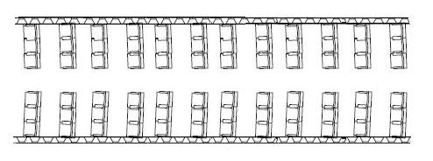
Uwb antenna  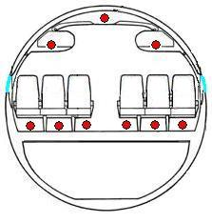  window | 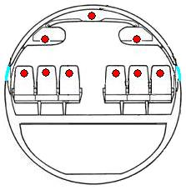
- Set up for the measurements
A2.1.2 Type of aircraft

This table gives general information about some aircraft:

- General information about some aircraft
Aircraft | A320 | A330 | A380 | Boeing737 | Boeing747
Length | 38m | 63m | 70m | 39m
Diameter | 4m | 5,6m | #9m | # 4m
Nb of windows | 40 |  |  | 43
Portholes shape | oval |  |  | Rectangular, with round corner
Portholes size |  |  |  | 25x35cm

A2.1.3 Angle between aircraft and victim system

The first assumption is that none of the flight configurations can be excluded, as it is stated in the ETSI SRdoc [2]: IFE systems have functionality during all phases of aircraft operations), even if it may be noted that use of IFE “on the ground” is generally restricted to a single channel of content.

The following figures show some possible geometrical configurations for aircraft and a radiolocation system.
In these figures, different angles “victim system/aircraft” are shown. These configurations visualise each stage of a flight. It can be noted that, in some cases, radar pencil beam will “see” only a part of the fuselage.

Both measurements and theoretical analysis show that the attenuation due to the aircraft can vary with both horizontal and vertical angle between the aircraft and the position of the victim system.

-1-  Aircraft at the airport (ground, taxi) | 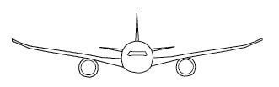 |  | 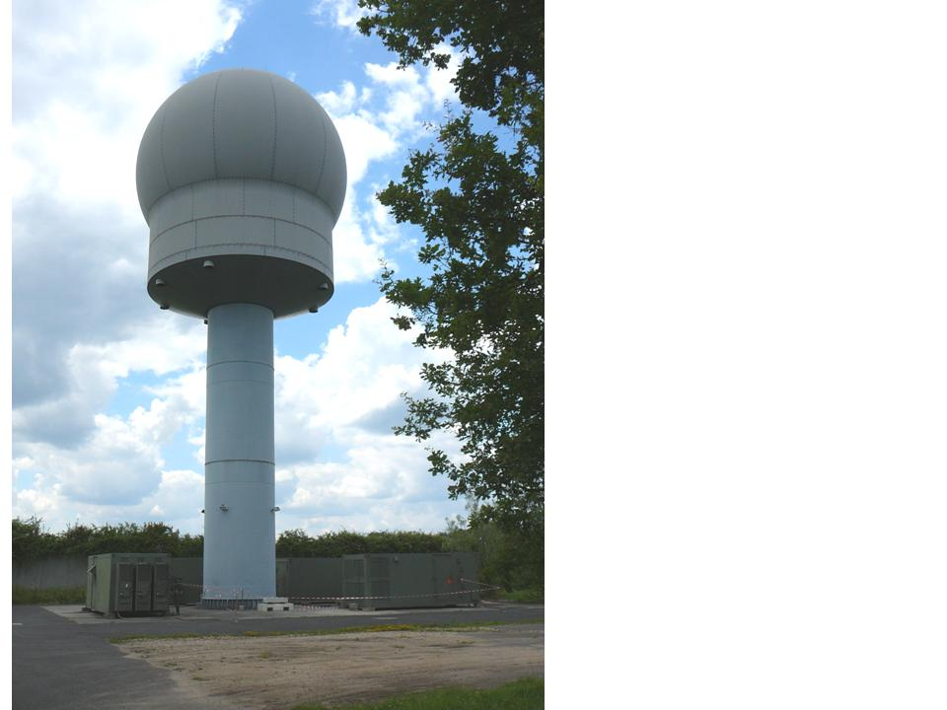
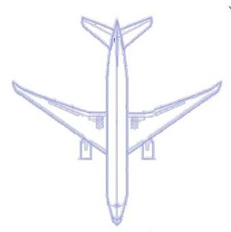
Radial orientation
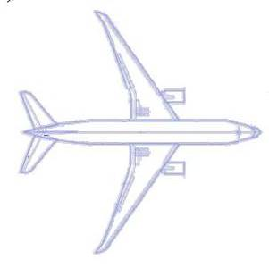
nose-on or tail-on orientations
-2-
Take off or landing
-3-
cruise
- Some configurations Aircraft/Victim system

A2.2 Values of attenuation due to aircraft
Several documents have already dealt with attenuation values. And in these documents, different values have been used. These differences are not unusual; they vary according to the type of the plane, the configuration “aircraft-victim system”, the frequency, the type of measurement (near field or far field), etc…
This section attempts to clarify the situation and to reach a conclusion for the use of a correct value according for each situation.
A2.2.1 ECC Report 93
ECC Report 93 [8] provides to use a table of attenuations (see annex 1, table13). Results are valid for 1800MHz /2400MHz frequency and. This table shows that three cases for attenuation due to aircraft are planned according to each specific calculation: a low case (A) a medium case (B) and a high case (C).
- A Minimum Coupling Loss calculations: typically given worst-case figures, i.e. the nominal (mean) power values of the interference in the worst geometry for the aircraft - victim receiver scenario, and on the limit conditions for the victim link.
- B Simulations of representative air traffic (e.g. speed, altitude and density) typically estimate the probability of the interference level exceeding a chosen limit. This type of estimate gives an indication of how often a disturbance may occur, but they assume that the terrestrial link is of the most vulnerable type (the interference level is compared to the thermal noise floor), used for SEAMCAT simulations.
- C Applying a representative distribution for the terrestrial network conditions, it estimates the real experienced level of interference, since it combines the probability of the interfering signals exceeding a certain limit, and the probability that the victim links are sufficiently vulnerable, used for SEAMCAT simulations.
Attenuation values are found to range between 1dB and 15dB.
It should be noted that in § B.2.6 (Field Measurement Challenges and Considerations), ECC Report 93 [8] provides the minimum conditions for a test campaign to measure attenuation of an aircraft (see annex 1).

A2.2.2 Boeing report
The Boeing measurement campaign [7] took place in 2004.

The first part of the report provides attenuation values measured on a 747 air-plane within the 5150-5250MHz band. The table below gives attenuation values (dB) for different each measurement point:
- Attenuation
 | Measurement point number
Measurement point height | 1 | 2 | 3 | 4 | 5 | 6 | 7 | 8 | 9
H3 | 36.1 | 21.1 | 0 | 18.8 | 6.3 | 19.3 | 22.8 | 21 | 19.5
H2 | 42 | 7.5 | 6.3 | 0.6 | (2) | 25 | 7.7 | 28.1 | 7.3
H1 | 24.1 | 17.3 | 10.6 | 8.1 | 11.6 | 27.6 | 24.3 | 23.6 | 21

Using these measurements, Boeing has calculated a mean value of 17.3dB.

The second part of the report provides results for the 1.8GHz frequency band, and for measurements were realised for a radius of roughly 10m beyond the wingtips. These measurements had been carried out on the ground but were not calibrated.

Other measurements were carried out on an aircraft cruising at 10000 feet and a ground station. In that case attenuation (see figure 3.4 - annex 2 of the report [7]) appears to range from 13dB to 30dB. The average value may be about 20dB.

A2.2.3 Advisor cirular 20-158
This document [9] provides information relevant for the protection of the operation of electrical and electronic systems on an aircraft when the aircraft is exposed to an external high-intensity radiated HIRF environment, from 100MHz to 18GHz.

Hence it is possible to derive estimates on generic attenuation due to the aircraft, even if the subject is the certification of aircraft electrical and electronic systems for operation in the HIRF environments.
The aircraft have been sectioned into five areas corresponding to different attenuation:
- no attenuation, areas where there is no guarantee of structural bonding or other open areas where no shielding is provided,
- 6dB attenuation, area such as cockpit in a nonconductive composite fuselage, with minimal additional shielding or area on the wing leading or trailing edges or in wheel wells,
- 12dB attenuation, area located entirely within aircraft with a metal fuselage or a composite fuselage with shielding effectiveness equivalent to metal : avionics bays not enclosed by bulkheads, cockpits, and areas near windows, access panels and doors without EMI gaskets,
- 20dB attenuation, area located entirely within aircraft with a metal fuselage or a composite fuselage with shielding effectiveness equivalent to metal, in addition wire bundles are installed close to metal structure….
- 32dB attenuation, area where equipment and all associated where wiring are located entirely within areas with effective shielding to form an electromagnetic enclosure.

A 12dB value is used for a generic attenuation of cruise cabin or passenger’s cabin, except for aircraft with specific shielding.

A2.2.3 Measurements of TU Braunschweig

New results from field measurements of TU Braunschweig are provided in [10].
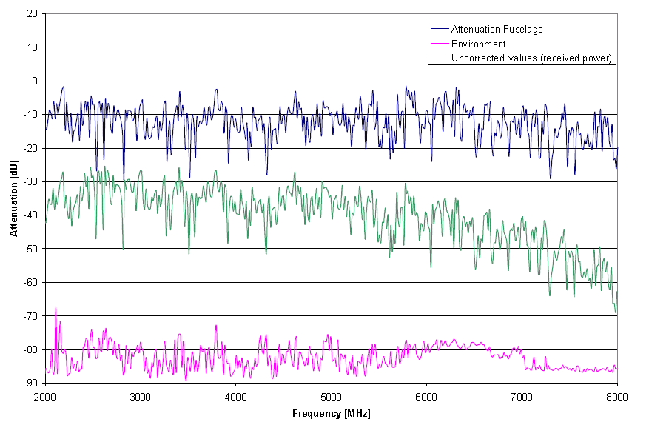
- Results from the Measurements
This campaign shows in the horizontal plane values for the fuselage attenuation between 10 and 15dB. These results are just applicable in the horizontal plane where the worst case emissions are expected due to the windows.

A2.3 Calculations and Simulations

Software “CST Microwave Studio”
CST STUDIO SUITE™ is a general-purpose electromagnetic simulator based on the Finite Integration Technique (FIT), first proposed by Weiland in 1976/1977 [25]. This numerical method provides a universal spatial discretization scheme applicable to various electromagnetic problems ranging from static field calculations to high frequency applications in time or frequency domain. Unlike most numerical methods, FIT discretizes the integral form of Maxwell’s equations rather than the differential one.

Application to calculate the attenuation of a structure
With « CST microwave Studio » software, it is possible to calculate the equivalent gain of an antenna which is composed of a dipole placed in a structure. The effective antenna gain is valid in far field. In our case, aircraft fuselage has been simulated by a tube (or pipe) with a diameter of 5,6m, and a length of 6m. On this structure holes have been placed (30cm diameter) at each meter to simulate windows.
A dipole λ/2 is chosen, with well-known antenna diagram. This antenna is placed at the center of the structure. An equivalent antenna diagram is the result of the numerical calculations.
Hence, the attenuation due to this structure is equal to the difference between the calculated antenna gain calculated and the dipole antenna gain.

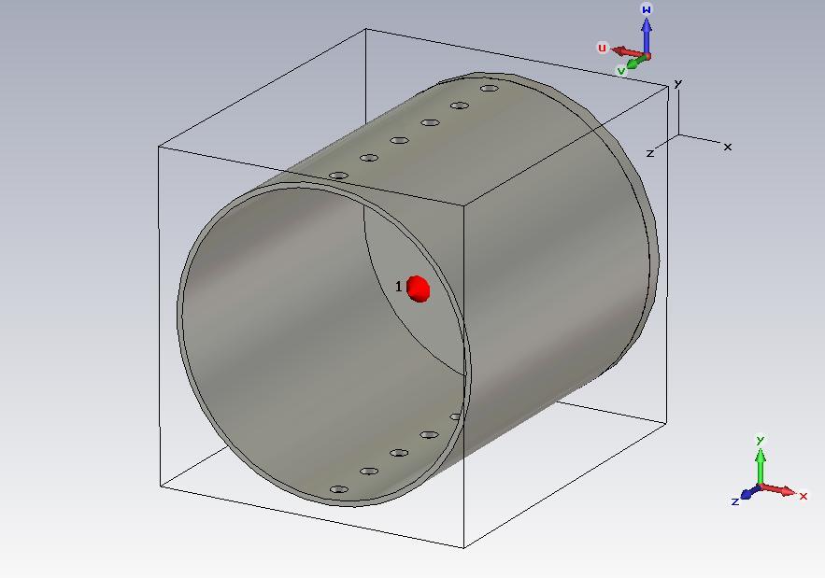
Discretisation ; x 10⁶ elements | Necessary memory : 8Go | Approximate calculation time: 16Hours
- Structure n°1 - part of fuselage, length= 6m, 2x 6 windows 30cm Ø, 1m separations
The first calculation was made for 1.8GHz in order to compare with ECC Report 93 (cf. annex 3). For the purpose of this report, results of a second set of calculations are given below.

The figure below shows the results of 3D calculations: it represents an equivalent diagram antenna which takes into account dipole antenna and structure.

Results [Far field array/ F=3300MHz]
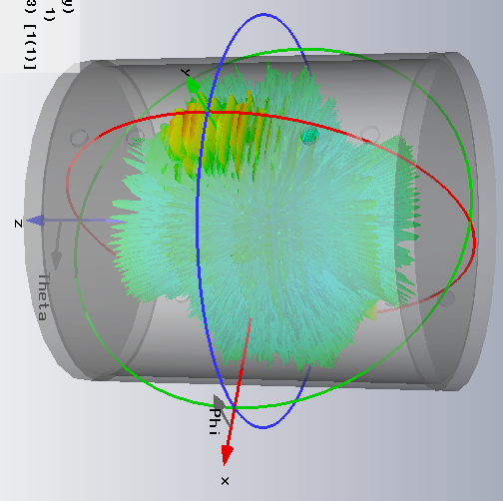 | 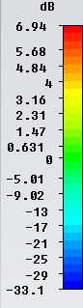  Greatest values in the direction of the windows.
- Results
- Synthesis of results
Plane | Attenuation due to the structure | Average Value | Ecart type
Theta | 4,5 to -21dB | -5,3dB | 5,8dB
Phi | -6 à -30dB | -14,3dB | 4,6dB
Theta | 4,5 to -21dB | -5,3dB | 5,8dB

Attenuation values are very different according to the direction under which the structure is seen. Furthermore, some attenuation values are negative (equivalent to a gain). The effects is caused by the window arrangement in the far field which is equivalent to a linear antenna network at each side of the aircraft.

A2.4 Summary on Attenuation due to the aircraft

A2.4.1 Comments
From documents and simulation presented above, it can be said that:
- Attenuation due to the aircraft varies from negative values to values around 40dB. Negative value signifies a gain and at certain angles the fuselage produces a gain. This phenomenon has been shown in the simulation, but the array effects can only be observed in the far field (order of km distance). The negative values of the Boeing Report (in the range of -2 to 42dB) could also be explained by this phenomenon. However, the measurements were performed in the near field and the explanation is not certain.
More support may be found in ECC Report 93 (§B2.3.2):“The far-field antenna pattern of the energy leaking through a single window (not obstructed by the wing) according to the single elevation and azimuth gain cuts are shown in Figure 77. Each window was found to have a peak aperture gain of +13.5 dB at 1920 MHz relative to an isotropic source. The location of this beam peak is directly abeam of the aircraft at an elevation of 36.5° below horizontal.”. Even if the concern is not exactly the same, the approach and the theory are similar.

- It has also been shown that a significant variation of “attenuation due to aircraft” is visible for the different directions in which aircraft are seen by the victim system. Results are also very different depending on the various the placements of the antenna. The figures below illustrate this point.

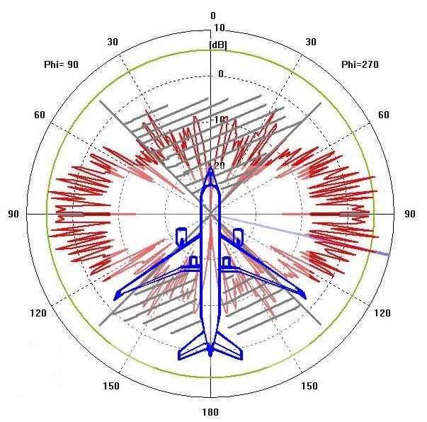 | 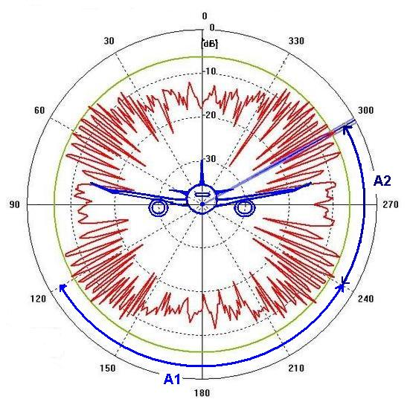
min 4,5dB max -21dB  average -5.3dB | Min -6dB max -30dB  average -14.3dB
values in sector A1
Min -6,6dB max- 27dB
average 14.5dB
values in sector A2
Min -6,8dB max -25dB
average -14dB
- Attenuation depending on the locations of the antenna
The ECC Report 93 [8] and the report from Boeing [7] provide empirical evidence that the wings may mask a part of the fuselage where are windows. However, this is not always the case when the aircraft is in the takeoff or landing phase, or when only a part of the aircraft is in the pencil beam of a radar (cf. §2.3)
The first part of the Boeing report describes measurements that have been performed in the near field at 5GHz band. A mean value of 17.3dB mean value has been calculated in this report. However, if using the table 3-2, a value of 16.8dB is obtained. The difference of 0.5dB needs clarification, especially if comparisons are made to the indoor/outdoor scenarios of draft ETSI report on UWB which gives a 17.3dB value [7].

It can be concluded from the second part of the Boeing report (measurements on figure 3.3, annexe 2), that attenuations in nose-on or tail-on orientations are lower than in radial orientation. This has to be carefully considered for different emitter locations. A single emitter was placed in the passenger’s cabin area for the measurements. However, for the compatibility studies undertaken in the framework of this ECC Report, the possibility to place the UWB antenna in the cabin cruise (or on the flight deck) needs to be taken into account, and in that case, the results from the Boeing measurements are not applicable; if the UWB antenna is placed closed to windshield the “attenuation due to the aircraft” will be weak.

- Radar antenna patterns

The radar antenna patterns are derived from Recommendation ITU-R M.1851, Equation (1), Table 2 [10].

Surface search radars

- Horizontal 3dB beamwidth: 2°
- Vertical 3dB beamwidth: 2°
- Elevation: 1°

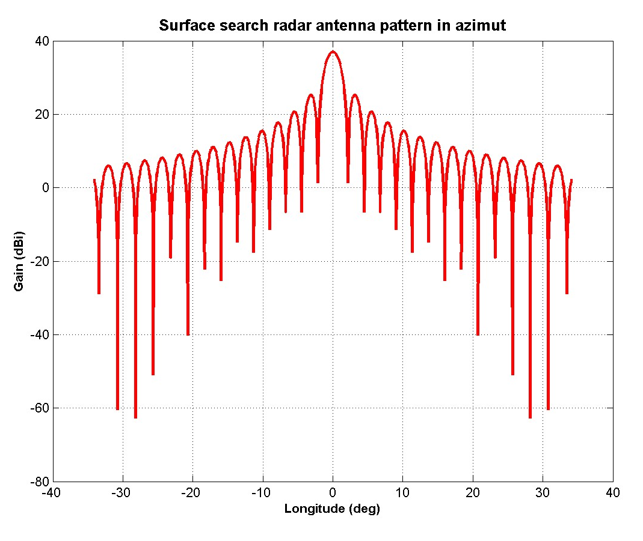 | 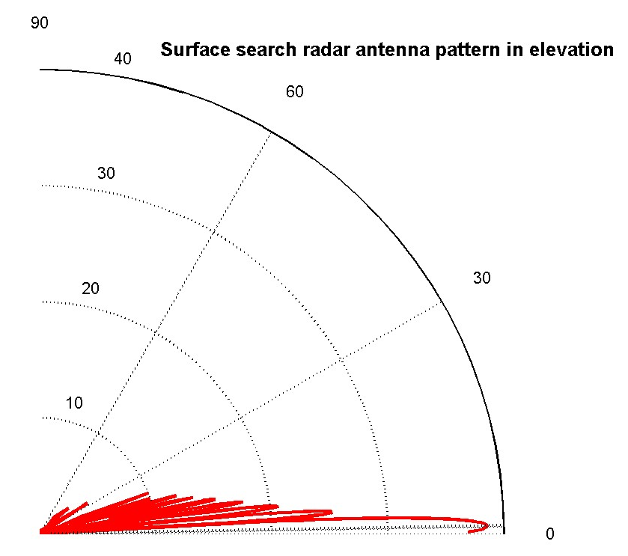
- Surface search radar antenna pattern
Air search radars

- Horizontal 3dB beamwidth: 1°
- Vertical 3dB beamwidth: 30°
- Elevation: 20°

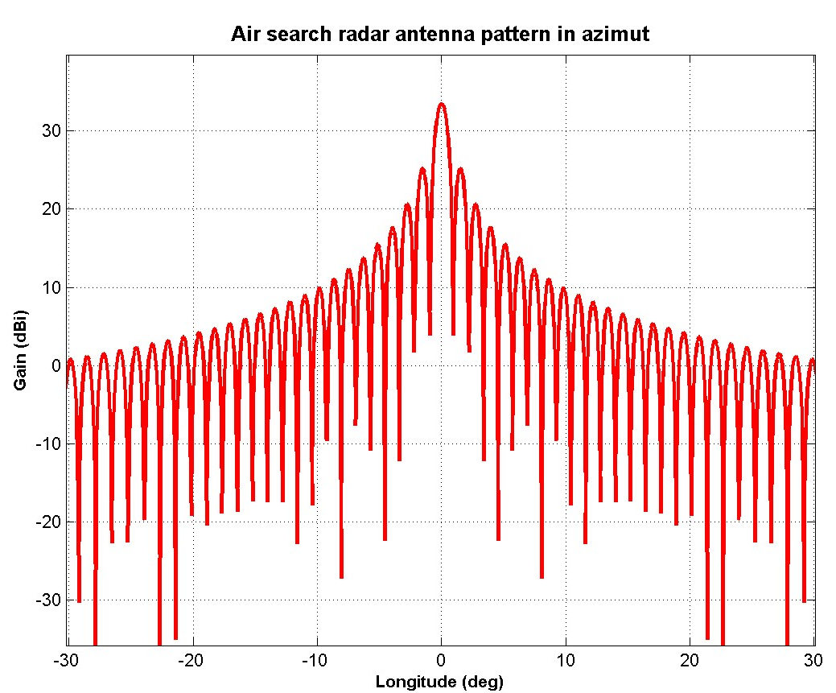 | 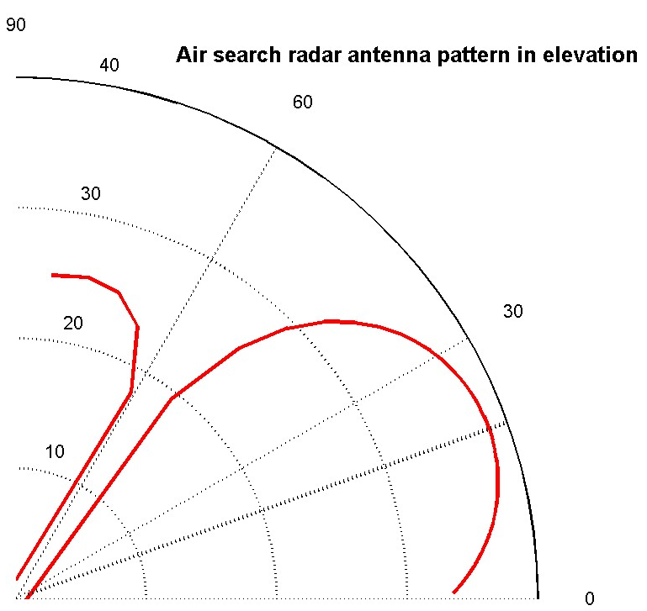
- Air search radar antenna pattern
- Satellites in GSO orbit active C-band payloads in June 2011 (Excepting military satellites)
- 161 satellites operating in C band beams
°Long | Name | °Long | Name | °Long | Name | °Long | Name
3E | Telecom 2C | 83E | APR-1 | 142W | Inmarsat-2 F1 | 55W | Intelsat 805
3E | Rascom 1 | 83E | Insat 3B | 138W | AMC 8 | 54W | Inmarsat-3 F4
6E | Measat 2 | 87.5E | Chinasat 5A | 137W | AMC 7 | 53W | Intelsat 707
10E | Eutelsat W2A | 88E | ST1 | 135W | AMC 10 | 50W | Intelsat 1R
11.5E | Intelsat 603 | 90E | Yamal 201 | 133W | Galaxy 12 | 47W | NSS 703
17E | Asiasat 2 | 91.5E | Measat 3 | 131W | AMC 11 | 45W | Intelsat 14
20E | Arabsat 2B | 91.5E | Measat 3A | 127W | Horizons 1 | 43W | Intelsat 11
25E | Inmarsat-3 F5 | 93E | Insat 4B | 127W | Galaxy 13 | 40W | NSS 806
25E | Inmarsat-4 F2 | 93E | Insat 3A | 125W | Galaxy 14 | 37W | NSS 10
26E | Arabsat 4C | 96E | Express AM 33 | 123W | Galaxy 18 | 34W | Intelsat 903
31E | Arabsat 5A | 98.5E | Thuraya 3 | 121W | Galaxy 23 | 32W | Intelsat 25
31.5E | Intelsat-25 | 101E | Asiasat 5 | 119W | Anik F3 | 29W | Intelsat 801
33E | Galaxy 11 | 103E | Express A2 | 117W | Satmex 5 | 27W | Intelsat 907
33E | IS New Dawn | 106E | Asiasat 3S | 115W | Solidaridad 2 | 24W | Intelsat 905
38E | Paksat 1 | 108E | Telkom 1 | 113W | Satmex 6 | 22W | NSS 7
38E | HGS-3 | 108E | NSS 11 | 111W | Anik F2 | 20W | NSS 5
40E | Express AM1 | 109E | Inmarsat-2 F4 | 107E | Anik F1 | 18W | Intelsat 901
44E | Thuraya 2 | 110E | Chinasat 5B | 107W | Anik F1-R | 15W | Inmarsat-3 F2
45E | Galaxy 27 | 113E | Palapa D | 105W | AMC 18 | 14W | Express A4
46E | Measat 1 | 116E | Chinasat 6B | 103W | AMC 1 | 11W | Express A3
47E | Intelsat 601 | 118E | Telkom 2 | 103W | SES 3 | 11W | Express AM 44
49E | Yamal 202 | 122E | Asiasat 4 | 101W | SES 1 | 5W | Atlantic Bird 3
50E | Intelsat 26 | 123E | Garuda-2 | 99W | Galaxy 16 | 1W | Intelsat 10-02
51E | Galaxy 26 | 125 E | Chinasat 6A | 98W | Inmarsat-4 F3
51E | Thaicom 2 | 128E | JCsat 3A | 97W | Galaxy 19
55E | Intelsat 709 | 128E | JCsat 12 | 95W | Galaxy 3C
55E | Insat 3E | 132E | JCsat 5A | 93W | Galaxy 25
57E | NSS 12 | 132E | Vinasat 1 | 92W | Brazilsat B2
60E | Intelsat 904 | 134E | Apstar 6 | 91W | Galaxy 17
62E | Intelsat 902 | 138E | Telstar 18/Apstar 5 | 89W | Galaxy 28
64E | Intelsat 906 | 140E | Express AM3 | 87W | AMC 3
64E | Inmarsat-3 F1 | 143.5E | Inmarsat-4 F1 | 84W | Brazilsat B4
66E | Intelsat 702 | 146E | ABS 5 | 81W | Intelsat 3R
66E | Intelsat 17 | 150E | Palapa C2 | 79W | AMC 2
68.5E | Intelsat 10 | 154E | JCsat 2A | 79W | Satcom C3
68.5E | Intelsat 7 | 166E | Intelsat 8 | 78W | Venesat 1
72E | Intelsat 706 | 169E | Intelsat 5 | 75W | Brazilsat B3
74E | GSat 3 | 172E | GE 23 | 72W | AMC 6
74E | Insat 3C | 174E | Intelsat 2 | 70W | StarOne C2
75E | ABS-1 | 178E | Intelsat 602 | 68W | Brazilsat B1
76.5E | Telstar 10 | 178E | Inmarsat-3 F3 | 67W | AMC 4
78.5E | Thaicom 5 | 180E | Galaxy IOR | 65W | StarOne C1
80E | Express AM2 | 180E | Intelsat 701 | 61W | Amazonas 1
80E | Express MD1 | 177W | NSS 9 | 61W | Amazonas 2
83E | Insat 2E | 164W | Thuraya 1 | 58W | Intelsat 9
83E | Insat 4A | 144W | Inmarsat-2 F2 | 58W | Intelsat 16

- information relating to the traffic information

This annex gathers some information related to the number of aircraft that an incumbent service can possibly “see”. The two first sections are based on observations and indicate the number of flight (over Germany for section 1 and for international airports in section 2), while the third section is based on estimates and indicates peak instantaneous aircraft numbers for various typical airspace volumes.

A5.1 Air traffic density over Germany

In this section the German situation is examined.

According to the German Air Traffic Control (DFS) the highest flight level is at 45000 ft or 13.8 km.

There are about 16500 daily flights over Germany, considering all German airports. The average duration of a flight within air traffic control zone is about one hour.

This means that, at any time during the day, there is an average of 688 (16500:24h=687.5) commercial aircrafts (departing, arriving, and transiting) under the national air traffic control.

The German national air traffic control zone has a radius of 434 km, therefore the average surface density of aircrafts over Germany is about 1.2·10⁻³/km².

A5.2 Airport traffic movements

The 2009 official report of the ACI (Airport Council International) indicates the number of aircraft movements per year for major airports (see table 22).

- Ranking of Total Traffic Movements (landing + take off of an aircraft) in 2009 for airports participating in the ACI annual traffic statistics collection
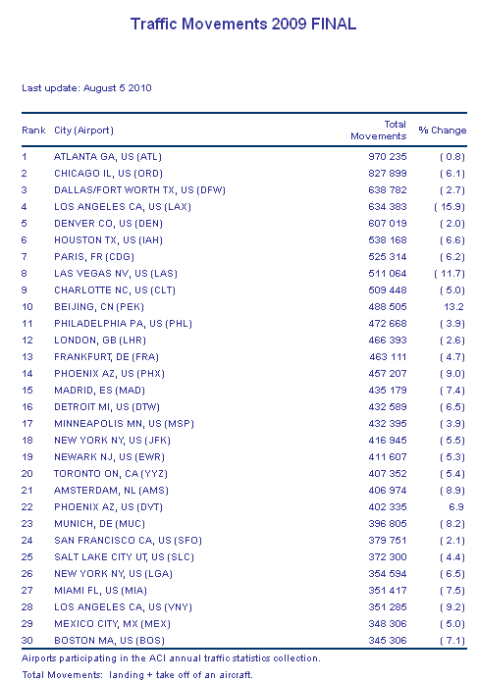

Considering the above Table, the average number of total aircraft movements at Charles de Gaulle, Heathrow, Frankfurt airport are the following:

- Daily and hourly traffic for some European airports
Airport | movements  per day | movements  per hour
Charles de Gaulle | 1440 | 60
Heathrow | 1278 | 53
Frankfurt | 1269 | 53
Amsterdam | 1115 | 46

A5.3 Peak Aircraft counts in typical airspace volumes

A report from Eurocontrol [26] aims at identifying future communication requirements based on emerging global future Air Traffic Management concepts. To achieve this goal, aircraft traffic inside tests volumes are estimated, where test volumes describe airspace volumes for typical aeronautical scenarios at airports and differing flight levels.

Peak aircraft counts obtained for each test volume were calculated by an air traffic growth-predicting tool. This information enabled Eurocontrol to extrapolate capacity data requirements.

Various categories of airspace were defined, in particular:
- Airport: a cylindrical volume centred on an airport extending from ground to 5000 ft.
- Terminal Manoeuvring Area (TMA): a typical sector within a TMA handles aircraft departing or landing, bridging upper airspace and the airport airspace. This has been defined as extending from FL050 to FL245.
- En-route (ENR): an upper sector where aircraft are typically cruising; defined as extending from FL245 to FL450 (13.8 km).

Service volumes used in COCR (Communication Operating Concept Requirements) are based on actual sectors of complex 3-dimensional shapes. To simplify things, these complex service volumes were transformed into geometric shapes of equivalent volume as shown in Table 23. This facilitates the generation of an aircraft count for each Test Volume (TV).
- Generic Test Volumes based on COCR sectors
Service | Shape | Dimensions | Height Range | Volume (NM³)
Airport | Cylinder | 10 NM diameter | 0 – FL050 | 64.6
TMA | Cuboid | 48.95 x 48.95 NM | FL050 – FL245 | 7,691
ENR | Cuboid | 54.8 x 54.8 NM | FL245 – FL450 | 10,132

Some technologies will have the capability to provide services in larger airspace volumes than the generic Test Volumes described above. This is why wider additional Test Volumes were generated in the Eurocontrol study. Only two of them (TMA Large and ENR Large) are considered here.

The table below summarizes some final test volumes listed in the Eurocontrol report with their corresponding PIAC:
- Extract of (final) generic Test Volumes
Test volume (TV) | Réf | Shape | Height Range | Dimensions | No. Aircraft  (PIAC)
Airport Zone | TV 1.1 | Cylinder | 0 – FL050 | 10 NM diameter | 26
TMA Small | TV 2.1 | Cuboid | FL050 – FL245 | 49 x 49 NM | 44
TMA Large | TV 2.2 | Cuboid | FL050 – FL245 | 75 x 75 NM | 53
ENR Small | TV3.1 | Cuboid | FL245 – FL450 | 55 x 55 NM | 45
ENR Large | TV 3.3 | Cuboid | FL245 – FL450 | 200 x 200 NM | 204

The table below shows the corresponding aircraft surface and volume densities:

- Peak instantaneous aircraft densities for the tests volumes considered
 | PIAC | Height  (Feet) | Size  (NM) | Area  (NM²) | Volume  (NM³) | Surface  density (per NM²) | Volume density (per NM³)
Airport | 26 | 5000 | 10 | 79 | 65 | 0,33104 | 0,40255
TMA small | 44 | 19500 | 49 | 2401 | 7691 | 0,01833 | 0,00571
TMA large | 53 | 19500 | 75 | 5625 | 18056 | 0,00942 | 0,00294
ENR small | 45 | 20500 | 55 | 3025 | 10132 | 0,01488 | 0,00441
ENR large | 204 | 20500 | 200 | 40000 | 134957 | 0,00510 | 0,00151

It can be noted that surface densities for “TMA small” and « ENR small » are quite similar, therefore, an homogeneous peak instantaneous surface density of about 0.015 aircraft/NM², or 0.00437/km², could be used for studies concerning aircraft between FL50 and FL450, that is for aircraft already in the air. This is four times the average value oven Germany given in previous section.

When considering aircraft counts near airports, the values corresponding to Airport and TMA volumes have to be added. Indeed TMA is defined as the airspace which handles aircraft departing or landing. This leads to a PIAC value of 70 (26+44) when considering “TMA Small”, which is not far from values indicated in section 1 corresponding to average hourly valued based on yearly traffic observations.

A5.4 Summary

Average surface densities
- Observations over Germany result in an average surface density of aircrafts per hour of about 1.2·10⁻³/km² (for altitudes up to 13.8 km).
- Estimations from Eurocontrol result in a peak instantaneous surface density of about 4.4·10⁻³/km² (between 5000 feet (1.5 km) and 45 000 feet (13.8 km)).
This latter value is four times higher than the average value observed over Germany, but this is consistent since the first value is a spatial average and the second one a local peak value.

Movements near airports
- The average movements per hour are 60 for Charles de Gaulle and 53 for Heathrow and Frankfurt.
- An estimation of the peak instantaneous aircraft count is 70
These values are consistent with the estimates given in the preceding sections

- LIST OF REFERENCES
- ECC/DEC/(06)04: UWB technology in bands below 10.6 GHz
- ETSI TR 102 384 1.1.1 (2009-05): System Reference Document Technical characteristics for airborne Ultra-Wide-Band (UWB) applications operating in the frequency bands from 3.1 GHz to 4.8 GHz and 6 GHz to 8.5 GHz
- ECC Decision (06)12: UWB devices using mitigation techniques
- ECC Report 64: Report on the protection requirements of radiocommunication systems below 10.6GHz from generic UWB applications
- Radio Regulations (www.itu.int)
- CEPT/ERC Report 25: "The European table of frequency allocations and utilisations covering the frequency range 9 kHz to 3000 GHz - Lisboa 02- Dublin 03- Kusadasi 04- Copenhagen 04- Nice 07- Baku 08"
- "Dynamic Frequency Selection (DFS) Functionality with Airborne Radio Local Area Networks (RLAN’s) Flight Tests, Results, and Conclusions" Boeing Cabin and Network Systems Technical Center (BE-431)
(Document nr D6-83753 18 February 2007)
- ECC Report 93: Compatibility of GSM on board aircraft (GSMOB)
- AC 20-158 - The Certification of aircraft Electrical and Electronic Systems for Operation in the High-Intensity Radiated Fields (HIRF) Environment
- I. Schmidt, A. Enders, M. Schwark, J. Schuur, R. Geise, M. Schirrmacher, and H. Stoefen, UWB aircraft transfer function measurements in the frequency range from 2 to 8 GHz, in Electromagnetic Compatibility – EMC Europe, 2008 International Symposium on, 2008. "Dynamic Frequency Selection (DFS) Functionality with Airborne Radio Local Area Networks (RLAN’s) Flight Tests, Results, and Conclusions" Boeing Cabin and Network Systems Technical Center (BE-431)
(Document nr D6-83753 18 February 2007
- Recommendation ITU-R M.1465: Characteristics and protection criteria of radars operating in the radiolocation service in the 3 100-3 700 MHz frequency band.
- Recommendation ITU-R M.1851: Mathematical models for radiodetermination radar systems antenna patterns for use in interference analyses
- Recommendations ITU-R SF.1006: Determination of the interference potential between earth stations of the fixed-satellite service and stations in the fixed service
- Recommendations ITU-R F.1094: Maximum allowable error performance and availability degradations to digital fixed wireless systems arising from radio interference from emissions and radiations from other sources
- Recommendations ITU-R S.1432: Apportionment of the allowable error performance degradations to fixed-satellite service (FSS) hypothetical reference digital paths arising from time invariant interference for systems operating below 30 GHz
- Recommendation ITU-R F.699: Reference radiation patterns for fixed wireless system antennas for use in coordination studies and interference assessment in the frequency range from 100 MHz to about 70 GHz
- Recommendation ITU-R RA.314: Preferred frequency bands for radio astronomical measurements
- Recommendation ITU-R SM.1757 Impact of devices using ultra-wideband technology on systems operating within radiocommunication services
- ITU-R Report SM.2057: Studies related to the impact of devices using ultra-wideband technology on radiocommunication services
- Recommendation ITU-R RA.769: Protection criteria used for radio astronomical measurements
- Recommendation ITU-R RA.1031: Protection of the radio astronomy service in frequency bands shared with other services
- Recommendation ITU-R RA.1631: Reference radio astronomy antenna pattern to be used for compatibility analyses between non-GSO systems and radio astronomy service stations based on the epfd concept
- Recommendation ITU-R P.452: Prediction procedure for the evaluation of interference between stations on the surface of the Earth at frequencies above about 0.1 GHz
- Recommendation ITU-R S.1428: Reference FSS earth-station radiation patterns for use in interference assessment involving non-GSO satellites in frequency bands between 10.7 GHz and 30 GHz
- Weiland, T., “A discretization method for the solution of Maxwell’s equations for six-component fields,” Electronics andCommunications AE ¨ U, Vol. 31, No. 3, 116–120, 1977.
- Eurocontrol/FAA : Future Communications Study (FCS) – Operational Concepts and Requirements Team

*(Additionally it is known that a comparatively small number of military satellites use frequencies within the 3.4-4.2 GHz band, for example Leasat-5 at 72E, Chinasat 20 at 98E, Chinasat 22 at 98E and Chinasat 22A at 103E.)
PIAC: Peak Instantaneous Aircraft Count. The PIAC was extracted from the aircraft quantity data for each TV to simulate a worst and most demanding case (let us recall that the purpose of the Eurocontrol report is to define communication services that will be operational even in busy periods).

