Practical arrangements-WGSE # 61, Åre 26-30 March, 2012

1 Meeting venue

Holiday Club Åre(****)
Holiday Club Sweden AB
Box 68
SE-83014 Åre
tel +46 (0)647-120 00
http://hcresorts.com/en/resorts/ore/introduction/
A block of rooms (70) is available at this hotel at negotiated rate per room and night
(quoted in SEK) using the code: PTS

Occupancy per room | Single (SEK) | Double  (SEK) | Trippel  (SEK)
Price including VAT, breakfast and access to the pool area | 1495 | 2190 | 2685
In case of accompanied children please make your reservation by e-mail or phone in order to obtain the discount for children.
NOTE: Hotel rooms should be reserved as soon as possible, but no later than February 12, 2012. Reservations after February 12, 2012 are subject to room- and rate availability.
For reservations, please contact the hotel directly by Phone: +46 647 120 60
or by E-mail: info.are@holidayclub.se (recommended)
Use Campaign Code “PTS” when contacting Holiday club Åre

2 Alternative Accommodation
If you prefer some alternative accommodation you may consult the following two hotels (both are located within 5 minutes by foot from Holiday Club Åre):
http://www.diplomathotel.com/en/Are/Hotel-Diplomat-Aregarden/
http://www.hotellaretorg.se/index_en.shtml
5km from Åre you will find “Åre Continental Inn” Hotel.
Phone: +46 647-17170 Website: www.areinn.se
For other hotels available in Åre: www.hotels.com
In any case you should make your reservation as soon as possible. Åre is a popular ski-resort!

3 Entering the country

Entry into Sweden
If you need an entry visa for Sweden, you are advised to make the necessary arrangements well in advance of your arrival. See Attachment1 if you require a letter of invitation to this meeting from the Swedish Administration to support your visa application.
Transportation
The local airport Östersund (Froesoe, OSD) can be reached by air from Stockholm International Airport Arlanda (http://www.are360.com/en-gb/Travel.aspx). The distance from this local Airport (Östersund) to the meeting place Åre is about 84 km.
The most convenient transfer from the local airport (Östersund) to Åre is to book a “Flygtaxi” (translates directly to Flight taxi) in advance using this link http://www.flygtaxi.se/products/transfer/are/? The cost for a “flygtaxi” is about €30 when pre- booked, otherwise the fare can be well above €200.
The trip will take one hour.
You may reach Åre by ground transportation from Trondheim Vaernes Airport as well.
This airport is located on the Norwegian side with a distance to Åre of about 130 km. http://www.avinor.no/en/airport/trondheim/tofromairport
The 3rd option with respect to transportation to Åre, in case you have time, and don’t need too much sleep, is to take the direct train (usually night-trains) from the cities of Stockholm (preferred), Gothenburg or Malmö. In this case you don’t need the ground transportation from the local airports to Åre. (http://www.are360.com/en-gb/Travel.aspx).

4 Other useful information

Currency/Exchange/Credit Cards
The currency in Sweden is Swedish Krona (SEK or Kr)
ATM’s are available twenty-four hours a day, most of them accept VISA and MASTERCARD, and some accept AMERICAN EXPRESS and DINERS.
The above cards are widely accepted in Swedish shops, restaurants, hotels and in Taxis.
Exchange rates (2011-12-14) :
http://www.forex.se/en/Currency/Converter/

Foreign currency | 1 EUR | 1 RUB | 1 GBP | 1 CHF | 1 HRK | 1 LVL | 1 LTL | 1 PLN | 1 RON | 1 CZK | 1 HUF | 1 USD
SEK  (Swedish “Krona”) | 9,49 | 0.24 | 11,34 | 7,68 | 1,29 | 13,76 | 2,78 | 2,12 | 2,29 | 0,38 | 0,03 | 7,29

Banks are usually open Monday to Friday from 10h00 to 15h00.

Local Information
The normal temperature in Åre in March/April is between -6º to + 2º Celsius.
Occasionally it can be much colder.
Please note that the weather will most likely be snowy and windy, i.e warm clothing (included shoes) is recommended!
To check the weather:
http://www.are360.com/en-gb.aspx
Webcams placed in Åre:
http://www.webbkameror.se/skidkameror/are/webkamera_are_1_640.php
http://www.webbkameror.se/skidkameror/are/webkamera_are_2_live.php
http://www.webbkameror.se/skidkameror/are/webkamera_are_3_640.php
For international calls to a number in Sweden the country code is +46.
For international calls from Sweden the code is 00 + the country code.

Electrical Appliances
Electricity in Sweden is 230V/50Hz. Plugs are the normal 2-pin round continental type.
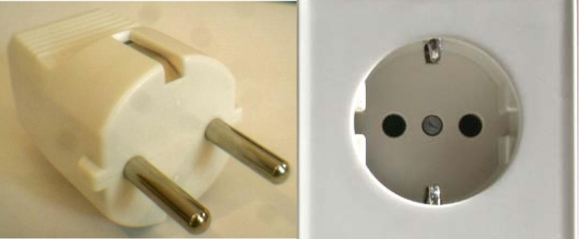

5 Contact point
For any further information, please contact Stefan Mattsson by e-mail or by phone:
E-mail: stefan.mattsson@pts.se
Phone : +46 708114071

_______

Attachment 1
Request for a letter of invitation from the Swedish Post and Telecommunication Agency in support of a visa application
Delegates who require a letter of invitation from the Swedish Administration to support their visa application are kindly requested to complete the information in the form below and to send it by email to:
anneli.forss@pts.se
____________________________________________________________________________________

Administration/ Organization / Company:
Address:

Invitation on the WGSE- meeting in Åre, 26-30 March 2012
Dear Sir/Madame,

The Swedish Post and Telecom Agency (PTS) have the honor of inviting
First name, last name:
Gender:
Date of birth:
Place of birth:
Nationality:
Passport number:
Date of issue:
Date of expiry:
to attend the WGSE-meeting.
The meeting will take place 26-30 March 2012.
The venue of the meeting will be:
Holiday Club Åre
Årestrand
Sweden

Urban Landmark
Head of Spectrum Department

