SE(12)034

Extract of FM(12)019rev1
(does not contain the Annexes)
 | Working Group FM
 | 74th Meeting
 | Bern, 23 – 27 April 2012
 | Date issued: | 21 March 2012
 | Source: | ECO
 | Subject: | WGFM QUESTIONNAIRE ON THE CURRENT STATUS OF DFS (DYNAMIC FREQUENCY SELECTION) IN THE 5 GHZ FREQUENCY RANGE
N
Group membership required to read? (Y/N)

Summary

This questionnaire was sent out from the Office on 24 October 2011. The official deadline was on the 1 March 2012.

By 21 March 2012, a total of 31 countries provided an answer to the questionnaire.

All the detailed responses are contained in annex 1 attached to this summary.

Proposal

WG FM is invited to consider the responses and the ECO summary for necessary actions to be taken on the subject.

The SRD/MG and WGSE are invited to consider the responses and the ECO summary and to provide guidance to WG FM.

- Responses

Replies were received from 31 administrations by 10 March 2012.

Albania  Austria (11) up to 23 km  Belarus  Belgium (1) 10 km  Bosnia Herzegovina  Croatia  Cyprus  Czech Republic (about 50 per annum) critical cases up to 50 km, some up to 100 km  Estonia (1) 6 km  Finland (a few) 1 to 6 km  France (11) 1 to 28 km  Georgia  Germany (10) No data  Hungary (45) 4 to 45 km  Ireland  Italy (3) 2 to 30 km  Latvia (23) 4 to 20 km  Lithuania | Macedonia  Malta  Montenegro  Polen (some) Up to 20 km  Portugal  Serbia  Slovak Republic (1) No data, interference was gone before it could fully assessed  Slovenia  Spain (3) 1 to 8 km  Sweden  The Netherlands (15) 4 to 30 km  The United Kingdom (24, many thousands of possible inter-ference events were noted. Of these, 24 were sufficiently long lasting and detectable by the Ofcom monitoring team. Up to 100 km  Turkey

The 15 countries which are in bold reported interference cases.

The number of cases within the timeframe 2010/2011 is added in brackets behind the respective country. All the reported cases were with meteorological radars; with some only minor exception (Germany reported one case with military radar, Austria one in 2008). This can either mean no information or no complaints from the military users.

The interference distance between the WAS/RLAN/BFWA interfering device and the victim radar is also given behind the respective country (13 countries provided interference distances). Most of the reported distances are between 1 km and 50 km while the UK and the Czech Republic reported distances up to 100 km. The interfering device has often been an outdoor device that operated within the frequency range 5600-5650 MHz. The configuration settings of the interfering device have often been accessible to the user (such as country setting, DFS on/off, output power, channel selection).

Several countries (Spain, Belgium, France, Latvia) included snapshots in their responses.

The UK indicated that many plots were produced by the “Met Office” in the UK. A representative selection of these plots has been made available to the ECO and can be provided for more detailed investigations, if needed. The Czech Republic provided a more detailed report including information about the 5 GHz Wifi market estimates in the Czech Republic and related interference problems (see addendum to answer 19 from the Czech Republic annexed to this document). The Czech Republic also offered additional information, i.e. technical protocols and statistical data, if needed, in support of the work in the ECC and ECO has already requested to send in this information.

Based on information of the Czech telecommunication cluster, there are more than 275 000 P-P or PMP connections in 5 GHz band provided by a thousand of operators in the Czech Republic. There are almost three times more other users of WiFi technology in 5 GHz band for different purposes. With regard to the number of users of RLANs technology in 5 GHz band, the Czech Republic stated it has already reached a “point of no-return”.

Spain:

Real time snapshot of the nature of the interference experienced on the radar screen or console
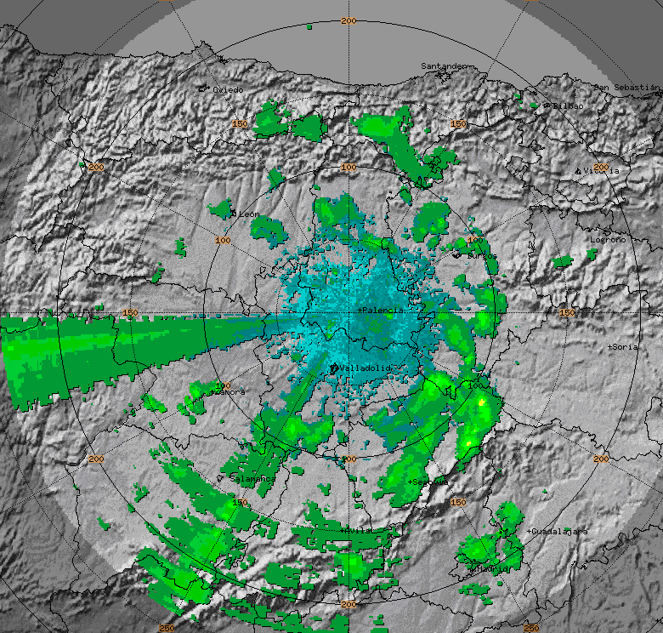

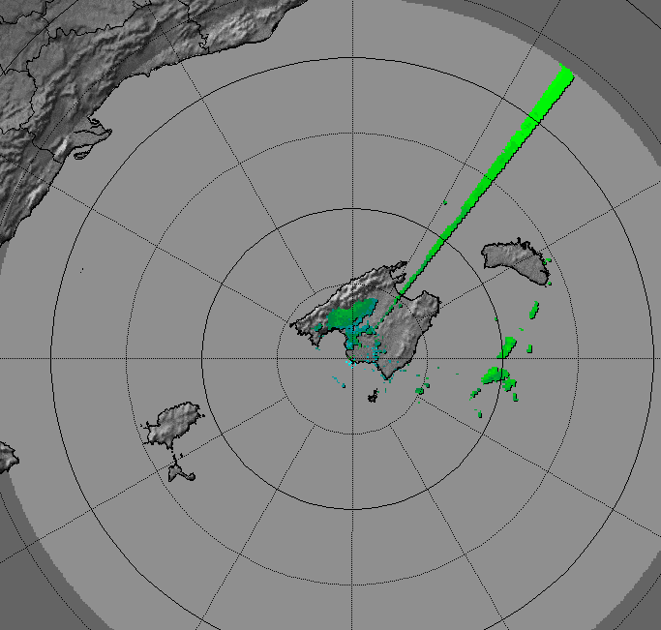

Belgium provided 3 snapshots

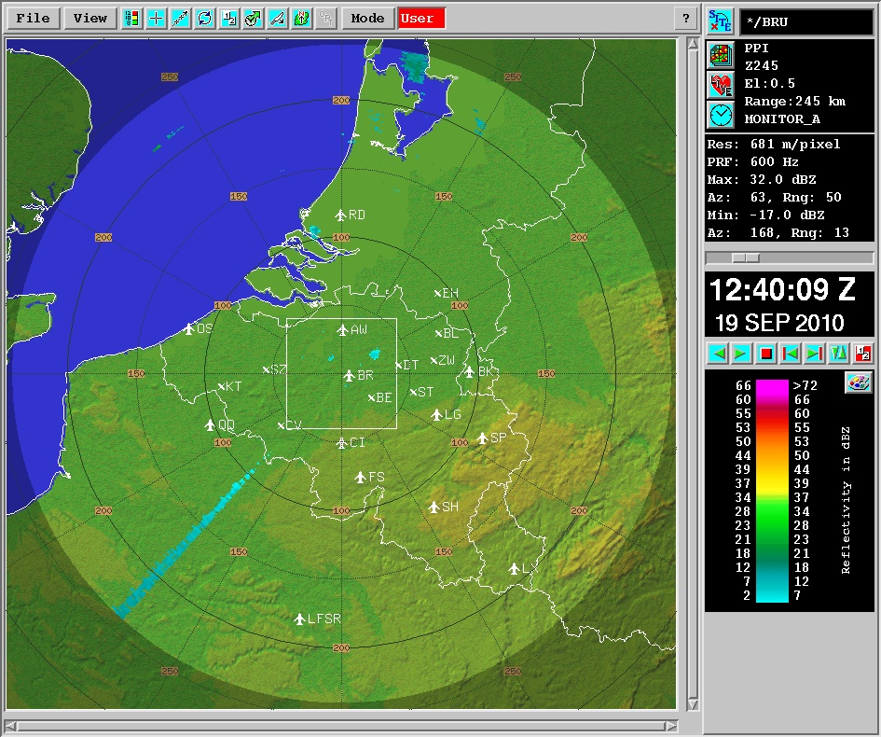
Radar with RLAN ON
Radar with RLAN OFF
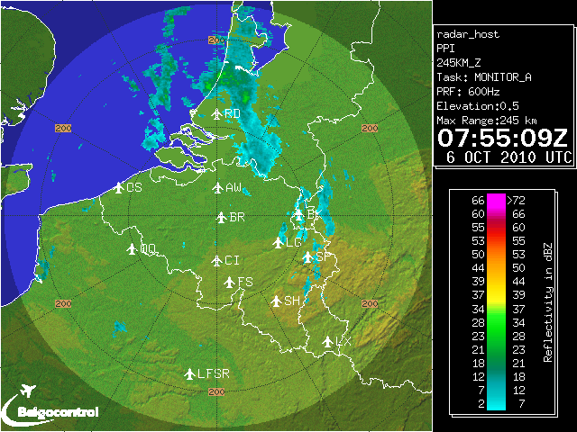

Distance between radar and RLAN : ~10km

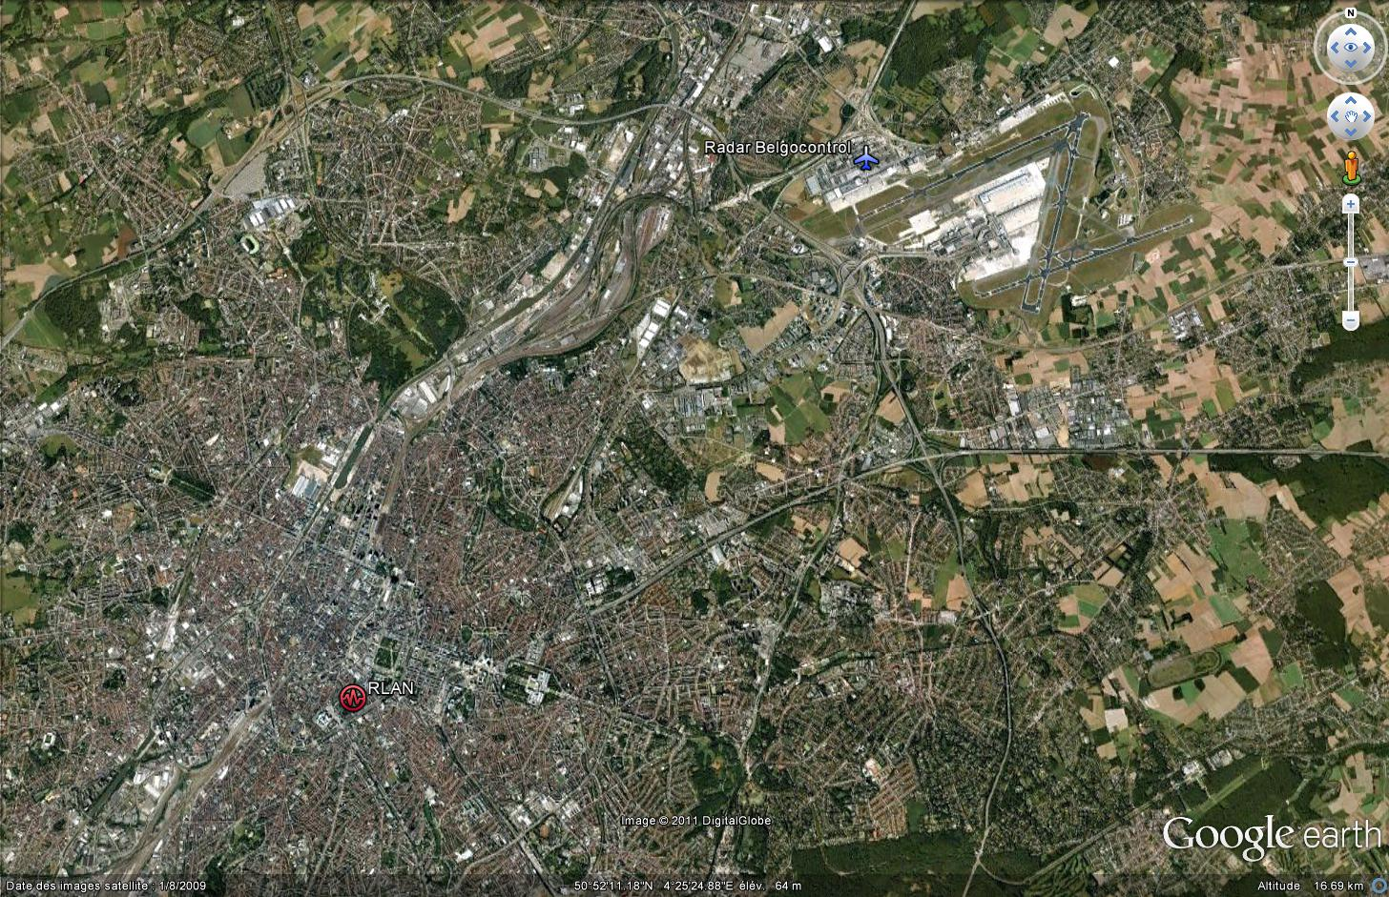

France
Straight lines observed on each illustration are the interferences caused by WAS/RLAN systems.

Latvia
Some examples of intereference to meteorological radar
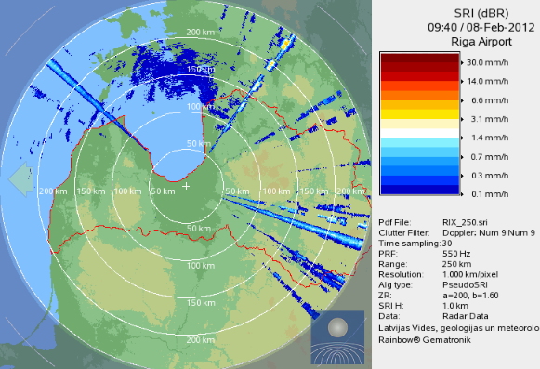

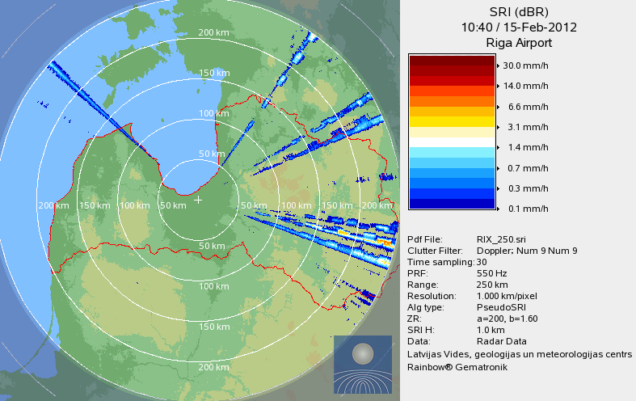

sITUATION AFTER ENFORCEMENT CAMPAIGN carried out during FEBRUARY/mARCH 2012
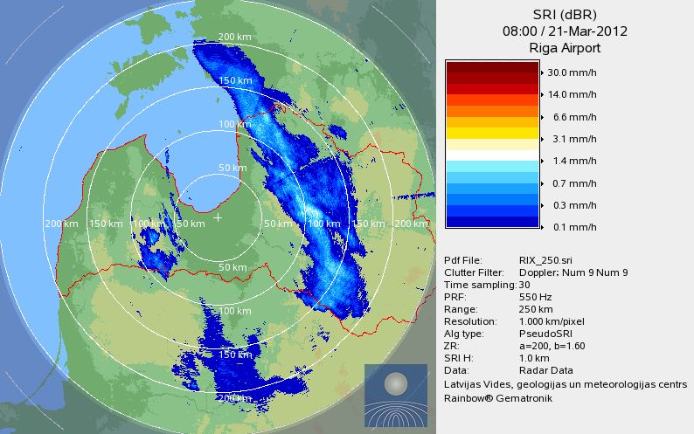

Spectrum of the meteorological radar (provided by Latvia)

Question 2 (in cases of several different interference cases, the box below could be used several times)
Was the WAS/RLAN/BFWA device operating co-channel with the radar? Please specify the operating frequencies of both interferer (WAS/RLAN/BFWA) and victim (radar) | The majority of the reported interference cases seem to be co-channel operation of the meteorological radar and the interfering device (WAS, RLAN, BFWA, or other):  Spain: 2 cases YES and 1 case NO  France: 4 different cases Yes and 3 different cases NO  UK: YES  Belgium: 1 case YES  Poland: YES (all cases)  Germany: Unknown. Due to the DFS mechanism the data base  contains only the frequency band.  Italy: YES (2 cases), 1 case nearly co-frequent  Czech Republic: YES  NL: YES, except one case where there was out of band  emissions by BFWA equipment, but meteo-radar has no  input filtering.  Slovak Republic: YES  Estonia: Yes  Hungary: Yes  Austria: YES  Latvia: YES , co-channel or overlapping
Radar operating frequency? | Spain: 5620 MHz (co-frequent interference case)  UK: 5600 – 5650 MHz  Belgium 5620 MHz  Poland: 5620-5680 MHz  France: 5630 MHz, 5627.5 MHz, 5635 MHz (2x),  5640 MHz (3x)  Italy: 5613 MHz, 5667,200 MHz – Bw 30 MHz  Czech Republic: 5630 MHz, 5645 MHz  Slovak Republic: 5600 MHz  Estonia: 5640 MHz  Hungary: 5610 MHz, 5625 MHz  Austria: 5625 MHz, 5600 MHz, 5640 MHz  Latvia: 5660 MHz  The problem exists mostly for the frequency range 5600-5650 MHz
WAS/RLAN/BFWA operating frequency? | (includes only the frequencies for the cases which were not co-frequent operations of the radar and the interfering device)  Spain: Frequency: 5500 MHz (victim on different frequency, The frequency 5500 MHz is the image frequency of the radar system (FRadar= 5620 MHz, FLO=5560 MHz and IF= 60 MHz) so the interference was produced by poor image frequency rejection.  UK: a bandwidth exceeding the 5600-5650 MHz  Belgium: 5200-5825 MHz Italy: 5680 MHz  Finland: close adjacent (overlapping) channel (only 10 MHz offset) at 5605/5615 MHz or radar image frequency

Question 3: What was the type of device/equipment that caused the interference?

The vast majority of proven interference cases are caused by outdoor operation of RLAN, wireless networks, links such as for wireless cameras, or BFWA.

 | Remarks
Individual Indoor RLAN device (private user)

Indoor RLAN network (office/enterprise/factory type of deployment)

Individual Outdoor WAS/RLAN/BFWA device | Czech Republic  Hungary (10% of all cases)  Austria  Latvia
Outdoor RLAN network, including Mesh networks, public networks, hotspot applications, … | Belgium: 1 case  Poland  France: Video surveillance equipment  (2 out of 11 interference cases)  Italy  Czech Republic  Hungary (20% of all cases)  Austria  Finland: See best documented ref:  2006.09.11 105SE(06)  The case we had inyear 2010 is almost similar but not documented in the same way.
Outdoor Point-to-Point link or BFWA | Spain: 3 cases  UK: 2 cases wireless cameras, 8 cases point to point links  France: 9 out of 11 interference cases  Czech Republic  NL: Wireless camera connections for police and security  Estonia  Hungary (70% of all cases)  Austria  Latvia
Other: …… | UK (14 cases): 1X cell phone enhancer,  1X mast head amplifier,  1 X Military radar,  1X military (unknown),  10 X not resolved and unknown transmitters.  Slovak Republic: Unknown, because interference had disappeared before it has been identified

Question 4: How was the interference case solved?

The responses received suggest that part of the problem is unlawful operation (DFS disabled, transmitter output power too high, etc.). In addition, the avoidance of co-channel operation by selecting a different operating channel has often been used.

 | Remarks
(Re-)Configuration of the WAS/RLAN/BFWA device (e.g. different operating channel) | Spain: 3 cases  UK: 5 of the 8 point to point links were retuned  2 of the 2 wireless cameras were retuned.  Poland (for all cases)  France: For 9 out of 11interference cases, the  operating frequency has been changed,  the frequency of the radar and two  adjacent channels have been put on the  blacklist  Italy: 1 case  Czech Republic YES  Netherlands: BFWA replaced by reseller.  Estonia YES  Hungary: indicated this as the preferred method  Finland: manual selection  Latvia: skipping channel
(Re-)Enabling DFS (in cases where DFS was disabled) | UK: 3 of the 8 point to point links had DFS re-enabled  France: when the DFS was disabled (3 out of 9 cases), it has been enabled. For 2 cases, this was not sufficient since the interference came back after few months of safe radar operation.  Czech Republic: Enabling DFS, however, sometimes the device interferes though DFS is enabled  NL (DFS enabled)  Austria: YES in all cases
Upgrading equipment (software/hardware) by vendor (to comply with later version of the standard) | France: For 1 equipment  NL (software upgrade or factory correction)  Latvia
Other: …… | UK: The 1X cell phone enhancer,  1X mast head amplifier,  1 X Military radar,  1X military (unknown) were all turned off or removed by the enforcement team.  10 X interference have not yet been solved  France: For one interference case, the power of the WLAN equipment has been decreased in order to solve the problem. The DFS (v1.4.1) was operational but it had no effect.  Belgium: Adjustment of the transmitter power  Italy: Change of radar operating frequency to 5577,200 MHz  NL (no further information)  Slovak Republic: Interference disappeared

Question 5: What is the version of EN 301 893/EN 302 502 to which compliance was declared?
Please check the standard version(s) that apply
EN 301 893 v 1.2.3  EN 301 893 v 1.3.1  EN 301 893 v 1.4.1  EN 301 893 v 1.5.1 RLANs  EN 302 502 v 1.1.1  EN 302 502 v 1.2.1 Fixed broadband data transmitting  “non-standard/illegal” | Spain, Belgium, Czech Republic: EN 301 893 V1.5.1  Spain, Czech Republic: EN 302 502 V1.2.1  UK: Remarks: This data was not collected for Wireless Access Systems.  The non-standard / illegal apparatus were;  2X military apparatus (non-standard),  1X mast head amplifier (unlawful) and  1X cell phone enhancer (unlawful)  No data: Poland, Germany, Finland  France: EN 301 893 V1.3.1 and V1.4.1 These answers are not exhaustive; the DFS version for some equipment wasn’t identified. For 1 case, the Standard version was not given in the documentation and neither the vendor nor the manufacturer was able/willing to provide the information.  NL: EN 301 893 V1.3.1  Estonia: EN 301 893 V1.4.1  Hungary: EN 301 893 V1.3.1, V1.4.1, and V1.5.1  Latvia: EN 301 893 V1.2.3, V1.3.1, 1.41 , and 1.5.1 as well as non-standard / illegal apparatus

Question 6: Was a Notified Body involved in the conformity assessment? (Can be checked by verifying the CE marking)

Was a Notified Body involved in the conformity assessment? | YES: Hungary, Spain, Belgium, Poland, France: only for some equipment (2 out of 11), Czech Republic, Netherlands (software update caused DFS to fail)  No data: UK, Germany, Italy  Estonia: No (for one specific equipment named in the response)  Austria, Finland: No  Latvia: in most cases only manufacturer’s declaration

Optional Questions:
The below are optional questions for which the answers may not always be known. However, if known, they may help to assess whether DFS, as defined in the harmonised standard, is adequate, or if additional measures are required to further improve the sharing of WAS/RLAN/BFWA and radars in the 5 GHz bands.
Questions 7 to 10 request details about the equipment that caused the interference.
Question 7: What is/are the operating frequency range(s) of the equipment?
Summary: Most cases concern the 5600-5650 MHz frequency range

- 5150-5250 MHz  - 5250-5350 MHz  - 5470-5725 MHz, INCLUDING 5600 – 5650 MHz  - 5470-5725 MHz, EXCLUDING 5600-5650 MHz  - 5725-5850 MHz | Austria, Hungary, Estonia Belgium, UK, Spain, Poland, France, Italy, Finland, Latvia: 5470-5725 MHz, INCLUDING 5600 – 5650 MHz (all cases)  Germany, Czech Republic: All these frequency ranges are involved  Netherlands: 5725-5850 MHz
Question 8: What type of antenna was used by the WAS/RLAN/BFWA device?
Summary: In almost all reported cases, directional or high gain directional antennas are used. Only Latvia reported also cases with omni directional antenna.

i. Omni directional antenna  ii. Directional antenna (patch, sector, …)  iii. High gain directional antenna (in case of P2P links) | Directional (Spain: 2 cases, Belgium 1 case, Poland)  High Gain (Spain 1 case, Poland)  UK: Either directional or high gain directional. The gain of the directional antenna was not recorded.  France: Directional and High Gain  Italy: directional  Czech Republic: direction and High Gain  NL: directional  Estonia: 14 dBi  Hungary: directional and high gain  Austria: directional or high gain directional  Finland: directional  Latvia: all cases

Question 9: Has the user the possibility to (re-)configure the equipment? (Please check all that apply):
Summary: User can often re-configure the equipment (country settings, DFS on/off, frequency selection)
Select a (different) country of operation (where other DFS rules might apply, or where no DFS is required. E.g. countries outside the EU) | YES:  Austria, Hungary, Estonia, Belgium, Poland, Czech Republic, Finland, Latvia  No:  Spain, Netherlands  No data:  UK, Germany, France, Italy
Alter or disable the DFS functionality (directly or indirectly), e.g. to avoid false DFS triggering. | YES  Austria, Hungary, Estonia, Belgium, Poland, France, Finland, Czech Republic, NL : (after software upgrade), Latvia  UK: 3 cases: point to point links had DFS re-enabled. Whether other devices had this facility was not recorded.  No  Spain  No data:  Germany, Italy
Select operating frequencies which are not allowed in your country | Yes  Hungary, Estonia, Belgium, Czech Republic, Finland Netherlands  NL (after software upgrade), Latvia  No  Spain, Austria  No data:  UK, Poland, Germany, France, Italy

Question 10: Verification/Testing performed?

Did you check/verify by testing the compliance of the product against the ETSI standard? | YES  Spain, Czech Republic, NL Hungary (only some)  Netherlands: field tested  UK: None as yet. However, the UK may take the opportunity to use the Met Office operational weather radar testing facility at Wardon Hill to undertake this testing in the near future.  No data or not checked: all others
For EN 301 893 v 1.5.1 compliant equipment, is the radar operational mode covered by any of the radar test signals in EN 301 893 v 1.5.1? | YES  Spain, Belgium, Czech Republic, Hungary  No data or not checked: all others
For EN 302 502 v 1.2.1 compliant equipment, is the radar operational mode covered by any of the radar test signals in EN 302 502 v 1.2.1? | YES  Spain, NL, Hungary  No data or not checked: all others

