|  |  |  |
| --- | --- | --- |
| WGSE PT45 meeting | | Doc. SE45(18)112R3 |
|  | | |
| Bonn, Germany, 10–12 December 2018 | | |
|  | | |
| Date issued: | 3 December 2018 | |
| Source: | 3dB, Alteros, Decawave, Hyundai, iRobot, Kia, Marquardt, Novelda, UbiSense, UWB Alliance, Zebra | |
| Subject: | Updated UWB studies | |
| Group membership required to read? (Y/N)  N | | |
|  | | |
| Summary: | | |
| This document proposes additional Monte Carlo studies for the UWB section of the report. | | |
| Proposal: | | |
| Invites Group to consider and insert the text in attachment in its CEPT report. | | |
| Background: | | |
| The proposed update to the UWB section includes a number of Monte Carlo in addition to the minimum coupling loss study that was previously presented. | | |

# Interference from RLAN into Ultra Wide Band (UWB) systems

## Introduction

Ultra-wideband (UWB) is a unique technology that can provide safe and secure wireless access services. Services include secure mobile transactions, vehicle access, and consumer ranging using devices such as smart phones, IoT connected devices, smart home devices, and industrial tags.

It is unique in that it provides the most precise locating capability using the least energy of any wireless technology. For example; a single coin cell can provide constant visibility for years.

UWB is unlicensed and coexists with all currently legal radio devices without causing or suffering interference. The installed base is greater than 2 million, and some of the installed base is already at 6.5 GHz centre frequency and cannot change. Market projections are 3.1 billion devices per year in 2025.

IEEE 802 is releasing a comment to the FCC NPRM in which coexistence concerns between UWB devices from 802.15 and the proposed 802.11ax devices, should they be allowed to operate in the 6GHZ range at the power levels proposed, were noted:

“IEEE 802.15 members are concerned about the ability of the new high-power broadband devices to coexist with the low power devices that use the current UWB and part 15.250 rule set. Currently there is no obvious resolution to the difference in power levels in the same band and IEEE 802 is aware that resolution to this problem must be determined.”

The 6 GHz band is critically important to the UWB industry because it is the one common band for UWB in the most countries including the the countries at accept ETSI standards as well as the Americas and including many Asian countries such as China as shown in the figure below:

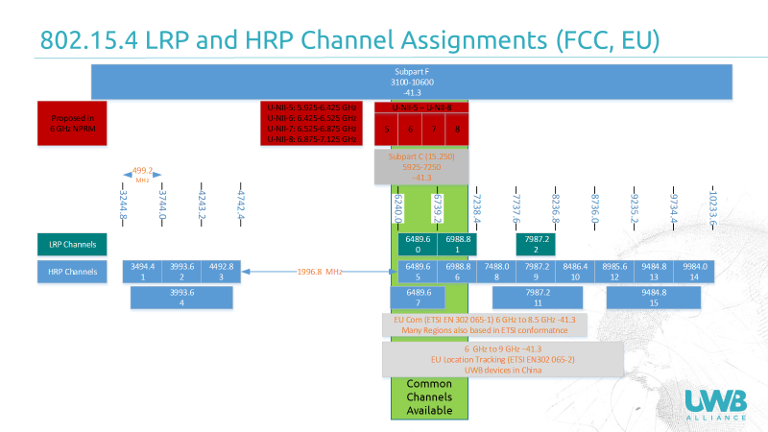

Figure 1: Proposed UNII and existing UWB channel assignments

Figure 1 shows the proposed U-NII bands, and UWB allocation in the EU, and the FCC. Additionally shown are the band plans for IEEE 802.15.4 UWB High Rate Pulse (HRP) and Low Rate Pulse (LRP) standards. These have been in place since 2006, and 2012 respectively. The figure also shows the FCC Wideband channel for FCC 15.250 for wideband systems. This is there because the UWB requirements in the USA are quite onerous, and so most manufacturers certify their equipment as wideband 15.250. This allows them to make devices that are unicast and thus have multi-year battery life powered with only a coin cell. The UWB rules in the USA still require the 20 second bidirectional response requirement that the ECC abandoned many years ago.

The final portion, shown in green, illustrates the common international band. As shown, the LRP bands which are intentionally aligned with the HRP bands align with LRP bands 0,1,and 2. But because of the subpart 15.250 rules the only common band is at band 0. This is the band that almost all manufacturers have chosen for their released and installed products. It allows the same product to be marketed throughout the EU, USA, China, and other parts of North and South America.

## Technical parameters

Ultra-wideband systems are short-range devices operating in the 6–8.5 GHz range with a minimum bandwidth of 50 MHz following ECC Decision (06)04 [54].

The characteristics of UWB systems and use cases used here are based on:

* ETSI TR 103 181-1, "Short Range Devices (SRD) using Ultra Wide Band (UWB); Technical Report - Part 1: UWB signal characteristics and overview CEPT/ECC and EC regulation " (V1.1.1, July 2015) [64];
* ETSI TR 103 181-2, " Short Range Devices (SRD) using Ultra Wide Band (UWB); Transmission characteristics - Part 2: UWB mitigation techniques" (V1.1.1, June 2014) [65].

The frequency range above 6 GHz is the most important frequency range for communications and location tracking applications and is the only band with international acceptance for UWB services. These frequencies are also important for sensor applications which are heavily dependent on the material properties for their use cases. The improved resolution and availability without mitigation techniques make the 6 GHz band attractive for these applications among others.

In this frequency range, UWB devices operate with a mean e.i.r.p. limited to -41.3 dBm/MHz. While the minimum bandwidth is 50 MHz, typical devices use bandwidths of 500 MHz or higher. Communication and location tracking devices typically use omnidirectional antennas. Sensing devices employ directional antennas, with typical antenna gains from 6 dBi.

Measurements performed for the compatibility studies here have shown that interfering signals with a level above -78 dBm, whether in a bandwidth of 40 or 160 MHz, at the receiver cause at least 3 dB degradation in the receiver sensitivity for communications and location tracking devices. For sensing applications, signal levels above -65 dBm cause more than 3 dB SNR degradation at the receiver.

The measurements demonstrate that the total interfering power in the UWB bandwidth determines the degradation of the UWB system performance.

Note that a degradation higher than 3 dB in link budget implies that the useful coverage area for the UWB link is at least halved, i.e. significantly impacting the performance of the UWB system.

## MCL studies for A single interferer

### Communication systems

A lot of the interest in UWB technology stems from the fact that the high bandwidth can be used for transmitting very high-data rate digital signals over relatively short ranges. High data rate communication of up to 500 Mbps over short distances up to 10 m can be achieved. Particularly in highly reflective, often industrial, environments, the wide bandwidth is attractive as it mitigates power variations due to multipath fading. UWB communications technology can therefore be found in a wide variety of environments, ranging from industrial and professional to office and consumer applications. In many regulatory environments, fixed outdoor transmitters are not allowed, so many UWB communications take place indoors. The high bandwidth and multipath resistance also makes UWB technology very successful for PMSE (Program making and special events) applications for professional wireless audio, providing an attractive solution to the loss of low-band spectrum for the operation of wireless microphone and other audio devices.

An overview of the technical characteristics of UWB systems is provided in ETSI TR 103 181-1. Most UWB communication applications are covered by ETSI EN 302 065-1 [66] and described in System Reference Document ETSI TR 101 994-1 [67]. Specific regulations exist for vehicular and railroad applications, covered by ETSI EN 302 065-3, and for applications on-board aircraft, subject of ETSI EN 302 065-5.

Previously, ECC Report 64 [68] considered the compatibility of RLAN and UWB systems. A reference distance of 36 cm between the UWB device and the RLAN terminal was considered, in combination with free space propagation and omnidirectional antennas.

Table 66 lists the separation distances for the various proposed RLAN transmit powers that limit the degradation to UWB sensitivity to 3 dB. Based on the results of the measurement campaign, it targets a total power level of -78 dBm coming from a single RLAN transmitter at the UWB victim receiver and assumes that the highest 160 MHz channel, centred at 6335 MHz is used.

Table 66: Separation distances resulting in 3 dB loss to UWB communications systems from RLAN transmitter

|  |  |
| --- | --- |
| RLAN e.i.r.p. transmit power | Separation distance |
| 1000 mW | 946 m |
| 250 mW | 473 m |
| 100 mW | 299 m |
| 50 mW | 212 m |
| 13 mW | 108 m |
| 1 mW | 30 m |
| Assumptions | |
| RLAN device | 1 transmitter, centred at 6335 MHz  -78 dBm total power at UWB receiver |
| UWB device | 3 dB sensitivity reduction |
| Propagation | Free space loss |

It is clear that these separation distances are orders of magnitude larger than the 36 cm assumed in ECC Report 64. Reducing these separation distances result in degradation of the UWB devices performance. To meet the separation distance of 36 cm results in an RLAN transmit power level of -38.4 dBm.

#### Example study regarding Wi-Fi Out of Band Emissions Impact on 6.5 GHz UWB Signal

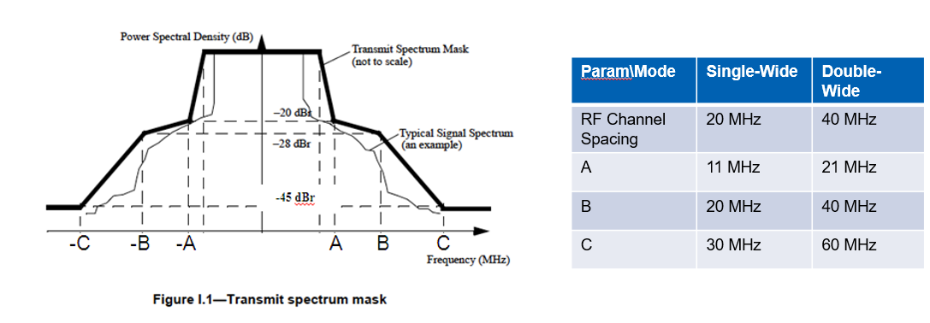

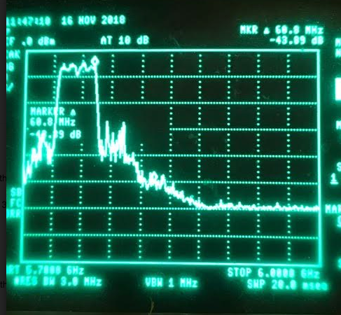Figure 3: IEEE 802.11 Out-of-Band Emissions (OOBE) requirement for OFDM transmissions

Figure 2: RLAN spectrum mask measurement

Figure 2 shows a spectrum analyzer capture of a double-wide OTA Wi-Fi transmission at 5 GHz. Observed OOBE is (barely) meeting 802.11 requirements, shown in Figure 3, and bottoms out at -55 dBr at fc +/- 120 MHz and beyond. The floor is most likely the spectrum analyzer’s noise floor.

For the analysis, it is assumed that the Wi-Fi transmissions with 20 MHz (40 MHz) channel spacing occur at Wi-Fi center frequencies that are at least 30 MHz (60 MHz) outside of the UWB band, so that any OOBE that hit the UWB band are at least 45 dB down from the peak PSD (see figure below)

It is also assumed (conservatively) that the shape of the noise PSD is flat so that the Wi-Fi OOBE can be modeled as AWGN that adds to the UWB receiver’s thermal noise floor (again see figure below)

A 6 dB UWB receiver noise figure, and Tx + Rx antenna gains of 0 dB are also assumed.

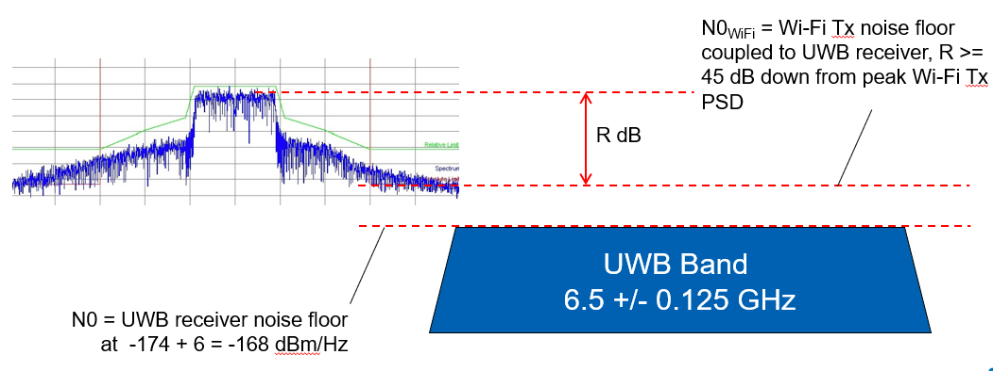

Figure 4: Noise floor analysis

The noise floor seen by UWB receiver due to an out-of-band Wi-Fi transmission is illustrated in Figure 4 and can be calculated as

N0WiFi = PTx – 10*log10(BW) – R – P(d), (formula (1))

where

* PTx = Wi-Fi device’s total transmit power in dBm.
* BW = Wi-Fi device’s Tx bandwidth = typically either 16.7 MHz or 33.3 MHz in US. The first two terms are the Tx PSD in dBm/Hz.
* R = level of attenuation (down from peak Tx PSD) of Wi-Fi OOBE, defined 2 slides back. Per 802.11 spectrum mask requirement, R is at least 45 dB. Our spec an capture of an actualy Wi-Fi transmission shows that 45 dB can be considered to be conservative. R = 55 dB is closer to reality for at least some Wi-Fi devices.
* P(d) = path loss in dB between W-iFi transmitter and UWB receiver. In this report path loss is computed using the Friis formula, using a path loss exponent of 2.0:

P(d) = 20*log10(4π/λ) + 20*log10(d),

And where d = distance in meters between UWB Rx and Wi-Fi transmitter, and λ = Tx wavelength in meters = c / 6.5 GHz.

How is a UWB receiver affected by an out-of-band double-wide Wi-Fi transmission of 14 dBm EIRP (typical for a Wi-Fi device) at 10 meters away?

Solution: Path loss P(10) between Wi-Fi transmitter and UWB receiver at distance 10 meters is

P(10) = 20*log10(4π/(c/6.5e9)) + 20*log10(10)

= 48.7 + 20 = 68.7 dB

Substituting P(10) into (1) yields an expression for the broadband noise level due to the Wi-Fi transmitter as seen by the UWB receiver:

N0WiFi = 14 - 10*log10(33.3 MHz) - R - P(10)

= -130 - R dBm/Hz

If the Wi-Fi Tx OOBE barely meets the 802.11 spec, then R = 45 dB and N0WiFi = -175 dBm/Hz.

The UWB receiver has a thermal noise floor of N0 = -168 dBm/Hz. The WiFi OOBE will add in RMS fashion to the thermal noise floor. Thus the total noise floor is

N0Tot = 10*log10[10-175/10 +10-168/10] = -167.2 dBm = -168 + 0.8 dBm

Result: The Wi-Fi OOBE coming from a 14 dBm WiFi mobile device 10 meters away will desensitize the UWB receiver by 0.8 dB. The impact on the range of the UWB link is 10-0.8/20 = 0.912 = about 9% less range than the interference-free case. A 3 dB loss of sensitivity would cause a 10-3/20 = 0.7071 = 30% UWB range impact; a 6 dB desense would cause a 50% range impact.

Using an approach very much like what was used in the previous example, a Matlab simulation was used to characterize UWB receiver range impact as a function of WiFi transmit power PTx, distance d and OOBE attenuation R. Results are summarized in Figure 5 below.

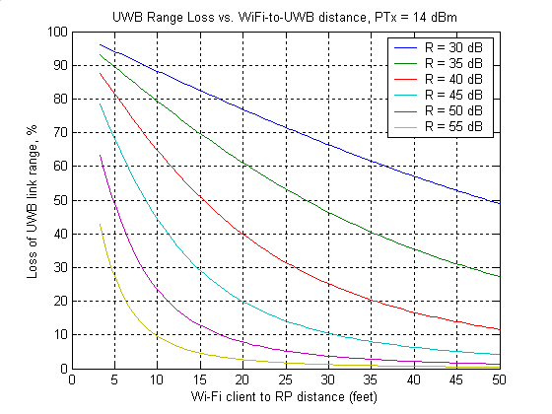

Figure 5: UWB range loss versus separation distance

Assuming Wi-Fi transmissions can be limited:

* in power to +14 dBm,
* in frequency to sufficiently outside of the UWB band so that their OOBE is attenuated by at least 45 dB relative to the peak Tx PSD per the 802.11 spec, and
* in distance to at most 30 feet from a UWB receiver

Then the impact on UWB link range is less than 10%. Not particularly severe.

Looking back at how the analysis was performed, one can trade off PTx and R “dB for dB” to explore different scenarios, for example:

* If OOBE can be limited to at most 55 dB from peak Tx PSD, the Wi-Fi Tx power can be increased to +24 dBm without causing more than a 10% UWB range impact at 30 feet.
* If Wi-Fi OOBE is exactly 45 dB and Wi-Fi Tx power is increased to +24 dBm at 30 ft distance, the impact on UWB range is significant – almost 50%.

It becomes clear that if any Wi-Fi transmissions occur inside the UWB band, the impact on UWB would be severe. This is because UWB link wouldn’t benefit from the R >= 45 dB attenuation it gets when Wi-Fi transmissions are kept out-of-band.

### Location tracking systems

UWB devices employ bandwidths of up to several GHz, thus allowing centimetre-level localization and positioning even in the presence of severe multipath effects caused by walls, furniture etc. In UWB location tracking sensors, small mobile or portable tags, operating as either transmitters or receivers or both, are attached to the objects to be located, or are carried by personnel within an area under surveillance. A network of fixed equipment around the area to be covered, communicate with the tags. The 2D/3D position of the tag can be found by analysing the time-of-arrival and/or angle-of-arrival of the radio signal relative to the known set of reference stations. Typically, the range between a tag and a reference station might be up to 200 m, depending on the area to be observed.

UWB is used within vehicles to prevent relay attacks in passive keyless entry systems. UWB services are also employed in a wide range of environments ranging from IoT connectivity to smart phones, to smart home connectivity, to industrial automation.

Location tracking type 1, LT1, is intended for applications in the frequency band from 6 GHz to 8.5 GHz for indoor, portable and mobile outdoor applications. These regulations were based on the System Reference Document ETSI TR 102 495-3 [69]. Passive keyless entry systems are described in System Reference Document ETSI TR 103 416 [70]. These systems typically offer localisation down to centimetre level accuracy.

ETSI TR 102 495-3 mentions typical ranges from tag to anchor between 10 and 100 metres over which the UWB system can achieve location accuracy below 10 cm.

Location tracking is achieved by an exchange of messages between UWB devices. The measurement campaign showed the same -78 dBm total power coming from a single RLAN transmitter at the UWB receiver resulting in 3 dB sensitivity loss. Hence, the results from Table 66 are equally valid for location tracking systems.

### Sensing applications

The UWB-band frequency range and large available bandwidth make UWB technology very well suited for sensing applications. These parameters enable fine range-resolution combined with good penetration capabilities at an affordable energy and Bill of Materials (BoM) cost budget. Most sensing applications are based on radiodetermination detecting various static or dynamic objects and their distance, position, speed etc. either measured from a remote distance or directly coupled to the object. These parameters are calculated based on a very precise and coherent time-of-flight measurement of a transmitted and reflected UWB pulse, enabling range and Doppler information with very high resolution and accuracy (mm-range).

Commercially available products based on such technology are found within industrial, digital health / medical and consumer markets including professional power tools for detecting obstacles in walls, presence sensors, vital-signs monitoring devices, and user interface sensors for portable / mobile consumer devices. In the past, most applications were found within professional segments, but recently the focus and market growth are mainly within high-volume markets like digital health, intelligent homes / buildings and consumer devices where the ability to securely and safely detecting human presence, position and vital signs is the main driver.

UWB sensing applications are operated in frequency bands from 3.1 GHz to 4.8 GHz and 6.0 GHz to 9.0 GHz for fixed (indoor only), mobile or portable use. As for communication devices, the technical characteristics of UWB sensing devices are described in ETSI TR 103 181-1 while their use are covered by the harmonized standards ETSI EN 302 065-1, ETSI EN 302 065-3, ETSI EN 302 065-4. More detailed descriptions of certain applications and use-cases may be found in System Reference Documents ETSI TR 103 313 [71] and ETSI TR 103 314 [72].

Table 67 lists the separation distances for the various proposed RLAN transmit powers that limit the degradation to UWB sensitivity to 3 dB. Based on the results of the measurements, it targets a total power level of -65 dBm coming from a single RLAN transmitter at the UWB victim receiver.

Table 67: Separation distances resulting in 3 dB loss to UWB sensor systems from RLAN transmitter

|  |  |
| --- | --- |
| RLAN e.i.r.p. transmit power | Separation distance |
| 1000 mW | 212 m |
| 250 mW | 106 m |
| 100 mW | 67 m |
| 50 mW | 47 m |
| 13 mW | 24 m |
| 1 mW | 7 m |
| Assumptions | |
| RLAN device | 1 transmitter, centred at 6335 MHz  -78 dBm total power at UWB receiver |
| UWB device | 3 dB sensitivity reduction |
| Propagation | Free space loss |

As many sensor systems have omnidirectional antennas, antenna gain compensation has not been included in the above table. Like Table 66, a centre frequency of 6335 MHz for the RLAN system is used.

## Monte Carlo studies for aggregate interference

### UWB apartment scenario

In a first aggregate interference scenario, the interference to an UWB receiver in an apartment block is considered.

The UWB victim receiver is located in an apartment block that is assumed to be 100 metres long, 16 metres wide and 10 floors high. Each individual apartment is 10 by 8 metres. Floors are assumed to be 3.5 metres high. On average, there are 3 people living in an apartment.

The UWB victim and the RLAN interferers are spread randomly throughout the building. Each person’s RLAN is active on average 1.97% of the time. Like before, a centre frequency of 6335 MHz for the RLAN system is used. RLAN power is randomly distributed according to weighted average RLAN e.i.r.p. from section 4.2.1.4.

The indoor path loss model from ITU R.1238-9 is used. According to the model, the path loss is given by

Ltotal = L(do) + N log10 + Lf  (n)                dB (1)

where:

N : distance power loss coefficient

f : frequency (MHz)

d : separation distance (m) between the base station and portable terminal (where d > 1 m)

do : reference distance (m)

L(do) : path loss at do (dB), for a reference distance do at 1 m, and assuming free‑space propagation L(do) = 20 log10 f −28 where f is in MHz

Lf  : floor penetration loss factor (dB)

n : number of floors between base station and portable terminal (n ≥ 0),   
Lf = 0 dB for n = 0.

The values for an apartment at 5.2 GHz come closest to our target frequency range and will be used, i.e. Lf = 13 dB and N=30.

The results of the Monte Carlo simulation are shown in Figure 87. The red line at -78 dBm correspond to the limits causing 3 dB sensitivity degradation to communication and location tracking systems. Similarly, the red line at -65 dBm shows the limit for sensing applications.

The limit for communications and location tracking devices is exceeded with a probability 15% while probability that the limit for sensing devices is exceeded is 3%.



Figure 6: Monte Carlo results UWB apartment scenario

### UWB London scenario

In this aggregate interference scenario, it is assumed that a random person in the city of London is trying to use an UWB receiver at their home.

Statistics of the total population and population density per borough are available from <https://data.london.gov.uk/dataset/london-borough-profiles>. A random borough is chosen with a probability proportional to its number of inhabitants.

Based on the results of the MCL studies, the UWB receiver is assumed to be at the centre of a 1 by 1 kilometre square. The square is randomly populated with people according to the population density of the chosen borough. At any moment in time, 1.97% of the population is assumed to have an active RLAN transmission. A centre frequency of 6335 MHz for the RLAN system is used. RLAN power is randomly distributed according to weighted average RLAN e.i.r.p. from section 4.2.1.4. The RLAN height distribution for sub-urban indoor homes from section 4.2.2 is used to distribute the RLAN randomly in height.

IEEE path loss model C is used. The model assumes that distance below 5 metres are line-of-sight and have a path loss exponent of 2. Beyond 5 metres, the link is assumed to be non-line-of-sight and the path loss exponent is increased to 3.5. Log-normal fading with a standard deviation of 4 for LOS and 5 for NLOS is assumed.

The results of the Monte Carlo simulation are shown in Figure 88 and Figure 89. The red line at -78 dBm correspond to the limits causing 3 dB sensitivity degradation to communication and location tracking systems. Similarly, the red line at -65 dBm shows the limit for sensing applications.

The results show a clear dependency on the number of nearby RLAN transmitters. Averaged over the entire city of London, probability that the limit for communications and location tracking devices is exceeded is 6% while the limit for sensing devices is exceeded with a probability of 3%. However, in the most densely populated borough of Islington, these values increase to 12% and 6% respectively.



Figure 7: Monte Carlo results UWB London scenario



Figure 8: Monte Carlo results UWB Islingon scenario

### UWB vehicular access scenario

In this section, UWB based vehicular access to a car parked outside an apartment block is considered.

The UWB victim is an UWB passive keyless entry unit, located on a car parked in the middle of the apartment block considered in section 12.4.1. The apartment block is assumed to be 100 metres long, 16 metres wide and 10 floors high. Each individual apartment is 10 by 8 metres. Floors are assumed to be 3.5 metres high. On average, there are 3 people living in an apartment.

The UWB victim and the RLAN interferers are spread randomly throughout the building. Each person’s RLAN is active on average 1.97% of the time. Like before, a centre frequency of 6335 MHz for the RLAN system is used. RLAN power is randomly distributed according to weighted average RLAN e.i.r.p. from section 4.2.1.4.

The indoor path loss model from ITU R.1238-9 is used. According to the model, the path loss is given by

Ltotal = L(do) + N log10 + Lf  (n)                dB (1)

where:

N : distance power loss coefficient

f : frequency (MHz)

d : separation distance (m) between the base station and portable terminal (where d > 1 m)

do : reference distance (m)

L(do) : path loss at do (dB), for a reference distance do at 1 m, and assuming free‑space propagation L(do) = 20 log10 f −28 where f is in MHz

Lf  : floor penetration loss factor (dB)

n : number of floors between base station and portable terminal (n ≥ 0),   
Lf = 0 dB for n = 0.

The values for an apartment at 5.2 GHz come closest to our target frequency range and will be used, i.e. Lf = 13 dB and N=30. Up to 13 dB wall attenuation is assumed.

UWB car access units are a form of UWB communications and location tracking devices. Therefore, only the limit at -78 dBm is evaluated. The figure shows that the probability that the limit is exceeded is 5%.



Figure 9: Monte Carlo results UWB vehicular access scenario

## [Summary]

Single interference scenario, minimum coupling loss study has shown that RLAN interferers up to 946 metres away cause more than 3 dB sensitivity reduction in UWB communications and location tracking systems. For sensing applications, the equivalent distance is 212 metres.

Aggregate interference evaluation with Monte Carlo simulations show that, assuming an RLAN duty cycle of 1.97%, the probability that the sensitivity reduction to UWB communications and location tracking devices exceeds 3 dB falls between 5 and 15%. For sensing device, the probability that the sensitivity reduction is more than 3 dB is between 3 and 6%.