|  |  |  |  |
| --- | --- | --- | --- |
|  | | | **Doc. (16) 12** |
|  | |  | |
|  | |  | |
|  | |  | |
| **Date issued:** | **30 March 2016** | | |
| **Source:** | **COM-ITU Chairman** | | |
| **Subject:** | **Guidance for COM-ITU document numbering** | | |

N

Password protection required? (Y/N)

|  |
| --- |
| **Summary:** |
| The document presents guidance for COM-ITU document numbering |
| **Proposal:** |
| For consideration |
| **Background:** |
|  |

**Introduction**

This document aims at facilitating access and increasing awareness for COM-ITU document numbering policy and streamlining document numbering across different Project Teams.

**Documents webpage**

COM-ITU Documents webpage is acessible through the link <http://www.cept.org/com-itu/groups/com-itu/client/meeting-documents>

Each calendar year includes a number of folders (one folder for each COM-ITU meeting).

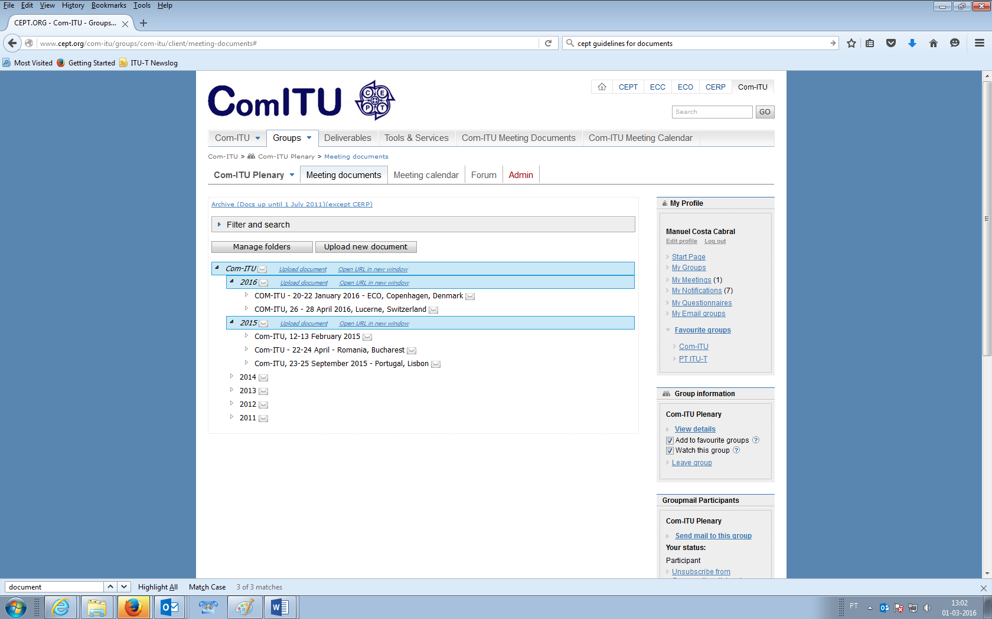

In addition to the documents for COM-ITU Plenary, Project Teams have their own area in the website.

Currently (March 2016) there is one Project Team active: PT ITU-T (<http://cept.org/com-itu/groups/com-itu/pt-itu-t>).

**Document numbering**

The table below clarifies the document numbering that it is used in COM-ITU Plenary meetings:

|  |  |  |  |
| --- | --- | --- | --- |
| Document Type | Description | Document Numbering | Notes |
| Invitation | Invitation to a COM-ITU meeting | No numbering | Subfolder for invitations: |
| Admistrative documents | Used for Administrative documents.  Examples: Agendas, Time plans, Reports, etc. | ADM X.  The number X is the sequencial number, starting in 01 each meeting.  Adding «REV» to revised versions | Reports will be saved under the corresponding meeting. Meaning that the report of the Lucerne Meeting will be saved on the Lucerne meeting folder.  Subfolder for Reports: |
| Contribution documents | Contributions provided by COM-ITU participants. Documents for consideration or approval. | (YY) XX.  The number YY in brackets represents the year in which the document was first published.  The number XX is the sequencial number, starting in 01 each calendar year.  Although a contribution to a meeting might be a revision of a contribution to a previous meeting, a new number will be assigned to the contribution in each meeting.  Adding «REV» to revised versions | A subfolder will be used to save:   1. Lastest versions of documents that were discussed and amended in the course of a COM-ITU meeting; 2. Multi-country proposals agreed by some participants during a COM-ITU meeting. |

|  |  |  |  |
| --- | --- | --- | --- |
| European Common proposals | Adopted ECPs | ECP/(EVENT)/X  EVENT: eg. WTSA16, WTDC17, PP18  The number X is the sequencial number, starting in 01 each Conference or Assembly. | Subfolder for Adopted ECPs (when needed): |
| Information documents | Documents used to provide relevant information to COM-ITU participants.  E.g.: Documents and Reports of ITU meetings; Letters from ITU to the Membership, Presentations, etc. | INFO X.  The number X is the sequencial number, starting in 01 each meeting. |  |

Note:

By **default**, all documents will be saved in the main folder of the corresponding meeting (except in the cases mentioned above, where a specific subfolder will be used).

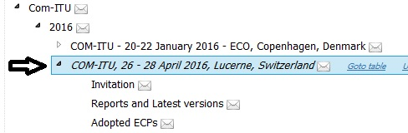

**Conclusion**

For consideration.

It is proposed that these guidelines are noted in order to be used in future COM-ITU meetings.

PT Chairs are adviced to follow a similar structure in future meetings (adding the acronym of the PT as a prefix. Eg.: PT ITU-T (16) 01; PT WTDC ADM 1).