CPG-15 PTD |  |  | CPG-PTD(15)043
CPG-15 PTD #9
Vilnius, Lithuania, 21-24 April 2015
Date issued: | 10 April 2015
Source: | GSMA
Subject: | 2.7-2.9 GHz band segmentation, radar spectrum efficiency, and compatibility between IMT and radars
N
Password protection required? (Y/N)

Summary:
This input contribution provides a study into 2.7-2.9 GHz band segmentation, including details on the spectrum efficiency of radars, the development of an illustrative frequency plan showing how existing radars could use the band more efficiently, and application of this to the existing radars in a radar-intensive case study area in the south of England. It also further investigates interference from IMT in the freed up spectrum into the radars.
The area used in the case study was selected because of the high density of radars in order to show that, if it is possible to use spectrum in the band more efficiently in this area, then the possibilities to use the spectrum more efficiently are even greater in areas/countries where there are fewer radars. The frequency plan developed is conservative and has ample spare capacity for changes in location of existing radars and for adding additional radars in the future.
Following investigation of the amount of spectrum required for the radars, the study investigates how much frequency separation will be required between IMT base stations in the freed up spectrum and the radars, and hence how much spectrum could potentially be made available for IMT / mobile broadband.
The study’s primary focus is on the feasibility of repacking radars into a portion of the 2.7-2.9 GHz band whilst, critically, still maintaining safe operation in respect of radar-to-radar interference, and providing for flexibility for changes and expansion. The study uses ‘real’ data and investigates required separations (both distance and frequency) for both the radar-to-radar and IMT-to-radar cases.

Proposal:
It is proposed that CEPT countries should have a free choice if they want to support the 2.7-2.9 GHz band identified for IMT at WRC-15, and hence CEPT should not have a ‘No Change’ ECP for this band.
Background:
The 2.7-2.9 GHz band is only lightly used in most countries in Europe and around the world, and offers a huge opportunity to use this spectrum much more efficiently. The band is an attractive option for IMT capacity enhancement, for example as an extension to the existing 2.6 GHz IMT band. One option to achieve this is band segmentation, with radars reallocated into the upper portion of the band, and the lower portion used for IMT, with suitable frequency separation between them.
2.7-2.9 GHz is being considered as a candidate band for WRC-15 agenda item 1.1. The band was originally placed in Category 2 in the Draft CEPT Brief, indicating that the band is “subject to further consideration”. At the 4th CPG meeting in March 2014, however, the band was downgraded to Category 3, despite sustained opposition to this course of action from a number of countries. There have been further inputs and discussions about this band at PTD and CPG meetings since then, and the 2.7-2.9 GHz band continues to be the subject of consideration and investigation within CEPT, hence the band should really be in Category 2.

Spectrum requirements for radar systems in the 2.7-2.9 GHz band - A UK-based case study on viability of band segmentation of the 2.7-2.9 GHz band between IMT and radars

Executive summary

This document provides a study into 2.7-2.9 GHz band segmentation, including an illustrative frequency plan showing how existing radars in this band could be repacked into a smaller amount of spectrum, and compatibility study between IMT and radars.
The case study of radar spectrum efficiency in Annex 1 of this document provides an illustrative frequency plan for a high number of radars located in a limited geographical area to be accommodated within 2.8-2.9 GHz. The frequency plan is based on a cellular concept and has taken into account the possible need for future changes and expansion. It has used a generic propagation model (P.452 smooth earth) to develop the initial frequency plan, followed by a specific terrain and clutter check that the plan is safe. The generic frequency plan shows that modern solid state radars are capable of co-existing in a smaller amount of spectrum than their predecessors.
The illustrative case study has demonstrated, using real world assumptions, that the existing radars in this densely packed region of the UK could be reallocated into no more than 100 MHz of spectrum when updated to solid state. Furthermore, if the frequency planning uses specific terrain and clutter details from the outset then further reduction in the amount of spectrum required for the radars is possible, perhaps by around 20 MHz. Such optimisation of the amount of spectrum used was however not the task of this study, and the illustrative frequency plan is capable of improvement without increased risk of interference or losing the flexibility for changes and expansion.
A number of previous studies have also concluded that greater spectral efficiency might be achieved by introduction of new radar technology. Technical changes are coming on stream now that would further ease the release of spectrum, including mitigation of both blocking and small signal leakage. Policy changes are also coming into effect in the UK that will add pressure on radar manufacturers and users to achieve greater spectral efficiency.
Earlier work has used very conservative assumptions about the levels of I/N ratio that can be applied to radar-to-radar interference. Given the nature of the tasks of these radars, a conservative approach is certainly valid. However the basis for such a conservative approach is technically weak, and there is a lot of evidence that more realistic I/N ratios would be much higher and provide much better spectral efficiency.
It is likely to be impractical to consider changing the frequencies used by marine radar systems above 2.9 GHz because of the international nature of the use of these bands. However, use of frequencies above 2.9 GHz remains viable for stations located away from the coast where the radars are capable of operation above 2.9 GHz.
Meteorological radars have not been included in this case study because there are no meteorological radars in the 2.7-2.9 GHz band in the UK. However such radars could be incorporated into frequency plans similar to the illustrative one presented in this document. It is understood that there are currently around 35 meteorological radars operating in S-band in Europe, many of which should be able to re-use the same frequency(s).
Given the above considerations, it is reasonable and realistic to assume that there could be a release of spectrum in S-Band (2.7-2.9 GHz) that could provide additional capacity for IMT and contribute to the more efficient use of radio frequency spectrum. The illustrative case study in this input contribution has demonstrated that it is possible to repack existing radars in the 2.7-2.9 GHz band into less than 100 MHz of spectrum, even in a region with a high density of radars, and in many countries much less spectrum would be needed.
The cellular approach used in this study can be scaled to fit lower deployment densities of radars and may also be used across borders where there is deployment of radars within a limited geographical area covering two or more countries.

Conclusions from compatibility study

Annex 2 of this document contains the study of interference of IMT downlink into radars
The study identified that the modern solid state radar is slightly more sensitive to interference from sources other than radar. This is because of a slightly increased sensitivity. The modern solid state radar is however far better at coping with offset frequency low level interference such that IF selectivity is not a limiting consideration.
The study also identified the two main interference mechanisms, one being the unwanted emissions from IMT base stations, and the other the radar receiver’s 1 dB compression point.
Although, at first glance, the unwanted emissions from IMT is by far the most prominent interference issue, the remedy for the radar receiver’s 1 dB compression point will provide for an easy solution for the reduction of the IMT unwanted emissions. To explain this; if we say that there should be an exclusion zone around a radar of (say) 1 km the requirements for the 1 dB compression point is not excessive, the critical points of the filter is its phase and amplitude loss/linearity in the pass band, this forces a less aggressive filter roll-off, i.e. more frequency separation towards the IMT base stations than otherwise would have been possible. A minimum roll-off of around 20 MHz would result and this of course also provides the same 20 MHz for IMT to reduce its unwanted emissions and it is expected that most equipment will meet the requirements off the shelf at this frequency separation; this of course needs to be verified or additional filters added to ensure the requirement is met within the radar’s operational band. For IMT unwanted emissions the required reduction is around 40 dB below the generic -30 dBm/MHz limit at more than 20 MHz frequency separation for an IMT macrocell base station operating at 1 km from a radar (30 dB reduction required for a microcell base station).
The requirement for the High Pass (HP) or Band Pass (BP) filter of the radar receiver is, in principle, not very demanding and is depending on the actual 1 dB compression point of the radar receiver. The 1 dB compression point for current generation radars is usually commercially sensitive and, therefore, difficult to obtain. Although it is also the case that the front end Low Noise Amplifiers, traditionally responsible for the system 1 dB compression point, are often bought in from specialist manufacturers. The 1 dB compression points of these subsystems are in the public domain but increasingly it is not the LNAs that are responsible for the 1 dB compression point. Scientifically, without compression no IM will occur so the important point is to match the filter attenuation with the actual compression value irrespective of where in the radar receiver this occurs. As an example the 1 dB compression point used in this study is -22 dBm plus the 6 dB aeronautical safety margin so effectively -28 dBm. At the level assumed in the study and with a 1 km exclusion zone, a reduction of only 3 - 4 dB is required plus any additional margin wanted. Assuming the filter used continues to roll off there is no significant risk of multiple interferers due to the close distance, the beam width of the radar antenna and the bandwidth of the IMT system.

General introduction
The study in Annex 1 of this document addresses one of the key issues that has not previously been addressed within any study of the band 2.7-2.9 GHz in the public domain. During preparations for WRC-15 a number of studies have been performed for the 2.7-2.9 GHz band in ITU-R and CEPT, making it one of the most studied bands during the process. The studies for this band can be roughly divided into two categories: studies assuming that IMT would operate alongside existing radars in the band on a ‘co-channel’ basis, and another group of studies assuming that a segmentation of the band would be made and therefore studying the compatibility between IMT and radars in adjacent frequency spectrum (separated by a guard band).
From previous discussions in CEPT and ITU-R it has been clear that the practicalities associated with implementation of band segmentation of the 2.7-2.9 GHz band were unclear and that this has been hindering consideration and discussion of this subject. One point often mentioned was the practicality of repacking the radars into a smaller piece of spectrum than is currently available.
This study’s primary focus is on the feasibility of repacking modern solid state radars into a part of the 2.7-2.9 GHz band whilst, critically, still maintaining safe operation in respect of radar-to-radar interference and providing for flexibility for changes and expansion. The study is using ‘real’ data and investigates required separations (distance and frequency) for both the radar-to-radar and IMT-to-radar cases.
To investigate the amount of spectrum required for safe operation of radars, a real geographic area is defined, selected and studied. The criteria for safe operation of radars are then investigated, in order that they can be applied to the re-packing of the radars in the 2.7-2.9 GHz band within the defined geographic area.
The study in Annex 2 investigates, in a more conventional way, the required frequency separations and geographical separations between existing radars and the IMT downlink for a suburban setting. The suburban environment is used because the frequency band 2.7-2.9 GHz is well suited to provide capacity for IMT in urban and suburban areas, whereas it is less likely to be used to provide rural coverage. This analysis does not consider the impact of some simple mitigation measures that could be applied, and the implications of such mitigation measures on frequency and geographic separations required for safe operation of the radars.
The geographical area selected for the case study in Annex 1 is a section of South-east England, and was chosen because it has a high density of radars. This area has a very high concentration of radars in the 2.7-2.9 GHz band, probably the highest in Europe. Using this geographical area makes it possible to establish the amount of spectrum required for all these radars, whilst still meeting the safety requirements in terms of radar-to-radar interference, for a real scenario which is one of the most challenging that could have been selected. This case study provides an indication of how much spectrum could be released for IMT (even in a country like the UK where there is a relatively large number of radars). Investigating an existing geographic area provides an opportunity to use real data for the radars to increase the accuracy of the study and its applicability to the real world.
Details of these studies are presented in annexes to this document:
- Annex 1 examines the spectrum efficiency of radars, and develops an illustrative frequency plan for repacking the existing radars in the case study area into a much smaller amount of spectrum. After first defining the geographical area and other aspects of the case study, and considering the criteria for safe operation of the radars, an illustrative frequency plan for the radars is developed.
- Annex 2 considers compatibility between IMT downlink and radars. Technical data and description of assumptions and methodology is followed by calculations based on MCL without antenna discrimination, and conversion into separation distances where the antenna discrimination is taken into account.

Annex 1. Spectrum Requirements for Radar Systems in the 2.7-2.9 GHz Band – A UK-Based Case Study

Introduction
This annex presents a case study based upon a part of the UK where radar density is very high, to illustrate that in future it will be possible to reduce the amount of spectrum required for radars in the 2.7-2.9 GHz band.

Geographic Considerations
In principle, it might be possible to develop an entirely synthetic scenario(s) to provide insight into the factors affecting the amount of spectrum that will be required by radars in the future. However, to provide credible results, such a scenario would need to be sufficiently rich in the practical problems that arise in the spectrum planning and management problem. The authors believed that to achieve this level of credibility would inevitably mean drawing on aspects of the real world. Therefore instead, it was decided to base the scenario on a real geographical situation. This approach may seem obvious but it is not without problems.
In any real world situation the number of radars in use in a given area is dynamic. There is a natural ebb and flow of radars in use as economic and military circumstances change. For example, a radar system may be removed from the band if an airfield is no longer economically viable. In such circumstances if the land is turned over to other purposes then there is no realistic likelihood of this being reversed. Whereas, new radars may be added if, for example, a new airport opens or the impact of a wind farm must be mitigated. Thus in a real-world scenario, the list of radars will inevitably become quickly out of date. But the authors believe this need not invalidate the approach, and the illustrative frequency plan developed in this document provides the necessary flexibility to be able to cope with such changes.
An important spectrum planning consideration is resilience and being able to adapt to changes. It is imperative that spectrum planning must not be so sensitive to change that addition of a new radar system makes the whole scheme untenable.
Having decided to base a scenario on real world geography it was then necessary to decide where that should be. For historical reasons S-Band has been used for radar since the earliest radar systems were developed and, therefore, use of the band is widespread throughout the world. However, in South Eastern England the density of radar systems is particularly great and it poses many spectrum planning challenges. Hence this area was chosen for the scenario.
The geographical area identified is formed by the southern coast of England and a three sided figure. The northern boundary of the figure is formed by latitude 53⁰ 05’ N. The western boundary is formed by longitude 3⁰ W. Vertices at 3⁰ W 51⁰ 28’N and 0⁰30’E define the third boundary. Figure A1.1 shows the geographical area selected for this case study.

The authors also appreciate that a further potential criticism of selecting a limited geographic region is that it may be considered an oversimplification of a more complex problem. In particular will the scenario take due account of the situation outside the boundaries of the scenario geography. This matter was considered and it was concluded that there is no perfect scenario. By choosing a location where it is believed the radar density is particularly high, it follows that densities outside this region are lower. Provided the scheme has in-built flexibility radars out of the region should be able to be accommodated.

However, the authors concede that the scenario is not perfect but it is believed that the scenario is good enough to demonstrate the principle that significant improvements in spectrum efficiency will be possible in the future without sacrificing safety which is always paramount.

Schedule of Radars
The baseline list of radars has been taken from the Ofcom Protected Radar List. The covering document for this list states: “The Protected Radar list will be re-issued from time to time”. This list represents the radars in service at a snapshot in time.

There are a total of 24 radar systems operating in the geographical area of interest. The radar systems and their locations are listed in Table A1.1.

Table A1.1
Radar Systems and Locations

Location | Radar Type | Model | Notes
 | Civil ATC | Marconi S511
  Bristol
 | Military ATC | Watchman | Subject to change by Project Marshall
  Yeovilton
 | Military ATC | Watchman | Subject to change by Project Marshall
  Portland
 | Civil ATC | SELEX-ATCR-44
  Bournemouth
 | Military ATC | Watchman | Subject to change by Project Marshall
  Boscombe
 | Military ATC | Watchman | Subject to change by Project Marshall
  Brize Norton
 | Military ATC | Watchman | Subject to change by Project Marshall
  Middle Wallop
 | Civil ATC | Watchman
  Southampton
 | Civil ATC | Unknown | Radar currently being replaced
  Oxford
 | Military ATC | Watchman | Subject to change by Project Marshall
  Benson
 | Military ATC | Watchman | Subject to change by Project Marshall
  Odiham
 | Civil ATC | Raytheon ASR-10
  Farnborough
 | Civil ATC | Raytheon ASR-10
  Heathrow
 | Civil ATC | Watchman
  Gatwick
 | Civil | AR-15
  Cambridge
 | Civil ATC | Raytheon ASR-10
  Stansted
 | Military ATC | Watchman | Subject to change by Project Marshall
  Marham
 | Military ATC | Raytheon GPN-20
  Lakenheath
 | Civil ATC | SELEX ATCR-44-S
  Southend
 | Military ATC | Watchman | Subject to change by Project Marshall
  Honington
 | Civil ATC | Raytheon ASR-10
  Norwich
 | NATS | Raytheon ASR-10
  Cromer
Manston | Civil ATC | Thales STAR 2000 | Airport currently not operational
Wittering | Mil ATC | Watchman | Subject to change by Project Martial

Figure A1.1

Radar Locations

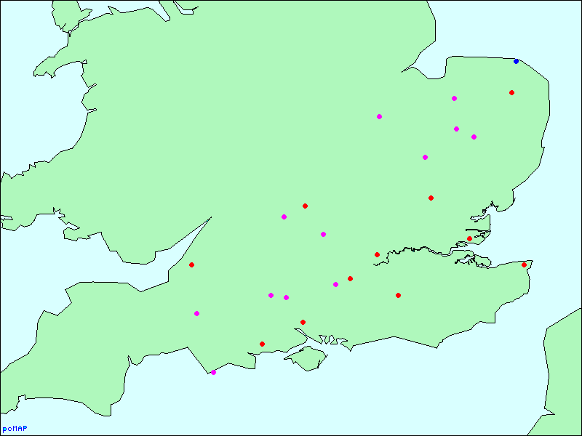
Military ATC
Civil ATC
NATS
Key

Radar types/sites considered but not included within the scenario

Air Defence Radars. The only fixed air defence site within the area of interest is at Remote Radar Head (RRH) Trimingham and the radar operating at this site is a new TPS-77 which has been provided for the purposes of wind farm mitigation. This radar operates in L-Band and hence is not of concern to this study. The general principle that Air Defence radars may be deployed to any sites on an as-required basis, for example to provide defence of special events was considered. However, Air Defence radars are required to be frequency agile as well as frequency diverse and have much greater flexibility to accommodate interference than civil radars. Hence it was considered that Air Defence radars could be accommodated by spare capacity in spectrum planning.

Animal and Plant Health Agency (APHA) Avian Radars. APHA operate a number of avian radars. These radars operate at both S-Band and X-Band. The radars are based on marine radar systems and operate above 3GHz and hence are not relevant for the purposes of this study.

Chilbolton Advanced Meteorological Radar (CAMRA) is present within the scenario geography but it operates on a fixed frequency of 3.0765 GHz. In the illustrative spectrum plan developed and described below the frequency separation between CAMRA and the other radars is greater than 100 MHz and no further special consideration has been given to CAMRA.

Wind Farm Mitigation In-Fill Radars. Wind farm mitigation radars can take a number of different forms. There are a number of examples in the UK where completely new, full scale, ATC radars have been purchased by the Wind Industry to mitigate wind farm effects on radars. For example, Robin Hood Airport Doncaster Sheffield and Glasgow Airport operate radars at Hibaldstow and Kincardine On Firth to mitigate wind farms effects. The wind farms in question, Keadby (and others that are almost co-located) and Whitelee are large wind farms. It is only these very large scale developments that can support the considerable investment of a new radar of these types. It is possible, albeit perhaps unlikely, that a development of that scale might take place in the South East of England but no specific radar for such a purpose has been included in the scenario. Should a radar for this purpose be required then it would need to be accounted for by any inherent flexibility in spectrum planning.

There are also smaller scale, in-fill, radars available for wind farm mitigation. These radars are low powered with short range. Of those currently being developed the only radar that would operate in S-Band is offered by C-Speed. There are no known deployments in the area of interest but if any were introduced in the future, it has been assumed that their low power will have a limited impact on the spectrum requirements, and the frequency plan is in any case flexible enough to accommodate them.

Test and Development Radars and Growth Capability. It is recognised that there is a requirement from time to time for Test and Development of radars. No particular consideration has been afforded to this in the case study, however there is also a requirement for growth, and the flexibility that has been built into the frequency plan should be sufficient to meet both these requirements.

Sensor Mix
The sensors in the schedule are representative of the UK as a whole including all of the following applications:

- Civil Terminal Manoeuvering Area (TMA)

- Military TMA

- One NATS En-Route

The current mix of radars in the scenario is typical of the rest of the UK. The list is dominated by the Watchman radar (10 military and 2 civil out of 24). These radars use Travelling Wave Tube (TWT) transmitters.

The Solid State Trend

The Project Marshall contract has been awarded by the Ministry of Defence to the Acquila consortium of National Air Traffic Services (NATS) and Thales. Over the course of the next seven years, 10 military radars within the scenario area will be replaced by State Of The Art Solid State radars. (Thales STAR 2000). It is worth noting that the reason stated for the replacement is that the new radars are more economical to operate than the older radars. This is a factor that would also be attractive to civilian operators.

A further 8 of the radars in this scenario are already modern solid state radars. Therefore, in the relatively near future 75% of the radars will be solid state radars.

The remaining radars have been in service for a long time and it might be anticipated that they will have to be replaced over the coming years. It is anticipated that these radars will also be replaced by solid state radars.

These changes are significant in terms of spectral efficiency. Numerous studies have reported on the benefits of solid state radar systems as a means of facilitating spectral efficiency.

Other Future Technology Trends

The study identified other new technology trends that will assist greater spectral efficiency in the future.

Amplifier Linearity

Low Noise Amplifier (LNA) linearity is improving. A vector for this trend is the introduction of new semiconductor materials. To illustrate the improvements foreseen, Figure A1.2 shows how the 1dB Compression Point has changed in recent years and the improvements foreseen over the next five years. Improved linearity will reduce radar susceptibility to blockage and saturation (described below).

Figure A1.2
1dB Compression Point of LNAs Trend

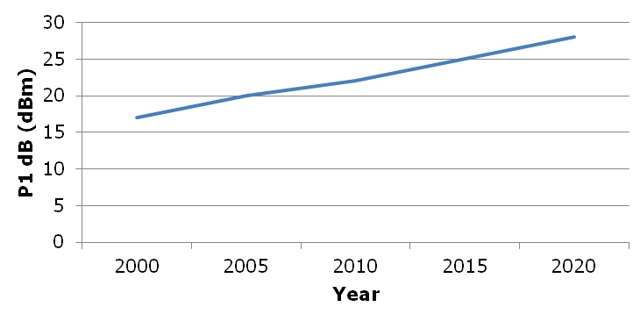

Improved Filter Design

There have been significant strides made in the development of filter technology. Figure 3 illustrates the level of performance that is currently achievable with filter designs.

For the near future the introduction of fabricated materials, in particular Metamaterials and Yttrium Iron Garnet, is now seen as a means of achieving even higher Q filter performance.

The improved performance of filter designs will facilitate the reduction in the size of guard bands between other services and radar systems and, perhaps a little later, improved in-band band pass filtering that will facilitate closer packing of similar services.

Policy Trends and the Future of Primary Radar
Both Primary and Secondary Surveillance radar systems have provided the backbone of air surveillance since World War 2. Prior to [US] 9-11, it would have been easy to foresee the transition away from Primary Surveillance to (Cooperative) Secondary Surveillance for many air surveillance roles. Secondary Surveillance is already more prevalent in Europe than it is in the UK. However, there are also differences between the way UK and Continental European Airspace is managed that lends itself to greater use of Secondary Surveillance. In particular, there is a greater use of controlled airspace adjacent to airfields in Continental Europe.

Figure A1.3
Band Pass Filter Performance

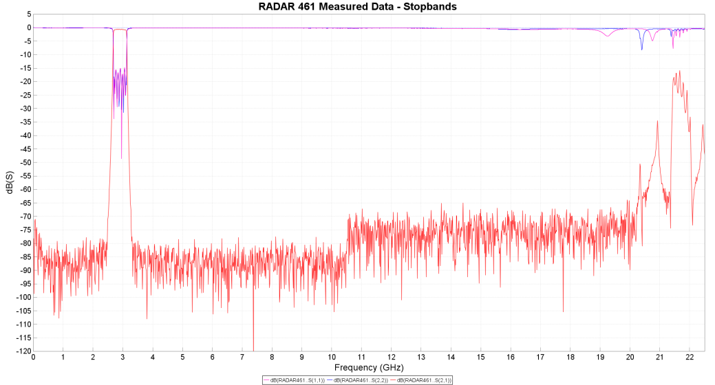

Notwithstanding these considerations, there have been and are various international initiatives that suggest that in the long term there will be a move away from primary surveillance. These initiatives have been given a new incentive owing to recent events which highlighted a significant shortcoming in present surveillance techniques i.e. they are limited to radar line of sight.

The simplest domain in which to employ alternative forms of surveillance, such as satellite based Automatic Dependent Surveillance Broadcast (ADS-B) would be in the en-route environment which may be followed by terminal environment. This is believed to become mandatory in most air spaces after 2020. Several other technologies are already in use like Multilateration (MLAT), Federal Aviation Administration (FAA) (in the context of a source of information or Flarm) which reduce but not eliminate the need for primary radar data.

Frequency Diversity

If the above factors reduce the requirement for spectrum there is another consideration that must be taken into account that limits the reduction possible in spectrum used by primary radar systems. This factor is the need for frequency diversity. Frequency diversity (not to be mistaken with frequency agility) mitigates the frequency sensitivity of Radar Cross Section (RCS) and multipath. The method works by switching transmitted frequency in a way that means every potential target is illuminated by more than one frequency. For example the rotational rate and beamwidth of a Watchman radar is such that each potential target will be illuminated by 18 consecutive pulses on each scan. The Watchman alternates transmitted frequencies every nine pulse repetition intervals (PRIs) to ensure that targets are illuminated by two different frequencies.

Frequency diversity has the same effect as reducing the target fluctuation and increasing the probability of detection. Ashton has demonstrated that frequency diversity provides an increase in signal to noise of at least 2.4dB (with higher probability of detection of targets). The minimum frequency separation to achieve this effect is 25 MHz. But pairings of 40MHz and higher are commonplace. Higher frequency separations provide better performance for smaller targets and it has been speculated that there may be a need in the future for frequency separations to increase to provide improved performance on targets such as microlights. This factor has been taken into account in the illustrative band plan described below.

Spectrum Policy Pressure

There are a number of international initiatives that are placing pressure on the spectrum:

- Within the UK, improving RF Equipment Standards and Performance is one of Ofcom’s seven ‘highest priority’ areas.

- The UK MOD is evaluating their spectrum use to limit amount of spectrum fees to spectrum they require for their operations and offload spectrum that is not essential.

- Within the EU, the Radio Equipment Directive requires both transmitters and, as a totally new requirement, also receivers to be spectrally efficient, i.e. sub-standard performance should not be used as an excuse for lack of compatibility with a new service in an adjacent band.

- In the US, the National Telecommunications and Information Agency (NTIA) is promulgating new transmitter spectrum emission masks to reduce spurious emissions.

Development of an Illustrative Spectrum Plan
In order to demonstrate that it might be feasible to reduce the spectrum required it was decided to develop an illustrative spectrum plan. The plan is not intended as a criticism of the existing band plan and certainly not of those who plan it. The spectrum has been managed safely and successfully over a long time. The aim of this plan is to show what might be achieved when it is possible to exploit new technologies that are coming on stream or already available.

Scenario Assumptions
The following assumptions have been made in developing an illustrative band plan:

Timeframe
Given all the above considerations it is assumed that the scenario is set a number of years into the future when it is assumed the radars have all been changed to become solid state radars such as the Thales STAR 2000, Raytheon ASR-10-SS or the SELEX ATCR-33-S.

Frequency Diversity
Each radar might require up to two frequency pairs for the purposes of frequency diversity. To accommodate possible future requirements a goal frequency separation was set of 50 MHz.

Frequency/Distance Separations
One of the studies that advocated adopting the principles of solid state technology set out the benefits of this technology by deriving graphs of Frequency/Distance spacing. This report was developed by BAe Systems, University College London, Cranfield University and Thales Air Systems. Hereafter this report is referred to as “The Spectral Efficiency Report”. See Figure A1.4
Figure A1.4
Frequency Re-use

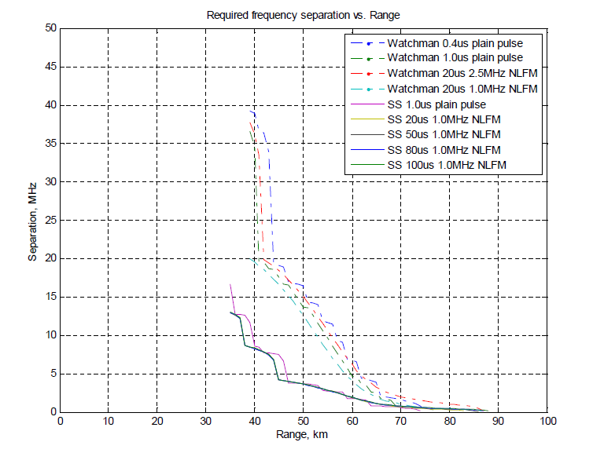

Special Cases
Some radars will continue to require multiple assignments within the band to provide additional resilience. For example, London Heathrow Airport and Cromer En-Route Radar, essential to the total London area air traffic management.

Method
The method adopted was based on the method used to allocate frequencies within a cellular radio base station network. This may not seem an obvious choice of method because if a new cellular network is being designed then there is some freedom to place base stations close to the middle of a cell and cell sizes are relatively small. By comparison there is an existing set of radar stations in the scenario which do not necessarily conform to a regular cellular pattern. However in practise these variations are also part of a cellular roll out and equivalent to cover for variation in population density, topography and practical arrangements for location of sites. Notwithstanding the obvious shortcomings this approach proved very useful in achieving a starting point for a frequency plan for radars.
A concept embodied in a cellular network is that cells are arranged in clusters. Each cell in a cluster has a frequency allocation different from the other cells in the cluster. The “pattern” of frequencies is repeated from cluster to cluster and depending on the size of a cluster a certain minimum frequency re-use distance is achieved.
Clusters have a number of cells. In this case a seven cell cluster was adopted. That is a central cell surrounded by six other cells. See Figure A1.4. Each cell contains a reference to 2 frequencies, the base frequency and the diverse pairing. For example the top cell in this cluster is designated 1/11. The numbers are a cross reference to a table of assignments. The table of assignments that was adopted for this illustrative plan is Table A1.1. Thus in this example the nominal frequency assignments are 2,800 MHz and 2.850 MHz.
The initial cell size chosen was 40km. This distance relates to Figure 4.3-36 in the Spectral Efficiency Report and is the distance associated with a frequency separation of 8MHz and separation distance of 40km for solid state radar waveforms. A pattern of 40km cell size was then overlaid on a map of the radar stations in the scenario. The resulting pattern showed that for all those cases where there was more than one radar within a cell there was an adjacent cell without a radar present. This offered the flexibility to assign frequencies satisfactorily and the resulting plan used 130MHz of spectrum but sadly also displayed a lot of underutilised spectrum and did not exploit re-use of frequencies well suggesting that the overall scheme was not as efficient as it might be.
Figure A1.4
Cluster Configuration

1/11
2/12
3/13
4/14
5/15
6/16
7/17

A second plan was then devised to determine if greater spectral efficiency could be achieved. This time the cell size was increased to 50km and the frequency separation set to 5MHz. The increase in cell size made little difference to the number of cells containing multiple radar stations but in this configuration the resulting plan used 100MHz of spectrum and a higher utilisation within this. As a proof of principle this concept was sufficient and not extended further. With additional work further spectrum savings could be made. It is important to recall this is illustrative and a proof of principle.
As was stated at the beginning of this section the cellular approach is only a start to development of a plan and the additional steps are described below.
The 50km cell size map is shown in Figure A1.5. The following features can be seen in this figure. The axes of the graph are calibrated in National Grid Easting and Northing. The red perimeter shown in the western, north western and northern sides of the area is the boundary of the scenario region. The hexagons are the cells and the coloured groups of cells are those cells in the same cluster. The blue symbols on the graph are radar stations. The red “radar” symbol is the location of Chilbolton.
Within each cluster, the initial frequency assignment of each radar station was taken from Table A1.1. The rationale behind this assignment table is described below.

Frequency Assignment Table
Table A1.1 lists the frequency assignments for a nominal 50km cell size. The frequencies are allocated a numeric reference corresponding to the numbers in the cell and, for convenience, a letter indicating how frequencies would normally be paired for the purposes of frequency diversity. Thus for example, a cell assigned frequency 1 would normally also be assigned frequency 11.
Table A1.1 has 10 groups of frequencies but only 7 are required for a strict correlation with clusters containing 7 cells. The remaining three pairs of frequencies are spare to the process and provide scope for flexibility to deal with the fact that the radars are already in existence and do not naturally conform to a cellular grid. The spare frequencies also allow multiple allocations at radars where greater frequency resilience is desirable, for example London Heathrow and Cromer En-Route Radar. Furthermore, the spare frequencies will allow for some growth in the radars using the band.

Table A1.1
Frequency Allocation Groups

Allocation Number | Allocation Group | Frequency (MHz)
1 | A |  | 2.800 | 2.801
2 | B |  | 2.805 | 2.806
3 | C |  | 2.810 | 2.811
4 | D |  | 2.815 | 2.816
5 | E |  | 2.820 | 2.821
6 | F |  | 2.825 | 2.826
7 | G |  | 2.830 | 2.831
8 | H |  | 2.835 | 2.836
9 | I |  | 2.840 | 2.841
10 | J |  | 2.845 | 2.846
11 | A |  | 2.850 | 2.851
12 | B |  | 2.855 | 2.856
13 | C |  | 2.860 | 2.861
14 | D |  | 2.865 | 2.866
15 | E |  | 2.870 | 2.871
16 | F |  | 2.875 | 2.876
17 | G |  | 2.880 | 2.881
18 | H |  | 2.885 | 2.886
19 | I |  | 2.890 | 2.891
20 | J |  | 2.895 | 2.896

Figure A1.5
50 km Cell Sizes Applied to the Scenario

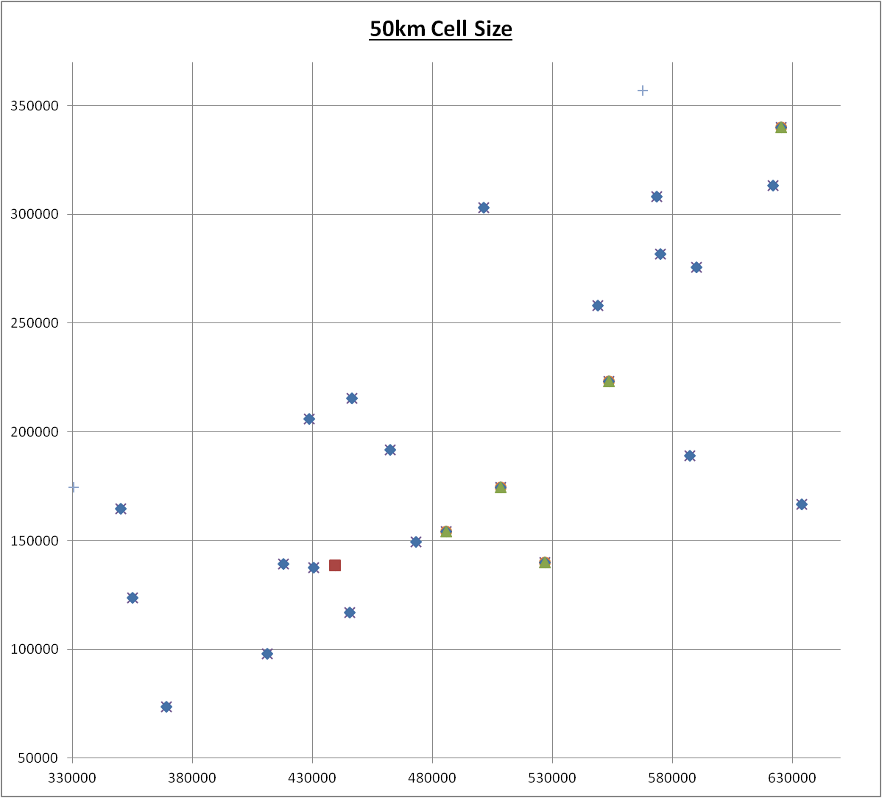

Two sets of constraints were then investigated: namely the frequency re-use distance and the nearest neighbour frequencies.

Frequency Re-use Distance
Once again, referring to Figure 4.3-36 in the Spectral Efficiency Report, a goal minimum frequency re-use distance was set at 100km. For every radar in the scenario, the frequency re-use distance was calculated (i.e. the distance to the next radar using the same frequency). On the initial pass a number of stations were less than 100km apart and frequencies were re-assigned to increase the re-use distances. After these changes were applied all the frequency re-use distances were greater than 100km except one pairing (Stansted and Manston) that was 98km. This result was considered acceptable.

Nearest Neighbour Frequencies
The distance between every radar station was calculated and pairs separated by less than 40km were investigated further. For each pairing with a separation distance less than 40km the path loss was calculated using ITU-R P.452 for both a smooth Earth (the basis upon which Figure 4.3-36 in the Spectral Efficiency Report was calculated) and using Ofcom’s 50m Terrain Model. With only three exceptions, the path loss was greater with the terrain modelled and the difference in loss was converted to an equivalent distance. Now in all but the aforementioned three cases the equivalent path length was greater than the goal of 40km.
The remaining three cases were as follows:

  - Cambridge to Lakenheath

  - RAF Benson to RAF Brize Norton

  - RAF Benson to Oxford Airport

The path loss in these three cases was then calculated using ITU-R P.1546 (Rural). In each case the equivalent distance exceeded the goal distance.
During the calculations for all the links (325) in this study we found a much closer correlation between a generic P1546 and P452 with terrain data than between P452 smooth earth and P452 with terrain data. Moreover, it was clear that if assigning frequencies with more spectrally efficient solid state radars was problematic, then it followed that the same or even worse problems must exist with the current radars in use. A former Senior Air Traffic Controller at RAF Benson was approached informally. He had no recollection of any interference problems at the station.

The Frequency Plan
Taking into account all the constraints identified a plan was created and this is listed in Table A1.2. The plan uses 100MHz of spectrum all of which is within the 2.8 to 2.9 GHz range. This amount of spectrum could be reduced further with further work.

Discussion
The frequency plan developed only considers radar-to-radar coordination and the issues of eliminating radar-to-radar interference. Other considerations that must be taken into account are the effects of adjacent spectrum users which, at the lower end of the spectrum, are not going to be radar systems.
A description of the interference mechanisms that affect radar systems follows. This description will provide:

- A background to the theory behind the scenario development,

- An insight into the considerations of communications systems to radar interference,

- An insight into possibilities for even greater spectral efficiency if more basic research work is carried out.

Table A1.2
Frequency Allocation Table

Interference Mechanisms in the S-Band Radars

Background
The purpose of the types of radar of interest to this study is to detect targets. The Probability of Detection (P_{D}) of a target of a given size, presenting with certain characteristics and the range at which it must be detected is one of the most important specifications for these radar systems. Figure A1.4 illustrates the block diagram of such a radar system.

Signals received by the radar antenna are directed to the radar receiver by a circulator. The signals are amplified and filtered in the receiver. The next stage of processing is carried out in the detector which must determine if targets are present. Within the detection process, signals are sampled, repeatedly, by Analogue to Digital Convertors (ADC). Each sample captures the signal amplitude (and usually phase) at fixed intervals of time after transmission by the radar. Therefore, the time of each new sample corresponds to an increasing distance from the radar to which a signal could have travelled and returned. Each sample, known as a range cell, will be tested to determine if a target is present.

Figure A1.6
A Typical Air Traffic Control Radar System

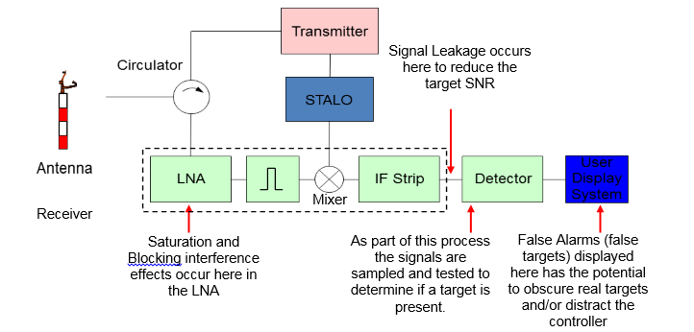

Each time a sample is tested there is an opportunity to detect a target but also it provides an opportunity to generate a false alarm. The Probability of False Alarm (P_{FA}) is the proportion of false alarms that can be tolerated which occur in a (large) ensemble of range measurements. If the testing process results in too many false alarms subsequent processing may be overloaded and real targets may be lost. If the false alarm rate is set too low then the radar may lack the sensitivity to detect real targets. Hence, the tolerance to P_{FA} is another important metric of radar performance. Typical values of P_{FA} are 10⁻⁵, 10⁻⁶, or 10⁻⁷.

Degradation of the Detection Process

The ability of a radar system to detect a target is degraded by the presence of noise. Noise arises naturally from many different sources including the radar systems own thermal noise, ambient or sky noise but also from man-made sources. In modern radar systems, the noise received at the antenna tends to be greater than that arising from internal (thermal) sources.

The unwanted emissions from telecommunications signals tend to present Continuous Wave (CW), CW-like or noise-like properties which appear to radar systems as elevated noise levels and, as such, they reduce Signal to Noise Ratio (SNR) of the targets. It follows that the presence of excessive levels of these signals could reduce the operational capability of a radar system. It is worth noting in this context, that ATC radars must meet certain minimum target detection criteria and a routine reduction in sensitivity would place at risk their ability to support Air Navigation Services. It is generally accepted, therefore, that a radar can only meet its required P_{D} for a given P_{FA} in the presence of lower than limiting Interference to Noise (I/N) ratio.

It is useful to consider the radar detection process in a little more detail. There are a number of distinct processes in signal detection:

  - Conversion of Intermediate Frequency (IF) signals to base band

  - Matched filtering and pulse compression

  - Determination of whether or not a target is present.

To determine if a target is present, the signal amplitude is compared with a threshold. In modern radar systems the threshold is calculated using a process that adapts to the ambient noise and clutter level, the process is designed to achieve a Constant False Alarm Rate (CFAR). The CFAR process calculates from signal levels in range cells adjacent to the cell being tested the average noise level in the vicinity of the target. From this average the threshold is computed.

CW, CW-like or noise like signals will be present across large numbers if not all range cells. Therefore, this effect causes the detection thresholds to rise, effectively desensitising the radar.

Whereas, a low duty cycle pulsed emitter will appear in fewer range samples with a reduced possibility of desensitising the radar.

Furthermore, the detection process is commonly followed by a process called binary integration. The binary integration processor only declares a target to be present when “M out of N” detections have been made. That is only if a return is seen at the same time (at the same range) after more than one transmission. Such processing provides a limited mitigation of interference from a CW signal but significant mitigation from interference from a pulsed emitter.

CFAR and binary integration are just two among other processes offering improvements in detection performance but they have also been developed in response to the prevailing situation whereby radars are all allocated to the blocks of spectrum separated in frequency from the spectrum allocated to telecommunications services. Therefore, radar system designs have traditionally had to incorporate systems to mitigate the effects of other radars but have not, until recently, had to mitigate the effects of unwanted emissions from telecommunications.

Interference Manifestation of Interference

The manifestation of interference by the two mechanisms is also very different in nature. Figure A1.6 illustrates how pulsed interference may be displayed. Even to the unskilled observer it will be clear that some level of interference of this nature is likely to be tolerable to a skilled operator.

It is impossible to be certain about the exact cause of the spurious points highlighted in Figure A1.6 but this is the form that interference may be seen. It is often the case that if the cause is interference they will tend to aggregate on or close to the bearing of the interference source.

Whereas, in the case of CW, CW-like or Noise like interference the effect is more insidious and targets may disappear from screens.

Figure A1.6

Interference Effects

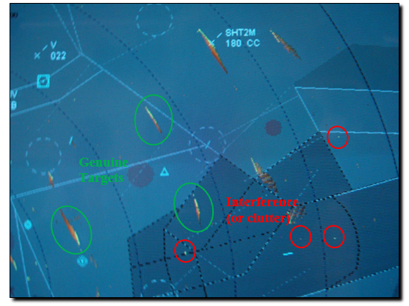

I/N Ratios and Different Classes of Emission
The relative performance benefits provided by these types of processing techniques compared with CW, CW-like and noise like emissions have been calculated amongst other by Sanders et al:

“1) Interference with communication-type signals degrades radar performance at interference-to noise (I/N) levels between -9 dB and -2 dB (well below the internal noise of the radar receivers). One radar lost targets at an I/N level of -10 dB, and I/N = -6 dB caused all but one of the radars to lose targets. Future improvements to weather radars are predicted to render them vulnerable at I/N levels as low as -14 dB.
2) In contrast to the effects of interference from communication signal modulations, pulsed interference at low duty cycles (less than about 1-3%) is tolerated at I/N ratios as high as +30 dB to +63 dB. In other words, the radar receivers that were tested performed very robustly in the presence of the type of signals that are transmitted by other radars. Radars tend to share spectrum well with other radars.”

The latter is also clearly demonstrated by the findings of “The Spectral Efficiency Report” mentioned earlier in this case study.

CW, CW-like and Noise-like Emissions
The radar type referred to in the first of these conclusions which suffered interference at an I/N ratio of -6dB is a short range ATC radar. Sanders et al go on to develop an argument for a threshold I/N value of -9dB. These recommendations are broadly consistent with recommendations promulgated by the ITU.

Conclusions

Numerous studies have concluded that greater spectral efficiency might be achieved by introduction of new radar technology. Technical changes are coming on stream now that would further ease the release of spectrum by mitigation of both blocking and small signal leakage. Such changes were predicted by earlier work but these predictions are proving to be valid.

Policy changes are coming into effect in the UK that adds pressure to radar manufacturers and users to achieve greater spectral efficiency.

Earlier work has used very conservative assumptions about the levels of I/N ratio that can be applied to radar-to-radar interference. Given the nature of the tasks of these radars a conservative approach is certainly valid. However, the basis for such a conservative approach is technically weak and there is a lot of evidence that more realistic I/N ratios would be much higher and provide much better spectral efficiency.

It is likely to be impractical to consider changing the frequencies used by marine radar systems because of the international nature of the use of these bands. However, greater use of frequencies greater than 2.9GHz remains viable for stations located away from the coast.

Given the above considerations it is reasonable and realistic to assume that there could be a release of spectrum in S-Band (2.7-2.9GHz) that could provide additional capacity for IMT and contribute to the more efficient use of radio frequency spectrum. The illustrative case study in this annex has demonstrated that in a densely packed region based on real world assumptions it is possible to pack radars into 100MHz of spectrum or less.

The cellular approach used in this study can be scaled down to fit lower deployment densities of radar and may also be used across borders where there are deployment of radars within a limited geographical area covering two or more countries.

If all the individual links are recalculated using real terrain/clutter data, rather than a generic smooth earth, further spectrum efficiency could be achieved without endangering the safe operation of the radars. This is because the cell sizes can be reduced and in many cases it will be possible to ‘borrow’ frequencies from empty adjacent cells to a cell that has more than one radar. Indications during the work on this case study for the high density of radars in the south of England point towards a figure around 80 MHz being required to obtain the same level of operational safety, flexibility for expansion and changes as was achieved using the generic smooth earth propagation model in this case study.

Glossary

ADC Analogue to Digital Converter
ADS-B Automatic Dependent Surveillance Broadcast
ANSP Air Navigation Service Provider
APHA Animal and Plant Health Agency
ASR Air Surveillance Radar
ATC Air Traffic Control
ATCR Air Traffic Control Radar
BP Band Pass
CAA Civil Aviation Authority
CAMRA Chilbolton Advanced Meteorological Radar
CFAR Constant False Alarm Rate
CW Continuous Wave
FAA Federal Aviation Administration
GA General Aviation
HP High Pass
IATA International Air Transport Association
IF Intermediate Frequency
LNA Low Noise Amplifier
MLAT Multilateration
NATS National Air Traffic Services (UK)
NTIA National Telecommunications and Information Agency
P_{D} Probability of Detection
P_{FA} Probability of False Alarm
PRI Pulse Repetition Interval
RCS Radar Cross Section
RRH Remote Radar Head
SNR Signal to Noise Ratio
STALO Stable Local Oscillator
TMA Terminal Manoeuvering Area
TWT Travelling Wave Tube

Annex 2. Study of interference from IMT downlink into radar

A2.0 Introduction

This Annex provides calculations of isolation requirements and separation distances between IMT base stations and radar systems for the case study scenario described in Annex 1. The calculations are using characteristics of real radars used in the UK, however it has not yet been possible to complete these calculations for all radar types due to missing information, and calculations to date are mainly for ‘Watchman’ and ASR-10 radars, which is the most common type of radar used in this band in the UK. It is assumed that the ASR-10 is a good representation of a modern solid state type radar and Watchman for a TWT type radar, and that only very minor variations by other brands of radars under these types would occur. These calculations do not take account of possible mitigation measures that may be applied to IMT base stations and/or radars.

A2.1 Technical characteristics

A2.1.1 Radar types and technical characteristics
The following radar types and the associated technical characteristics are contained in Table A2.1
Table A2.1
Radar Parameter |  | Unit | Radar
Transmitter |  |  | Siemens Plessey  Watchman | Raytheon ASR-10 | Thales STAR 2000
Power to the antenna |  | dBW | 47.8 | 39.6, 42.6 or 45.6
 |  | dBm/MHz
3 dB emission bandwidth |  | MHz |  | 1.25
Rec. ITU-R SM.329/1541 spurious emission limits |  | dBc
 |  | dBm
 |  | dBm/MHz
Pulse length |  | µs | 0.4/20
Pulse repetition rate |  | Hz | 1100
Receiver
Noise Figure (system) |  | dB | 2.9 | 2.9
3 dB RF bandwidth LNA |  | MHz | ˃400 | >400
RX HP filter roll off
3 dB bandwidth (total RX) |  | MHz | 2.5 | 1.25
Receiver sensitivity |  | dBm
 |  | dBm/MHz | −111.1 | -111.1
Required I/N |  | dB | -10
1 dB compression point |  | dBm | -22 | -22
IM3 intercept point |  | dBm
Antenna
Pattern |  |  | Cosecant squared/parabolic reflector
Polarization |  |  | Linear horizontal/Circular/Mixed
Gain |  | dBi | 33.8 | 34.5 | 34.3
‘Plumbing loss’ conservative (see Table A2.2) |  | dB | 4.1
Azimuthal beamwidth |  | degrees | 1.5
Back lobe gain approximately |  | dBi | -40
Side lobe gain approximately |  | dBi | -25 to -30
Rotation |  | Rpm | 15
Location |  |  | Ground
Nominal height |  | m | 15
Aeronautical safety factor for ATC |  | dB | 6
Attenuation of interfering signal by radar IF selectivity assuming guardband of | 20 MHz | dB | 93.9 | 117.1
 | 30 MHz | dB | 106.0 | 129.5
 | 40 MHz | dB | 114.9 | 138.4

The radar IF selectivity parameters have been added to the above table. A selectivity roll-off of 80 dB per decade from the radar 3 dB bandwidth has been assumed as suggested by Recommendation ITU-R M.1461-1 (end of Section 3.2). Also a guardband of between 20 and 40 MHz has been assumed between the radar and IMT system channel edges, and an IMT system bandwidth of 10 MHz.
Table A2.2
Radar ‘Plumbing loss and associated losses’

Plumbing loss | Unit | Skolnik | Example of ideal radar installation
100ft of RG-113/U Aluminium Wave Guide | dB | 1 | 0.5
Duplexer and Associated Devices | dB | 2 | 1.5
Rotary Joint (in the antenna) | dB | 0.8 | 0.3
Connectors and bends in the wave guide | dB | 0.3 | 0.2
Other RF devices in the feed | dB | 0.4 | 0.2
HP filter ‘remediation’ | dB |  | 0.5
LNA mismatch loss |  |  | 0.8
Antenna mismatch pointing loss, not taken into account for interference |  |  | (1.6)
Antenna resistive loss | dB | 0.1 | 0.1
Total Feeder loss (without pointing loss) | dB | 4.6 | 4.1

Table A2.3
Radar relative antenna gain

Relative radar antenna gain
Main beam |  | Aux beam
Elevation º | Relative gain dB | Elevation º | Relative gain dB
3 | -0.1 | 3 | -5.4
2 | -1 | 2 | -9.5
1 | -2.5 | 1 | -14.3
0 | -5.4 | 0 | -17.5
-1 | -9.5 | -1 | -19.8
-2 | -14.3 | -2 | -23.2
-3 | -17.5 | -3 | -25.7
-4 | -19.8 | -4 | -27
-5 | -23.2 | -5 | -28.1
-6 | -25.7 | -6 | -29.1

The technical characteristics of the new U-LNA used in connection with the ‘remediation programme’ to allow for the filter insertion loss in table A2.4 below.
Table A2.4
Radar LNA characteristics

Parameter | Unit | Value
Frequency range | GHz | 2.7 – 3.1
Gain | dB | 35 ±1
Gain Flatness | dB max | ±0.5
Gain variation vs. temperature max | dB pp/30Cº | 2
Maximum Input Power, CW | W | 2
Maximum Input Power, spike | W | 2
Output 3rd order intercept point, | dBm | 22
Output power (1 dB compression Point), | dBm | >18
Noise Figure, NF max | dB | <1
Phase Linearity | Degree/10 MHz | < ±0.2
Input | VSWR | < 1.5 : 1
Output | VSWR | < 1.5 : 1

Figure A1

Radar time domain susceptibility ‘side lobes’

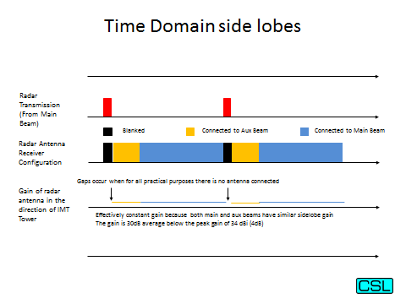

Figure A2

Radar time domain susceptibility ‘bore sight’

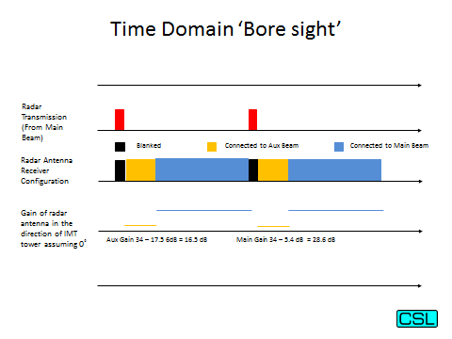

A2.1.2 IMT system
The technical characteristics of the IMT system are described in this section for the base stations (macrocell and microcell) and the UE characteristics.

A2.1.2.1 Base station
The base station characteristics shown in Table A2.5 are based on the suburban macrocell characteristics. A bandwidth of 10 MHz has been used.
Table A2.5
IMT base station characteristics
Base station |  | Units | LTE
Downlink frequency |  | MHz | 2 800
Bandwidth |  | MHz | 10
Maximum transmitter power | BW=5 MHz | dBm  dBm/MHz | 43
Maximum transmitter power | BW = 10 MHz | dBm  dBm/MHz | 46
Maximum transmitter power | Power density | dBm  dBm/MHz | 36
Spurious emission limits | limit | dBm/MHz | −30
Max antenna gain (3-sector sites assumed for macro) |  | dBi | 16
Feeder loss |  | dB | 3
Antenna height |  | m | 25
Antenna down tilt |  | Degrees | 6
Antenna type |  |  | Sectoral (3 sectors)
Antenna pattern |  |  | Rec. ITU-R F.1336-3
Polarization |  |  | ±45° cross-polarized
3 dB antenna aperture in elevation |  | Degrees | 12
3 dB antenna aperture in azimuth |  | Degrees | 65
Receiver noise figure (worst case) |  | dB | 5
Receiver thermal noise level | BW = 5 MHz | dBm  dBm/MHz | −102
Receiver thermal noise level | BW = 10 MHz | dBm  dBm/MHz | −99
Receiver thermal noise level | Power density | dBm  dBm/MHz | −109
Required I/N |  | dB | −6

A2.1.2.2 Microcells
The microcell base station characteristics are shown in Table A2.6. A bandwidth of 10 MHz has been used for this analysis.
Table A2.6
Microcell base station characteristics
Base Station |  |  | Units | LTE
Downlink frequency |  |  | MHz | 2 800
Bandwidth |  |  | MHz | 10
Maximum transmitter power |  | BW = 10 MHz | dBm | 35
 |  | Power density | dBm/MHz | 25
Spurious emission limits |  | limit | dBm/MHz | −30
Max antenna gain |  |  | dBi | 5
Feeder loss |  |  | dB | N/A
Antenna height |  |  | m | 6
Antenna down tilt |  |  | Degrees | N/A
Antenna type |  |  |  | Omni
Antenna pattern |  |  |  | Rec. ITU-R F.1336-3
Polarization |  |  |  | Linear
3 dB antenna aperture in elevation |  |  | Degrees | 34
3 dB antenna aperture in azimuth |  |  | Degrees | 360
Receiver noise figure (worst case) |  |  | dB | 5
Receiver thermal noise level | BW = 5 MHz |  | dBm  dBm/MHz | −102
Receiver thermal noise level | BW = 10 MHz |  | dBm  dBm/MHz | −99
Receiver thermal noise level | Power density |  | dBm  dBm/MHz | −109
Required I/N |  |  | dB | −6

A2.1.2.3 User equipment (UE)
The UE characteristics are shown in Table A2.7. A bandwidth of 10 MHz has been used for the IMT system.
Table A2.7
IMT UE characteristics
Mobile station |  | Units | LTE
Downlink frequency |  | MHz | 2 800
Bandwidth |  | MHz | 10
Maximum transmitter power |  | dBm | 23
 |  | dBm/MHz | 13
Antenna gain |  | dBi | −3
Antenna height |  | m | 1.5
Antenna type |  |  | Omnidirectional
Polarization |  |  | Linear
Body loss |  | dB | 4
Spurious emission limits |  | dBm/MHz | −30
Receiver noise figure (worst case) |  | dB | 9
Receiver thermal noise level | BW = 10 MHz | dBm  dBm/MHz | −95
Receiver thermal noise level | Power density | dBm  dBm/MHz | −105
Required I/N |  | dB | −6

A2.2 Analysis
In this section the assumptions, methodology, calculations and results are described for the deterministic analysis of adjacent channel compatibility of IMT base stations and UEs with radar systems both for the ‘baseline’ case based on the technical characteristic outlined in Section A2.1.

A.2.2.1 Assumptions
In addition to the assumptions described in Section A2.1, the following assumptions apply.
- The calculations are based on the impact of a single interferer on a single victim.
- IMT in this frequency band is assumed to be deployed in urban or suburban areas.
- Maximum transmission power is assumed
- A polarisation loss of 3 dB applies for base stations due to the difference in polarisation to radars.
- P 452 is used to calculate propagation losses for radar to radar, calculations has been performed both as sooth earth and using Ofcom’s 50 m terrain and clutter data base.
- For IMT to radar both P452 0.1 % and P1546 1 % has been used, see justification below
- For distances less than 10 km rural setting and no clutter has been used because of the antenna heights

It should be noted that during the calculations for radar to radar where we calculated the links between the individual radars using P452, 0.1 % time, smooth earth and then again with Ofcom’s 50 m terrain and clutter data base that we found a much better correlation between P452 with terrain data and a generic P1546 than between P452 with terrain data and P452 smooth earth. Hence the values for a generic case using P1546 have more relation to the real world. It is however recommended to perform a specific link calculation using P452 with the relevant terrain data where there is co-channel of IMT and radar within a couple of hundred km separation distance or more if over water.

A2.3 Methodology
The following analysis is based on MCL to determine the attenuation required to ensure compatibility between IMT systems and radar in the frequency band 2 700-2 900 MHz. The required attenuation is then calculated into a required distance using P.452 and P.1546. The studies address IMT systems co-channel and adjacent channel to radar systems, and consider compatibility without the application of mitigation techniques.
The adjacent channel analysis considers the impact of both the unwanted emissions from the IMT system and the radar receiver adjacent channel/band rejection of the wanted signal of the IMT system.

A2.3.1 Potential interferer spurious emissions in the victim passband
This analysis calculates the power spectral density (PSD) at the radar receiver from the unwanted emissions of the IMT system at zero distance and compares it against the acceptable receiver interference PSD level to find the required isolation. The difference between the PSD of the IMT system at the radar receiver and the acceptable receiver interference PSD level represents the isolation required.
Spurious PSD of the potential interferer at the victim receiver:
$${SPSD}_{RX}={SPSD}_{TX}-{FL}_{TX}+G_{TX}+G_{TX,REL}-G_{RX}+G_{RX,REL}-{FL}_{RX}-{POL}_{RX}$$
where:
SPSD_{RX} = spurious PSD of the potential interferer at the victim receiver
SPSD_{TX} = spurious PSD of the potential interfering transmitter
FL_{TX} = transmit feeder loss for base stations or body loss for UE
G_{TX} = transmit maximum antenna gain
G_{TX,REL} = transmit antenna gain relative to maximum in direction of victim
G_{RX} = receive antenna gain
G_{RX,REL} = receive antenna gain relative to maximum in direction of interferer
FL_{RX} = receive feeder loss
POL_{RX} = polarization loss
Acceptable receiver interference PSD level:
$$ILPSD=TNPSD+I/N-SM$$
where:
ILPSD = acceptable receiver interference PSD level
TN = receiver thermal noise PSD level
I/N = required interference to noise protection level
SM = safety margin (only applicable for aeronautical services)
Required isolation:
$$ATT={SPSD}_{RX}-ILPSD$$
where:
ATT = required isolation
SPSD_{RX} = spurious PSD of the potential interferer at the victim receiver
ILPSD = acceptable receiver interference PSD level
In this analysis, the guard band between the radar and IMT systems is assumed to be sufficient to ensure that the interference at the victim receiver is dominated by spurious emissions rather than out of band emissions (OOBEs).

A2.3.2 Victim receiver rejection of the potential interferer fundamental signal
This analysis calculates:
the PSD at the radar receiver from the wanted signal PSD of the IMT system as attenuated by the adjacent channel rejection of the radar receiver and compares it against the acceptable receiver interference PSD level to find the required isolation;
and
the power at the radar receiver from the wanted signal of the IMT system and compares it with the 1 dB compression point (radar) to find the required isolation.
The difference between the PSD/power of the IMT system at the radar receiver and the acceptable receiver interference PSD/power level represents the isolation required.

A2.3.2.1 Adjacent channel rejection
PSD of the potential interferer at the victim receiver:
$${PSD}_{RX}={PSD}_{TX}-{FL}_{TX}+G_{TX}+G_{TX,REL}-G_{RX}+G_{RX,REL}-{FL}_{RX}-{POL}_{RX}$$
where:
PSD_{RX} = PSD of the potential interferer at the victim receiver front end
PSD_{TX} = PSD of the potential interfering transmitter
FL_{TX} = transmit feeder loss for base stations or body loss for a UE
G_{TX} = transmit maximum antenna gain
G_{TX,REL} = transmit antenna gain relative to maximum in direction of victim
G_{RX} = receive antenna gain
G_{RX,REL} = receive antenna gain relative to maximum in direction of interferer
FL_{RX} = receive feeder loss
POL_{RX} = polarization loss
Acceptable receiver interference PSD level:
$$ILPSD=TNPSD+I/N-SM+{ACR}_{RX}$$
where:
ILPSD = acceptable receiver interference PSD level
TNPSD = receiver thermal noise PSD level
I/N = required interference to noise protection level
SM = safety margin (only applicable for aeronautical services)
ACR_{RX} = maximum adjacent channel rejection of the receiver
Required isolation:
$$ATT={PSD}_{RX}-ILPSD$$
where:
ATT = required isolation
PSD_{RX} = PSD of the potential interferer at the victim receiver
IL = acceptable receiver interference PSD level

A2.3.2.2 1 dB compression point
Power of the potential interferer at the victim receiver:
$$P_{RX}=P_{TX}-{FL}_{TX}+G_{TX}+G_{TX,REL}-G_{RX}+G_{RX,REL}-{FL}_{RX}-{POL}_{RX}$$
Where:
P_{RX} = power of the potential interferer at the victim receiver
P_{TX} = power of the potential interfering transmitter
FL_{TX} = transmit feeder loss
G_{TX} = transmit maximum antenna gain
G_{TX,REL} = transmit antenna gain relative to maximum in direction of victim
G_{RX} = receive antenna gain
G_{RX,REL} = receive antenna gain relative to maximum in direction of interferer
FL_{RX} = receive feeder loss
POL_{RX} = polarization loss
Acceptable receiver interference level:
$${IL}_{CP}={CP}_{RX}-SM$$
where:
IL_{CP} = acceptable receiver interference level for 1 dB compression point
CP_{RX} = receiver 1 dB compression point
SM = safety margin (only applicable for aeronautical services)
Required isolation:
$$ATT=P_{RX}-{IL}_{CP}$$
where:
ATT = required isolation
P_{RX} = power of the potential interferer at the victim receiver
IL_{CP} = acceptable receiver interference level for 1 dB compression point

A2.4 Calculations
The calculations of interference between IMT systems and radar systems are described in this section. Refer to Sections A2.1 for details of the technical characteristics.

A2.4.1 Co-channel
Calculations for Suburban Macrocell base station and Suburban Microcell base station.

Table A2.8
IMT suburban Macrocell base station co-channel of a radar receiver
 | Units | Siemens Plessey  Watchman | Raytheon ASR-10 | Thales STAR 2000
Base station transmit power | dBm/  MHz | 36
Base station feeder loss | dB | 3.0
Base station maximum antenna gain | dB | 16.0
Radar maximum antenna gain | dBi | 33.8 | 34.5 | 34.3
Radar ‘plumbing loss’ | dB | 4.1
Polarization loss | dB | 3.0
Power at the radar receiver front-end | dBm | 75.7 | 76.4 | 76.2
Radar thermal noise floor | dBm/  MHz | −111.1 | -111.1
Required I/N | dB | −10.0
Safety factor | dB | 6.0/0
Acceptable interference level | dBm/  MHz | −127.1/−121.1 | −127.1/−121.1
Required isolation | dB | 202.8/196.8 | 203.5/197.5

Table A2.9

Required separation distance for IMT Suburban Macrocell base station co-channel of a radar receiver
 | Units | Siemens Plessey  Watchman | Raytheon ASR-10 | Thales STAR 2000
Required Isolation | dB | 202.8/196.8 | 203.5/197.5
P452, 0.1 % time, 10 dB clutter TX end | km | 466/438 | 469/441
Relative base station antenna gain in direction of the radar at distance | dB | 3 | 3
Relative radar gain in direction of the base station at distance | dB | 5.4 | 5.4
Additional loss | dB | 8.4 | 8.4
New isolation | dB | 194.4/188.4 | 195.1/189.1
Recalculation P452 | km | 425/394 | 429/397
Required Isolation | dB | 202.8/196.8 | 203.5/197.5
P1546, 1% time, suburban | km | 206/146 | 213/153
Relative base station antenna gain in direction of the radar at distance | dB | 3 | 3
Relative radar gain in direction of the base station at distance | dB | 5.4 | 5.4
Additional loss | dB | 8.4 | 8.4
New isolation | dB | 194.4/188.4 | 195.1/189.1
Recalculation P1546 | km | 125/84 | 131/88

It should be noted that during the calculations for radar to radar where we calculated the links between the individual radars using P452, 0.1 % time, smooth earth and then again with Ofcom’s 50 m terrain and clutter data base that we found a much better correlation between P452 with terrain data and a generic P1546 than between P452 with terrain data and P452 smooth earth. Hence the values for a generic case using P1546 have more relation to the real world. It is recommended to perform a specific link calculation using P452 and terrain data where there is co-channel of IMT and radar within a couple of hundred km separation distance or more if over water.
Table A2.10

IMT Suburban Microcell base station co-channel of a radar receiver
 | Units | Siemens Plessey  Watchman | Raytheon ASR-10 | Thales STAR 2000
Base station transmit power | dBm/  MHz | 25
Base station feeder loss | dB | 0.0
Base station maximum antenna gain | dB | 5.0
Radar maximum antenna gain | dBi | 33.8 | 34.5 | 34.3
Radar ‘plumbing loss’ | dB | 4.1
Polarization loss | dB | 3.0
Power at the radar receiver front-end | dBm | 56.7 | 57.4 | 57.2
Radar thermal noise floor | dBm/  MHz | −111.1 | -111.1
Required I/N | dB | −10.0
Safety factor | dB | 6.0/0
Acceptable interference level | dBm/  MHz | −127.1/−121.1 | −127.1/−121.1
Required isolation | dB | 183.8/177.8 | 184.5/178.5

Table A2.11

Required separation distance for IMT Suburban Microcell base station co-channel of a radar receiver
 | Units | Siemens Plessey  Watchman | Raytheon ASR-10 | Thales STAR 2000
Required Isolation | dB | 183.8/177.8 | 184.5/178.5
P452, 0.1 % time, 10 dB clutter TX end | km | 337/301 | 341/305
Relative base station antenna gain in direction of the radar at distance | dB | 0 | 0
Relative radar gain in direction of the base station at distance | dB | 5.4 | 5.4
Additional loss | dB | 5.4 | 5.4
New isolation | dB | 178.4/172.4 | 179.1/173.1
Recalculation P452 | km | 305/264 | 309/269
Required Isolation | dB | 183.8/177.8 | 184.5/178.5
P1546, 1% time, suburban | km | 18.1/13.4 | 18.7/14
Relative base station antenna gain in direction of the radar at distance | dB | 0 | 0
Relative radar gain in direction of the base station at distance | dB | 5.4 | 5.4
Additional loss | dB | 5.4 | 5.4
New isolation | dB | 178.4/172.4 | 179.1/173.1
Recalculation P1546 | km | 13.9/10 | 14.4/10.4

A2.4.2 Adjacent channel
Calculations for Suburban Macrocell base station and Suburban Micro base station.

A2.4.2.1 IMT suburban base station impact on radar
The calculation of the required additional attenuation when considering the impact of IMT base station unwanted emissions on the radar receiver is shown in Table A2.12. A guard band of ˃10 MHz is assumed for the Category B −30 dBm/MHz base station spurious emissions limit to apply. In Table A2.13 the required separation distances are shown.
Table A2.12
IMT Suburban Macrocell base station spurious emissions falling in the pass-band of a radar receiver
 | Units | Siemens Plessey  Watchman | Raytheon ASR-10 | Thales STAR 2000
Base station spurious emission limit | dBm/  MHz | -30
Base station feeder loss | dB | 3.0
Base station maximum antenna gain | dB | 16.0
Radar maximum antenna gain | dBi | 33.8 | 34.5 | 34.3
Radar ‘plumbing loss’ | dB | 4.1
Polarization loss | dB | 3.0
Power at the radar receiver front-end | dBm | 9.7 | 10.4 | 10.2
Radar thermal noise floor | dBm/  MHz | −111.1 | -111.1
Required I/N | dB | −10.0
Safety factor | dB | 6.0/0
Acceptable interference level | dBm/  MHz | −127.1/−121.1 | −127.1/−121.1
Required isolation | dB | 136.8/130.8 | 137.5/131.5

Table A2.13

Required separation distance for IMT Suburban Macrocell base station spurious emissions falling in the pass-band of a radar receiver
 | Units | Siemens Plessey  Watchman | Raytheon ASR-10 | Thales STAR 2000
Required Isolation | dB | 136.8/130.8 | 137.5/131.5
P452, 0.1 % time, 10 dB clutter TX end | km | 32.4/18.3 | 33.13/20.3
Relative base station antenna gain in direction of the radar at distance | dB | 3 | 3
Relative radar gain in direction of the base station at distance | dB | 5.4 | 5.4
Additional loss P452 | dB | 8.4 | 8.4
New isolation P452 | dB | 128,5/122.5 | 129.1/123.1
Recalculation P452 | km | 12.8/4.87 | 14/5.35
Required Isolation | dB | 136.8/130.8 | 137.5/131.5
P1546, 1% time, suburban | km | 5.3/3.66 | 5.52/3.83
Relative base station antenna gain in direction of the radar at distance | dB | 2.7 | 2.7
Relative radar gain in direction of the base station at distance | dB | 4.3 | 4.3
Additional loss P1546 | dB | 7.0 | 7.0
New isolation P1546 | dB | 129.9/123.9 | 130.5/124.5
Recalculation P1546 | km | 3.449/2.286 | 3.59/2.385

The calculation of the required additional attenuation when considering the suppression of the IMT base station wanted signal by the radar IF selectivity is shown in Table A2.14. The required additional attenuation is calculated for guard bands of between 20 MHz and 40 MHz. In Table A2.15 the required separation distances are shown.
Table A2.14
IMT Suburban Macrocell base station wanted signal suppressed by radar IF selectivity
 |  | Units | Siemens Plessey  Watchman | Raytheon ASR-10 | Thales STAR 2000
Base station transmit power |  | dBm/  MHz | 36
Base station feeder loss |  | dB | 3.0
Base station maximum antenna gain |  | dB | 16.0
Radar maximum antenna gain |  | dBi | 33.8 | 34.5 | 34.3
Radar ‘plumbing loss’ |  | dB | 4.1
Polarization loss |  | dB | 3.0
Power at the radar receiver front-end |  | dBm | 75.7 | 76.4 | 76.2
Radar thermal noise floor |  | dBm/  MHz | −111.1 | -111.1
Required I/N |  | dB | −10.0
Safety factor |  | dB | 6.0/0
Acceptable interference level |  | dBm/  MHz | −127.1/−121.1 | −127.1/−121.1
Attenuation of interfering signal by radar IF selectivity assuming guard band of | 20  MHz | dB | 93.9 | 117.1
 | 30  MHz | dB | 106.0 | 129.5
 | 40  MHz | dB | 114.9 | 138.4
Acceptable interference level assuming guard band of | 20  MHz | dBm/  MHz | -33.2/-27.2 | -10/-4
Acceptable interference level assuming guard band of | 30  MHz | dBm/  MHz | -21.1/-15.1 | 2.4/8.4
Acceptable interference level assuming guard band of | 40  MHz | dBm/  MHz | -12.2/-6.2 | 11.3/17.3
Required isolation assuming guard band of | 20  MHz | dB | 108.5/102.5 | 86.4/80.4
Required isolation assuming guard band of | 30  MHz | dB | 96.8/90.8 | 74/68
Required isolation assuming guard band of | 40  MHz | dB | 87.9/81.9 | 65.1/59.1

Table A2.15

Required separation distance for IMT Suburban Macrocell base station wanted signal suppressed by radar IF selectivity
20 MHz guard band | Units | Siemens Plessey  Watchman | Raytheon ASR-10 | Thales STAR 2000
Required Isolation | dB | 108.5/102.5 | 86.4/80.4
P452, 0.1 % time, no clutter due to distance | km | 2.73/1.24 | 0.18/0.089
Relative base station antenna gain in direction of the radar at distance | dB | 7/6 | 0/3.5
Relative radar gain in direction of the base station at distance | dB | 4.4/3.4 | 0.5/0
Additional loss P452 | dB | 11.4/9.4 | 0.5/3.5
New isolation P452 | dB | 97.1/93.1 | 85.9/76.9
Recalculation P452 | km | 0.637/0.395 | 0.169/0.06
Required Isolation | dB | 108.5/102.5 | 86.4/80.4
P1546, 1% time, rural no clutter due to distance | km | 1.11/0.71 | 0.179/0.09
Relative base station antenna gain in direction of the radar at distance | dB | 6/5 | 0/3.5
Relative radar gain in direction of the base station at distance | dB | 3.4/1.9 | 0.5/0
Additional loss P1546 | dB | 9.4/6.9 | 0.5/3.5
New isolation P1546 | dB | 99.1/95.6 | 85.9/76.9
Recalculation P1546 | km | 0.594/0.447 | 0.169/0.06

30 MHz guard band | Units | Siemens Plessey  Watchman | Raytheon ASR-10 | Thales STAR 2000
Required Isolation | dB | 96.8/90.8 | 74/68
P452, 0.1 % time, no clutter due to distance | km | 0.615/0.301 | 0.043/0.022
Relative base station antenna gain in direction of the radar at distance | dB | 1.2/3 | 13.8/16
Relative radar gain in direction of the base station at distance | dB | 1.9/1.2 | 0/0
Additional loss P452 | dB | 3.1/4.2 | 13.8/16
New isolation P452 | dB | 93.7/86.6 | 60.2/52
Recalculation P452 | km | 0.423/0.183 | <0.01
Required Isolation | dB | 96.8/90.8 | 74/68
P1546, 1% time, rural no clutter due to distance | km | 0.493/0.297 | 0.043/0.022
Relative base station antenna gain in direction of the radar at distance | dB | 4/3 | 13.8/16
Relative radar gain in direction of the base station at distance | dB | 1.3/1.2 | 0/0
Additional loss P1546 | dB | 5.3/4.2 | 13.8/16
New isolation P1546 | dB | 91.5/86.6 | 60.2/52
Recalculation P1546 | km | 0.322/0.183 | <0.01

40 MHz guard band | Units | Siemens Plessey  Watchman | Raytheon ASR-10 | Thales STAR 2000
Required Isolation | dB | 87.9/81.9 | 65.1/59.1
P452, 0.1 % time, no clutter due to distance | km | 0.214/0.107 | <0.015
Relative base station antenna gain in direction of the radar at distance | dB | 1/1
Relative radar gain in direction of the base station at distance | dB | 0/0
Additional loss P452 | dB | 1/1
New isolation P452 | dB | 86.9/80.9
Recalculation P452 | km | 0.190/0.095 | <0.01
Required Isolation | dB | 87.9/81.9 | 65.1/59.1
P1546, 1% time, rural no clutter due to distance | km | 0.213/0.107 | <0.015
Relative base station antenna gain in direction of the radar at distance | dB | 1/1
Relative radar gain in direction of the base station at distance | dB | 0/0
Additional loss P1546 | dB | 1/1
New isolation P1546 | dB | 86.9/80.9
Recalculation P1546 | km | 0.190/0.095 | <0.01

The calculation of the required attenuation when considering the impact of the IMT base station wanted signal on the 1 dB compression point of a radar receiver is shown in Table A2.16. In Table A2.17 the required separation distances are shown.
Table A2.16
IMT Suburban Macrocell base station wanted signal on the 1 dB compression point of a radar receiver
 | Units | Siemens Plessey  Watchman | Raytheon ASR-10 | Thales STAR 2000
Base station transmit power | dBm | 46
Base station feeder loss | dB | 3.0
Base station maximum antenna gain | dB | 16.0
Radar maximum antenna gain | dBi | 33.8 | 34.5 | 34.3
Radar ‘plumbing loss’ | dB | 4.1
Polarization loss | dB | 3.0
Power at the radar receiver front-end | dBm | 85.7 | 86.4 | 86.2
Radar 1 dB compression point (input of LNA) | dBm | −22 | -22
Safety factor | dB | 6.0/0
Acceptable interference level | dBm | −28/-22 | −28/-22
Required isolation | dB | 113.7/107.7 | 114.4/108.4

Table A2.17

Required separation distance for IMT Suburban Macrocell base station wanted signal on the 1 dB compression point of a radar receiver
 | Units | Siemens Plessey  Watchman | Raytheon ASR-10 | Thales STAR 2000
Required Isolation | dB | 113.7/107.7 | 114.4/108.4
P452, 0.1 % time, without clutter due to distance | km | 5.86/2.45 | 6.55/2.694
Relative base station antenna gain in direction of the radar at distance | dB | 6.4/5.9 | 6.5/6
Relative radar gain in direction of the base station at distance | dB | 5.1/4.9 | 5.1/4.9
Additional loss P452 | dB | 11.5/10.8 | 11.6/10.9
New isolation P452 | dB | 102.2/96.9 | 102.8/97.5
Recalculation P452 | km | 1.195/0.622 | 1.29/0.67
Required Isolation | dB | 113.7/107.7 | 114.4/108.4
P1546, 1% time, rural, no clutter due to distance | km | 1.744/1.157 | 1.83/1.214
Relative base station antenna gain in direction of the radar at distance | dB | 6/5 | 6/5
Relative radar gain in direction of the base station at distance | dB | 4/2 | 4/2
Additional loss P1546 | dB | 10/7 | 10/7
New isolation P1546 | dB | 103.7/100.7 | 104.4/101.4
Recalculation P1546 | km | 0.86/0.775 | 0.91/0.715

A2.4.2.2 IMT Suburban Microcell base station impact on radar
The calculation of the required attenuation when considering the impact of IMT Suburban Microcell base station spurious emissions on the pass-band of a radar receiver is shown in Table A2.18. In Table A2.19 the required separation distances are shown.
Table A2.18
IMT Suburban Microcell base station spurious emissions falling in the pass-band of a radar receiver
 | Units | Siemens Plessey  Watchman | Raytheon ASR-10 | Thales STAR 2000
Base station spurious emission limit | dBm/  MHz | -30
Base station feeder loss | dB | 0
Base station maximum antenna gain | dB | 5.0
Radar maximum antenna gain | dBi | 33.8 | 34.5 | 34.3
Radar ‘plumbing loss’ | dB | 4.1
Polarization loss | dB | 3.0
Power at the radar receiver front-end | dBm | 1.7 | 2.4 | 2.2
Radar thermal noise floor | dBm/  MHz | −111.1 | -111.1
Required I/N | dB | −10.0
Safety factor | dB | 6.0/0
Acceptable interference level | dBm/  MHz | −127.1/−121.1 | −127.1/−121.1
Required isolation | dB | 128.8/122.8 | 129.5/123.5

Table A2.19

Required separation distance for IMT Suburban Microcell base station spurious emissions falling in the pass-band of a radar receiver
 | Units | Siemens Plessey  Watchman | Raytheon ASR-10 | Thales STAR 2000
Required Isolation | dB | 128.8/122.8 | 129.5/123.5
P452, 0.1 % time, 10 dB clutter TX end | km | 10.885/5.1 | 11.328/5.67
Relative base station antenna gain in direction of the radar at distance | dB | 0 | 0
Relative radar gain in direction of the base station at distance | dB | 5.5/5.8 | 5.5/5.8
Additional loss P452 | dB | 5.5/5.8 | 5.5/5.8
New isolation P452 | dB | 123.3/117 | 124/118.7
Recalculation P452 | km | 5.51/2.225 | 6.15/2.807
Required Isolation | dB | 128.8/122.8 | 129.5/123.5
P1546, 1% time, rural, no clutter due to distance | km | 1.996/1.374 | 2.08/1.435
Relative base station antenna gain in direction of the radar at distance | dB | 0 | 0
Relative radar gain in direction of the base station at distance | dB | 6.4/6.6 | 6.4/6.6
Additional loss P1546 | dB | 6.4/6.6 | 6.4/6.6
New isolation P1546 | dB | 122.4/116.2 | 123.1/117.1
Recalculation P1546 | km | 1.34/0.894 | 1.4/0.957

The calculation of the required attenuation when considering the suppression of the IMT base station wanted signal by the radar IF selectivity is shown in Table A2.20. The required attenuation is calculated for guard bands of between 20 MHz and 40 MHz. In Table A2.21 the required separation distances are shown.

Table A2.20
IMT Suburban Microcell base station wanted signal suppressed by radar IF selectivity
 |  | Units | Siemens Plessey  Watchman | Raytheon ASR-10 | Thales STAR 2000
Base station transmit power |  | dBm/  MHz | 25
Base station feeder loss |  | dB | 0.0
Base station maximum antenna gain |  | dB | 5.0
Radar maximum antenna gain |  | dBi | 33.8 | 34.5 | 34.3
Radar ‘plumbing loss’ |  | dB | 4.1
Polarization loss |  | dB | 3.0
Power at the radar receiver front-end |  | dBm | 56.7 | 57.4 | 57.2
Radar thermal noise floor |  | dBm/  MHz | −111.1 | -111.1
Required I/N |  | dB | −10.0
Safety factor |  | dB | 6.0/0
Acceptable interference level |  | dBm/  MHz | −127.1/−121.1 | −127.1/−121.1
Attenuation of interfering signal by radar IF selectivity assuming guard band of | 20  MHz | dB | 93.9 | 117.1
 | 30  MHz | dB | 106.0 | 129.5
 | 40  MHz | dB | 114.9 | 138.4
Acceptable interference level assuming guard band of | 20  MHz | dBm/  MHz | -33.2/-27.2 | -10/-4
Acceptable interference level assuming guard band of | 30  MHz | dBm/  MHz | -21.1/-15.1 | 2.4/8.4
Acceptable interference level assuming guard band of | 40  MHz | dBm/  MHz | -12.2/-6.2 | 11.3/17.3
Required isolation assuming guard band of | 20  MHz | dB | 89.9/83.9 | 67.4/61.4
Required isolation assuming guard band of | 30  MHz | dB | 77.8/71.8 | 55/49
Required isolation assuming guard band of | 40  MHz | dB | 68.9/62.9 | 46.1/40.1

Table A2.21

Required separation distance for IMT Suburban Microcell base station wanted signal suppressed by radar IF selectivity
20 MHz guard band | Units | Siemens Plessey  Watchman | Raytheon ASR-10 | Thales STAR 2000
Required Isolation | dB | 89.9/83.9 | 67.4/61.4
P452, 0.1 % time, no clutter due to distance | km | 0.270/0.134 | 0.020/0.010
Relative base station antenna gain in direction of the radar at distance | dB | 0 | 0
Relative radar gain in direction of the base station at distance | dB | 13.8/19.7 | >25
Additional loss P452 | dB | 13.8/19.7 | >25
New isolation P452 | dB | 76.1/64.2
Recalculation P452 | km | 0.054/0.014 | <0.01
Required Isolation | dB | 89.9/83.9 | 67.4/61.4
P1546, 1% time, rural, no clutter due to distance | km | 0.126/0.072 | 0.020/0.010
Relative base station antenna gain in direction of the radar at distance | dB | 0 | 0
Relative radar gain in direction of the base station at distance | dB | 19.7/>25 | >25
Additional loss P1546 | dB | 19.7/>25 | >25
New isolation P1546 | dB | 70.2/<58.9
Recalculation P1546 | km | 0.015/<0.01 | <0.01

30 MHz guard band | Units | Siemens Plessey  Watchman | Raytheon ASR-10 | Thales STAR 2000
Required Isolation | dB | 77.8/71.8 | 55/49
P452, 0.1 % time, no clutter due to distance | km | 0.066/0.033 | <0.01/<0.01
Relative base station antenna gain in direction of the radar at distance | dB | 0 | 0
Relative radar gain in direction of the base station at distance | dB | >25 | >25
Additional loss P452 | dB | >25 | >25
New isolation P452 | dB
Recalculation P452 | km | <0.01 | <0.01
Required Isolation | dB | 77.8/71.8 | 55/49
P1546, 1% time, rural no clutter due to distance | km | 0.035/0.018 | <0.01/<0.01
Relative base station antenna gain in direction of the radar at distance | dB | 0/0 | 0/0
Relative radar gain in direction of the base station at distance | dB | >25 | >25
Additional loss P1546 | dB | >25 | >25
New isolation P1546 | dB
Recalculation P1546 | km | <0.01 | <0.01

40 MHz guard band | Units | Siemens Plessey  Watchman | Raytheon ASR-10 | Thales STAR 2000
Required Isolation | dB | 68.9/62.9 | 46.1/40.1
P452, 0.1 % time, no clutter due to distance | km | 0.024/0.012 | <0.01
Relative base station antenna gain in direction of the radar at distance | dB | 0 | 0
Relative radar gain in direction of the base station at distance | dB | >25 | >25
Additional loss P452 | dB | >25 | >25
New isolation P452 | dB
Recalculation P452 | km | <0.01 | <0.01
Required Isolation | dB | 68.9/62.9 | 46.1/40.1
P1546, 1% time, rural no clutter due to distance | km | 0.013/<0.01 | <0.01
Relative base station antenna gain in direction of the radar at distance | dB | 0 | 0
Relative radar gain in direction of the base station at distance | dB | >25 | >25
Additional loss P1546 | dB | >25 | >25
New isolation P1546 | dB
Recalculation P1546 | km | <0.01 | <0.01

The calculation of the required attenuation when considering the impact of the IMT base station wanted signal on the 1 dB compression point of a radar receiver is shown in Table A2.22. In Table A2.23 the required separation distances are shown.
Table A2.22
IMT Suburban Microcell base station wanted signal on the 1 dB compression point of a radar receiver
 | Units | Siemens Plessey  Watchman | Raytheon ASR-10 | Thales STAR 2000
Base station transmit power | dBm | 35
Base station feeder loss | dB | 0
Base station maximum antenna gain | dB | 5.0
Radar maximum antenna gain | dBi | 33.8 | 34.5 | 34.3
Radar ‘plumbing loss’ | dB | 4.1
Polarization loss | dB | 3.0
Power at the radar receiver front-end | dBm | 66.7 | 67.4 | 67.2
Radar 1 dB compression point (input of LNA) | dBm | −22 | -22
Safety factor | dB | 6.0/0
Acceptable interference level | dBm | −28/-22 | −28/-22
Required isolation | dB | 94.7/88.7 | 95.4/89.4

Table A2.23

Required separation distance for IMT Suburban Microcell base station wanted signal on the 1 dB compression point of a radar receiver
 | Units | Siemens Plessey  Watchman | Raytheon ASR-10 | Thales STAR 2000
Required Isolation | dB | 94.7/88.7 | 95.4/89.4
P452, 0.1 % time, without clutter due to distance | km | 0.478/0.235 | 0.519/0.255
Relative base station antenna gain in direction of the radar at distance | dB | 0 | 0
Relative radar gain in direction of the base station at distance | dB | 9.5/14.5 | 9.5/14.5
Additional loss P452 | dB | 9.5/14.5 | 9.5/14.5
New isolation P452 | dB | 85.2/74.2 | 85.9/74.9
Recalculation P452 | km | 0.156/0.044 | 0.169/0.047
Required Isolation | dB | 94.7/88.7 | 95.4/89.4
P1546, 1% time, rural, no clutter due to distance | km | 0.18/0.115 | 0.19/0.121
Relative base station antenna gain in direction of the radar at distance | dB | 0 | 0
Relative radar gain in direction of the base station at distance | dB | 16.5/21.5 | 16.5/21.5
Additional loss P1546 | dB | 16.5/21.5 | 16.5/21.5
New isolation P1546 | dB | 78.2/67.2 | 78.9/67.9
Recalculation P1546 | km | 0.037/<0.01 | 0.040/<0.01

Summary of required isolation including 6 dB aeronautical safety margin

Radar type | Units | IMT Macrocell | IMT Microcell
TWT Co-channel | dB | 202.8 | 183.8
Solid State Co-channel | dB | 203.5 | 184.5

TWT type radar | Units | IMT Macrocell | IMT Microcell
IMT unwanted emissions | dB | 136.8 | 128.8
Radar selectivity 20 MHz | dB | 108.5 | 89.9
Radar selectivity 30 MHz | dB | 96.8 | 77.7
Radar selectivity 40 MHz | dB | 87.9 | 68.9
Radar receiver compression | dB | 113,7 | 94.7

Solid State type radar | Units | IMT Macrocell | IMT Microcell
IMT unwanted emissions | dB | 137.5 | 129.5
Radar selectivity 20 MHz | dB | 86.4 | 67.4
Radar selectivity 30 MHz | dB | 74.0 | 55.0
Radar selectivity 40 MHz | dB | 65.1 | 46.1
Radar receiver compression | dB | 114.4 | 95.4

Discussion of the results
From the isolation requirement we can see that the solid state radar is slightly more sensitive than its predecessor but it is also noticeable that the selectivity of the new solid state radars is better.
The required isolation points to two critical points which are the unwanted emissions of the IMT and the radar 1 dB compression point.

Summary of required separation including 6 dB aeronautical safety margin

Radar type | Units | IMT Macrocell P452 | IMT Macrocell P1546 | IMT Microcell P452 | IMT Microcell P1546
TWT Co-channel | km | 425 | 125 | 305 | 13.9
Solid State Co-channel | km | 429 | 131 | 309 | 14.4

Discussion of the results
The co-channel figures using P1546 are not surprising and will require cross border co-ordination with countries which are operating radars on frequencies allocated to IMT. However, it would appear that P452, which is a point-to-point path specific propagation model, is not providing realistic values when used as area-to-point over long distances. Whether it is believable that an IMT microcell base station located at 6 m height in a suburban or urban area really can interfere at 309 km is a good question, and hence the P1546 figures are also provided and may be more realistic than P452 for the generic paths that are modelled here. It is noted that P1546 has also been used by the vast majority of previous studies for co-channel.

For the results below using band segmentation and frequency separation between radars and IMT the propagation models have been set to rural and with no clutter (smooth earth) where the resulting distance is less than 10 km.

TWT type radar | Units | IMT Macrocell P452 | IMT Macrocell P1546 | IMT Microcell P452 | IMT Microcell P1546
IMT unwanted emissions | km | 12.800 | 3.449 | 5.610 | 1.340
Radar selectivity 20 MHz | km | 0.637 | 0.549 | 0.054 | 0.015
Radar selectivity 30 MHz | km | 0.423 | 0.322 | <0.01 | <0.01
Radar selectivity 40 MHz | km | 0.190 | 0.190 | <0.01 | <0.01
Radar receiver compression | km | 1.196 | 0.860 | 0.156 | 0.037

Solid State type radar P452 | Units | IMT Macrocell P452 | IMT Macrocell P1546 | IMT Microcell P452 | IMT Microcell P1546
IMT unwanted emissions | km | 14.000 | 3.590 | 6.150 | 1.400
Radar selectivity 20 MHz | km | 0.169 | 0.169 | <0.01 | <0.01
Radar selectivity 30 MHz | km | <0.01 | <0.01 | <0.01 | <0.01
Radar selectivity 40 MHz | km | <0.01 | <0.01 | <0.01 | <0.01
Radar receiver compression | km | 1.290 | 0.910 | 0.169 | 0.040

From the resulting distances again it is clear that the performance of the solid state radar is better, selectivity is not an issue.
Under these assumptions and without mitigation, IMT unwanted emissions is an issue as is the radar 1 dB compression point. From the UK remediation programme it is expected that HP or BP filters set at a slightly higher frequency would be able to improve the 1 dB compression point issue. The separation required for this filter to roll off is also providing more than sufficient frequency separation for the IMT base station to roll off the unwanted emissions and it is expected that most equipment will meet the requirements off the shelf; this of course needs to be verified or additional filters added to ensure the requirement is met within the radar’s operational band. The required reduction is around 40 dB below the generic -30 dBm/MHz limit at more than 20 MHz frequency separation for IMT macrocell base stations operating at 1 km from a radar (30 dB required for a microcell base station). The requirement to the HP filter for the radar receiver is in principle not very demanding and is depending on the actual 1 dB compression point of the radar receiver. This appears to be a very difficult parameter to nail down and there have been some discussions about where in the radar receiver compression might occur, this mixed with fears of IM occurring. Scientifically, without compression no IM will occur so the important point is to match the filter with the actual compression irrespective of where in the radar receiver this occurs. As an example the 1 dB compression point used in this study is -22 dBm plus the 6 dB aeronautical safety margin so effectively -28 dBm. Assuming the filter used continues to roll off there is insignificant risk of multiple interferers due to the close distance, the beam width of the radar antenna and the bandwidth of the IMT system.

Annex 3 to Notice Of Coordination Procedure Required Under Spectrum Access Licences for the 2.6 GHz Band: Coordination with Aeronautical Radar in the 2.7GHz Band. Schedule of radars dated 18 September 2014
A project to transform Air Traffic Management at UK military airfields. See for example: http://www.nats.aero/news/aquila-selected-uk-ministry-defence/
3.025 GHz, 3.053 GHz, and 3.088 GHz
Whitelee Wind Farm is the largest on-shore wind farm in the UK
See for example: ”Reduction of Spurious Emissions of Radar Systems Operating in the 3GHz and 5GHz Band”, ITU-R-M.1314. 1997 This report discusses benefits of Linear Beam Amplifiers and Solid State Amplifiers compared with Cross-Field devices (the magnetron and co-axial magnetron). “The Report of an Investigation into the Characteristics, Operation and Protection Requirements of Civil Aeronautical and Civil Maritime Radar Systems”, Alenia Marconi Systems Limited, October 2002. Discusses the performance of solid state devices compared with other amplifiers and transmitters ”Radar Unwanted Emissions”, John Holloway, Briefing to ITU WP 8B Radar Seminar, September 2005. This report specifically highlights the benefits of solid state amplifiers.
Courtesy Terry Edwards Consulting
David Howett, Michael P. Busse (Microwave Products Group), David Rawlinson (BSC Filters), Jeff Burkett, Tim Dolan & Rafi Hershtig (K&L Microwave) and Douglas King (Pole/Zero Corporation), “Recent Market Driven Filter Advances”, Microwave Journal, November 2014, pp 24-44.
E-mail from Mr Rawlinson of BSc Filters and the Author 17 December 2014.
See for example, http://www.microlambdawireless.com/apppdfs/ytfdefinitions2.pdf
Where, inter alia, aircraft equipped with transponders is mandated.
For example, US Space Command 2020 Vision which predicted use of satellite technology for tracking of aircraft and International Air Transport Association (IATA) Aircraft Tracking Task Force.
A technology based on ADS-B designed for use by General Aviation (GA) (Light aircraft)
Frequency agility is used in military radars for the purpose of mitigating jamming.
See for example Mepward Report “Phase 2 of 2.6GHz Trials at RAF Honington Aug 2009” Lee Ashton, Issue 2 Dated 4 November 2009
“Radar Spectrum Engineering Criteria: A Critical Review”, Robert Hinkle
Study into Spectrally Efficient Radar Systems in the L and S Bands for Ofcom performed by BAE systems, University College London, Cranfield University and Thales Air Systems (May 2006)
See for example Flood (1998), “Telecommunications Networks”, Second Edition, Edited by J.E. Flood OBE, Publishers: Institution of Electrical Engineers, ISBN: 0-85296 886 8
It might be assumed that this must be the purpose of all radars but this is not the case. For example, Meteorological radars cannot detect the presence of individual hydrometeor targets and instead they measure the density of “targets” in volumes of the sky.
Viz the Probability Density Function (PDF) of a signal reflected by a target.
The distinction is made between large interference signals which have the effect of causing saturation and blocking in the amplification stages of the receiver and the effects of small signals which do not cause blocking but which can be processed through the receiver and their residual effects can leak into the detection process.
See, for example, “Radar Handbook”, Third Edition, Merrill I. Skolnik , Publishers: McGraw Hill, ISBN: 978-0-07-148547-0
Ibid
This term is defined in a number of ITU recommendations; see for example, ITU-R-SM-1541.
See for example, Civil Aviation Authority (CAA) Publication (CAP) 670, Air Traffic Services Safety Requirements
This is a form of binary hypothesis testing after Neyman and Pearson. See “On the Problem of the Most Efficient Tests of Statistical Hypotheses”, J Neyman and E S Pearson, In Philos. Trans. R. Soc of London, Vol 231, Ser A, pp 289-337, 1933. Implementations are described in, for example, Skolnik.
The extent to which CFAR mitigates pulsed interference diminishes as the duty cycle of the received signal increases.
For a mathematical analysis of binary integration see “Fundamentals of Radar Signal Processing”, Mark A Richards, Publishers: McGraw Hill, ISBN: 978-0-07-177648-6.
Processing of this kind is promulgated as good practice by ITU-R-M-1372.
Further processes include but are not limited to pulse width discrimination, sidelobe blanking, Pulse Repetition Interval (PRI) discrimination.
See for example, “Effects of RF Interference on Radar Receivers”, Sanders et Al, NTIA Report TR-06-444, Sep 2006.
ITU-R-M-1464

