|  |  |  |
| --- | --- | --- |
| ECC PT1 | | ECC PT1(17)213 |
| ECC PT1 #57 | | |
| Sophia Antipolis, France, 11-15 December 2017 | | |
|  | | |
| Date issued: | 5th December 2017 | |
| Source: | ESA, EUMESAT and EUMETNET | |
| Subject: | Proposal for a new recommendation on the methodology to calculate the exclusion/coordination zone around EESS and SRS earth stations to avoid interference by IMT-2020 mobile systems. | |
| Group membership required to read? (Y/N)  N | | |
|  | | |
| Summary: | | |
| The various studies in PT1 and in TG 5/1 about the compatibility between IMT 2020 and SRS/EESS earth stations operating in the frequency band 25.5-27 GHz are converging in their results. They show that the mechanism to achieve compatibility would be to calculate for each SRS/EESS earth station an exclusion or a coordination zone. Initial 32 and 37 GHz results are similar to the 26 GHz case.  Although some IMT 2020 parameters still need consolidation, it is expected that the results for the example cases studied will not drastically change as a consequence of the finalization of these parameters. Exclusion zones of a few km for EESS earth stations and coordination zones of a few tens of km for SRS earth stations (less numerous and more remote) would be required. The exact exclusion or coordination zone shape will have to be calculated on a case-by-case, mainly depending on the terrain profile around the specific earth station considered and the type of station.  The main task for PT1 (and for TG 5/1) in this study area is now to define a recommendation describing the methodology to be used by an administration when calculating these exclusion and coordination zones. Although this process presents some similarity with the process described in Appendix 7 to define coordination between FS systems and SRS/EESS earth stations, this methodology is more complex, since it is not a static worst case analysis, but a dynamic Time Variable Gain (TVG) analysis.  This document contains a proposal for such a recommendation.  Given the differences in protection criteria and earth station antenna operations among SRS, NGSO EESS and GSO EESS, 3 slightly different methodologies are described in 3 separate annexes. In particular, with regard to SRS, the spacecraft trajectory is highly variable and therefore, in order to cover all cases, the antenna movement is not taken into consideration; this leads to slightly higher distances and it is suggested that the relevant zones be specified as coordination zones instead of exclusion zones. | | |
| Proposal: | | |
| It is proposed to ECC/PT1 to consider this draft recommendation in order to come eventually to its finalization on time for having a common CEPT proposal at a future TG 5/1 meeting.  It is also proposed to modify the CEPT Brief on agenda item 1.13 by adding the following text at the end of the sub-section EESS(s-E)/SRS(s-E) in section 2.2.1:  "A draft recommendation is under development to describe the methodology used to perform the analysis, that is based on a dynamic Time Variable Gain scenario. This recommendation will be used by individual administrations for calculating the exclusion and coordination zones around any specific SRS/EESS earth station” | | |
| Background: | | |
| See Summary section | | |

RECOMMENDATION ITU-R M.XXXX

Methodologies for calculating the exclusion and coordination zones around EESS and SRS earth stations to avoid interference by IMT-2020 mobile systems in the frequency bands 25.5-27 GHz, 31.8-32.3 GHz and 37-38 GHz.

(20YY)

Scope

This Recommendation contains the methodologies to be used for calculating the exclusion and coordination zones around EESS and SRS in order to avoid the risk of interference by IMT-2020 systems deployed in the frequency bands 25.5-27 GHz, 31.8-32.3 GHz and 37-38 GHz. Due to the differences in the protection criteria and in the earth station operations of EESS (GSO and NGSO) and SRS systems, three different methodologies are provided for the 3 cases.

Keywords

IMT 2020, EESS earth stations, SRS earth stations, mobile systems, sharing/compatibility issues

Related Recommendations and Reports

Report ITU-R M.2292 − Characteristics of terrestrial IMT-Advanced systems for frequency sharing/interference analyses.

….

Recommendation ITU-R M.2101.

Recommendation ITU-R SA.1027 - Sharing criteria for space-to-Earth data transmission systems in the Earth exploration-satellite and meteorological-satellite services using satellites in low-Earth orbit.

Recommendation ITU-R SA.1161 - Sharing and coordination criteria for data dissemination and direct data readout systems in the Earth exploration-satellite and meteorological-satellite services using satellites in geostationary orbit.

Recommendation ITU-R SA.609 - Protection criteria for radiocommunication links for manned and unmanned near-Earth research satellites.

Recommendation ITU-R SA.1157-1, Protection criteria for deep-space research

Recommendation ITU-R SA.1396, protection criteria for the space research service in the 37-38 GHz and 40-40.5 GHz bands

The ITU Radiocommunication Assembly,

Considering

*a)* that a methodology is needed to calculate the coordination zones around SRS earth stations for compatibility with IMT-2020 systems deployed in the frequency band[s] 25.5-27 GHz, 31.8-32.3 GHz and 37-38 GHz;

*b)* that a methodology is needed to calculate the exclusion zones around EESS earth stations for compatibility with IMT-2020 systems deployed in the frequency band 25.5-27 GHz;

*c)* that only a consistent application of these methodologies by all administrations would ensure protection of the EESS and SRS earth stations;

*d)* that the resulting exclusion and coordination zones will differ for all earth stations cases that will be analysed, due to the specificity of the terrain surrounding each of these earth stations;

recommends

1. that the methodology described in Annex 1 be used to calculate the coordination zone around SRS earth stations operating in the frequency band[s] 25.5-27 GHz, 31.8-32.3 GHz and 37-38 GHz;
2. that the methodology described in Annex 2 be used to calculate the exclusion zone around NGSO EESS earth stations operating in the frequency band 25.5-27 GHz;
3. that the methodology described in Annex 3 be used to calculate the exclusion zone around GSO EESS earth stations operating in the frequency band 25.5-27 GHz.

List of abbreviations:

BS base station

EESS Earth Exploration Satellite Service

GSO geostationary

IMT international mobile telecommunication

NGSO non-geostationary

RF radio frequency

SRS Space Research Service

UE user equipment

ANNEX 1

Methodology for calculating the coordination zone around SRS earth stations

# Introduction

Although it is recognized that the SRS earth station is most of the time tracking a NGSO spacecraft, and hence, its gain towards the horizon varies with time, the trajectory of SRS spacecraft varies considerably from one mission to the other. All types of missions can be envisaged for SRS (near Earth), ranging from Low Earth Orbits (LEO) to missions around one of the Lagrange points, and including Geo Synchronous Earth Orbits (GSO), Highly Elliptical Orbits (HEO) or Lunar missions. Similarly, SRS (deep space) missions generally target planets in the ecliptic plane, but can stay for an extended period in near earth orbits, or depart from the ecliptic plane when chasing comets, asteroids or other bodies.

To ensure that the methodology defined here will cover all types of SRS missions, the SRS earth station antenna is assumed to be pointing towards the azimuth of the IMT-2020 station, at its minimum elevation angle.

The zone area which is determined through this methodology can be relatively large given the sensitivity of SRS earth stations, and the impossibility to consider a specific trajectory or orbit for the spacecraft. Hence, such zones should be considered as coordination zones where IMT-2020 can still be deployed, after agreement is obtained with the SRS operator.

The methodology used is the Time Variable Gain (TVG) methodology given in RR Appendix 7. This methodology would give results like a Monte Carlo analysis, but is much faster and more efficient.

Given that the user equipment will operate either indoor or in heavy clutter, the methodology focusses on the IMT-2020 base station. Since studies have shown that there is little aggregate effect from several base stations and user equipment near the earth station, the methodology only considers a single base IMT-2020 base station. When considering the aggregation of multiple BS, distances are not expected to increase as long as BS antenna panels are not concurrently pointing towards the ES in azimuth.

# TVG standard methodology

The required minimum propagation loss is then given by (1-1).

$L_{req}\left(p_{v}\right)= P_{t}+G_{t}(p_{n}) + G_{r} - I(p)$ (1-1)

Where,

* 𝑃𝑡 is the total transmitting power level (dBW) in the reference bandwidth of a transmitting IMT-2020 base station;
* 𝐼(𝑝) is the protection threshold (dBW) in the reference bandwidth to be exceeded for no more than 𝑝% of the time at the input of the antenna of the receiving SRS earth station that may be subject to interference;
* 𝐺𝑡(𝑝𝑛) is the gain towards the horizon of the transmitting antenna (dBi) that is exceeded for 𝑝𝑛% of the time on the azimuth under consideration;
* 𝐺𝑟 is the gain towards the physical horizon for a given azimuth (dBi) of the victim SRS earth station antenna;
* 𝐿𝑟𝑒𝑞(𝑝𝑣) is the minimum required propagation loss (dB) for 𝑝𝑣% of the time; this loss must be exceeded by the propagation path loss for all possible 𝑝𝑣% values retrieved from the considered gain complementary cumulative distribution function. 𝑝𝑣 is the time percentage that approximates the convolution between the variable horizon gain and the propagation mode path loss and is given by (1-2).

 (1-2)

The limitation to 50% comes from the propagation model used, Recommendation ITU-R P.452, which is limited to percentages of time up to 50%.

# Determination of the IMT-2020 base station total power

The IMT-2020 base station total power is given by (1-3).

$P_{t}=P_{e}+10\log\left(N\right)-L_{O}- 30 +10log\left(\frac{B_{ref}}{B_{IMT}}\right)$ (1-3)

Where,

* Pe (dBm) is the power per antenna element;
* N is the number of antenna elements;
* LO (dB) is the ohmic losses;
* *Bref* is the reference bandwidth of the SRS protection criterion (MHz);
* *BIMT* is the reference bandwidth of the IMT base station (MHz);

As an example, an urban or suburban 8 x 8 elements antenna at 26 GHz with an input power of 10 dBm/200 MHz per element and a 3 dB ohmic loss would have a total power of -28 dBW/MHz.

# Determination of the distribution of the IMT-2020 BS antenna gain towards the horizon

The base station antenna panel is assumed pointing towards the SRS earth station in azimuth. The distribution of antenna gain towards the horizon is determined from the distribution of electric azimuth angles φescan and electrical tilt angles θetilt, as well as the mechanical tilt θmtilt. Those distributions themselves are given by the distributions of azimuths and distances of the user equipment as seen from the base station, using the BS and UE antenna heights.

The following distribution has been derived for a suburban open space base station at 15m height with a -15° antenna mechanical tilt, and a user equipment at 1.5m height. In this case, the azimuth beam pointing φescan is assumed normal distributed in azimuth 𝒩(𝜇, 𝜎2) with zero mean 𝜇 = 0° and 𝜎 = 30°, capped at -60° and +60°. The φescan distribution is shown in Figure 1-1.

FIGURE 1-1

**IMT-2020 5G BS (Suburban Open-Space) – Azimuth beam pointing distribution**

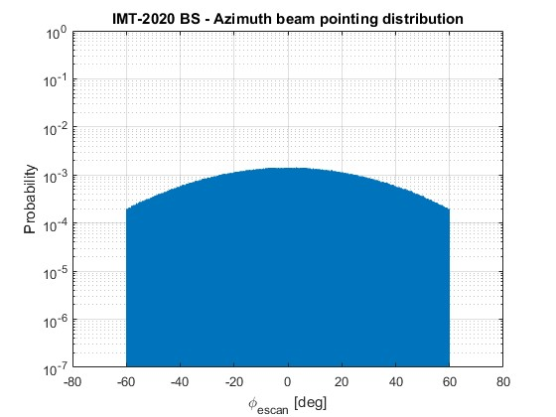

The elevation tilt θtilt TOT = θetilt + θmtilt (see Figure 1-2) distribution has to be retrieved from the log-normal distribution (𝜇 = 3.9°; 𝜎 = 0.42°) of the distance between BS and UE.

FIGURE 1-2

**IMT-2020 5G BS (Suburban Open-Space) – Definition of total tilt**

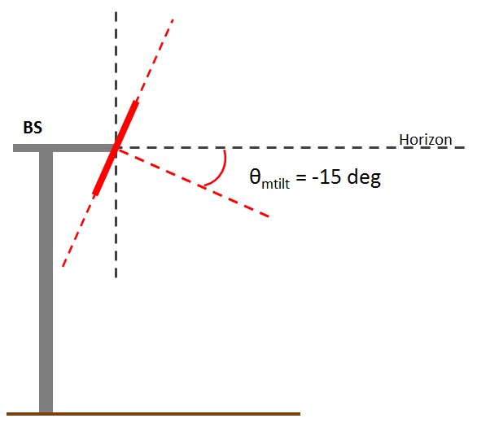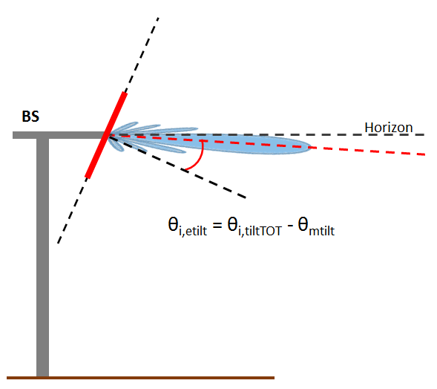

The UE distance and θtilt TOT PDFs are shown in Figure 1-3 and Figure 1-4, respectively.

FIGURE 1-3

**IMT-2020 5G BS (Suburban Open-Space) – UE distance from BS PDF**

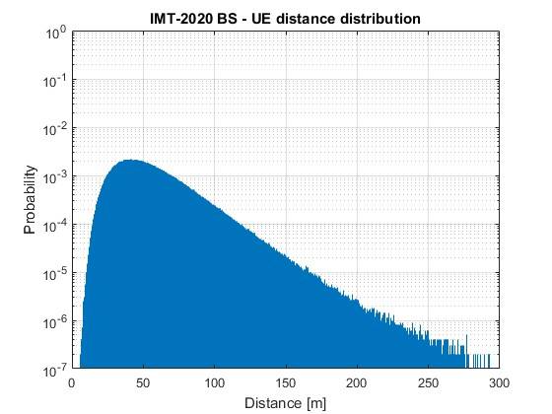

FIGURE 1-4

**IMT-2020 5G BS (Suburban Open-Space) – Total elevation tilt PDF**

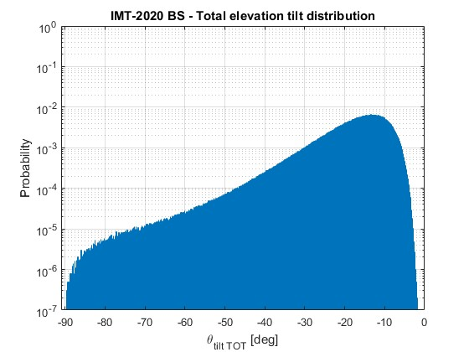

From these distributions, it is possible to determine the antenna gain distribution towards the victim earth station, using the antenna pattern from recommendation ITU-R M.2101. The pattern for an 8x8 antenna with a 65° element aperture with an antenna gain of 5 dBi and a front to back lobe ratio of 30 dB is given in Figure 1-5. The ITU-R M.2101 antenna radiation pattern has been capped at -30 dB (which is the minimum value of the single element radiation pattern of the array).

FIGURE 1-5

**IMT-2020 5G BS (Suburban Open-Space) – BS antenna pattern at 0° electrical tilt**

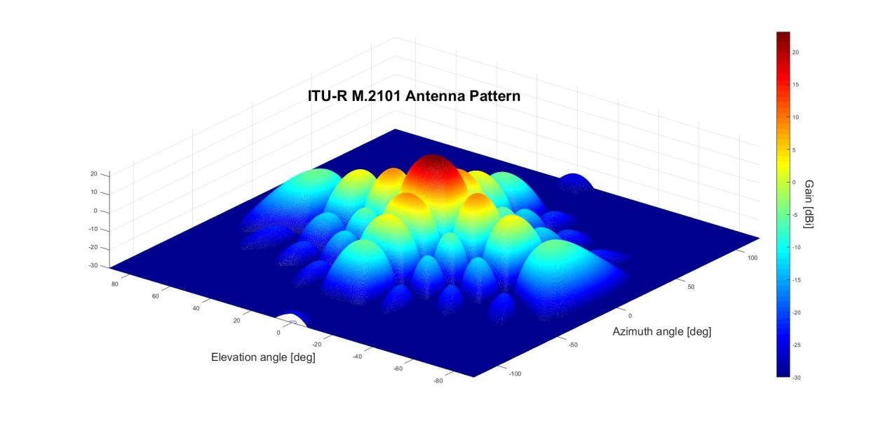

The distribution has been computed assuming a flat terrain, i.e. horizon 0 deg. The latter is a worst-case assumption given that higher horizon angles would provide lower antenna gain values (the antenna is pointing towards ground). It is given in Figure 1-6 for 26 and 32 GHz, and in Figure 1-7 for 37 GHz. The gain on the X-axis is Gt, and the percentage on the Y-axis is pn, as described in (1-1).

FIGURE 1-6

**Gain toward the horizon CCDF (IMT-2020 5G BS Suburban open space, 24.25 - 33.40 GHz)**

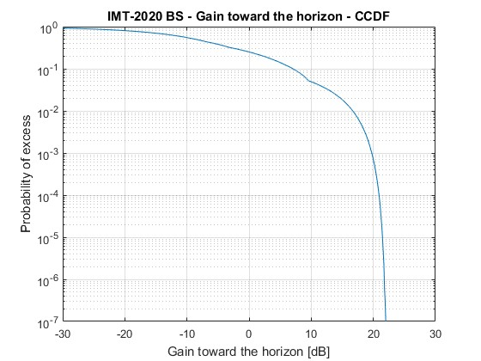

FIGURE 1-7

**Gain toward the horizon CCDF (IMT-2020 5G BS Suburban open space, 37.00 – 43.50 GHz)**

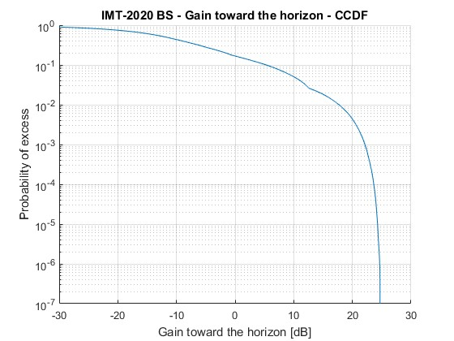

# Determination of the SRS antenna gain Gr towards the horizon

The SRS antenna gain towards the horizon is determined using the minimum pointing elevation angle for the azimuth considered and the relevant antenna pattern.

* The minimum elevation angle for SRS (near-Earth) in the bands 25.5-27 GHz and 37-38 GHz is either 5°, or 1° above the horizon when the horizon elevation is higher than 4°.
* The minimum elevation angle for SRS (deep space) in the bands 31.8-32.3 GHz and 37-38 GHz is either 10°, or 1° above the horizon if the horizon elevation is higher than 9°.

As an example, Figure 1-8 gives the horizon profile for the NASA SRS earth station in Robledo (Spain). The elevation angle around 75° azimuth and above 250° is higher than 4°, hence the minimum elevation angle is 1° above this horizon. Elsewhere, the relevant value would be 5°.

FIGURE 1-8

**Horizon profile around Robledo**

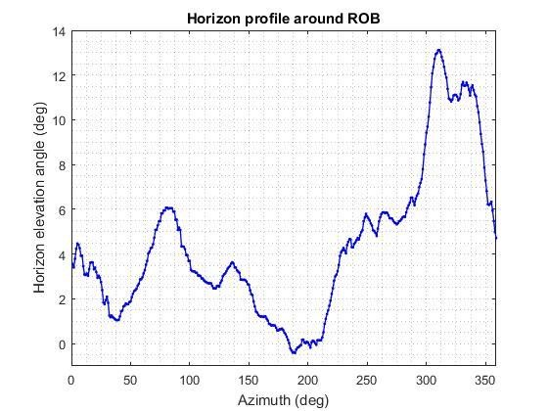

The SRS offset angle is then the difference between the minimum elevation angle and the horizon elevation angle. When the horizon elevation angle is above 4°, the offset angle is always 1°.

The SRS antenna pattern depends on each antenna and frequency band of interest. Recommendation ITU-R SA.509 can be used in the 25.5-27 GHz band, and Recommendation ITU-R SA.1811 can be considered for the bands 31.8-32.3 GHz and 37-38 GHz. Alternatively, the antenna patterns contained in RR Appendices 7 or 8 could also be considered.

Figure 1-9 provides an example of SRS antenna gain Gr as function of the azimuth around the NASA SRS earth station in Robledo (Spain).

FIGURE 1-9

**NASA SRS earth station antenna gain towards the horizon around Robledo**



# Determination of the SRS protection threshold and reference bandwidth

* The SRS protection threshold I is given in Recommendation ITU-R SA.609 for SRS (Near-Earth) below 30 GHz, as -156 dBW in a reference bandwidth Bref of 1 MHz. The associated percentage of time p is either 0.1% for unmanned missions or 0.001% for manned missions. Since most of SRS earth stations can support both manned and unmanned missions, the value of 0.001% should be used.
* The SRS protection threshold I is given in Recommendation ITU-R SA.1157 for SRS (deep space) in the band 31.8-32.3 GHz as -217 dBW in a reference bandwidth Bref of 1 Hz. The associated percentage of time p is 0.001%.
* The SRS protection threshold I is given in Recommendation ITU-R SA.1396 for SRS in the band 37-38 GHz as -217 dBW in a reference bandwidth Bref of 1 Hz. The associated percentage of time p is either 0.1% for unmanned missions or 0.001% for manned missions. Since most of SRS earth stations can support both manned and unmanned missions, the value of 0.001% should be used.

Those criteria do not include any apportionment, that could be envisaged on a case-by-case basis.

# Determination of the required propagation loss and associated percentage of time

For each azimuth around the SRS earth station, and each percentage of time pn determined in section 4, the required propagation loss Lreq and associated percentage of time pv should be determined using equations (1-1) and (1-2) respectively.

# Determination of the coordination contour

For each of the azimuth around the SRS earth station, each of the distances from the SRS earth station location, and each of the percentages of time pv determined in section 7, the propagation loss should be determined using Recommendation ITU-R P.452-16, considering the terrain elevation surrounding the earth station.

The terrain elevation recommended is the 1-arcsec resolution terrain profile data of the Shuttle Radar Topography Mission (SRTM). The terrain profiles can be sampled with an azimuth step of 1 deg around the earth station of interest and a distance step of 25 m. The losses can then be computed around the station with an azimuth step of 1 degree and a distance step of 100 m.

For each azimuth and percentage of time pv, the separation distance required is then the maximum distance at which the propagation loss calculated is just below the required propagation loss Lreq(pv). The coordination distance to be retained for the azimuth angle considered is the maximum distance obtained for all values of pv.

The following figure 1-10 provides as an example the coordination contour obtained around the ESA station in Cebreros (Spain) for an 8x8 suburban open space area base station at 26 GHz.

FIGURE 1-10

**Google Earth view of coordination contour and protection level violations around Cebreros**

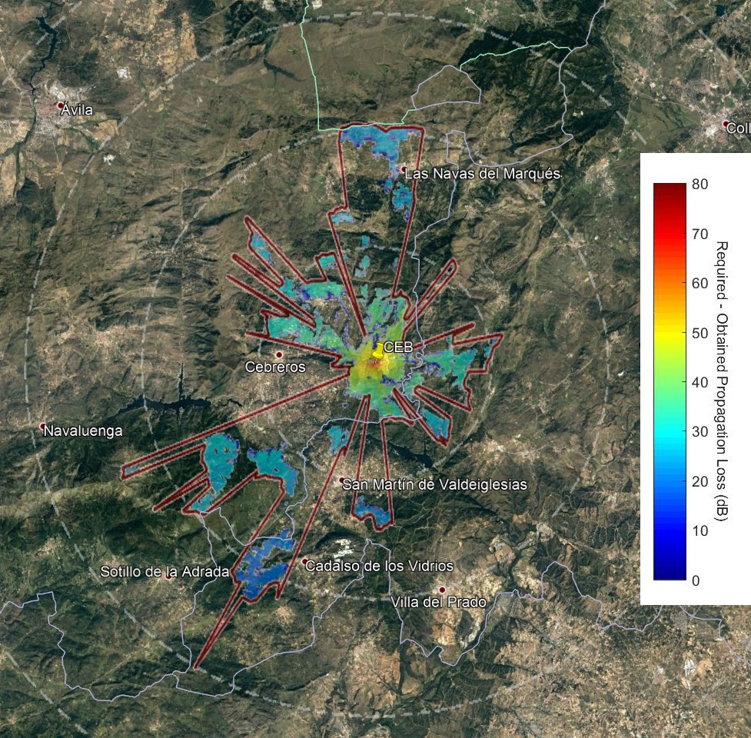

Annex 2  
  
Methodology for calculating the exclusion zone around NGSO EESS earth stations in the band 25.5-27 GHz

# Introduction

Most of NGSO EESS satellites using this frequency band will be LEO satellites on polar orbits. Other types of orbits are as well usable with different inclinations, however it is not expected that this would change the results obtained when using this methodology with a particular satellite on a 800 km sun synchronous orbit, as proposed in Section 5.

The methodology used is based on the Time Variable Gain (TVG) methodology given in RR Appendix 7. However, since both the transmitter and receiver antenna gains are varying, a convolution has to be made between the distributions of those gains and hence, the methodology has to be slightly revised.

Given that the user equipment will operate either indoor or in heavy clutter, the methodology focusses on the IMT-2020 base station. Since studies have shown that there is little aggregate effect from several base stations and user equipment near the earth station, the methodology only considered a single base IMT-2020 base station. When considering the aggregate, distances are not expected to increase as long as BS antenna panels are not concurrently pointing towards the ES in azimuth.

# TVG modified methodology

A modified version of the Time Variable Gain (TVG) methodology given in RR Appendix 7 has been used to approximate the convolution of the distributions of the transmitter antenna gain (base station tracking the UE), the receiver antenna gain (the EESS earth station tracking an EESS satellite on a typical polar orbit), and the propagation model. Equation (1-1) can be rewritten as follows:

𝐿𝑟𝑒𝑞(𝑝𝑣) = 𝑃𝑡 + 𝐺𝑡(𝑝𝑡) + 𝐺𝑟(𝑝𝑟) − 𝐼(𝑝) – *Lc* = 𝑃𝑡 + 𝐺𝑡𝑜𝑡(𝑝𝑛) − 𝐼(𝑝) – *Lc* (2-1)

Where,

* 𝑃𝑡 is the total transmitting power level (dBW) in the reference bandwidth of a transmitting IMT-2020 base station;
* 𝐼(𝑝) is the protection threshold (dBW) in the reference bandwidth to be exceeded for no more than 𝑝% of the time at the input of the antenna of the receiving SRS earth station that may be subject to interference;
* 𝐺𝑡(𝑝t) is the gain towards the horizon of the transmitting antenna (dBi) that is exceeded for 𝑝t% of the time on the azimuth under consideration;
* 𝐺𝑟 is the gain towards the physical horizon for a given azimuth (dBi) of the victim SRS earth station antenna that is exceeded for 𝑝r% of the time on the azimuth under consideration;
* 𝐺𝑡𝑜𝑡(𝑝𝑛) = 𝐺𝑡(𝑝𝑡) + 𝐺𝑟(𝑝𝑟) is given by the convolution between the transmitting gain distribution 𝐺𝑡(𝑝𝑡) and the victim Earth station distribution 𝐺𝑟(𝑝𝑟);
* *Lc* is the clutter loss (dB) applicable to the IMT-2020 base station specific environment, if any;
* 𝐿𝑟𝑒𝑞(𝑝𝑣) is the minimum required propagation loss (dB) for 𝑝𝑣% of the time; this loss must be exceeded by the propagation path loss for all possible 𝑝𝑣% values retrieved from the considered gain complementary cumulative distribution function. 𝑝𝑣 is the time percentage that approximates the convolution between the variable horizon gain and the propagation mode path loss and is given by (1-2).

# Determination of the IMT-2020 base station total power

Same as Annex 1 - Section3.

# Determination of the distribution of the IMT-2020 BS antenna gain towards the horizon

Same as Annex 1 – Section 4.

# Determination of the EESS antenna gain Gr towards the horizon

To determine the EESS earth station antenna gain towards the horizon for each azimuth, it is necessary to run a simulation whereby an EESS satellite orbit is propagated over a given period.

EESS satellites are generally using sun-synchronous orbits, with altitudes between 400 and 1400 km, a typical value being 800 km. For such altitude, the orbit inclination would be 98.7°. Figure 2-1 provides a view of such orbit.

FIGURE 2-1

**EESS satellite orbit**

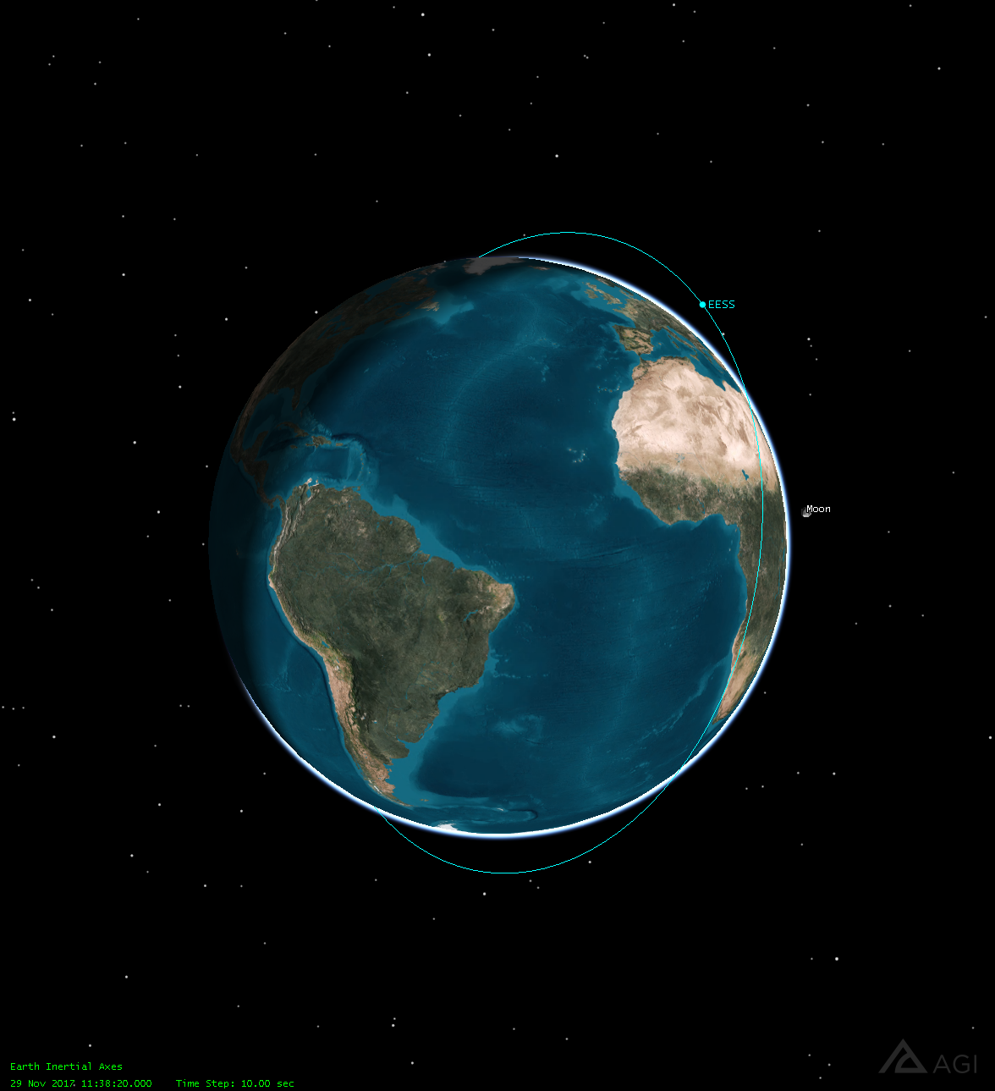

It is then necessary to determine the visibilities of such satellite from the EESS earth station considered. The satellite is visible as soon as its elevation angle as seen from the earth station is over 5°. Figure 2-2 provides as an example a view of the portions of orbits that are visible from Kiruna (Sweden) over 5° elevation over a 11 days period.

FIGURE 2-2

**Visibility of the EESS satellite from a given earth station**

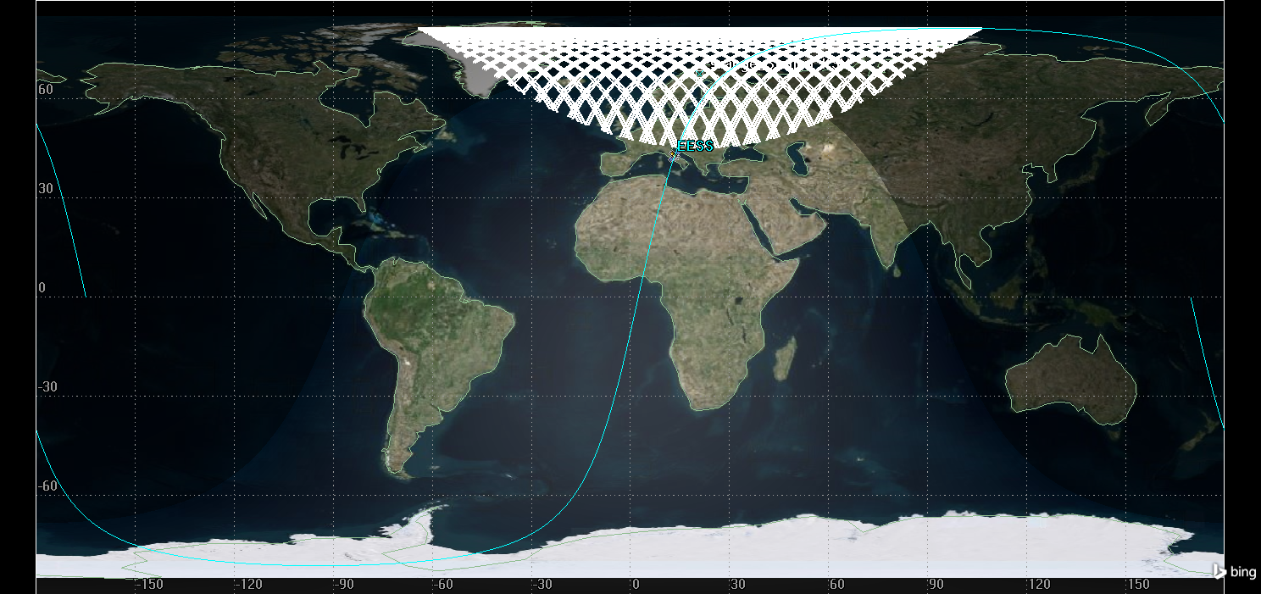

For each of the time steps where the satellite is in visibility, and each azimuth around the earth station, it is then necessary to determine the offset angle between the vector earth station-satellite, and the horizon direction for the azimuth considered. This offset angle can then be used to determine the antenna gain towards the horizon, using antenna patterns such as RR Appendix 7 or Appendix 8. The cumulative distribution function of the antenna gain can then be extracted for each azimuth, as shown in Figure 2-3 for Kiruna, and an antenna following AP8 with a 70.7 dBi maximum antenna gain.

FIGURE 2-3

**EESS Antenna gain towards the horizon**

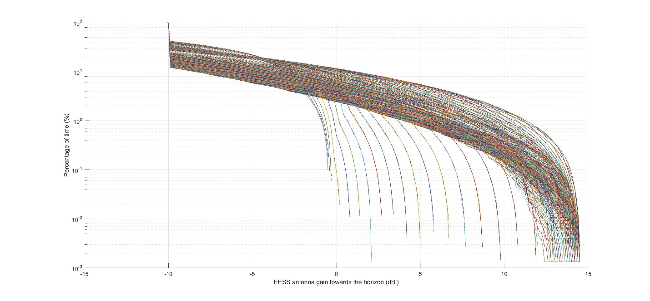

This cdf provides on the X-axis the value of Gr and on the Y-axis the value of pr used in equation (2-1), for each azimuth.

# Determination of the convolution Gtot of both antenna gains towards the horizon

When both distributions of base station gain towards the horizon and EESS gain towards the horizon are available, the next step is to convolve them. This can be done directly for each azimuth, or using this alternative approach:

* Generate N random base station antenna gain values Gt following the distribution (Gt,pt) obtained in section 4;
* Generate N random EESS earth station antenna gain values Gr following the distribution (Gr,pr) obtained in section 5;
* Sum the two random numbers obtained Gtot=Gt+Gr;
* Generate the cdf of Gtot.

This has been done as an example for the EESS earth station in Kiruna, for all azimuth around the earth station, in Figure 2-4.

FIGURE 2-4

**Composite gain Gtot**

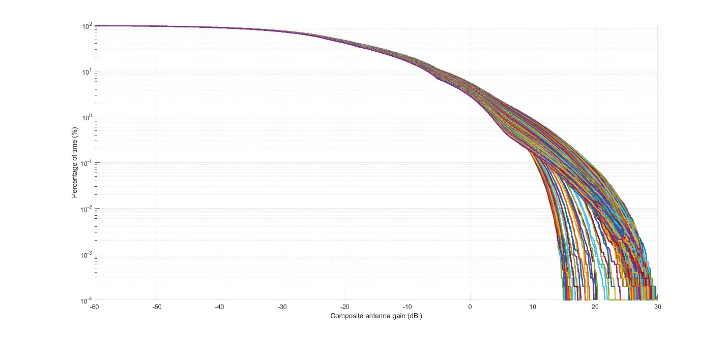

# Determination of the EESS protection threshold and reference bandwidth

The EESS sharing threshold I is given in Recommendation ITU-R SA.1027. This recommendation proposes two criteria, one long-term and one short-term. Monte Carlo analyses have shown that when the short-term criterion was met, the long-term was also met. In addition, applying this methodology with the long-term criterion and a percentage of time of 20% would largely overestimate the separation distances required to ensure protection to EESS earth stations.

The sharing criterion to be used is therefore the short-term criterion, given as -116 dBW in a reference bandwidth Bref of 10 MHz. The associated percentage of time p is 0.005%.

# Determination of the required propagation loss and associated percentage of time

Same as Annex 1 – Section 7.

# Determination of the exclusion zone contour

For each of the azimuth around the EESS earth station, each of the distances from the EESS earth station location, and each of the percentages of time pv determined in section 8, the propagation loss should be determined using Recommendation ITU-R P.452-16, considering the terrain elevation surrounding the earth station.

The terrain elevation recommended is the 1-arcsec resolution terrain profile data of the Shuttle Radar Topography Mission (SRTM). The terrain profiles can be sampled with an azimuth step of 1 deg around the earth station of interest and a distance step of 25 m. The losses can then be computed around the station with an azimuth step of 1 degree and a distance step of 100 m.

For each azimuth and percentage of time pv, the separation distance required is then the maximum distance at which the propagation loss calculated is just below the required propagation loss Lreq(pv). The separation distance to be retained for the azimuth angle considered is the maximum distance obtained for all values of pv.

The following figure 2-5 provides as an example the exclusion zone contour obtained around the ESA station in Kiruna (Sweden) for an 8x8 suburban open space area base station at 26 GHz.

FIGURE 2-5

**Google Earth view of exclusion zone contour around Kiruna**

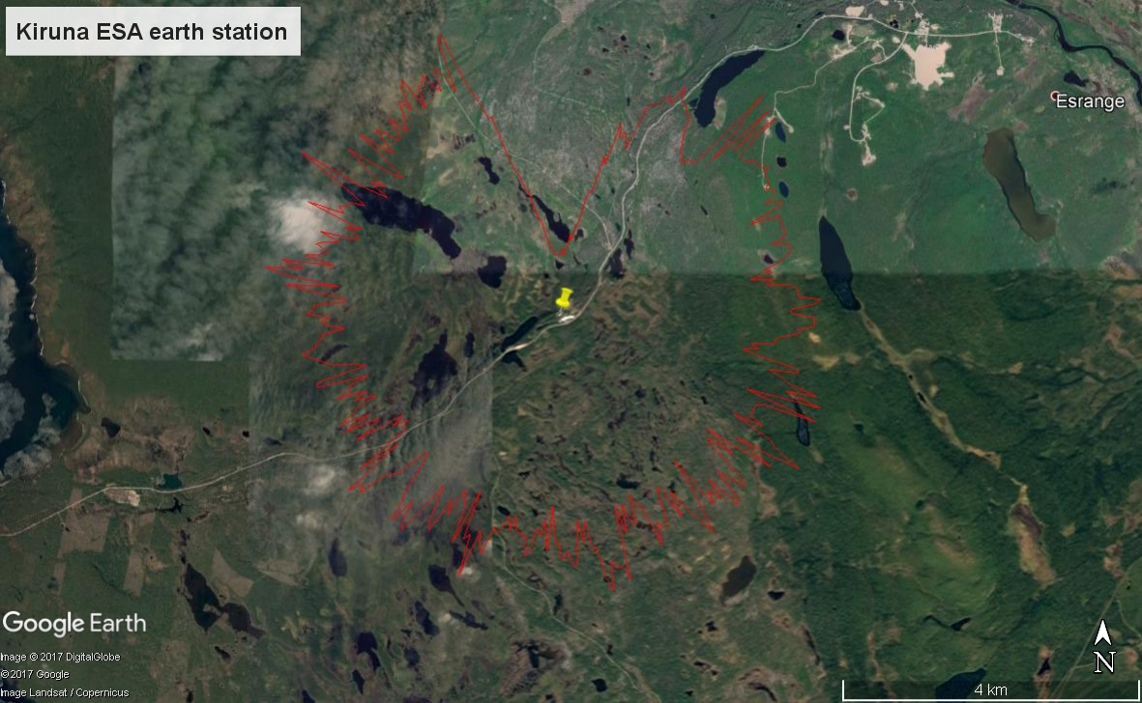

Annex 3  
  
Methodology for calculating the exclusion zone around GSO EESS earth stations in the band 25.25 – 27.5 GHz

# Introduction

This methodology would apply to EESS satellites performing observations from the GSO orbit, such as meteorological satellites, in the band 25.5-27 GHz.

In this case, the EESS earth station is tracking a given GSO satellite and hence its antenna is not moving. The TVG methodology given in RR Appendix 7 can therefore be applied as such. This methodology would give results similar to a Monte Carlo analysis, but is much faster and more efficient.

Given that the user equipment will operate either indoor or in heavy clutter, the methodology focusses on the IMT-2020 base station. Since studies have shown that there is little aggregate effect from several base stations and user equipment near the earth station, the methodology only considered a single base IMT-2020 base station. When considering the aggregate, distances are not expected to increase as long as BS antenna panels are not concurrently pointing towards the ES in azimuth.

# TVG standard methodology

See Annex 1 section 2.

# Determination of the IMT-2020 base station total power

See Annex 1 section 3

# Determination of the distribution of the IMT-2020 BS antenna gain towards the horizon

See Annex 1 section 4

# Determination of the EESS antenna gain Gr towards the horizon

In this case, the GSO satellite is fixed at a given longitude on the GSO arc, at round 36 000 km altitude. It is therefore easy to determine only once the vector going from the EESS earth station towards the EESS satellite. The offset angle between this vector and the horizon direction for each azimuth can also be determined only once, whereas for a NGSO satellite it had to be determined for each time step.

This offset angle allows to determine the antenna gain of the EESS earth station towards the horizon for the azimuth considered. Normally, it should be at its maximum value in the azimuth corresponding to the azimuth where the GSO satellite is.

# Determination of the EESS protection threshold and reference bandwidth

The short-term EESS sharing threshold I is given in Recommendation ITU-R SA.1161, as -133 dBW in a reference bandwidth Bref of 10 MHz. The associated percentage of time p is 0.1%.

# Determination of the required propagation loss and associated percentage of time

See Annex 1 section 7.

# Determination of the exclusion zone contour

For each of the azimuth around the EESS earth station, each of the distances from the EESS earth station location, and each of the percentages of time pv determined in section 7, the propagation loss should be determined using Recommendation ITU-R P.452-16, considering the terrain elevation surrounding the earth station.

The terrain elevation recommended is the 1-arcsec resolution terrain profile data of the Shuttle Radar Topography Mission (SRTM). The terrain profiles can be sampled with an azimuth step of 1 deg around the earth station of interest and a distance step of 25 m. The losses can then be computed around the station with an azimuth step of 1 degree and a distance step of 100 m.

For each azimuth and percentage of time pv, the separation distance required is then the maximum distance at which the propagation loss calculated is just below the required propagation loss Lreq(pv). The separation distance to be retained for the azimuth angle considered is the maximum distance obtained for all values of pv.

The following figure 3-1 provides as an example the exclusion zone contour obtained around the EUMETSAT earth station in Leuk (Switzerland) for a 8x8 suburban open space area base station at 26 GHz.

FIGURE 3-1

**Google Earth view of the exclusion zone contour around Leuk**

